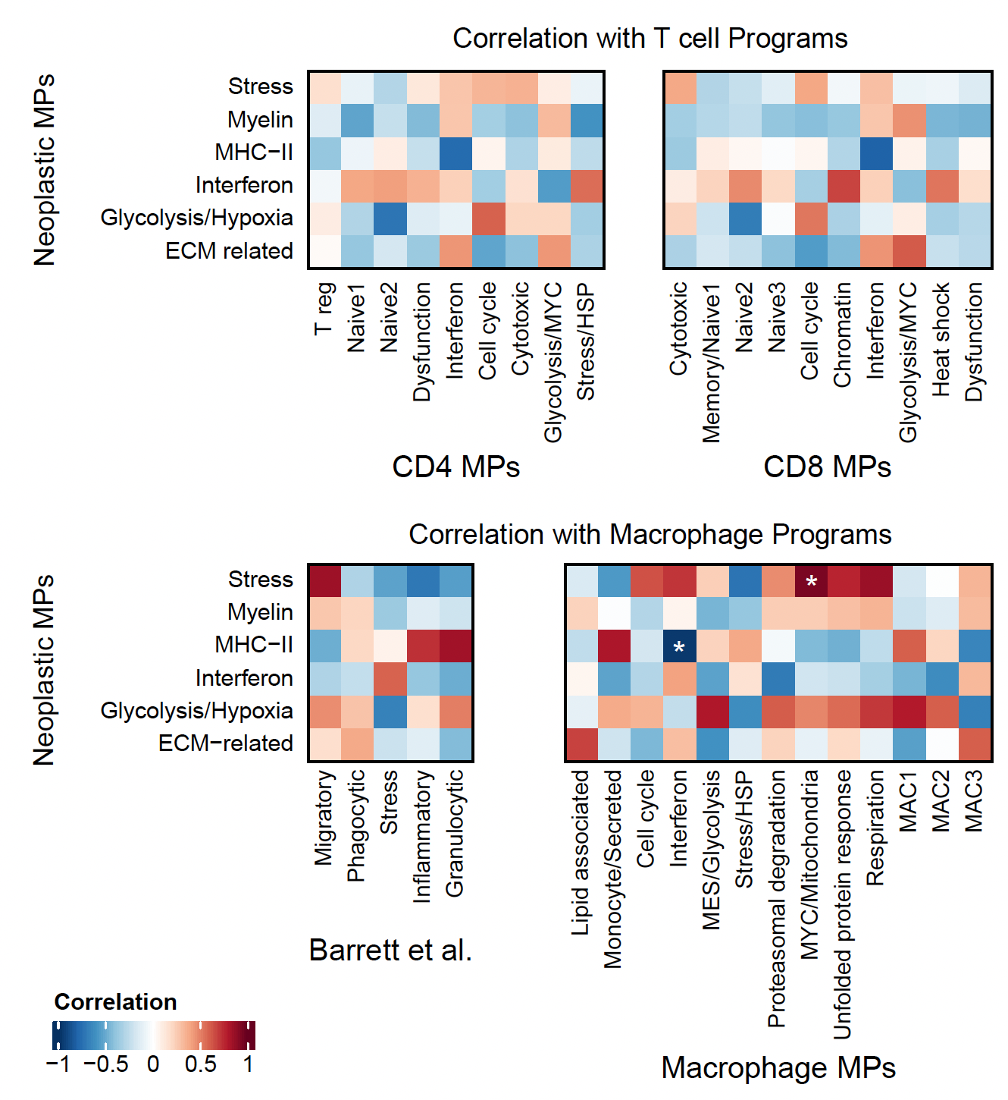
Additional file 15: Fig. S8: Correlations between neoplastic cell metaprograms and T cell and macrophage signatures. After correction for multiple comparisons, we observe significant correlations between our stress neoplastic program and the MYC/mitochondria macrophage signature (0.94, p=0.045), as well as between the MHC class II neoplastic metaprogram and the interferon macrophage signature (-0.96, p=0.032).

