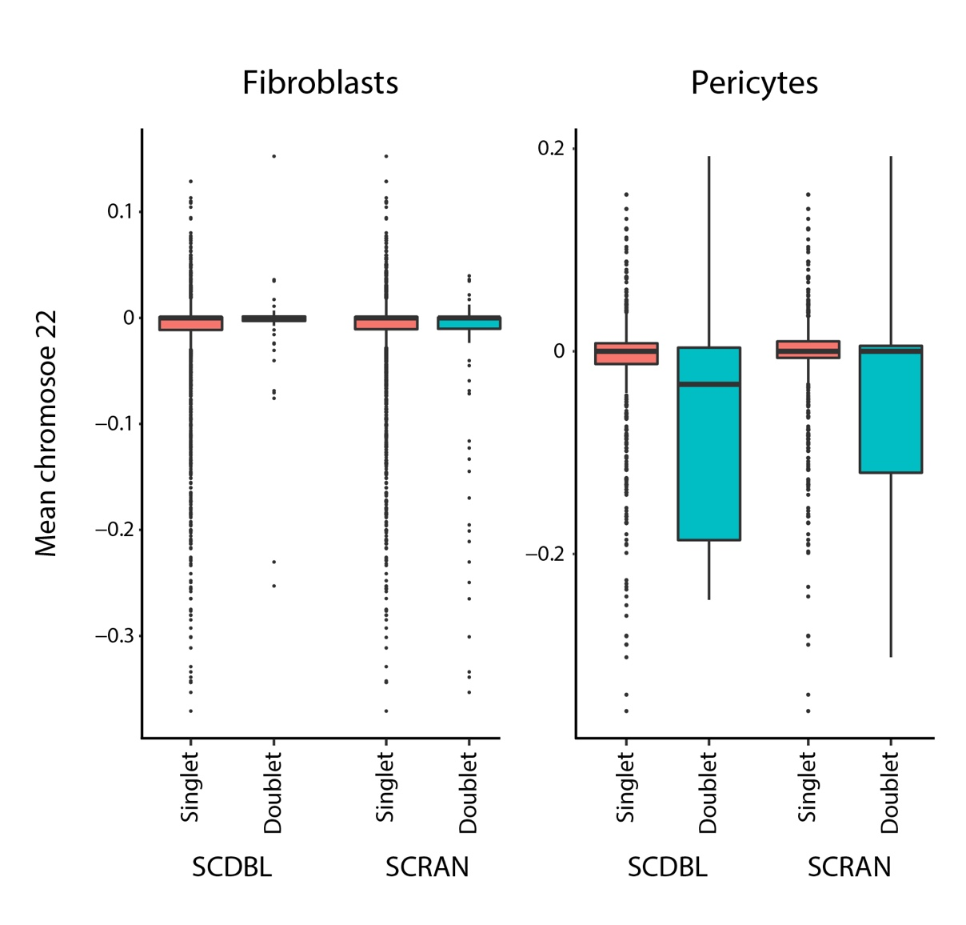
Additional file 3 - Fig. S1: Doublet inference using two different methods (SCDBL and SCRAN) and a high cutoff of 5% doublet assumption. Mean CNA on chromosome 22 on fibroblasts and pericytes is plotted using both methods, comparing values in the presumed doublets to those in singlets. Notably, of the fibroblasts with a 22 chromosome CNA mean less than -0.15 (total of 90 cells), only one cell was a presumed doublet by both methods. Similarly, only two pericytes (out of 32 cells with mean less than -0.15) were presumed doublet by both methods. Using a lower cutoff of 1% doublets did not yield any such cells.

