Supplementary Information

Multi-omics analysis reveals immunosuppression in oesophageal squamous cell carcinoma induced by creatine accumulation and HK3 deficiency

Yingzhen Gao, Siyu He, Xiaoyan Meng, Kun Zheng, Heyang Cui, Yikun Cheng, Xinyuan Shen, Yuanfang Zhai, Binbin Zou, Fang Wang, Hongyi Li, Pengzhou Kong, Yanqiang Wang, Xuefei Feng, Bin Yang, Ruifang Sun, Yongsheng Meng, Enwei Xu, Yanlin Guo, Ning Ding, Weimin Zhang, Xiaolong Cheng, Lunzhi Dai, Yongping Cui, Ling Zhang

Correspondence: Xiaolong Cheng (chengxl@sxmu.edu.cn); Lunzhi Dai (lunzhi.dai@scu.edu.cn); Yongping Cui (cuiyp@sxmu.edu.cn); Ling Zhang (zhanglingty@sxmu.edu.cn; Tel.:86-351-4135728)

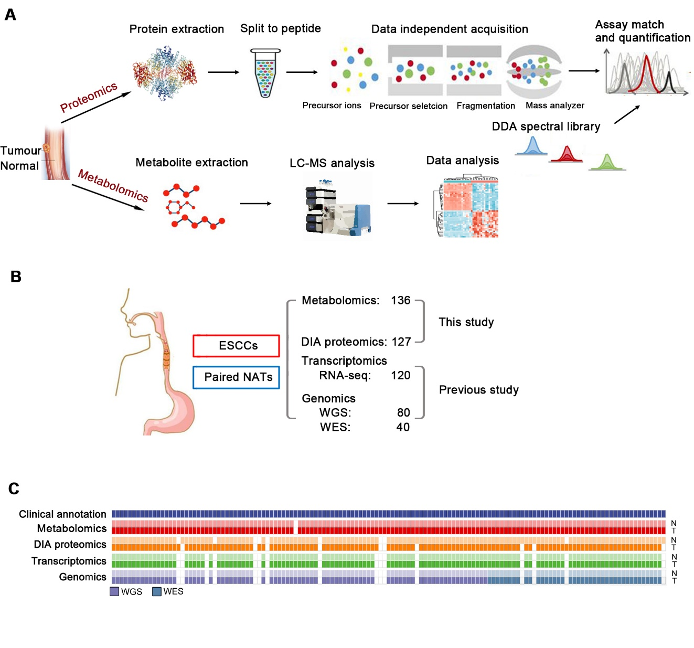
Supplementary Figure

Fig. S1. Overview of multi-omics landscape of ESCC samples. Related to Fig. 1, Fig. 2 and Table S1.
A Overview of the experimental design for the proteomics and metabolomics analyses of ESCC. B Sample composition in our multi-omics study. C Illustration of ESCC cases used in the individual omics experiments. The metabolome, proteome, transcriptome and genome experiments are coloured red, orange, green and purple respectively. For each omics dataset, the top panel represents the non-tumour tissues (N) and the bottom panel represents the tumour tissues (T). 126 tumour samples overlapping between metabolomics and proteomics datasets were used for molecular subtyping, and 120 tumour samples shared across all four omics (metabolomics, proteomics, transcriptomics, and genomics) were used for integrated multi-omics analysis.

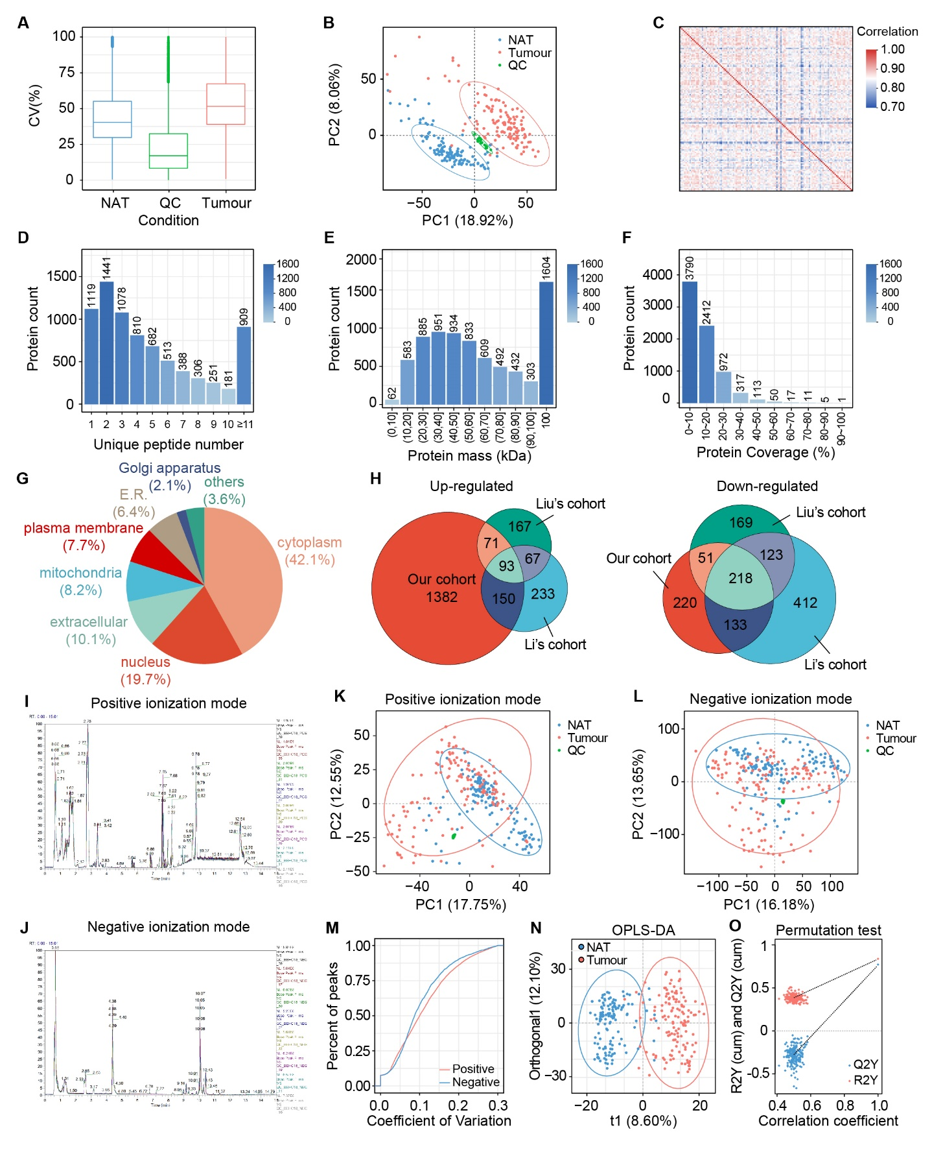
Fig. S2. Quality control and overview of proteome and metabolome. Related to Fig. 1 and Fig. 2.
A-C The quality of the DIA data was evaluated based on intra-group coefficient of variation (CV) (A), principal component analysis (PCA) (B), and quantitative Spearman’s correlation coefficients of samples (C). D-F The basic statistics of the DDA identification results, which are unique peptide distribution (D), protein mass distribution (E) and protein coverage distribution (F) respectively. For (D), the x-axis is the number of unique peptides for each protein, and the y-axis is the number of proteins. For (E), the x-axis is protein mass interval (Kilodalton), and the y-axis is the number of proteins. For (F), the x-axis is coverage percentage interval, and the y-axis is the number of proteins. G Subcellular localization of differentially expressed proteins. H The number of up-regulated (left) and down-regulated (right) proteins in three ESCC cohorts. I,J Chromatogram overlap in positive ionization mode (I) and negative ionization mode (J) of QC samples. K,L Principal component analysis (PCA) in positive ionization mode (K) and negative ionization mode (L) for all samples and QC samples. M CV distribution of compounds in each sample. Red: Positive ionization mode. Blue: Negative ionization mode. N Orthogonal partial least squares-discriminant analysis (OPLS-DA) model between the comparative group (two groups) was established after log2-conversion of the data, and the method used for scaling is Par. The seven-fold cross validation was performed during modelling. O Response permutation testing (RPT) graph of the OPLS-DA model.

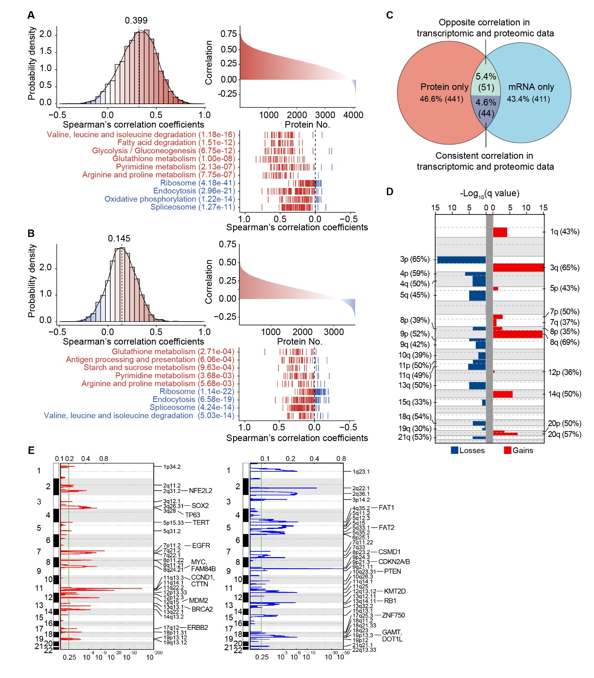
Fig. S3. Integrative analyses of genomics, transcriptomics and proteomics data in ESCC samples. Related to Fig. 3 and Table S6.
A mRNA-protein correlation in tumours. Red: pathways in which positively correlated genes were involved; blue: pathways in which negatively correlated genes were involved. B mRNA-protein correlation in NATs. Red: pathways in which positively correlated genes were involved; blue: pathways in which negatively correlated genes were involved. C Overlap of genes with prognostic power based on transcriptomics or proteomics data (log-rank test, P < 0.01, FDR < 0.05). D Arm-level CNAs. Red denotes amplification and blue denotes deletion. E Genome-wide focal amplifications and deletions. Chromosomal locations of peaks of significantly recurring focal amplifications (red) and deletions (blue) were filtered by FDR. Peaks were annotated with candidate driver oncogenes or tumour suppressors.

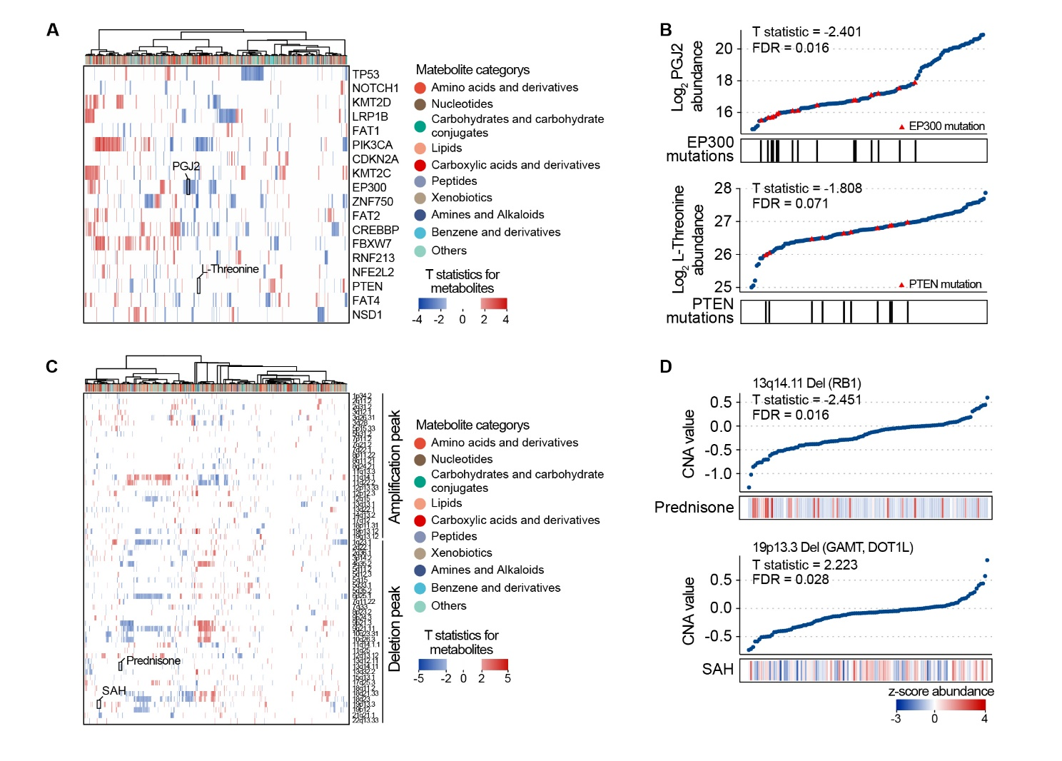
Fig. S4. An extensive analysis connecting metabolites with genomic features. Related to Table S8 and S9.
A Heatmap showing the associations between the abundances of metabolites and the presence of mutations within the indicated genes. The mutations include high frequency somatic mutations (mutated in at least 6% of the samples) within cancer-related genes in ESCC. T statistics were calculated by a linear regression model that adjusted the confounding factors. B Upper: Correlations between EP300 mutations and PGJ2 levels. Bottom: Correlations between PTEN mutations and L-Threonine abundance levels. The P-values were adjusted using Benjamini-Hochberg false discovery rate (FDR) correction. C Heatmap showing the associations between the abundances of metabolites and the ESCC-specific CNAs peaks. T statistics were calculated by a linear regression model that adjusted the confounding factors. D Upper: Correlations between 13q14.11 deletion and prednisone levels. Bottom: Correlations between 19p13.3 deletion and S-adenosylhomocysteine (SAH) levels. The P-values were adjusted using Benjamini-Hochberg false discovery rate (FDR) correction.

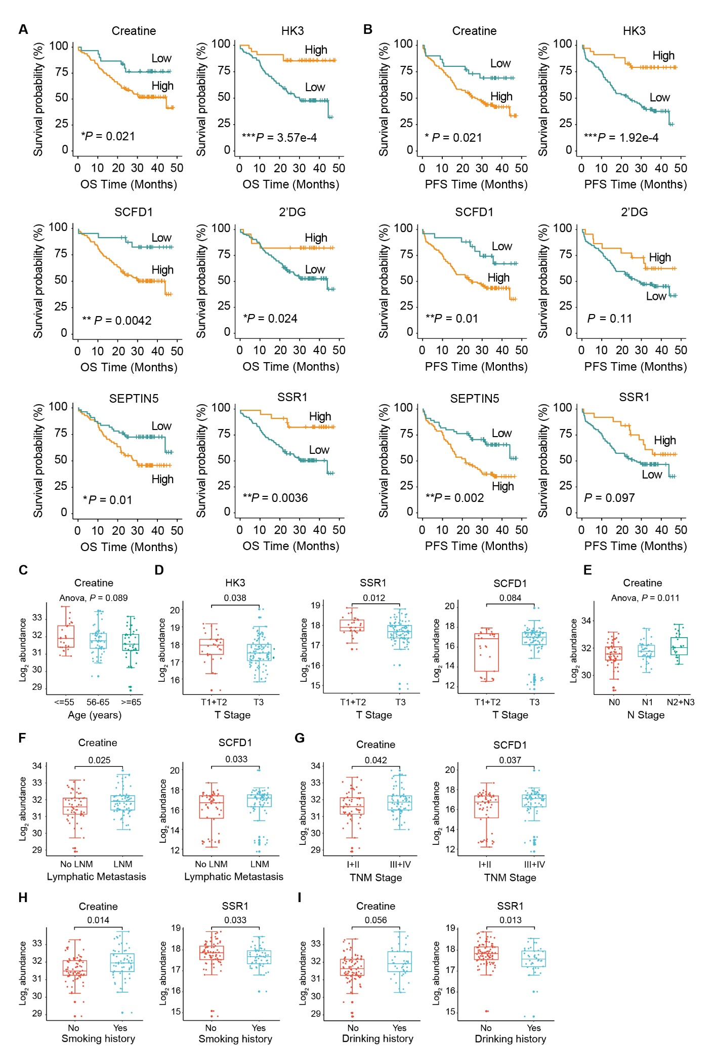
Fig. S5. The prognostic value of six signatures in the subtype diagnostic model and their associations with clinical features. Related to Fig. 5.
A,B Kaplan-Meier curves illustrate overall survival (OS) (A) and progression-free survival (PFS) (B) probabilities stratified by the expression levels of creatine, HK3, SCFD1, 2’DG, SEPTIN5, and SSR1. The P values were calculated using the log-rank test. C Log2 abundance of creatine across patients with different age groups. D Log2 abundance of HK3, SSR1, and SCFD1 across patients with different tumour size and invasion stages (T Stage). E Log2 abundance of creatine across patients with different lymph node involvement stages (N Stage). F Log2 abundance of creatine and SCFD1 across patients with lymph node metastasis (LNM) or not (No LNM). G Log2 abundance of creatine and SCFD1 across patients with different TNM stages. H Log2 abundance of creatine and SSR1 across patients with different smoking history groups. I Log2 abundance of creatine and SSR1 across patients with different drinking history groups.

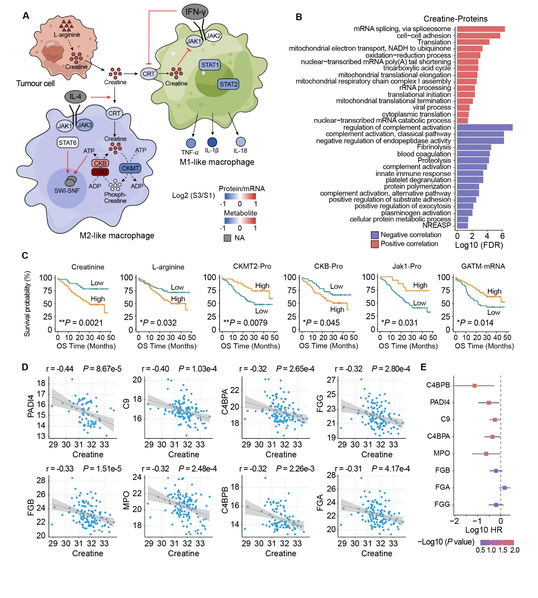
Fig. S6. Analysis of immune infiltration associated with the abundance of creatine. Related to Fig. 6.
A The profile of creatine metabolism and polarization-related genes in macrophages. Log2 fold changes of metabolites, proteins and mRNAs in S3 and S1 subtypes are colour-coded. B Functional enrichment analysis of the proteins with a significant correlation (|Spearman’s correlation coefficient| > 0.3, P < 0.05) with the abundance of creatine in metabolomics. Red: positive correlation. Blue: negative correlation. C Kaplan-Meier curves for overall survival analysis of several metabolites abundance and genes expression related to creatine metabolism (P value from log-rank test). D,E Dot plot showing the expression of immune-related proteins significantly negative correlation with the abundance of creatine (Spearman’s correlation coefficient < 0.3, P < 0.05) (D). Log10-based hazard ratio and P value of these immune-related proteins are shown (E).

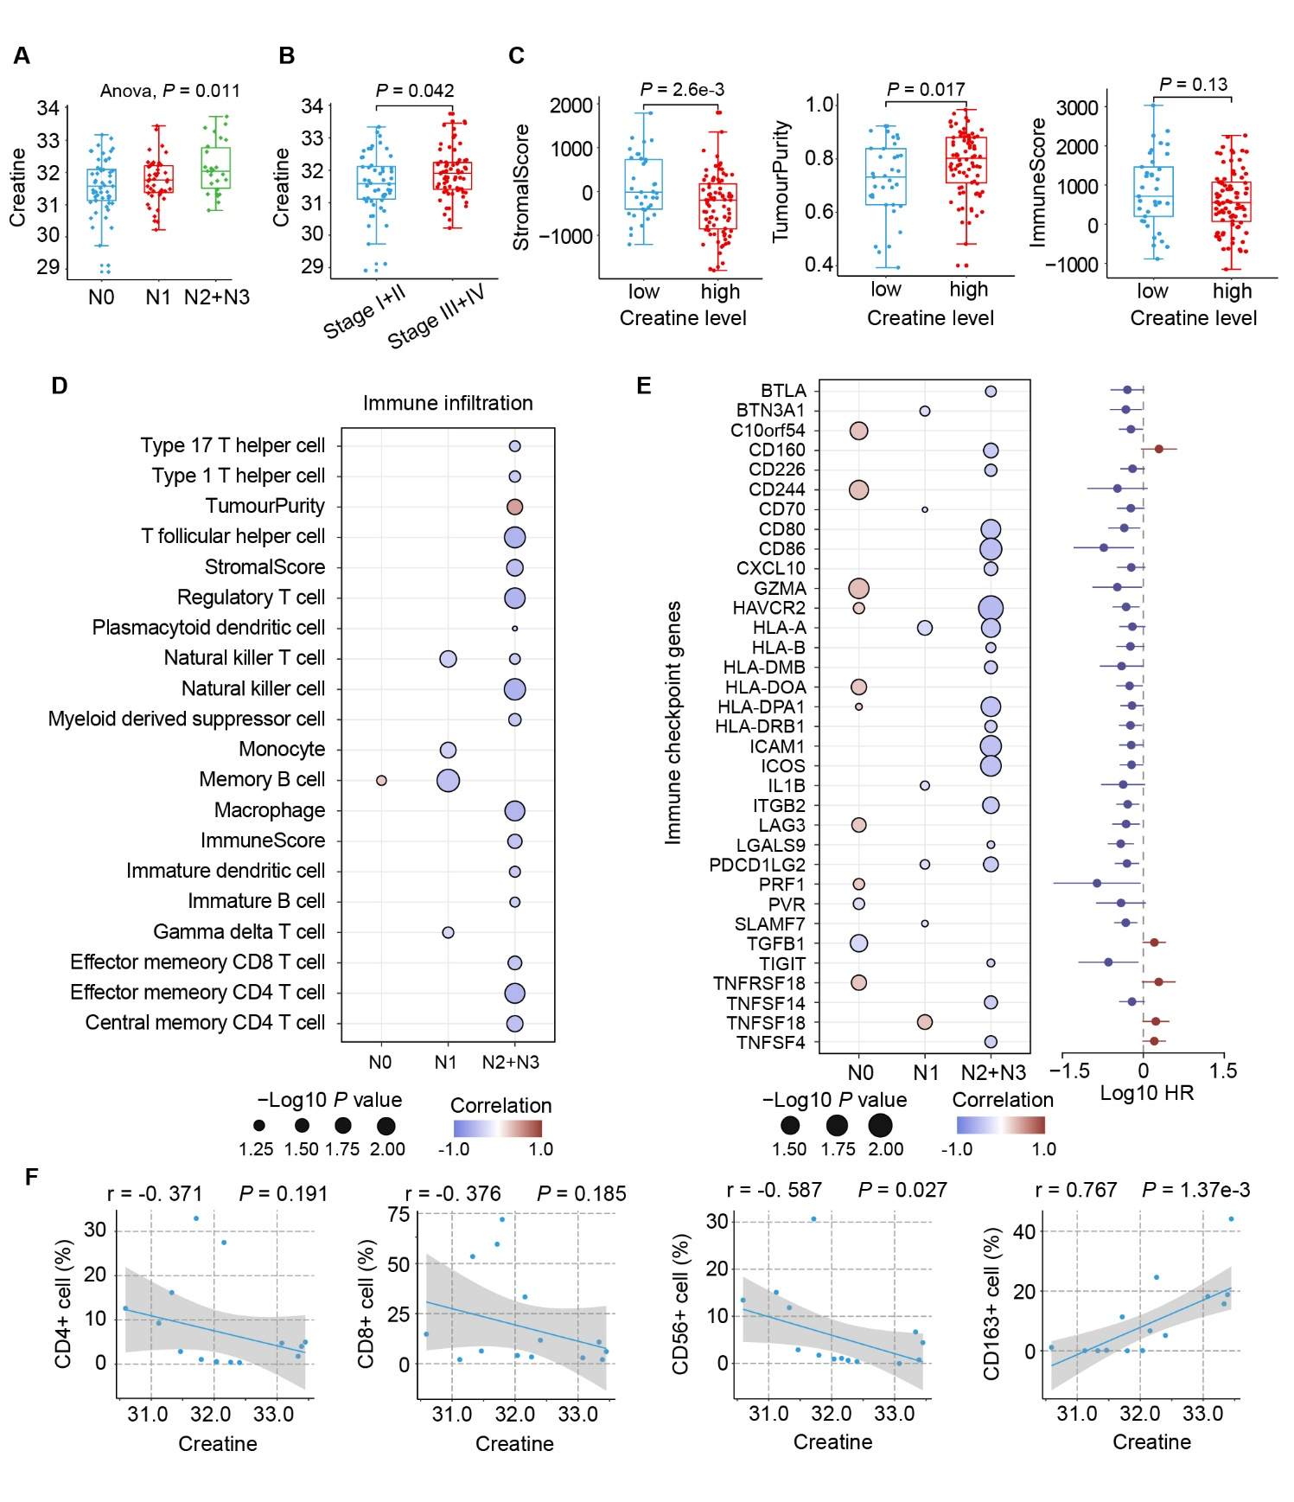
Fig. S7. The association between creatine abundance and the progression of ESCC. Related to Fig. 6.
A Creatine abundance in patients with different degrees of regional lymph node metastasis. B Creatine abundance in patients with different tumour stages. C Stromal score, tumour purity and immune score in patients with higher or lower creatine abundance. Data presented as mean ± s.d.; P values by Wilcoxon rank-sum test. D Spearman’s correlation coefficients of each immune cell infiltration score and the abundance of creatine in patients with different degrees of regional lymph node metastasis (only shown P < 0.05). E Spearman’s correlation coefficients of immune checkpoint genes expression and the abundance of creatine in patients with different degrees of regional lymph node metastasis (only shown |Spearman’s correlation coefficient| > 0.3, P < 0.05, left), and log10-based hazard ratio and P value of these genes by univariate cox regression analysis (right). F Spearman’s correlation coefficients of the percentage of positive cells quantified by multiple immunofluorescence in Fig. 4E and the abundances of creatine (n = 14).

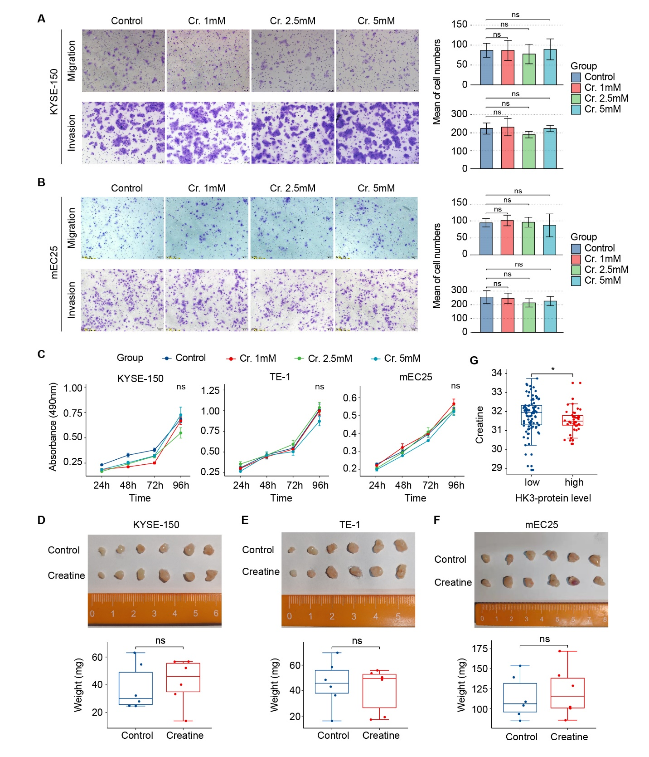
Fig. S8. Effect of creatine treatment on tumour cell functions in vivo and in vitro. Related to Fig. 7.
A,B Various creatine concentrations treatment did not affect the migration and invasion ability of ESCC cell lines (A: KYSE-150, B: mEC25). Data presented as mean ± s.d.; P values by two-tailed Student’s t test; n = 5. ns, not significant. C Various creatine concentrations treatment did not promote tumour growth. D-F Creatine-containing diet have not promoted the tumour growth in subcutaneous injected NTG mice. Data presented as mean ± s.d.; P values by two-tailed Student’s t test; n = 6. ns, not significant. G The high HK3 protein expression group had lower creatine abundance than HK3 low expression group. Data presented as mean ± s.d.; P values by two-tailed Student’s t test.

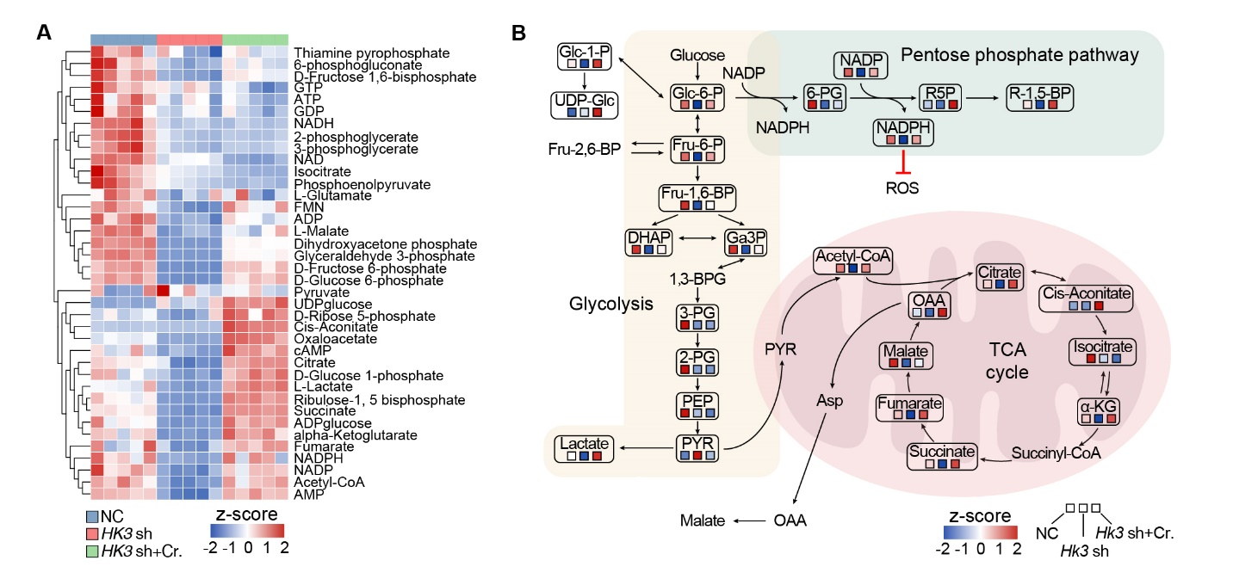
Fig. S9. Hk3 knockdown and creatine supplementation support energy-related metabolism reprogramming in RAW264.7 cells. Related to Table S11.
A,B Heatmap (A) and pathway overview (B) showing the abundances of metabolites involved in energy-related metabolism pathways in Hk3 knockdown and creatine supplementation-treated RAW264.7 cells were determined by targeted metabolomics analysis.

