Supplementary Information
Additional file 2: Figure S1
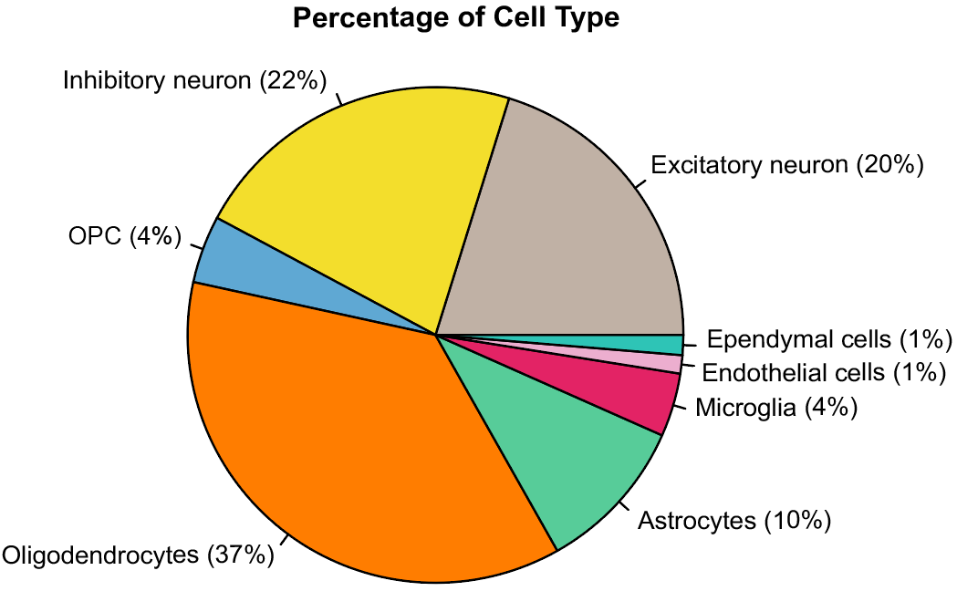
Fig. S1 The pie chart depicts the percentages of eight major cell types present in the prefrontal cortex of dementia subtypes (AD, DLB and PDD) and non-cognitive impairment controls (NCI). The percentage for each cell type was obtained by dividing the number of nuclei in that cell type by the total number of nuclei across all dementia subtypes.

Additional File 2: Figure S2
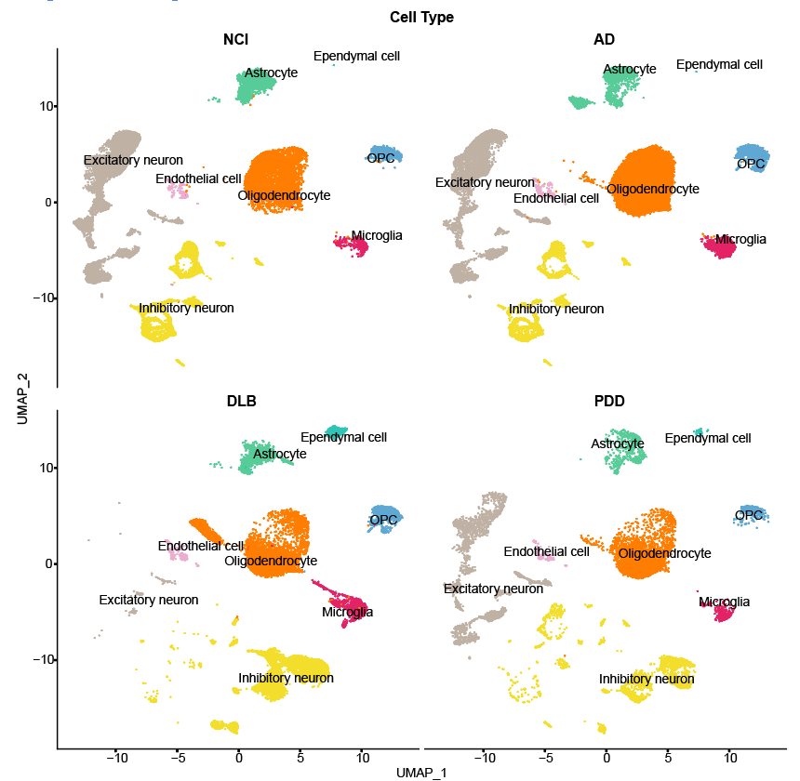
Fig. S2 UMAP projections show the whole snRNA-seq dataset clustered into 8 major cell types found in prefrontal cortex samples from NCI, AD, DLB, and PDD.

Additional file 2: Figure S3
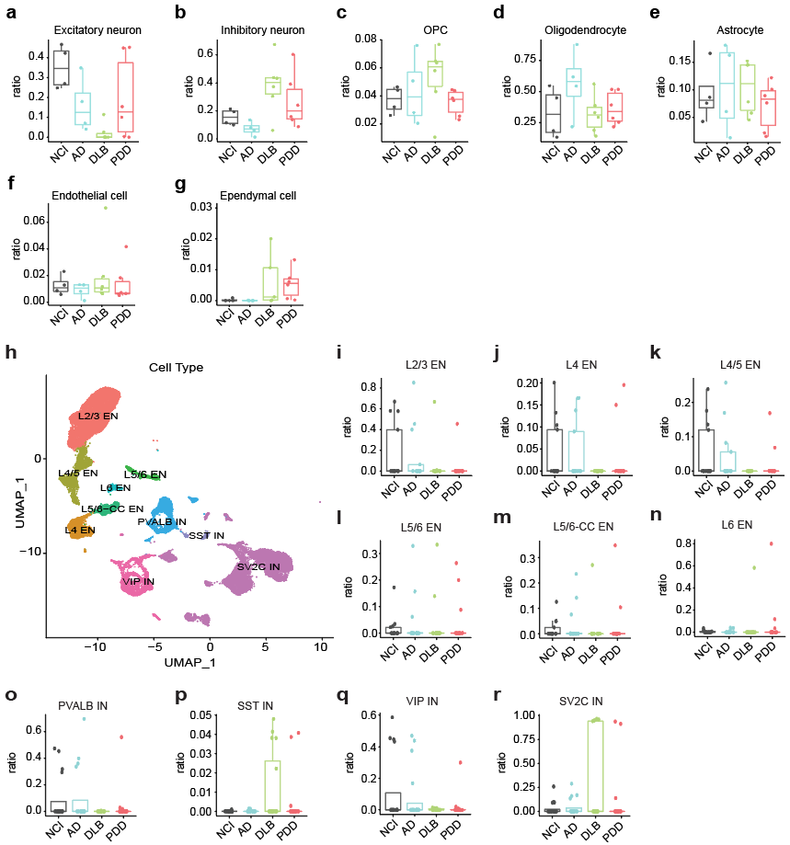
Fig. S3 (a-g) Box plots comparing the composition of cell types among the NCI, AD, DLB and PDD. (h) UMAP visualization showing the four inhibitory neuron subclusters and six excitatory neuron subclusters identified in the prefrontal cortex from NCI, AD, DLB and PDD. (i-r) Box plots showing the composition of (i-n) excitatory neuronal subclusters and (o-r) inhibitory neuron subclusters among the NCI, AD, DLB and PDD.

Additional file 2: Figure S4
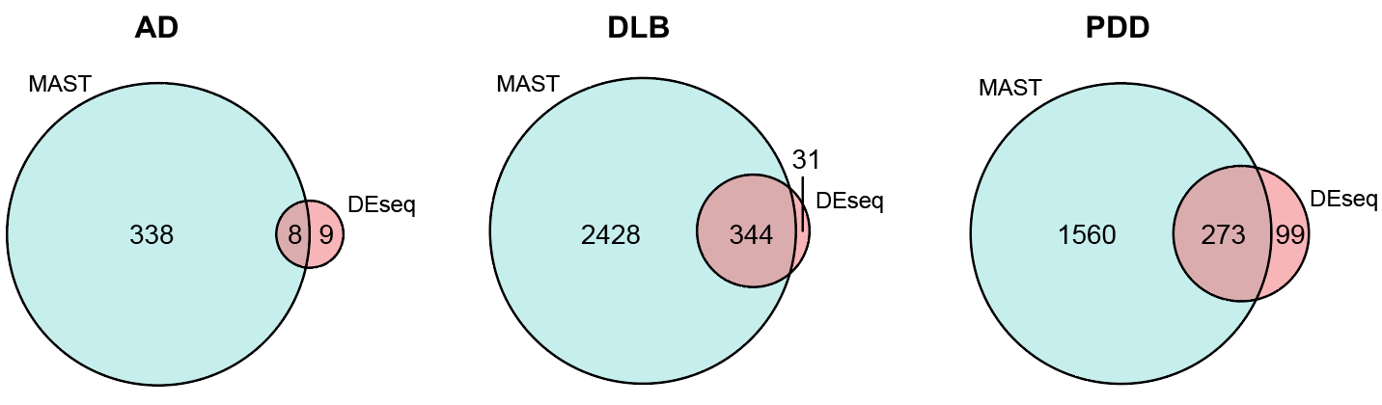Fig. S4 Venn diagram showing the DEGs identified by MAST and DESeq2.

Additional file 2: Figure S5
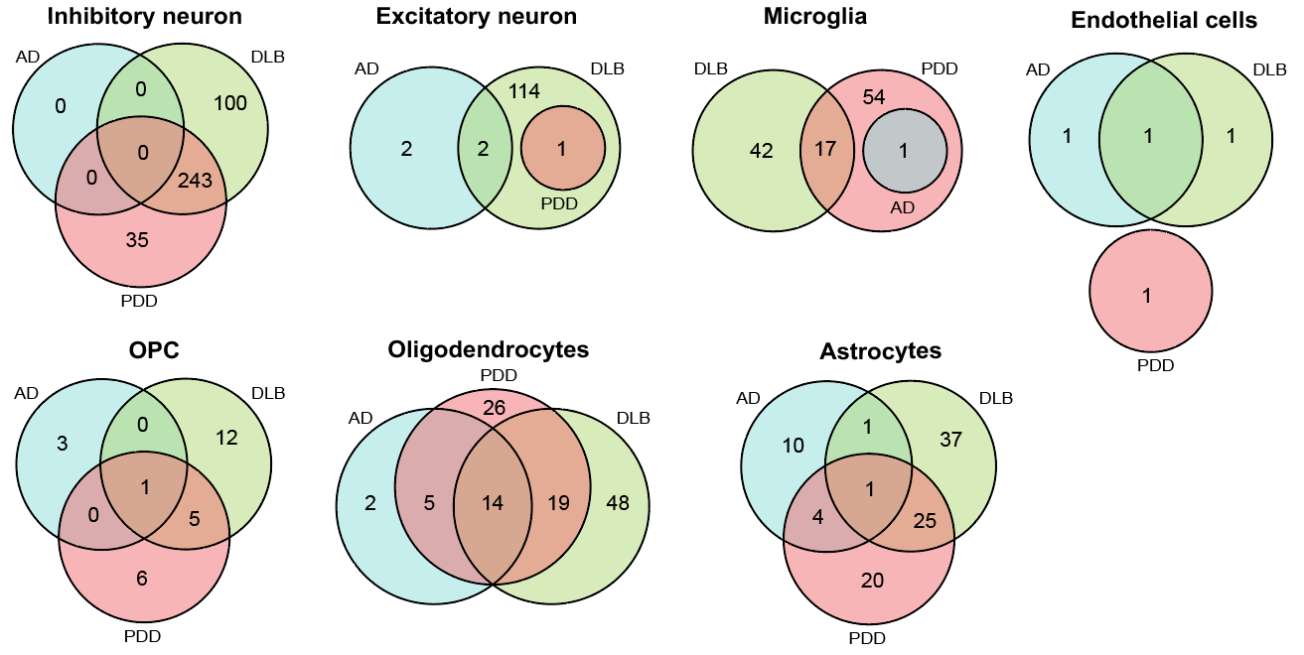
Fig. S5 Venn diagrams illustrate the overlap of differentially expressed genes (DEGs) among AD, PDD and DLB dementia subtypes for inhibitory neurons, excitatory neurons, microglia, endothelial cells, oligodendrocytes precursor cells (OPC), oligodendrocytes and astrocyte.

Additional file 2: Figure S6

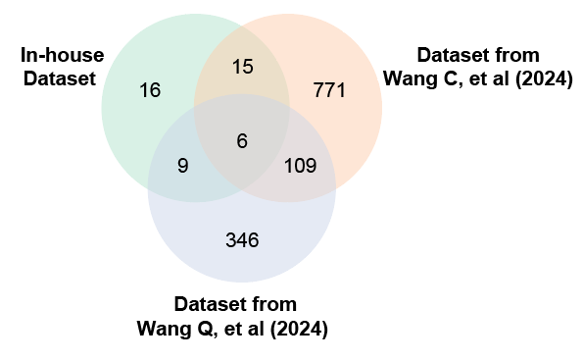
Fig. S6 Venn diagram showing the AD DEGs in the in-house dataset compared to two published datasets.

Additional file 2: Figure S7
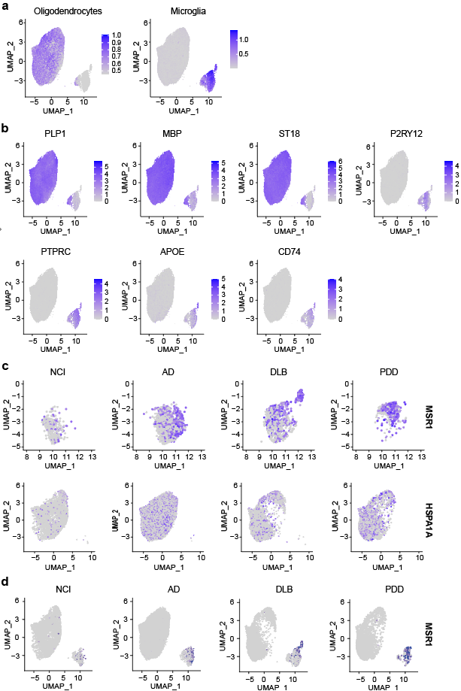
Fig. S7 UMAP visualization of the gene expression. (a) UMAP plots showing the cell state annotation based on marker genes for oligodendrocytes (left panel) and microglia (right panel). (b) UMAP plot showing the gene expression of microglia markers (P2RY12, PTPRC, APOE and CD74) and oligodendrocytes markers (PLP1, MBP and ST118). (c) UMAP plots showing the gene expression of MSR1 in the microglia cluster (top panel) and HSPA1A in the oligodendrocyte cluster (bottom panel) from NCI, AD, DLB, and PDD. (d) UMAP plots showing the upregulation of MSR1 expression in the microglia cluster from AD, DLB and PDD compared to NCI.

Additional file 2: Figure S8
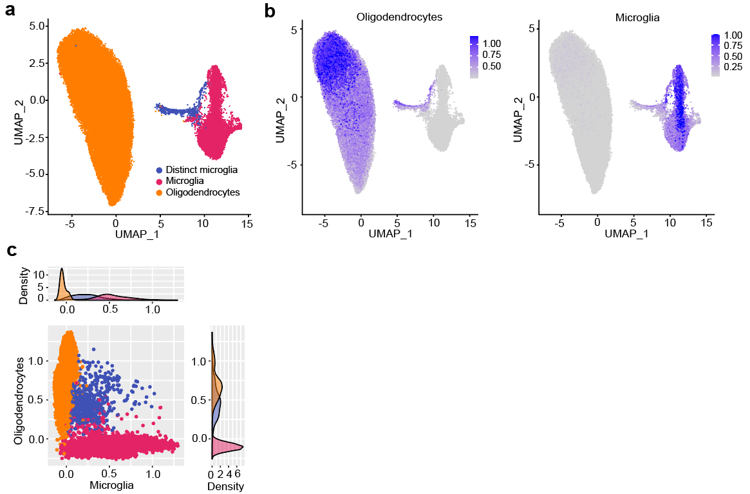
Fig. S8 Detection of a distinct microglia state from a previously published dataset (Lau SF, et al. 2020). (a) UMAP projection illustrates the re-clustered microglial and oligodendrocyte clusters, with each represented by a distinct colour. Microglial cluster is highlighted in red, oligodendrocyte cluster in orange, and the distinct microglia in blue. (b) UMAP projections show the cell state annotation based on marker genes for oligodendrocytes (left panel) and microglia (right panel). (c) Diffusion map and density plot are generated based on the signature scores per cell for microglial and oligodendrocyte clusters.

Additional file 2: Figure S9
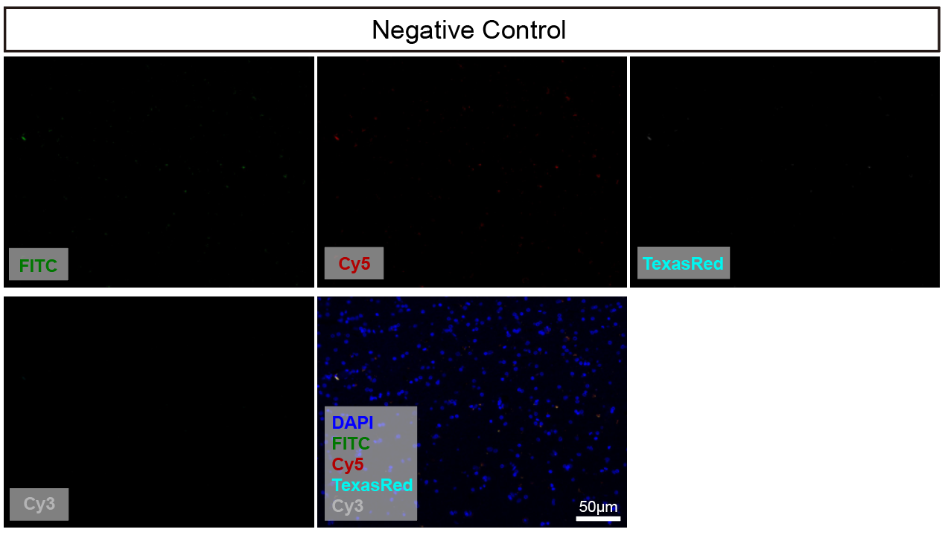
Fig. S9 Representative images of RNAscope performed with negative control probe set. All cells were counterstained with DAPI. Scale bar, 50 μm.

Additional file 2: Figure S10
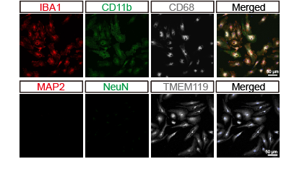
Fig. S10 Isolation of pure microglia from 15-17 month-old non-transgenic mouse brain. Cells were immunofluorescence stained with antibodies against microglial markers, including CD11b, IBA1, CD68 and TMEM119, as well as neuronal markers NeuN and MAP2. Scale bar, 50 μm.

