Supplementary Figures
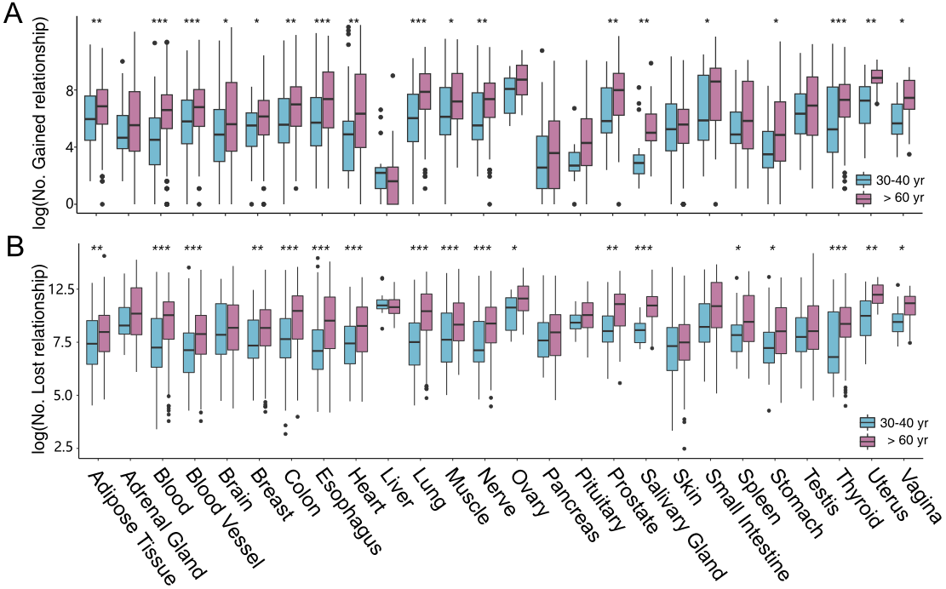
Fig S1. (A) Comparison of gained coordinated relationships counts in younger samples (30-40 years old) and elder samples (> 60 years old), using the 20-30 yrs group as the baseline. (B) Comparison of lost coordinated relationships counts in younger samples (30-40 years old) and elder samples (> 60 years old) , using the 20-30 yrs group as the baseline. (BH-adjusted *P < 0.05, **P < 0.01, ***P < 0.001; Wilcoxon’s test).

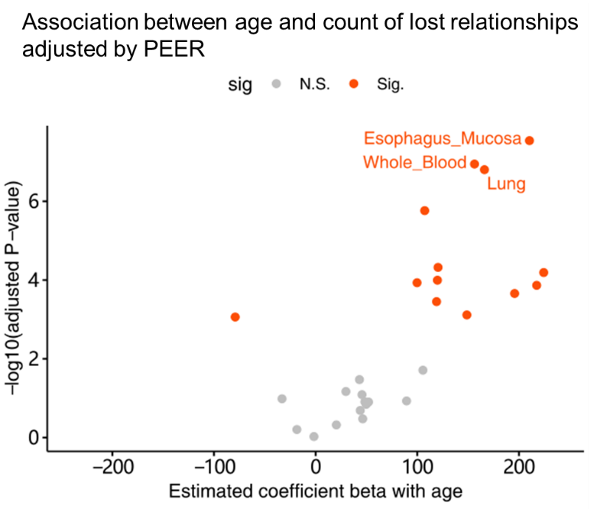
Fig S2. Association between age and lost CERs count adjusted by PEER factors by linear regression analysis. BH-adjusted P value < 0.05 was labeled as significance.

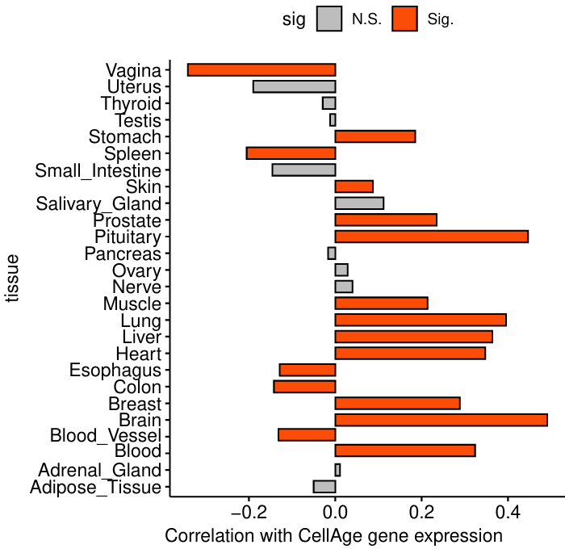
Fig S3. Correlation between lost CERs count and CellAge gene expression. BH-adjusted P value < 0.05 was labeled as significance.

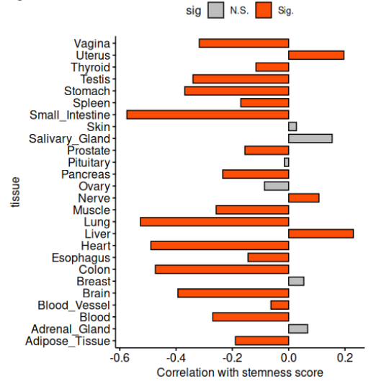
Fig S4. Correlation between lost CERs count and stemness score. BH-adjusted P value < 0.05 was labeled as significance.

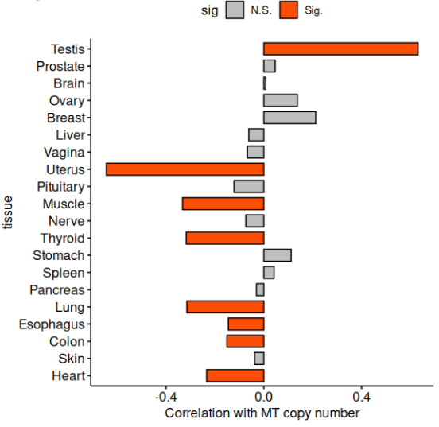
Fig S5. Correlation between lost CERs count and mitochondrion DNA copy number. BH-adjusted P value < 0.05 was labeled as significance.
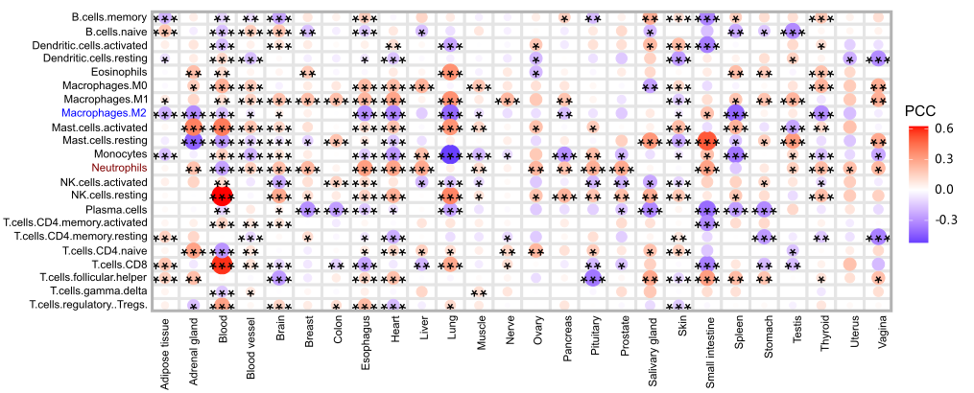
Fig S6. Heatmap illustrating correlation between cellular proportions and lost CER counts (BH-adjusted *P < 0.05, **P < 0.01, ***P < 0.001; Pearson’s correlation test). The cell proportions were computed using CIBERSORT deconvoluted methods.

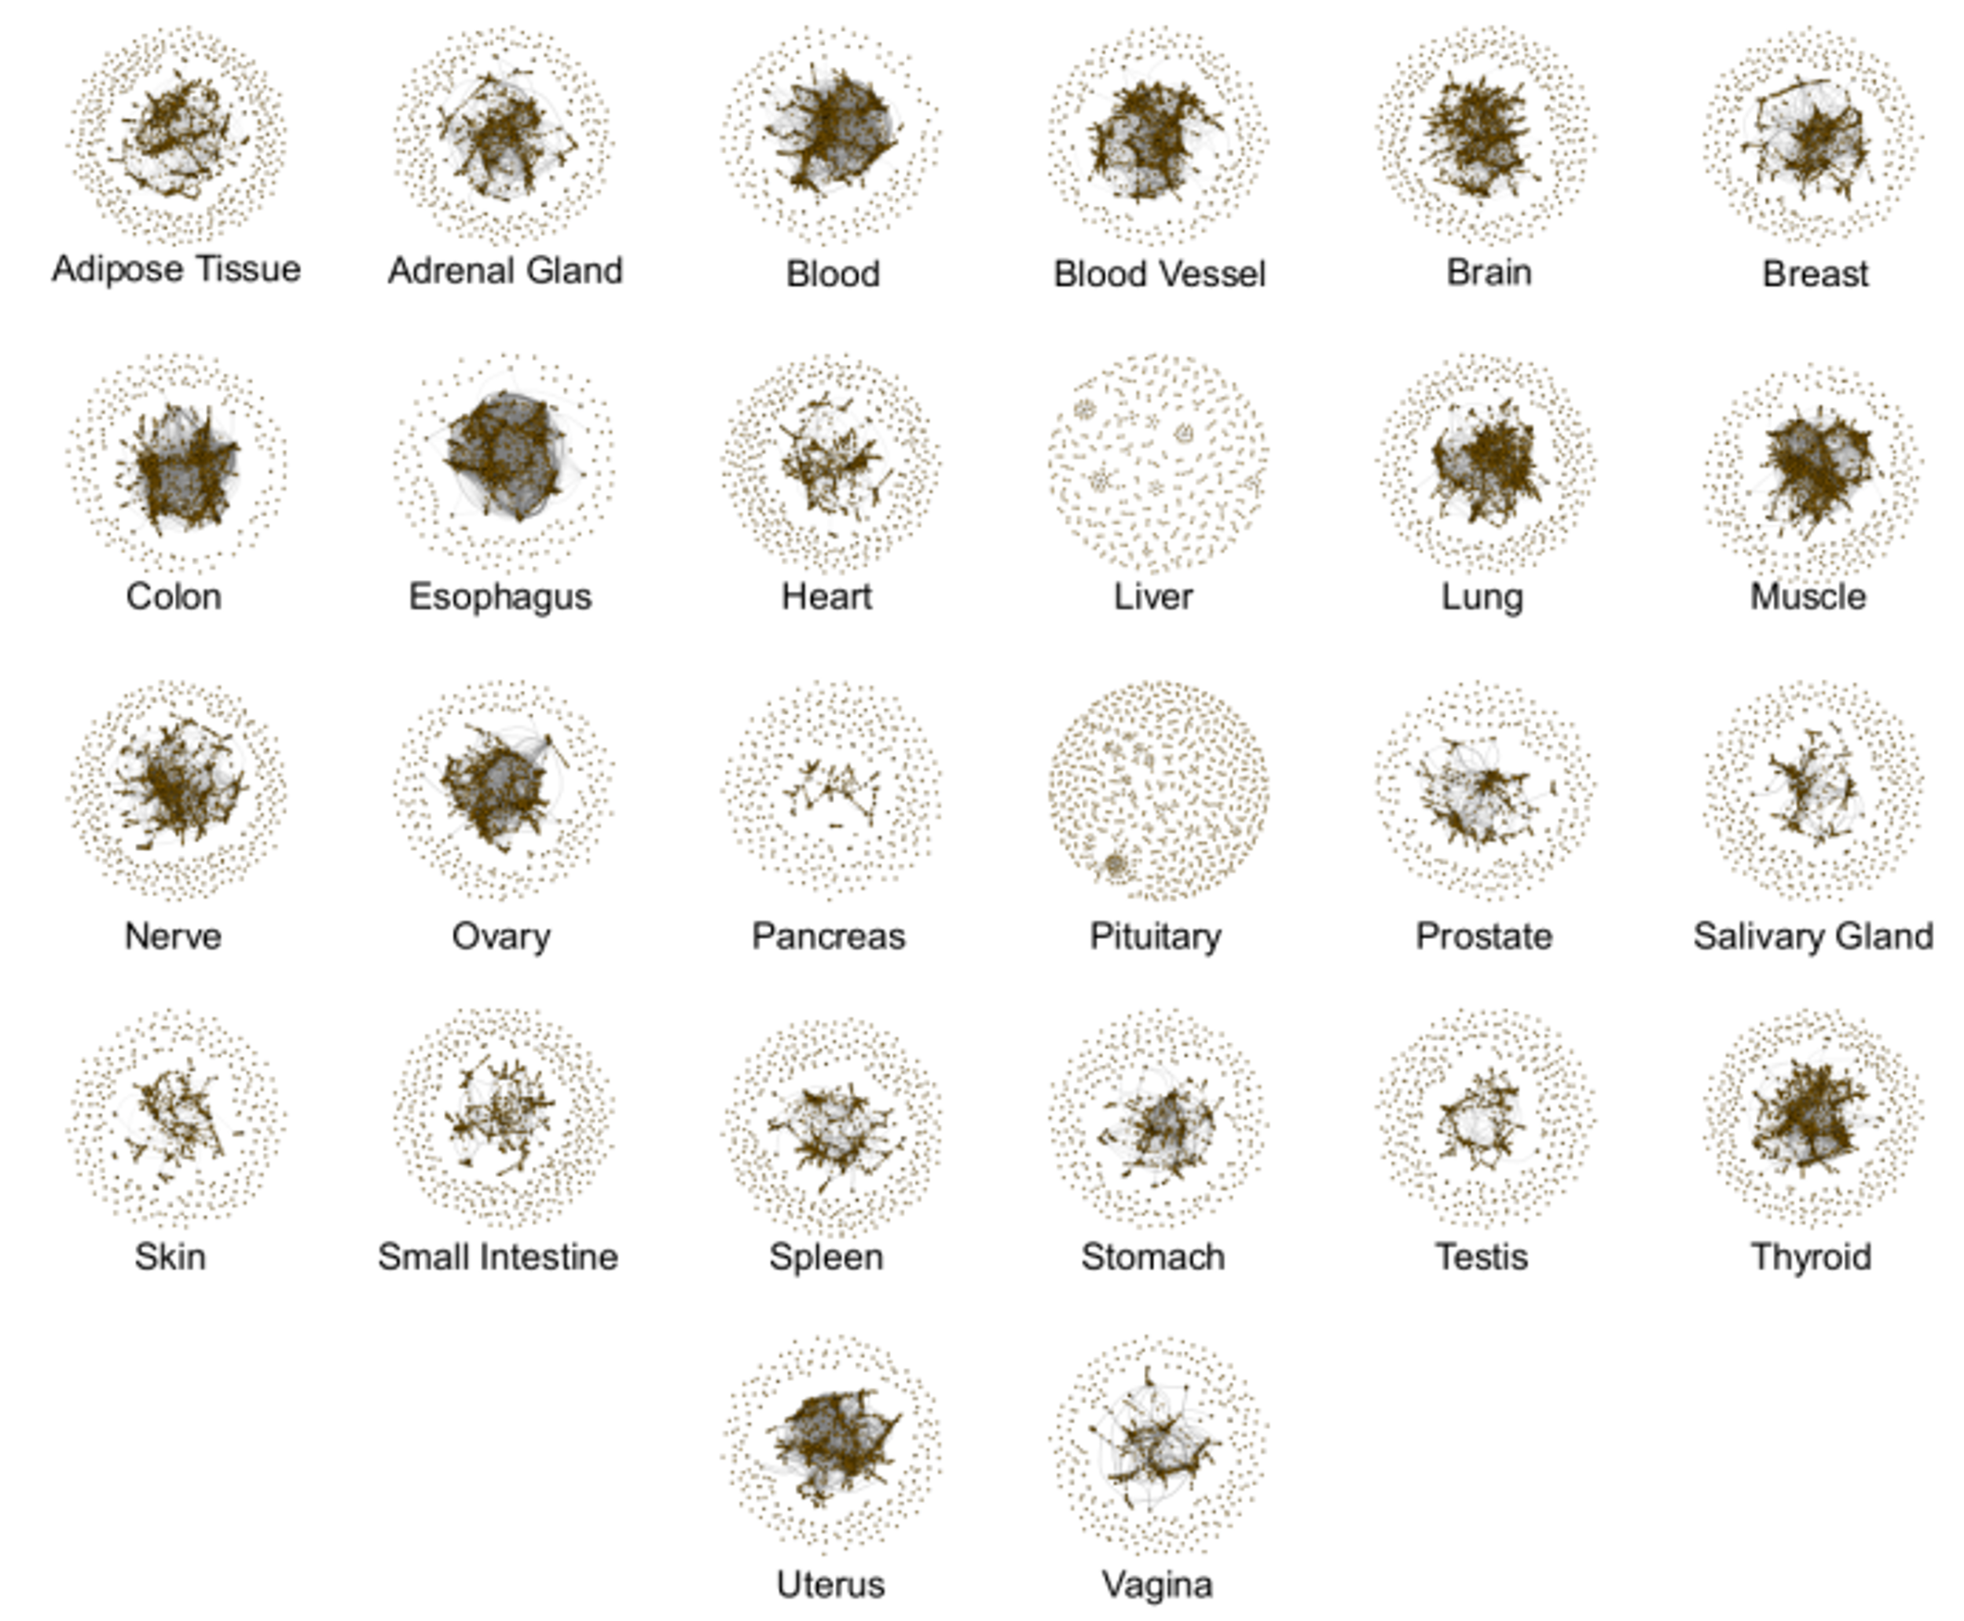
Fig S7. ARLNs for 26 tissues in our analysis.
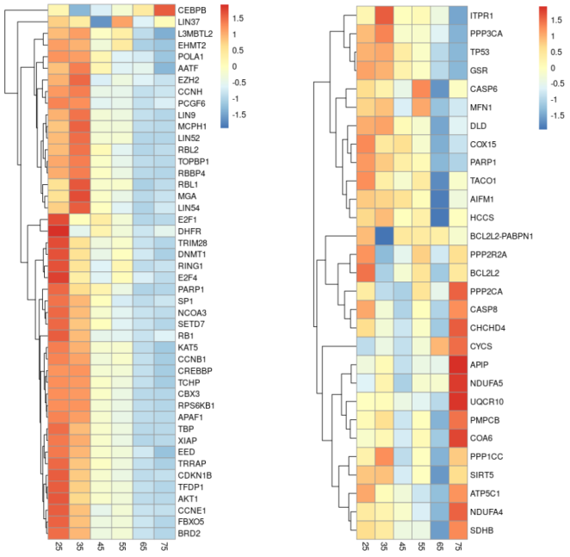
Fig S8. Normalized expression level of core module genes in ARLNs of brain (left) and adrenal gland (right). Each column represents an age group.

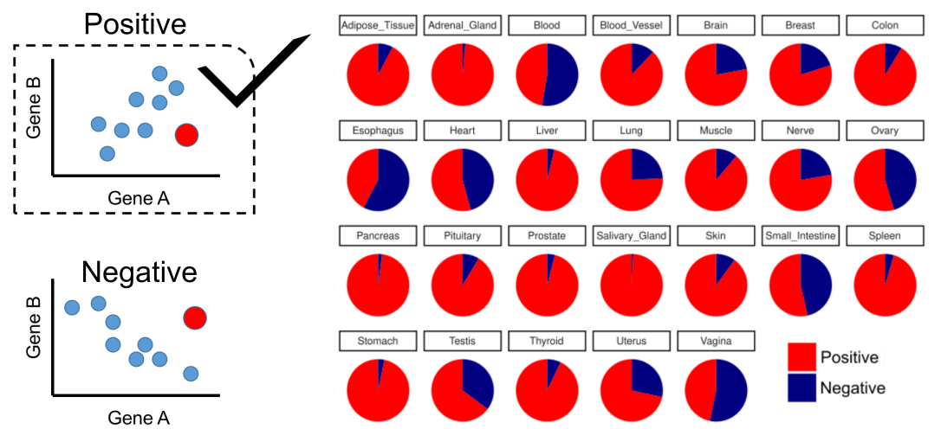
Fig S9. Two expression patterns of paired genes in CER loss and their proportions across tissues.

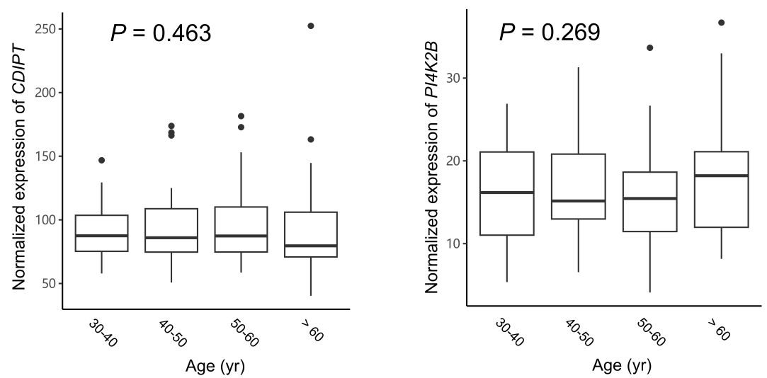
Fig S10. Expression pattern of CDIPT and PI4K2B in small intestines.

