Supplementary Information
Additional file 1: Supplementary Materials for: TiRank prioritizes phenotypic niches in tumor microenvironment for clinical biomarker discovery. This file includes Supplementary Methods and Supplementary Figures: Fig. S1-S21.

Fig S1. TiRank overview and performance on drug response datasets.
Fig S2. Performance evaluation of TiRank across drug response datasets.
Fig S3. Visualization of TiRank scores in Drug response predictions.
Fig S4. Summary of cellular subpopulations with clinical significance.
Fig S5. Cellular annotation of scRNA-seq data involved for phenotype-associated cell subpopulations identification.
Fig S6. Benchmarking TiRank against other algorithms in predicting prognosis-associated cell subpopulations from scRNA-seq data.
Fig S7. TiRank identifies cell subpopulations associated with anti-PD-1 therapy response in melanoma.
Fig S8. CD8+ T Cells associated with anti-PD1 therapy response in Melanoma.
Fig S9. Benchmarking TiRank against other algorithms in predicting phenotype-associated spatial niches from CRC ST Data.
Fig S10. Benchmarking TiRank against other algorithms in predicting phenotype-associated spatial niches from GC ST Data.
Fig S11. TiRank identifies interactions between myofibroblasts and SPP1+ TAMs associated with prognosis in CRC.
Fig S12. Co-occurrence of SPP1+ TAM and myofibroblast in poor prognostic regions in CRC.
Fig S13. Spatial distributions of TiRank scores across tissue slices from CRC.
Fig S14. Spatial distributions of TiRank scores across tissue slices of GC.
Fig S15. Spatial characteristics of TiRank labels in GC.
Fig S16. Cellular fractions at individual spots based on deconvolution analysis in GC.
Fig S17. IMC images and the corresponding hematoxylin and eosin-stained images of tumor regions in GC.
Fig S18. Abundance of cell subpopulations through IMC in GC.
Fig S19. Cellular neighborhoods associated with TRG in GC.
Fig S20. Visualization of Fibro-Bar and cell distributions through IMC.
Fig S21. Features associated with the Fibro-Bar score in GC patients receiving NACI.

Supplementary Methods
Collection and processing bulk transcriptomics datasets
Preprocessing of GDSC and CCLE data. The Genomics of Drug Sensitivity in Cancer (GDSC) database (https://www.cancerrxgene.org/) and Cancer Cell Line Encyclopedia (CCLE) database (https://sites.broadinstitute.org/ccle/) are publicly available online resources. We downloaded gene expression data and half maximal inhibitory concentration (IC50) values for cell lines from these datasets. Following the methodology outlined in a previous study, we classified cell lines into two groups based on their drug response: sensitive (response, annotated as 0) or resistant (non-response, annotated as 1). Specifically, we applied the waterfall method to rank cell lines according to their log-10-transformed IC50 values (denoted as lg(IC50)), generating a curve of lg(IC50) against cell line rank within each dataset. The cutoff point for lg(IC50) was determined using the following steps: (1) If the waterfall distribution was nonlinear (Pearson correlation coefficient of the linear fit ≤ 0.95), the inflection point of the lg(IC50) curve was identified as the point with the maximum perpendicular distance to a line connecting the start and end points of distribution. (2) If the distribution was linear (Pearson correlation coefficient > 0.95), the median lg(IC50) value was used as the cutoff. Cell lines with lg(IC50) values below the cutoff were classified as sensitive (response), while those above were classified as resistant (non-response).
Melanoma datasets with anti-PD-1 immunotherapy. For this study, we compiled four bulk transcriptomics datasets from melanoma studies: Riaz2017, Gide2019, Liu2019, and PUCH2021. We included only samples from patients treated with anti-PD-1 checkpoint inhibitors. To thoroughly analyze cell subpopulations associated with anti-PD-1 treatment response in melanoma, we integrated these four datasets and applied TiRank for data integration and subpopulation discovery. Additional details about these datasets are provided in Supplementary Table 1.
Gastric cancer datasets with treatment. Kim et al. collected gastric cancer data from two patient cohorts treated with anti-PD-1 immunotherapy. The first cohort comprised 45 patients, and the second included 19 patients. Due to missing bulk data for two patient and three duplicated cases, four patients were excluded, leaving a total of 59 patients. To mitigate batch effects and standardize the data, we performed batch correction using the SVA algorithm to merge the two cohorts into a single dataset. Additionally, Razvan et al. collected 300 primary tumor samples from gastric cancer patients across TNM stages I-IV, with gene expression profiles available in the GEO database under accession number GSE66229. For our analysis, we selected samples from clinical stages II and III from patients who had received adjuvant chemotherapy, resulting in 62 gastric cancer samples with adjuvant chemotherapy. Details of these datasets are summarized in Supplementary Table 1.
Datasets for other cancer types. To investigate prognosis-associated cell subpopulations and spatial niches in acute myeloid leukemia (AML), gastric cancer (GC), colorectal cancer (CRC), lung adenocarcinoma (LUAD), and hepatocellular carcinoma (HCC), we utilized multiple bulk transcriptomics datasets from public repositories, including GEO and TCGA. We included only patients with available overall survival (OS) or recurrence-free survival (RFS) records. To focus on clinically relevant stages, we restricted our analysis to patients with TNM stages II to III. Specifically, for AML, we incorporated two datasets from the Wave study. Additionally, to explore immune checkpoint blockade (ICB)-associated spatial niches in non-small cell lung cancer (NSCLC) using TiRank, we included datasets GSE33072, GSE166449, and GSE126044, which contain data on ICB treatment and patient responsiveness. Further details of these datasets are provided in Supplementary Table 1.

Collection and processing of scRNA-seq datasets
Cell line datasets for method benchmarking. Single-cell RNA sequencing (scRNA-seq) datasets for cell lines were obtained from the GEO database under accession numbers GSE112274, GSE117872, GSE140440, GSE149383, GSE162045, and GSE120575. Details of these datasets are summarized in Supplementary Table 1. Quality control procedures for the scRNA-seq data followed those described in the original publications. When raw count matrices were provided, they were normalized and log-transformed using the NormalizeData function with default parameters in the R package. When transcripts per million (TPM) or fragments per kilobase of transcript per million fragments mapped (FPKM) values were available, expression values were log-transformed using the log1p function.
Melanoma immunotherapy scRNA-seq dataset. Sade-Feldman et al. collected 16,291 immune cells from 48 tumor samples of melanoma patients undergoing checkpoint inhibitor treatment. These cells, sorted as CD45⁺ immune cells, were sequenced using the Smart-seq2 platform, with TPM-transformed expression profiles available in the GEO database under accession number GSE120575. For our study, we analyzed only pre-treatment samples, comprising 5,928 immune cells.
scRNA-seq datasets for treatment-naïve samples of other cancer types. We utilized scRNA-seq datasets from multiple cancer types: acute myeloid leukemia (AML), lung adenocarcinoma (LUAD), hepatocellular carcinoma (HCC), gastric cancer (GC), and colorectal cancer (CRC), to prioritize prognosis-associated cell subpopulations using TiRank, as presented in Figure 2. These datasets were sourced from the GEO database, corresponding to studies. Specifically, for gastric cancer, we used dataset GSE183904, which includes 31 primary tumor samples from patients across clinical stages I-IV, comprising over 100,000 cells. To enhance computational efficiency, we performed random down-sampling to reduce this dataset to 25,000 cells.

Preprocessing of scRNA-seq datasets
We followed the standard preprocessing workflow in Seurat and applied it to each previously collected scRNA-seq dataset. Initially, TPM expression matrices and associated clinical information were downloaded. We removed genes expressed in fewer than three cells and cells with fewer than 200 features or more than 20% mitochondrial gene content. Following filtration, highly variable genes were selected. Principal component analysis (PCA) was performed to reduce dimensionality, and the Louvain algorithm was employed for cell clustering. Cell annotations were derived from original data sources, with cell labels, such as treatment conditions, retrieved from the GEO database for GSE112274, GSE117872, GSE140440, GSE149383, GSE162045, and GSE120575, and manual cell type annotations from the original studies integrated for acute myeloid leukemia, hepatocellular carcinoma, gastric cancer, and colorectal cancer datasets. Clusters were visualized using the uniform manifold approximation and projection (UMAP) algorithm.

Collection and processing of spatial transcriptomics datasets
We incorporated spatial transcriptomics data from slides generated using the 10x Visium platform across two cancer types. All slides were derived from human cancer samples from patients who had not received neo-adjuvant treatment. Specifically, we obtained 18 slides from seven CRC patients from previous two studies. We employed Seurat for preprocessing these slides, retaining all spots to preserve the entire tissue structure. Subsequently, spatially variable genes were identified, followed by dimension reduction and clustering, which yielded distinct spatial regions. These regions were integrated into the spatial similarity awareness module of TiRank.

Implementation details of benchmark computational algorithms
This study integrated bulk RNA-seq and scRNA-seq or ST to benchmark computational methods for identifying phenotype-associated cell subpopulations or spatial niches.
TiRank was employed in ‘binomial’ mode to identify cells positively or negatively correlated with drug resistance or sensitivity, ‘cox’ mode to identify prognosis associated cell subpopulations and spatial niches, using bulk and scRNA-seq (or ST) datasets as inputs; all subsequent methods utilized these datasets for consistency.
Scissor (https://github.com/sunduanchen/Scissor), a machine learning algorithm, integrated RNA-seq and scRNA-seq data with a balancing parameter (α = 0.5), classifying cells as drug-resistant, sensitive or background.
DEGAS (https://github.com/tsteelejohnson91/DEGAS) applied a multi-task architecture to transfer phenotype labels from RNA-seq to scRNA-seq, using default parameters and ‘BlankClass’ mode, with cells in the top 5% and bottom 5% of phenotype-related scores classified as drug-resistant or sensitive, respectively.
Beyondcell (https://github.com/cnio-bu/beyondcell) processed scRNA-seq data and a curated gene list from the Drug Sensitivity Signatures collection (SSc), outputting drug sensitivity scores; cells below the median score were classified as drug-resistant, and those above as sensitive, noting that some drugs lacked relevant SSc genes.
CIBERSORT (https://github.com/Moonerss/CIBERSORT) combined penalized logistic regression with bulk and scRNA-seq data to identify therapeutic response-associated subpopulations, followed by Cox regression (hazard ratio, HR; resistant: HR > 1, sensitive: HR < 1, (p ≤ 0.05)).
CytoCommunity (https://github.com/tanlabcode/CytoCommunity), a Python-based toolkit, analyzed ST data with spatial coordinates and clinical labels to identify phenotype-associated spatial niches (‘supervised’ mode), outputting binary labels (0: not associated, 1: associated).
TaiChi (https://github.com/C0nc/TAICHI) processed ST data with spatial coordinates and condition labels across experiments, generating binary labels (0: not associated, 1: associated) for phenotype association.

Ablation study
The TiRank framework's performance was evaluated across ten drug response datasets (Dataset1-Dataset10). The evaluation comprised three main components. First, the REO-transformation module's efficacy was assessed by comparing TiRank's performance with gene-based versus GP-based inputs, using F1-score, accuracy, precision, and recall. Second, the impact of various model architectures, including DenseNet, MLP, and Transformer, was evaluated using the same metrics. Third, an ablation study assessed the contribution of loss function components: bulk loss and regularization loss, relative to the full model. All evaluations used 50 random seeds to ensure statistical robustness and reproducibility.

External clinical-cohort benchmark
Cohorts and preprocessing. We evaluated two clinical single-cell cohorts with available treatment outcomes: (i) Breast cancer (BRCA), pre-treatment day 0 samples; and (ii) non-small-cell lung cancer (NSCLC) patients receiving tyrosine-kinase inhibitors (TKIs). For each cohort, we retained tumor cells using the original authors’ annotations. Raw matrices and clinical labels were downloaded from the source studies [1,2].
Drugs evaluated. We used letrozole and ribociclib for FELINE, and erlotinib, dabrafenib, osimertinib, and trametinib for NSCLC from Sinha et al. [3].
Cell-line training data. Bulk expression and drug response data for cancer cell lines were obtained from DepMap via Zenodo (https://zenodo.org/records/ 7860559). For each drug, we extracted the corresponding sensitive matrix of each cell line. To create binary labels (sensitive vs. resistant) from continuous sensitive values, we employed the waterfall method as described in "Preprocessing of GDSC and CCLE data".
Benchmarking. We trained TiRank, Scissor, and DEGAS using the bulk cell line expression data and the corresponding binary drug response labels. We then applied the trained models to the patient scRNA-seq data to generate a response score for each individual tumor cell. To obtain a patient-level prediction, we calculated the mean TiRank score across all tumor cells for a given patient. This patient-level score was then used to calculate the Area Under the Curve (AUC) against the true clinical response labels.

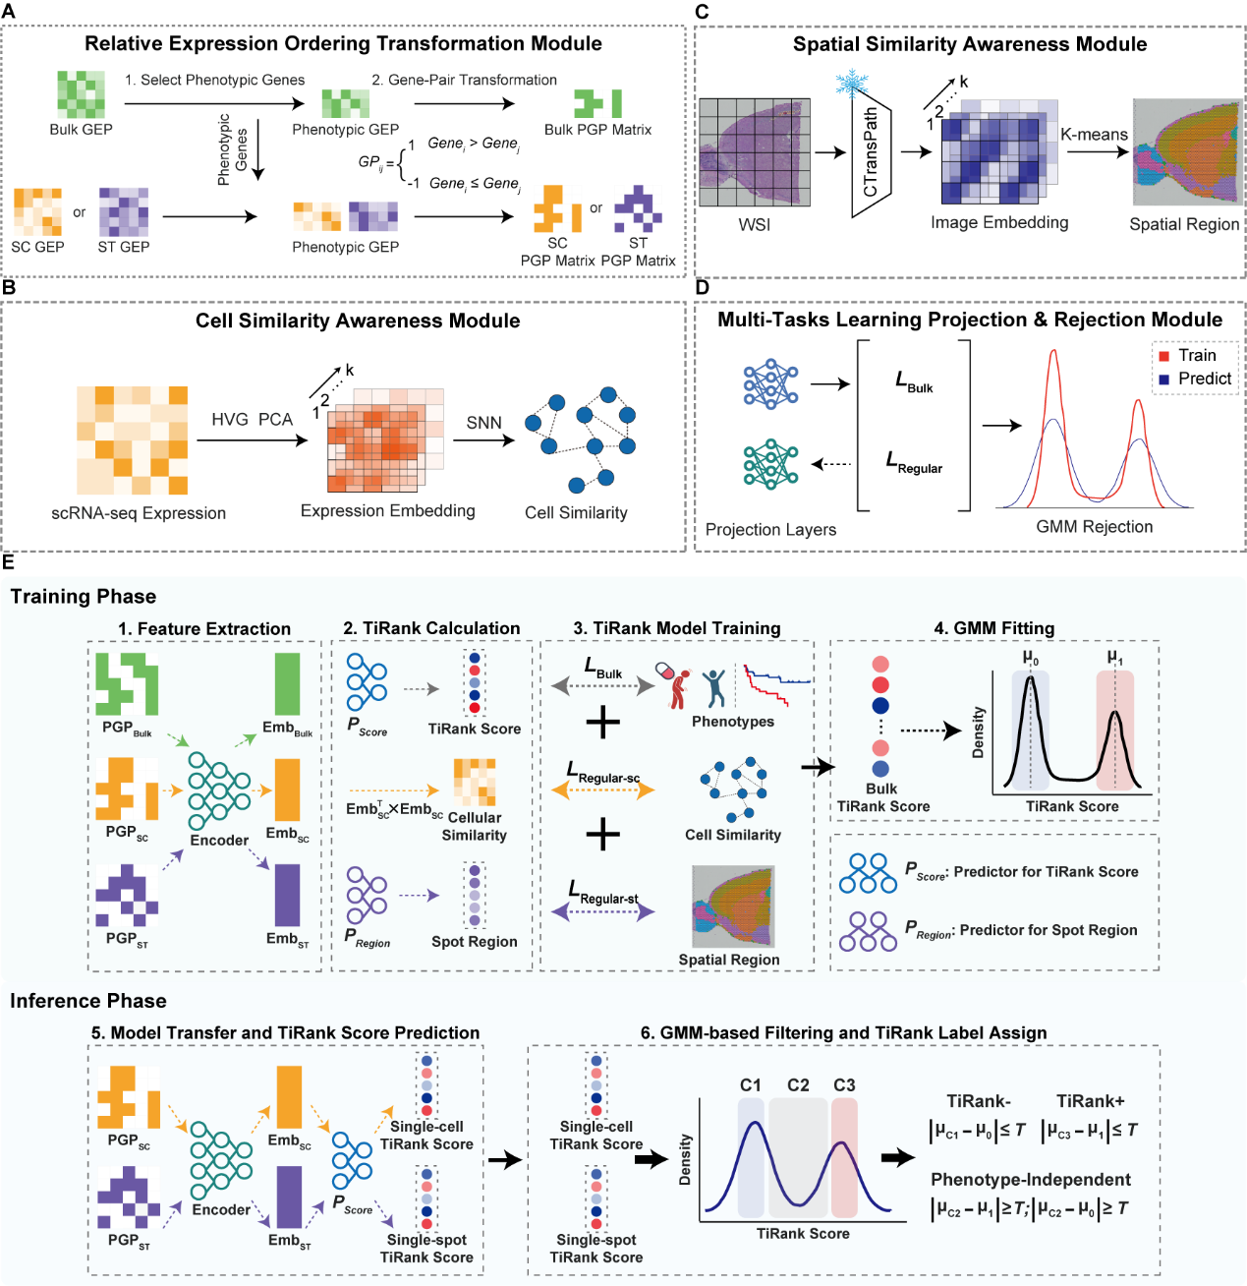
Fig. S1 | Modules of TiRank.
A, TiRank identifies phenotype-associated genes from bulk transcriptomic data and calculates the relative expression order of gene pairs, converting the expression profiles from bulk, single-cell, and spatial transcriptomics into binary phenotypic gene pairs (PGPs). REO, relative expression order.
B, The Cell Similarity Network Construction block utilizes highly variable genes, principal component analysis, and shared nearest neighbor to reconstruct cellular relationships from scRNA-seq or spatial transcriptomics data.
C, The Spatial Position Embedding module uses whole slide images and k-means clustering to capture spatial positions from image embeddings.
D, Finally, the Multi-Task Projection and Rejection Module uses projection layers and Gaussian Mixture Model rejection to guide the neural network in distinguishing phenotype-associated cells from phenotype-independent cells across bulk, cell-cell similarity, and spatial awareness tasks.
E, Simplified end-to-end schematic of TiRank. Training Phase (bulk with phenotype labels): (i) REO/PGP construction converts bulk expression into phenotypic gene-pair (PGP) matrices; (ii) a multitask framework (encoder + task heads with joint losses) learns low-dimensional representations predictive of the phenotypic labels; (iii) the bulk TiRank scores are modeled with a three-component GMM, and the fitted parameters are saved. Inference Phase (scRNA-seq/ST without labels): (i) REO/PGP construction is applied to single-cell/spatial data; (ii) the trained model outputs TiRank scores per cell/spot; (iii) the saved GMM classifies each cell/spot into TiRank⁺, TiRank⁻, or phenotype-independent; (iv) optional aggregation identifies clinically relevant cell subpopulations and spatial niches, with permutation testing for niche-level significance. Outputs include cell/spot-level scores and labels, niche summaries, and visualization-ready maps.

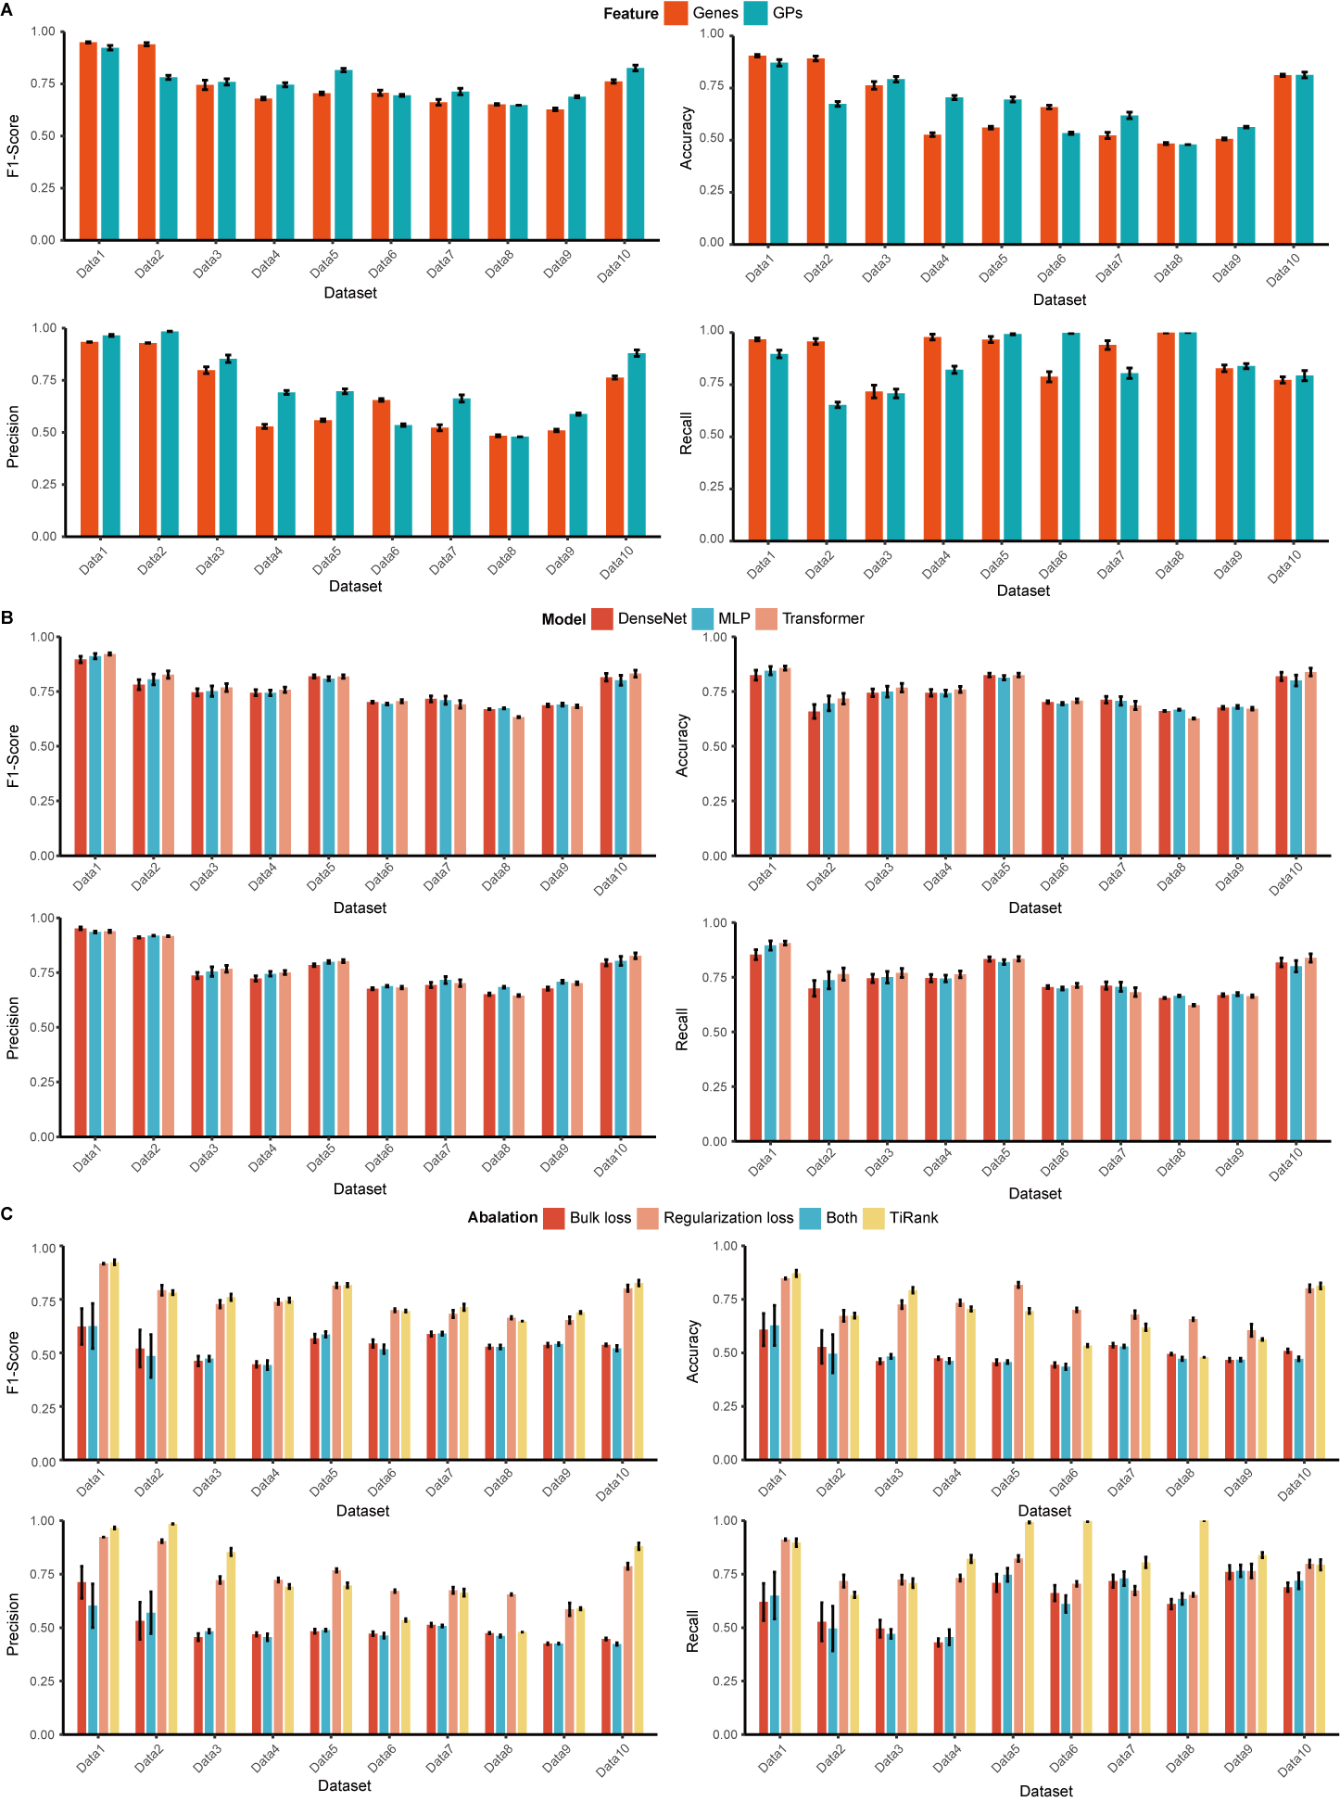
Fig. S2 | Performance evaluation of TiRank across drug response datasets.
A, Effect of REO-transformation module (genes versus gene pairs) on TiRank performance, evaluated across four metrics in sub-panels: F1-score (top left), accuracy (top right), precision (bottom left), and recall (bottom right). Bar heights denote mean values, with error bars representing standard deviations from 50 random seeds.
B, Assessment of TiRank performance with different model architectures (DenseNet, MLP, Transformer), evaluated across F1-score, accuracy, precision, and recall in sub-panels as in (A). Bar heights indicate mean performance, with error bars showing standard deviations from 50 random seeds.
C, Ablation study of loss function variants (bulk loss, regularization loss) on TiRank performance compared to the full model, assessed across F1-score, accuracy, precision, and recall in sub-panels as in (A). Bar heights represent mean values, with error bars indicating standard deviations from 50 random seeds.

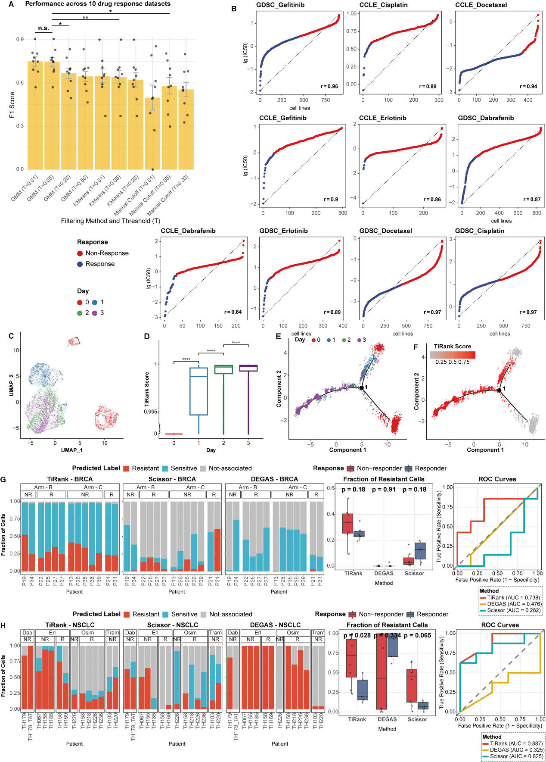
Fig. S3 | Visualization of TiRank scores in Drug response predictions.
A, Comparative benchmark of GMM-based filter module. We compared its F1-score (y-axis) against simpler models (1D K-means, Manual Cutoff) and performed a sensitivity analysis on its threshold parameter ($T$). Bars represent the mean F1-score across 10 drug response datasets, with points showing individual dataset performance. Error bars represent standard error.
B, Waterfall plots illustrating the distribution of drug response values across cell lines for five drugs (Gefitinib, Erlotinib, Docetaxel, Cisplatin, Dabrafenib) in CCLE and GDSC datasets. The x-axis ranks cell lines by IC50 values in descending order, and the y-axis displays logarithmic IC50 values (lg(IC50)). A dashed line connects the distribution’s endpoints. Cell lines with lg(IC50) values below the cutoff are classified as drug-sensitive (blue), and those above as drug-resistant (red). The Spearman correlation coefficient ($r$) is indicated for each plot.
C, UMAP visualization of melanoma cell lines (SKMEL28) treated with Dabrafenib, colored by treatment duration (red: day 0, blue: day 1, green: day 2, purple: day 3). The plot depicts the distribution of cell states over time under drug treatment.
D Boxplot of predicted drug resistance scores across Dabrafenib treatment time points (days 0-3) in SKMEL28 cells. The y-axis is exponentiated to highlight score differences across time points.
E-F, Cell state trajectories in SKMEL28 cells inferred using Monocle, colored by treatment duration (E; day 0-3) and predicted drug resistance scores (F; scale: 0.25 to 0.75). Trajectories illustrate the transition of cell states over time and their corresponding resistance scores.
G-H, External validation of TiRank on clinical patient cohorts. Models were trained only on bulk cell line data (DepMap) and applied to predict patient-level clinical response from scRNA-seq data. G, the breast cancer (BRCA) dataset, which involved two treatment approaches: arm B, an intermittent high-dose combination of letrozole and the CDK4/6 inhibitor ribociclib; and arm C, a continuous lower-dose combination of letrozole and ribociclib. The bar plot shows the predicted resistant and sensitive labels of individual tumor cells by each method. The box plot shows the resistant-cell fraction of each patient; statistical significance was determined by a two-sided Wilcoxon rank-sum test. H, the non-small cell lung cancer (NSCLC) dataset with four treatments: erlotinib (Erl; a first-generation epidermal growth factor receptor (EGFR) inhibitor), dabrafenib (Dab; a serine/threonine kinase B-RAF inhibitor), osimertinib (Osim; a third-generation EGFR inhibitor), and trametinib (Tram; a MEK inhibitor).

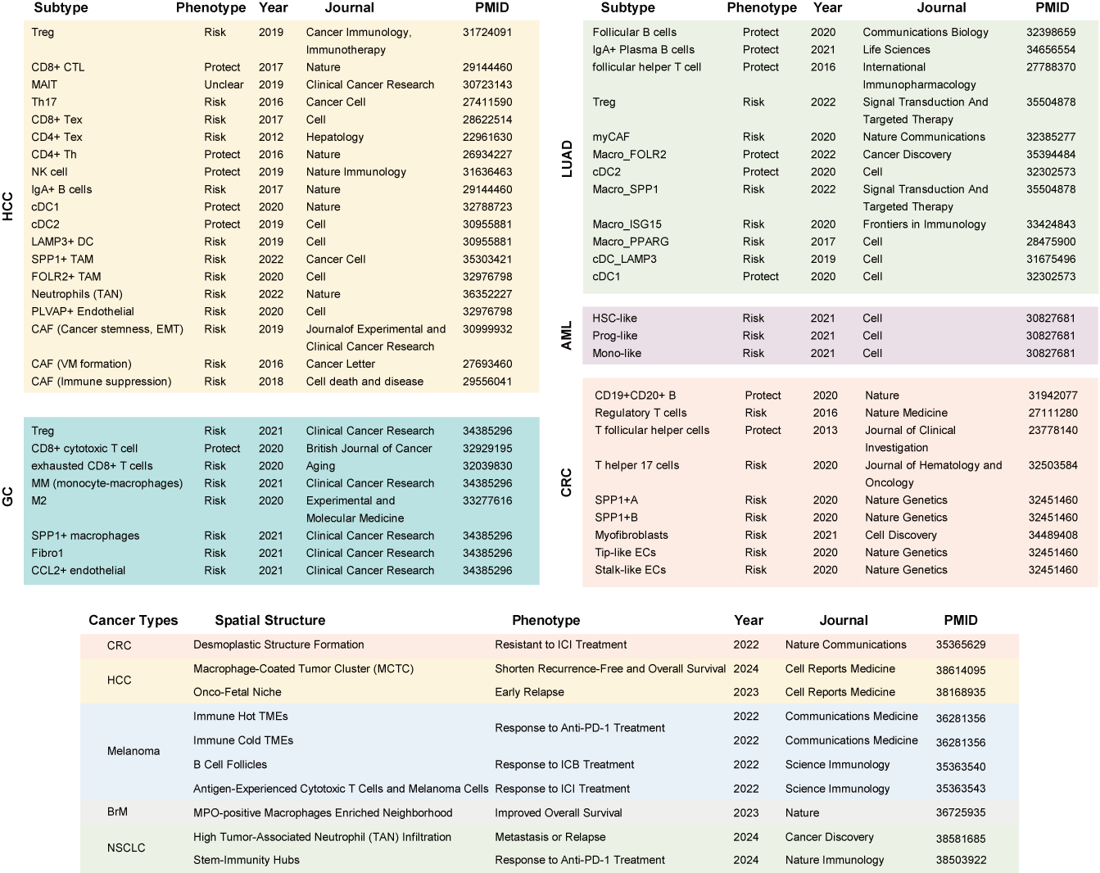
Fig. S4 | Summary of cellular subpopulations with clinical significance.
A comprehensive literature review of cellular subpopulations and spatial niches across different cancer types. Top row: Review of cell subpopulations; Bottom row: Review of spatial niches. Experimental evidences of these. cellular niches from the previous studies are provided in Supplementary Table 3.

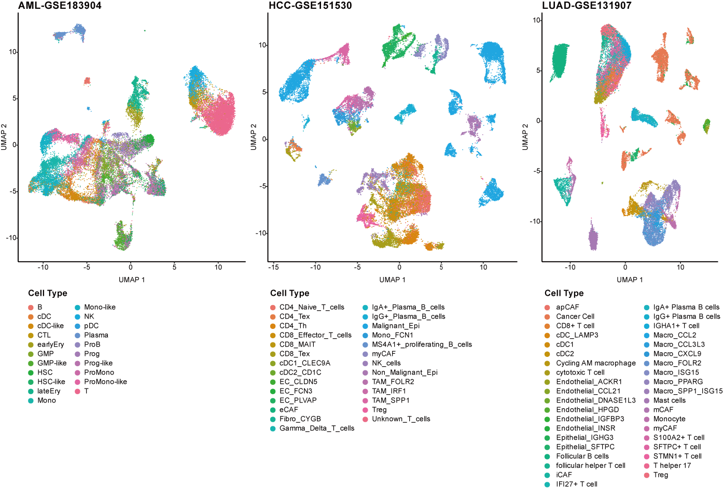
Fig. S5 | Cellular annotation of scRNA-seq data involved for phenotype-associated cell subpopulations identification.
UMAP plots display the cellular identities of three scRNA-seq datasets from AML, HCC, and LUAD. Annotations were obtained from the corresponding original studies. Each point represents an individual cell, with colors indicating distinct cell subpopulations.

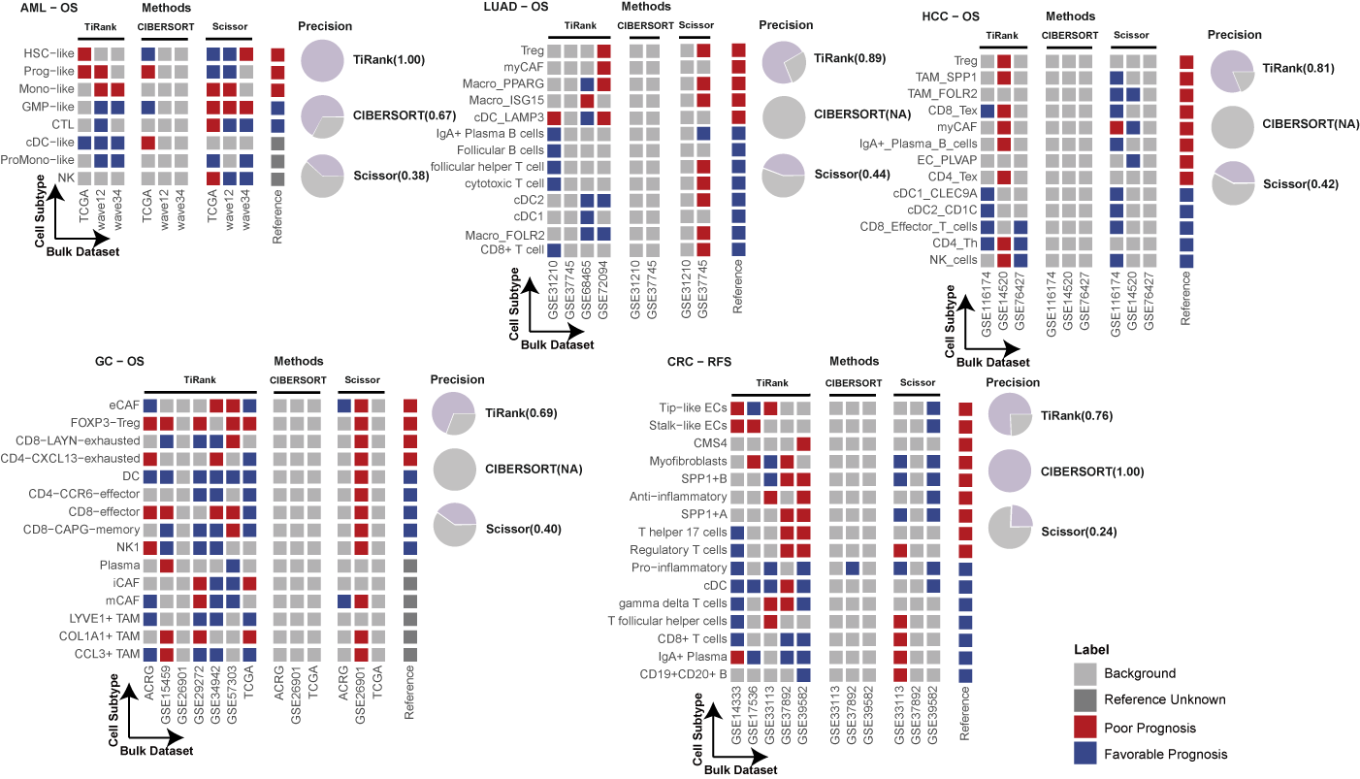
Fig. S6 | Benchmarking TiRank against other algorithms in predicting prognosis-associated cell subpopulations from scRNA-seq data.
Heatmaps compare the performance of TiRank, CIBERSORT, and Scissor in predicting prognosis-associated cell subpopulations across five cancer types: AML, LUAD, HCC, GC, and CRC. Each row represents a distinct cell subpopulation, and each column corresponds to predictions based on specific bulk transcriptomic datasets (indicated by GSE identifiers). The reference (ground truth) was established from prior studies, with red indicating poor prognosis-associated subpopulations, blue indicating favorable prognosis-associated subpopulations, and grey indicating subpopulations not associated with prognosis. Pie charts display the precision of each method, defined as the ratio of correct positive predictions to all positive predictions, consistent with the definition in Figure 2.

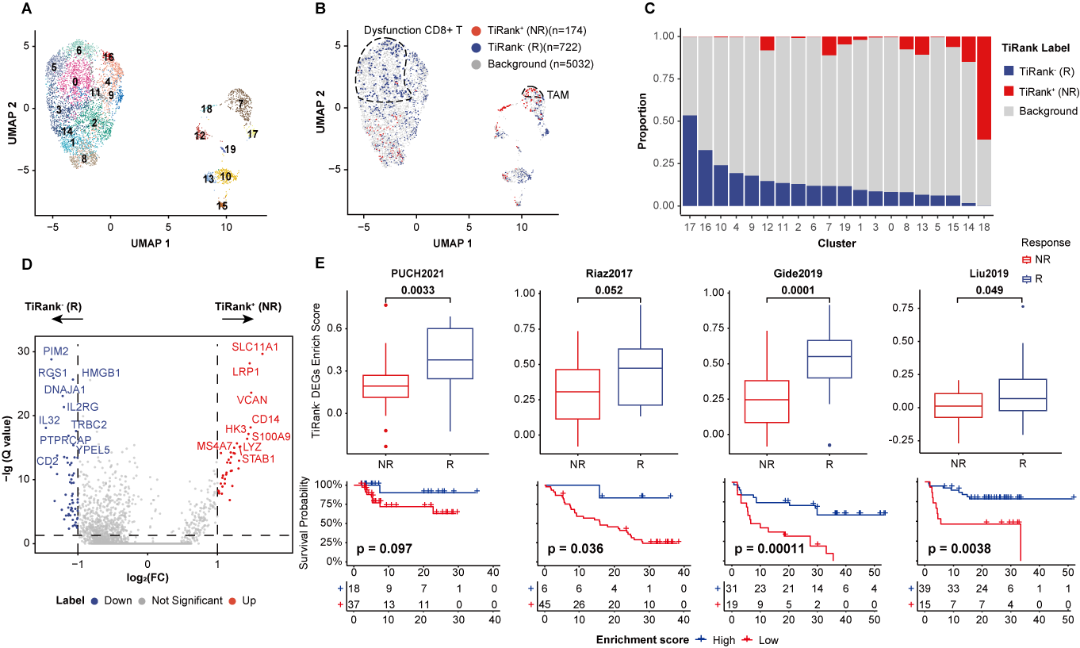
Fig. S7 | TiRank identifies cell subpopulations associated with anti-PD-1 therapy response in melanoma.
A, UMAP visualization of 20 clusters in the scRNA-seq dataset of melanoma.
B, UMAP highlighting cell subpopulations associated with anti-PD-1 therapy response. TiRank⁺ cells (red) are associated with ICB non-response (resistance), while TiRank⁻ cells (blue) are associated with response. Gray dots represent background cells.
C, Stacked bar plot showing the distribution of TiRank labels (TiRank⁺, TiRank⁻, and background) across the 20 clusters. The x-axis denotes cluster numbers, and the y-axis indicates the proportion of each classification within the clusters.
D, Differential gene expression analysis comparing TiRank⁺ and TiRank⁻ cells. TiRank⁺ cells overexpress TAM-associated markers such as SLC11A1, LRP1, and MS4A7, suggesting the TAM subpopulations associated with resistance to anti-PD-1 therapy. In contrast, TiRank⁻ cells exhibit elevated expression of genes associated with immune activation, including IL2RG and TRBC2.
E, Enrichment analysis of the anti-PD-1 therapy response signature across four melanoma cohorts (PUCH2021, Riaz2017, Gide2019, Liu2019). Top row: Box plots comparing signature enrichment scores between non-responders (NR, red) and responders (R, blue) in each cohort. Bottom row: Kaplan-Meier survival analysis of overall survival stratified by high (blue) and low (red) enrichment scores. Statistical significance is shown for each cohort from a t-test. TiRank⁻ DEGs reflect genes associated with anti-PD-1 therapy response.

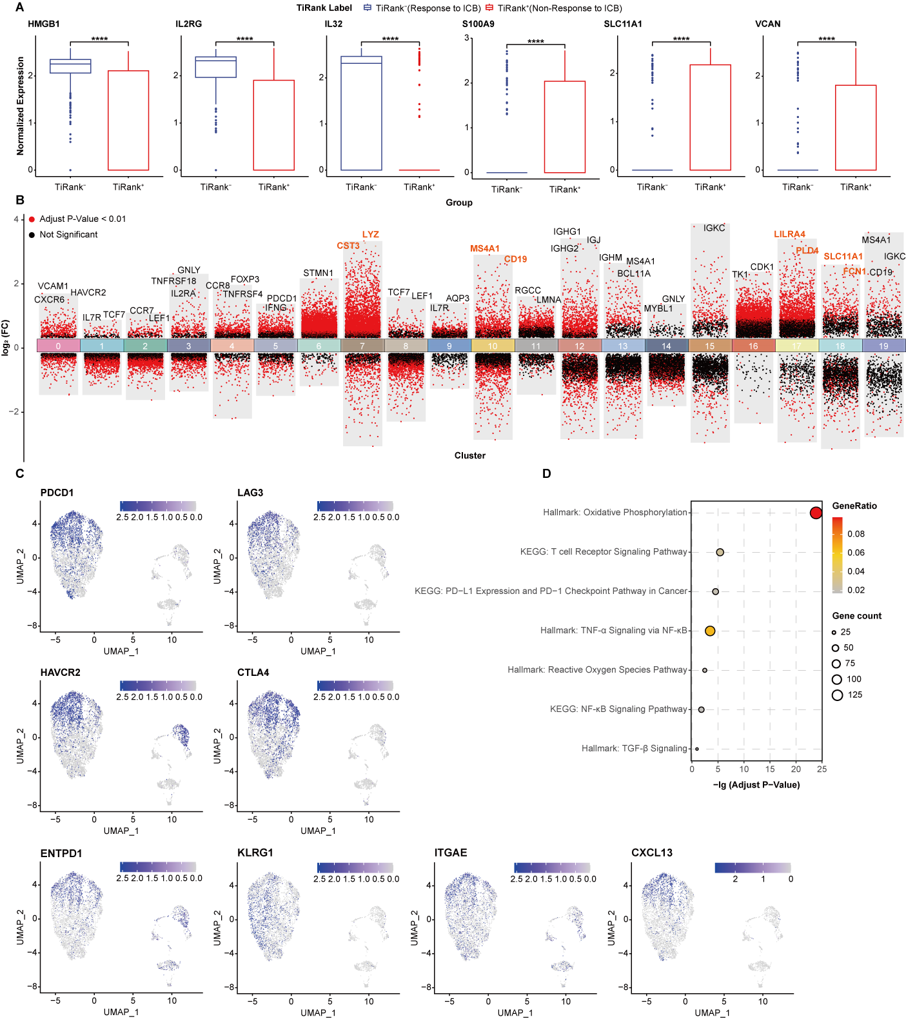
Fig. S8 | CD8⁺ T Cells associated with anti-PD1 therapy response in Melanoma.
A, Scatter plot showing differentially expressed genes across all cell clusters. The top differentially expressed genes in each cluster are labeled.
B, Pathway enrichment plot illustrating the significantly enriched pathways in anti-PD1 therapy response associated CD8⁺ T cell population compared to therapy resistant CD8⁺ T cells, as predicted by TiRank.
C, Feature plots of cell type markers used to annotate cell clusters. Three genes (ENTPD1, ITGAE, KLRG1) represent tumor activity in T cells, and one gene (CXCL13) highlights the role of T cells in the tumor microenvironment.
D, Boxplots showing normalized expression levels of key genes (HMGB1, IL2RG, IL32, S100A9, SLC11A1, VCAN) in TiRank predicted responsive CD8⁺ T Cell versus resistant CD8⁺ T cells, Statistical significance is indicated by asterisks (****p ≤ 0.0001) from a t-test.
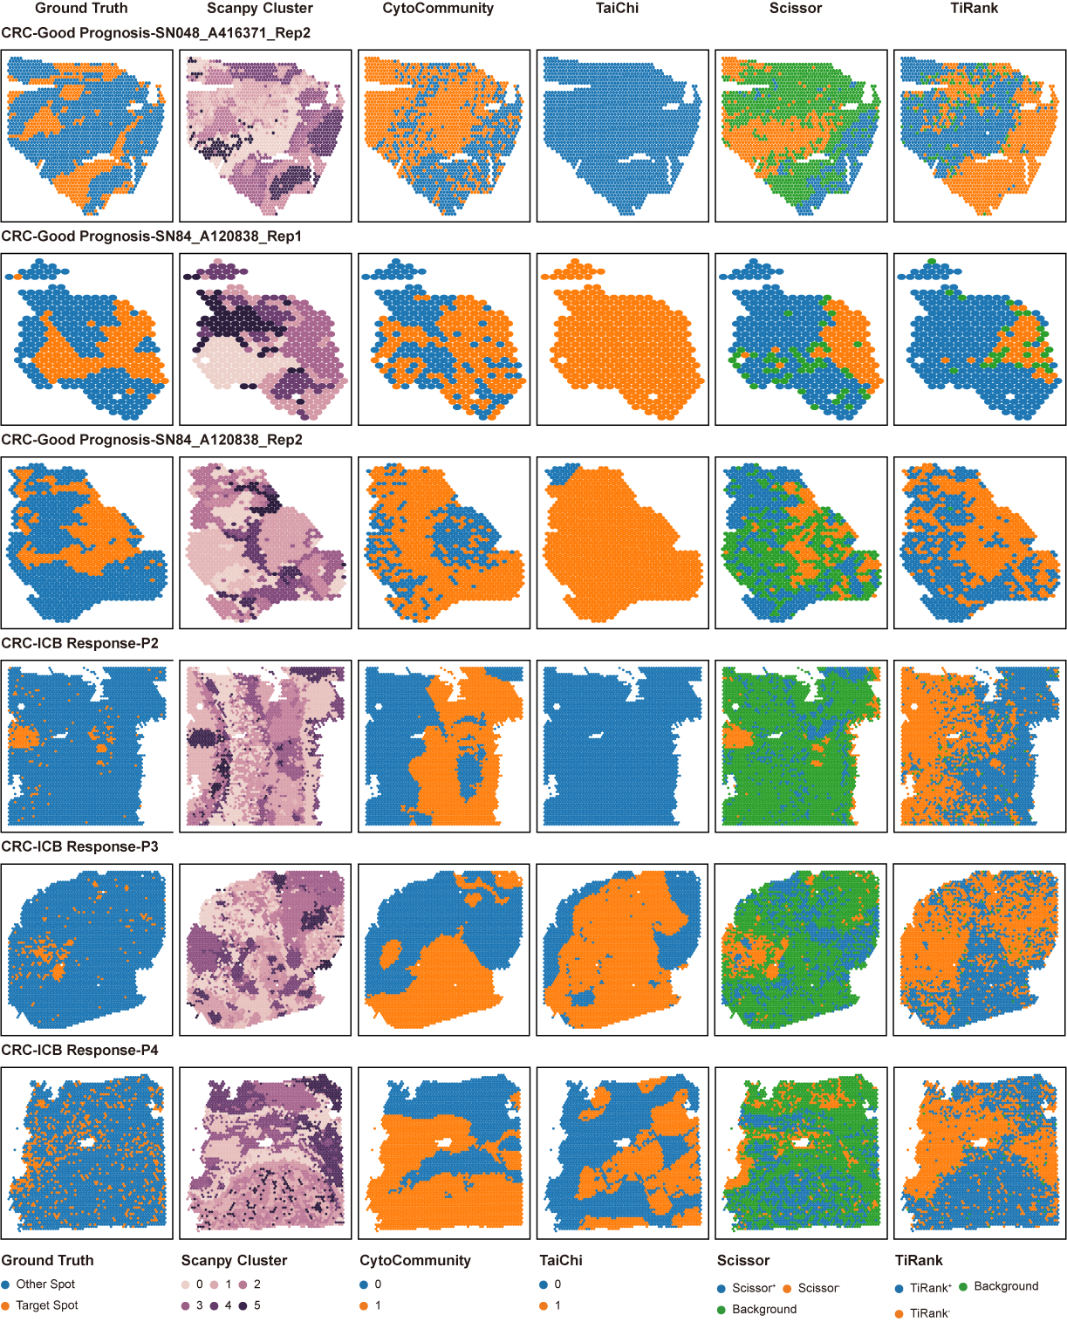
Fig. S9 | Benchmarking TiRank against other algorithms in predicting phenotype-associated spatial niches from CRC ST Data.
Spatial maps compare the performance of TiRank, CytoCommunity, TaiChi, and Scissor in predicting phenotype-associated spatial niches in CRC ST data. Rows 1 to 3 depict favorable prognosis-associated niches (SN048, SN84_A120838_Rep1, and SN84_A120838_Rep2), while rows 4 to 6 depict ICB treatment response niches in CRC patients receiving neoadjuvant chemotherapy (P2, P3, and P4). Each row represents an individual ST slide, and each column corresponds to a different method: ground truth, Scanpy clustering, CytoCommunity, TaiChi, Scissor, and TiRank. Ground truth, determined by manual annotations, labels target spots (orange) associated with the phenotype and background spots (blue). Scanpy clustering shows gene expression-based clusters (0 to 5). Predictions by CytoCommunity, TaiChi, Scissor, and TiRank highlight phenotype-associated spots (orange) versus background (green for CytoCommunity, TaiChi, and Scissor; blue for TiRank).

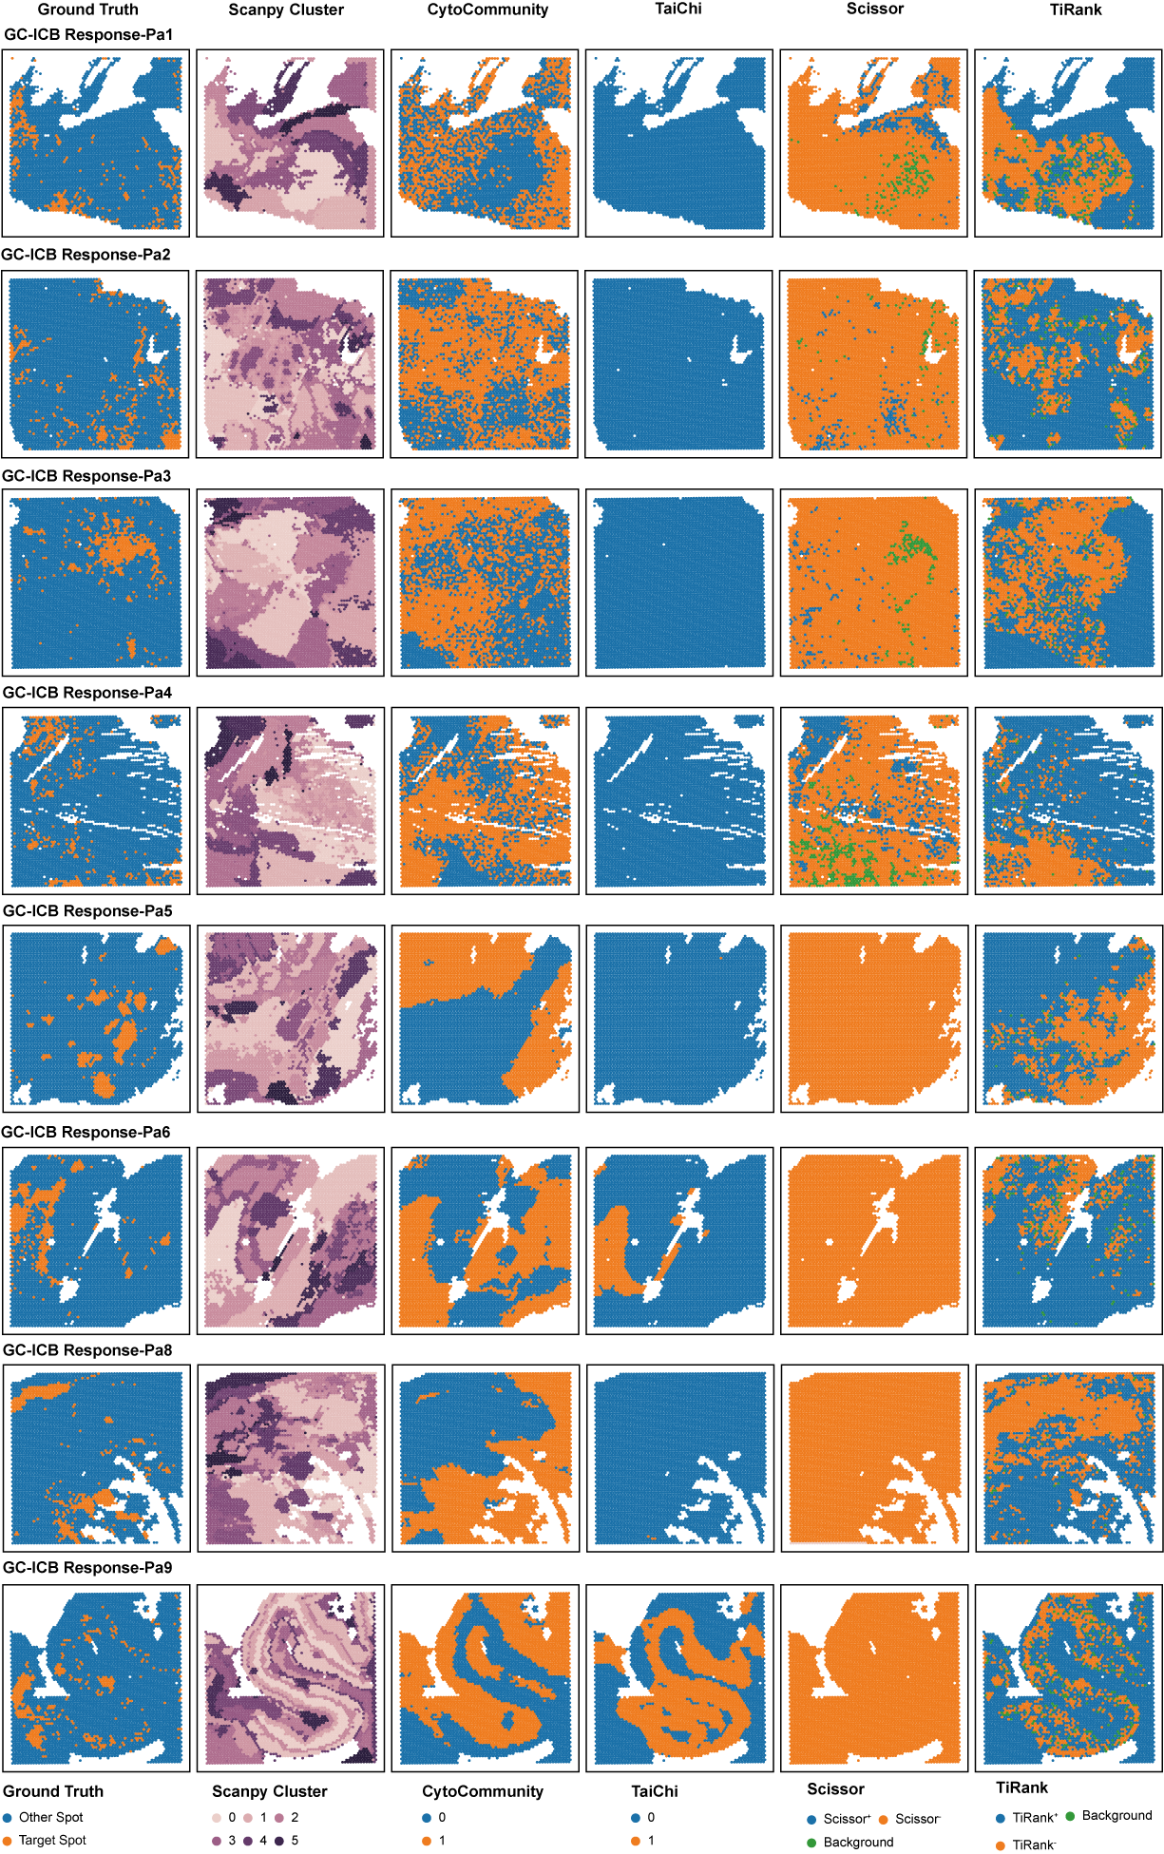
Fig. S10 | Benchmarking TiRank against other algorithms in predicting phenotype-associated spatial niches from GC ST Data.
Spatial maps compare the performance of TiRank, CytoCommunity, TaiChi, and Scissor in predicting spatial niches associated with ICB-response in GC ST data. Each row represents an individual ST slide, and each column corresponds to a different method: ground truth, Scanpy clustering, CytoCommunity, TaiChi, Scissor, and TiRank. Ground truth, determined by manual annotations, labels target spots (orange) associated with the phenotype and background spots (blue). Scanpy clustering shows gene expression-based clusters (0 to 5). Predictions by CytoCommunity, TaiChi, Scissor, and TiRank highlight phenotype-associated spots (orange) versus background (green for CytoCommunity, TaiChi, and Scissor; blue for TiRank).

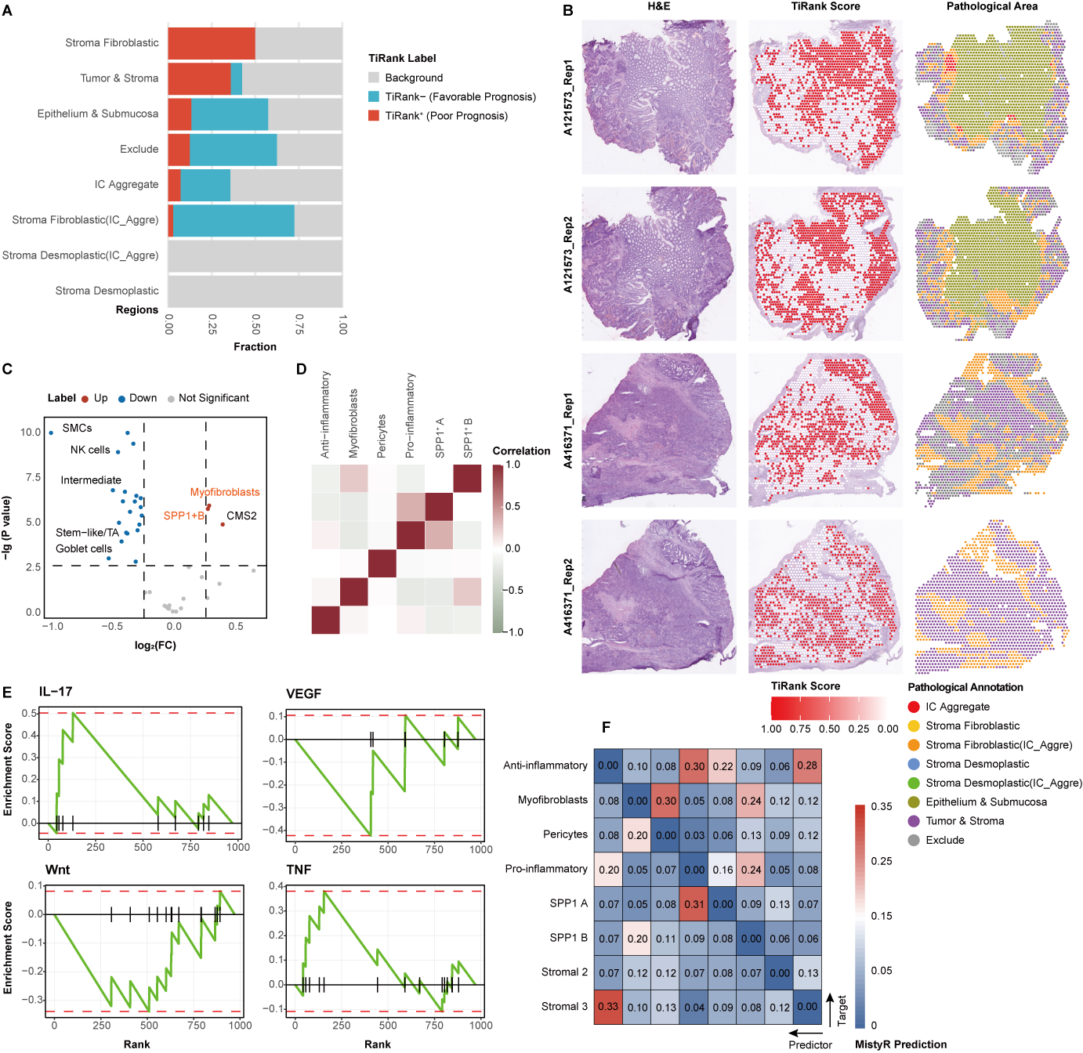
Fig. S11 | TiRank identifies interactions between myofibroblasts and SPP1⁺ TAMs associated with prognosis in CRC.
A, Stacked bar plot showing the distribution of TiRank labels across various pathological regions in CRC. TiRank⁺ (red) indicates poor-prognostic spots, TiRank⁻ (blue) denotes favorable-prognostic spots, and gray represents background spots. The y-axis represents different pathological regions, while the x-axis shows the fraction of each label across 14 CRC spatial slices.
B, Spatial distribution of TiRank scores across four tissue slices. The left column shows the H&E images, the middle column represents the TiRank score distribution (from white to red, indicating favorable to poor prognosis), and the right column displays the pathological annotation. The color-coded regions in the pathological annotation correspond to distinct pathological features or microenvironmental regions, as annotated by an experienced pathologist.
C, Volcano plot illustrating the differential abundance of cell subpopulations between TiRank⁺ and TiRank⁻ spots within fibroblastic stromal regions. Red dots indicate cell subpopulations enriched in TiRank⁺ spots, while blue dots correspond to those enriched in TiRank⁻ spots and grey denote not significant. SPP1⁺ A and SPP1⁺ B, two previously defined SPP1⁺ macrophage subpopulations.
D, Heatmap of Pearson correlation coefficients showing the co-occurrence of various cell subpopulations within TiRank⁺ spots in fibroblastic stromal regions. The x-axis and y-axis represent different types of cell subpopulations.
E, Pathway enrichment analysis of differentially expressed genes (DEGs) between TiRank⁺ and TiRank⁻ spots. The DEGs are ranked by fold change, with pathways corresponding to up-regulated genes in TiRank⁺ spots shown on the left and those up-regulated in TiRank⁻ spots on the right.
F, Heatmap showing the contribution of cell subpopulations to the prediction of other cell subpopulations in fibroblastic stromal areas, as determined by MISTy. The color intensity indicates the degree of contribution from cell subpopulations on the x-axis to those on the y-axis.

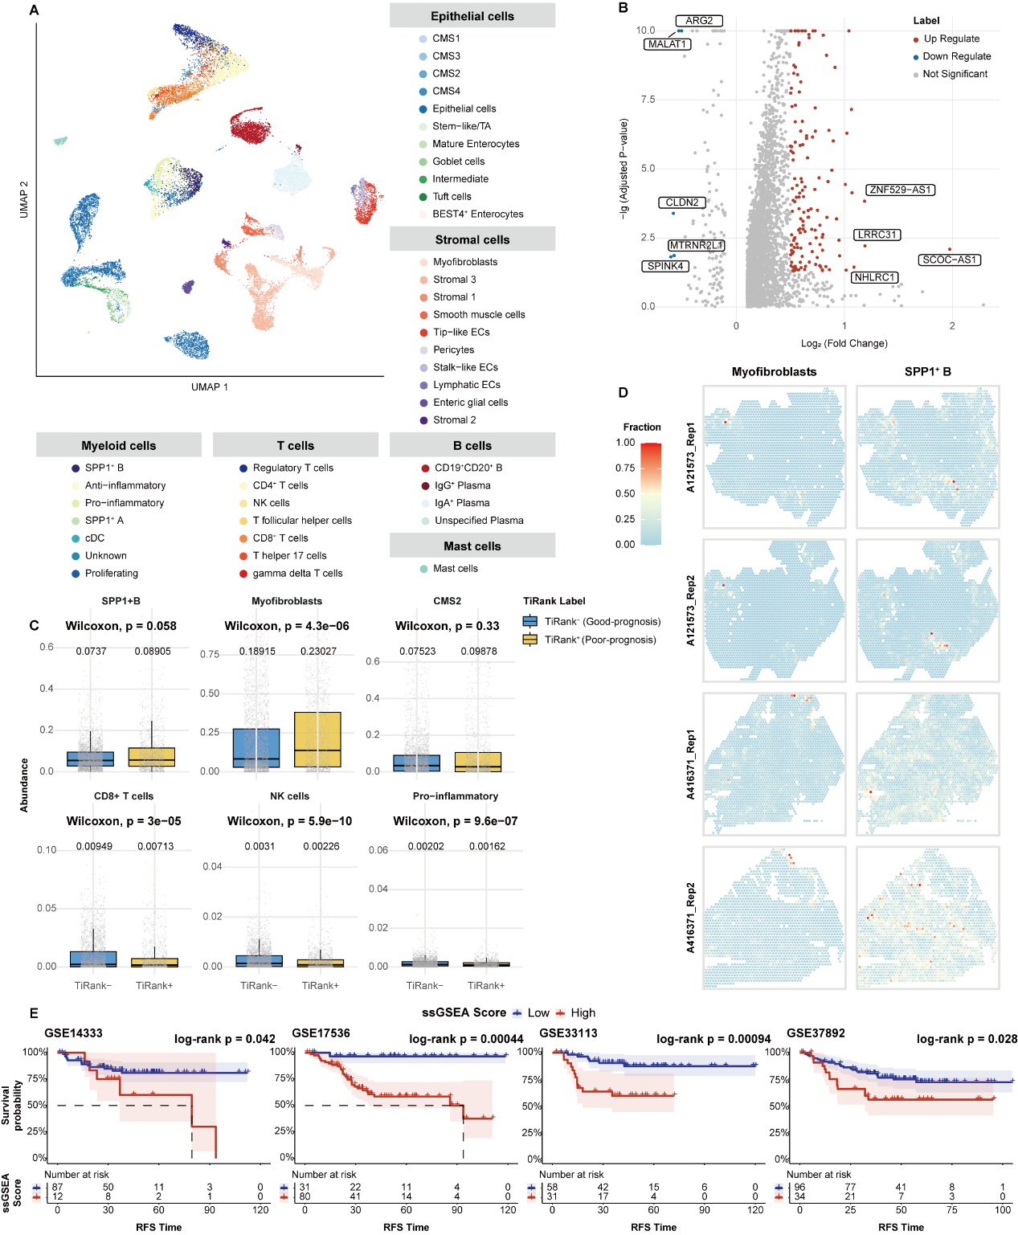
Fig. S12 | Co-occurrence of SPP1⁺ TAM and myofibroblast in poor prognostic regions in CRC.
A, UMAP visualization showing major and subpopulations of cells annotated from the scRNA-seq dataset (GSE144735), used as a reference for cell type deconvolution in ST data.
B, Volcano plot illustrating differentially expressed genes between poor prognostic and favorable prognostic spots within fibroblastic stromal areas of ST data for CRC. Up: red (TiRank⁺), poor prognosis; Down: blue (TiRank⁻), favorable prognosis; Not Significant: grey. Genes with significant differential expression are highlighted.
C, Boxplots showing the fractions of selected cell subpopulations, including SPP1⁺ TAM, CAFs such as myofibroblasts and pro-inflammatory cells, tumor cells (CMS2), and cytotoxic cells (CD8⁺ T cells, NK cells) in TiRank⁺ and TiRank⁻ spots within fibroblastic stromal regions. The x-axis represents TiRank group, and the y-axis shows the fraction of deconvoluted cell subpopulations.
D, Spatial images depicting the location of spots in fibroblastic stromal areas for myofibroblasts (left) and SPP1⁺ TAM (right). Representative sections from two patients are displayed, with each patient having two adjacent slices. Colors indicate the fraction of deconvoluted cell subpopulations as determined by the CARD package.
E, Kaplan-Meier survival analysis for recurrence-free survival in four independent CRC cohorts (GSE14333, GSE17536, GSE33113, GSE38832). Patients were stratified by ssGSEA scores using a signature derived from genes upregulated in TiRank⁺ spots. P-values were determined by log-rank test.

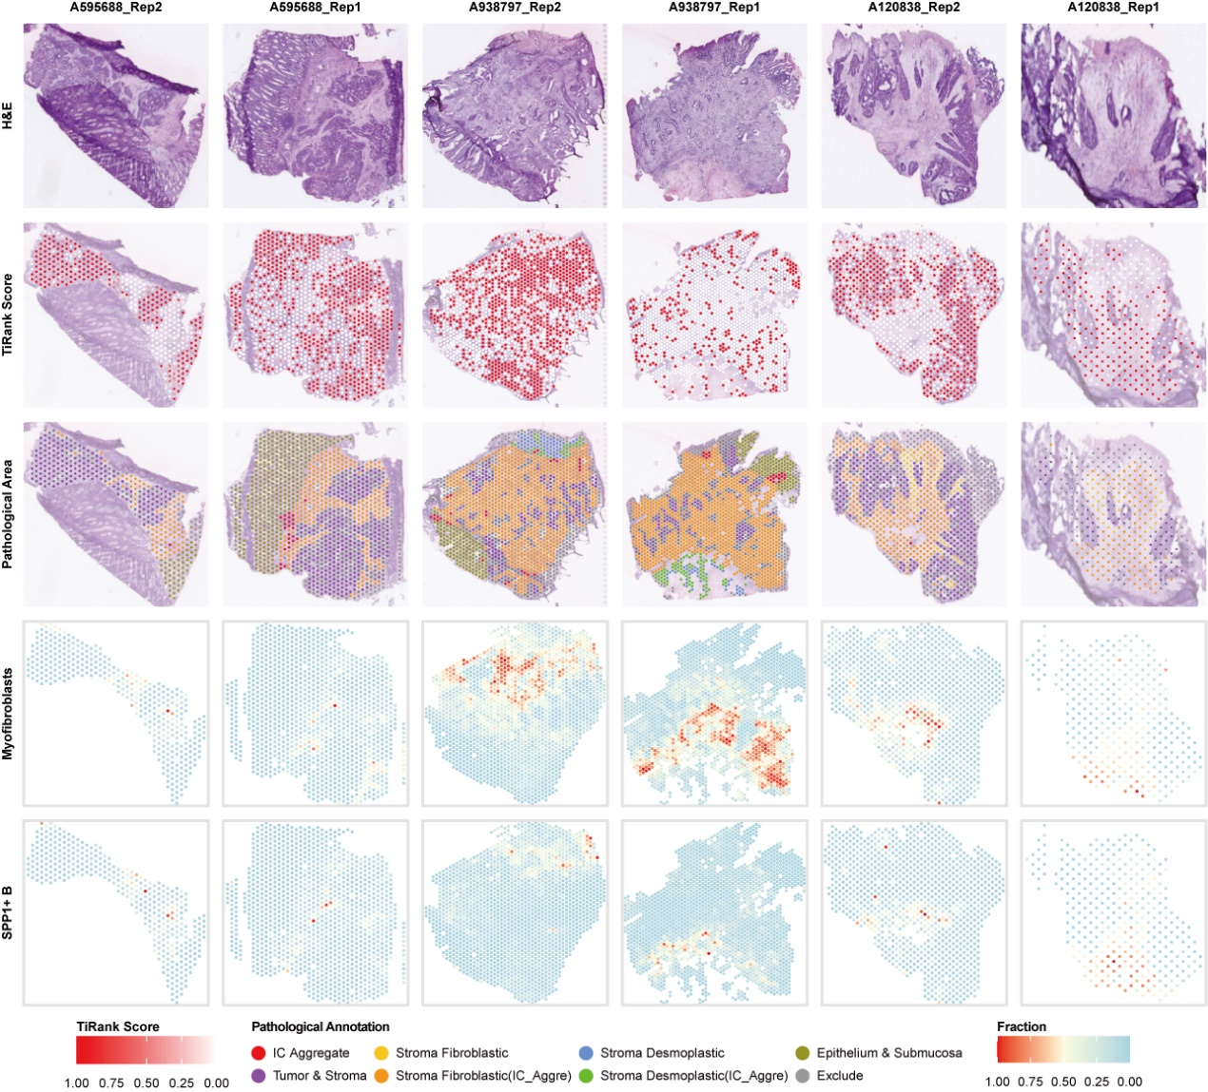
Fig. S13 | Spatial distributions of TiRank scores across tissue slices from CRC.
The top row shows the H&E images, the second row displays the distribution of TiRank scores. Ranging from white to red, indicating favorable to poor prognosis. The third row represents the pathological annotation. The final two rows depict the spatial distributions of myofibroblasts and SPP1⁺ TAM, respectively. The color-coded regions in the pathological annotation correspond to distinct tissue types, including immune cell (IC) aggregates, stroma fibroblastic, stroma desmoplastic, and other tissue components, as annotated by an experienced pathologist. And color gradient from sky blue to red indicating the relative fraction of each cell population at individual spots based on deconvolution analysis.

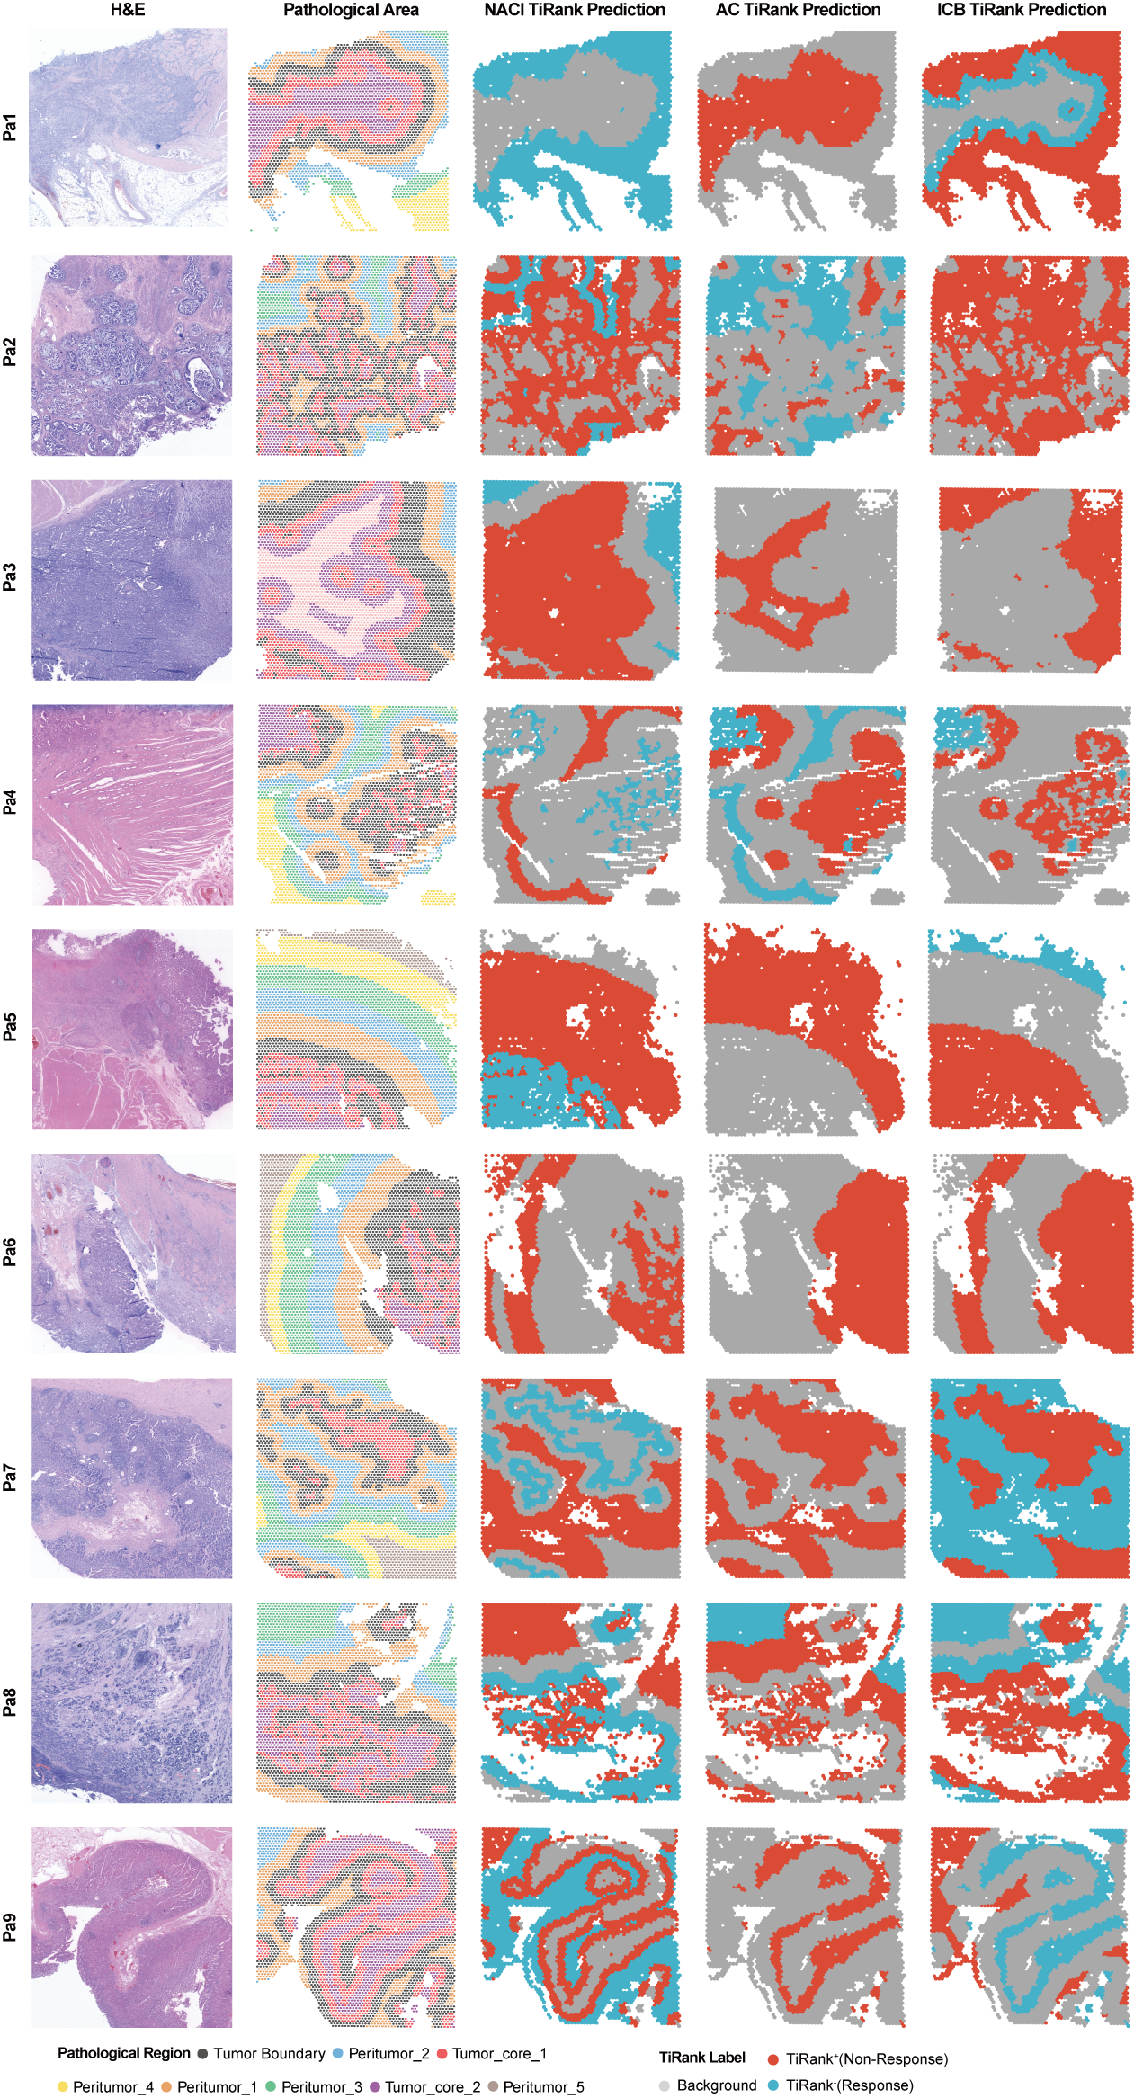
Fig. S14 | Spatial distributions of TiRank scores across tissue slices of GC.
Spatial mapping of TiRank predictions in tissue slices from all nine gastric cancer patients. The first column displays H&E-stained images; the second column highlights boundary structures annotated by the Cottrazm package; and the final three columns show TiRank prediction categories for three therapies: red (TiRank⁺), indicating resistance; blue (TiRank⁻), indicating response; and gray, representing background.

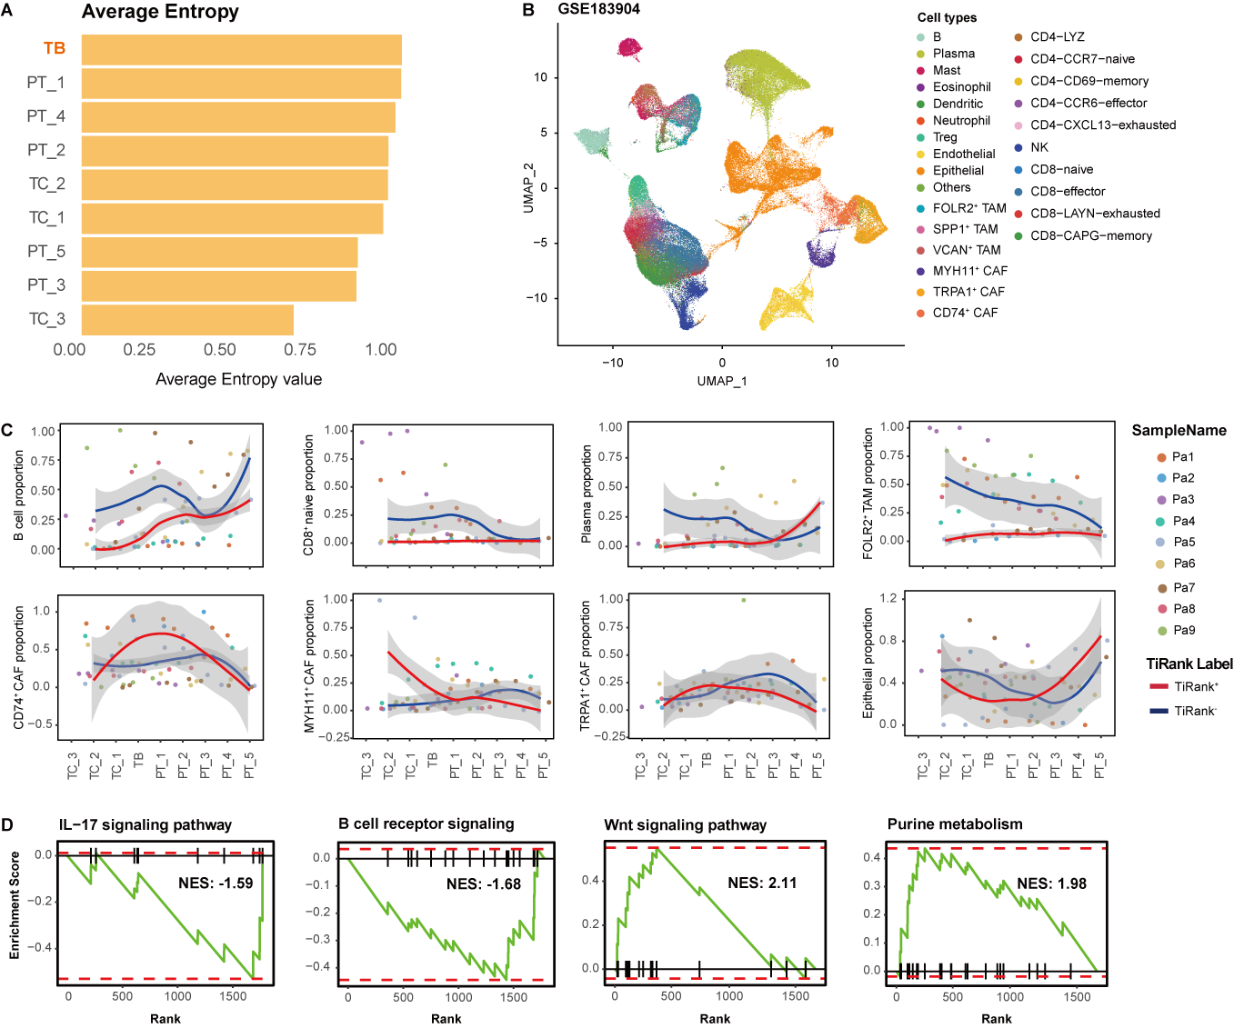
Fig. S15 | Spatial characteristics of TiRank labels in GC.
A, Bar plot showing the average entropy of each pathological region. The x-axis shows average entropy value, while the y-axis represents distinct pathological regions.
B, UMAP visualization showing subpopulations of cells annotated from the scRNA-seq dataset (GSE183904), used as a reference for cell type deconvolution in ST data. CAF, cancer-associated fibroblast; TAM, tumor-associated macrophage; DC, dendritic cell; NK, natural killer cell.
C, The average abundance of key cell subtypes, across spatial regions from the core tumor to the peritumor area. The points represent average abundance at each location for individual patients. Data are presented as mean values $±$ s.d.
D, Pathway enrichment analysis of differentially expressed genes between TiRank⁺ and TiRank⁻ spots within the tumor boundary under NACI. Genes upregulated in TiRank⁺ are shown on the left, and those in TiRank⁻ on the right, ranked by fold change. Only genes with p < 0.05 are included.

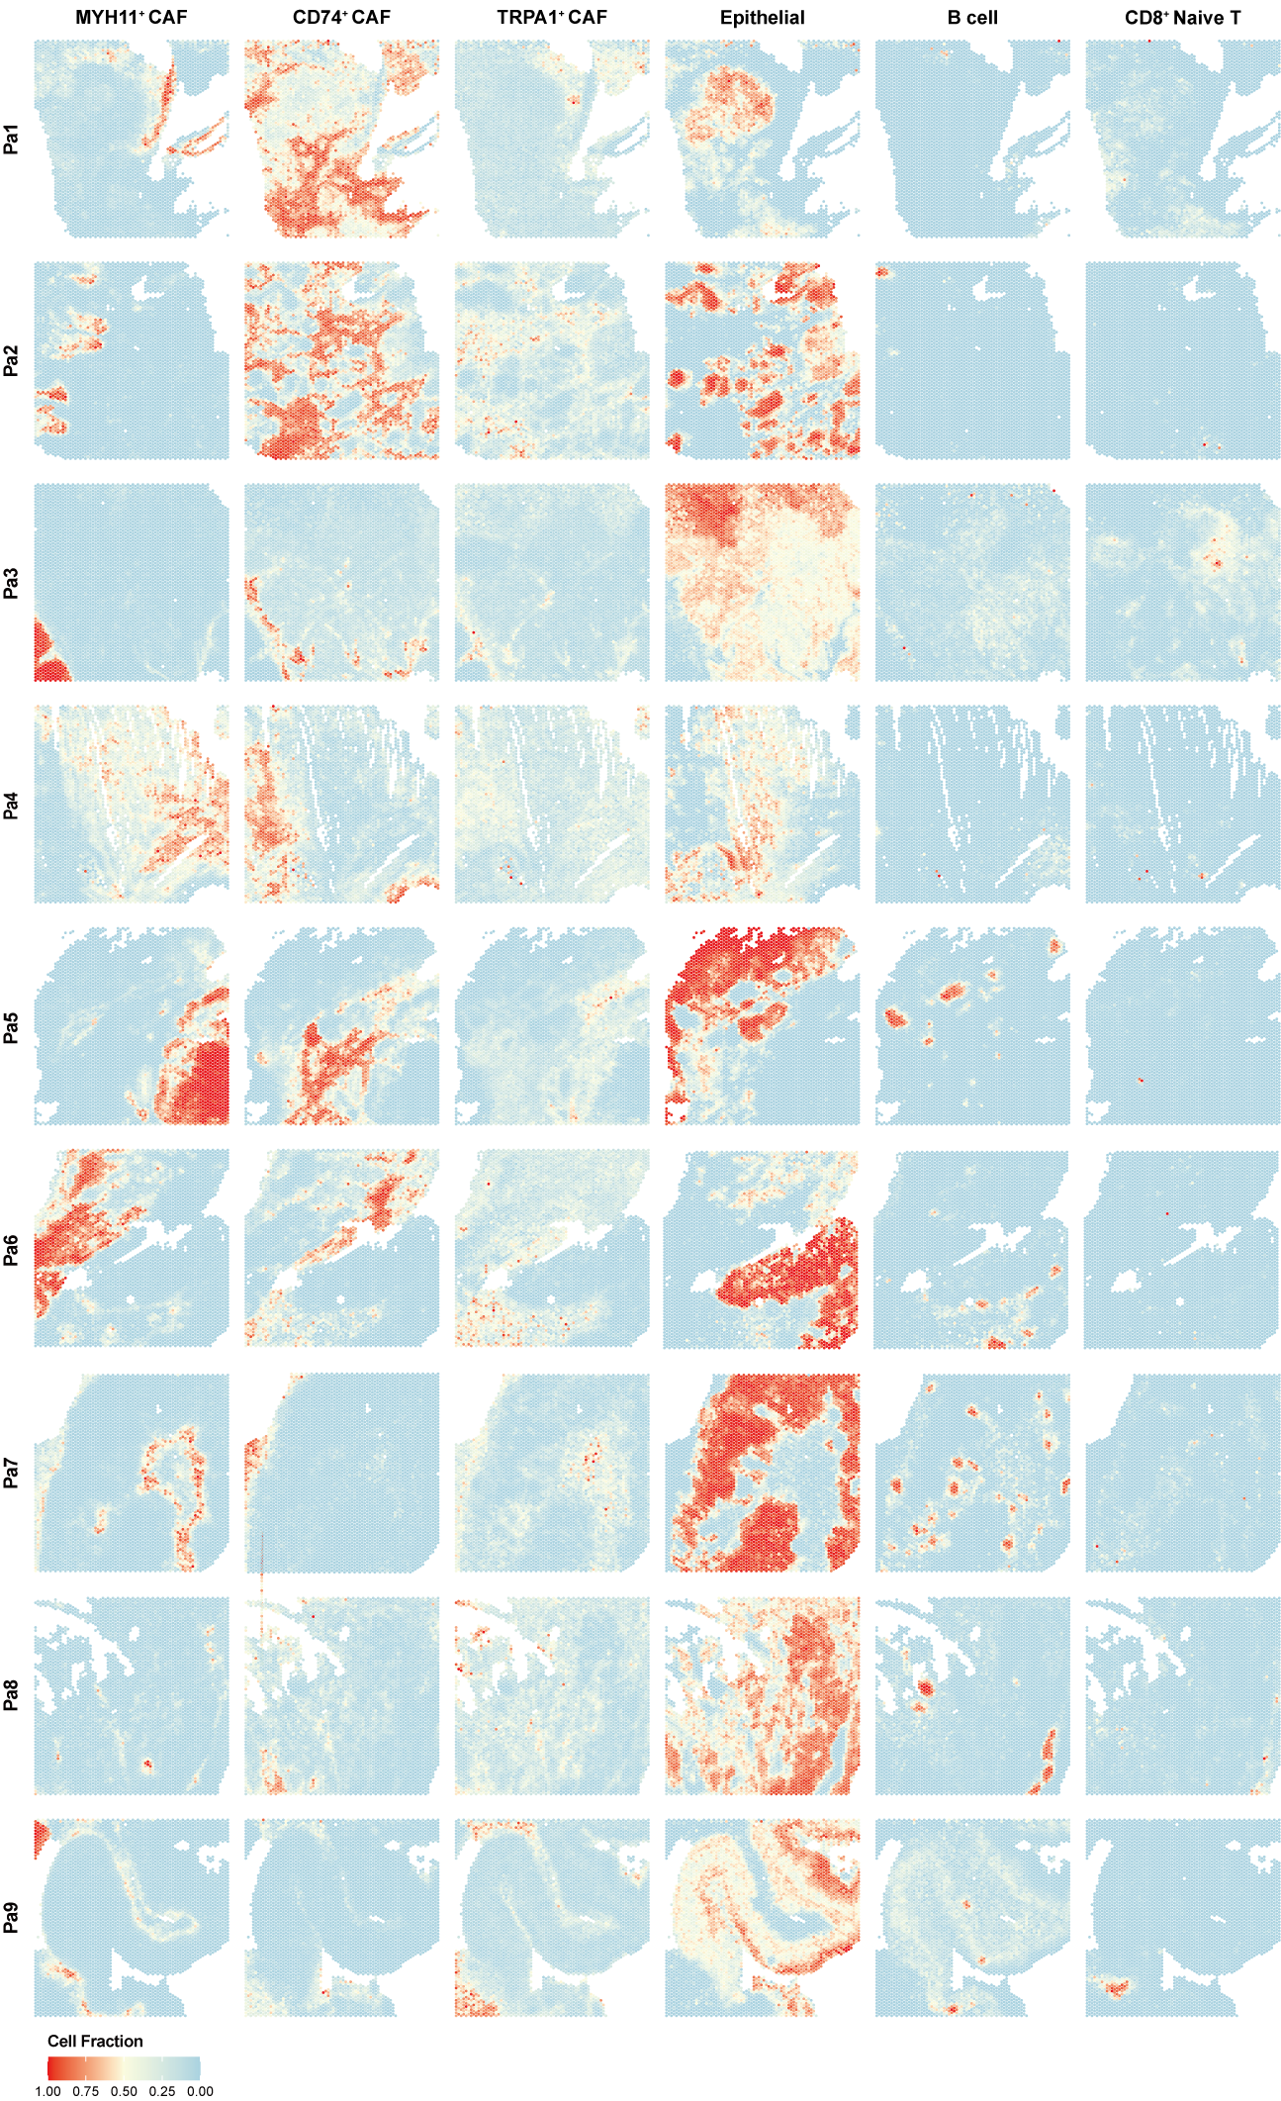
Fig. S16 | Cellular fractions at individual spots based on deconvolution analysis in GC.
Heatmaps show spatial distribution of key cell subtypes in GC, with a color gradient from sky blue to red indicating the relative fraction of each cell population at individual spots based on deconvolution analysis.

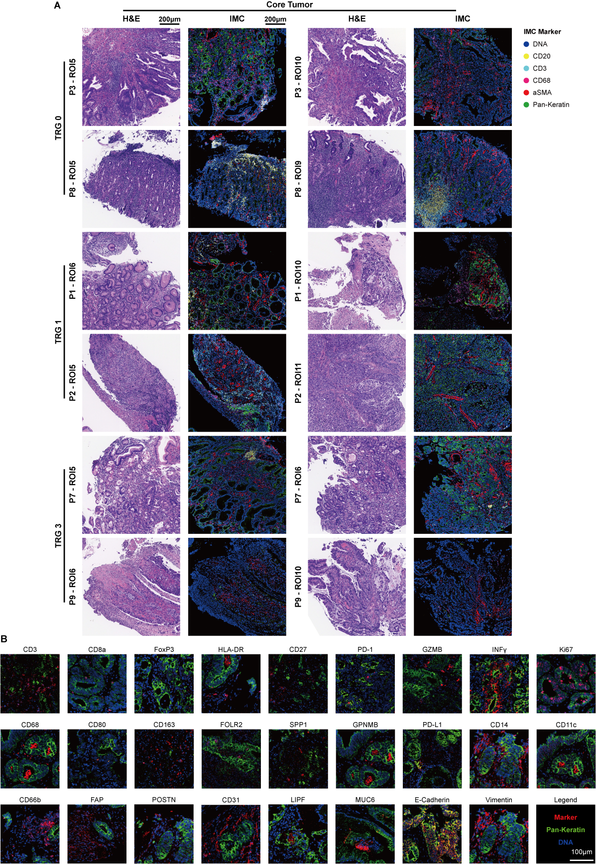
Fig. S17 | IMC images and the corresponding hematoxylin and eosin-stained images of tumor regions in GC.
A, Paired H&E-stained and IMC images of tumor ROIs categorized by TRG. ROIs are labeled with their sample name, ROI number, and TRG classification. H&E images (left) reveal tumor histology, while IMC images (right) highlight spatial protein expression. TRG 0 and TRG 1 indicate response to NACI, while TRG 3 denotes stable tumors with no significant regression. IMC markers shown include CD3 (cyan), CD20 (yellow), CD68 (red), αSMA (pink), and Pan-Keratin (green). Scale bar, 200 μm.
B, Representative IMC images displaying protein expression patterns for key markers, including immune markers, checkpoint markers, stromal markers, and others. Tumor cells are labeled with Pan-Keratin (green), nuclei with DNA (blue), and specific markers with red. Scale bar, 100 μm.

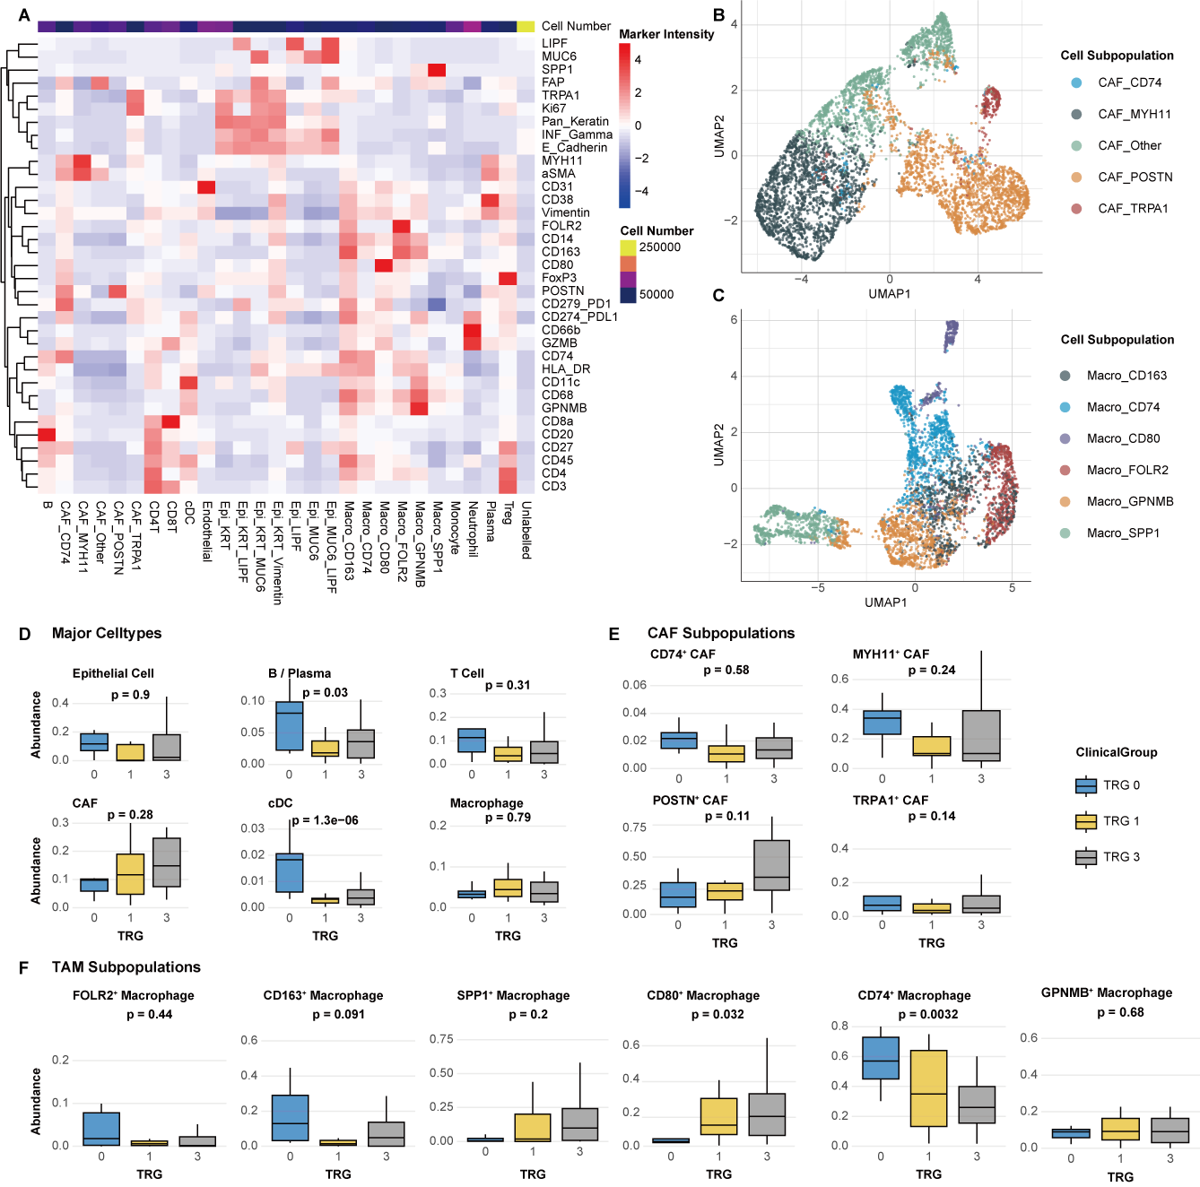
Fig. S18 | Abundance of cell subpopulations through IMC in GC.
A, Heatmap showing mean marker expression levels across 28 cell subpopulations identified in 61 ROIs from 10 GC samples. The color gradient ranges from blue (low expression) to red (high expression), and annotated bars summarize the number of cells per ROI.
B-C, UMAP visualizations of cell subpopulations derived from unsupervised clustering. B, Distribution of five CAF subpopulations, including CAF_CD74, CAF_MYH11, CAF_POSTN, CAF_TRPA1, and CAF_Other.
C, Distribution of six tumor-associated macrophage (TAM) subpopulations, including Macro_CD163, Macro_CD74, Macro_CD80, Macro_FOLR2, Macro_GPNMB, and Macro_SPP1.
D, Box plots comparing the proportions of major cell types, including epithelial cells, B/plasma cells, T cells, CAFs, cDCs, and macrophages, across different TRG groups. TRG 0 and TRG 1 indicate response to therapy, while TRG 3 denotes minimal or no tumor regression. Statistical significance was determined using one-way ANOVA, with p-values indicated above each plot.
E, Box plots comparing the abundance of CAF subpopulations across TRG groups. Subpopulation proportions were calculated as the ratio of each CAF subpopulation to the total CAF population. Statistical significance was assessed using one-way ANOVA, with p-values shown above the plots.
F, Box plots showing the abundance of TAM subpopulations across TRG groups. Subpopulation proportions were computed as the ratio of each TAM subpopulation to the total TAM population. Statistical significance was determined using one-way ANOVA, with p-values indicated.

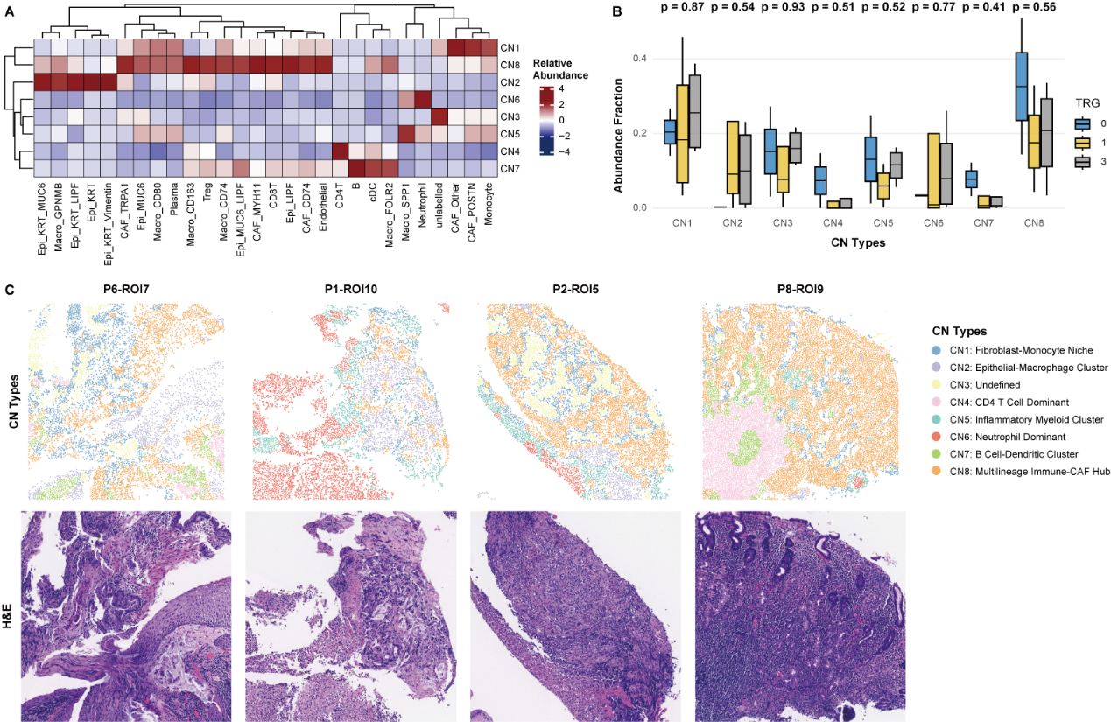
Fig. S19 | Cellular neighborhoods associated with TRG in GC.
A, Heatmap showing the relative abundance of cell types across eight cellular neighborhoods (CNs) identified in core tumor and peritumor regions using a k-nearest-neighbor graph (k = 20). The color gradient represents relative abundance, ranging from blue (low) to red (high).
B, Box plots showing the distribution of CNs across TRG groups. Frequencies of CNs were averaged across multiple ROIs from the same patient. Statistical significance was determined using one-way ANOVA, with p-values indicated above the plots.
C, Representative images of ROIs, displaying CN classifications (top row) and corresponding H&E-stained images (bottom row). CN types are labeled on the right, and the edge length of each ROI is 1000 μm.

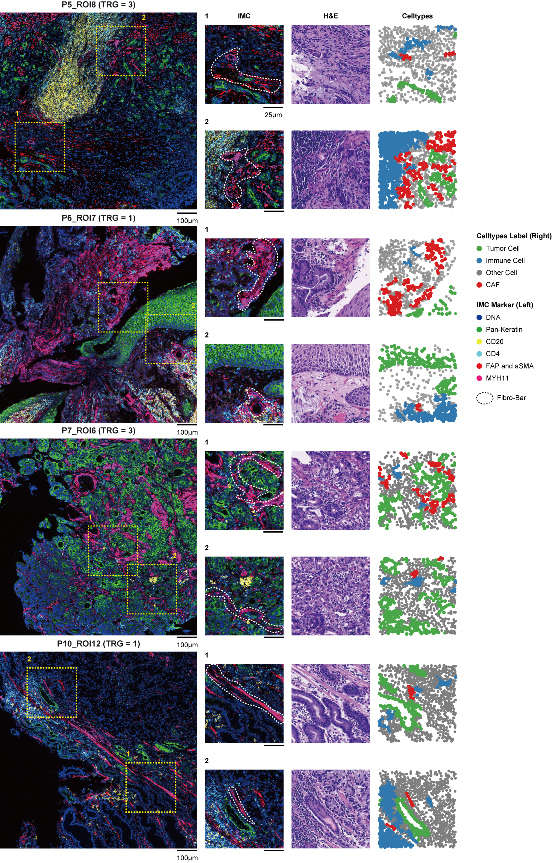
Fig. S20 | Visualization of Fibro-Bar and cell distributions through IMC.
IMC images showing the Fibro-Bar and the spatial organization of tumor cells, CAFs, and immune cells across four ROIs from four distinct patients. For each ROI, two cropped regions are displayed, with IMC images (left), hematoxylin and eosin H&E-stained images (middle), and cell subpopulation distributions (right). White arrows indicate the Fibro-Bar structure. Scale bars: 100 μm (full ROI) and 25 μm (cropped regions).

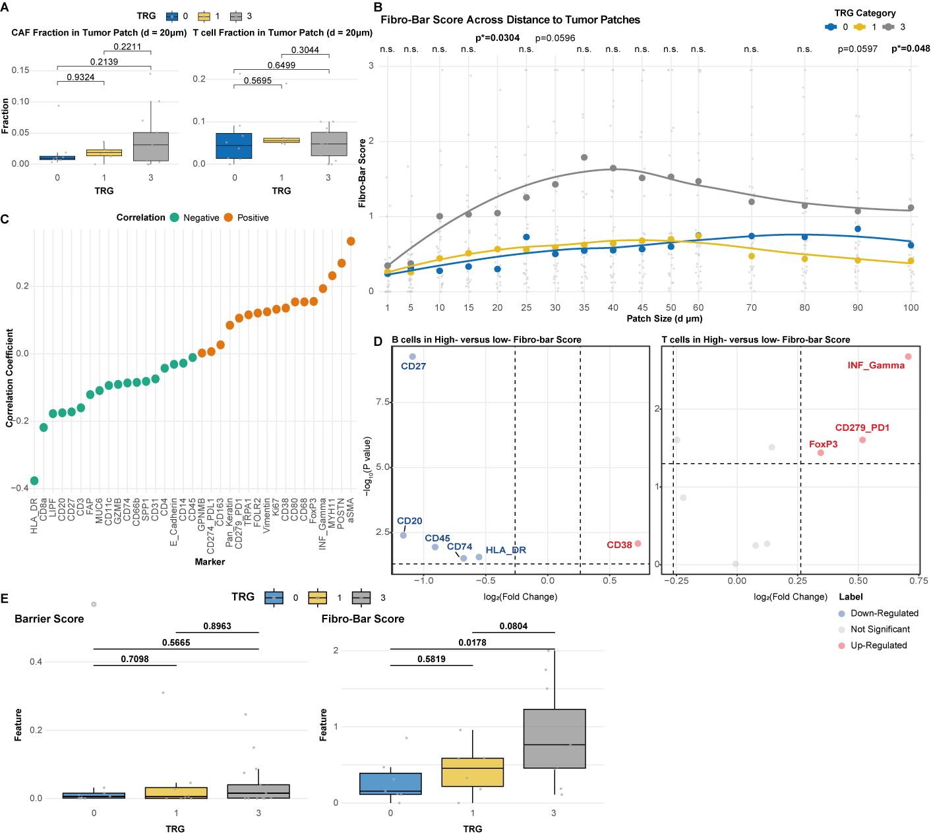
Fig. S21 | Features associated with the Fibro-Bar score in GC patients receiving NACI.
A, Box plots comparing the fraction of cancer-associated fibroblasts (CAFs) (left) and T cells (right) within tumor patches across Tumor Regression Grade (TRG) groups (TRG 0-3) in 10 GC patients. Tumor patches are defined as regions containing aggregated tumor cells and their neighboring areas within a 20 μm radius. Statistical significance was assessed using a two-sided Student’s t-test, with p-values indicated.
B, Line plots illustrating Fibro-Bar scores across tumor patches at varying distances from the tumor center (1-100 μm) in ROIs. Each point represents an individual ROI, with TRG groups color-coded (TRG 0: blue, TRG 1: yellow, TRG 3: grey). Statistical significance was determined using one-way ANOVA, with significant differences (*p ≤ 0.05) marked.
C, Correlation analysis of protein expression with Fibro-Bar scores. Each dot represents the Spearman correlation coefficient for a protein marker, with positive correlations in orange and negative correlations in green.
D, Volcano plots showing differential protein expression in B cells (left) and T cells (right) between tumor patches with high versus low Fibro-Bar scores. Red dots indicate proteins upregulated in high Fibro-Bar score patches, and blue dots indicate proteins upregulated in low Fibro-Bar score patches. Key markers (e.g., CD27, CD38, IFN-γ) are labeled.
E, Box plots comparing the Fibro-Bar score with the barrier score (Enfield et al.) across TRG groups (TRG 0-3). The Fibro-Bar score shows a stronger association with NACI efficacy in the cohort of 10 GC patients, with statistical significance assessed using a two-sided Student’s t-test (p-values indicated).

Reference
1. Greaves M, Maley CC. Clonal evolution in cancer. Nature. 2012;481:306–13. https://doi.org/10.1038/nature10762
2. Keats JJ, Chesi M, Egan JB, Garbitt VM, Palmer SE, Braggio E, et al. Clonal competition with alternating dominance in multiple myeloma. Blood. 2012;120:1067–76. https://doi.org/10.1182/blood-2012-01-405985
3. Sinha S, Vegesna R, Mukherjee S, Kammula AV, Dhruba SR, Wu W, et al. PERCEPTION predicts patient response and resistance to treatment using single-cell transcriptomics of their tumors. Nat Cancer. 2024; https://doi.org/10.1038/s43018-024-00756-7

