Additional file 1. Supplementary Figures and Tables for

Pathogenic CGG expansions in oculopharyngodistal myopathy exhibit distinct characteristics of each causative gene on the flanking sequences as well as methylation status
Nobuyuki Eura, Satoru Noguchi, Megumu Ogawa, Kyuto Sonehara, Ai Yamanaka, Takashi Kurashige, Shinichiro Hayashi, Yukinori Okada, Kazuma Sugie, Ichizo Nishino

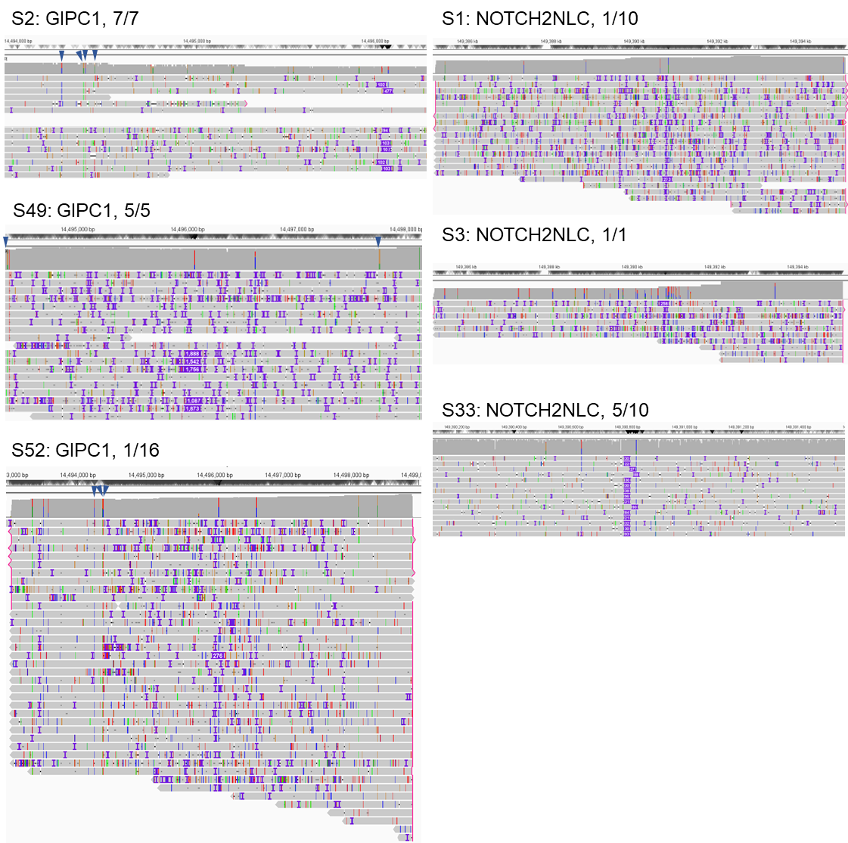

Fig. S1. Data from patients with repeat expansions in two genes.

Six patients had repeat expansions in two distinct genes. Panels show reads from genes other than the predicted causative genes. Three patients (S2, S49, and S52) had reads with repeat expansions in GIPC1 in addition to causative expansions in LRP12, and three (S1, S3, and S33) had reads with repeat expansions in NOTCH2NLC in addition to causative expansions in LRP12. Numbers indicate the detection rates of reads derived from each allele.

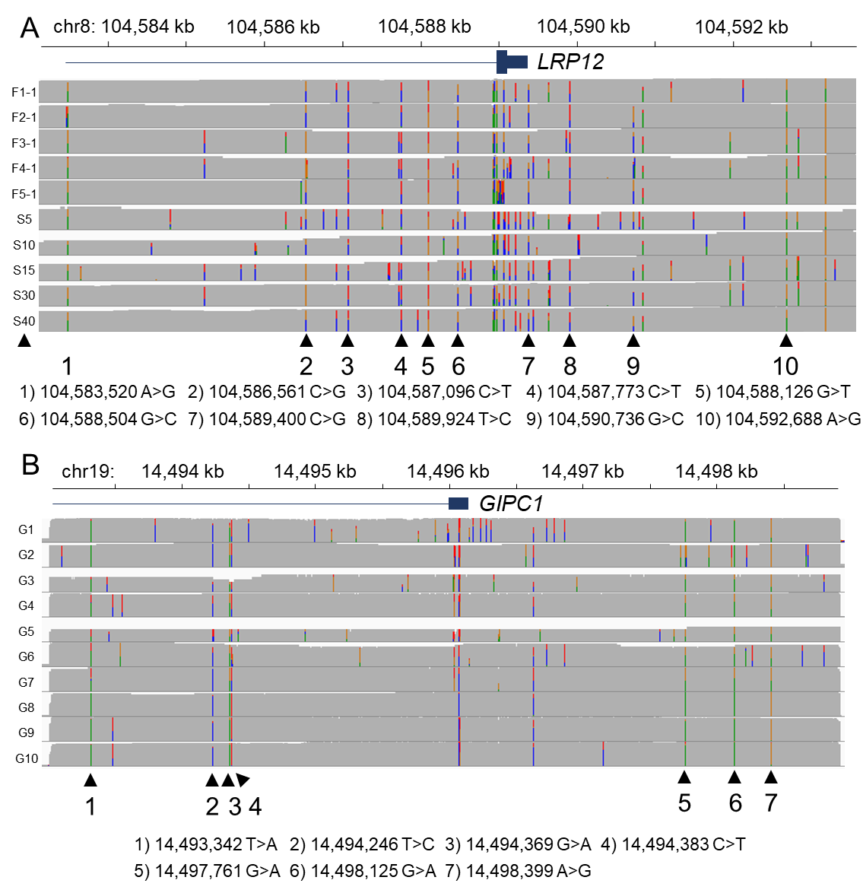

Fig. S2. Specific haplotypes found in LRP12 and GIPC1 alleles with expanded reads.

(A) Ten common single nucleotide variants (SNVs) detected in reads with LRP12 repeat expansions; data from 11 patients are presented. (B) Seven common SNVs found in reads with GIPC1 repeat expansions; data from 10 patients are presented.

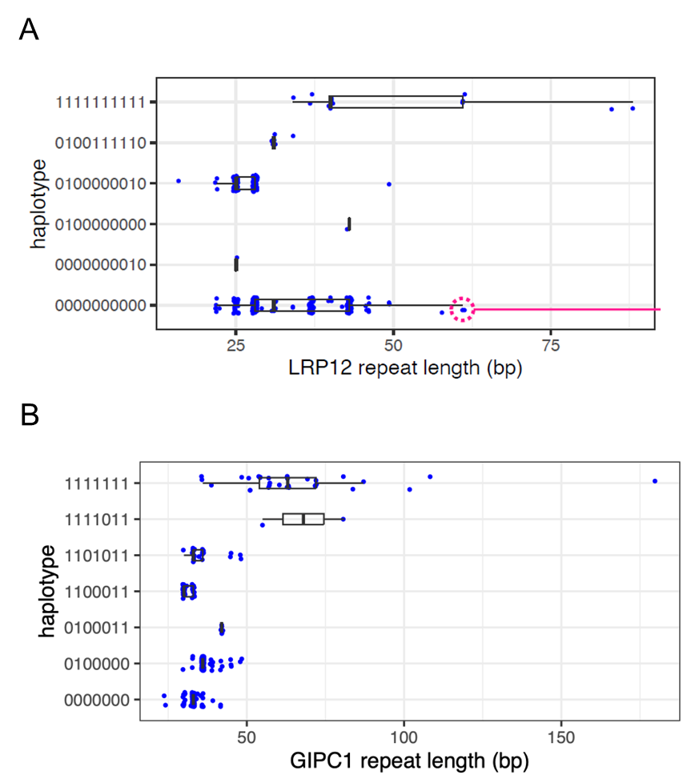

Fig. S3. CGG repeat lengths in normal individuals with specific LRP12 and GIPC1 haplotypes in the general population in Japan.

(A) Distribution of CGG repeat lengths in different haplotypes defined by 10 SNV sites in LRP12 in the general population. The specific haplotype with the 10 SNVs (all 1) had larger size of repeat length. (B) Distribution of CGG repeat lengths in haplotypes defined by 7 SNV sites in GIPC1 in the general population. The specific haplotype with the 7 SNVs (all 1) had larger size of repeat length.

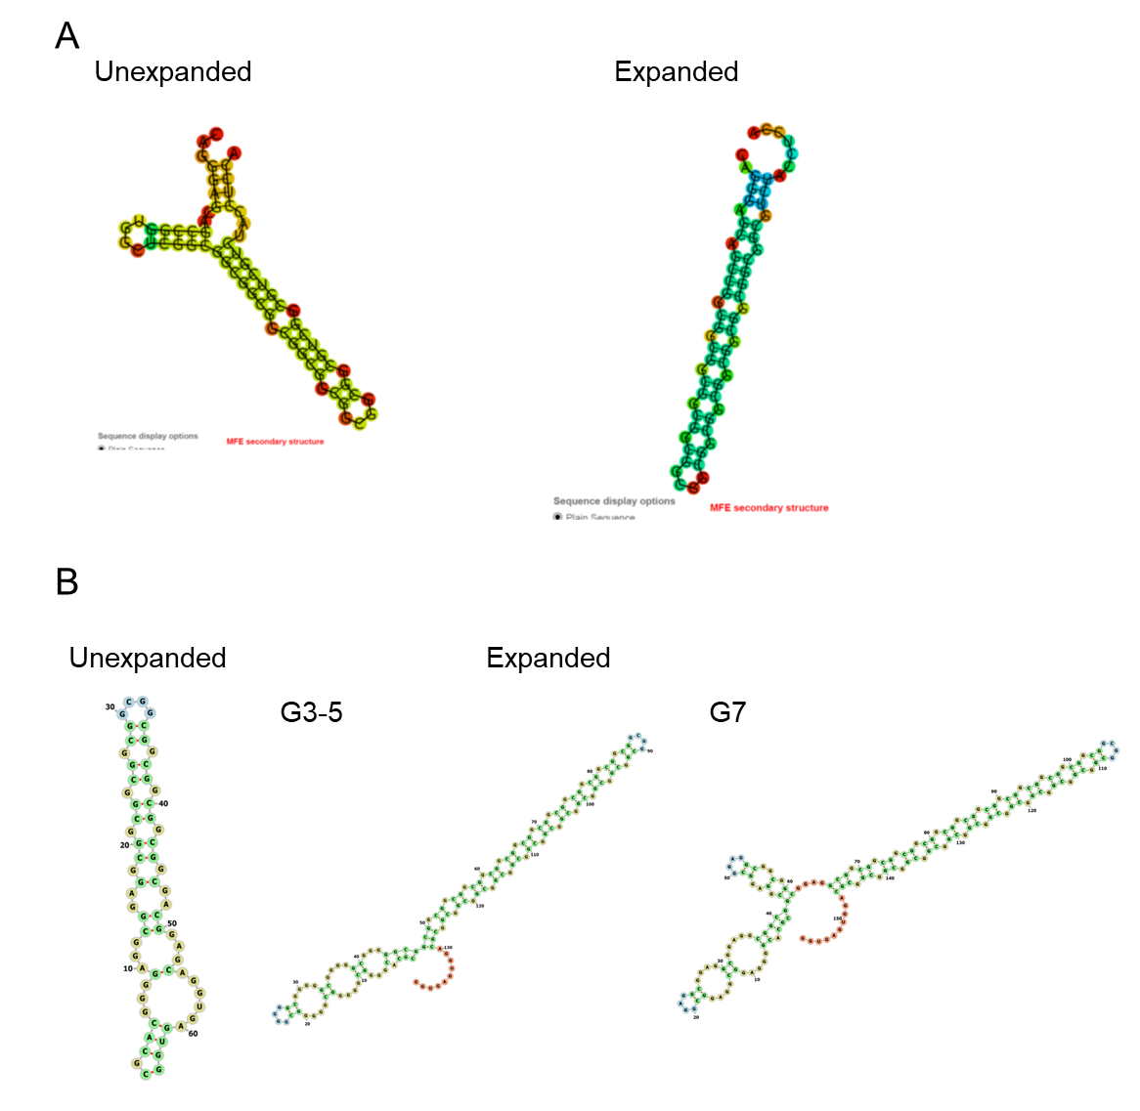

Fig. S4. RNA secondary structures of LRP12 and GIPC1 expansions and their flanking sequences.

(A) Predicted secondary structures of flanking sequences in expanded and non-expanded LRP12 alleles. (B) Predicted secondary structures of flanking sequences in expanded and non-expanded GIPC1 alleles.

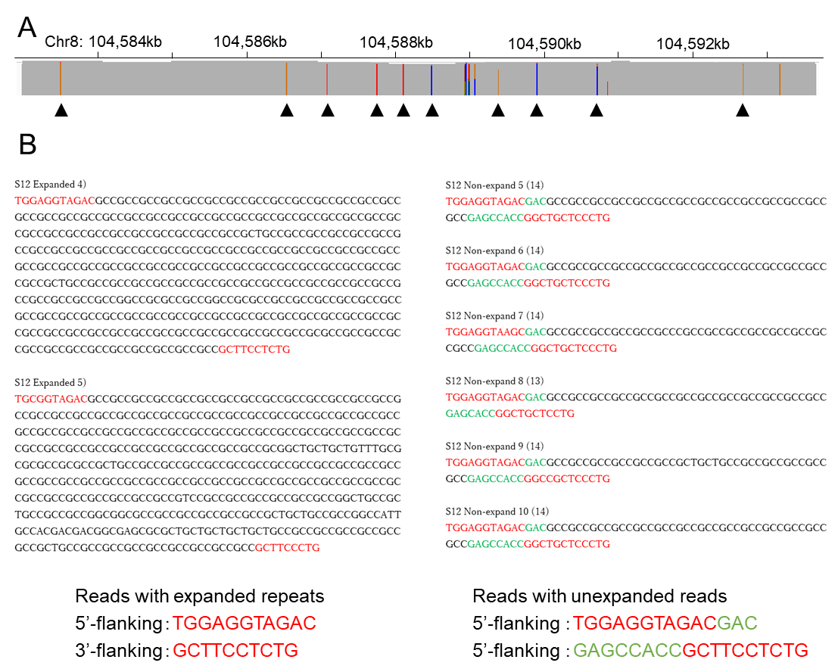

Fig. S5. Flanking sequences of an LRP12 patient whose both expanded and non-expanded alleles show the same haplotype.

(A) LRP12 single nucleotide variant (SNV) data from a patient with an LRP12 expansion who was homozygous for all 10 LRP12 SNVs (see Fig. S1). (B) The expanded allele sequence showing lack of the flanking sequences (green), which were present in the non-expanded allele.

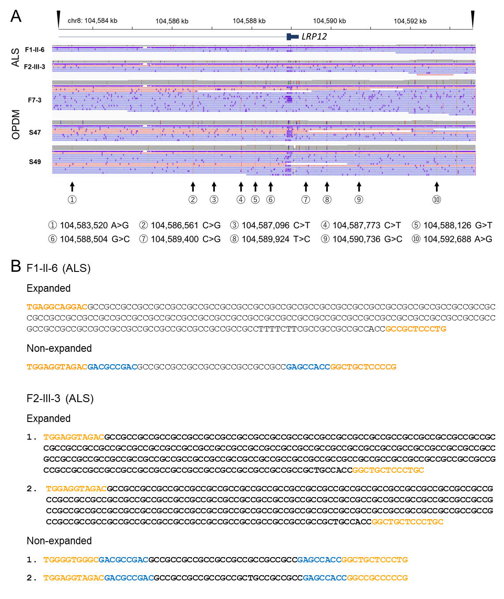
Fig. S6. Specific haplotype and flanking sequence in the patients with amyotrophic lateral sclerosis caused by CGG repeat expansion in LRP12.
(A) Ten single-nucleotide variants (SNVs) defining the specific haplotype observed in expanded LRP12 alleles from two patients with amyotrophic lateral sclerosis (ALS), identical to that in OPDM_LRP12.
(B) Flanking sequence comparison between expanded and unexpanded alleles from the same patients. Expanded alleles lacked the alternative flanking sequences (blue) present in unexpanded alleles, consistent with OPDM_LRP12. The orange sequence indicates the consensus flanking sequence.
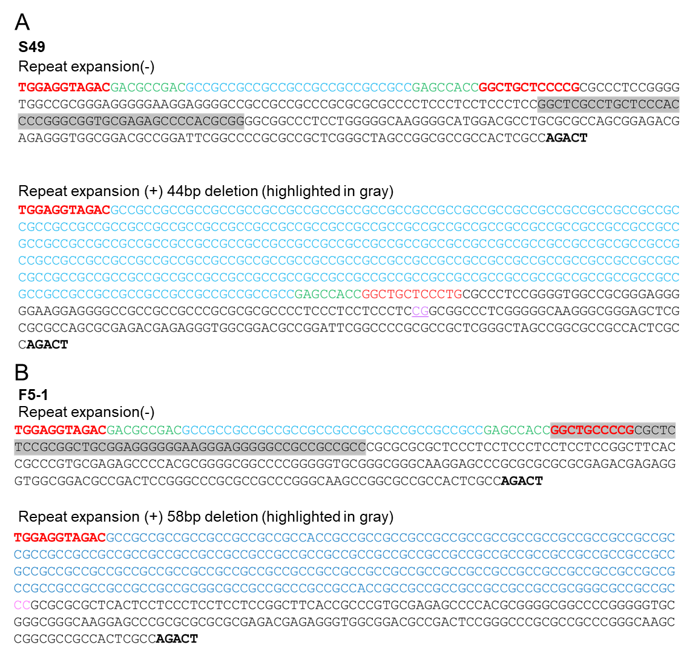

Fig. S7. Structural variations in LRP12 expanded reads in two patients.

(A) A 44-bp deletion (highlighted gray in non-expanded reads) between the dinucleotides in pink upstream of the expansion (light blue) and flanking sequences (green and red) in the transcript direction in Patient S49. (B) A 58-bp deletion (highlighted gray in non-expanded reads) between the dinucleotides in pink upstream of the expansion (light blue) and flanking sequences (green and red) in the transcript direction in Patient F5-1. The transcription start site is indicated in bold.

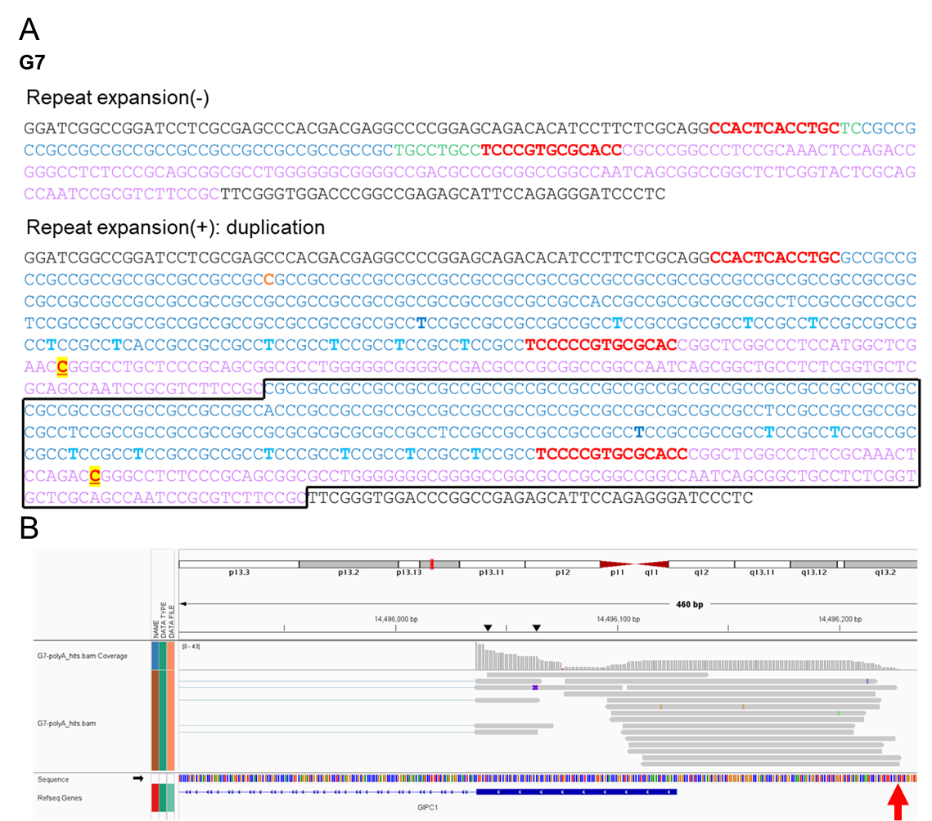

Fig. S8. Structural variation in GIPC1 expanded reads and the transcription start site in G7.

(A) Sequence from patient G7, showing a duplication (black rectangle) including the expanded repeat sequence (light blue) and its 5'-upstream region (pink) in expanded GIPC1 reads. (B) Transcript analysis of data from patient G7 revealing transcription initiation from an upstream transcriptional start site (arrow) located within the duplicated region.

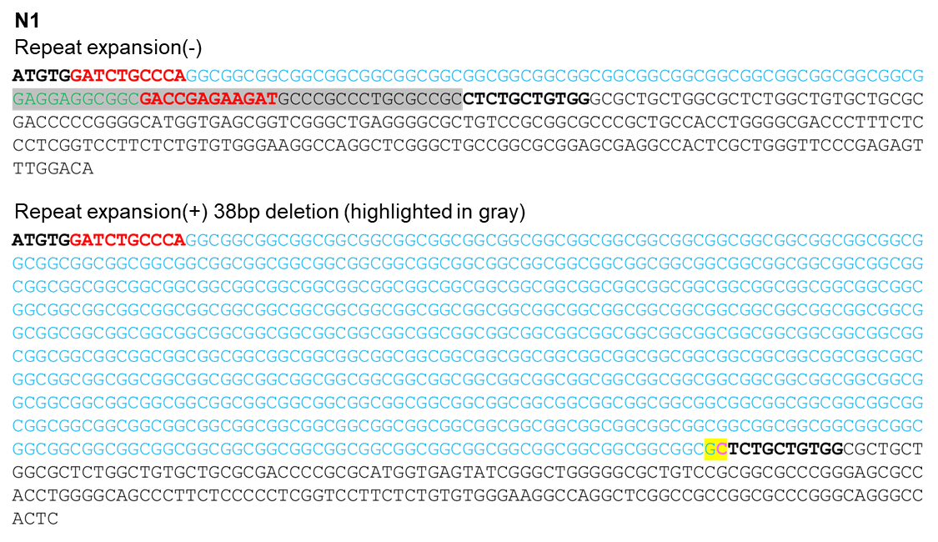

Fig. S9. Structural variation in the region downstream of the repeat expansion in NOTCH2NLC.

A patient with a 38-bp deletion (highlighted gray in non-repeat sequence) between the dinucleotides highlighted yellow downstream of the CGG repeats in NOTCH2NLC.

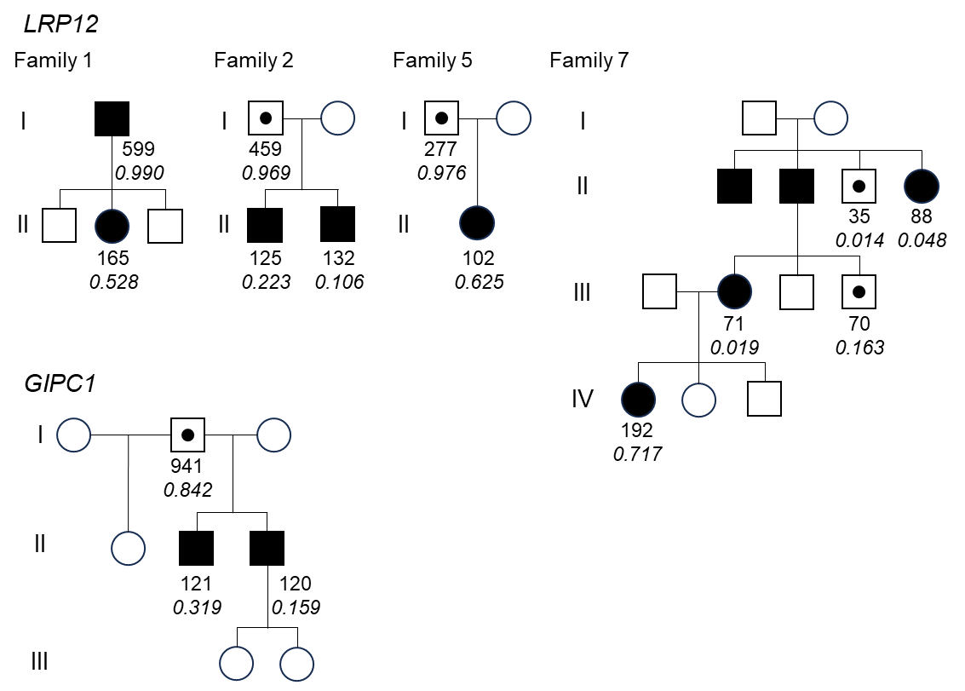

Fig. S10. Intrafamilial dynamics of repeat lengths in LRP12 and GIPC1.

Pedigrees of four LRP12 families and one GIPC1 family. Numbers indicate mean repeat size. Italicized values represent methylation rates within 1 kb upstream of the transcription start site.

Table S1. Guide RNA sequences for nCATS of four causative genes.

 | Position (GRCh38) | Strand | Sequence
LRP12-Forward | Chr18: 104,582,979 | + | UCUUUACCUCUUACGGCAAG
LRP12-Reverse | Chr18: 104,593,660 | - | UCUGGUCCCGUAGAGUCCAC
GIPC1-Forward | Chr19: 14,493,014 | + | GACGCUGUUGUCAUUACUAU
GIPC1-Reverse | Chr19: 14,498,910 | - | ACAUCUAAGCUGCUCACCAU
NOTCH2NLC-Forward | Chr1: 149,385,226 | + | GGAGACAUCUUGGUGCAUAC
NOTCH2NLC-Reverse | Chr1: 149,395,095 | - | AAGCGCAUUUGUACAUGAGA
RILPL1-Forward | Chr12: 123,530,597 | + | ACCUCAAUGAAUGUCUCUCC
RILPL1-Reverse | Chr12: 123,534,571 | - | GUCUGAUGGACAAGUGGAUU

Table S2. Clinical information, average size of expanded repeats, and numbers of obtained expanded and non-expanded reads in each patient.
-, no data; NA, not analyzed.

Table S3. Average methylation rates in 1kb-sequence intervals around transcription start sites in expanded and non-expanded reads.

ND, no data; NI, not identified; NS, no sequence.

Table S4. Average methylation rates in the expanded reads observed in the additional genes in six patients having repeat expansions in two distinct genes.

NI, not identified.

