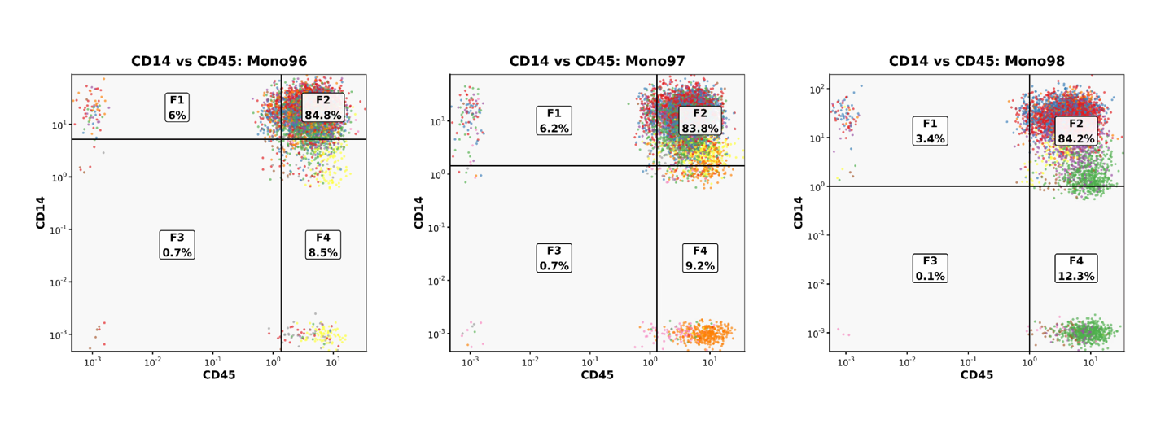
Fig. S1: Proportion of CD14⁺/CD45⁺ cells identified by scRNA-seq–based cell-type clustering in three enriched human PBM samples. CD14 and CD45 are the specific membrane markers on monocytes and mononuclear cells, respectively.

Fig. S2: Simulation shows the selection-driven MAF-effect-size pattern (a) All SNP-CpG tests; (b) Significant pairs (FDR < 0.05) (c) All tests with standardized effects. (d) Significant pairs with standardized effects (FDR < 0.05).

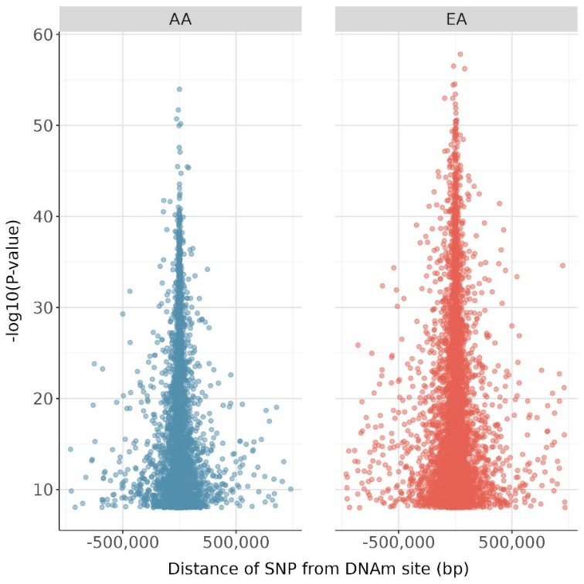
Fig. S3: Relationship between p-values and the distance from SNP to DNAm site in the AA and EA populations. The scatter plots depict the association between the distance from the SNP to the DNAm site (measured in base pairs, bp) and the corresponding -log10(p-values) for the detected meQTLs in the AA (left panel) and EA (right panel) populations. Higher values indicate more significant meQTL associations.

Fig. S4: Characterization of cis-meQTLs using a MAF $≥$ 1% cutoff. (a) Relationship between cis-meQTL effect sizes and MAF with regression trends shown in orange. (b) Effect size distribution as a function of distance between SNP and DNAm site in AA (left) and EA (right) populations, measured in base pairs. (c) Genomic distribution of CpG sites with cis-meQTLs. The bar chart categorizes CpG sites based on the number of cis-meQTLs identified, with annotations for four genomic regions: CpG islands, which are regions with a high CpG density; CpG shores, located within 2 kb of islands; CpG shelves, extending an additional 2 kb from shores; and Open Sea, which represents areas more distal to the islands, shores, and shelves. Each region is color-coded.

Fig. S5: Characterization of cis-meQTLs using a fixed $P<1×{10}^{-6}$ cutoff. (a) Relationship between cis-meQTL effect sizes and MAF with regression trends shown in orange. (b) Effect size distribution as a function of distance between SNP and DNAm site in AA (left) and EA (right) populations, measured in base pairs. (c) Genomic distribution of CpG sites with cis-meQTLs. The bar chart categorizes CpG sites based on the number of cis-meQTLs identified, with annotations for four genomic regions: CpG islands, which are regions with a high CpG density; CpG shores, located within 2 kb of islands; CpG shelves, extending an additional 2 kb from shores; and Open Sea, which represents areas more distal to the islands, shores, and shelves. Each region is color-coded.

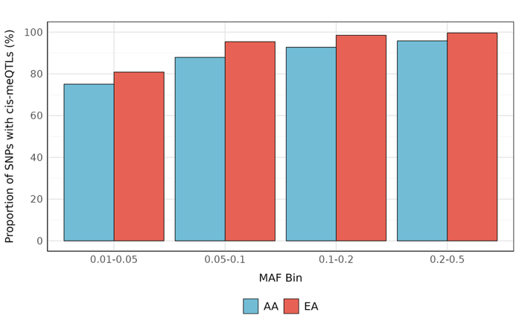
Fig. S6: Proportion of variants with cis-meQTLs ($P<1×{10}^{-6}$) per MAF bin.

Fig. S7: Characterization of cis-meQTLs for down-sampled EA (n = 160). (a) Relationship between cis-meQTL effect sizes and minor allele frequencies MAF with regression trends shown in orange. (b) Effect size distribution as a function of distance between SNP and DNAm site in AA (left) and EA (right) populations, measured in base pairs. (c) Genomic distribution of CpG sites with cis-meQTLs. The bar chart categorizes CpG sites based on the number of cis-meQTLs identified, with annotations for four genomic regions: CpG islands, which are regions with a high CpG density; CpG shores, located within 2 kb of islands; CpG shelves, extending an additional 2 kb from shores; and Open Sea, which represents areas more distal to the islands, shores, and shelves. Each region is color-coded. (d) Fine-mapping results showing the distribution of credible set sizes from SuSiE analysis for CpG sites with significant cis-meQTLs in both populations. Box plots show median, quartiles, and 1.5$×$IQR whiskers; violin width indicates data density.

Fig. S8: Venn diagrams showing overlap of significant cis-meQTLs (FDR < 0.01) between AA, EA, and meta-analysis. (a) Fixed-effects meta-analysis. (b) Random-effects meta-analysis. All numbers indicate the count of significant associations in each region. Percentages shown within the meta-analysis (blue) regions indicate their proportion relative to the total number of meta-analysis associations.

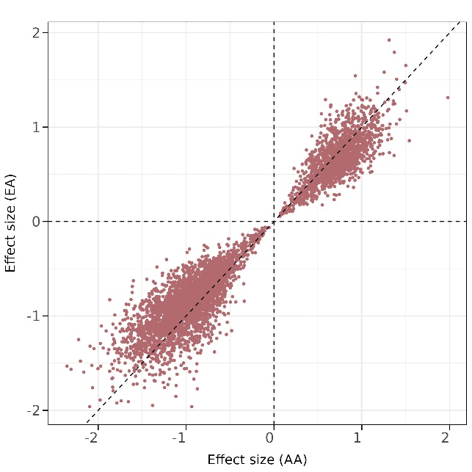
Fig. S9 Correlation of cis-meQTL effect sizes between AA and EA population.

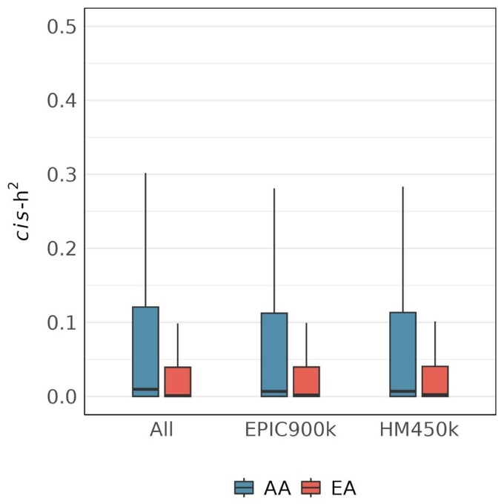
Fig. S10 Comparison of cis-h2 distributions between WGBS data and conventional array-based platforms (900K and 450K), highlighting the comprehensive coverage of WGBS. Box plots show median, quartiles, and 1.5×IQR whiskers.

Fig. S11: Correlation of trans-meQTL effect sizes between AA and EA population. (a) Significant trans-meQTL in either population. (b) All tested CpG-SNP pairs.

Note S1: Evaluation and filtering of CpG sites overlapping SNP positions
SNPs within CpG dinucleotides (CpG–SNPs) can distort bisulfite-based DNAm measurements or induce non-biological genotype–methylation associations.
Across the profiled methylome, we identified 3.8% of CpG sites (970,539 out of 25,721,231) in AA and 2.4% of CpG sites (607,275 out of 25,721,231) in EA that overlap with known SNP positions (MAF > 0.01). These CpG–SNP sites exhibited substantially inflated meQTL characteristics compared with non-overlapping sites:
- In AA, 82.1% (796,367 out of 970,539) of the CpG-SNP sites had at least one cis-meQTL, compared to only 10.4% (2,569,292 out of 24,750,692) of the non-CpG-SNP sites. The pattern is similar in EA population, with 91.0% (552,456 out of 607,275) of the CpG-SNP sites had at least one cis-meQTL, compared to only 9.5% of the non-CpG-SNP sites.
- In AA, these CpG-SNP sites were associated with an average of 55.7 SNPs, while the non-CpG-SNP sites were associated with only 24.2 SNPs on average. In EA, CpG-SNP sites were associated with an average of 151.0 SNPs, while the non-CpG-SNP sites were associated with only 54.6 SNPs.
- The mean estimated cis-h² of CpG-SNP sites is 0.40 in AA and 0.31 in EA, which is higher than the mean estimated cis-heritability of non-CpG-SNP sites (0.08 in AA and 0.03 in EA).
Together, these patterns are most parsimoniously explained by allelic mapping/measurement artifacts at the CpG–SNP locus rather than true biological effects.

