Supplementary Figures:
Fig S1: Supopulation atlas of human IUA and normal endometrium in scRNA-seq and snATAC-seq.
A. UMAP plot of all collected cells colored by 27 subclustered cell type of the IUA and normal endometrium by single cell RNA-seq (scRNA-seq). B. Dot plot showing specific marker genes for each 27 subpopulations cell type. C. Heatmap showing specifically expressed gene signature of the 27 subpopulation cell types of IUA and normal endometrium. D. snATAC-seq UMAP plot of all collected cells colored by 13 subpopulation cell types of the IUA and normal endometrium. E. Heatmap showing specific marker gene activity of the 13 subpopulation cell types by scATAC-seq.

Fig S1:
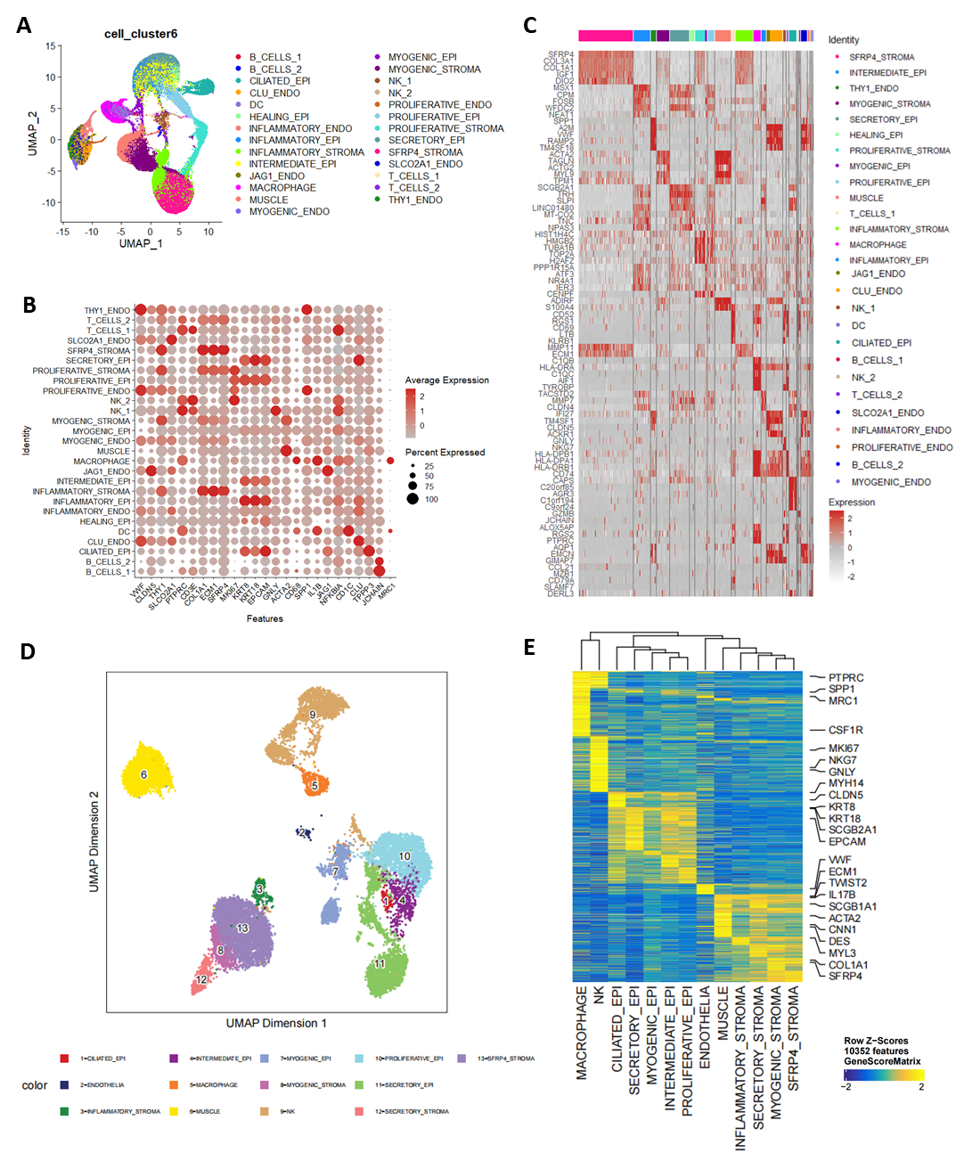

Fig S2: Immunostaining of key regulators in normal and IUA endometrium
A. Representative image of IF staining of VIM and GATA2 in normal and IUA endometrium, Scale bar=10µm; the magnification image with split color of the white box area showed next to the image; the quantification of the average fluorescence intensity (AFI) of GATA2 in Vim positive cells showed on the right. B. Representative image of IF staining of KRT8 and TWIST2 in normal and IUA endometrium, Scale bar=10µm; the magnification image with split color of the white box area showed next to the image; the quantification of the AFI of TWIST2 in KRT8 positive cells showed on the right.

Fig S2:
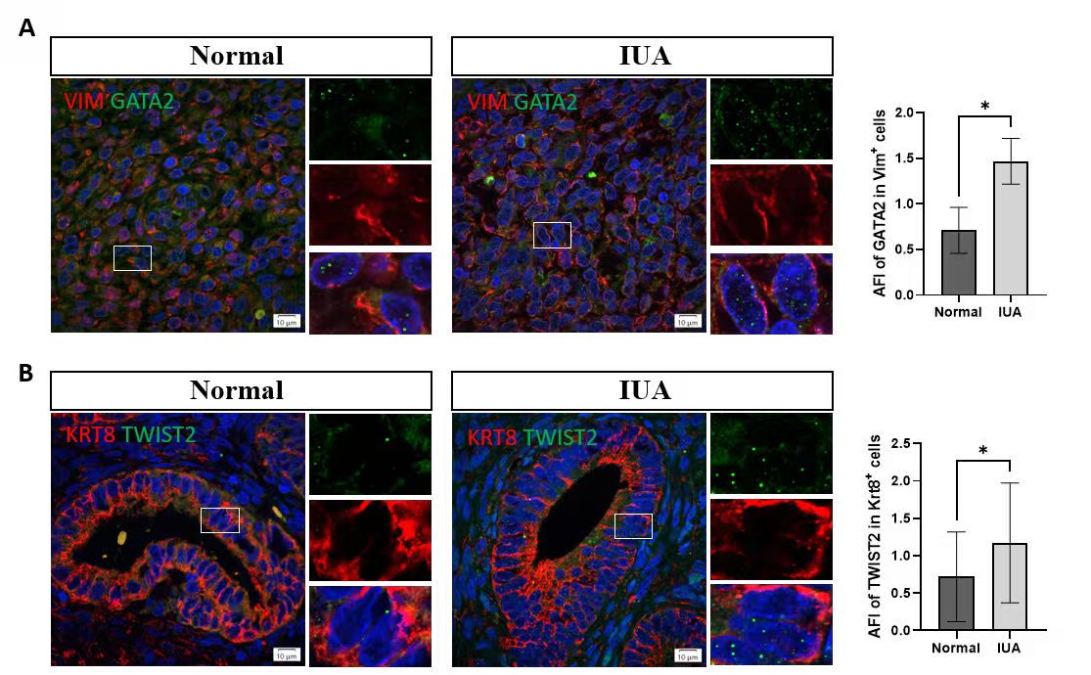

Fig S3: Characterization of EMT markers in epithelial subpopulations. ** P value<0.01, *** P value<0.001.

Fig S3:
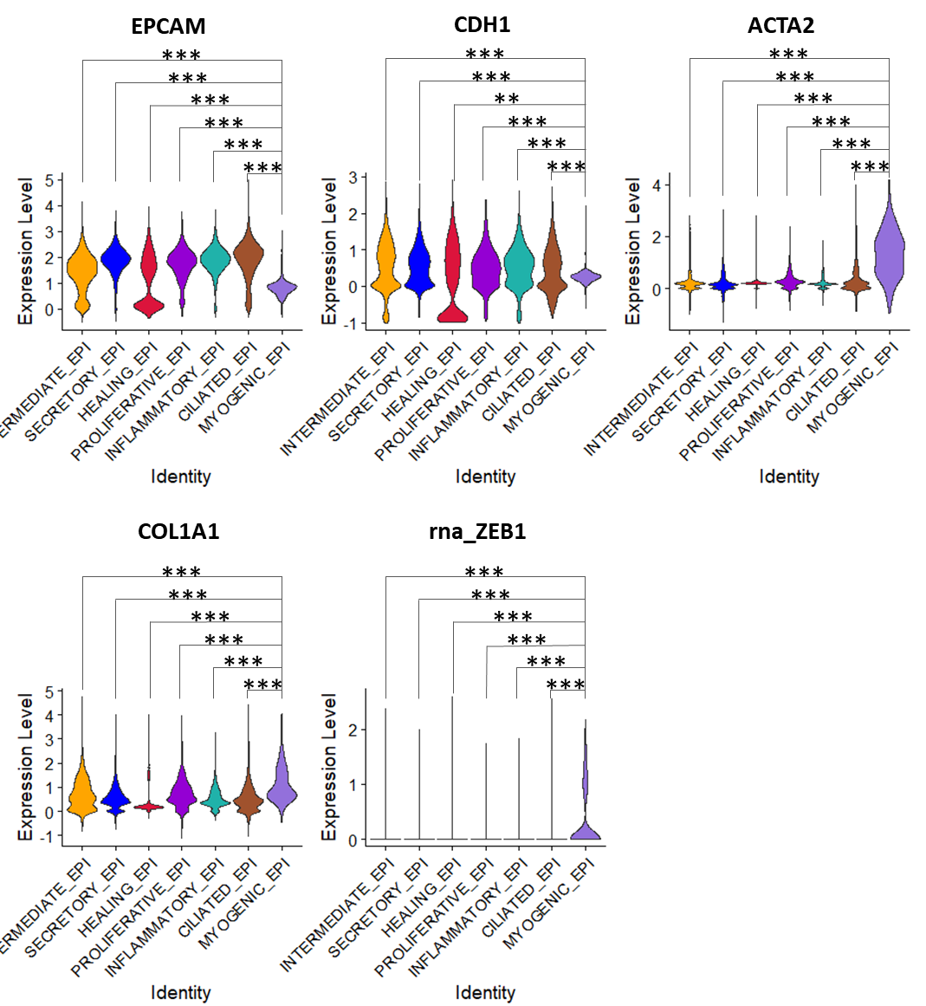

Fig S4: Single cell atlas of rat IUA and normal endometrium.
A. Masson trichrome staining of the normal and IUA uterus from rat animal experiment. B. Quantification of fibrotic area ratio in normal and IUA endometrium in rat model, n=3 biological replicates in each group, **** p value<0.0001. C. UMAP plot of all collected cells colored by 5 main cell types of the rat IUA and normal endometrium by scRNA-seq, n=3 biological replicates in each group. D. UMAP plot of all collected cells colored by groups (rat IUA and normal groups) in scRNA-seq. E. Heatmap showing specific gene expression of the 5 main cell types by scRNA-seq.

Fig S4:
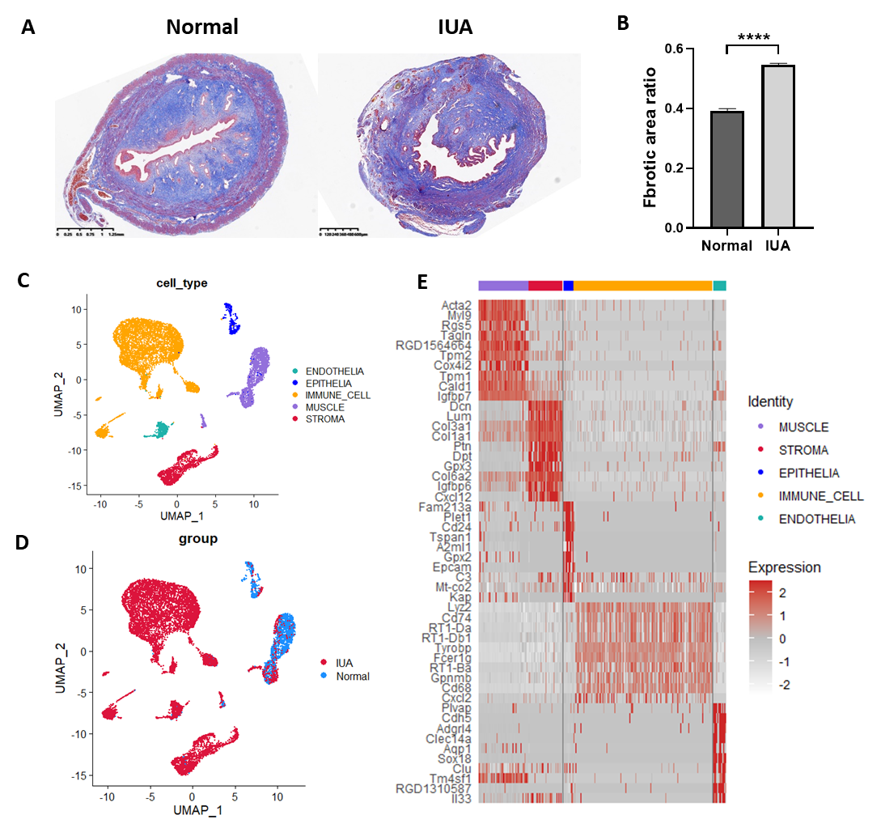

Fig S5: Identification of heterogenous fibrogenic cell populations in rat IUA by scRNA-seq
A. UMAP plot of all stromal cells colored by 5 subset cluster identity of rat IUA and normal endometrium in scRNA-seq. B. UMAP plot of all stromal cells colored by groups (rat IUA and normal groups) in scRNA-seq. C. Violin plot showing specific marker genes for each rat stromal subpopulation. D. Cell proportion of 5 stromal subpopulation in rat IUA and normal endometrium by scRNA-seq. E. Heatmap of transcription factors (TFs) activity in each rat stromal cell subpopulation by scRNA-seq. F. UMAP plot of all epithelial cells colored by 5 subset cluster identity of rat IUA and normal endometrium in scRNA-seq. G. UMAP plot of all epithelial cells colored by groups (rat IUA and normal groups) in scRNA-seq. H. Violin plot showing specific marker genes for each rat epithelial subpopulation. I. Cell proportion of 5 epithelial subpopulation in rat IUA and normal endometrium by scRNA-seq. J. Heatmap of transcription factors (TFs) activity in each rat epithelial cell subpopulation by scRNA-seq. K. UMAP plot of all endometrial cells colored by 4 subset clusters identity of rat IUA and normal endometrium in scRNA-seq. L. UMAP plot of all endometrial cells colored by 4 subset clusters identity of rat IUA and normal endometrium in scRNA-seq. M. Violin plot showing specific marker genes for each rat endothelial subpopulation. N. Cell proportion of 4 endometrial subpopulation in rat IUA and normal endometrium by scRNA-seq. O. Heatmap of transcription factors (TFs) activity in each rat endothelial cell subpopulation by scRNA-seq.

Fig S5:
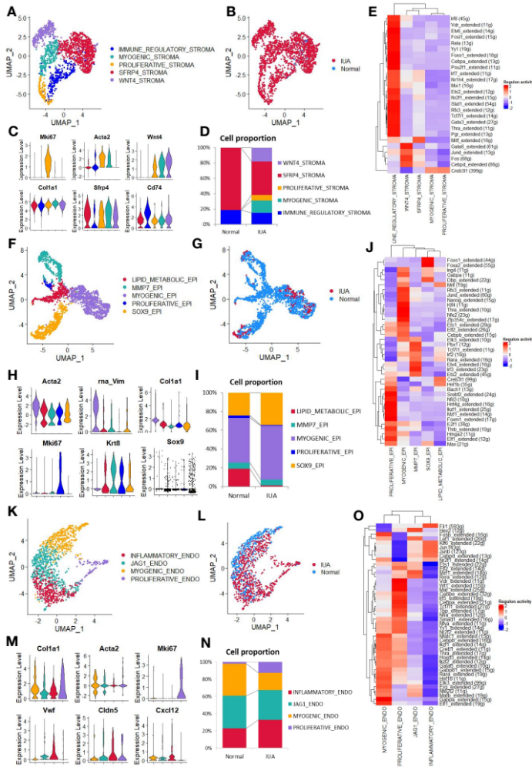

Fig S6: The pro-fibrogenic immune microenvironment of rat IUA.
A. UMAP plot of all immune cells colored by 4 subset cluster identity of rat IUA and normal endometrium in scRNA-seq. B. UMAP plot of all immune cells colored by groups (rat IUA and normal groups) in scRNA-seq. C. Violin plot showing specific marker genes of the 4 immune subpopulation cell types of rat IUA and normal endometrium. D. Cell proportion of 4 immune subpopulation in rat IUA and normal endometrium by scRNA-seq. E. Violin plot showing comparative expression level of Spp1 and Lgals9 in immune cell subsets from rat normal and IUA endometrium.

Fig S6:
