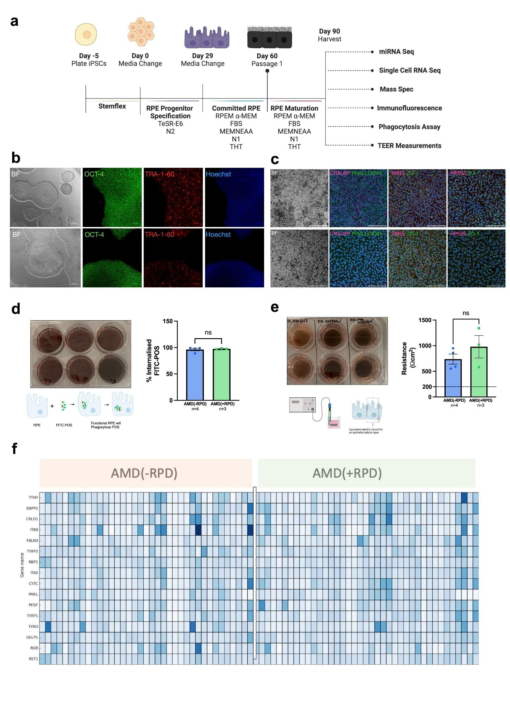
Fig S1. Quality control.
(a) Schematic overview of the experimental workflow (created with BioRender.com). (b) Quality control of generated iPSC lines showing representative brightfield (BF) and immunofluorescence images for OCT-4, TRA-1-60, and Hoechst 33342 in a AMD/RPD- line (MBE-03556, top) and an AMD/RPD+ line (MBE-01986, bottom). Scale bars: 500 µm (BF), 100 µm (fluorescence). Images are representative of all lines. (c) Characterisation of iPSC-derived RPE cells from the same two lines, showing BF and immunostaining for phalloidin (magenta) and CRALBP (green); PMEL (magenta) and ZO-1 (green); RPE65 (magenta) and ZO-1 (green). Scale bars: 100 µm. (d) Phagocytosis assay. Representative pigmented RPE cells and schematic (BioRender) showing uptake of FITC-labelled photoreceptor outer segments (POS). Functional assay results for AMD/RPD- (MBE-03556, MBE-03556, MBE-03556, MBE-03556) and AMD/RPD+ (TOB-01986, TOB-01986, TOB-01986) lines, presented as mean % engulfment ± SEM from technical triplicates of each unique iPSC-derived RPE line. Significance was assessed by t-test (p < 0.05). (e) Transepithelial electrical resistance (TEER) assay. Representative pigmented RPE cells on transwell inserts and schematic (BioRender) of the TEER setup. Resistance values are shown for AMD/RPD- (MBE-03556, MBE-03556, MBE-03556, MBE-03556) and AMD/RPD+ (TOB-01986, TOB-01986, TOB-01986) lines. Each dot represents the average of technical triplicates for each iPSC-derived line. Data are shown as mean ± SEM, with statistical significance determined by t-test (p < 0.05). (f) Heatmap of RPE canonical marker expression from mass spectrometry across all AMD/RPD- and AMD/RPD+ lines. Each rectangle represents one line; colour intensity reflects raw abundance values from minimal (light blue) to maximal (dark blue).

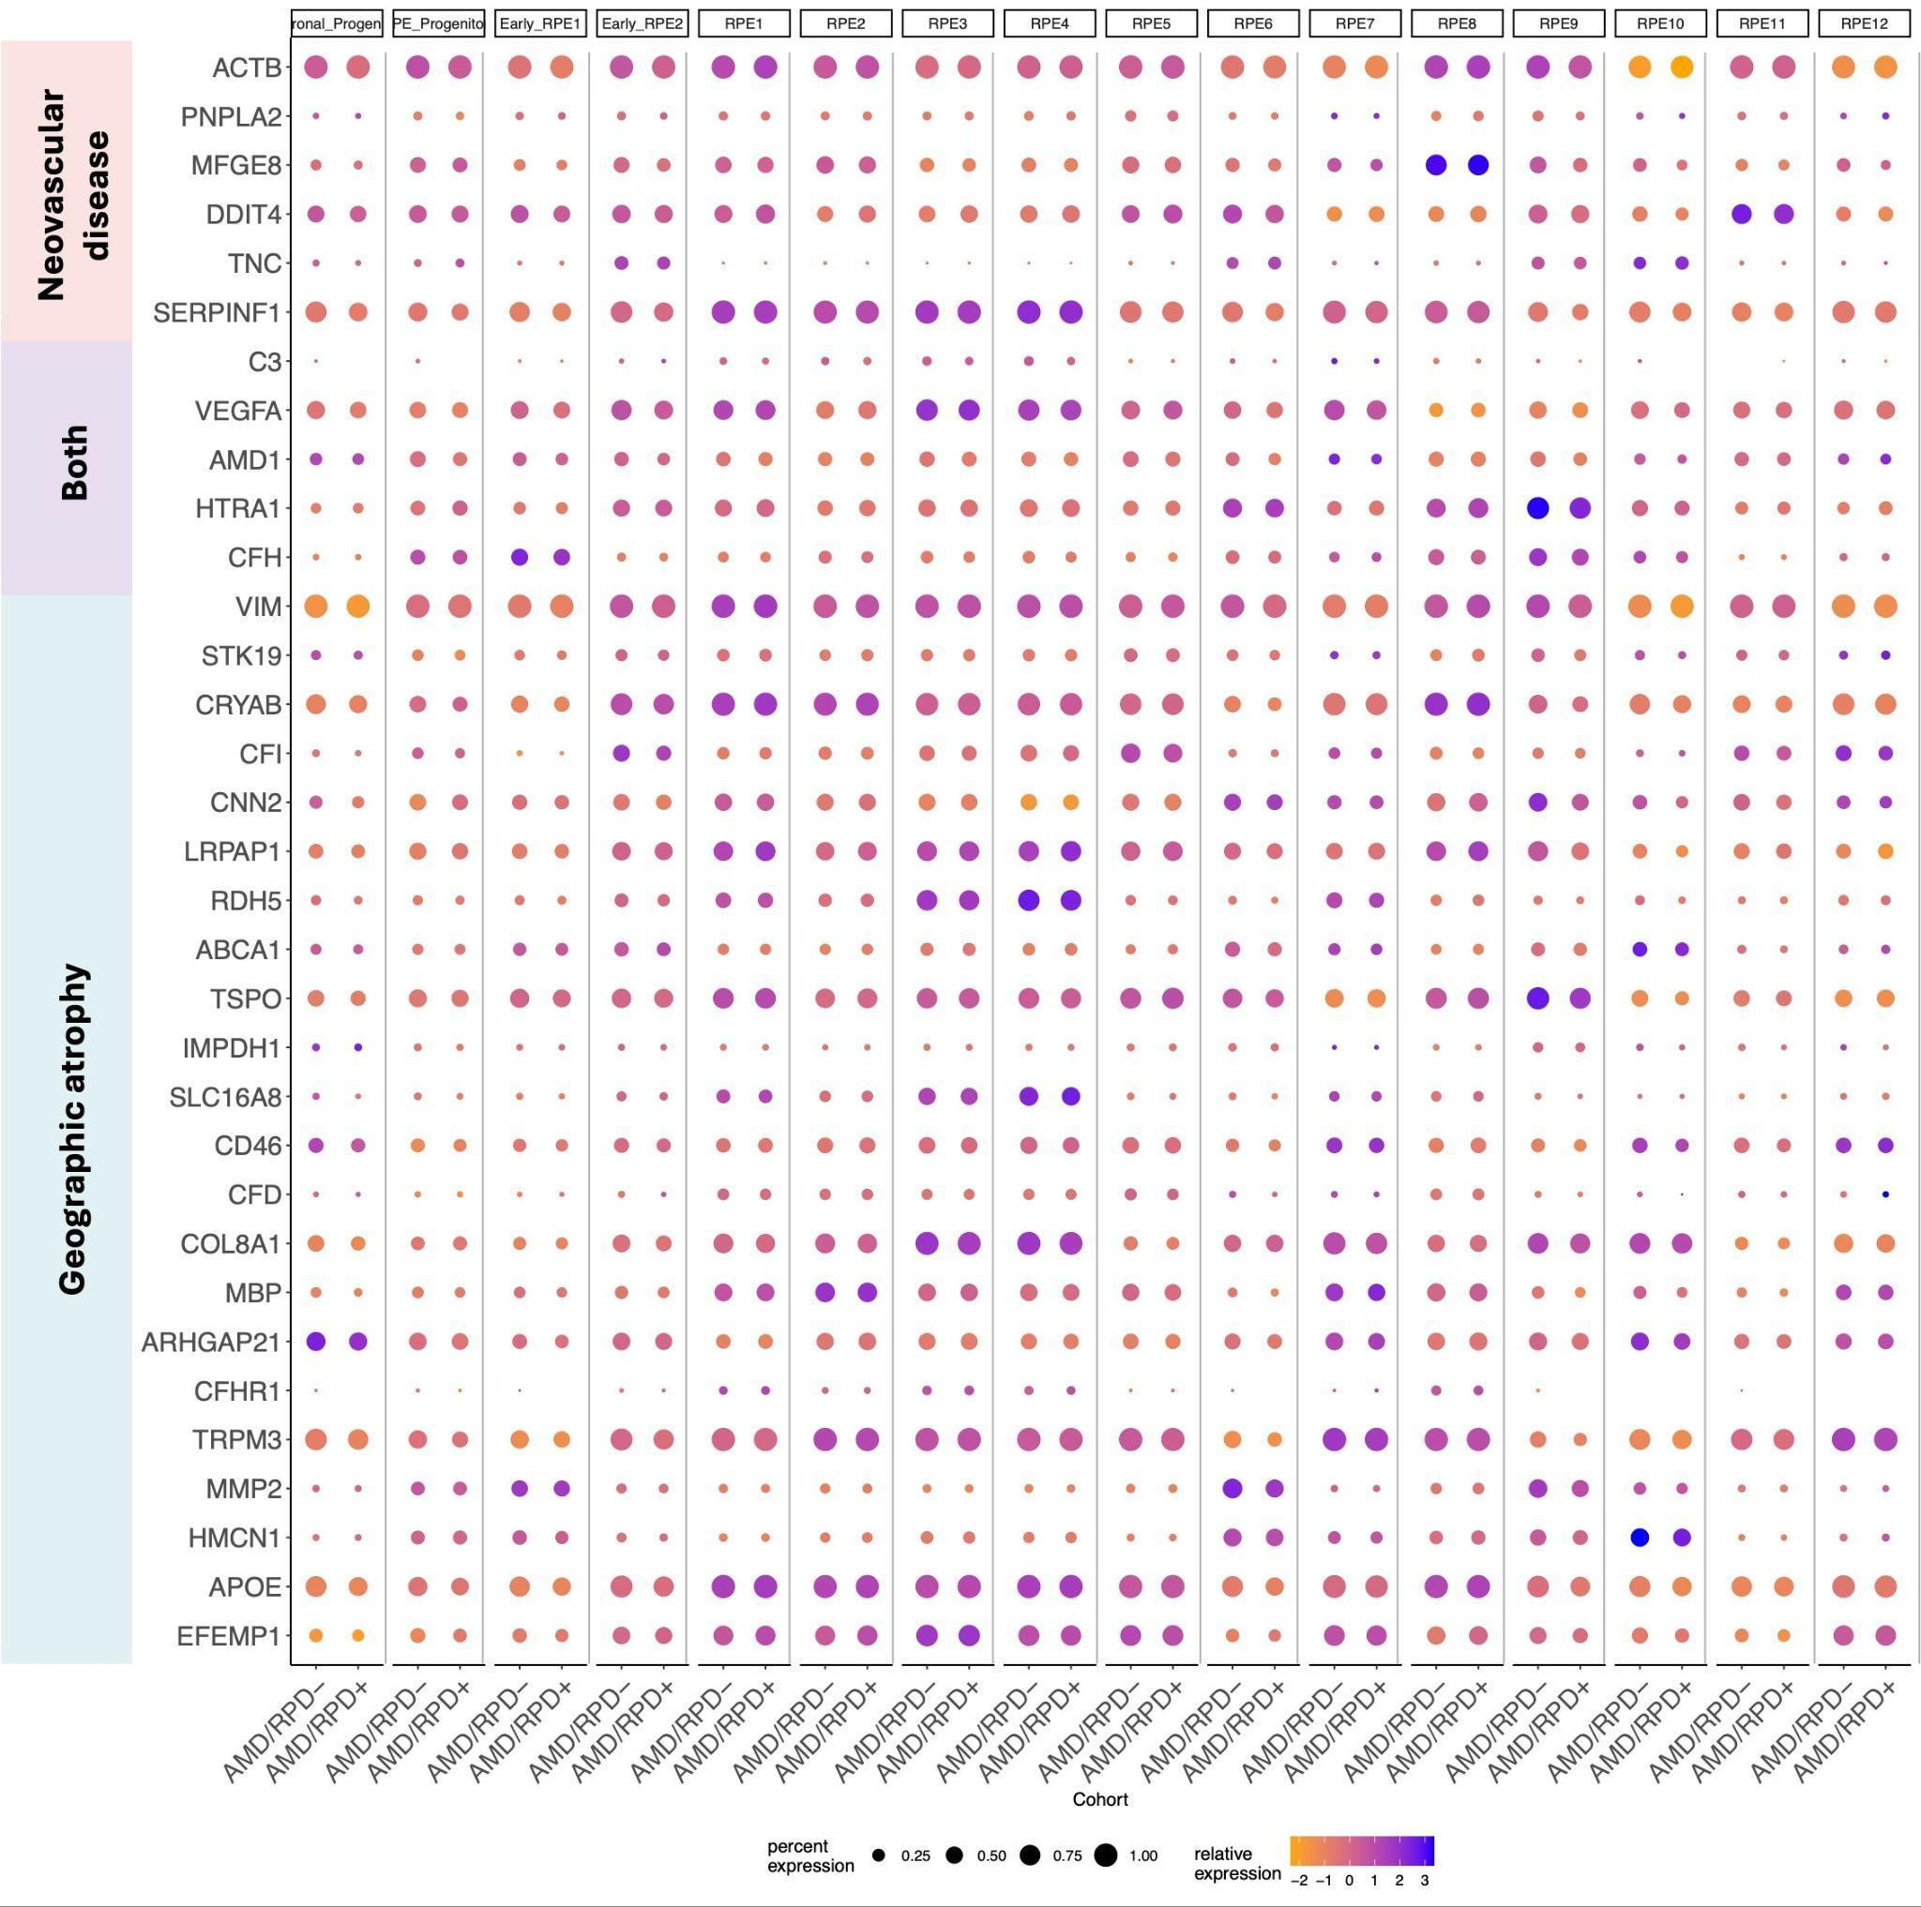
Fig S2. Genes associated with cell subpopulations and their expression in AMD/RPD- and AMD/RPD+ cells. Dotplot representation of single-cell expression profiles for genes linked to AMD. Plots show scaled average expression (z-scores; color scale) and the percentage of cells within each cluster expressing the gene (dot size).

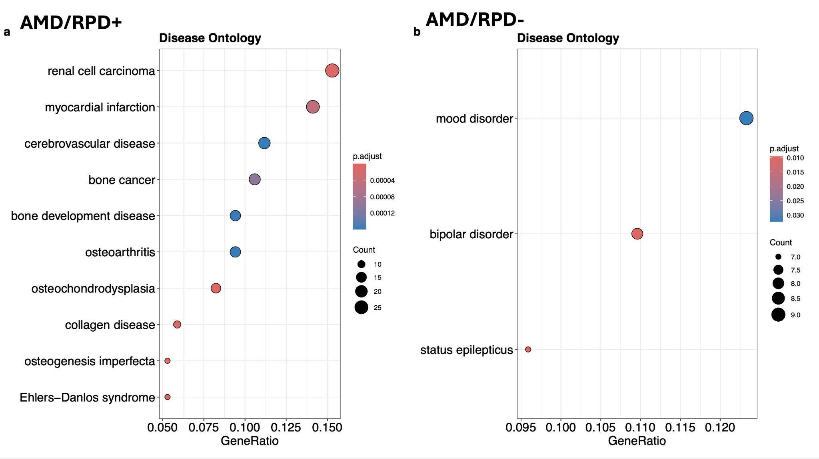

Fig S3. Disease Ontology enrichment analysis of differentially expressed genes in AMD/RPD+ and AMD/RPD- RPE cells. The top 10 enriched Disease Ontology categories are shown. The number of genes associated with each term, and colour indicates the adjusted p value (p.adjust).

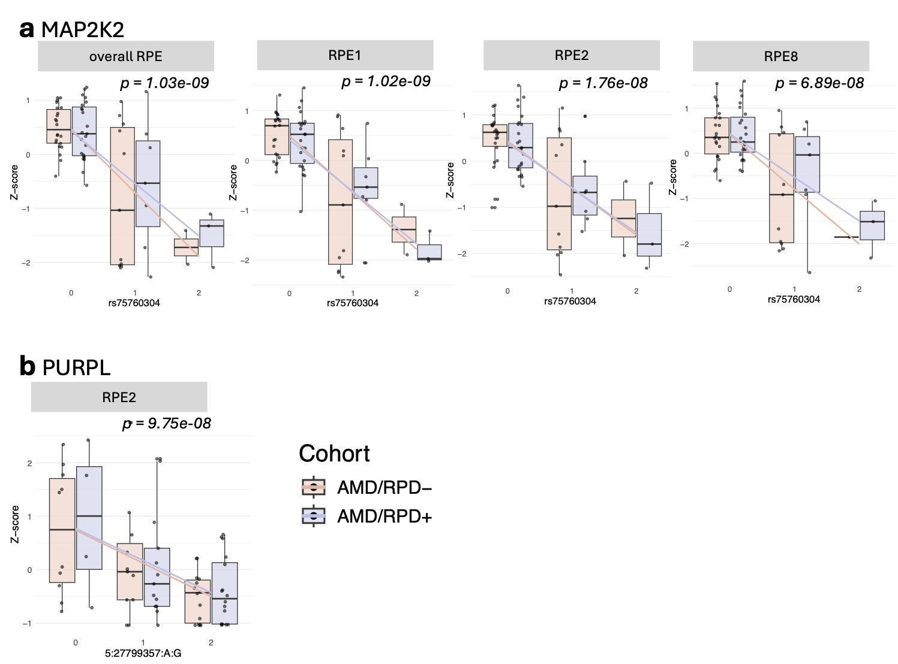
Fig S4. Examples of eQTLs in RPE subpopulations. (a) Expression of MAP2K2 stratified by rs75760304 genotype in overall RPE and in individual subpopulations (RPE1, RPE2, RPE8), shown separately for AMD/RPD- and AMD/RPD+ cohorts. (b) Expression of PURPL stratified by 5:27799357:A:G genotype in RPE2, shown separately for AMD/RPD- and AMD/RPD+ cohorts. Expression values are represented as z-scores.

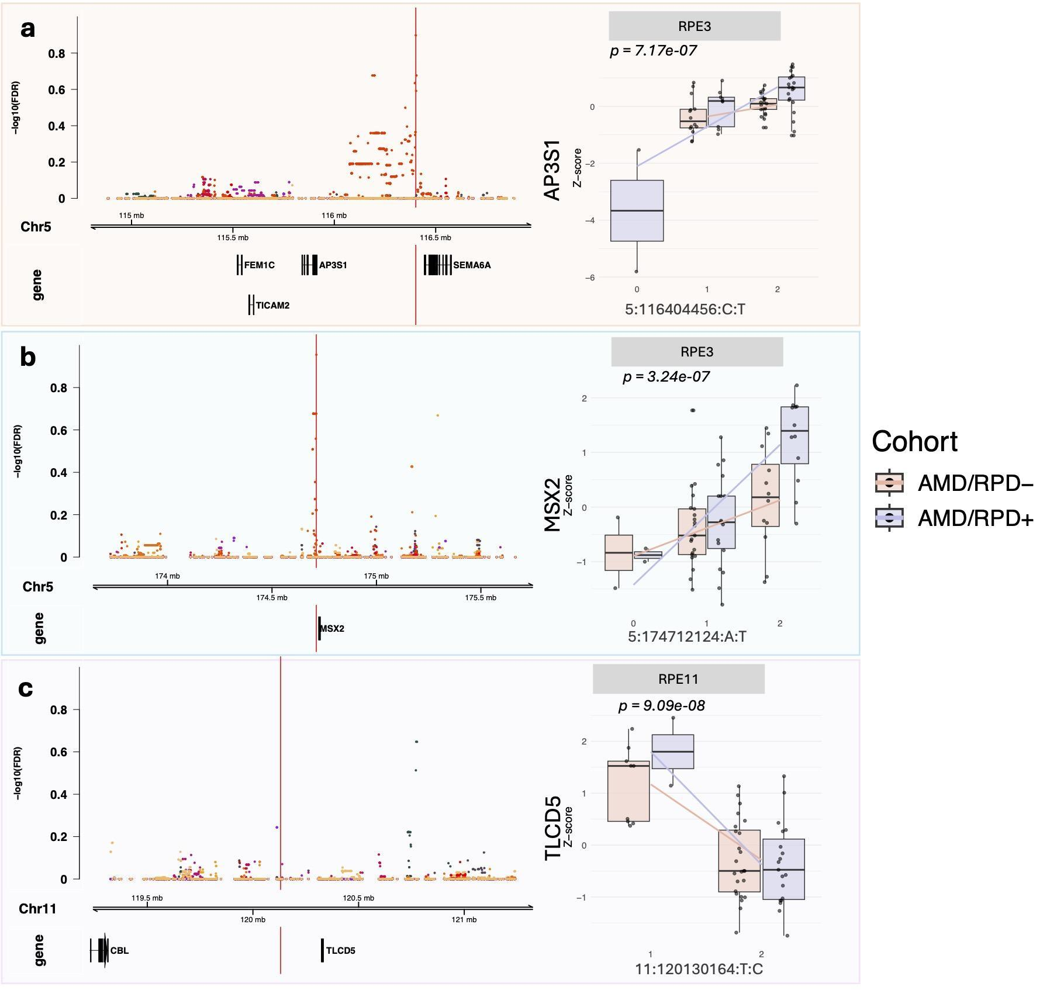Fig S5. Examples of disease-interacting eQTLs in RPE subpopulations. Regional association plots (left) depict local association signals (-log10 false discovery rate) across the genomic locus, with the lead SNP indicated by a vertical red line. Boxplots (right) show expression stratified by genotype and cohort, with regression lines illustrating allele dosage effects. (a) AP3S1 in RPE3 (5:116404456 C>T; p = 7.17 × 10⁻⁷). (b) MSX2 in RPE3 (5:174712124 A>T; p = 3.24 × 10⁻⁷). (c) TLCD5 in RPE11 (11:120130164 T>C; p = 9.09 × 10⁻⁸).
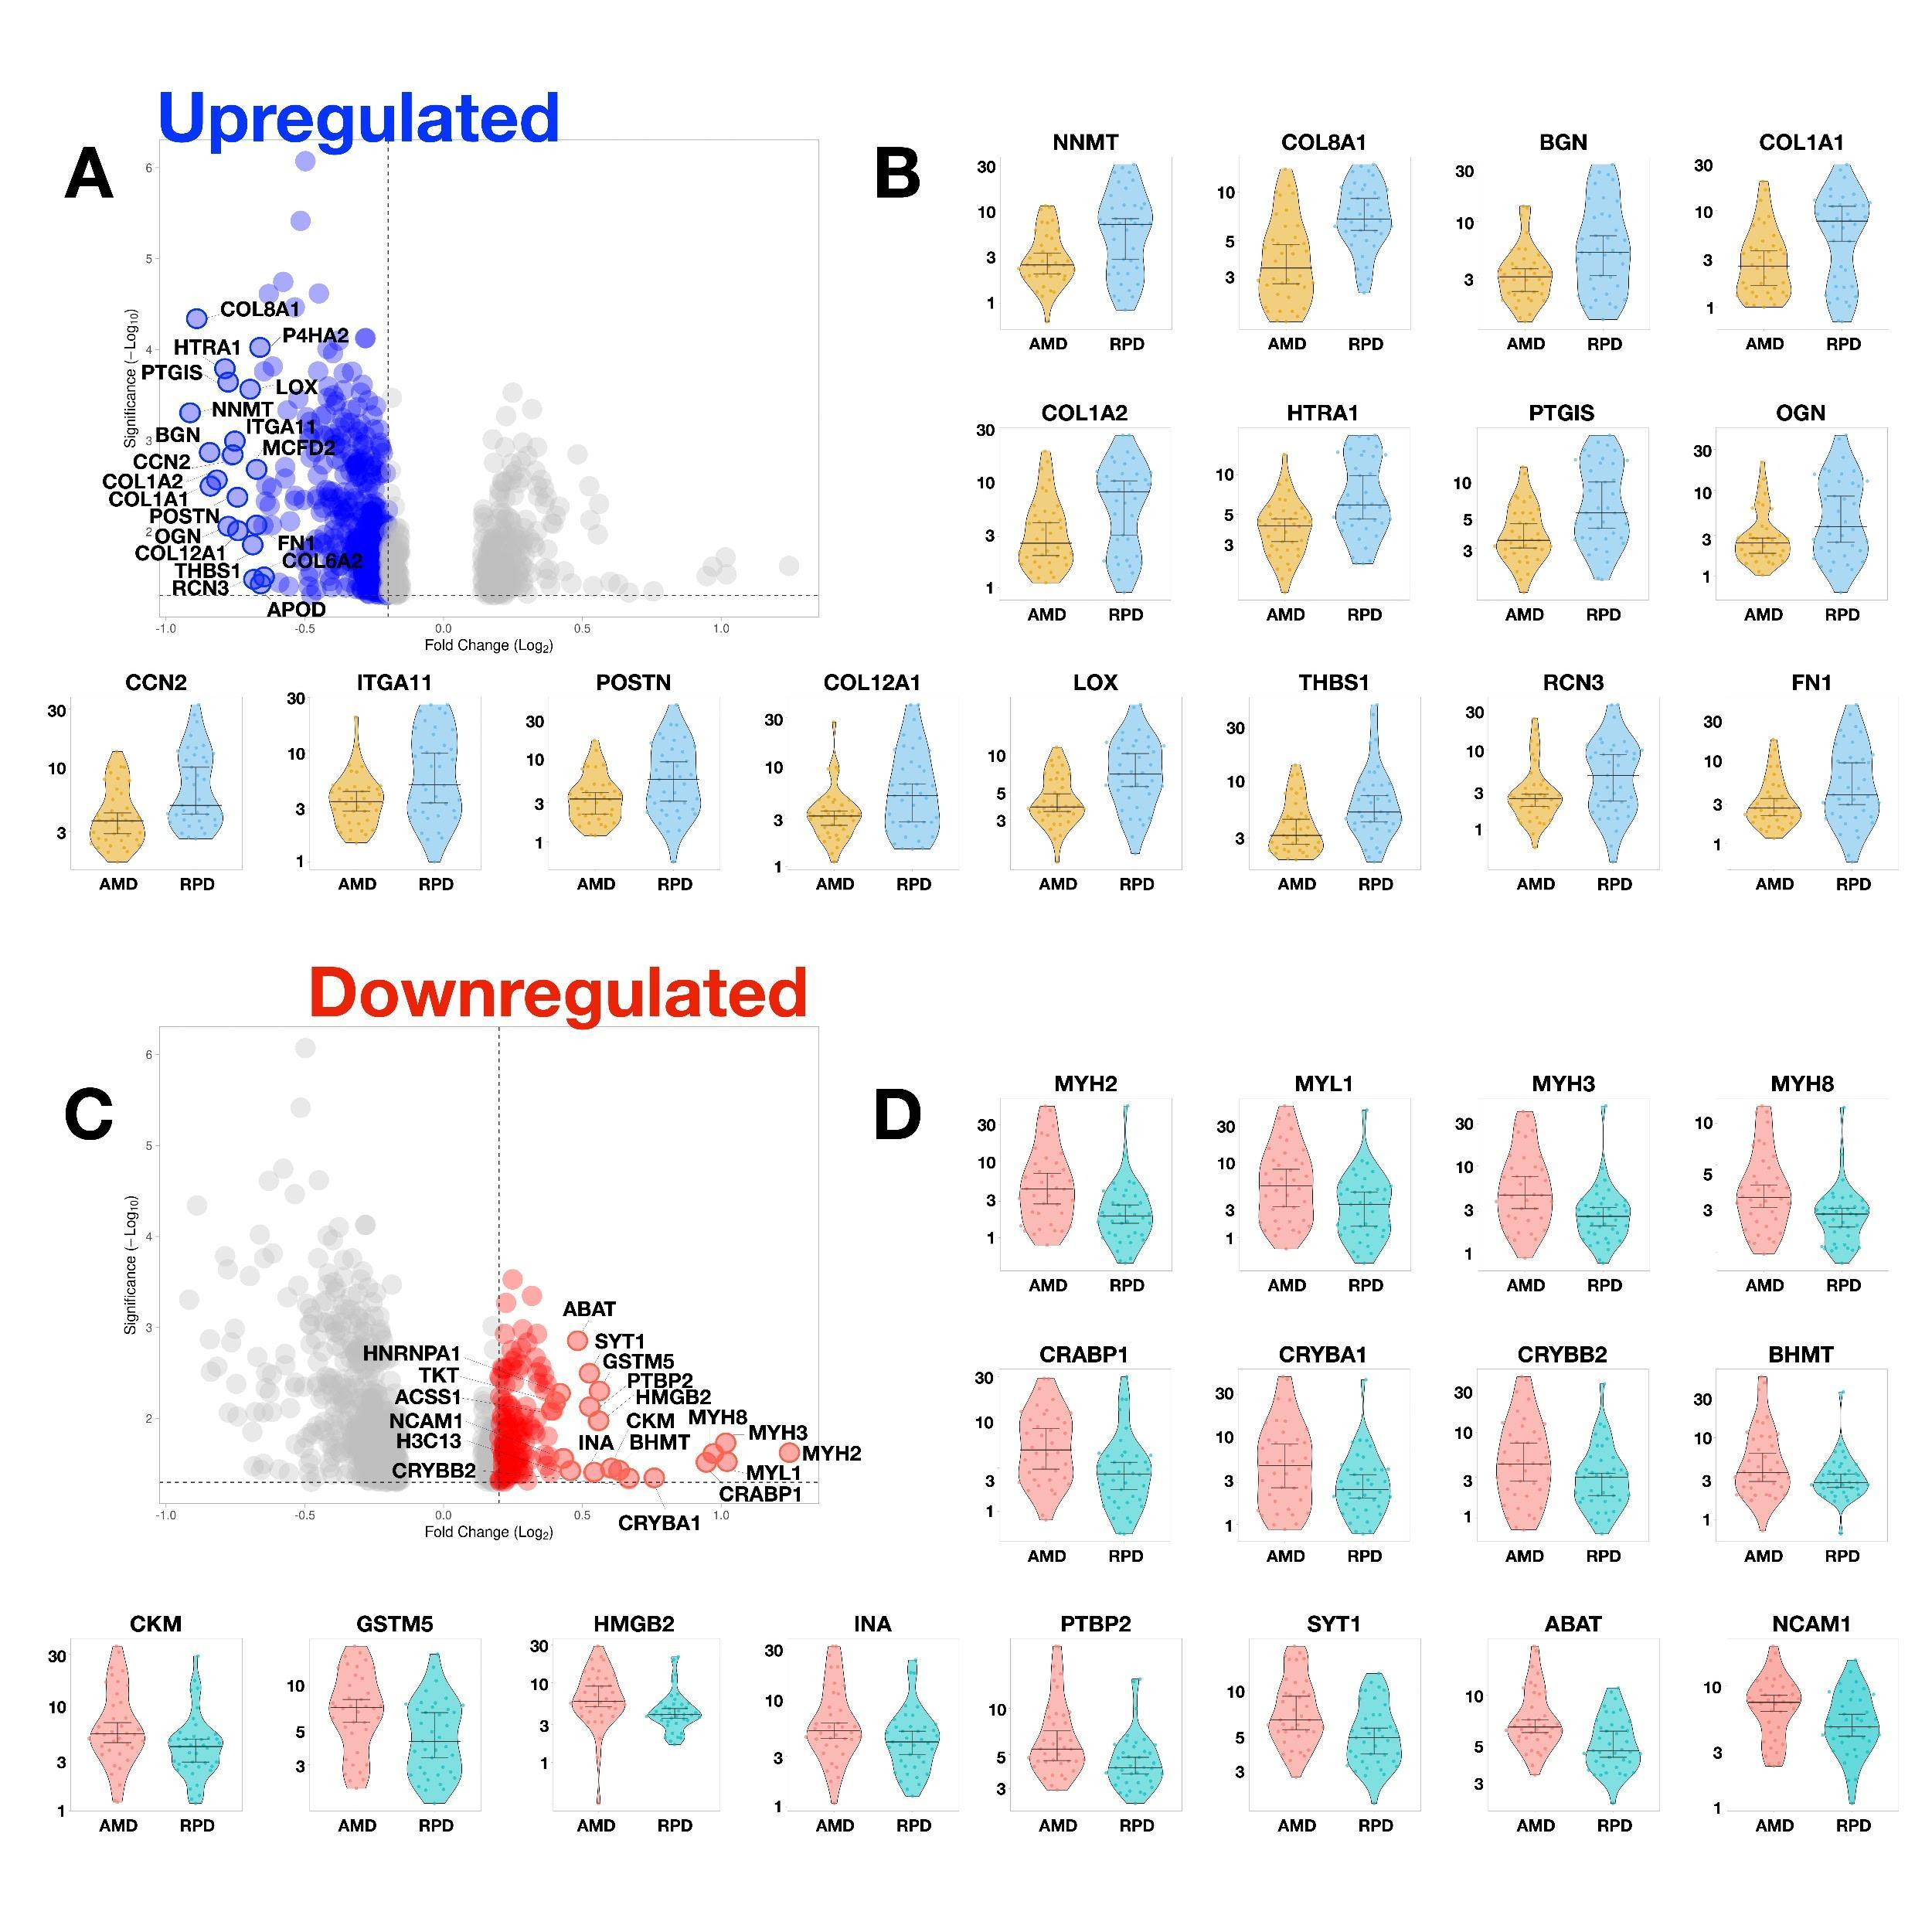
Fig S6. Top differentially expressed proteins between the two cohorts. Violin plots showing the top 16 proteins most significantly up- or down-regulated in AMD/RPD+ relative to AMD/RPD- RPE cells based on log₂-normalised TMT proteomic data. Each violin represents the distribution of protein abundance.

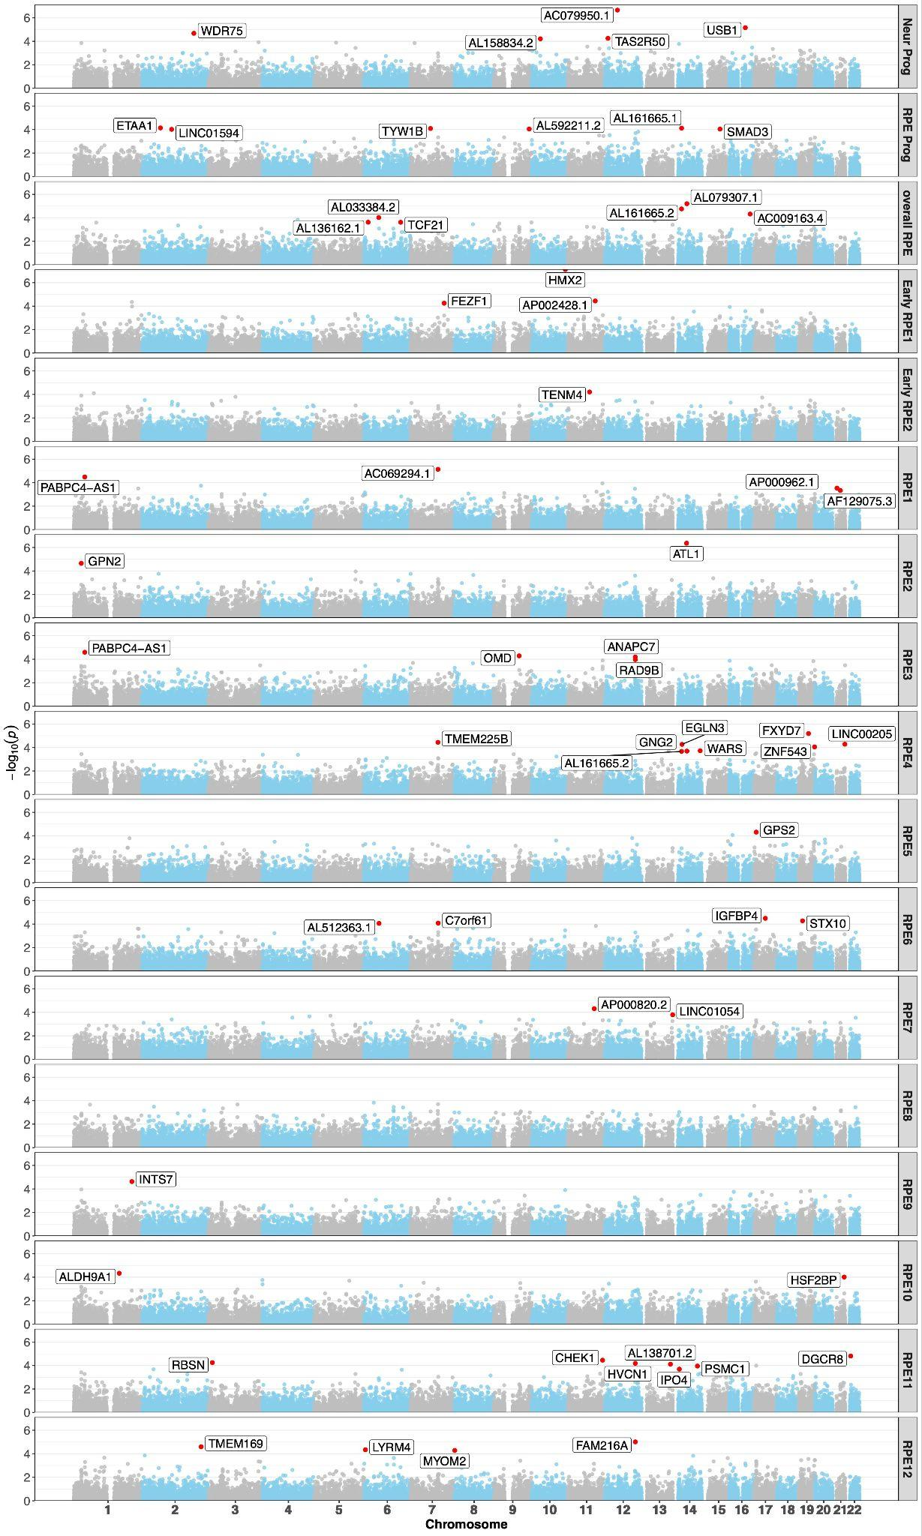
Fig S7. Transcriptome-wide association study (TWAS) of RPD risk across RPE populations. Manhattan plots showing TWAS results for overall and subpopulation-specific RPE transcriptomic models. Each point represents a gene-level association between genetically predicted expression and RPD risk, plotted by genomic position. The red dashed line denotes the significance threshold (false discovery rate < 0.1). Significant loci are labelled.

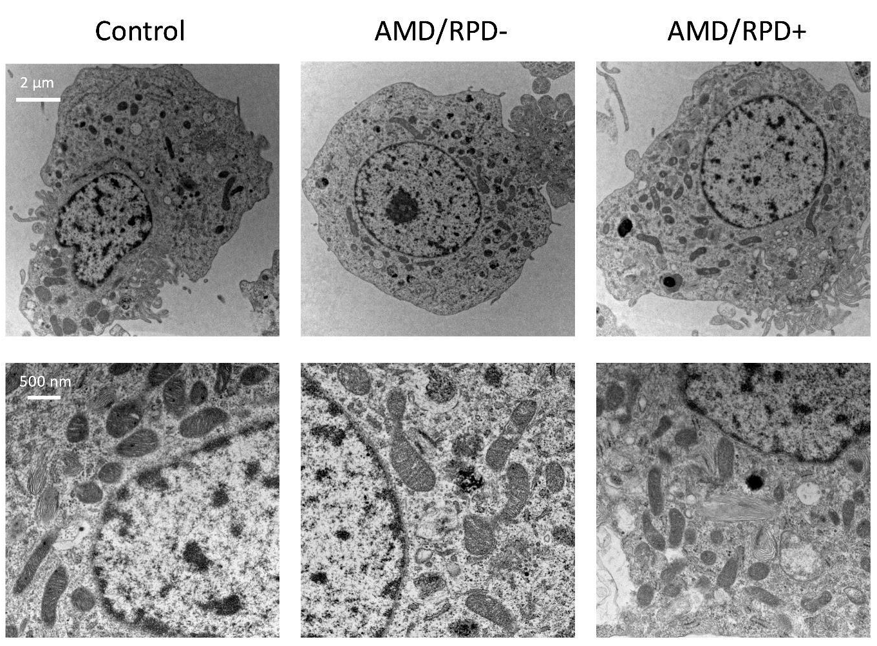
Fig S8. Transmission electron microscopy of iPSC-derived RPE cells. Representative images of RPE cells derived from control, AMD/RPD-, and AMD/RPD+ donors. Top row: low-magnification views showing overall cell morphology, including nuclei, cytoplasmic organisation, and organelles (scale bar: 2 µm). Bottom row: higher-magnification views highlighting mitochondrial ultrastructure and cytoplasmic detail (scale bar: 500 nm). No consistent ultrastructural differences were observed between cohorts.

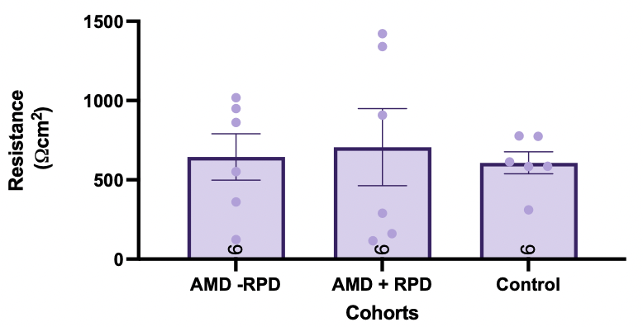
Fig S9. Transepithelial electrical resistance (TEER) in iPSC-derived RPE cells. Resistance values are from control, AMD/RPD- (AMD - RPD), AMD/RPD+ (AMD + RPD) and control lines (n= 6 lines per cohort). Each dot represents the average of technical triplicates for each iPSC-derived line. Data are shown as mean ± SD, with statistical significance determined by one way ANOVA (p < 0.05).

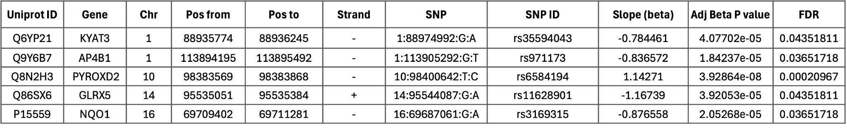
Table S1. Full details of significant pQTLs. Complete information including genomic coordinates and alleles.

