Supplementary data for manuscript:

Comparative genomics identifies small interfering RNA with activity against all five human betacoronaviruses
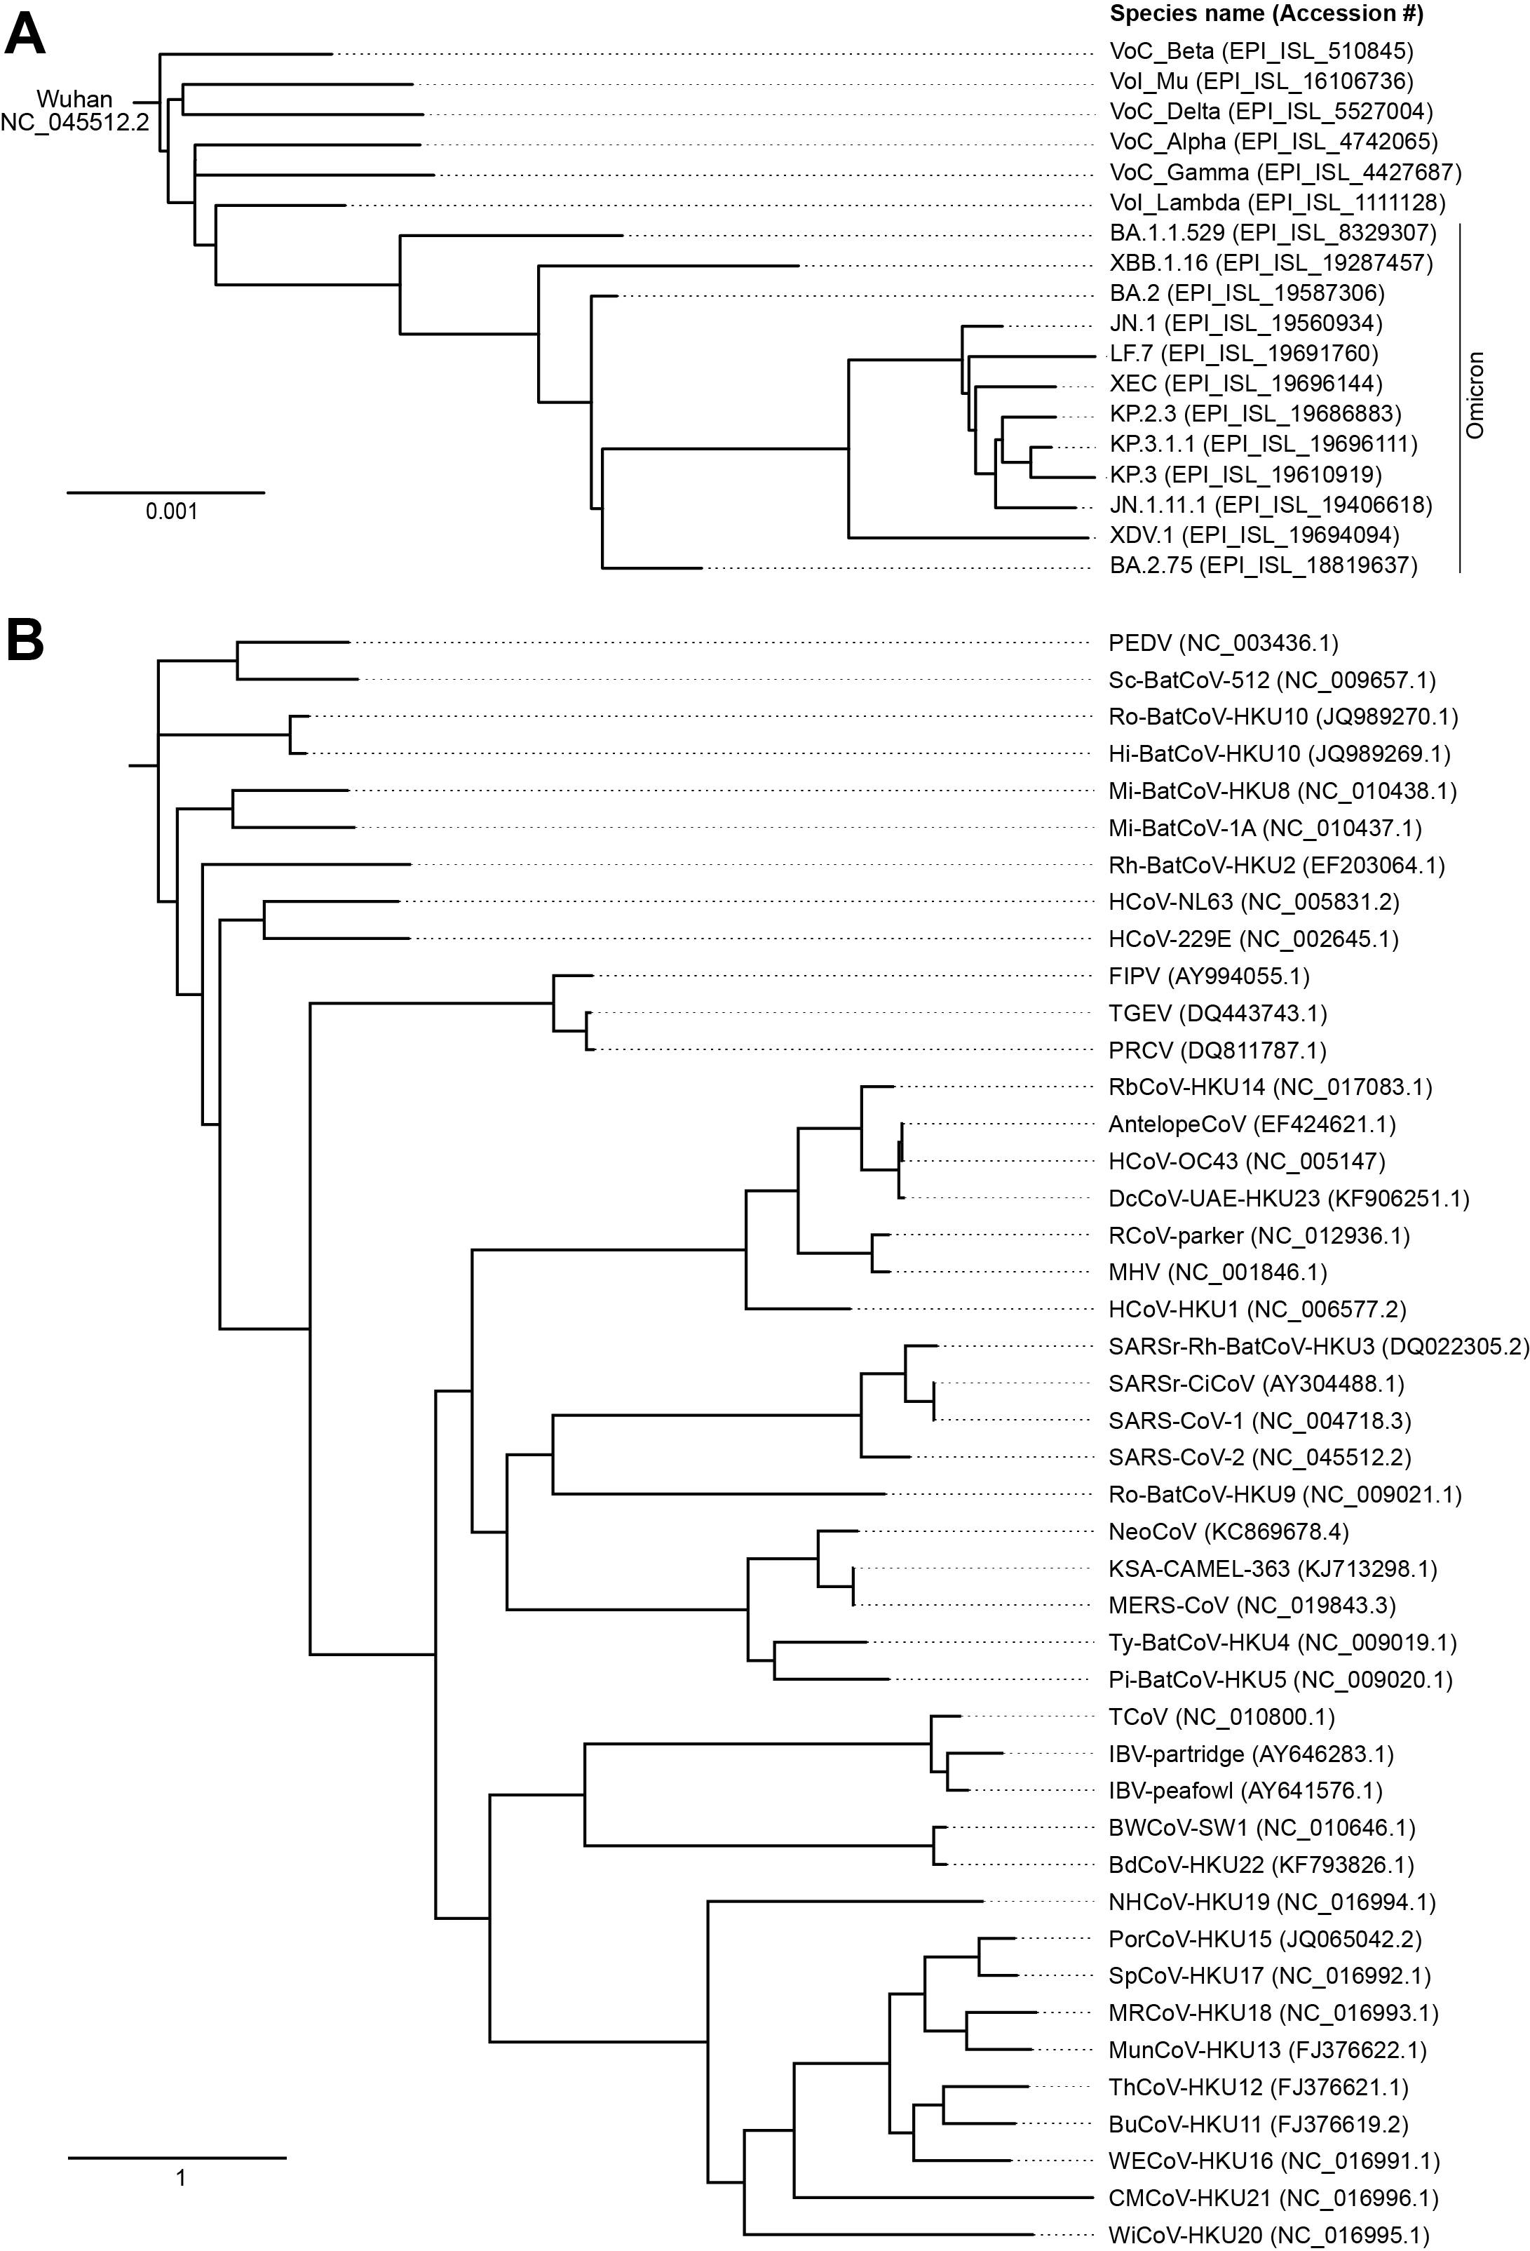

Fig S1. Phylogenetic tree of reference sequences used to categorize Orthocoronavirinae sequences. References used to categorize (A) SARS-CoV-2 strains into the specific variants or (B) allocate non-SARS-CoV-2 sequences to a specific species are shown. Accession numbers are shown in brackets. Bar at lower left of graphs represents evolutionary distance. Abbreviations: PEDV, porcine epidemic diarrhea virus; Sc-BatCoV 512, Scotophilus bat coronavirus 512; Ro-BatCoV HKU10, Rousettus bat coronavirus HKU10; Hi-BatCoV HKU10, Hipposideros bat coronavirus HKU10; Mi-BatCoV HKU8, Miniopterus bat coronavirus HKU8; Mi-BatCoV 1A, Miniopterus bat coronavirus 1A; Rh-BatCoV HKU2, Rhinolophus bat coronavirus HKU2; HCoV-NL63, human coronavirus NL63; HCoV-229E, human coronavirus 229E; FIPV, feline infectious peritonitis virus; TGEV, transmissible gastroenteritis virus; PRCV, porcine respiratory coronavirus; RbCoV HKU14, rabbit coronavirus HKU14; AntelopeCoV, sable antelope coronavirus; HCoV-OC43, human coronavirus OC43; DcCoV UAE-HKU23, dromedary camel coronavirus UAE-HKU23; RcoV parker, rat coronavirus Parker; MHV, murine hepatitis virus; HCoV-HKU1, human coronavirus HKU1; SARSr-Rh-BatCoV HKU3, SARS-related Rhinolophus bat coronavirus HKU3; SARSr-CiCoV, SARS-related palm civet coronavirus; SARS-CoV-1, SARS coronavirus 1; SARS-CoV-2, SARS coronavirus 2; Ro-BatCoV-HKU9, Rousettus bat coronavirusHKU9; NeoCoV, coronavirus Neoromicia/PML-PHE1/RSA/2011; KSA-CAMEL-363, KSA-CAMEL-363 isolate of Middle East respiratory syndrome coronavirus; MERS-CoV, Middle East respiratory syndrome coronavirus; Ty-BatCoV-HKU4, Tylonycteris bat coronavirus HKU4; Pi-BatCoV-HKU5, Pipistrellus bat coronavirus HKU5; TcoV, turkey coronavirus; IBV-partridge, avian infectious bronchitis virus partridge isolate; IBV-peafowl, avian infectious bronchitis virus peafowl isolate; BWCoV-SW1, beluga whale coronavirus SW1; BdCoV HKU22, bottlenose dolphin coronavirus HKU22; NHCoV HKU19, night heron coronavirus HKU19; PorCoV HKU15, porcine coronavirus HKU15; SpCoV HKU17, sparrow coronavirus HKU17; MRCoV HKU18, magpie robin coronavirus HKU18; MunCoV HKU13, munia coronavirus HKU13; ThCoV HKU12, thrush coronavirus HKU12; BuCoV HKU11, bulbul coronavirus HKU11; WECoV HKU16, white-eye coronavirus HKU16; CMCoV HKU21, common-moorhen coronavirus HKU21; WiCoV HKU20, wigeon coronavirus HKU20
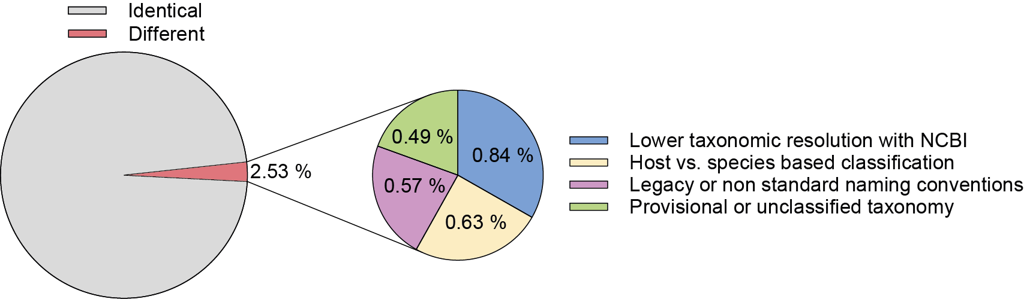

Fig S2. Comparison of BLAST-based species assignments with NCBI taxonomy.
Overview of concordance between BLAST-based species clustering and NCBI-provided taxonomy across all 48,977 CoV genomes analyzed. The left pie chart shows the proportion of sequences with identical species assignments (97.47%) versus differing assignments (2.53%). The right pie chart breaks down the non-identical cases into four explanatory categories: lower taxonomic resolution in NCBI annotations compared with the reference sequence set, host-based (NCBI) versus virus species-based (BLAST) naming, legacy or non-standard nomenclature in NCBI records, and provisional or unclassified taxonomy at the time of submission. Percentages in the right chart refer to the fraction of all sequences.
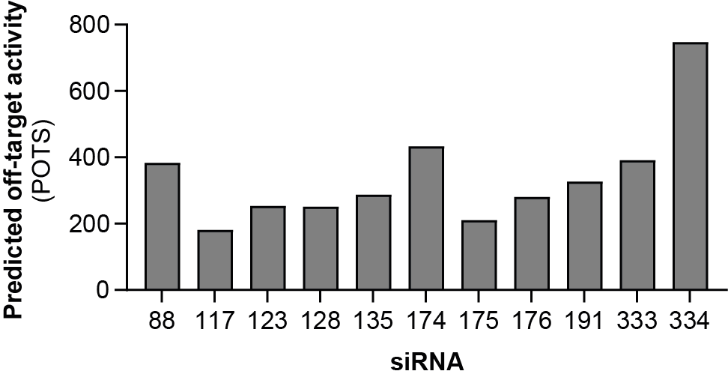
Fig S3. Sequence based off-target prediction of eleven siRNA candidates. Off-target potential was assessed using the siSPOTR algorithm, which calculates the Probability of Off-Targeting Score (POTS) based on complementarity of the siRNA seed region to the human transcriptome. Lower POTS values indicate reduced likelihood of off-target interactions
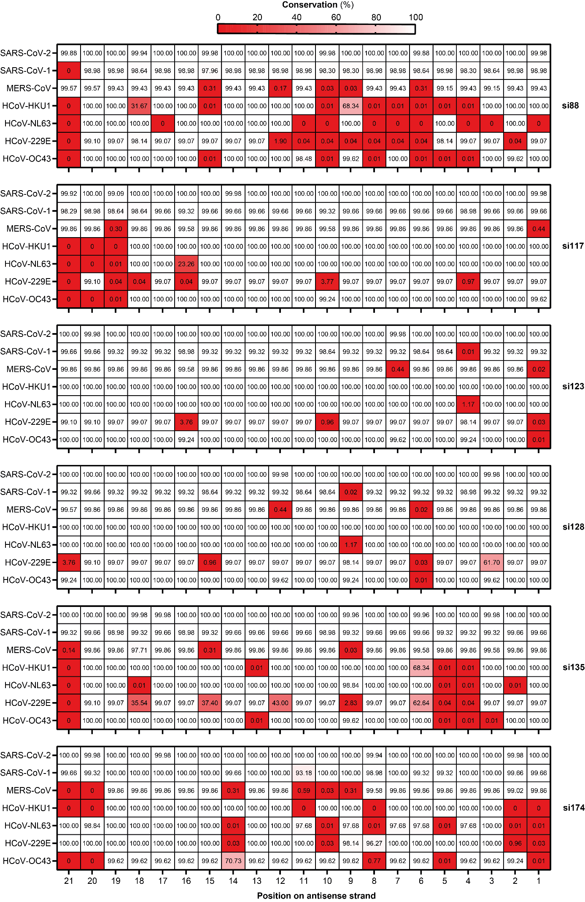
Fig S4. Conservation of individual nucleotide positions of the target sites of si88, si117, si123, si128, si135, and si174 across HCoVs. For all HCoVs except SARS-CoV-2, conservation was calculated from alignments of sequences that were contained in the database shown in Fig.1 and Fig. 2. For SARS-CoV-2, the conservation analysis was based on a globally representative multiple sequence alignment obtained from the Nextstrain SARS-CoV-2 open dataset. Conservation is expressed as the percentage of analyzed sequences within each CoV species that contain the complementary base to the siRNA antisense strand. The conservation is indicated by the color code and % values given in cells.
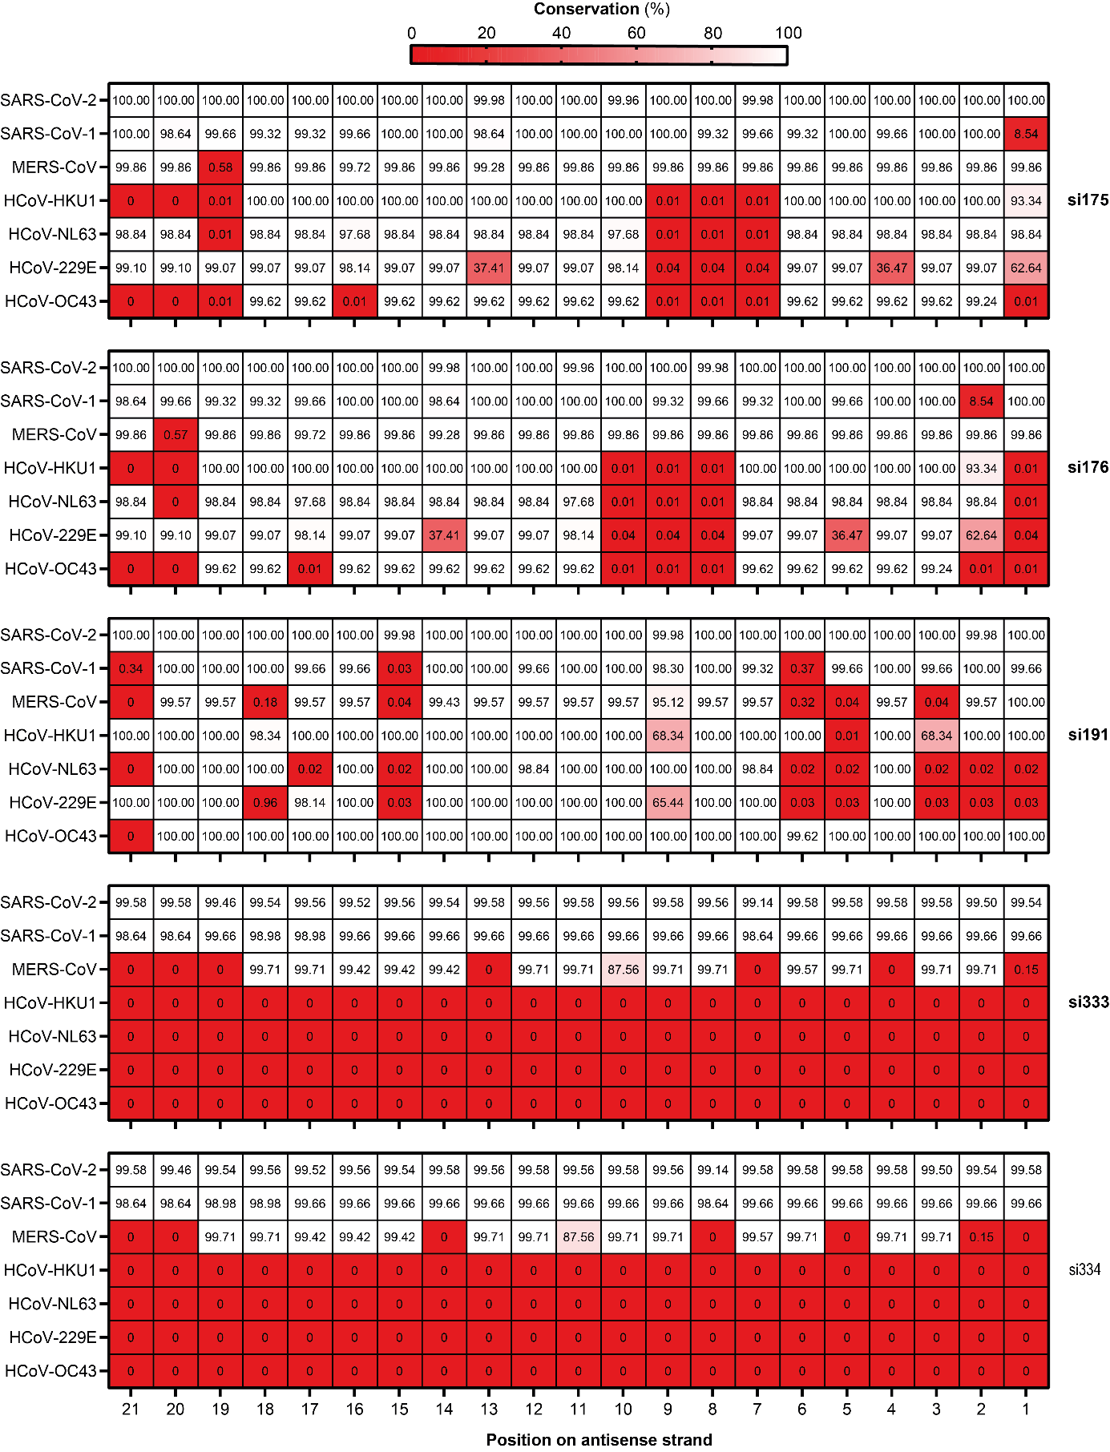

Fig S5. Conservation of individual nucleotide positions of the target sites of si175, si176, si191, si333, and si334 across HCoVs. For all HCoVs except SARS-CoV-2, conservation was calculated from alignments of sequences that were contained in the database shown in Fig.1 and Fig. 2. For SARS-CoV-2, the conservation analysis was based on a globally representative multiple sequence alignment obtained from the Nextstrain SARS-CoV-2 open dataset. Conservation is expressed as the percentage of analyzed sequences within each CoV species that contain the complementary base to the siRNA antisense strand. The conservation is indicated by the color code and % values given in cells.

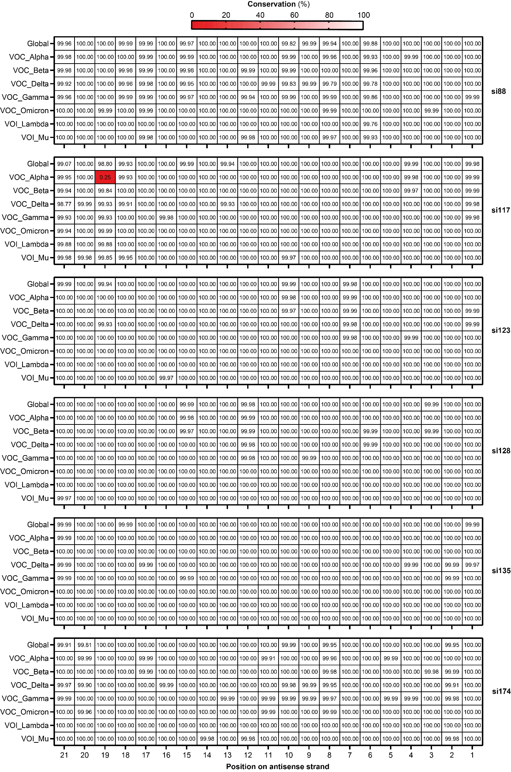
Fig S6. Conservation of individual nucleotide positions of the target sites of si88, si117, si123, si128, si135, and si174 across SARS-CoV-2 variants. The conservation was derived from approximately 200,000 SARS-CoV-2 genome sequences that were retrieved from GISAID and grouped by variant. Conservation is expressed as the percentage of analyzed sequences within each variant that contained the complementary base to the siRNA antisense strand. The conservation is indicated by the color code and % values given in cells.
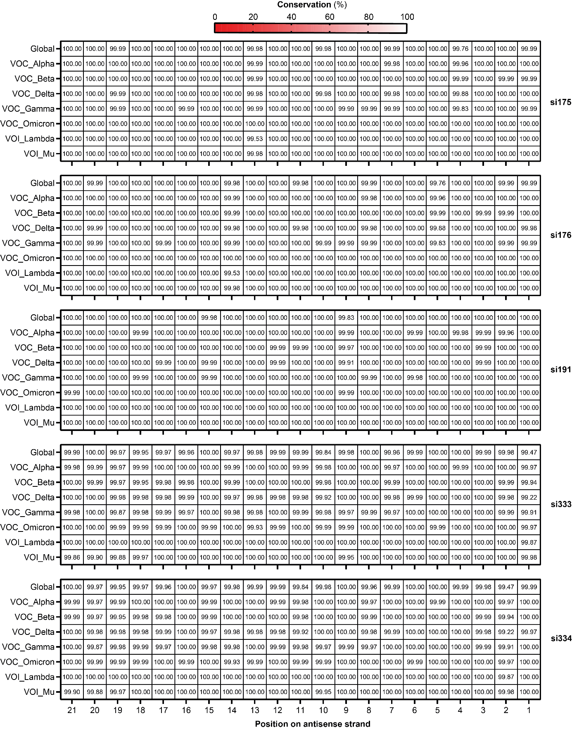

Fig S7. Conservation of individual nucleotide positions of the target regions of si175, si176, si191, si333, and si334 across SARS-CoV-2 variants. The conservation was derived from approximately 200,000 SARS-CoV-2 genome sequences that were retrieved from GISAID and grouped by variant. Conservation is expressed as the percentage of analyzed sequences within each variant that contained the complementary base to the siRNA antisense strand. The conservation is indicated by the color code and % values given in cells.
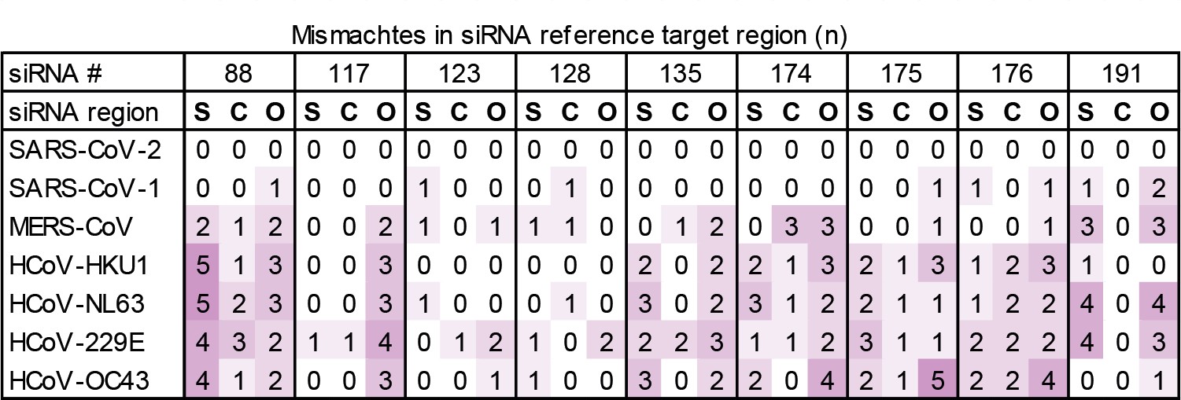

Fig S8. Mismatch analysis of siRNA target sites in HCoV reference genomes used for the design of luciferase reporters. The table summarizes the number of mismatches between each siRNA and the corresponding HCoV target sites derived from the reference genome sequences shown in Supplementary Figure S1. Mismatches are grouped according to their position within the siRNA antisense strand as S (seed region, positions 2–8), C (central region, positions 9–12), and O (other positions, position 1 and positions 13–21). Color intensity reflects the total number of mismatches within each category.

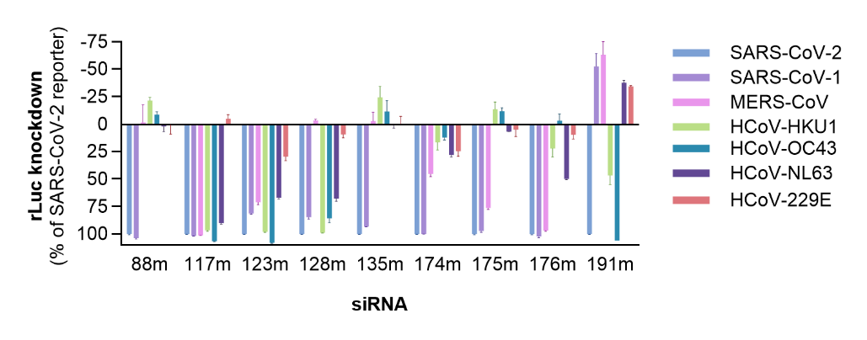
Fig S9. Evaluation of siRNA activity against target site variations derived from HCoVs using dual-luciferase reporters including negative knockdown values. siRNAs were co-transfected at a dose representing 100 x IC₅₀ values, along with plasmids containing the respective version of the siRNA target site in the 3´UTR of Renilla luciferase (rLuc). Data were normalized to the knockdown efficiency observed for the SARS-CoV-2 reporter. Data represent mean ± SD (n = 3 to 6).

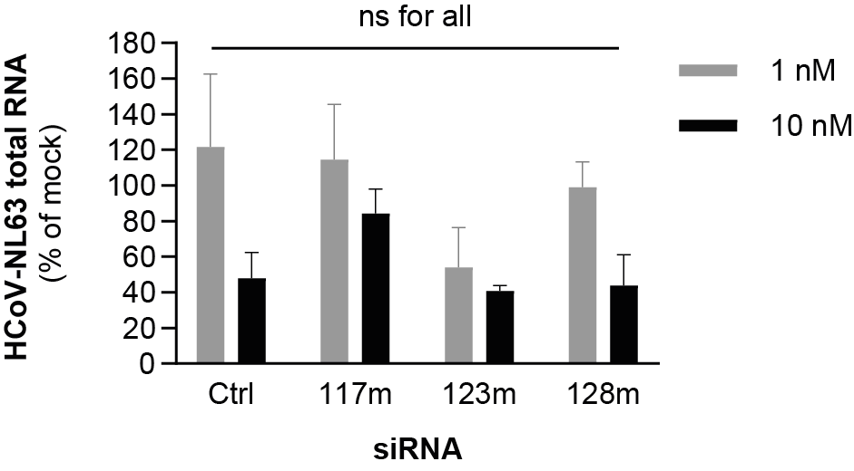
Fig S10. Antiviral activity of selected siRNAs against HCoV-NL63. Chemically modified siRNA were reverse transfection into Huh7.5 cells at the indicated siRNA concentrations using Lipofectamine RNAiMAX and 4 hours later infected with HCoV-NL63 (MOI = 0.1). Viral replication was quantified by RT-qPCR from cell lysates 48 hours post infection. Bars represent mean ± SD (n=3). Statistical differences between CoV-specific siRNAs and the control siRNA (Ctrl) were calculated using Brown–Forsythe and Welch ANOVA followed by Dunnett’s T3 multiple comparisons test. ns = non-significant
Table S1. Primer and probe sequences used for RT-qPCR analysis
Primer/Probe Name | Target | Sequence (5’-3’)
OC43-RdRP_fw | HCoV-OC43 RNA-dependent RNA polymerase (Nsp12) | TATGGTGGCTGGGATGATATGTTAC
OC43-RdRP_rev | HCoV-OC43 RNA-dependent RNA polymerase (Nsp12) | AGGTTTGGCATAGCACGATCACACTT
OC43-RdRP_probe | HCoV-OC43 RNA-dependent RNA polymerase (Nsp12) | FAM- ACAATCCTGTACTTATGGGTTGGGATTATCCT- BHQ1
OC43_NC_fw | HCoV-OC43 nucleocapsid protein | CGATGAGGCTATTCCGACTAGGT
OC43_NC_rev | HCoV-OC43 nucleocapsid protein | CCTTCCTGAGCCTTCAATATAGTAACC
OC43_NC_probe | HCoV-OC43 nucleocapsid protein | FAM- TCCGCCTGGCACGGTACTCCCT- BHQ1
NL63_NC_fw | HCoV-NL63 nucleocapsid protein | GCGTGTTCCTACCAGAGAGGA
NL63_NC_rev | HCoV-NL63 nucleocapsid protein | GCAAGCTGTGGAAAACCTTTGGCA
NL63_NC_probe | HCoV-NL63 nucleocapsid protein | FAM- ATGTTATTCAGTGCTTTGGTCCTCGTGAT- TAM
SARS1_RdRP_fw | SARS-CoV-1 RDRP | CGTCTGCGGAATGTGGAAAG
SARS1/2_RdRP_rev | SARS-CoV-1 RDRP | TAAGACGGGCTGCACTTACA
SARS1_N_fw | SARS-CoV-1 nucleocapsid protein | GACCCCAATCAAACCAACGT
SARS1_N_rev | SARS-CoV-1 nucleocapsid protein | TCTGGTTATTGTCAGTTGAATCTG
SARS2_RdRP_fw | SARS-CoV-2 RDRP | CGTCTGCGGTATGTGGAAAG
SARS2_N_fw | SARS-CoV-2 nucleocapsid protein | GACCCCAAAATCAGCGAAAT
SARS2_N_rev | SARS-CoV-2 nucleocapsid protein | TCTGGTTACTGCCAGTTGAATCTG
18s_Fw | 18s rRNA | AAACGGCTACCACATCCA
18s_rev | 18s rRNA | CCTCCAATGGATCCTCGT
MERS_up-E_fwd | MERS-CoV envelope protein | GCAACGCGCGATTCAGTT
MERS_up-E_rev | MERS-CoV envelope protein | GCCTCTACACGGGACCCATA
hRPS18_fwd | 18s rRNA | GCGGCGGAAAATAGCCTTTG
hRPS18_rev | 18s rRNA | GATCACACGTTCCACCTCATC

Table S2. Cycling conditions used for RT-qPCR analysis
Cycle Step | Temp. | Time | Cycle No.
PCR cycling conditions for HCoV-OC43 and HCoV-NL63 RNA
Reverse transcription (RT) | 50°C | 10 min | 1
RT inactivation | 95°C | 3 min | 1
Denaturation | 95°C | 15 s | 45
Annealing/Extension | 60°C | 30 s | 45
PCR cycling conditions for SARS-CoV-1 and SARS-CoV-2 RNA
Reverse transcription (RT) | 50°C | 10 min | 1
RT inactivation | 95°C | 3 min | 1
Initial Denaturation | 95°C | 5 min | 1
Denaturation | 95°C | 15 s | 45
Annealing | 55°C | 10 s | 45
Extension | 72°C | 25 s | 45
PCR cycling conditions for MERS-CoV RNA
Initial Denaturation | 95°C | 60 s | 1
Denaturation | 95°C | 15 s | 45
Annealing/Extension | 60°C | 30 s | 45
Melt Curve | 60-95°C | 15 s | 1

