SUPPLEMENTARY DATA
Supplementary Table

Supplementary Table 1. Baseline characteristics of study participants by PAX4 R192H genotype.
PAX4 R192H genotype | PAX4 Arg/Arg  (n=3,650) | PAX4 Arg/His, His/His  (n=592) | P value*
Age (years) | 51.1 (8.4) | 50.9 (8.3) | 0.676
Sex (%, male) | 1703 (47) | 291 (49) | 0.278
Body mass index (kg/m²) | 24.4 (3.0) | 24.7 (3.0) | 0.014
Fasting plasma glucose (mg/dL) | 82.8 (8.4) | 83.8 (8.6) | 0.004
2 h glucose (mg/dL) | 113 (29) | 116 (31) | 0.054
HbA1c (%) | 5.52 (0.34) | 5.56 (0.35) | 0.017
Fasting insulin (pmol/L)† | 6.3 (1.9) | 6.6 (1.7) | 0.080
IGI₆₀† | 6.8 (3.5) | 6.3 (3.5) | 0.167
ISI† | 9.8 (1.8) | 9.5 (1.8) | 0.168
Disposition Index† | 70.9 (3.4) | 61.1 (3.2) | 0.021
Total Cholesterol (mmol/L)† | 187 (1.2) | 188 (1.2) | 0.774
Triglycerides (mmol/L)† | 134 (1.6) | 138 (1.6) | 0.270
HDL cholesterol (mmol/L)† | 44.1 (1.2) | 44.3 (1.2) | 0.555
LDL cholesterol (mmol/L)† | 111 (1.3) | 110 (1.4) | 0.432

Data are unadjusted means (standard deviation), geometric means (geometric standard deviation), or n (%).
*P values for the difference between genetic risk groups are calculated with t-test and the χ² test for continuous and categorical variables, respectively.
†Variables were log-transformed before statistical analysis and shown as geometric mean (geometric standard deviation).
IGI₆₀, insulinogenic index at 60 min; ISI, insulin sensitivity index.

Supplementary Figure
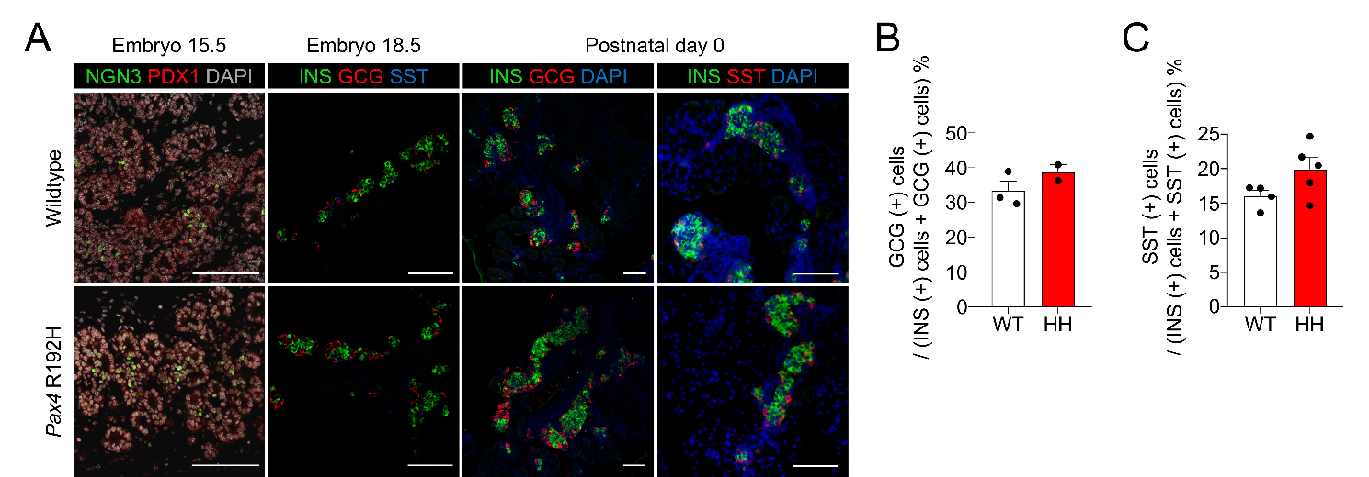

Supplementary Figure 1. Pancreatic endocrine development was not altered in Pax4 R192H mice
(A) Immunofluorescence staining of Neurogenin3 (green) and Pdx1 (red) in the pancreas of wildtype and Pax4 R192H mice at embryonic day 15.5 (E15.5), with nuclei stained with DAPI (gray). Immunofluorescence staining of endocrine hormones, including glucagon(red) and somatostatin(blue), and insulin (green) in the pancreas of wildtype and Pax4 R192H mice at embryonic day 18.5 (E18.5). Immunofluorescence staining of endocrine hormones in the pancreas at postnatal day 0 (P0), showing Insulin (green), glucagon (red) or somatostatin (red) with nuclei stained with DAPI (blue); n ≥3 per group. Scale bar, 100 μm. (B,C) The number of glucagon positive (GCG⁺) α cells (B) and somatostatin-positive (SST⁺) δ cells (C) was quantified in pancreatic sections from wildtype (white bars) and Pax4 R192H (red bars) mice at postnatal day 0; n ≥2 per group.

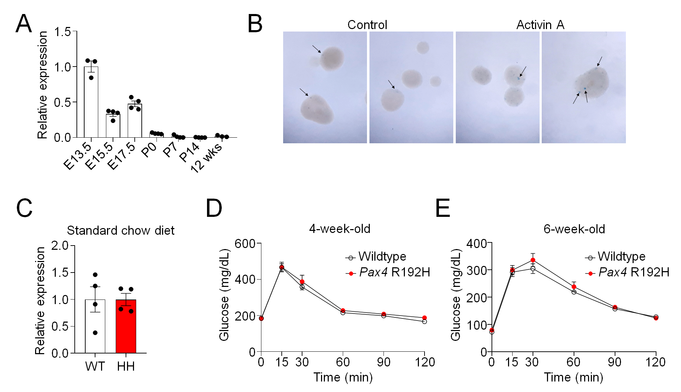

Supplementary Figure 2. Pax4 expression in adult islets and glucose tolerance of Pax4 R192H mice
(A) Pax4 mRNA expression in whole pancreas at embryonic day 13.5 (E13.5) through postnatal day 14 (P14), and in isolated pancreatic islets from 12-week-old adult mice, as measured by quantitative RT–PCR. The accompanying table shows the mean Ct values obtained from qRT–PCR for each condition, providing information on transcript abundance. Expression levels were normalized to Actb as an internal control, which exhibited stable Ct values of approximately 21 across all samples, supporting the reliability of the qRT–PCR measurements. (B) Representative bright-field images of isolated pancreatic islets from Pax4^{LacZ/+} reporter mice stained with X-gal. X-gal-positive cells (arrows) were detected in adult islets, indicating Pax4 expression with heterogeneous distribution among islet cells. (C) Pax4 mRNA expression in isolated islets from Pax4 R192H mice under standard chow diet conditions. The accompanying table shows the mean Ct values obtained from qRT–PCR for each condition, providing information on transcript abundance. Actb was used as an endogenous control. n ≥ 3 mice per group. (D,E) Intraperitoneal glucose tolerance test in wildtype and Pax4 R192H mice after 16-hour fasting in 4-week-old (D) and 6-week-old (E); n ≥5 per group. WT, wildtype; HH, Pax4 R192H; GCG, glucagon; SST, somatostatin; INS, insulin.

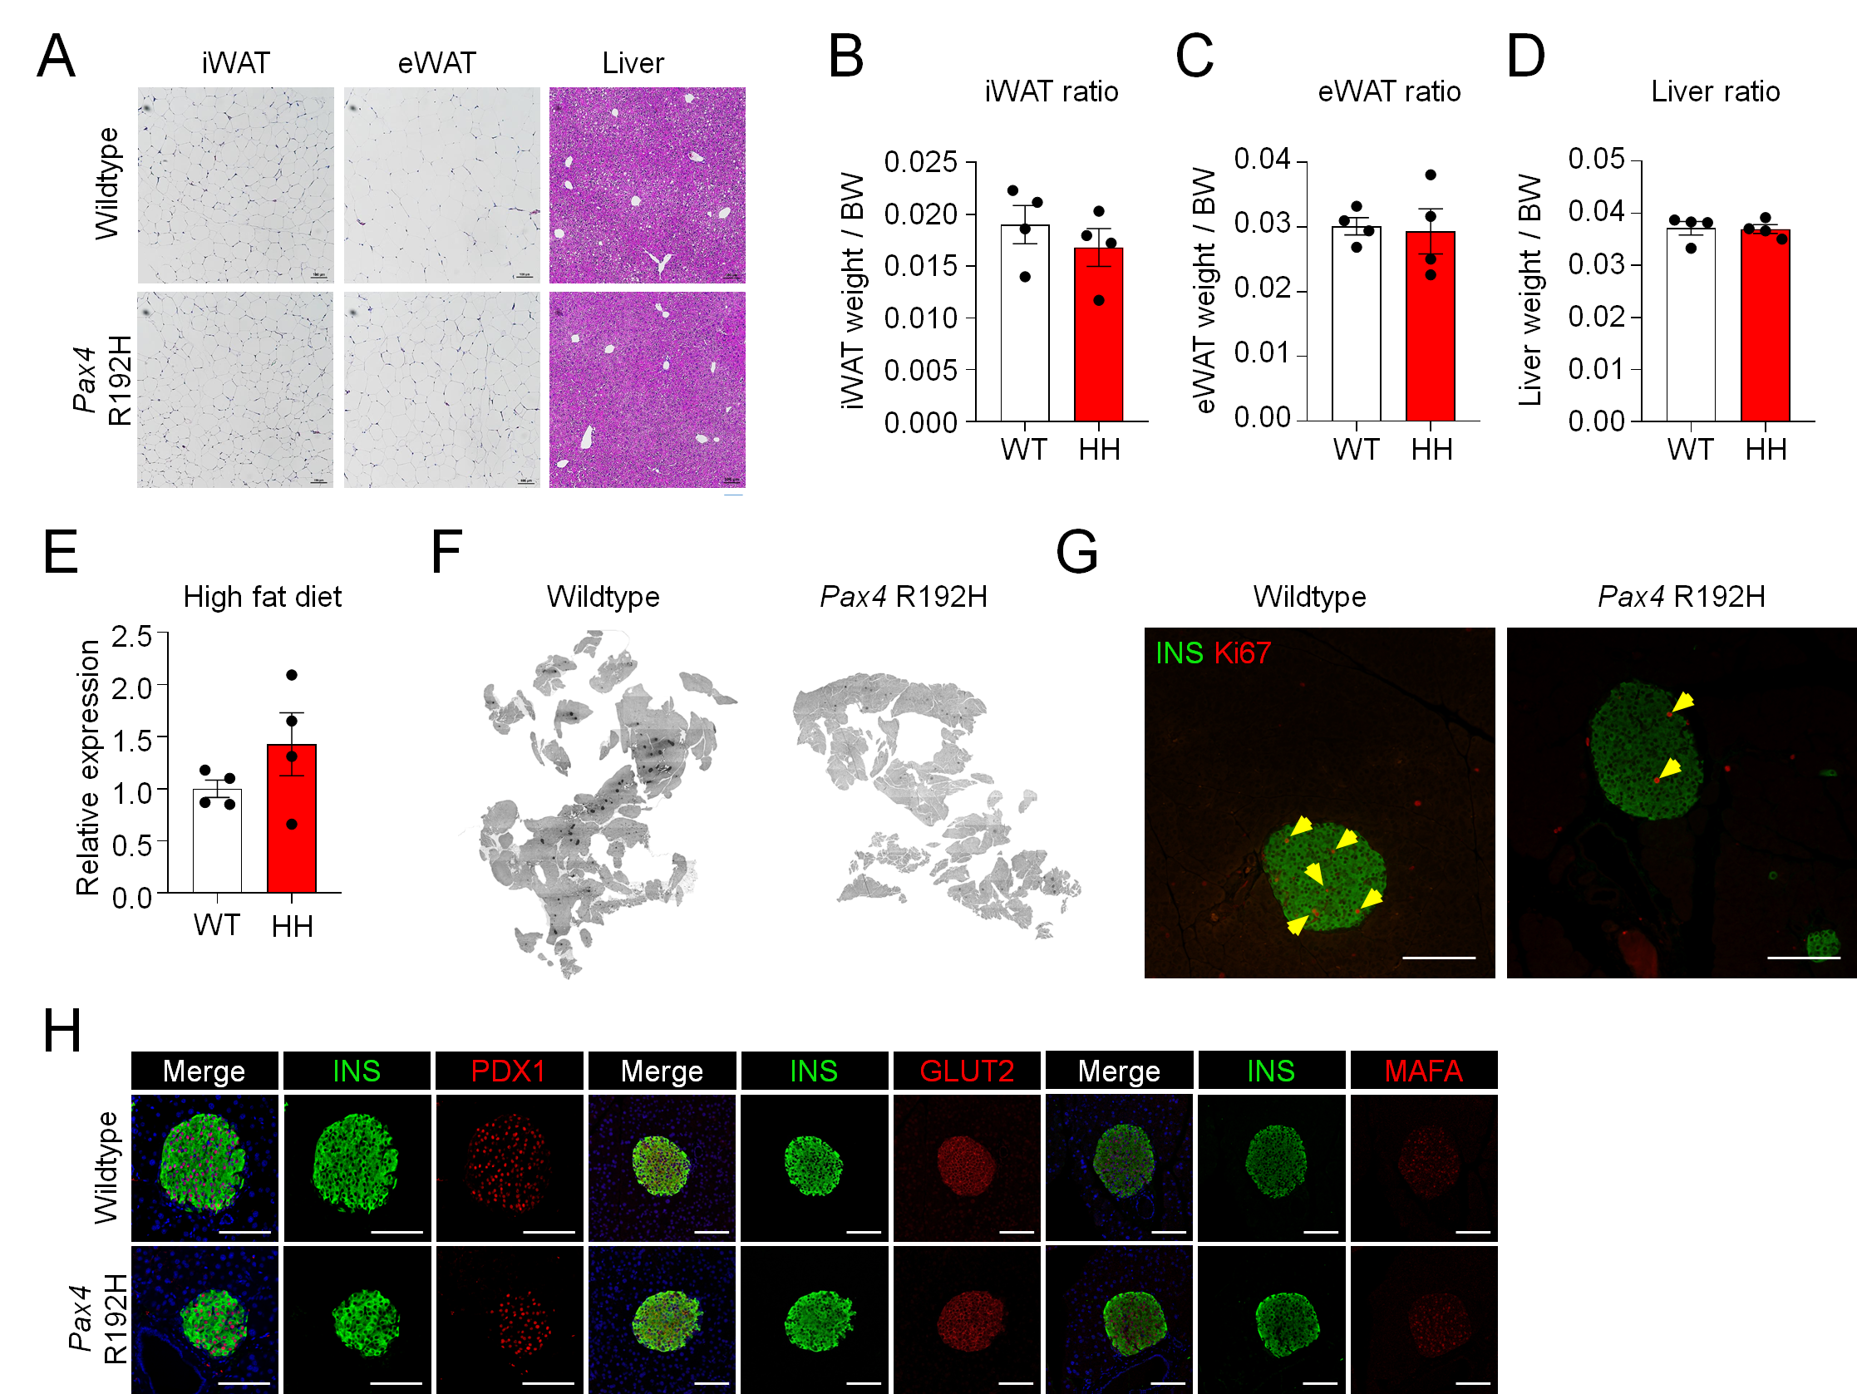

Supplementary Figure 3. Metabolic phenotypes of Pax4 R192H mice under high fat diet
(A) Representative hematoxylin and eosin (H&E) staining of adipose tissue (iWAT, eWAT) and liver sections from mice fed a high fat diet for 4 weeks (16-week-old); n=4 per group. (B-D) Adipose tissue and liver to body weight ratio of iWAT (B), eWAT (C), and liver (D); n=4 per group. (E) Pax4 mRNA expression in isolated islets from Pax4 R192H mice under high fat diet conditions. The accompanying table shows the mean Ct values obtained from qRT–PCR for each condition, providing information on transcript abundance. Actb was used as an endogenous control. n ≥ 3 mice per group. (F) Immunohistochemical staining of insulin in pancreatic sections from wildtype and Pax4 R192H mice fed a high fat diet for 4 weeks (16-week-old); n=5 per group. (G) Immunofluorescence staining with Ki67 (red) and insulin (green) of wildtype and Pax4 R192H mice fed 2 weeks of high fat diet (14-week-old). Yellow arrows=Ki67 and insulin co-positive cells; n=4 per group. Scale bar, 100 μm. (H) Immunofluorescence of β cell markers (PDX1, UCN3 and MAFA) and insulin in pancreatic sections from mice fed 4 weeks of high fat diet (16-week-old); n=4 per group. Scale bar, 100 μm. BW, body weight; WT, wildtype; HH, Pax4 R192H.
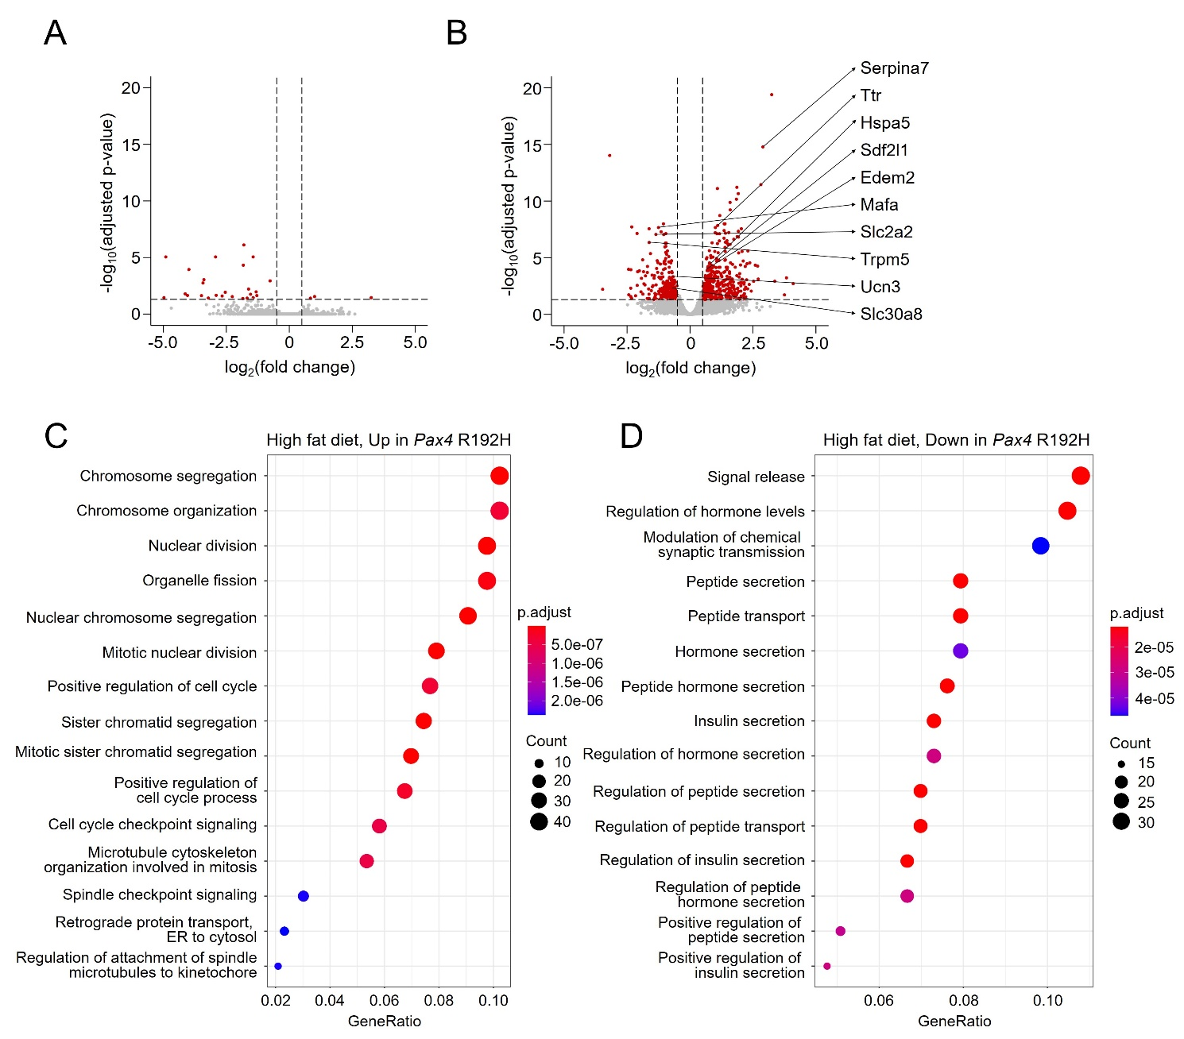

Supplementary Figure 4. Gene set enrichment analysis reveals altered transcriptional programs in Pax4 R192H islets under high fat diet
(A, B) Volcano plots showing differential gene expression between wildtype and Pax4 R192H mice within each diet condition: (A) SCD at 12 weeks; (B) HFD at 16 weeks. Vertical lines indicate |log₂(fold change)| = 0.5, and horizontal line indicates -log₁₀(adjusted P value) = 1.3. (C, D) Results of over-representation analysis showing gene sets in the GO Biological Process pathway upregulated (C) or downregulated (D) in Pax4 R192H islets under high fat diet (16-week-old).

Supplementary Figure 5. Pax4 variant induces distinct transcriptomic changes in β cells compared to other endocrine cells
(A) UMAP plot of pancreatic endocrine cells from wildtype and Pax4 R192H mice fed standard chow diet (12-week-old) or high fat diet (16-week-old). Colors represent a distinct cell cluster. (B) Composition pattern of cell clusters in wildtype and Pax4 R192H mice fed standard chow diet (12-week-old) or high fat diet (16-week-old). (C) Dot plot showing relative expression of endocrine cell markers in each cluster. Colors indicate relative expression levels and dot sizes indicate percentage of cells expressing each gene. (D) UMAP plots showing the scaled expression of representative islet hormone genes (Ins1, Gcg, Sst, and Ppy) (E–H) Volcano plots showing differential gene expression in β cells (E), α cells (F), δ cells (G) or PP cells (H) between wildtype and Pax4 R192H under standard chow diet or high fat diet. Vertical lines indicate |log₂(fold change)| = 0.5, and horizontal line indicates -log₁₀(p-adj) = 2. WT SCD, wildtype with standard chow diet; HH SCD, Pax4 R192H homozygous knock-in with standard chow diet; WT HFD, wildtype with high fat diet; HH HFD, Pax4 R192H homozygous knock-in with high fat diet.

Supplementary Figure 6. Pax4 variant induces loss of β cell identity with activation of UPR and translation process
(A) UMAP plot showing pancreatic endocrine cells from wildtype and Pax4 R192H mice fed standard chow diet (12-week-old) or high fat diet (16-week-old). Colors represent cell types. (B) Dot plot showing expression levels of genes included in Gene Ontology (GO) terms identified by pathway analysis of β cell clusters. Colors indicate relative expression levels and dot sizes indicate percentage of cells expressing genes included in gene sets. (C) Dot plot showing relative expression of genes in gene sets termed 'Response to endoplasmic reticulum stress’ and ‘Cytoplasmic translation’ in β cell clusters. Colors indicate relative expression levels and dot sizes indicate percentage of cells expressing each gene. (D) Violin plot showing expression levels of Aldh1a3 and Serpina7 among β cell clusters. WT SCD, wildtype with standard chow diet; HH SCD, Pax4 R192H homozygous knock-in with standard chow diet; WT HFD, wildtype with high fat diet; HH HFD, Pax4 R192H homozygous knock-in with high fat diet.

Supplementary Figure 7. PAX4 binding targets are associated with β cell function
(A) Venn diagram showing the number of genes associated with PAX4 binding peaks in EndoC-βH1 (Russ-Silsby et al. Mol Metab. 2025) and differentially expressed genes in β3 cluster from the scRNA-seq analysis in Figure 4. (B-D) Violin plots showing expression levels of Glp1r (B), Cacna1d (C), and Itpr1 (D) among β cell clusters from wildtype and Pax4 R192H mice fed high fat diet.

Supplementary Figure 8. Pax4 Deletion in Pax4 βiKO Islets
(A) PCR analysis of genomic DNA purified from pancreatic islets confirming Cre-mediated recombination of the Pax4 floxed allele in Pax4 βiKO mice. The intact floxed allele yields a 2,097 bp PCR product, whereas recombined alleles generate a <500 bp fragment. (B) Quantitative RT–PCR analysis of Pax4 mRNA expression in isolated islets from control and Pax4 βiKO mice. n=3 mice per group.

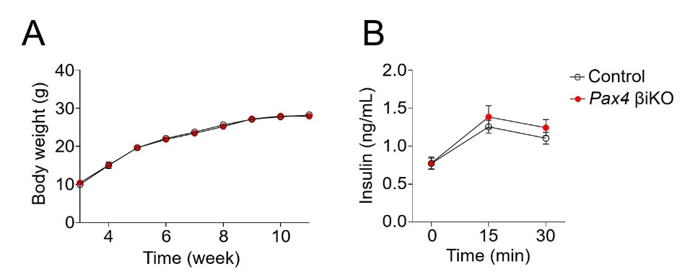

Supplementary Figure 9. Pax4 βiKO mice exhibit comparable phenotypes under standard chow diet conditions
(A) Body weight of Pax4 βiKO and control mice fed a standard chow diet (12-week-old); n=8–11 per group. (B) In vivo glucose-stimulated insulin secretion test in 12-week-old control and Pax4 βiKO mice fed a standard chow diet for 16-hour fasting; n=4–7 per group.
Supplementary Figure 10. Decreased GLUT2-positive area and proportion of MAFA-positive cells in HFD-fed Pax4 βiKO mice
(A) Quantification of GLUT2-positive area normalized to insulin-positive area based on immunofluorescence images using ImageJ. (B) Quantification of MAFA-positive/Insulin-positive cells normalized to total insulin-positive cells in control and Pax4 βiKO mice. n ≥3 mice per group and more than 100 islets per mouse were analyzed.

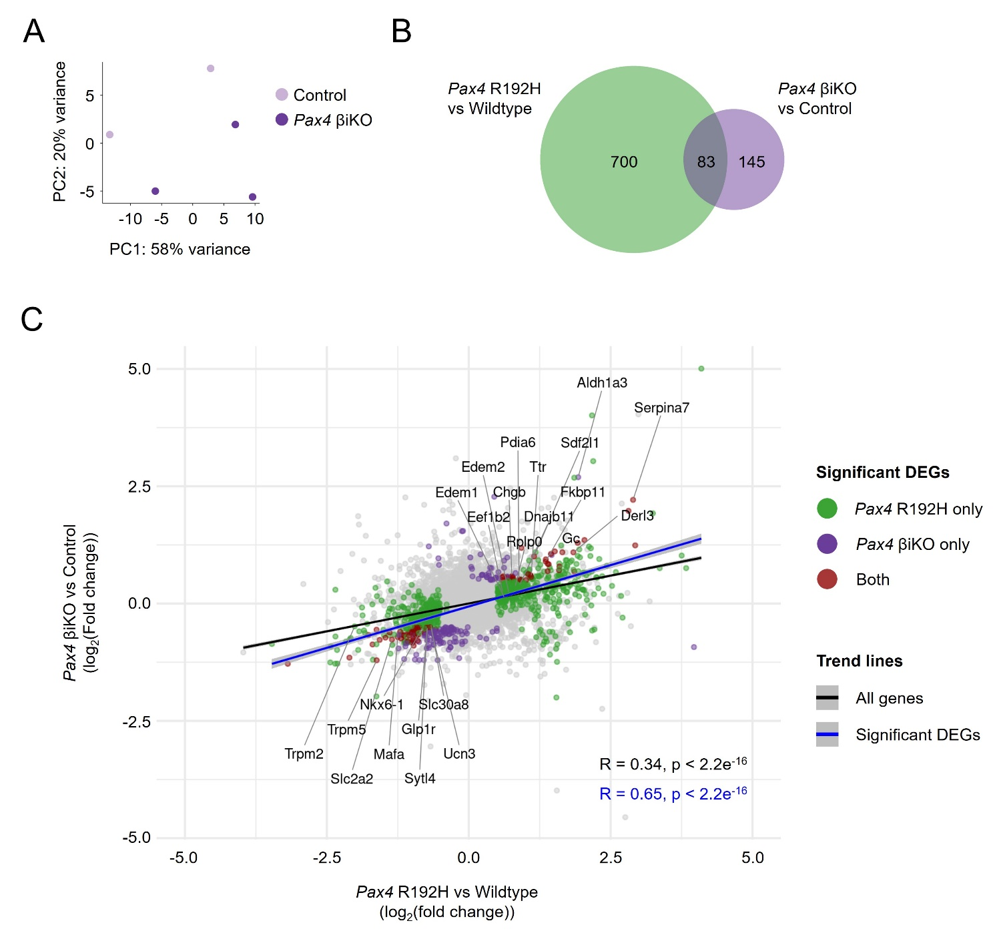

Supplementary Figure 11. Transcriptomic analyses revealed a positive correlation between gene expression changes observed in Pax4 R192H and Pax4 βiKO islets.
(A) Principal component analysis (PCA) of bulk RNA-seq data from control and Pax4 βiKO islets after 8 weeks of high fat diet (20-week-old). (B) Venn diagram showing the number of differentially expressed genes (DEGs, log₂(fold change) >0.5, adjusted P value <0.05) in islets of Pax4 R192H mice (compared to wildtype mice, green circle) and Pax4 βiKO mice (compared to control mice, purple circle) respectively. (C) Scatterplot showing the correlation of log₂ fold changes of gene expression in islets of Pax4 R192H mice (compared to wildtype mice) and Pax4 βiKO mice (compared to control mice). Colored dots indicate significant DEGs (log₂(fold change) >0.5, adjusted P value <0.05) in Pax4 R192H mice (green), Pax4 βiKO mice (purple), or both genotypes (red). Trend lines and Pearson correlation coefficient were derived from all genes (black) or significant DEGs (blue).

