SUPPLEMENTAL INFORMATION

Fig S1. Computational and experimental validation of additional candidate GFs. (A) IGV plot (top) with a subset of the input reads (gray), highlighting split alignments within the chromosomal regions of interest. Gene names and reported breakpoints (indicated by dotted lines) are annotated for clarity. Genome Ribbon single-read view (bottom) with labeled gene regions by name and the input read orientation is denoted by the arrow. GFs shown in (A): (A1) ABL1::WDR83OS (Sample 38), (A2) BCL11A::VIRMA (Sample 48), (A3) CTNND2::EIF5A (Sample 34), (A4) MDM2::NUP107 (Sample 64), (A5) PRICKLE1::FHIT (Sample 40), (A6) DDX6::DCTN2 (Sample 64). (B) Gel electrophoresis validation. The K562 cell line was used as a negative control, and validation was performed using RNA extracted from patient samples as noted. GFs shown in (B): (B1) ABL1::WDR83OS, BCL11A::VIRMA, MDM2::NUP107, PRICKLE1::FHIT, DDX6:DCTN2. (B2) CTNND2::EIF5A, DDX6:DCTN2 (*re-designed primers), MDM2::NUP107 (*re-designed primers), PRICKLE1::FHIT (*re-designed primers). (C) Sanger sequencing traces of positively validated GFs. GFs shown in (C): (C1) ABL1::WDR83OS and (C2) MDM2:: NUP107.

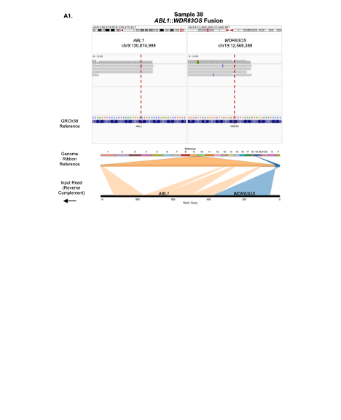

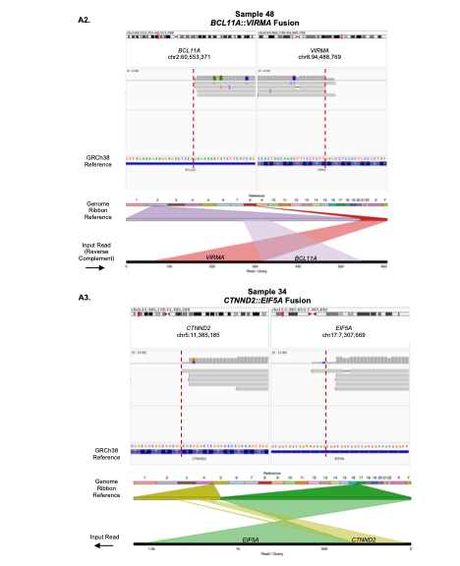
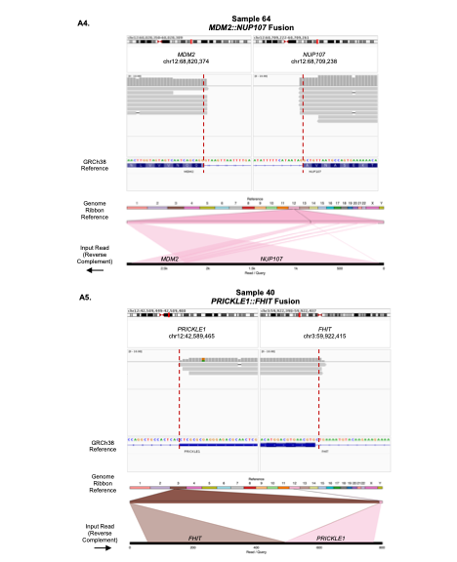
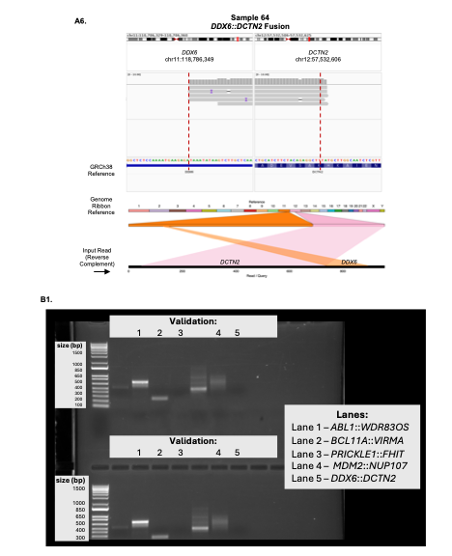
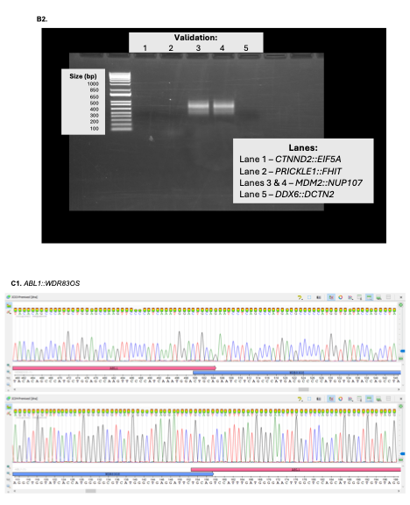
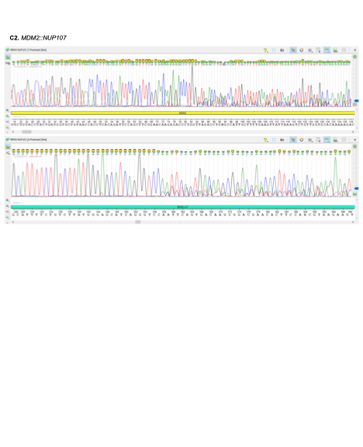

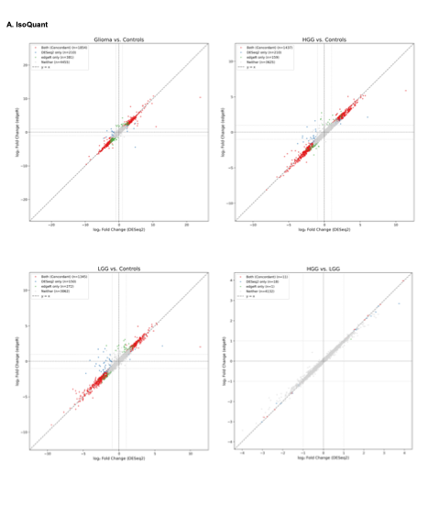 Fig S2. Differential transcript isoform expression across glioma comparisons for IsoQuant and FLAIR derived transcripts. Concordance scatter plots between edgeR and DESeq2 are shown for all four glioma comparisons (Glioma vs. Controls, HGG vs. Controls, LGG vs. Controls, and HGG vs. LGG) for isoforms identified by IsoQuant (A) and FLAIR (B). Each point represents an individual transcript isoform, with edgeR log2 fold change on the y axis and DESeq2 log2 fold change on the x axis. Significant differentially expressed isoforms from both tools (DESeq2 (FDR in edgeR, adjusted p-value in DESeq2 ≤0.05, and the absolute value of the log2 FC in expression ≥1) are shown, where concordant isoforms (significant in both edgeR and DESeq2) are colored red, DESeq2 only are colored blue, edgeR only are colored green, and gray for not significant in either method. Concordant isoforms cluster along the dotted diagonal (y = x), illustrating strong agreement in effect sizes between tools across all comparisons.

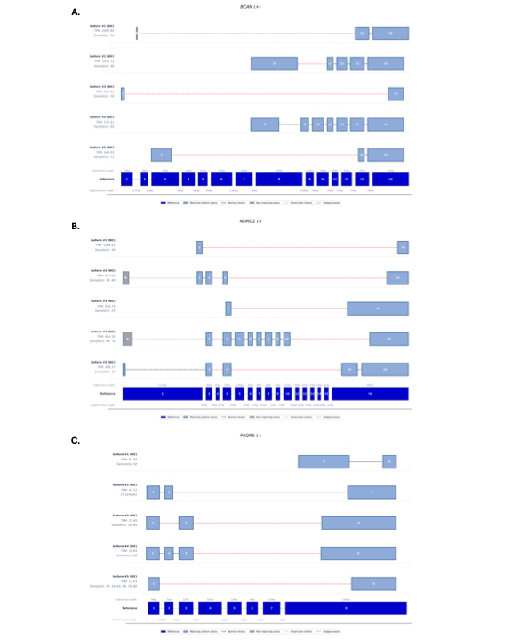

Fig S3. Representative novel transcript isoform structures for selected genes with recurrent novel isoforms in glioma. The top five most recurrent novel isoform structures detected by IsoQuant are shown for (A) BCAN, (B) NDRG2, and (C) PAQR6, aligned to their respective GENCODE reference transcript (bottom, dark blue). Each isoform is labeled with its novelty classification (NIC, novel-in-catalog), average TPM expression value, and the sample(s) in which it was detected. Notable features include truncated isoforms with extensive exon skipping in BCAN, novel first exons and exon skipping in NDRG2, and diverse exon skipping patterns in PAQR6. Light blue boxes indicate exons matching reference positions, gray boxes indicate non-matching or novel exons ("N"), black dashed lines indicate normal introns, gray dashed lines indicate novel intronic connections, and red dashed lines indicate skipped exons. Exon numbers and original exon and intron lengths correspond to the reference annotation.

Fig S4. pERK immunostaining in Drosophila larval VNCs expressing candidate gene fusions. (A) Representative images of dissected third instar larval VNCs with repo-GAL4 driving mRFP expression and GFs in glia (red) and immunostaining for phosphorylated ERK (pERK, blue). Genotypes shown include WT control and transgenic lines expressing candidate GFs selected based on significant alterations in VNC area or length (BAZ1A::PI3, BSG::GNAS, CLDND1::WRN, DUSP22::APOE, MDM2::NUP107, OLIG2::CHTOP, TCF12::CALM2, ZNF254::GNAS). Scale bar = 50 µm. (B) Quantification of the pERK signal intensity across genotypes, measured as normalized mean gray value. Data are mean ± SEM with individual larvae plotted. Statistical analysis was performed using one-way ANOVA followed by Dunnett's multiple comparisons test, with significance determined relative to WT (*p < 0.05, **p < 0.01). N>7 larvae

Fig S5. FLAG immunostaining confirms expression of breakpoint-defined GFs in Drosophila melanogaster transgenic lines. Confocal images of dissected third instar larval VNCs with repo-GAL4 driving mRFP expression and GFs in glia. GF expression was detected by immunostaining of the FLAG epitope (green channel). All GFs show detectable FLAG signal, with localization observed in glial processes and/or nuclei. Scale bar = 50 µm.

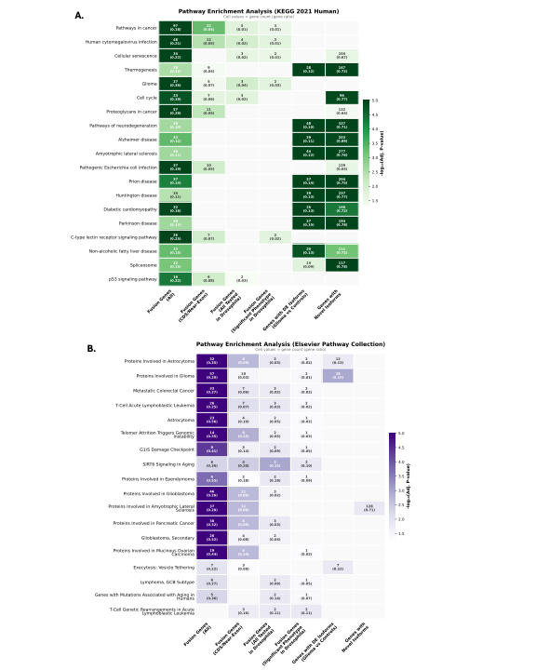
Fig S6. Pathway enrichment analysis of gene sets associated with glioma gene fusions and transcript isoform diversity. Heatmaps showing significantly enriched pathways (adjusted p-value < 0.05) from (A) KEGG 2021 Human and (B) Elsevier Pathway Collection databases across six gene sets derived from fusion gene and isoform analyses. Pathways significantly enriched in three or more gene sets are shown. Cell color represents statistical significance (-log10 adjusted p-value), with darker shading indicating stronger enrichment. Cell values display the gene count and gene ratio (in parentheses), where gene ratio represents the proportion of genes in the pathway identified within each gene set. Gray cells indicate non-significant enrichment. Pathways are ordered by the number of gene sets in which they were significantly enriched. Enrichment analysis was performed using EnrichR.

