Figures S1-S18

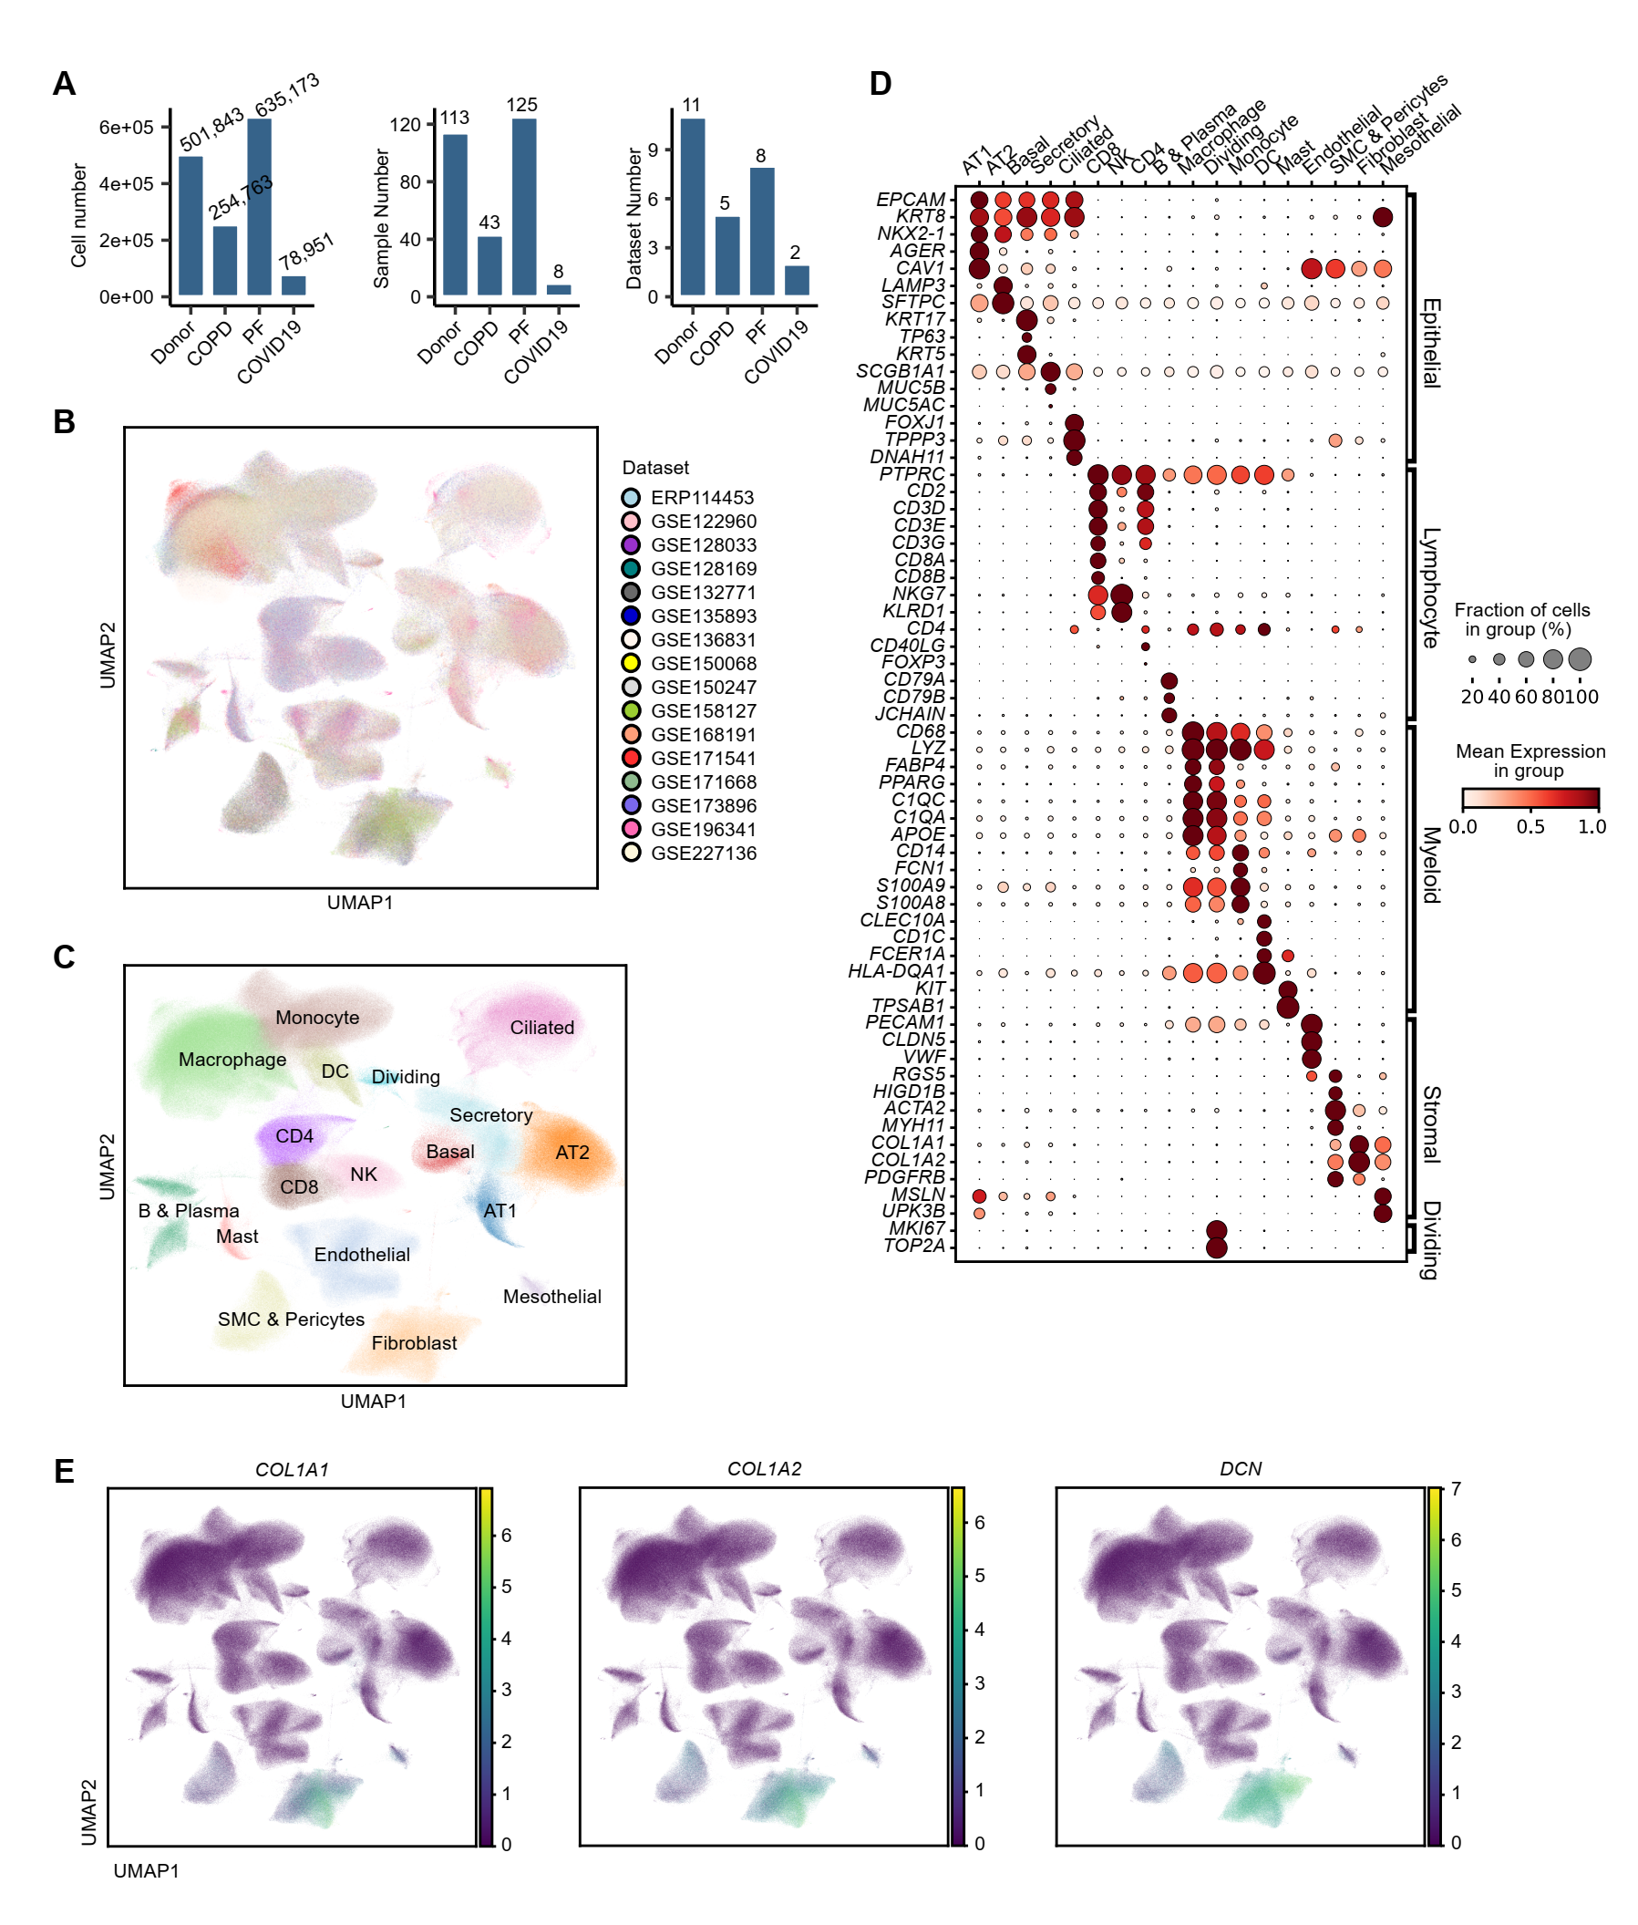
Fig. S1. Validation of cell type annotation across integrated lung single-cell datasets.
(A) Summary of cell, sample and datasets numbers across healthy donor, COPD, PF, and COVID-19 lungs.
(B) UMAP visualization of all lung cells colored by dataset, showing consistent distributions across integrated datasets.
(C) UMAP visualization of identifed cell types.
(D) Bubble plot showing canonical marker expression across cell types defined in Fig. S1C. Circle size indicates the proportion of cells expressing each gene, and color reflects the average expression (row z-score).
(E) Feature plots displaying canonical fibroblast markers (COL1A1, COL1A2, DCN) overlaid on the UMAP from Fig. S1C, confirming robust fibroblast identification.
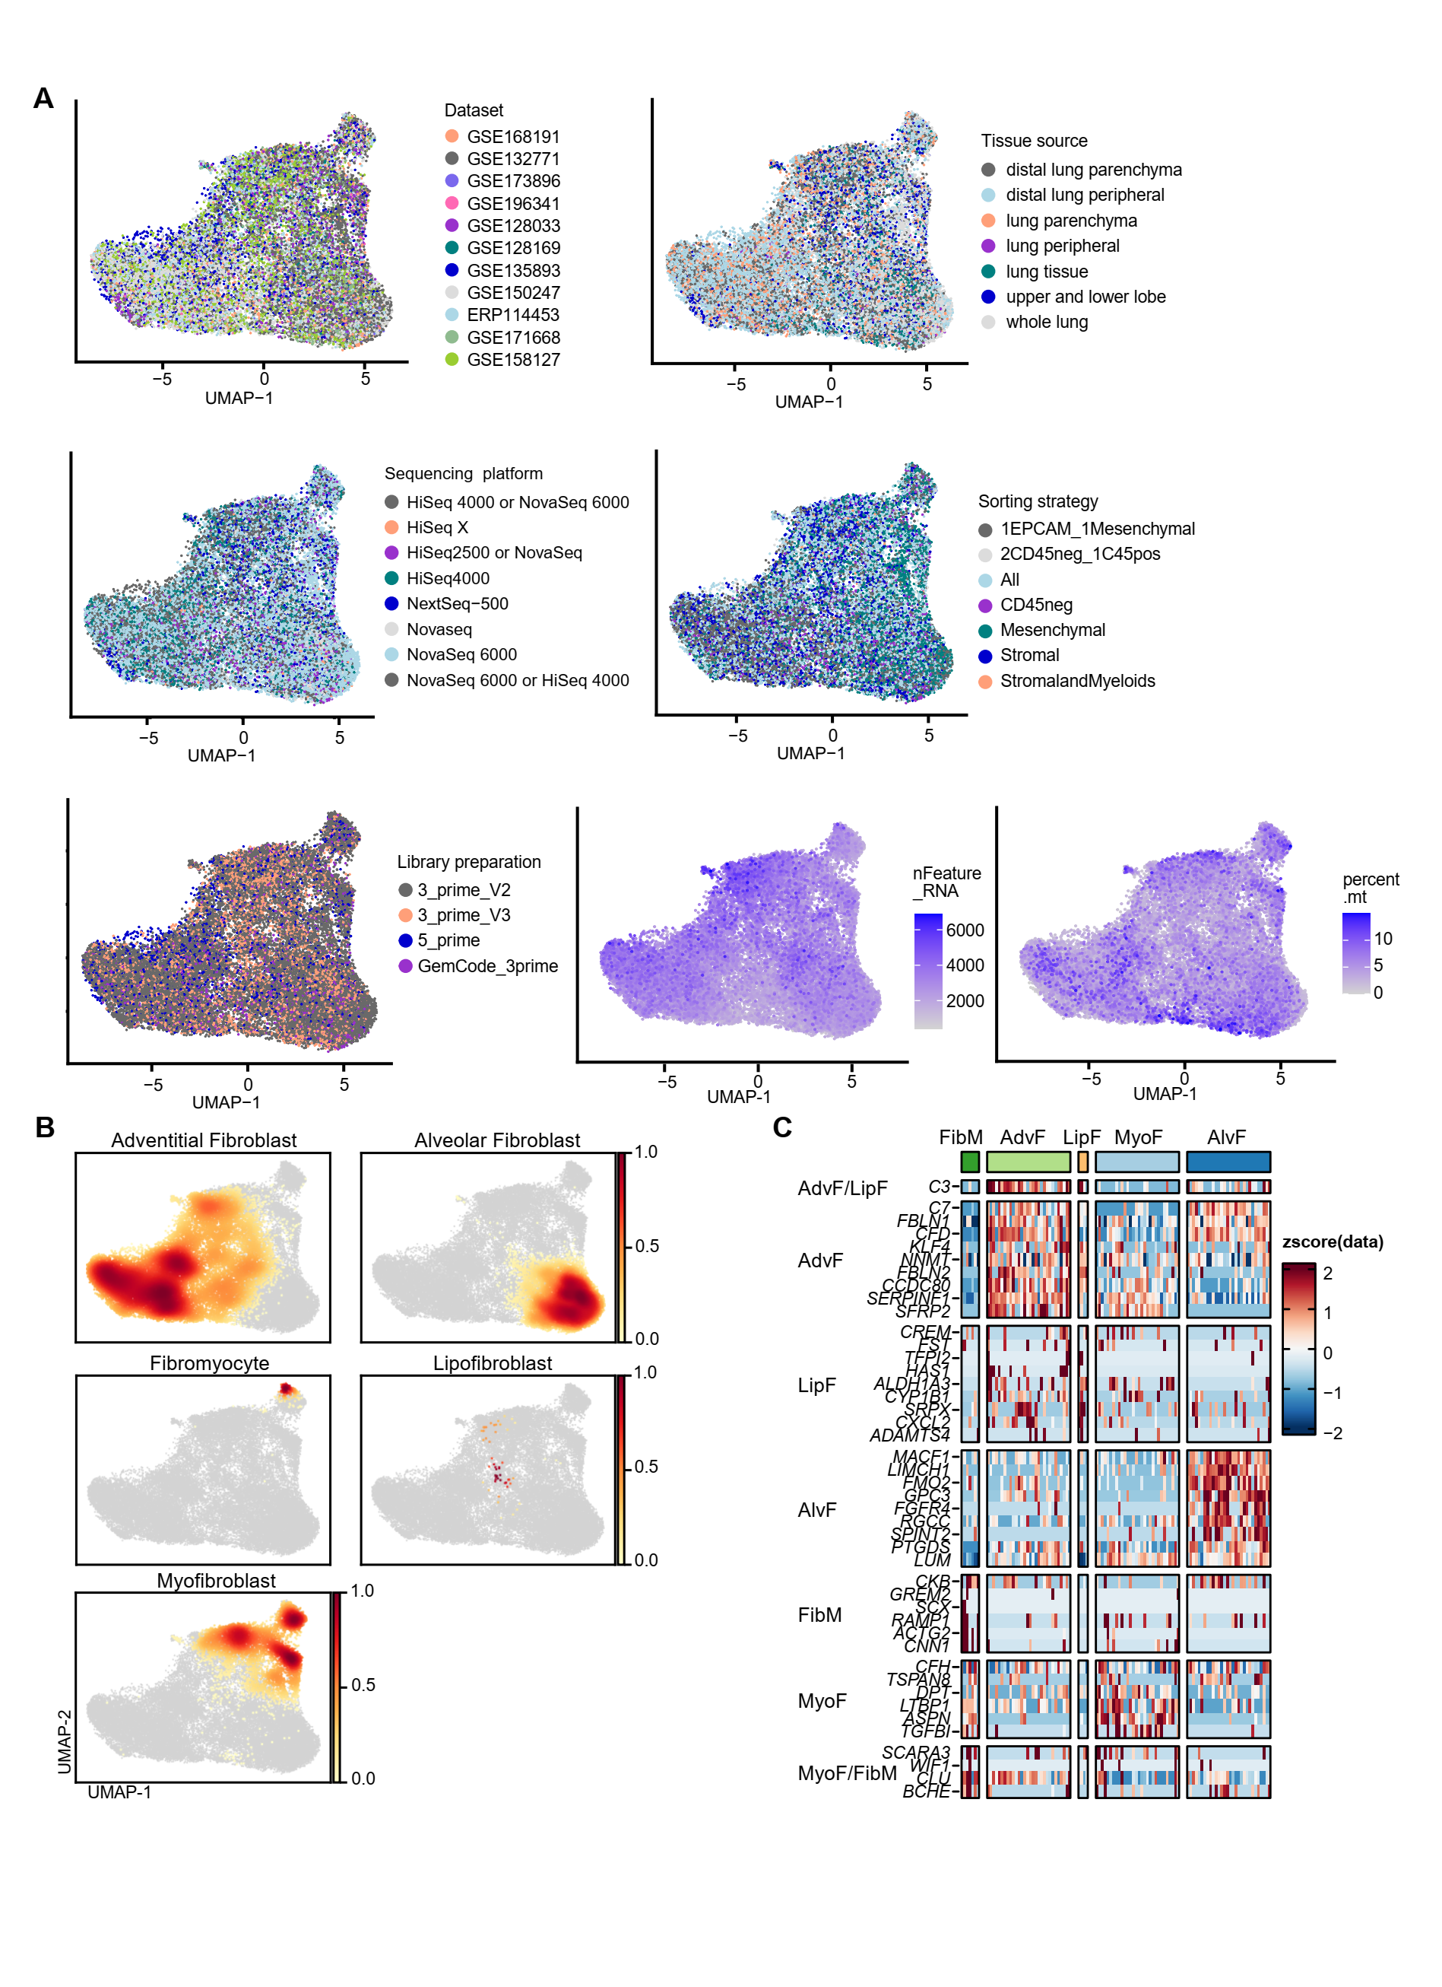
Fig. S2. Assessment of potential technical batch effects and fibroblast subtype identification.
- Evaluation of potential technical batch effects on UMAP visualization for major fibroblasts types.
- Density plots showing the distribution of major fibroblast subtypes.
(C) Heatmap showing expression of the top 10 marker genes per fibroblast subtype as reported by Travaglini et al. (2020) [6], using 1,000 randomly sampled cells per subtype.

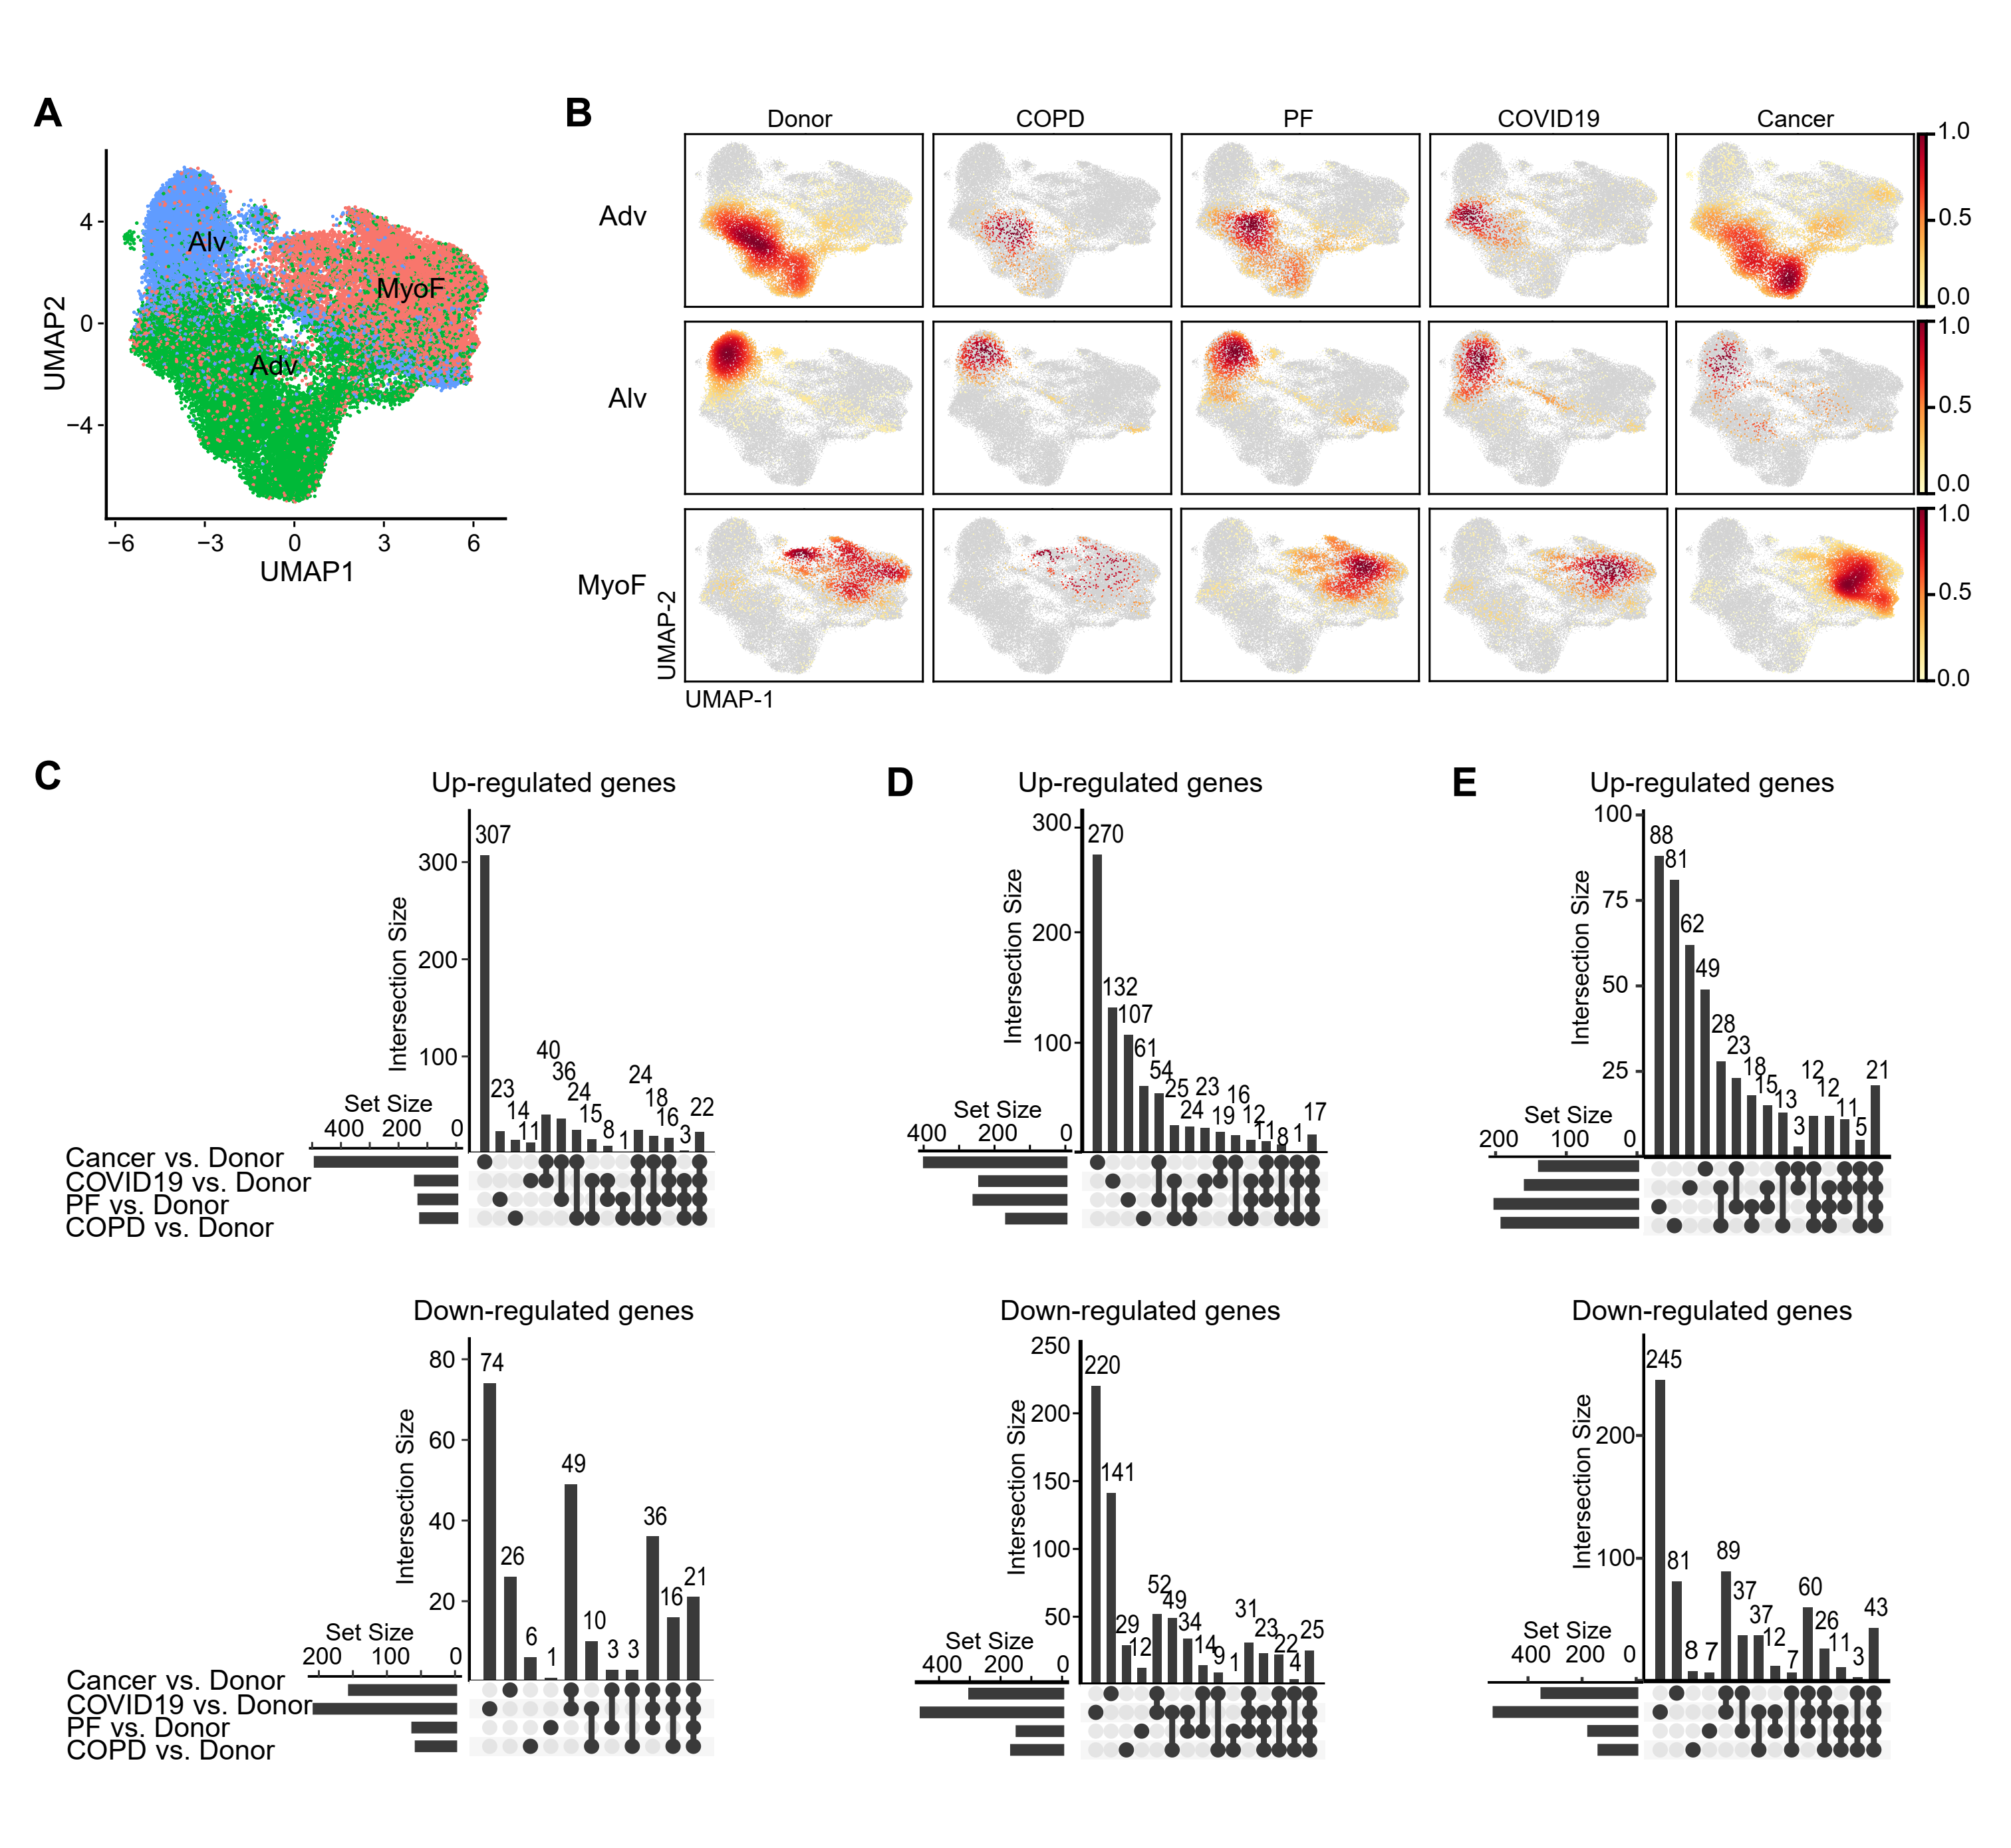
Fig. S3. Disease-specific transcriptional programs distinguish non-cancerous fibroblasts from cancer-associated fibroblasts.
- Joint UMAP embedding of fibroblasts from healthy, COPD, PF, COVID-19, and cancerous lungs.
(B) Density plots showing fibroblast distributions by condition and subtype.
(C–E) UpsetR plots showing up- (upper) and downregulated (lower) DEGs in (C) myofibroblasts, (D) adventitial fibroblasts and (E) alveolar fibroblasts across conditions versus donor, highlighting shared and unique transcriptional responses.
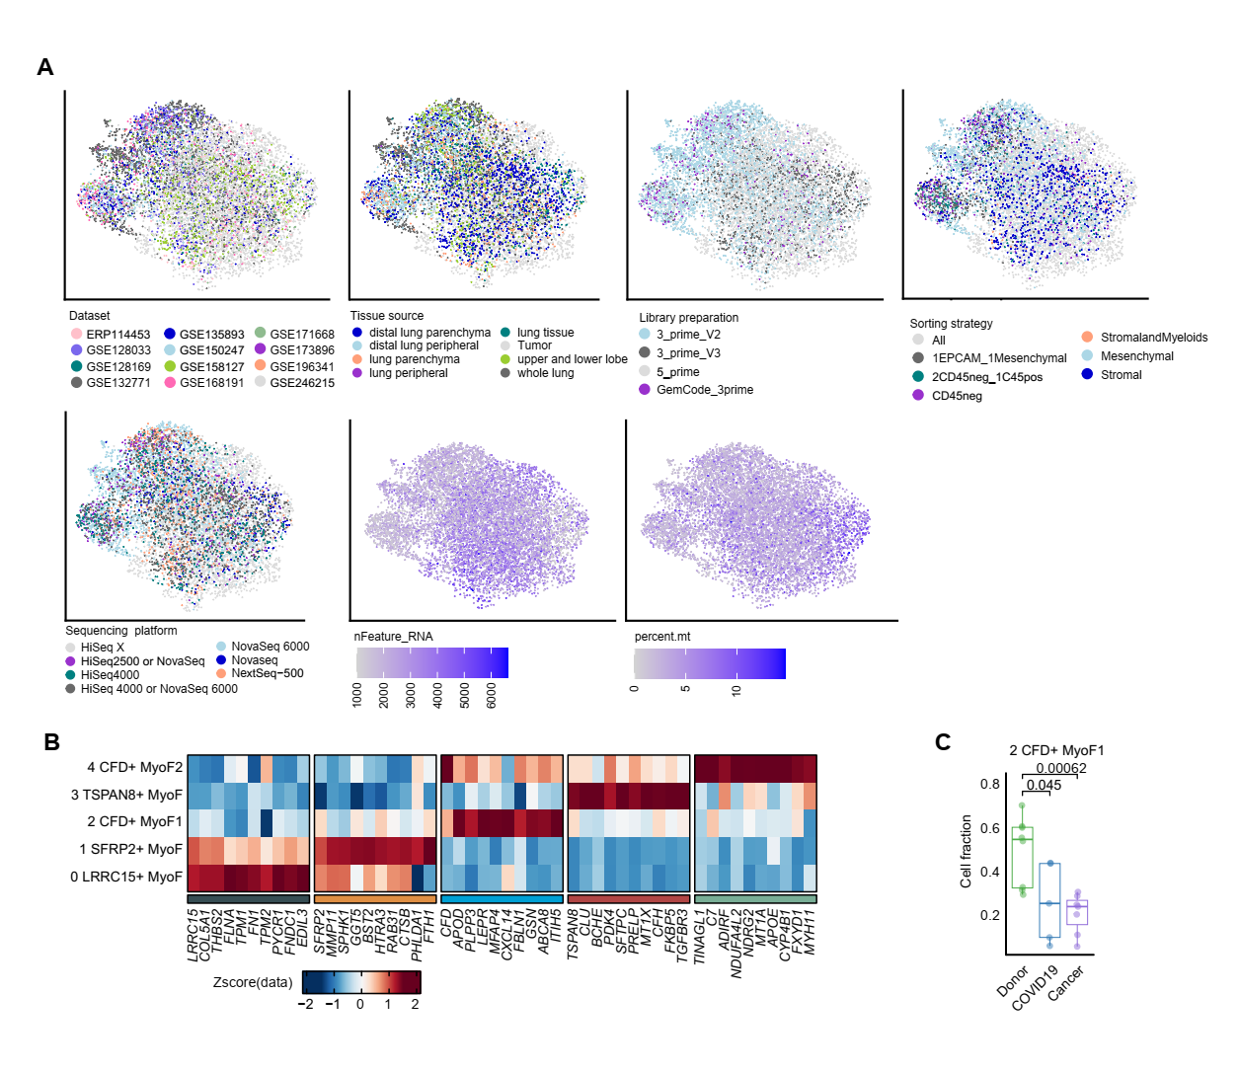
Fig. S4. Intra-subtype heterogeneity and disease-skewed distributions of myofibroblasts across cancer and non-cancer conditions.
(A) Evaluation of technical effects on myofibroblasts subtypes.
(B) Heatmaps showing differentially expressed genes for each subcluster of MyoFs.
(C) Boxplot showing proportions of MyoF subclusters within individual samples, normalized to the total number of MyoF cells per sample.

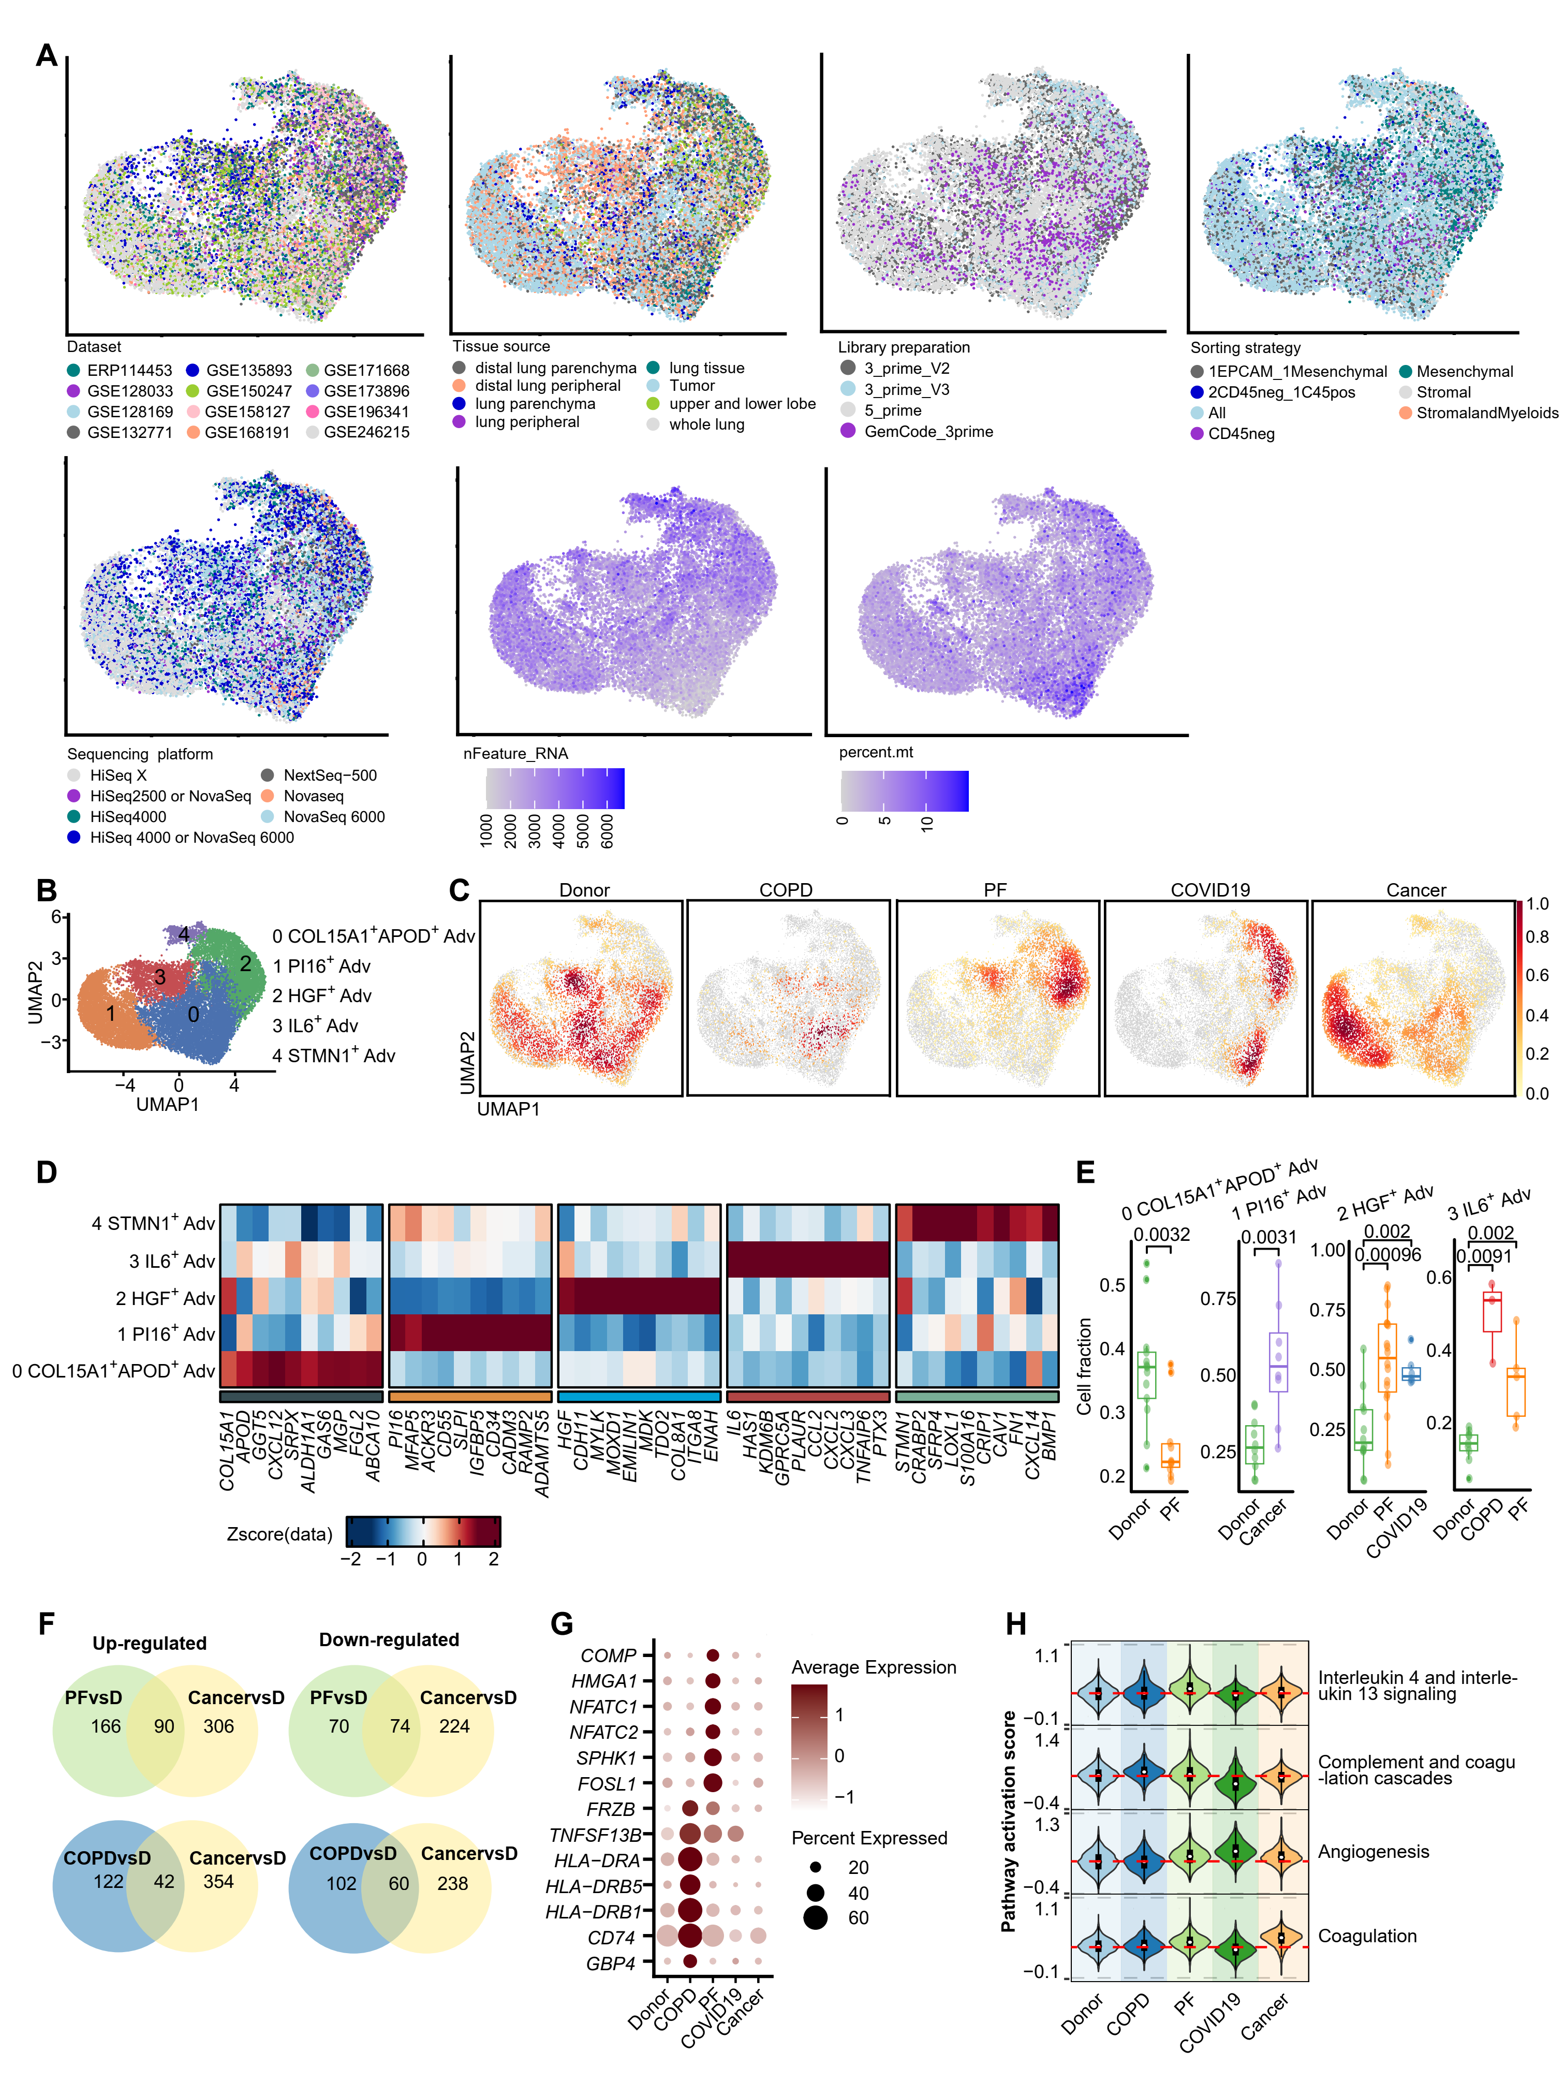
Fig. S5. Intra-subtype heterogeneity and disease-skewed distributions of adventitial fibroblasts across cancer and non-cancer conditions.
(A) Evaluation of technical effects on adventitial fibroblasts subtypes.
(B-C) Re-clustering and density plots of Advs revealing five transcriptionally distinct subclusters with disease-skewed distributions.
(D) Heatmaps showing differentially expressed genes for each subcluster of Advs.
(E) Boxplot showing proportions of Adv subclusters across conditions.
(F) Venn diagrams showing overlap of DEGs in Advs between PF vs. donor and cancer vs. donor, and between COPD vs. donor and cancer vs. donor, separated into up- and downregulated sets.
(G) Dot plot showing PF- and COPD-specific DEGs in Advs relative to other conditions.
(H) Violin plots showing pathway activation scores for key biological processes in Advs across diseases.
Statistical significance: ns, not significant; *p < 0.05; **p < 0.01.

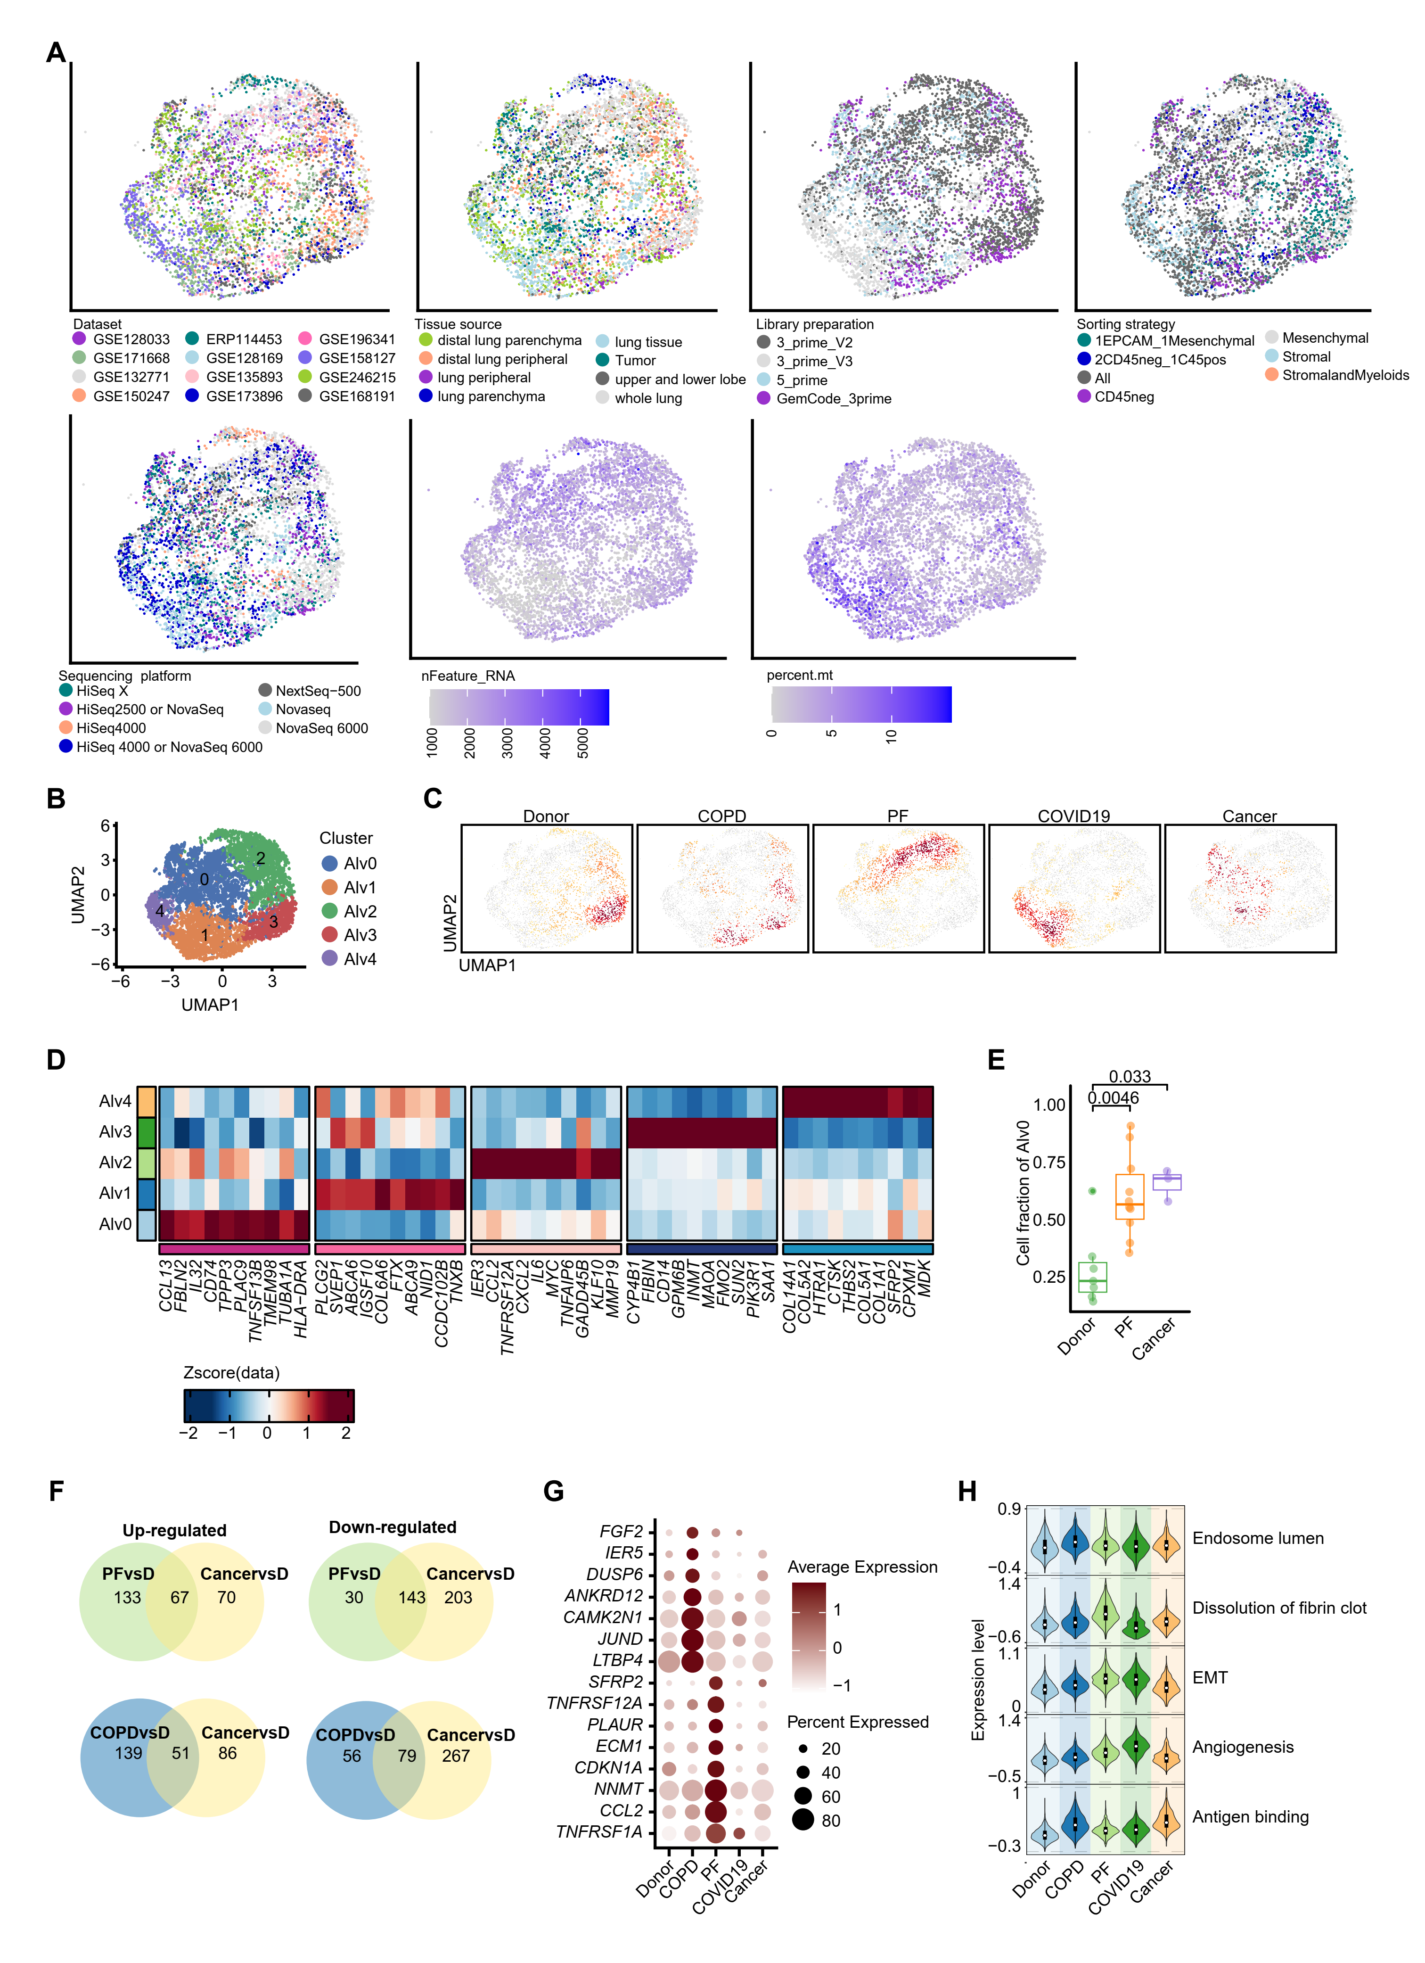
Fig. S6. Intra-subtype heterogeneity and disease-skewed distributions of alveolar fibroblasts across cancer and non-cancer conditions.
(A) Evaluation of technical effects on alveolar fibroblasts subtypes.
- C) Re-clustering and density plots of Alvs revealing five transcriptionally distinct subclusters with disease-skewed distributions.
(D) Heatmaps showing the expression of alveolar fibroblasts subtype marker genes
(E) Boxplot showing proportions of alveolar fibroblasts subclusters within individual samples, normalized to the total number of alveolar fibroblast cells per sample in the five conditions.
(F) Venn diagrams showing overlap of DEGs in Alvs between PF vs. donor and cancer vs. donor, and between COPD vs. donor and cancer vs. donor, separated into up- and downregulated sets.
(G) Dot plot showing PF- and COPD-specific DEGs in Alvs relative to other conditions.
(H) Violin plots showing pathway activation scores for key biological processes in Alvs across diseases.
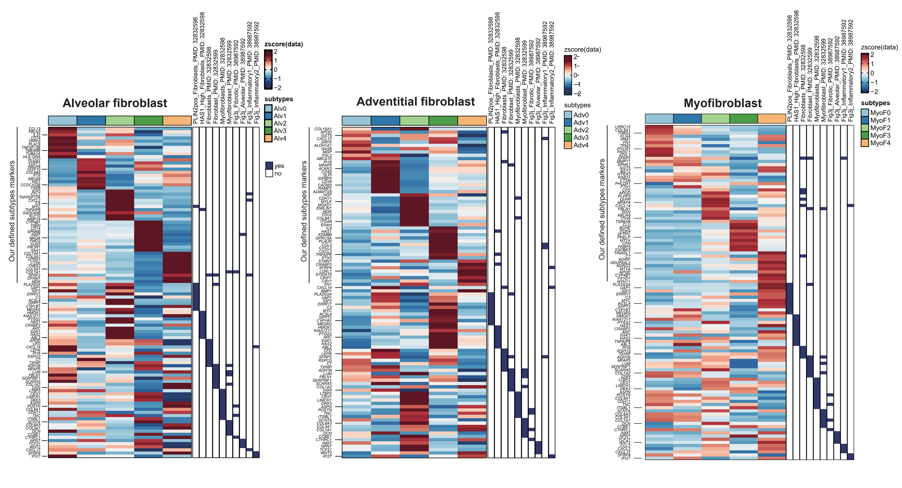Figure S7. Heatmap showing the expression of markers of our defined fibroblast subtypes and previously reported fibroblast states

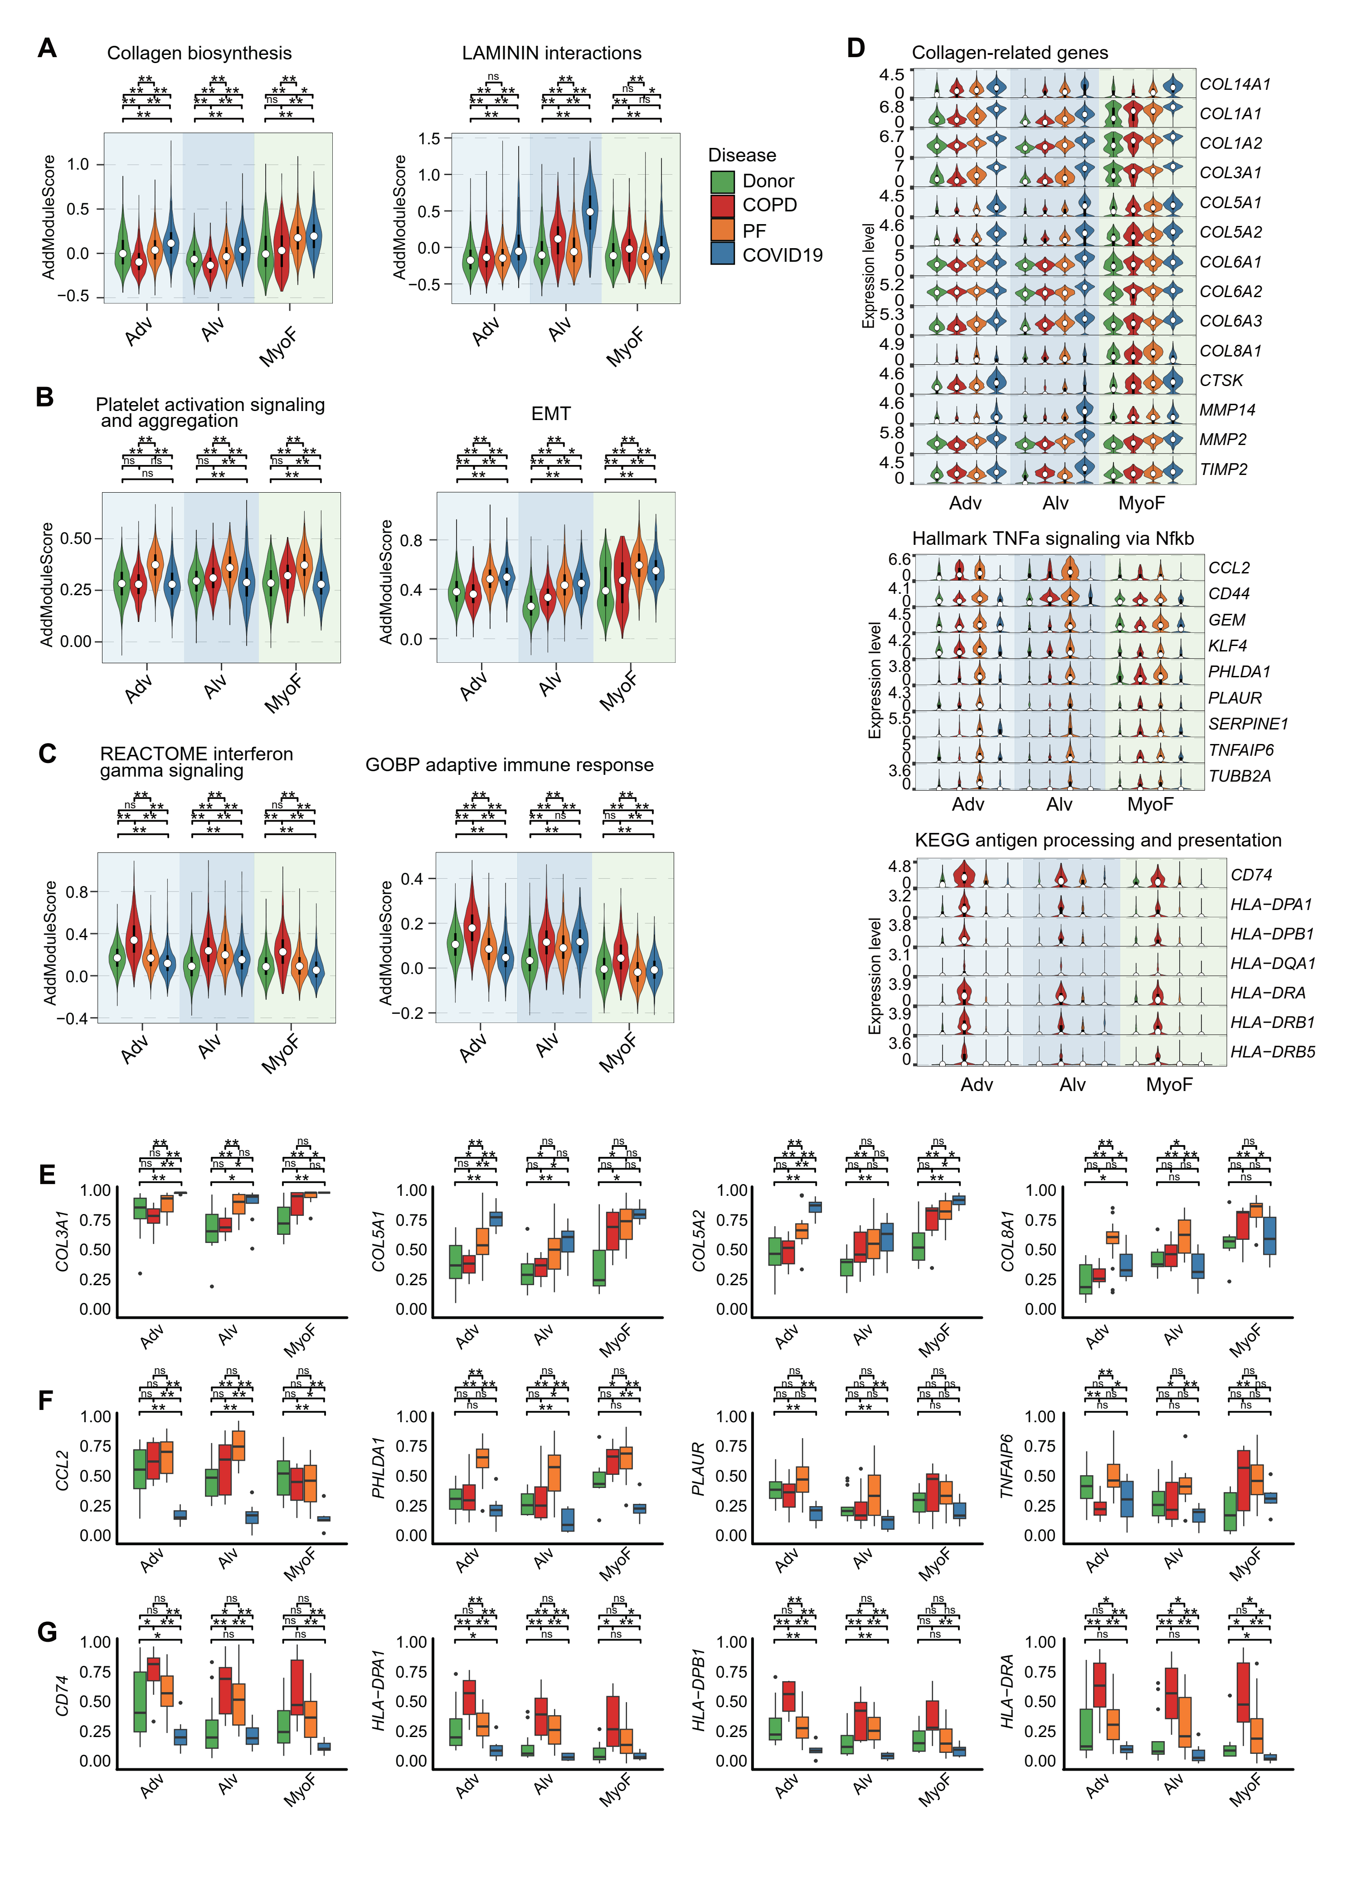
Fig. S8. Disease-specific pathway and gene activation in lung fibroblasts across COVID-19, PF, and COPD.
(A–C) Violin plots showing module scores of pathways upregulated in (A) COVID-19, (B) PF, and (C) COPD fibroblasts.
(D) Violin plots showing representative gene expression within pathways from Figure 2G–I.
(E–G) Boxplots showing the fraction of fibroblast cells expressing pathway genes in individual samples grouped by condition for (E) COVID-19, (F) PF, and (G) COPD.
Statistical significance: ns, not significant; *p < 0.05; **p < 0.01.

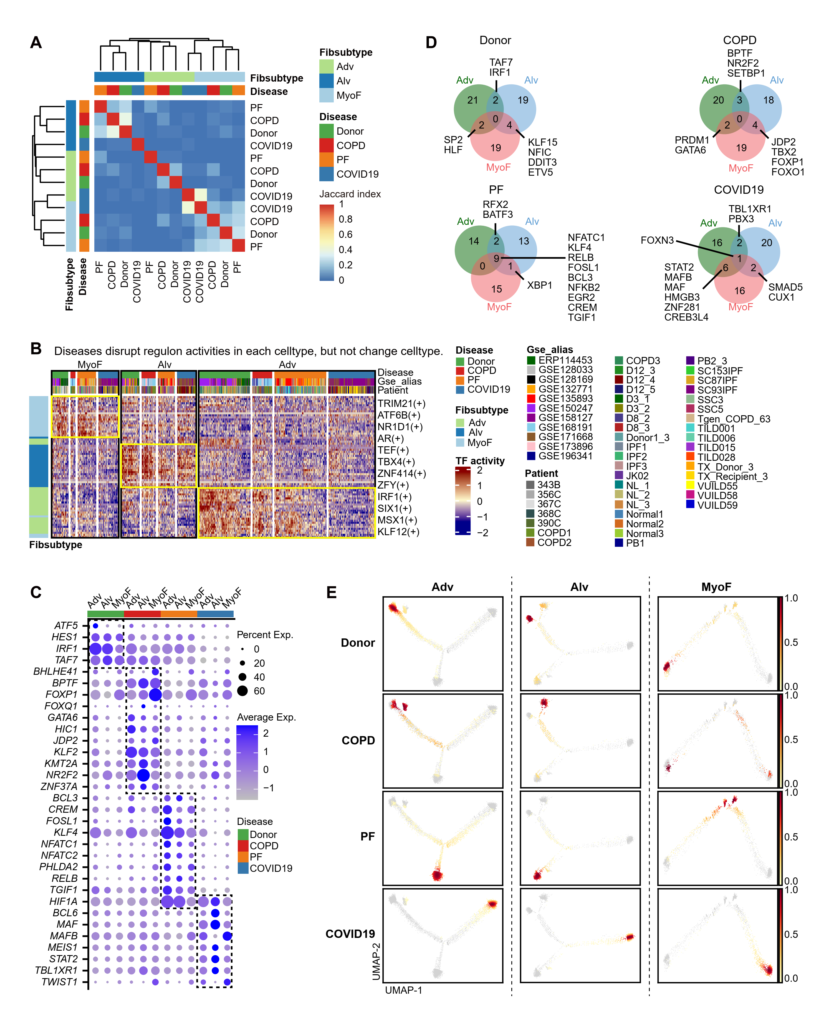
Fig. S9. Subtype-specific transcription factor activity in lung fibroblasts across disease conditions.
(A) Heatmap of pairwise Jaccard indices for top 25 TFs between disease and cell type combinations, revealing subtype-specific regulatory networks.
(B) AUC heatmap showing regulon activity of top 25 TFs in healthy fibroblast subtypes relative to disease conditions (total of 75 TFs), with color scale based on row z-scores.
(C) Dot plot showing expression of disease-specific upregulated TFs.
(D) Venn diagrams showing overlap of top 25 TFs across fibroblast subtypes within each disease.
(E) Density plots showing cell distributions across four conditions on subtype-specific trajectorie

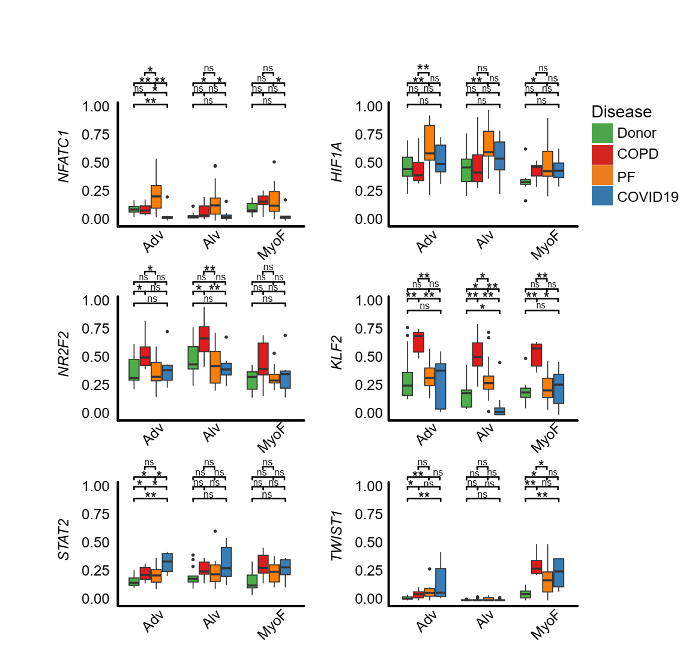
Fig. S10. Expression fraction for selected TFs.

Boxplots showing the fraction of fibroblast cells expressing selected TFs in individual samples grouped by condition.
Statistical significance: ns, not significant; *p < 0.05; **p < 0.01.

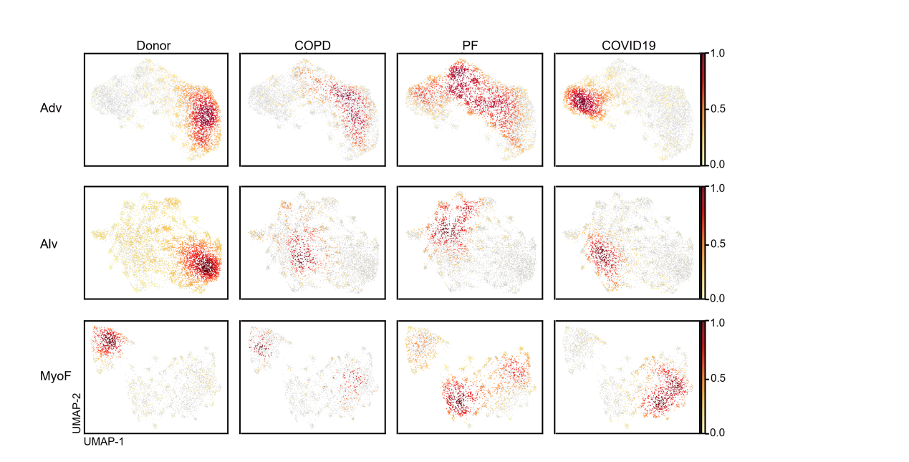
Fig. S11. Single-cell distribution of fibroblasts stratified by chronic and acute fibrosis gene signatures.
Density plots showing the distribution of fibroblast cells across the four conditions, corresponding to the UMAP projections in Figure 4B.

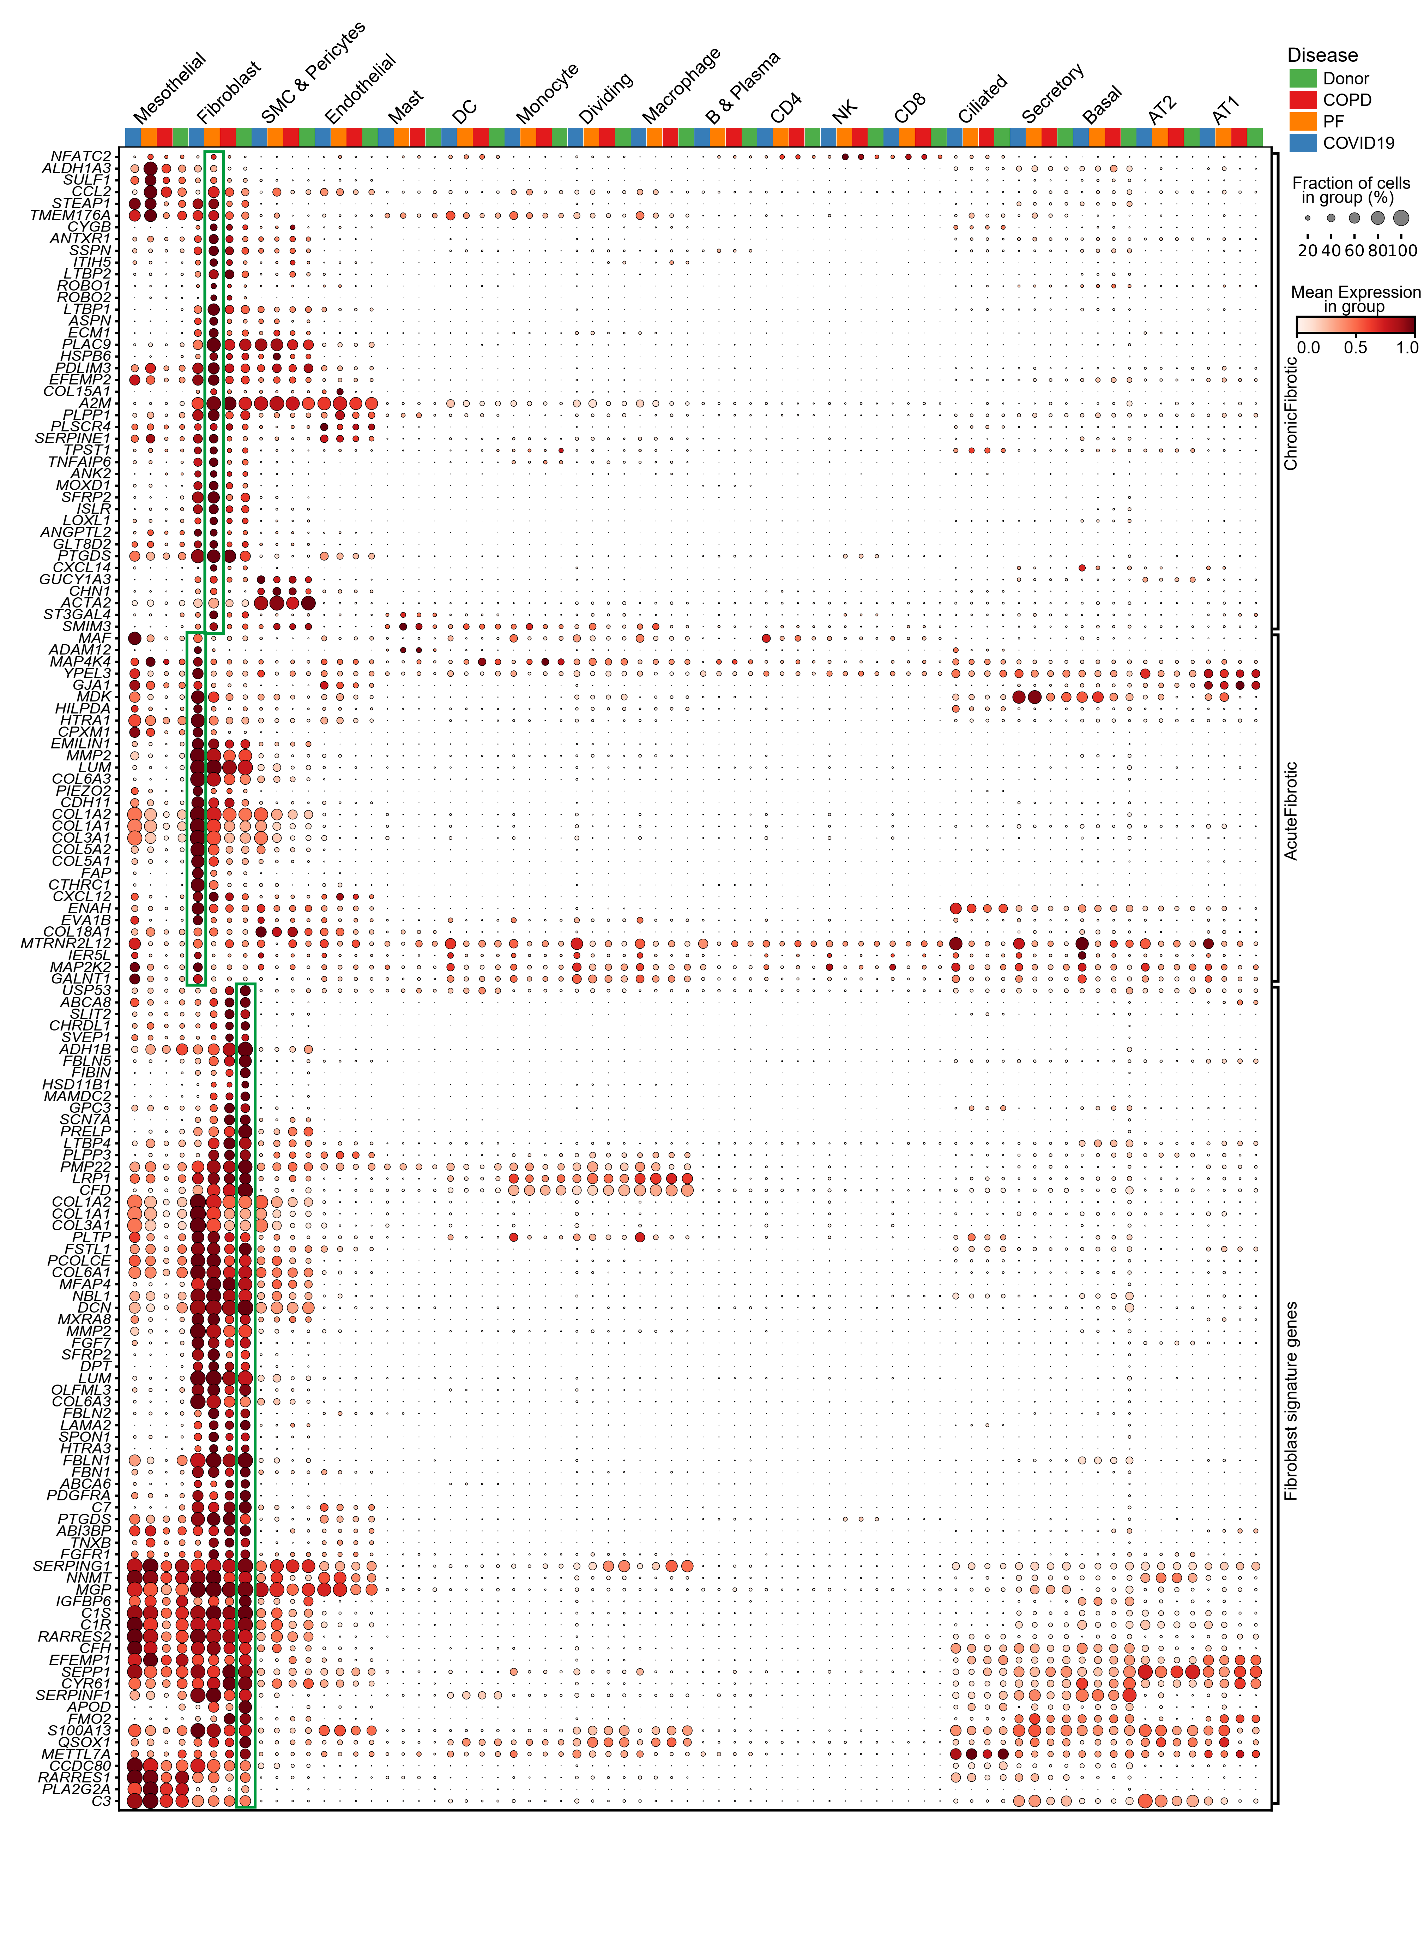
Fig. S12. Cell type- and disease-specific expression patterns of chronic and acute fibrosis gene signatures.
Dot plots showing the expression of chronic fibrosis signature genes, acute fibrosis signature genes, and fibroblast markers across all cell types and disease conditions. Circle size represents the proportion of expressing cells, and color reflects the average expression level (row z-score).

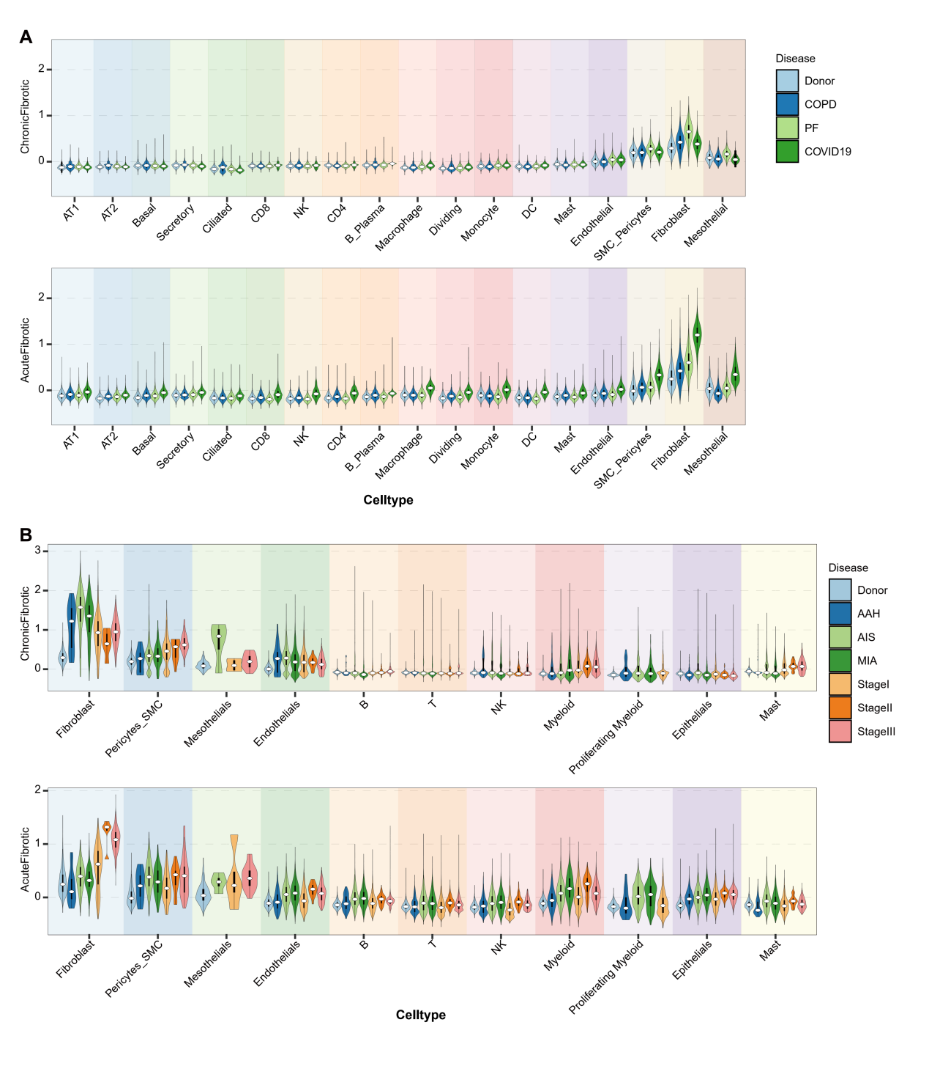
Fig. S13. Predominant expression and dynamics of chronic and acute fibrosis gene signatures in lung fibroblasts.
(A) Module scores of chronic and acute fibrosis gene signatures across all major lung cell types from donor, COPD, PF, and COVID-19 samples, corresponding to Figure 4C.
(B) Dynamics of chronic and acute fibrosis signature expression across all cell types during lung adenocarcinoma progression, corresponding to Figure 4D.

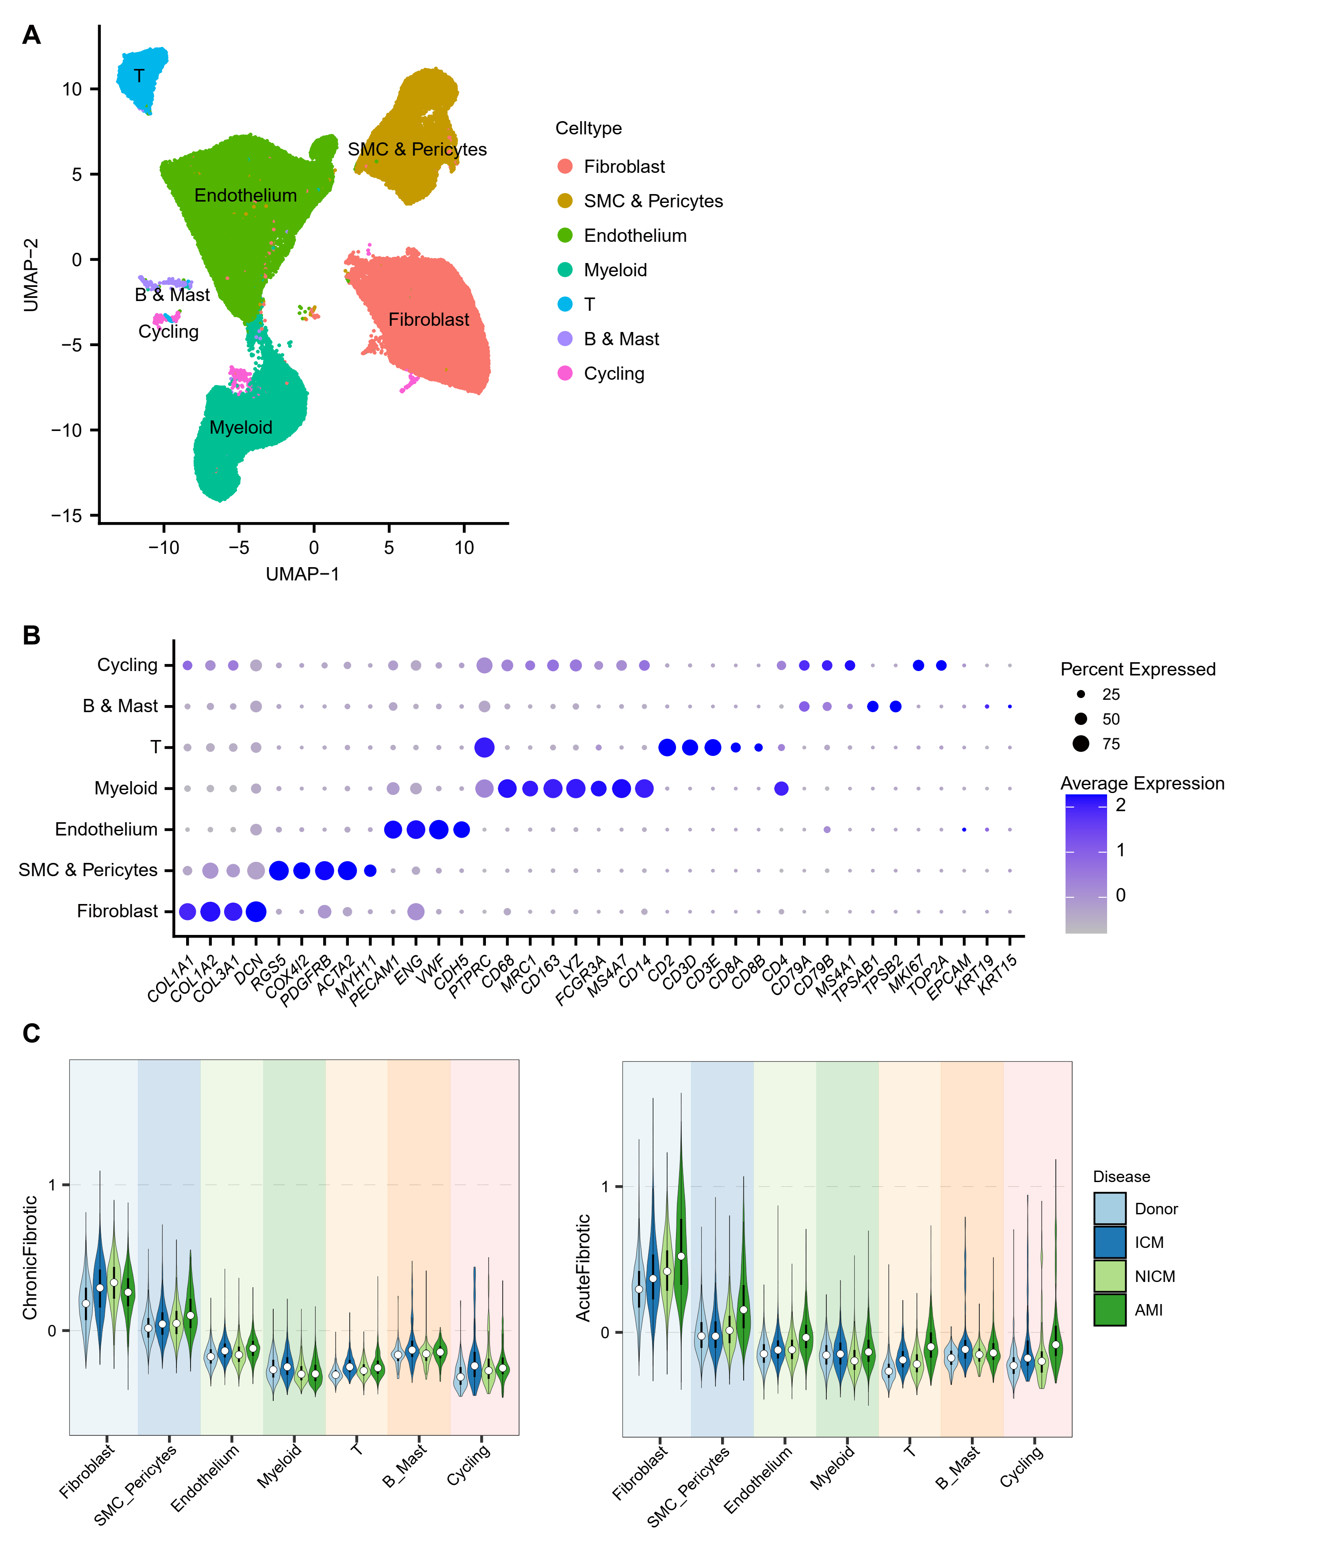
Fig. S14. Cross-tissue validation of chronic and acute fibrosis gene signatures in cardiac fibroblasts.
(A) UMAP visualization of all cell types from the single-cell RNA-seq dataset GSE217494.
(B) Bubble plot illustrating the expression of canonical marker genes across cell types defined in panel A. Circle size indicates the proportion of expressing cells, and color represents average expression level (column z-score).
(C) Module scores of chronic and acute fibrosis gene signatures across all cell types from heart samples, corresponding to Figure 4F.

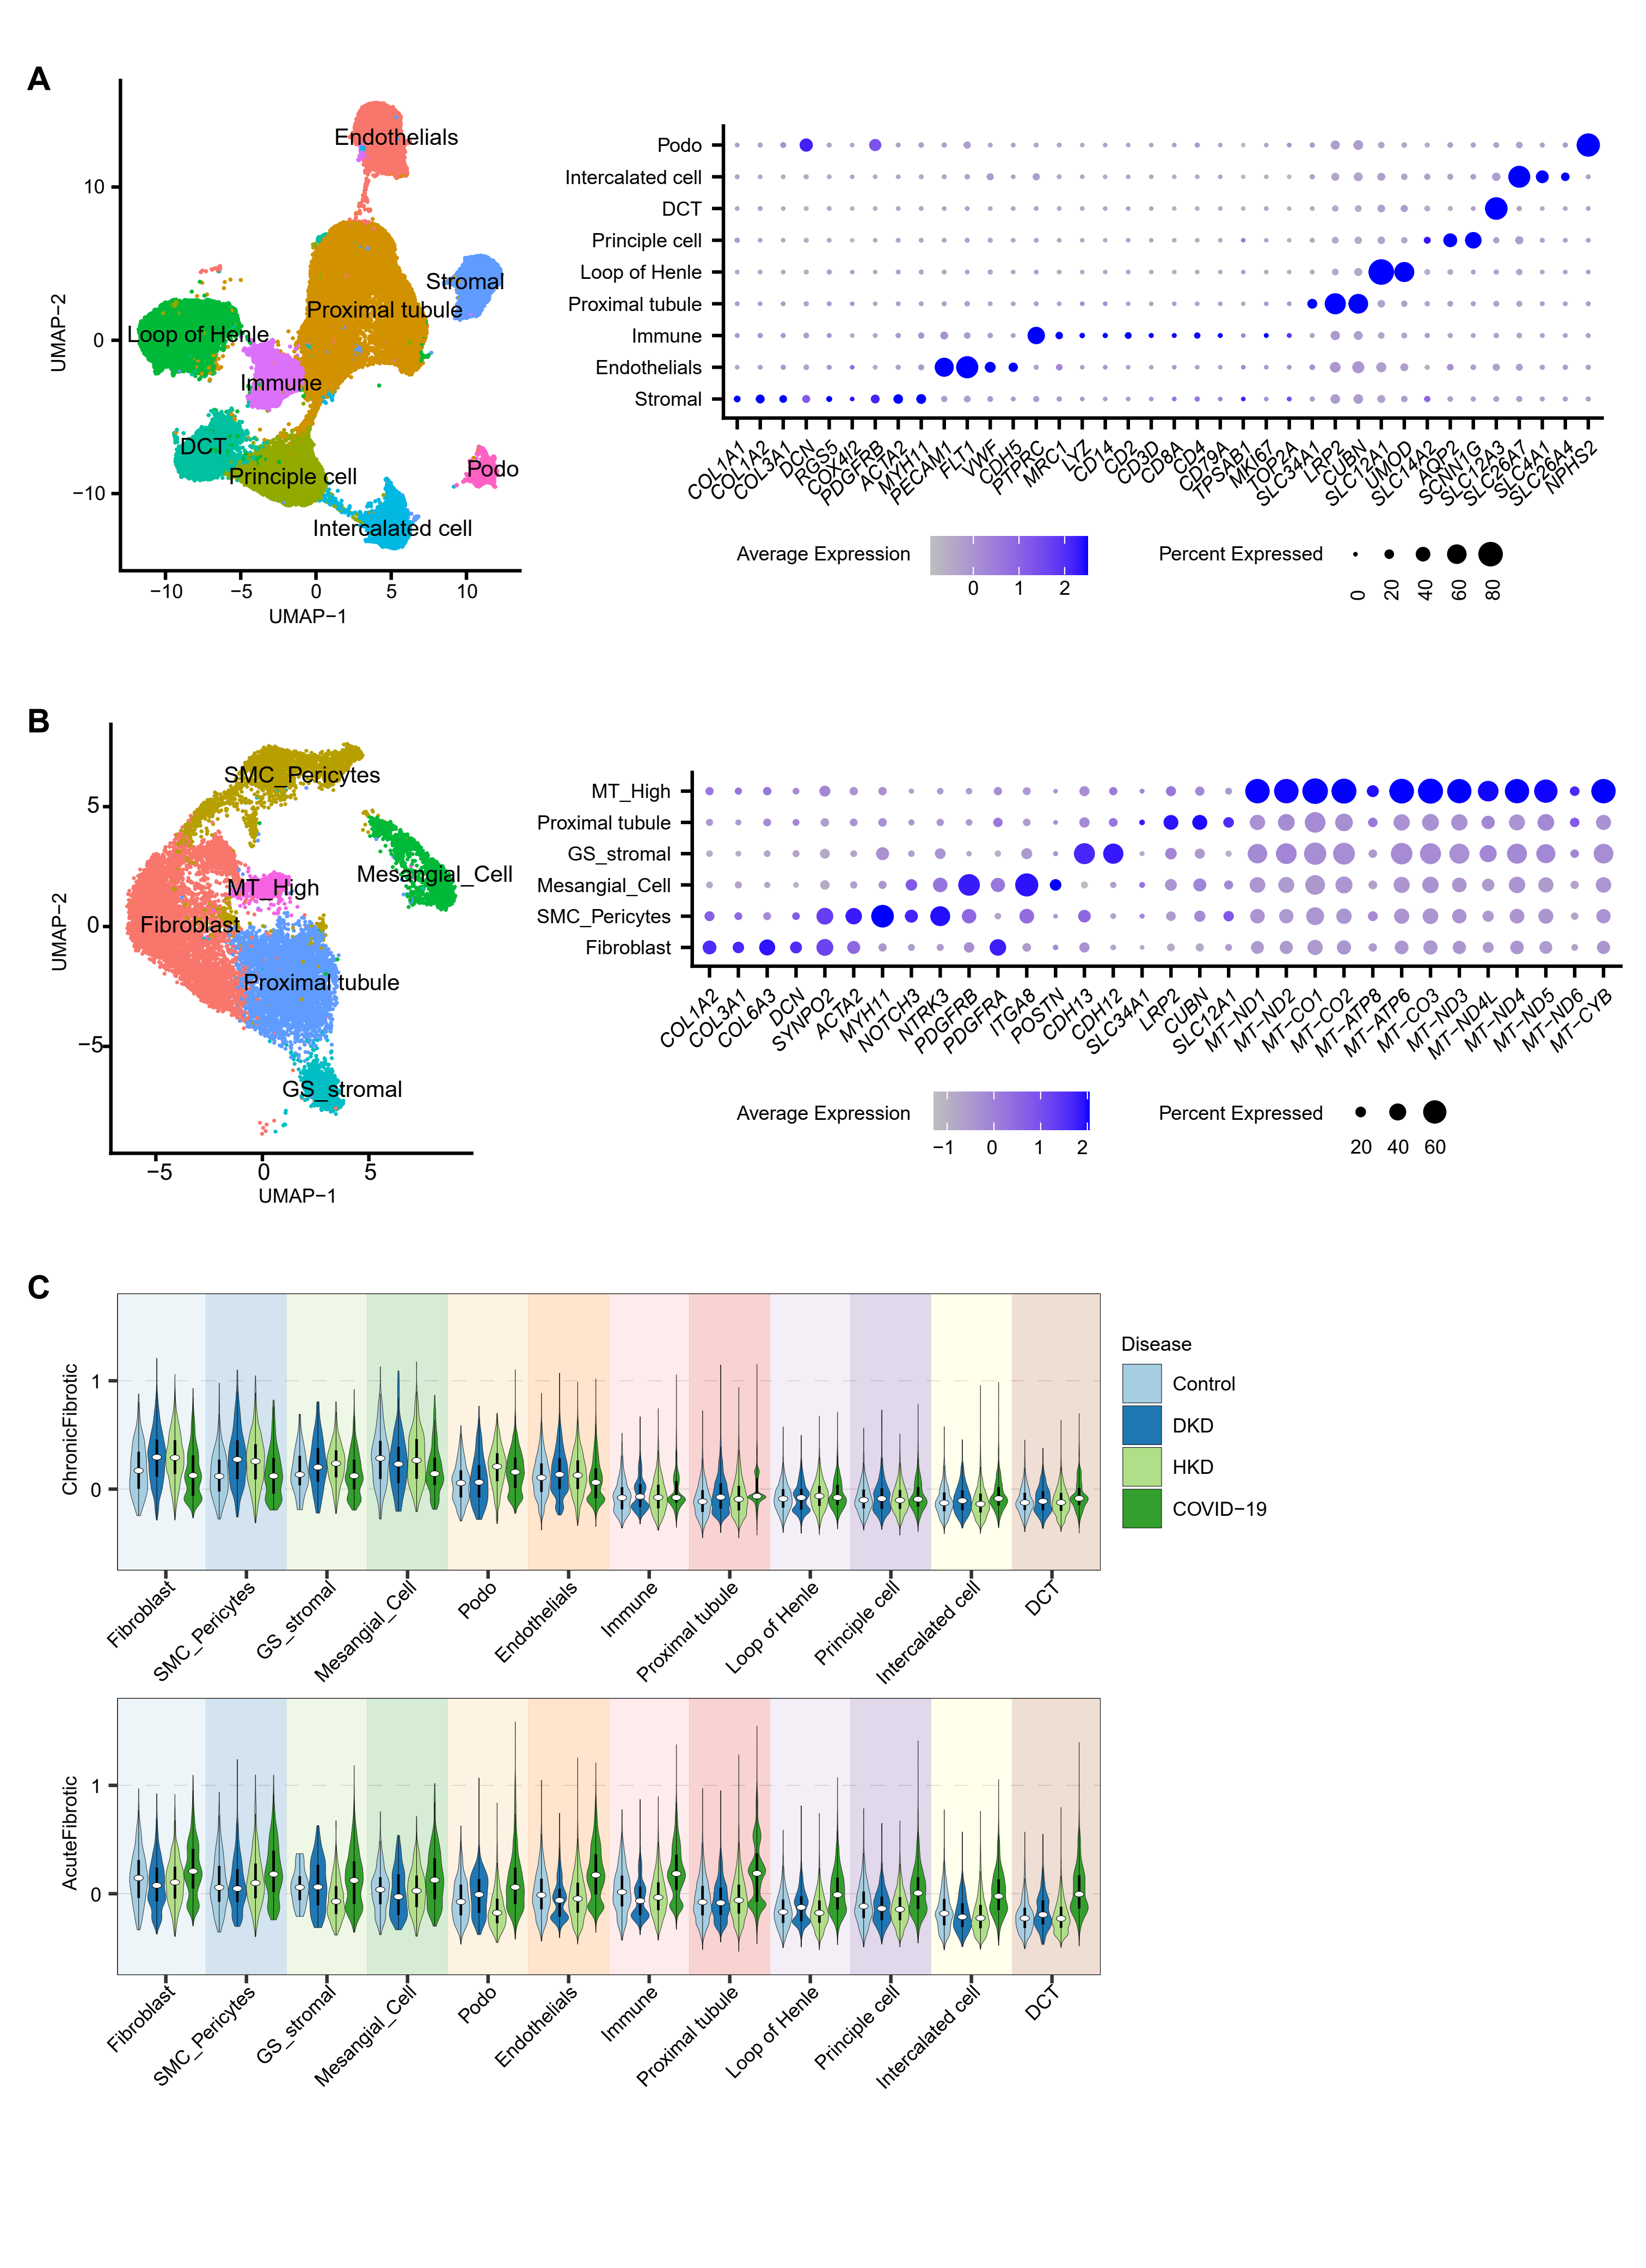
Fig. S15. Cross-tissue validation of chronic and acute fibrosis gene signatures in kidney fibroblasts..
(A) UMAP visualization of all cell types and bubble plot of canonical marker gene expression in single-cell RNA-seq datasets GSE171668 and GSE211785. Circle size represents the proportion of expressing cells, and color reflects average expression level (column z-score).
(B) Re-clustering of stromal cells, with UMAP plots showing subclusters and bubble plot showing corresponding marker gene expression.
(C) Module scores of chronic and acute fibrosis gene signatures across all cell types from kidney samples, corresponding to Figure 4G.

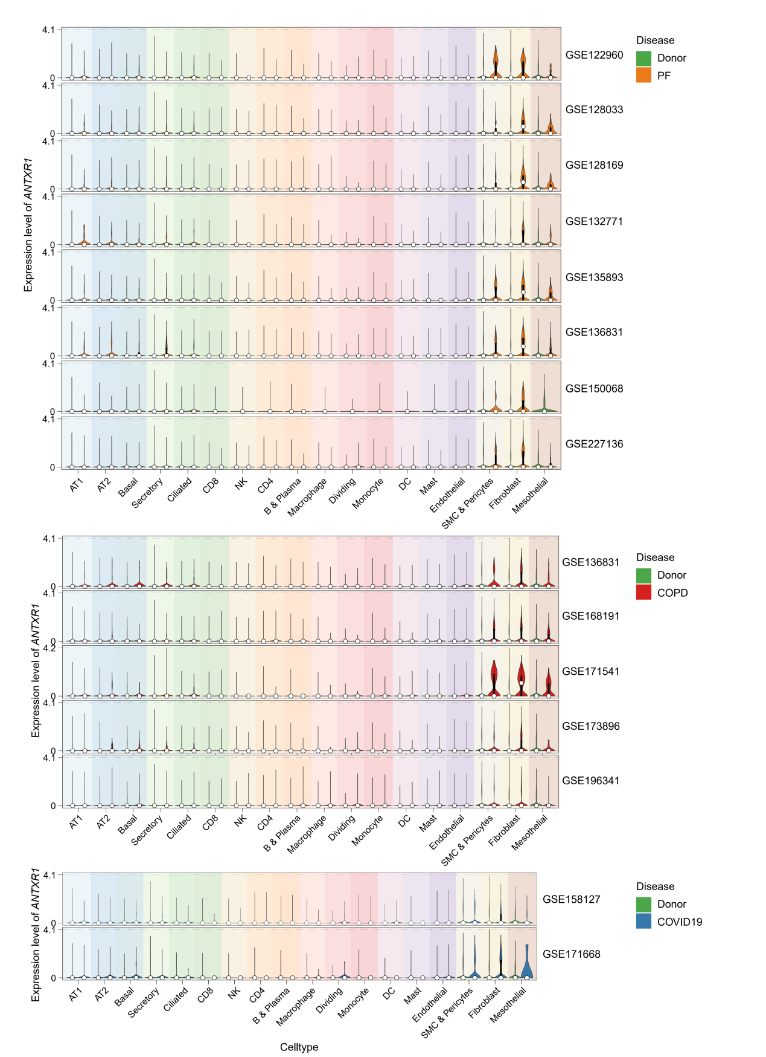
Fig. S16. Expression of ANTXR1 across all cell types in individual human scRNA-seq datasets.
Violin plots showing ANTXR1 expression across all major cell types in each human scRNA-seq dataset. The upper panel shows eight PF datasets, the middle panel shows five COPD datasets, and the bottom panel shows two COVID-19 datasets, each including both donor and disease groups.

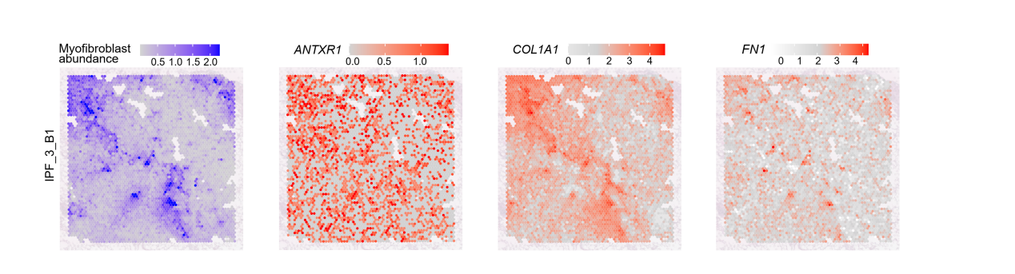
Fig. S17. Spatial transcriptomic validation of ANTXR1 in an independent IPF lung section.
Representative spatial transcriptomics maps from a second IPF lung section showing the spatial distribution of myofibroblast abundance and expression of ANTXR1, COL1A1, and FN1.

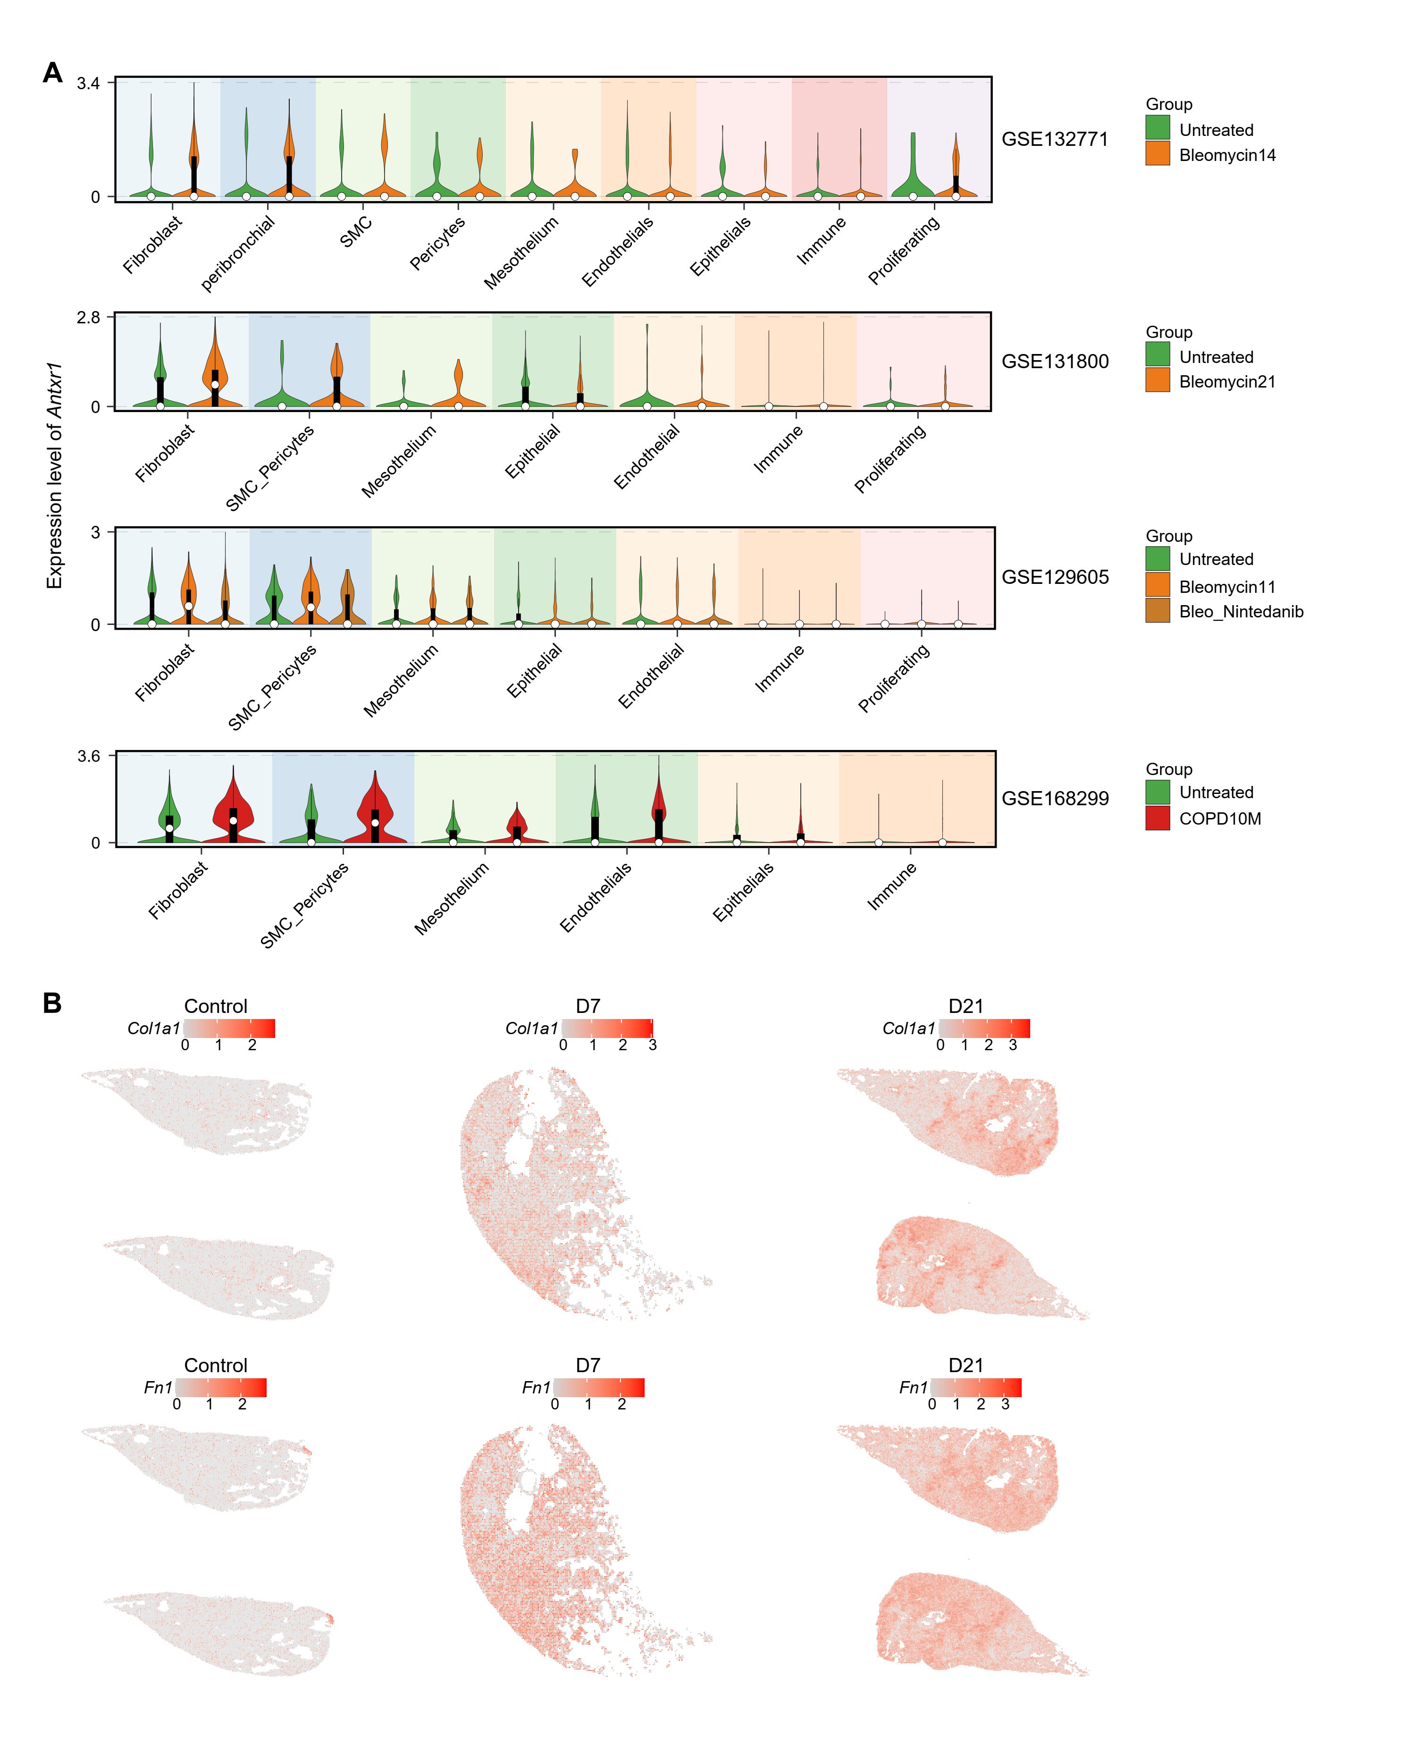
Fig. S18. Validation of Antxr1 expression in murine models of pulmonary fibrosis.
(A) Violin plots showing Antxr1 expression across all major cell types in three independent murine scRNA-seq datasets of bleomycin-induced pulmonary fibrosis and one murine dataset of cigarette smoke-exposed lungs.
(B) Spatial transcriptomic maps of mouse lungs showing expression of Col1a1 and Fn1 in control, 7-day, and 21-day post-bleomycin treatment samples, corresponding to Figure 5E.

