Figure S1. STARD flow diagram of patient selection and the integrated workflow for hereditary cancer syndrome identification

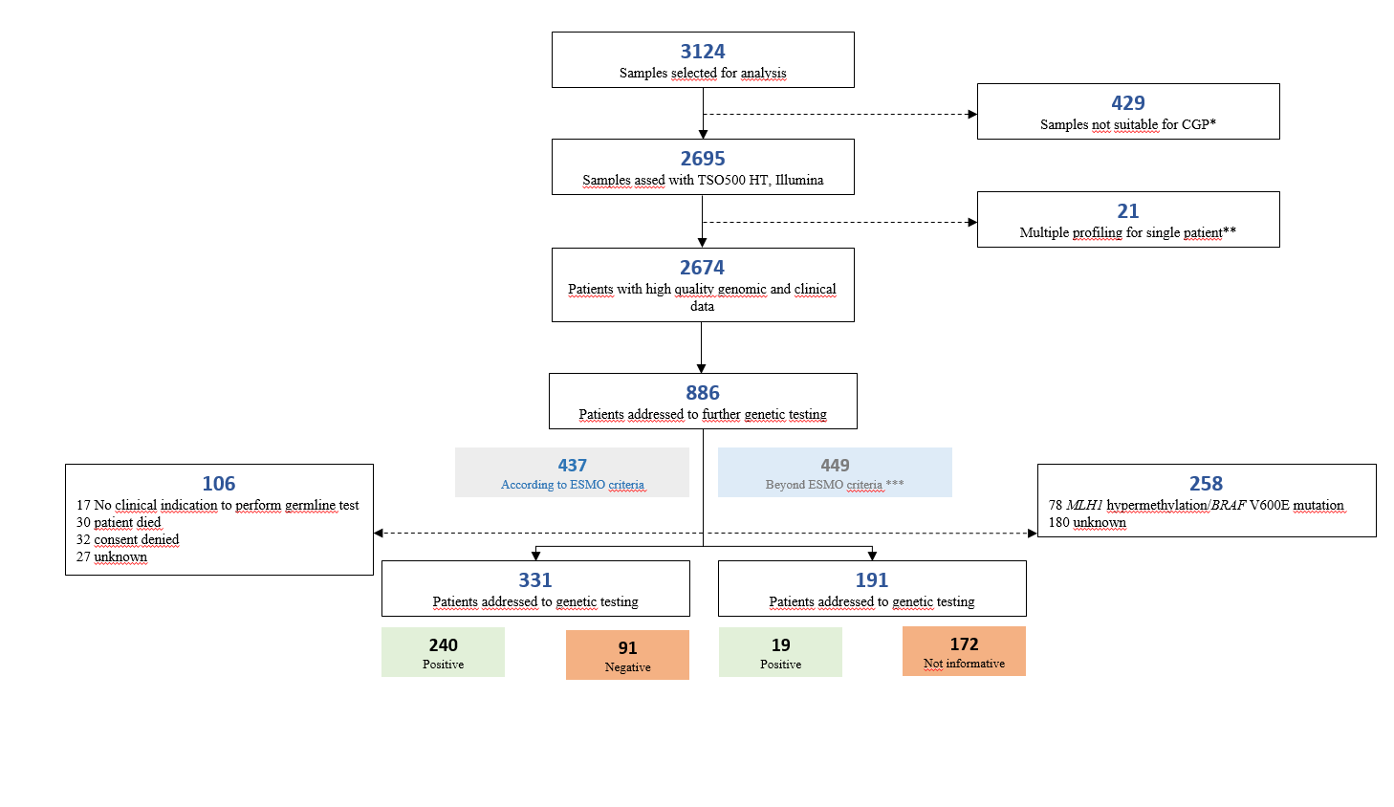
CGP=cancer genome profiling
* Samples not reaching 20 ng of DNA/RNA were switched to other assays: Thermofisher oncomine focus (n=151), Myriapod Diatech (n=17), TSO500 Illumina Virtual Panel (N=120), Devyser BRCA (n= 114), Thermofisher Oncomine Precision (n=6),
AMOYDX-Real Time (n=2), 19 none
** Samples from synchronous tumors (n=14) and multiple profiling from the same tumor (n=7)
*** MLPA analysis of BRCA1/2 (n=241), dMMR status (n=142), suggestive personal and/or family history (n=66)

Figure S1. The STARD diagram illustrates the number of patients referred for CGP (n = 3,124) and those with a complete report available (n = 2,674), excluding cases with synchronous tumors (n = 14) or multiple profiling analyses performed on the same tumor (n = 7). Overall, 886 patients were referred for further genetic evaluation: 437 according to ESMO criteria and 449 outside these criteria. Subsequently, 331 and 191 patients, respectively, underwent germline genetic testing, which led to the identification of hereditary cancer syndromes in 240 and 19 patients, respectively.

Figure S2. Constitutional Variant Testing Results by Cancer Type and Gene
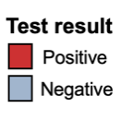
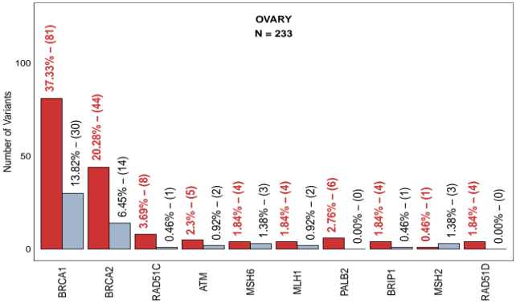
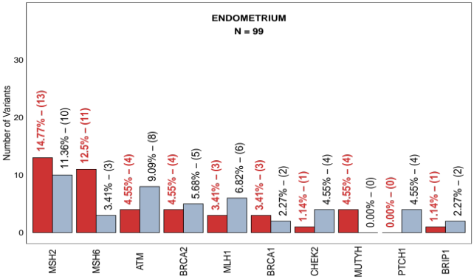
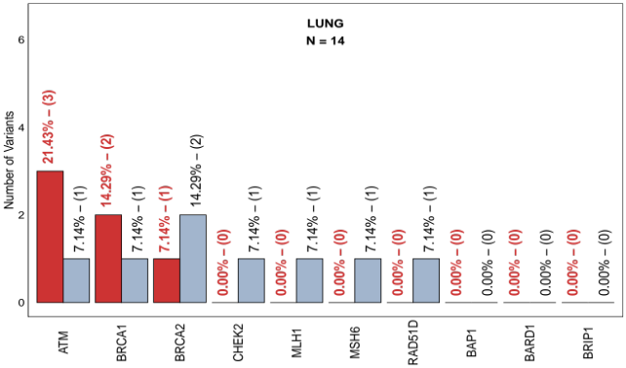
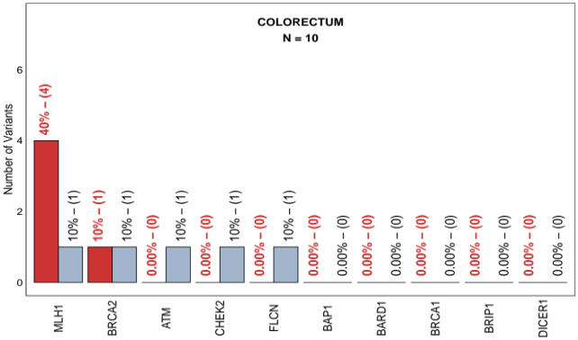
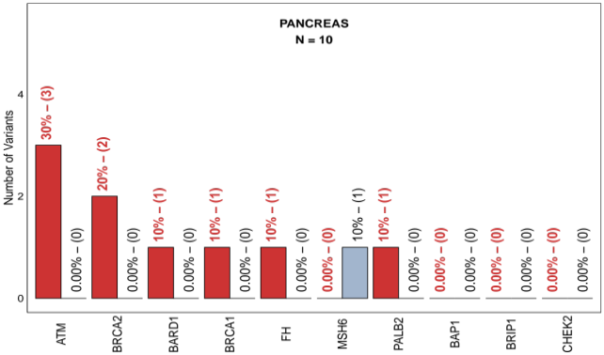
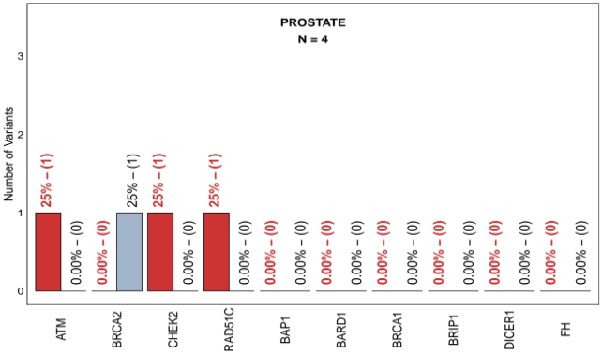
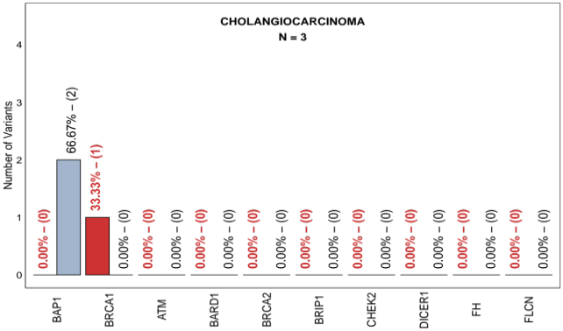
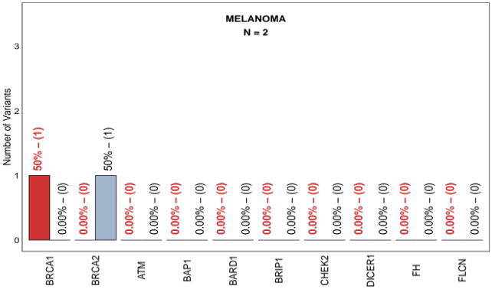
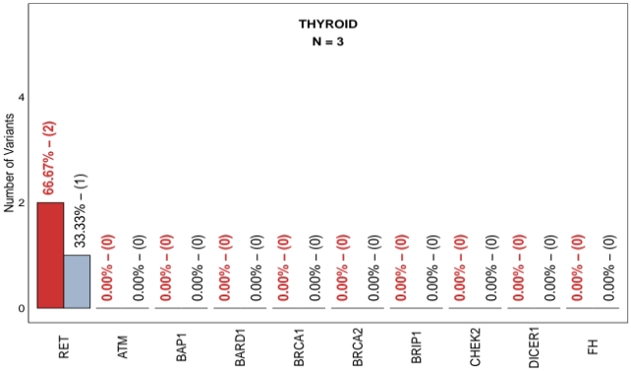
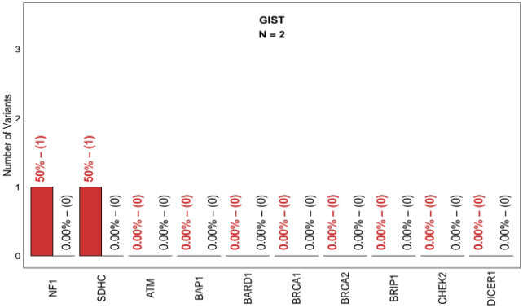
Figure S2. This figure shows the number of germline variants tested across various types of cancer. Each panel represents a different cancer type (e.g., ovarian, endometrial, lung), with the total number of tested candidate variants indicated at the top (e.g., N = 233 for ovarian cancer). The x-axis lists the top 10 most frequently mutated genes, while the y-axis represents the number of detected variants. The bar plots display two columns for each gene: positive test results (red bars) and negative test results (grey bars). Above red/grey bars, the percentage of positive/negative tests for that gene relative to the total number of variants tested for that specific neoplasm is provided in red/black text, followed by the absolute count of positive/negative variants in parentheses for that specific gene.

Figure S3. Landscape of germline variants across multiple cancer types
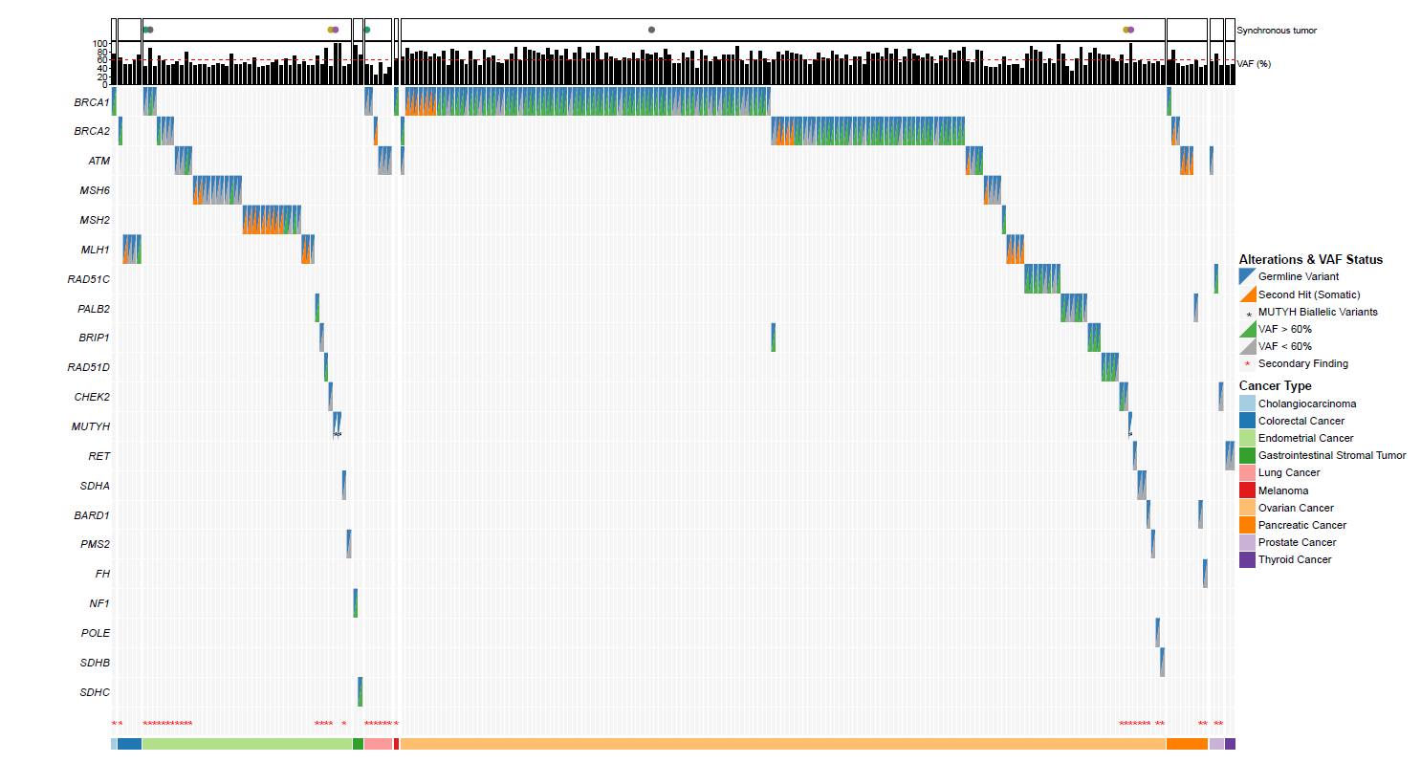
Figure S3. The oncoplot summarizes the genetic alteration profiles of somatic variants with constitutional confirmation, stratified by cancer type. Upper annotations indicate the presence of synchronous tumors and the variant allele frequency (VAF, %) for each variant, with a dashed red line marking the 60% VAF threshold. In the main heatmap, each row represents a specific gene and each column corresponds to an individual patient. Blue shading indicates a germline variant, whereas orange shading denotes a second-hit (somatic) event. Green boxes represent germline variants with a VAF > 60%, while grey boxes indicate a VAF ≤ 60%. Black asterisks in the MUTYH row identify biallelic MUTYH variants. A dedicated row at the bottom of the heatmap uses red asterisks to highlight cases classified as secondary findings. The bottom color bar indicates each patient’s cancer type.

Figure S4. Distribution of all constitutional pathogenic variants by gene

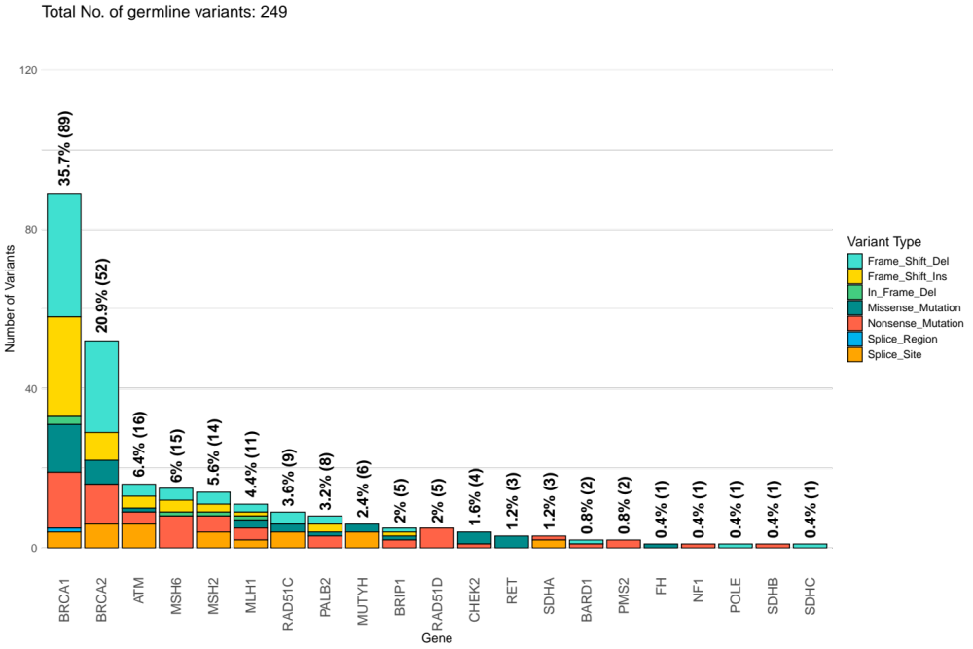

Figure S4. This figure shows the number of constitutional variants detected across multiple cancer types. The x-axis lists the genes, while the y-axis represents the total number of detected constitutional variants considering all the neoplasms. Bars are color-coded to indicate the different variant types, as shown in the legend on the right. Each bar is stacked to reflect the contribution of each variant type to the total variant count for a given gene. At the top of each bar, the percentage of the total number of variants for the corresponding gene relative to the overall total of 249 constitutional variants is displayed in black. The total number of variants for every gene is also reported in brackets.

