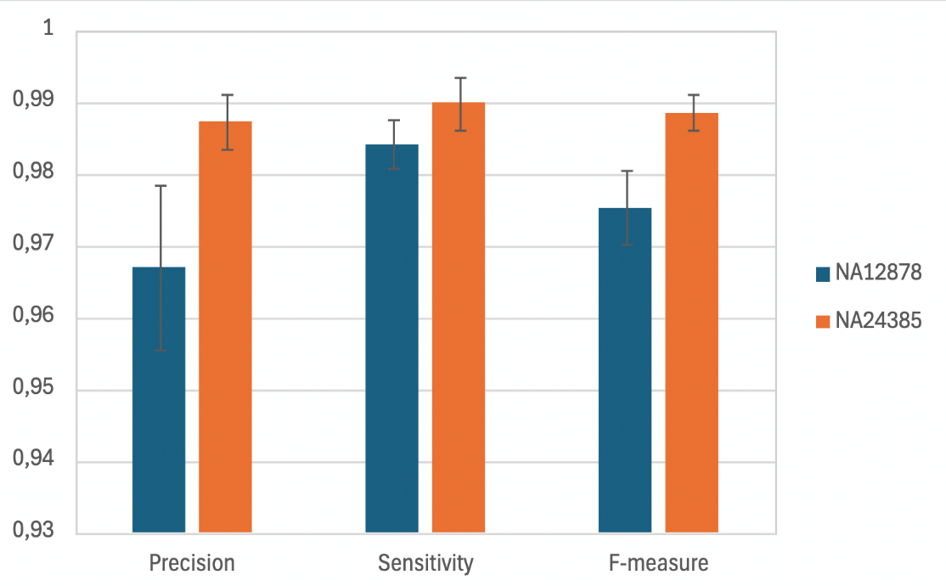
Fig S1 : Performance of SNVs and indels detection across the 8 genetic centers.

Additional Figure 1. Mean precision, sensitivity and F-measure for the detection of SNVs/indels using GS for the two Genome-In-A-Bottle cell lines, HG001 (=NA12878, in blue) and HG002 (=NA24385, in orange), across the 8 genetic centers. The error bars represent the standard deviation of the values in the different genetic centers.
Abbreviations: GS, genome sequencing; SNV, single nucleotide variant.

Fig S2: Study flow diagram.
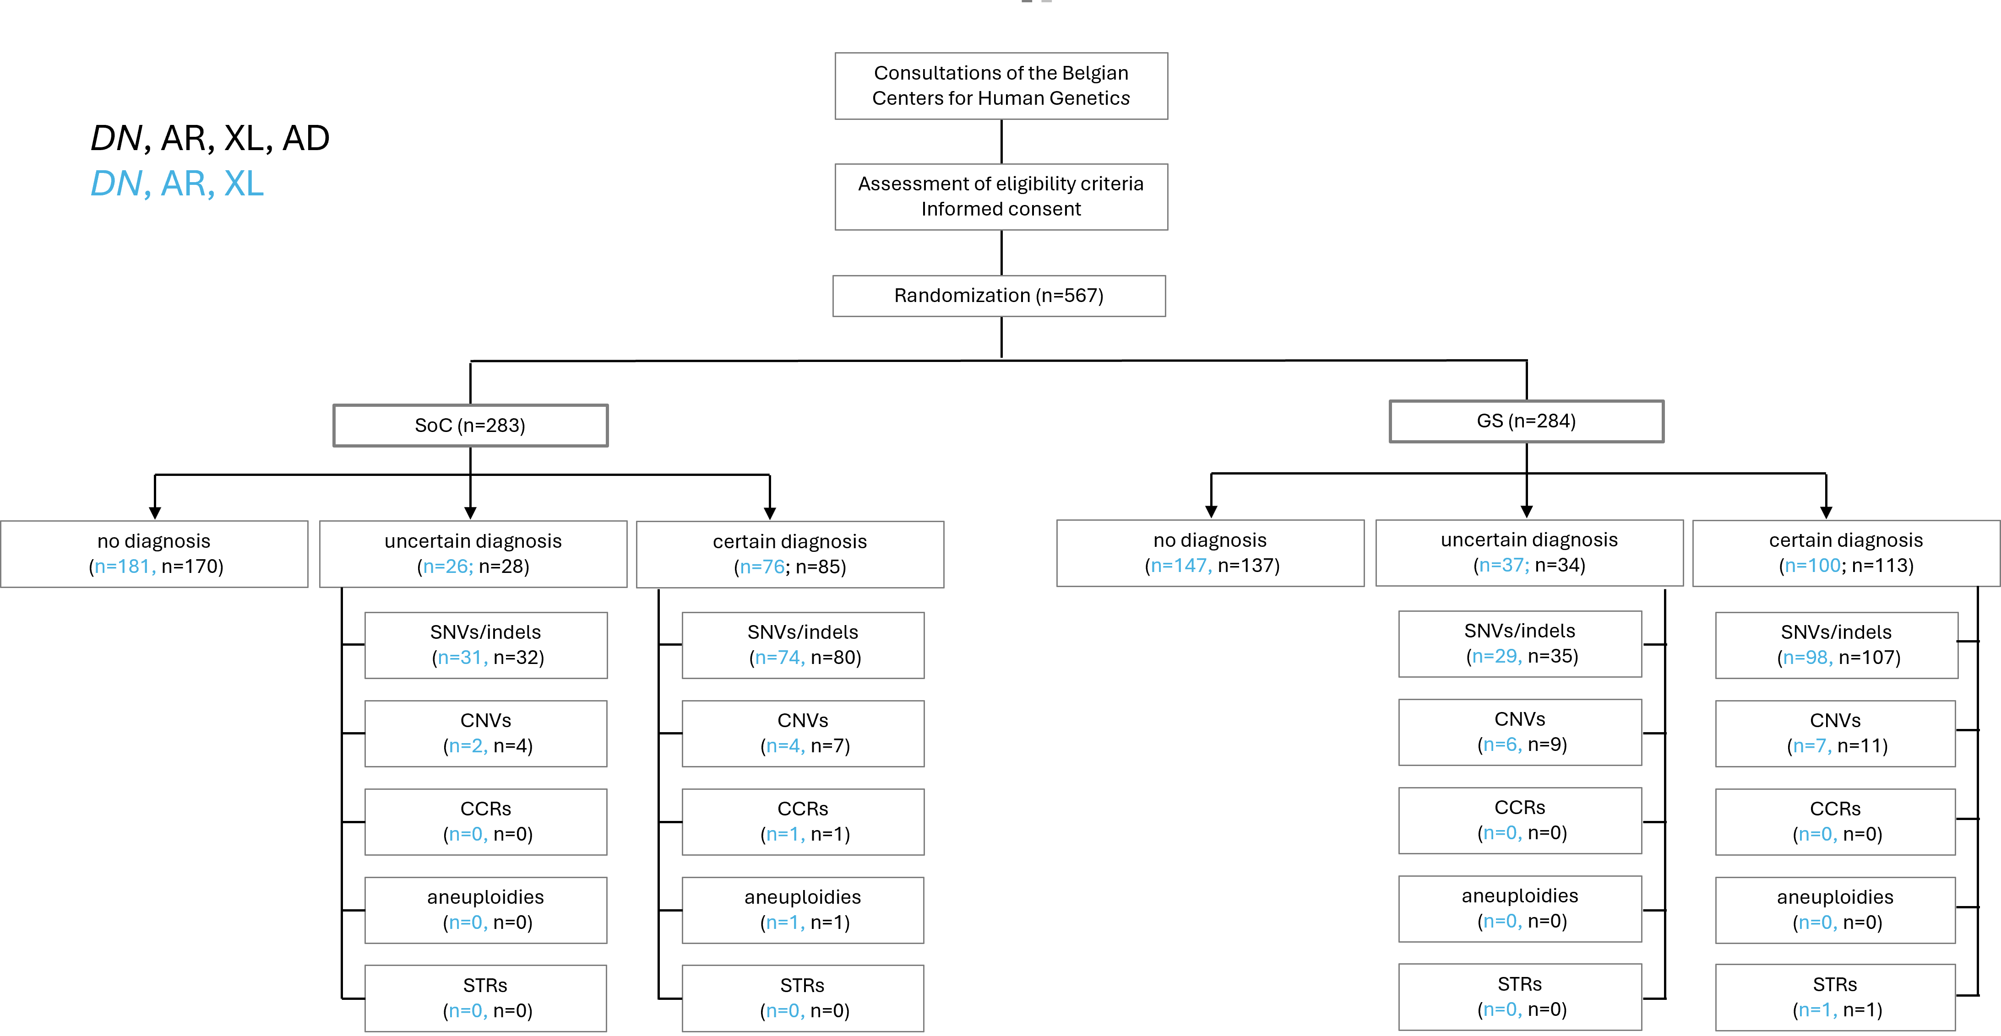

Additional Figure 2. Distribution of included probands in both study arms as well as primary outcome for each individual, being the absence of a diagnosis, an uncertain diagnosis or a certain diagnosis. In addition, the numbers of identified variants are given for each variant subtype. The numbers are given without analysis of AD inherited variants in blue, and after completing this analysis in black.
For the primary outcome, probands in which both a certain diagnosis and an additional uncertain diagnosis were identified, are only accounted in the certain diagnosis group. For the variant types, each identified variant is taken into account. Since multiple variants were identified in some probands, the total amounts of variants may differ from the total amount of probands with a diagnosis.
Abbreviations: AD, autosomal dominant inherited; AR, autosomal recessive inherited; DN, de novo; CCR, complex chromosomal rearrangement; CNV, copy number variant; GS, genome sequencing; SoC, standard of care; SNV, single nucleotide variant; STR, short tandem repeat; SV, structural variant; XL, X-linked inherited.
Fig S3 : Diagnostic yield for each mode of inheritance.

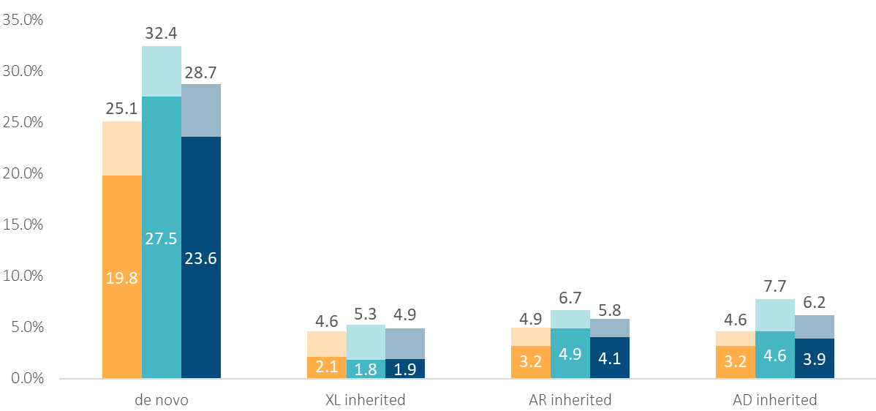
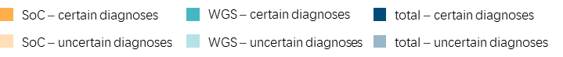

Additional Figure 3. Diagnostic yield for each mode of inheritance, in the SoC arm, the GS arm, and the overall cohort, including uncertain diagnoses. Each bar represents the diagnostic yield of each inheritance analysis, the dark part representing the certain diagnoses as defined in the manuscript (class 4 and 5 variants, with partial or full contribution to the phenotype), whereas the lighter bars represent the uncertain diagnoses (class 3 variants and/or variants with uncertain contribution to the phenotype). Data labels in the dark box give the yield (percentage) for the certain diagnoses, upper data labels give the yield (total percentage) for both certain and uncertain diagnoses.
Abbreviations: AD, autosomal dominant inherited; AR, autosomal recessive inherited; GS, genome sequencing; SoC, standard of care; XL, X-linked inherited.

Fig S4 : Diagnostic yield for each genetic sex.

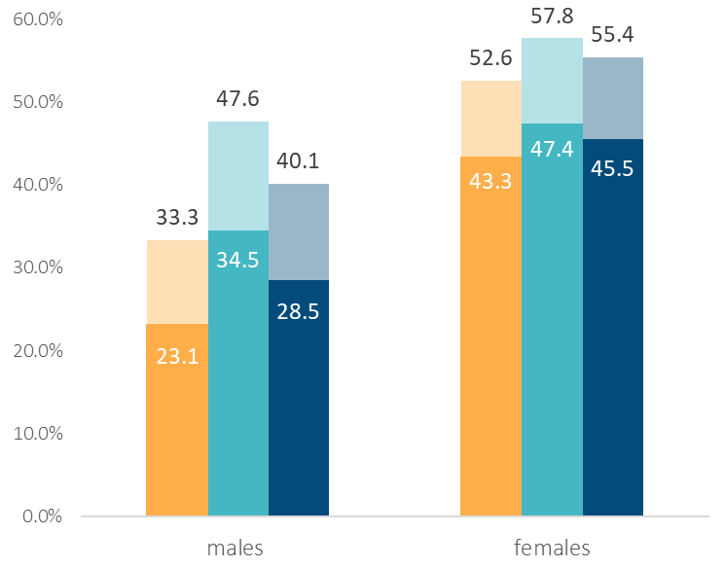
Additional Figure 4. Diagnostic yields in males vs females, in the SoC arm, the GS arm, and over the overall cohort, including uncertain diagnoses. The dark part of each bar represents the certain diagnoses as defined in the manuscript (class 4 and 5 variants, with partial or full contribution to the phenotype), whereas the lighter bars represent the uncertain diagnoses (class 3 and/or variants with uncertain contribution to the phenotype). Data labels in the dark box give the yield (percentage) for the certain diagnoses, upper data labels give the yield (total percentage) for both certain and uncertain diagnoses.
Abbreviations: GS, genome sequencing; SoC, standard of care.

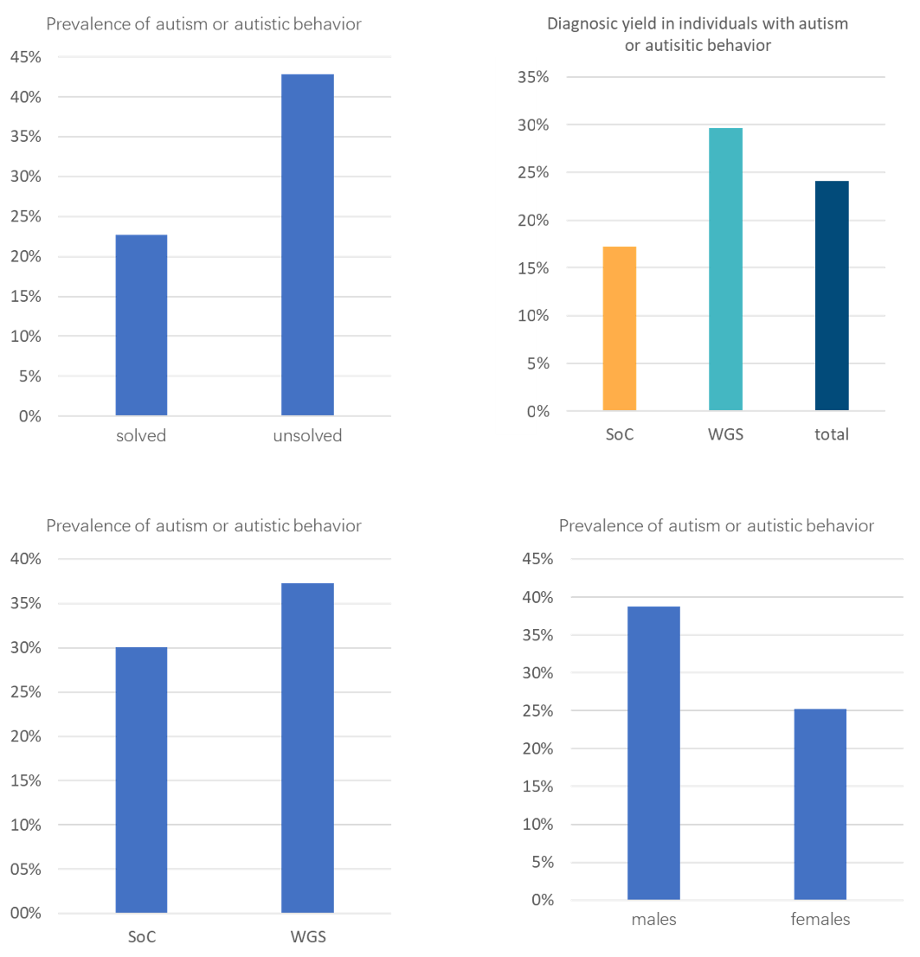
Fig S5 : Autism and autistic behavior.
Additional Figure 5. Comparison of autism and autistic behavior prevalence across different groups: solved vs unsolved participants (top left), Soc vs GS study arms (bottom left), and males vs females (bottom right). The diagnostic yield among probands with reported autism or autistic behavior is shown in the top right panel.
Abbreviations: GS, genome sequencing; SoC, standard of care.

Fig S6 : Diagnostic yield for the 20 most prevalent HPO terms.
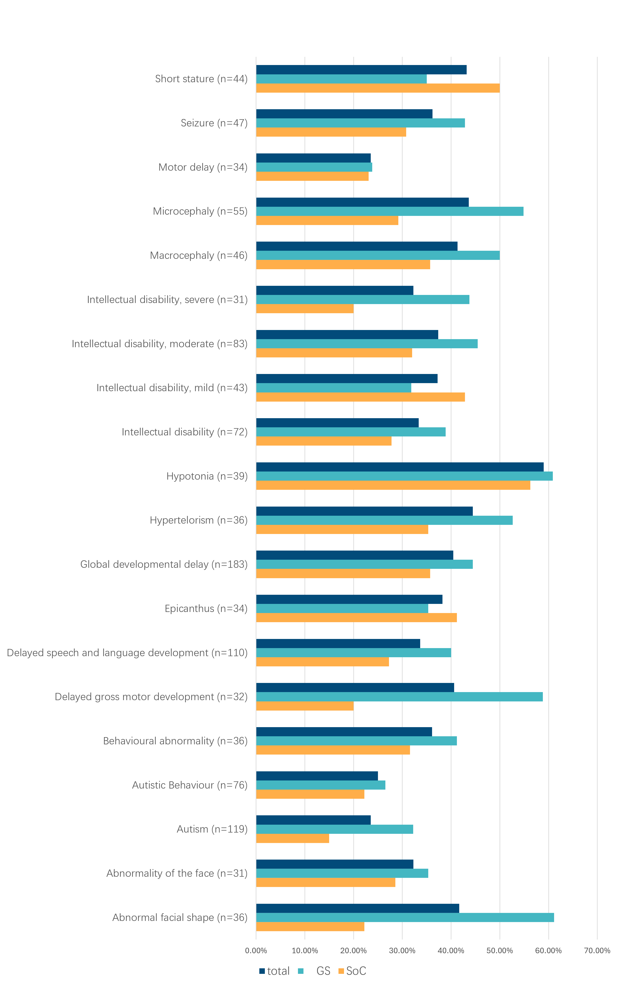
Additional Figure 6. Diagnostic yield within each study arm and across the overall cohort for the 20 most prevalent phenotypic traits, reported using the HPO terminology. The number of probands with each phenotypic trait is indicated in parentheses.
Abbreviations: GS, genome sequencing; HPO, human phenotype ontology; SoC, standard of care.

Table S1: Distribution and diagnostic yields across both study arms for each of the 8 participating centers.
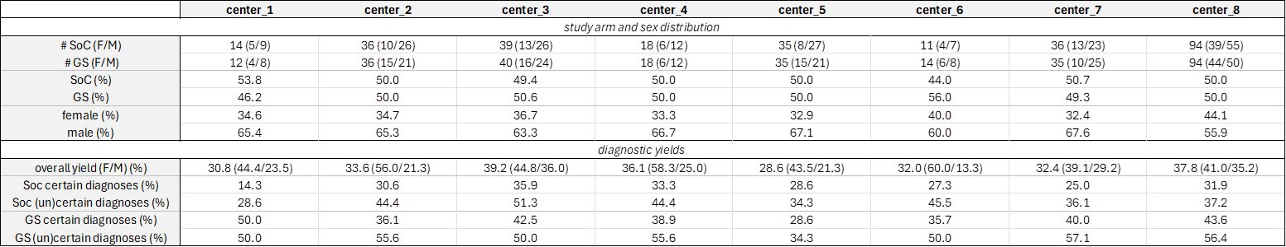

Table S2: Sequencing, bioinformatic and interpretation pipeline in each center.
Table S2A. Sequencing
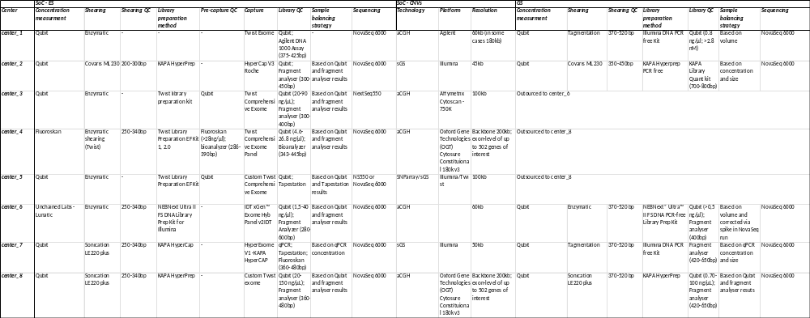

Table S2B. Bioinformatic pipeline
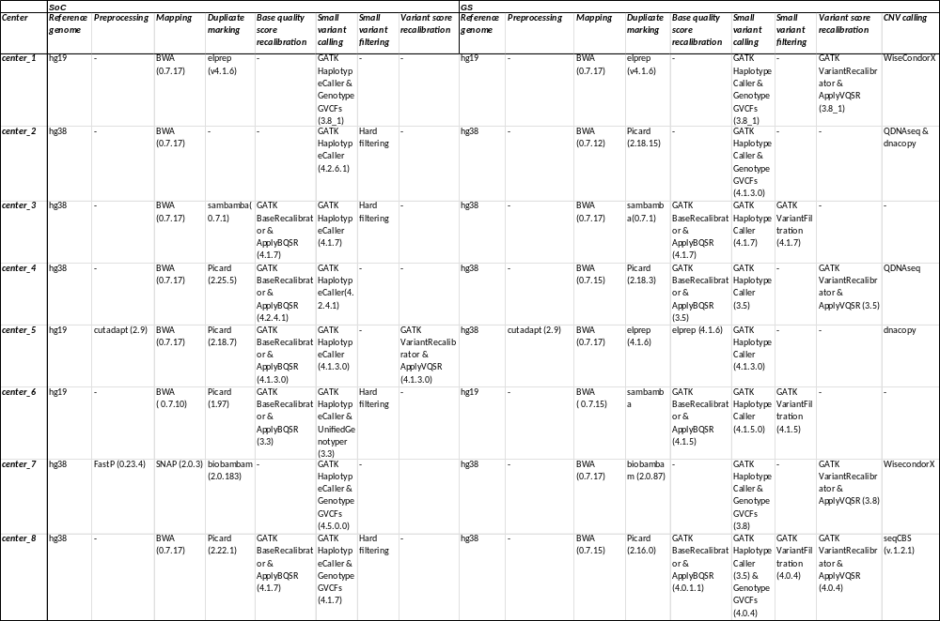
Table S2C. Interpretation
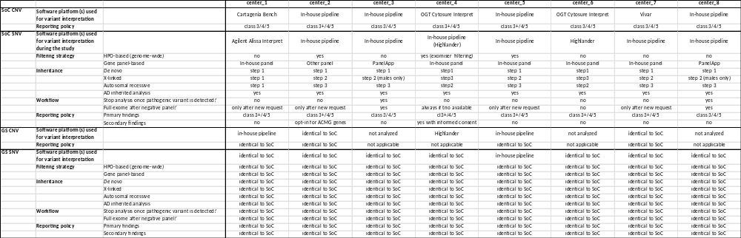

Table S3: Description of demographic characteristics, inclusion criteria, phenotypes and identified molecular variants for all probands.
cfr separate Excel table => Additional file 2

Table S4: Autosomal dominant inherited variants.
- SNVs/indels
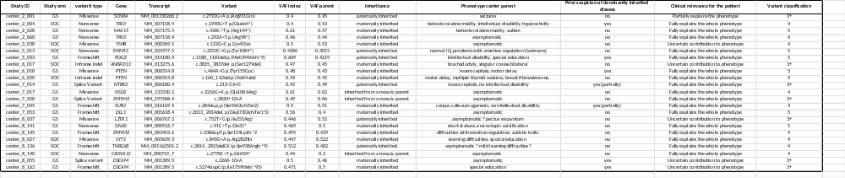
- CNVs
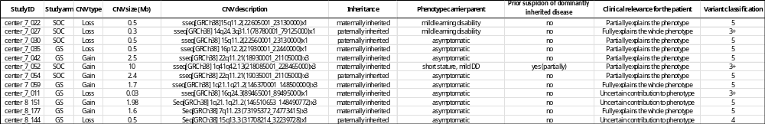

Table S5 : ES coverage of SNVs/indels identified in the GS arm.
cfr separate Excel table => Additional file 3

Table S6 : Comparison of the diagnostic yield between females and males and adjusting the comparison between both study arm for these differences
- Comparison of the yields between females and males (SoC)
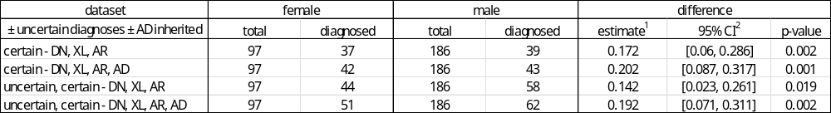
- Comparison of the yields between females and males (GS)
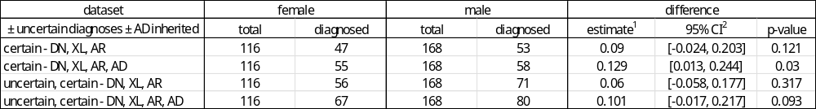
- Comparison of the yields between females and males (total cohort)
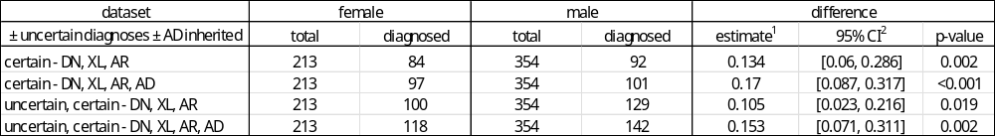
- Comparison between the SoC and GS arms, adjusting for the differences between both genetic sexes
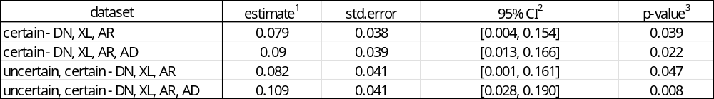
¹ estimate of the risk difference between SoC and GS, ² 95% confidence intervals based on Laud (2017), ³ logistic regression model
Abbreviations: AD, autosomal dominant inherited; AR, autosomal recessive inherited; CI, confidence interval; DN, de novo; GS, genome sequencing SoC, standard of care; XL, X-linked inherited.
Table S7 : Comparison of the diagnostic yields between males and females across the different indication groups.
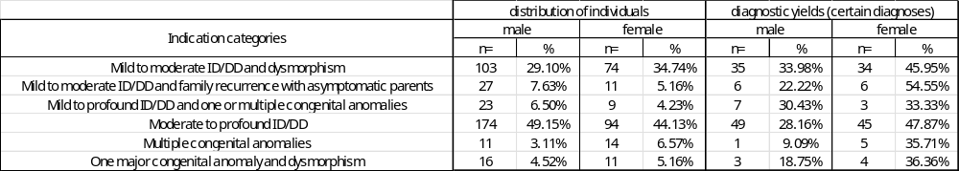
Abbreviations: ID, intellectual disability; DD, developmental delay.

