Additional file 2: Fig. S1-S4

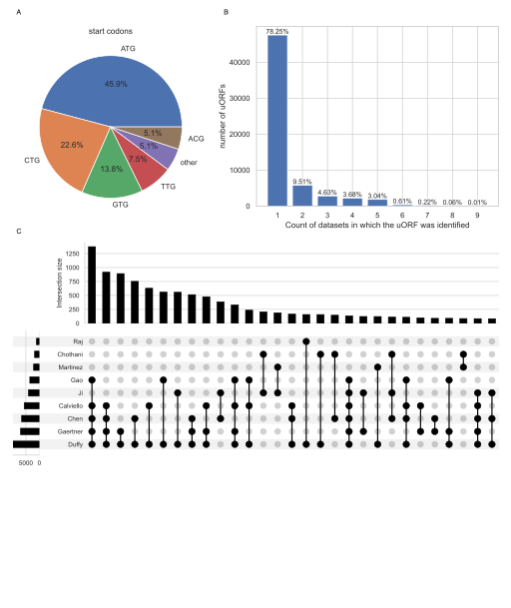
Fig. S1: Overview of the uORF data collated in this pipeline. A) Proportion of codon sequences identified as the start site of a uORF. B) The number of sources which identify each uORF. C) Intersection between the sources (minimum subset of uORFs = 80).
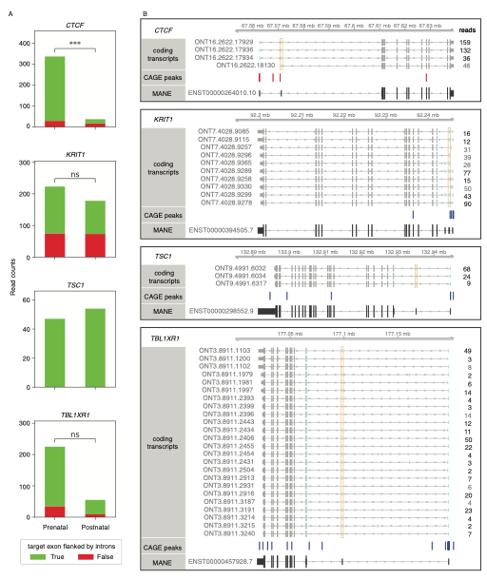
Fig. S2: For selected genes A) the number of reads from transcripts categorised by whether the target exon is skippable, flanked by introns, in prenatal and postnatal samples. B) Isoforms identified by long-read sequencing, predicted to be coding⁵⁴, and supported with a CAGE peak. For CTCF only there was a significant decrease in the proportion of reads from transcripts where the target exon can be skipped between prenatal and postnatal samples (fisher exact test, odds ratio = 0.11, p < 0.001).
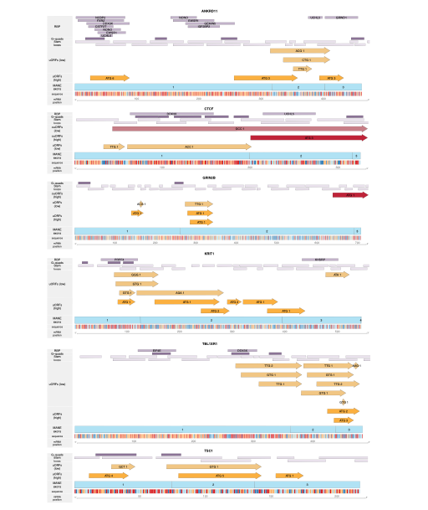
Fig. S3: Schematics of 5ʹUTR features in prioritised gene targets.
5UTR exons are light blue, uORFs are annotated in orange, ouORFs are annotated in red, start codons are highlighted along the sequence. G-quadruplex sections, stem loops and RBPs are annotated in purple-grey. There are no known IRES sites in these six target genes.

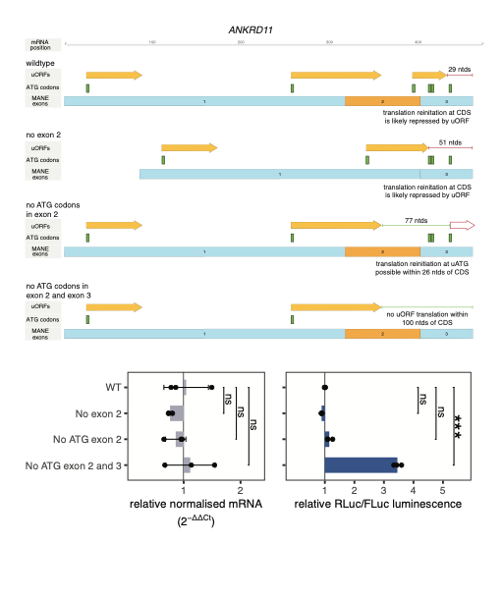 Fig. S4: Redundancy between uORFs and normally untranslated uATGs in ANKRD11 and the impact on exon skipping. In ANKRD11 the uORF initiating in the target exon has an intercistronic region of 29 ntds which is unlikely to facilitate translation reinitiation at the CDS. However, when the target exon is skipped the uORF initiating in exon 1 extends, such that there is only a marginal increase in the intercistronic region. Further, when the ATG site is mutated, reinitiation may occur at ATGs within exon 3. It is only when the uORF in exon 2, and the ATG codons downstream are removed that translation from the CDS increases. Error bars show standard error.

