Supporting information for
Cross-population genome-wide meta-analysis identifies pancreatic cancer susceptibility loci and etiologic pathways
Shuai Yuan, Tengfei Li, Yuqian Tan, Jie Chen, Zhongquan Sun, Jianhui Zhao, Jing Sun, Xixian Ruan, Xun Hu, Ming Chao, Weilin Wang, Yuan Ding, Susanna C. Larsson, and Xue Li

Table of Contents
Fig S1. Locus plot for 1:966179. 3
Fig S2. Locus plot for 1:112521149 3
Fig S3. Locus plot for 1:198262661 3
Fig S4. Locus plot for 1:200038304. 4
Fig S5. Locus plot for 5:1337791. 4
Fig S6. Locus plot for 7:40801973. 4
Fig S7. Locus plot for 7:130995762. 5
Fig S8. Locus plot for 8:127707639. 5
Fig S9. Locus plot for 9:133257521. 5
Fig S10. Locus plot for 11:27357580. 6
Fig S11. Locus plot for 12:52884728. 6
Fig S12. Locus plot for 12:132565825. 6
Fig S13. Locus plot for 13:26800841. 7
Fig S14. Locus plot for 13:27983752. 7
Fig S15. Locus plot for 13:72240491. 7
Fig S16. Locus plot for 13:73342491. 8
Fig S17. Locus plot for 16:75200974. 8
Fig S18. Locus plot for 17:72404025. 8
Fig S19. Cohort-specific forest plot for the locus at 1:966179. 9
Fig S20. Cohort-specific forest plot for the locus at 1:112521149. 9
Fig S21. Cohort-specific forest plot for the locus at 1:198262661. 10
Fig S22. Cohort-specific forest plot for the locus at 1:200038304. 10
Fig S23. Cohort-specific forest plot for the locus at 5:1337791. 11
Fig S24. Cohort-specific forest plot for the locus at 7:40801973 11
Fig S25. Cohort-specific forest plot for the locus at 7:130995762. 12
Fig S26. Cohort-specific forest plot for the locus at 8:127707639. 12
Fig S27. Cohort-specific forest plot for the locus at 9:133257521. 13
Fig S28. Cohort-specific forest plot for the locus at 11:27357580. 13
Fig S29. Cohort-specific forest plot for the locus at 12:52884728. 14
Fig S30. Cohort-specific forest plot for the locus at 12:132565825. 14
Fig S31. Cohort-specific forest plot for the locus at 13:26800841. 15
Fig S32. Cohort-specific forest plot for the locus at 13:27983752. 15
Fig S33. Cohort-specific forest plot for the locus at 13:72240491. 16
Fig S34. Cohort-specific forest plot for the locus at 13:73342491. 16
Fig S35. Cohort-specific forest plot for the locus at 16:75200974. 17
Fig S36. Cohort-specific forest plot for the locus at 17:72404025. 17
Fig S37. Number of phenotypes associated with pancreatic cancer lead variants. 18

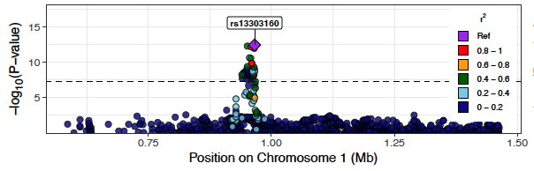
Fig S1. Locus plot for 1:966179.

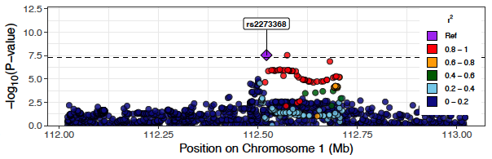
Fig S2. Locus plot for 1:112521149.

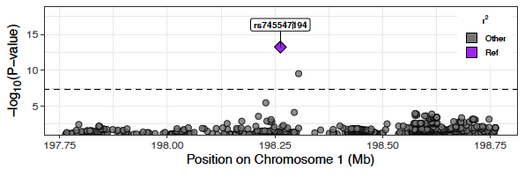
Fig S3. Locus plot for 1:198262661.
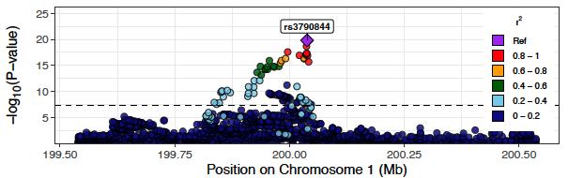
Fig S4. Locus plot for 1:200038304.

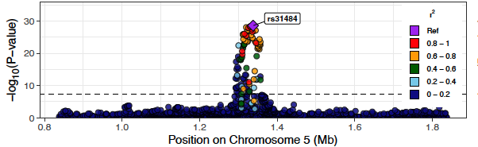
Fig S5. Locus plot for 5:1337791.

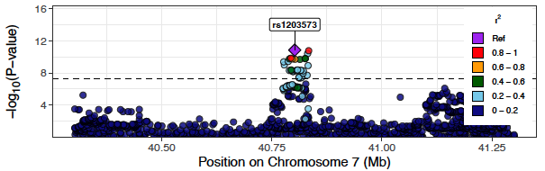
Fig S6. Locus plot for 7:40801973.
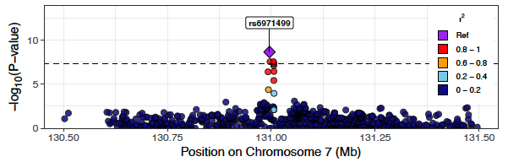
Fig S7. Locus plot for 7:130995762.

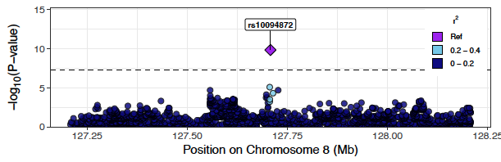
Fig S8. Locus plot for 8:127707639.

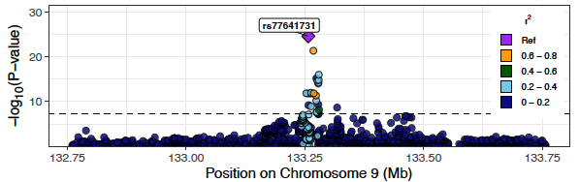
Fig S9. Locus plot for 9:133257521.
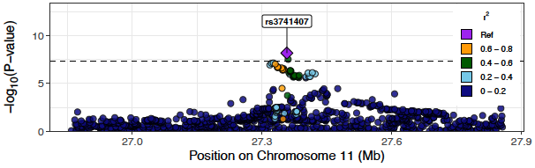
Fig S10. Locus plot for 11:27357580.
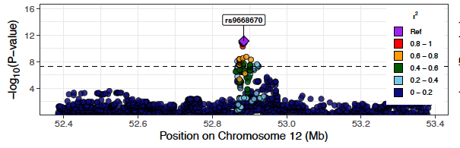
Fig S11. Locus plot for 12:52884728.

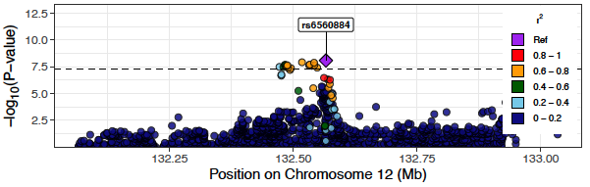
Fig S12. Locus plot for 12:132565825.
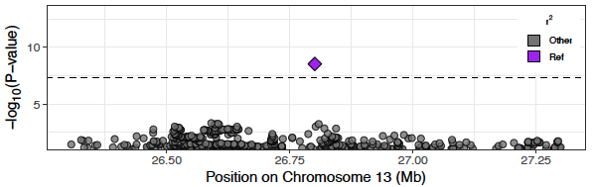
Fig S13. Locus plot for 13:26800841.

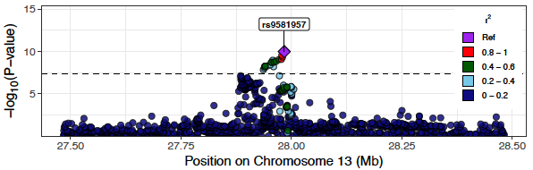
Fig S14. Locus plot for 13:27983752.

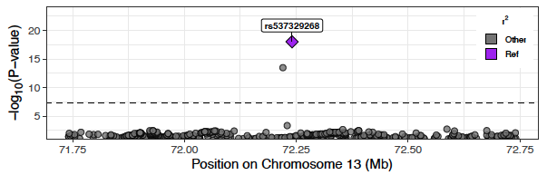
Fig S15. Locus plot for 13:72240491.
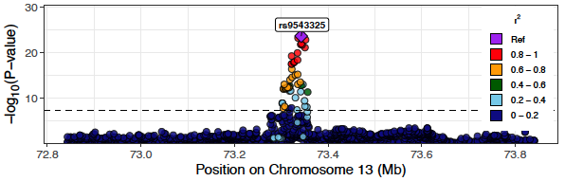
Fig S16. Locus plot for 13:73342491.

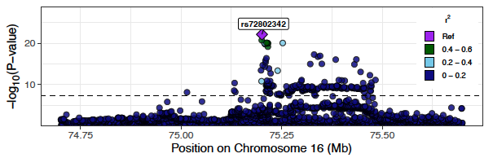
Fig S17. Locus plot for 16:75200974.

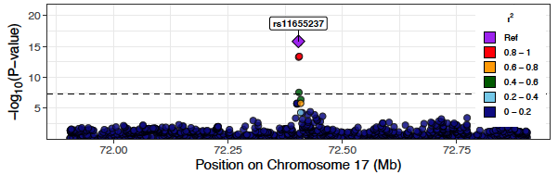
Fig S18. Locus plot for 17:72404025.
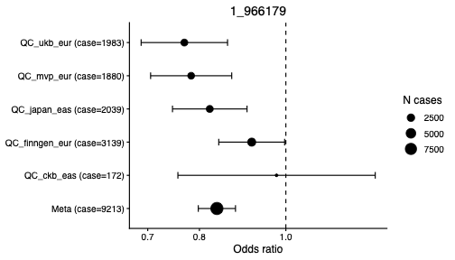

Fig S19. Cohort-specific forest plot for the locus at 1:966179.

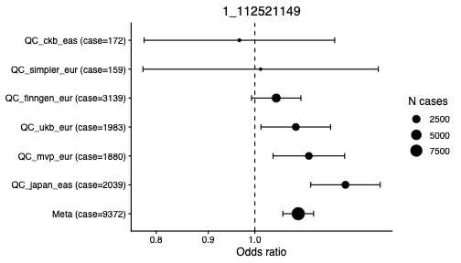

Fig S20. Cohort-specific forest plot for the locus at 1:112521149.
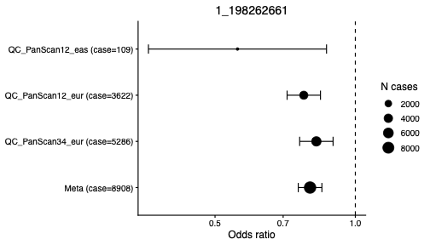

Fig S21. Cohort-specific forest plot for the locus at 1:198262661.

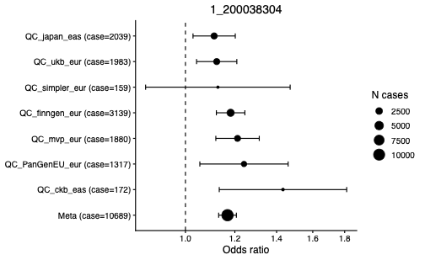

Fig S22. Cohort-specific forest plot for the locus at 1:200038304.
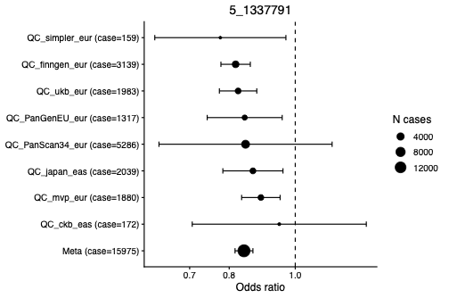

Fig S23. Cohort-specific forest plot for the locus at 5:1337791.

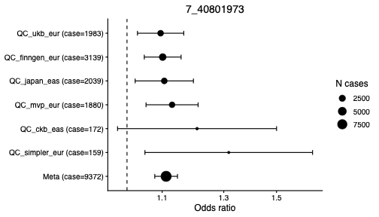
Fig S24. Cohort-specific forest plot for the locus at 7:40801973.
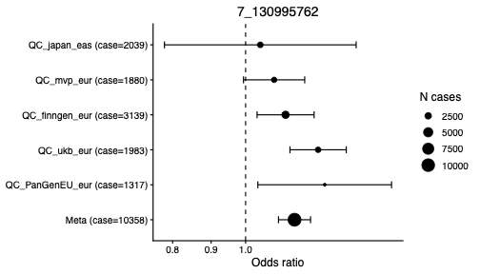

Fig S25. Cohort-specific forest plot for the locus at 7:130995762.

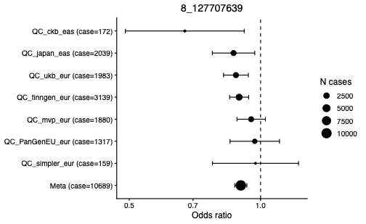

Fig S26. Cohort-specific forest plot for the locus at 8:127707639.
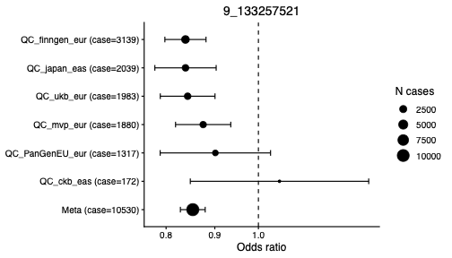

Fig S27. Cohort-specific forest plot for the locus at 9:133257521.

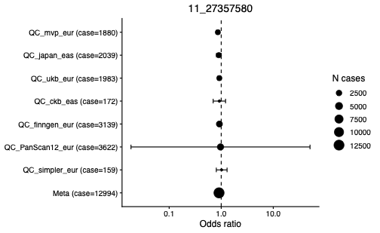

Fig S28. Cohort-specific forest plot for the locus at 11:27357580.
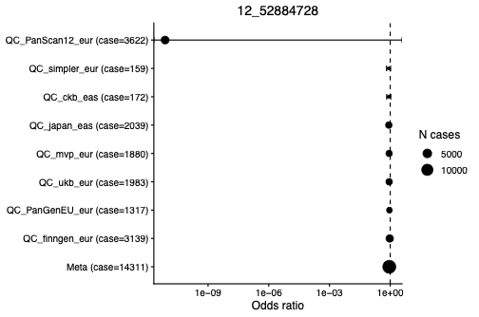

Fig S29. Cohort-specific forest plot for the locus at 12:52884728.

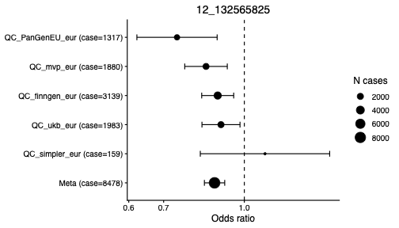

Fig S30. Cohort-specific forest plot for the locus at 12:132565825.
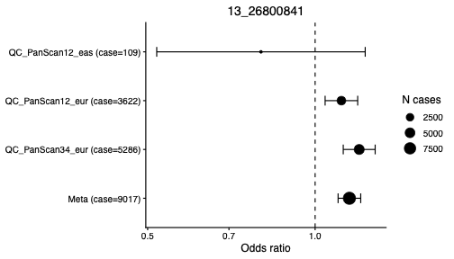

Fig S31. Cohort-specific forest plot for the locus at 13:26800841.

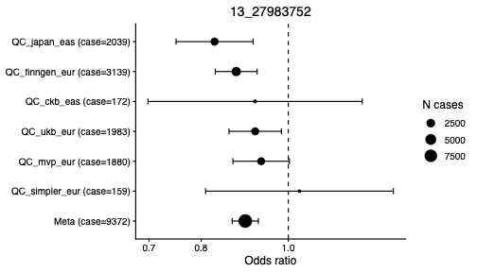

Fig S32. Cohort-specific forest plot for the locus at 13:27983752.
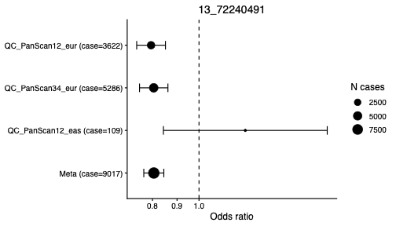

Fig S33. Cohort-specific forest plot for the locus at 13:72240491.

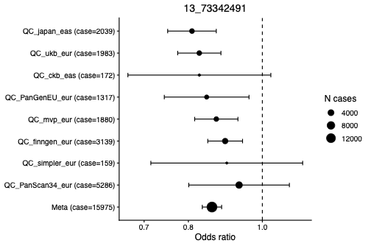

Fig S34. Cohort-specific forest plot for the locus at 13:73342491.
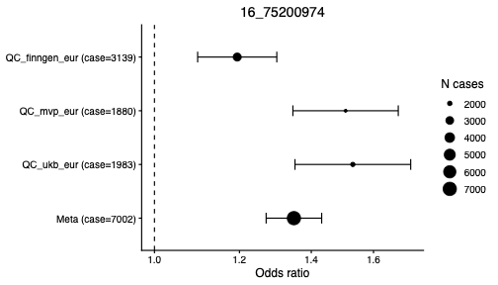

Fig S35. Cohort-specific forest plot for the locus at 16:75200974.

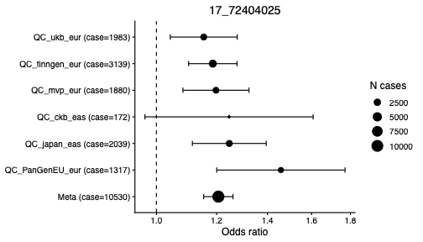

Fig S36. Cohort-specific forest plot for the locus at 17:72404025.
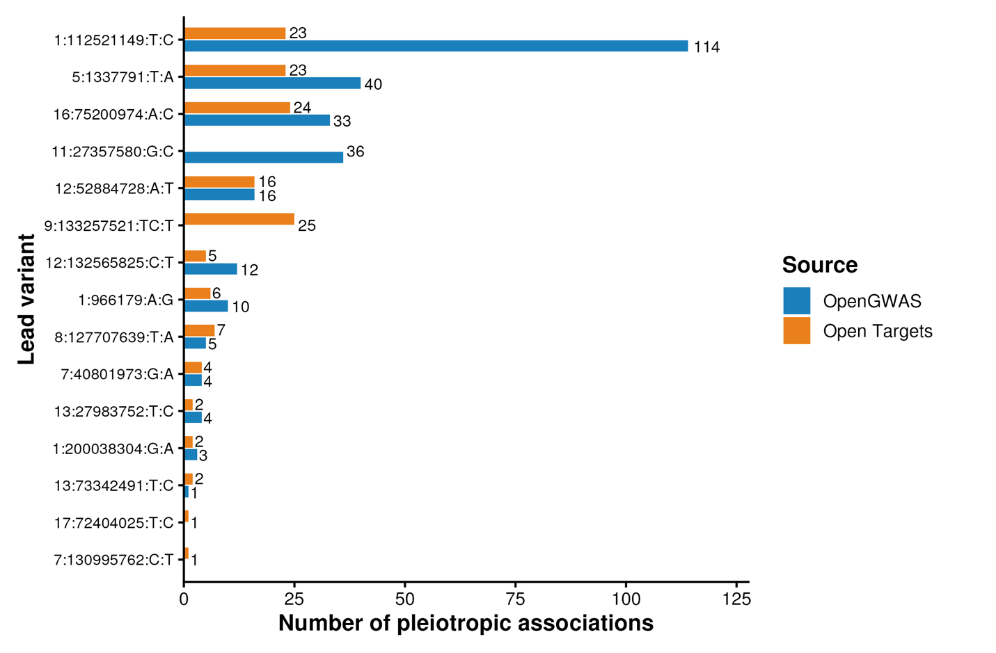

Fig S37. Number of phenotypes associated with pancreatic cancer lead variants.

