SUPPLEMENTARY FIGURES
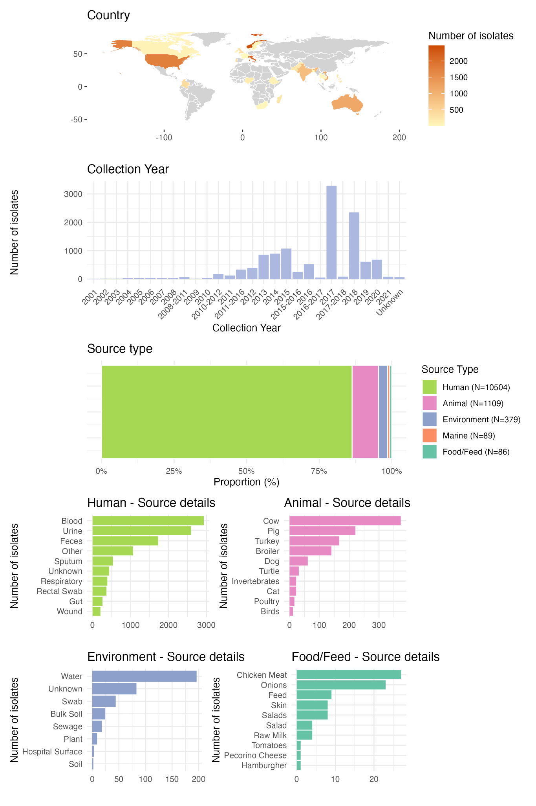

Fig. S1. Global and diverse collection of KpSC isolates with ciprofloxacin susceptibility tests (N=12,167) from the KlebNET-GSP AMR Genotype-Phenotype Group. The isolates were collected from 27 countries between 2001 and 2021 and sampled from predominantly human sources, but also include animals, environment, and food / feed sources.

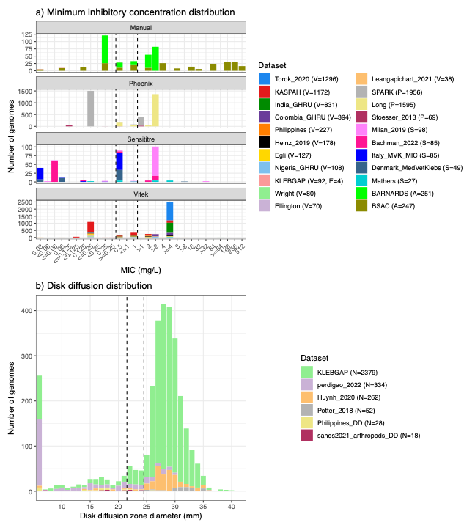Fig. S2. Phenotype distribution for discovery datasets. (A) Minimum inhibitory concentration (MIC) distribution for discovery datasets. The number of isolates tested using each MIC method (Vitek (V), E-test (E), Phoenix (P), Sensititre (S), and agar dilution (A)) is indicated within the bracket. All datasets have lower bounds (</≤) and upper bounds (>/≥) with the exception of the BSAC (A=251) and KLEBGAP (E=4) datasets (see Table S1 for more detail). Vertical lines indicate the EUCAST/CLSI S breakpoint (≤0.25 mg/L) and the EUCAST/CLSI R breakpoint (>0.5 mg/L). (B) Disk diffusion distributions for discovery datasets. The number of isolates tested with disk diffusion are indicated in brackets. Vertical lines indicate the EUCAST/CLSI R breakpoint (<22 mm) and the EUCAST S breakpoint (≥25 mm). Note the CLSI breakpoint is ≥26 mm, and measurements generated using CLSI protocol (Philippines, N=28 and Potter 2018, N=52) were interpreted with this breakpoint.

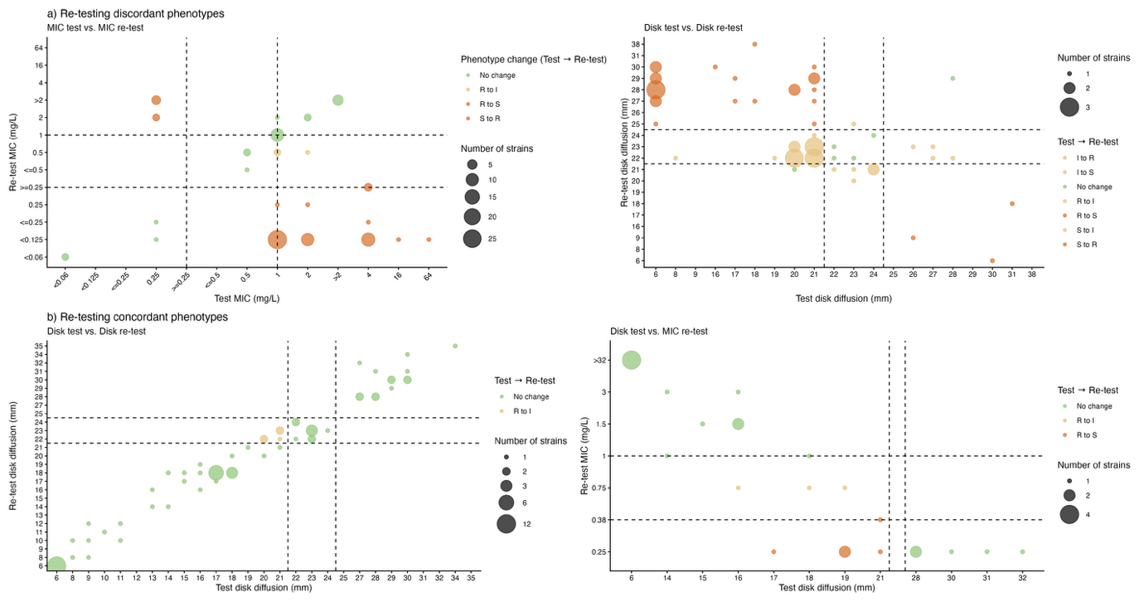Fig. S3. Phenotype distribution for re-tested strains. (A) Re-testing discordant isolates (i.e., expected phenotype does not match tested phenotype based on genotype) where the initial test is on the x-axis and the re-test measurement is on the y-axis. Three isolates initially tested using disk diffusion and re-tested using MIC method were excluded from plotting (Table S3). Colour indicates the phenotype change from initial test to re-test and size of circle represents the number of strains. The dotted vertical and horizontal lines represent the EUCAST susceptible and resistant breakpoints, respective of each method of phenotypic testing. (B) Re-testing concordant isolates (i.e., expected phenotype matches the tested phenotype based on genotype) with the same plotting features as panel (A).

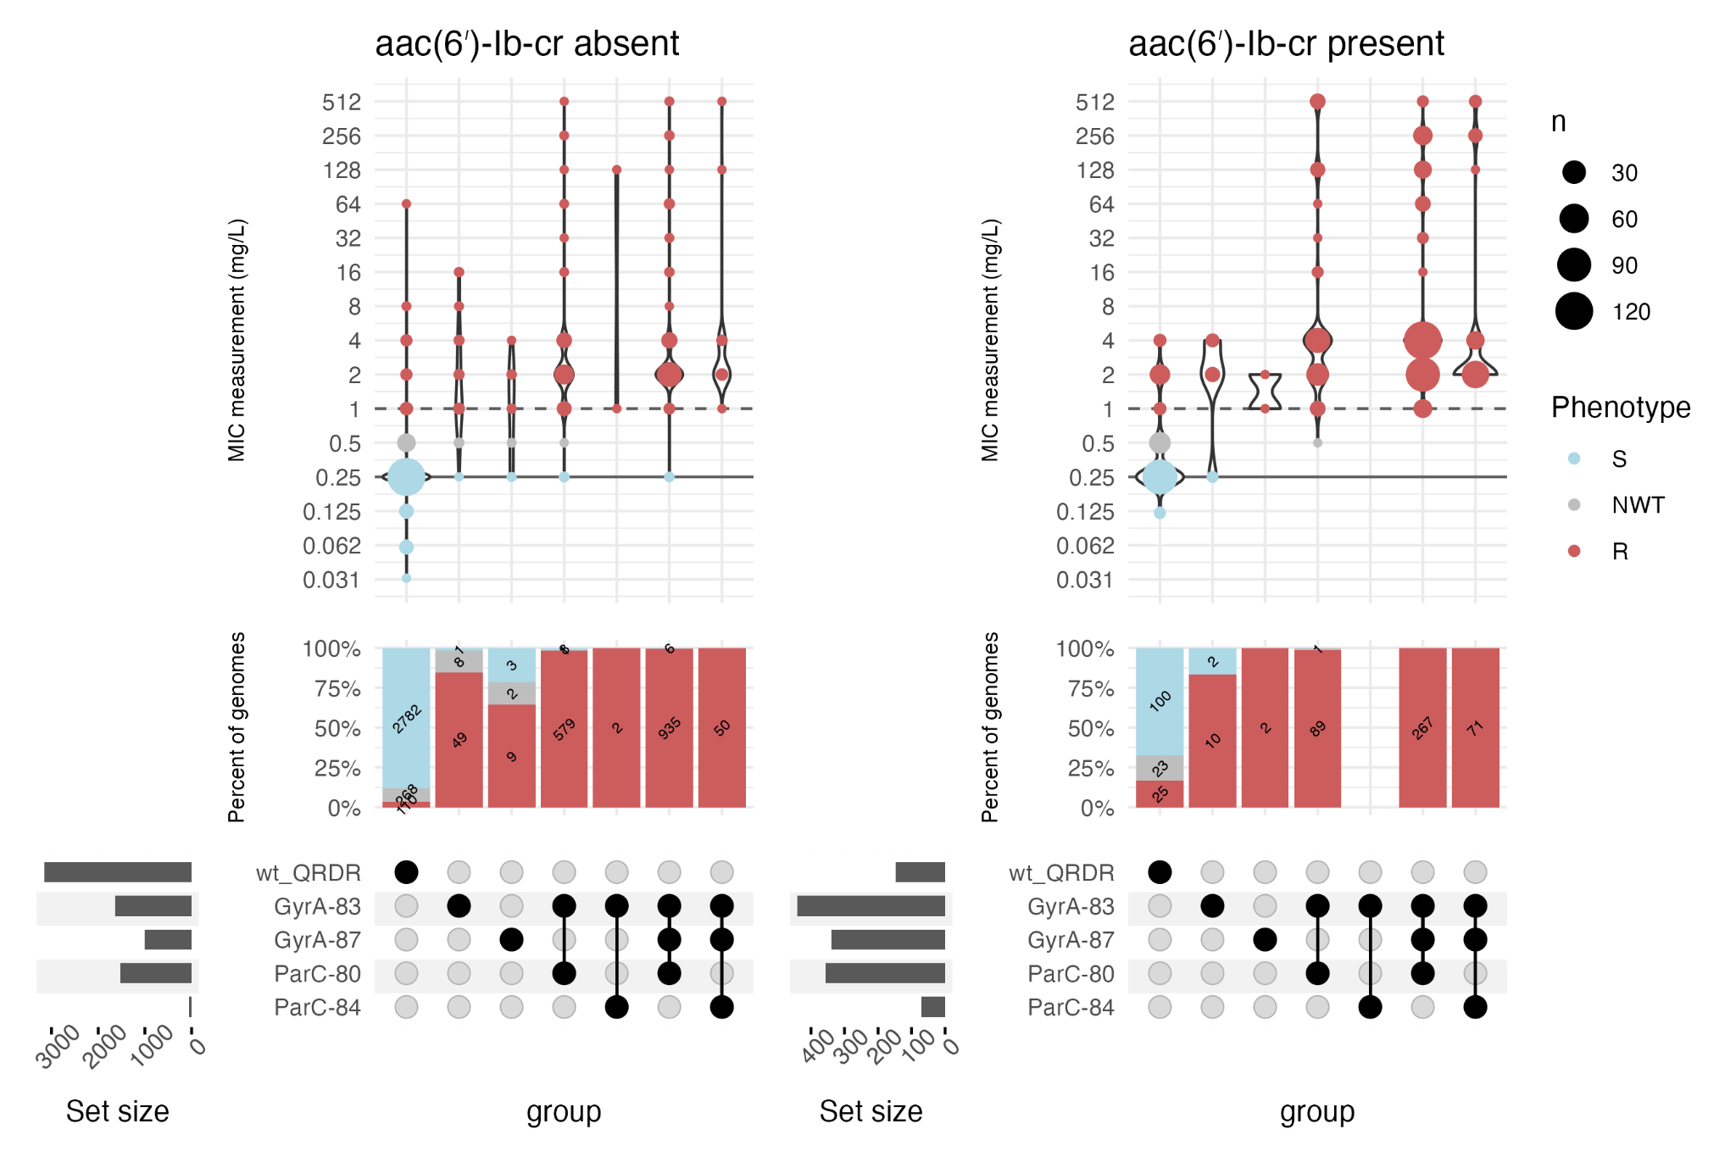

Fig. S4. MIC distribution for QRDR mutations, in the absence of PMQR genes. Filled circles in the upset plot indicate the genotype as indicated in the row label. wt_QRDR indicates genomes with wildtype QRDRs. Note that other mechanisms such as oqx disruption, oqx copy number, porin mutations were not considered here and may be present in some isolates.

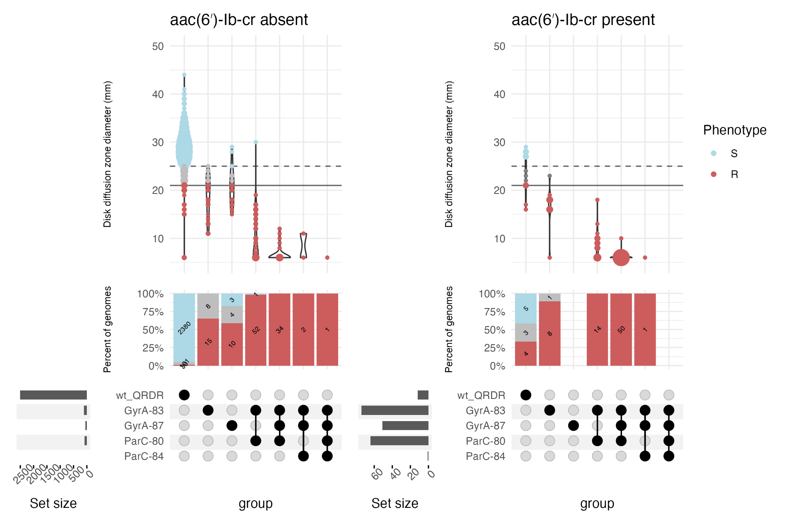

Fig. S5. Disk diffusion zone diameter distribution for QRDR mutations, in the absence of PMQR genes. Filled circles in the upset plot indicate the genotype as indicated in the row label. wt_QRDR indicates genomes with wildtype QRDRs. Note that other mechanisms such as oqx disruption, oqx copy number, porin mutations were not considered here and may be present in some isolates.
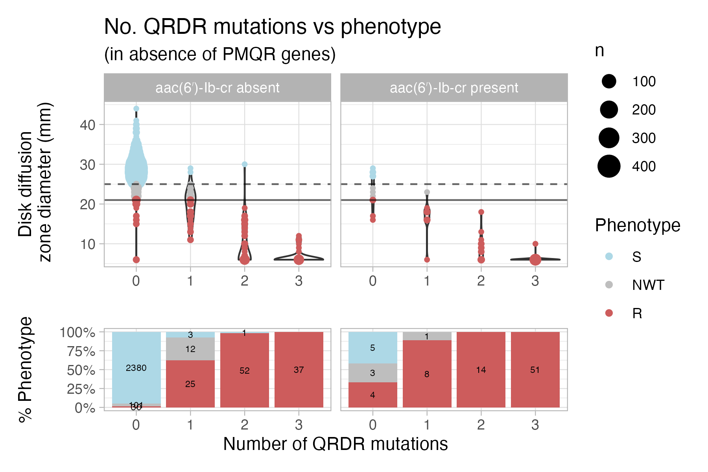

Fig. S6. Number of QRDR mutations vs phenotype, for isolates with disk diffusion measurements. Filled circles in the upset plot indicate the genotype as indicated in the row label. Note that other mechanisms such as oqx disruption, oqx copy number, porin mutations were not considered here and may be present in some isolates.

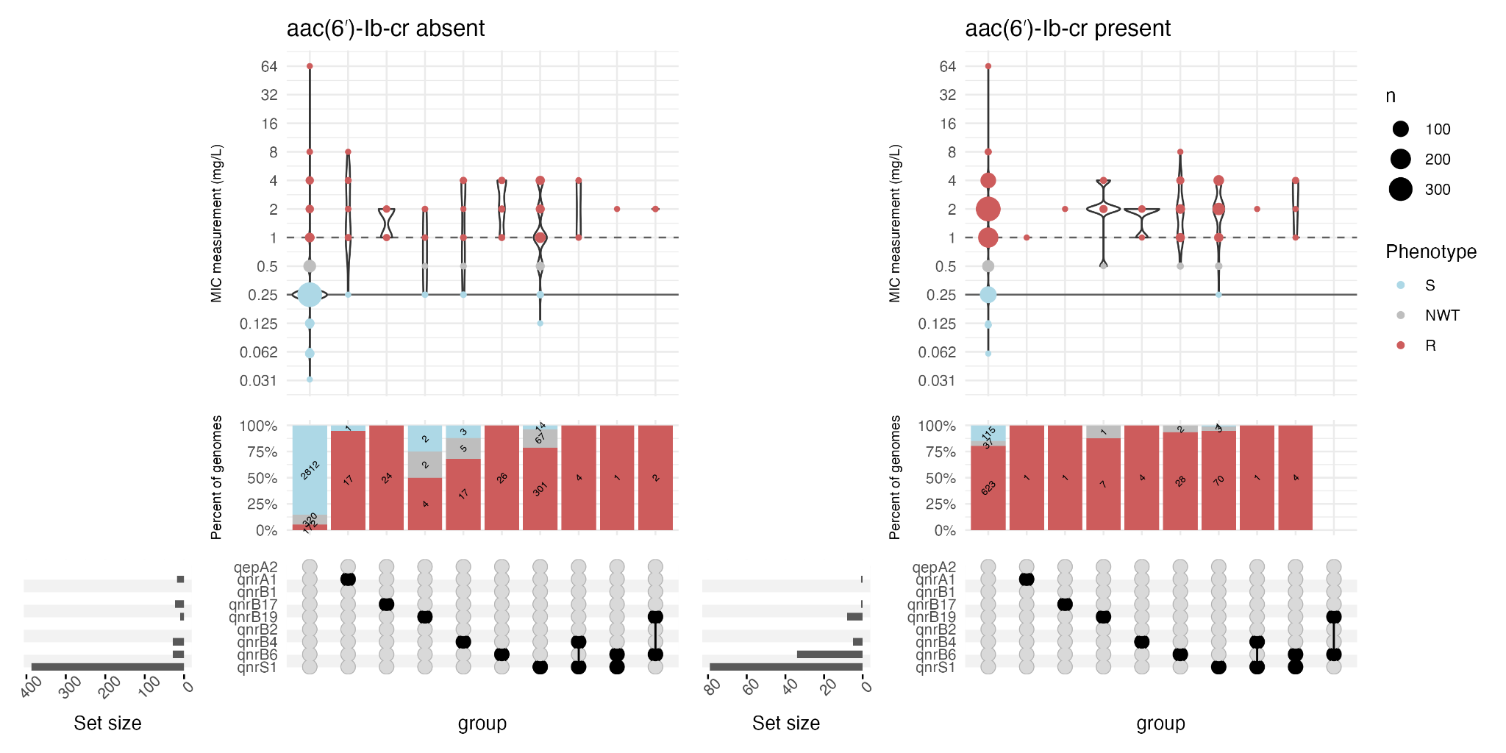

Fig. S7. MIC distribution for PMQR gene combinations, in the absence of QRDR mutations. Filled circles in the upset plot indicate the genotype as indicated in the row label. Note that other mechanisms such as oqx disruption, oqx copy number, porin mutations were not considered here and may be present in some isolates.

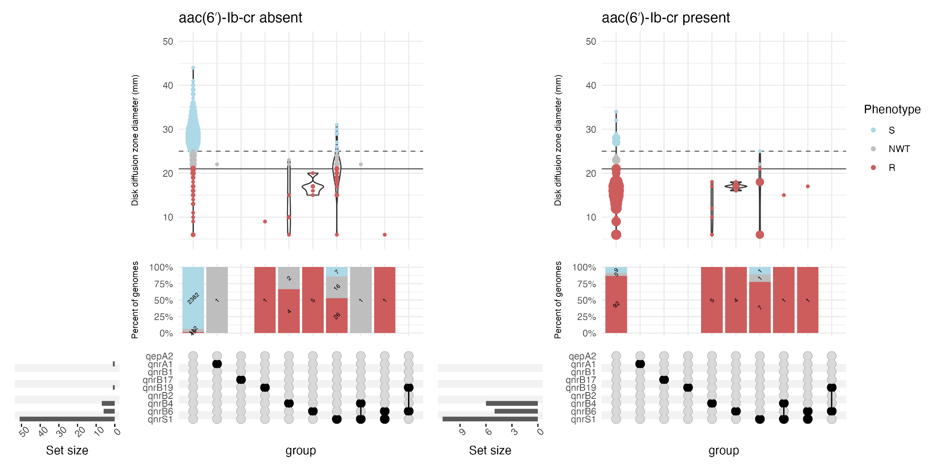

Fig. S8. Disk diffusion zone diameter distribution for PMQR gene combinations, in the absence of QRDR mutations. Note that other mechanisms such as oqx disruption, oqx copy number, porin mutations were not considered here and may be present in some isolates.

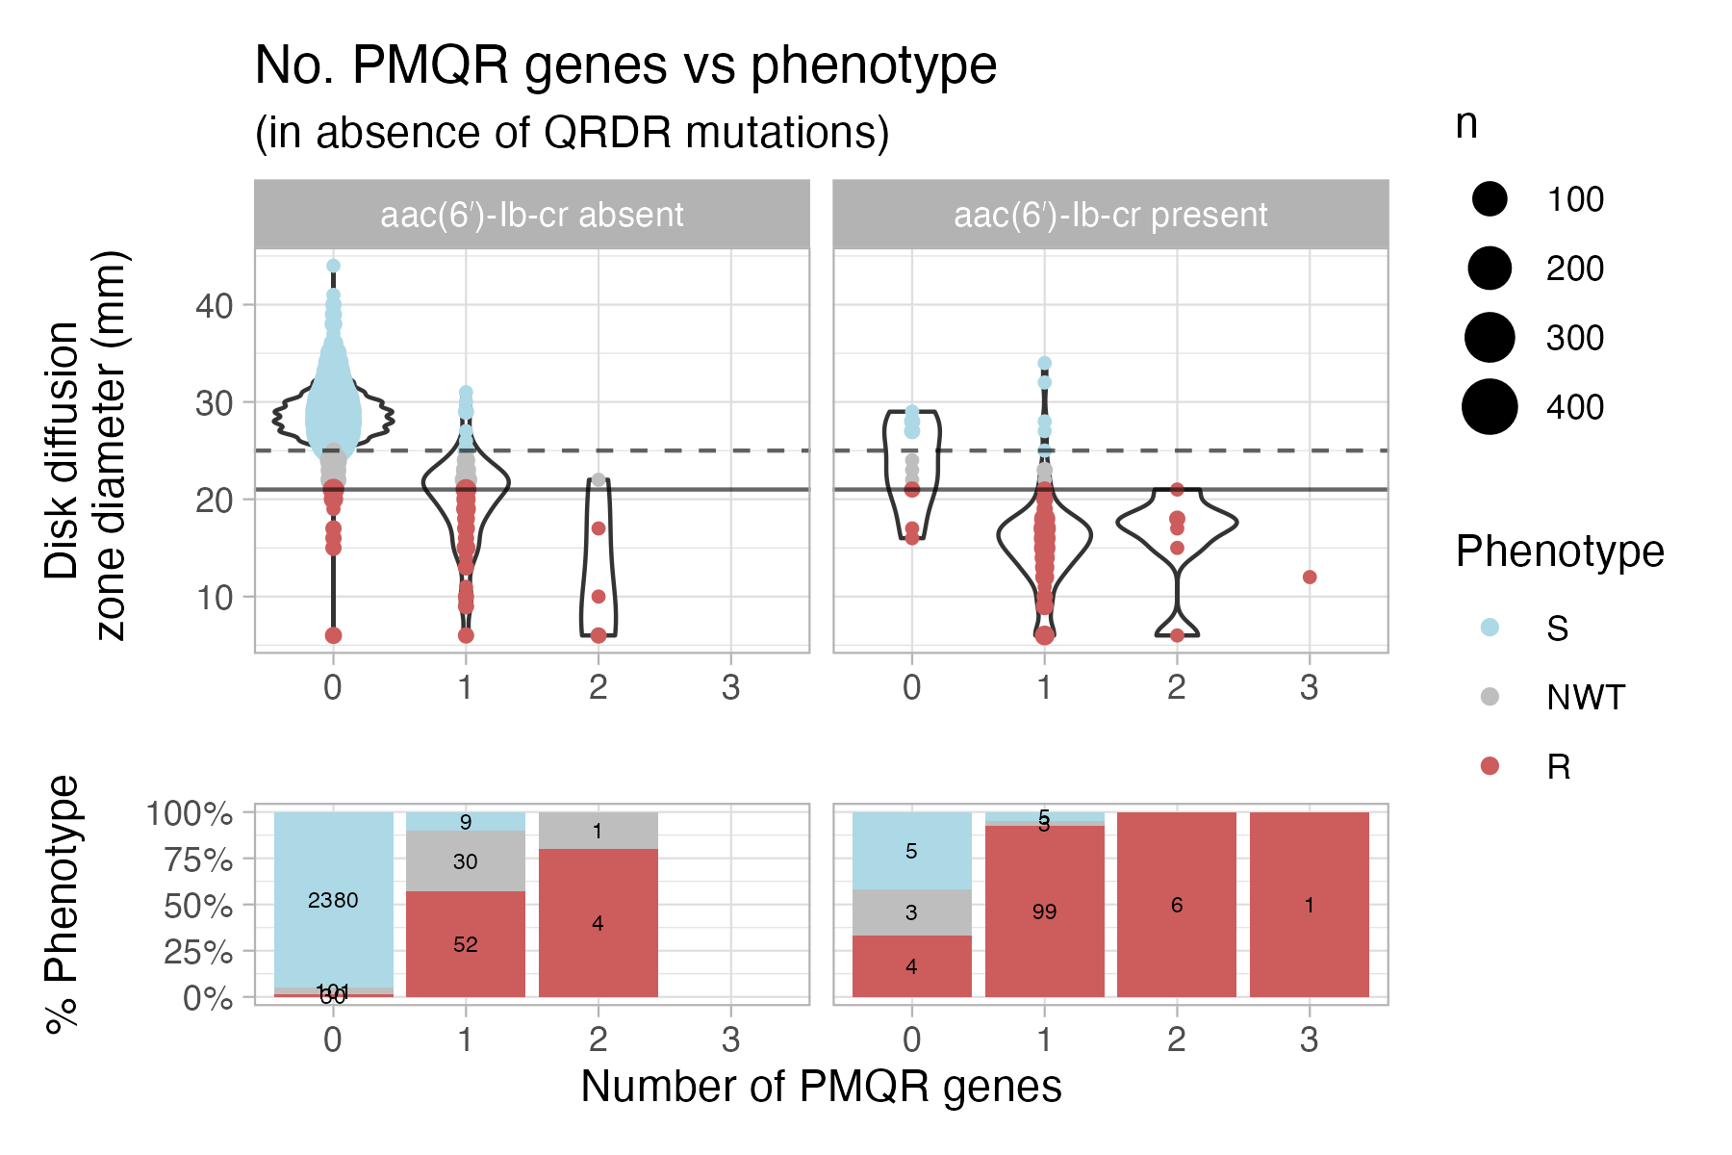

Fig. S9. Number of qnr/qep genes vs phenotype, for isolates with disk diffusion measurements. Note that other mechanisms such as oqx disruption, oqx copy number, porin mutations were not considered here and may be present in some isolates.

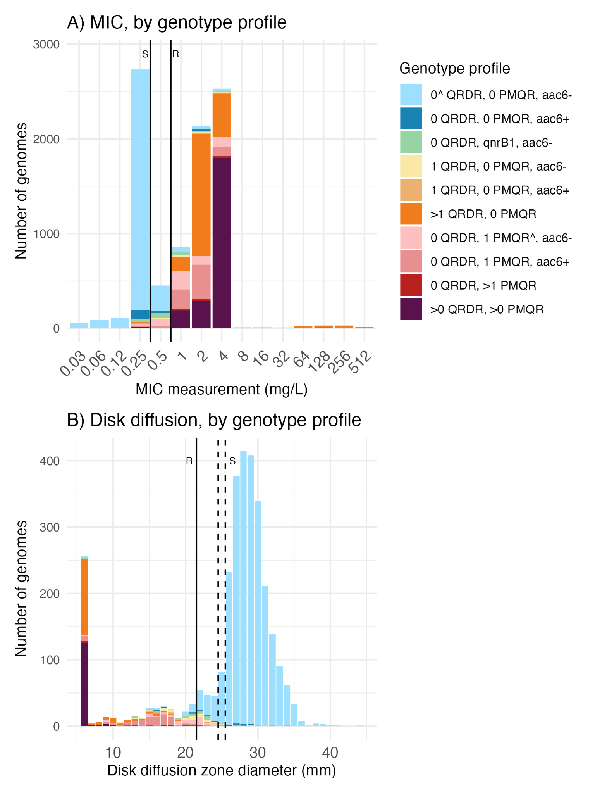

Fig. S10. Phenotype distributions stratified by genotype profiles for the discovery datasets. (A) MIC measurement (mg/L) and (B) disk diffusion zone diameter (mm) distributions coloured according to the genotype profiles assigned by the rule-based classifier. All MIC datasets have lower bounds (</≤) and upper bounds (>/≥) with the exception of two datasets (totalling N=255 isolates, see Fig. S1, Table S3 for more detail). The vertical solid line indicates the EUCAST/CLSI R breakpoint (<22mm) and the vertical dotted lines indicate the EUCAST S breakpoint (≥25 mm) and CLSI S breakpoint (≥26 mm).

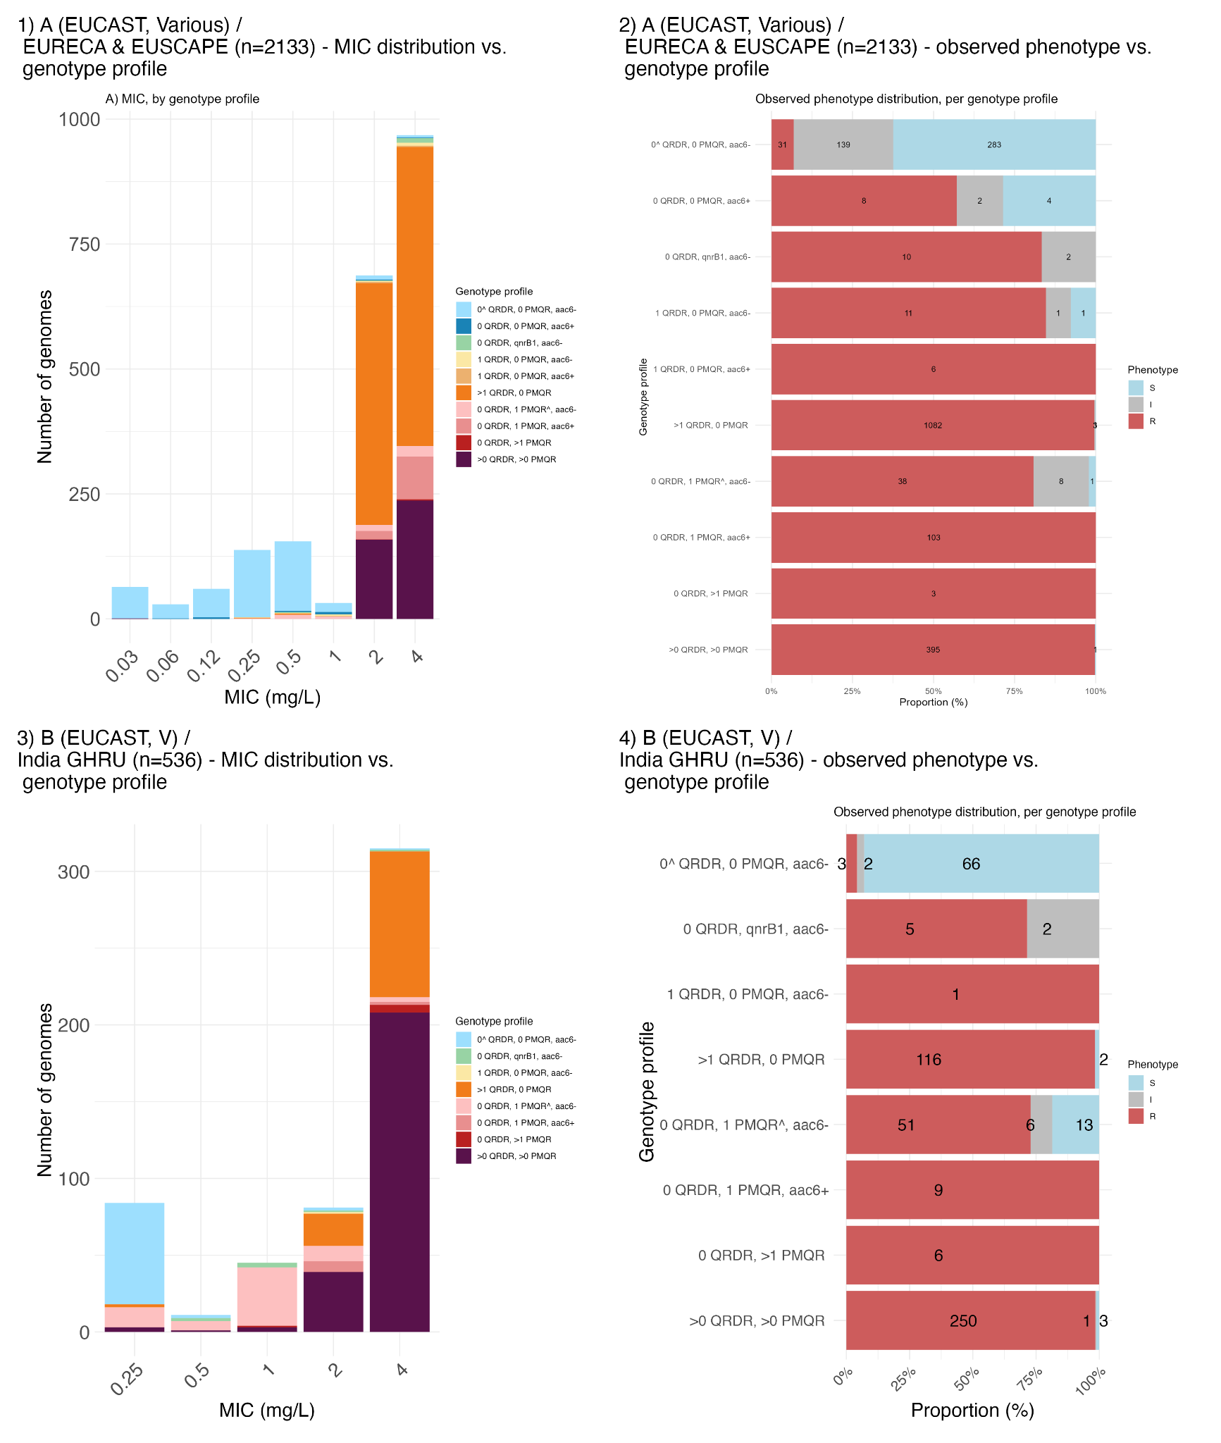

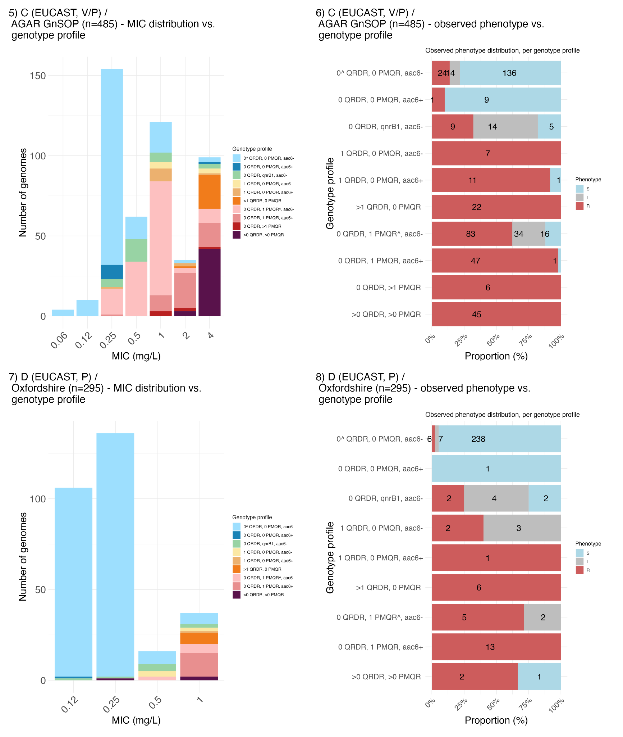
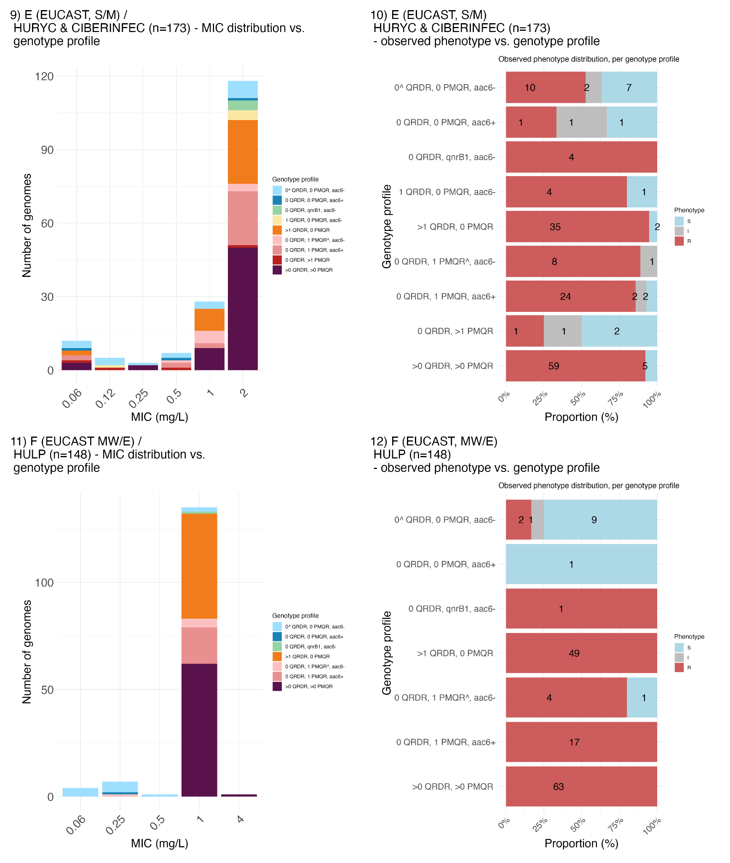

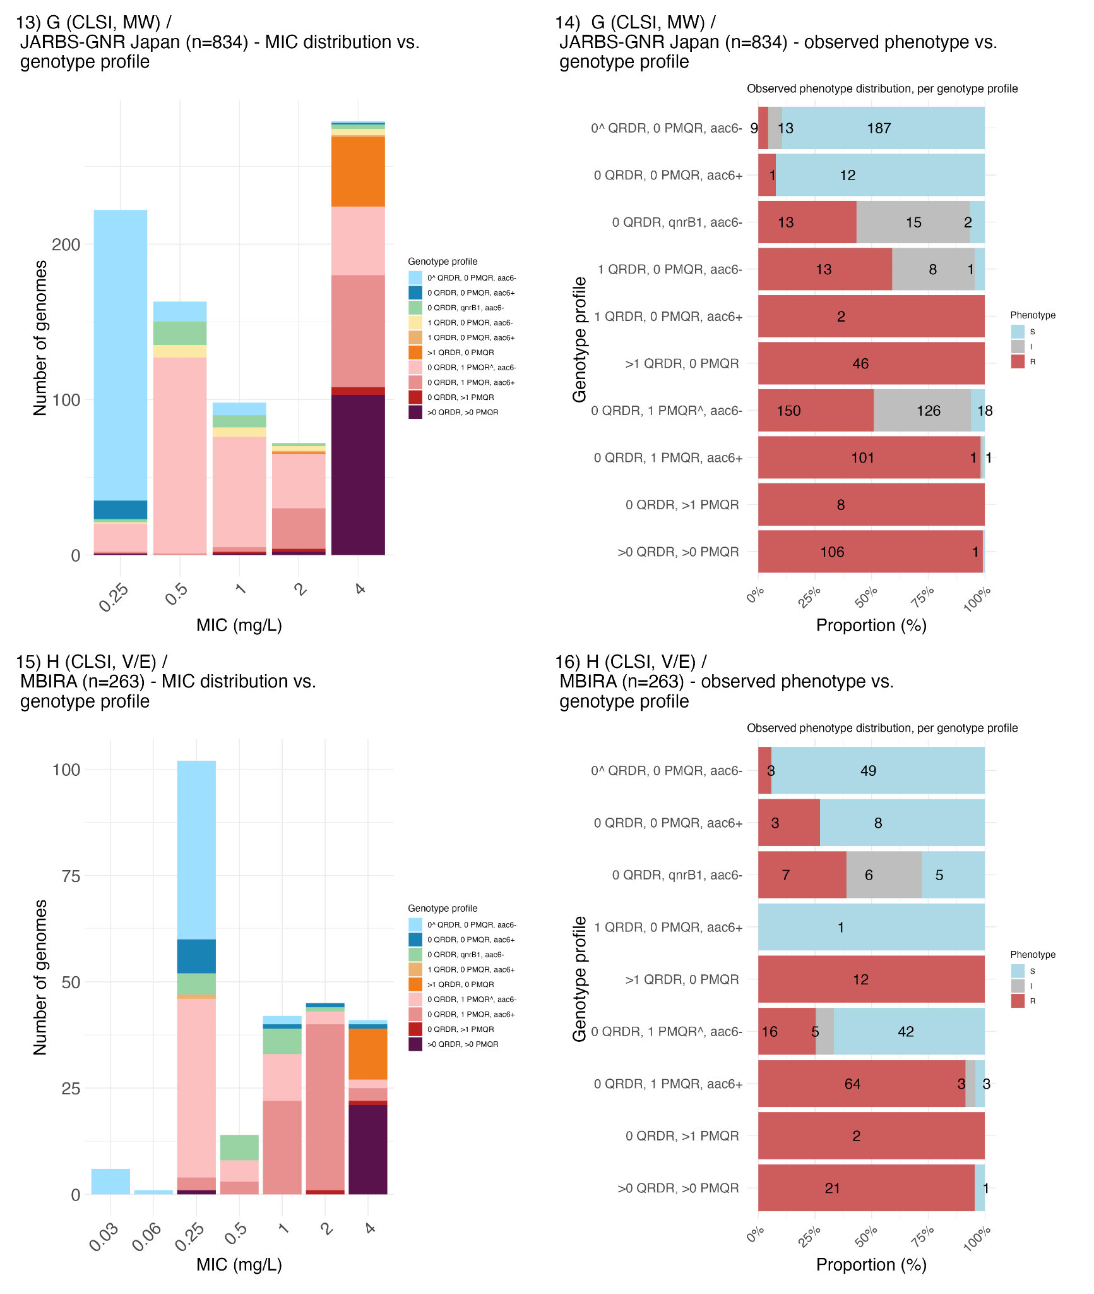

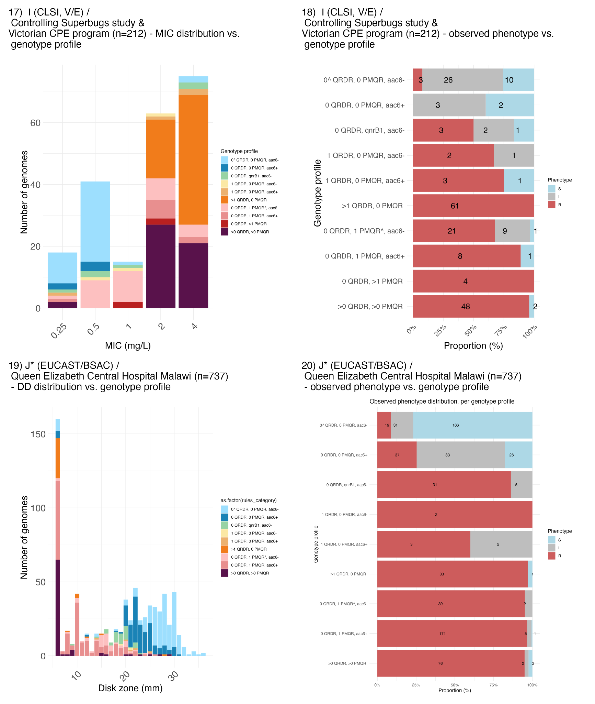

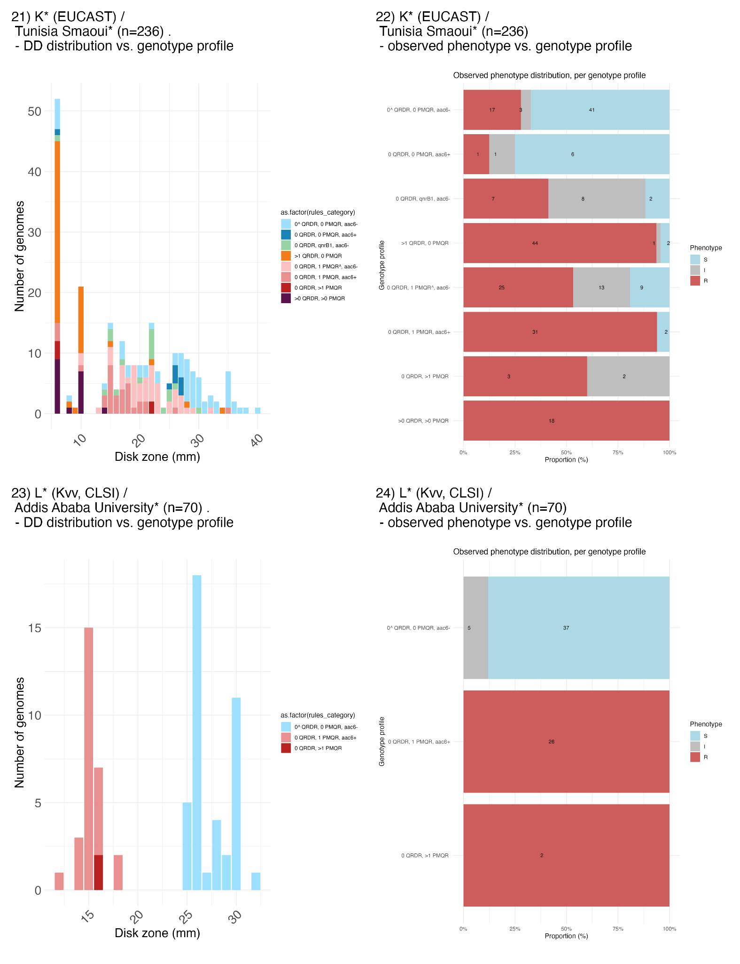

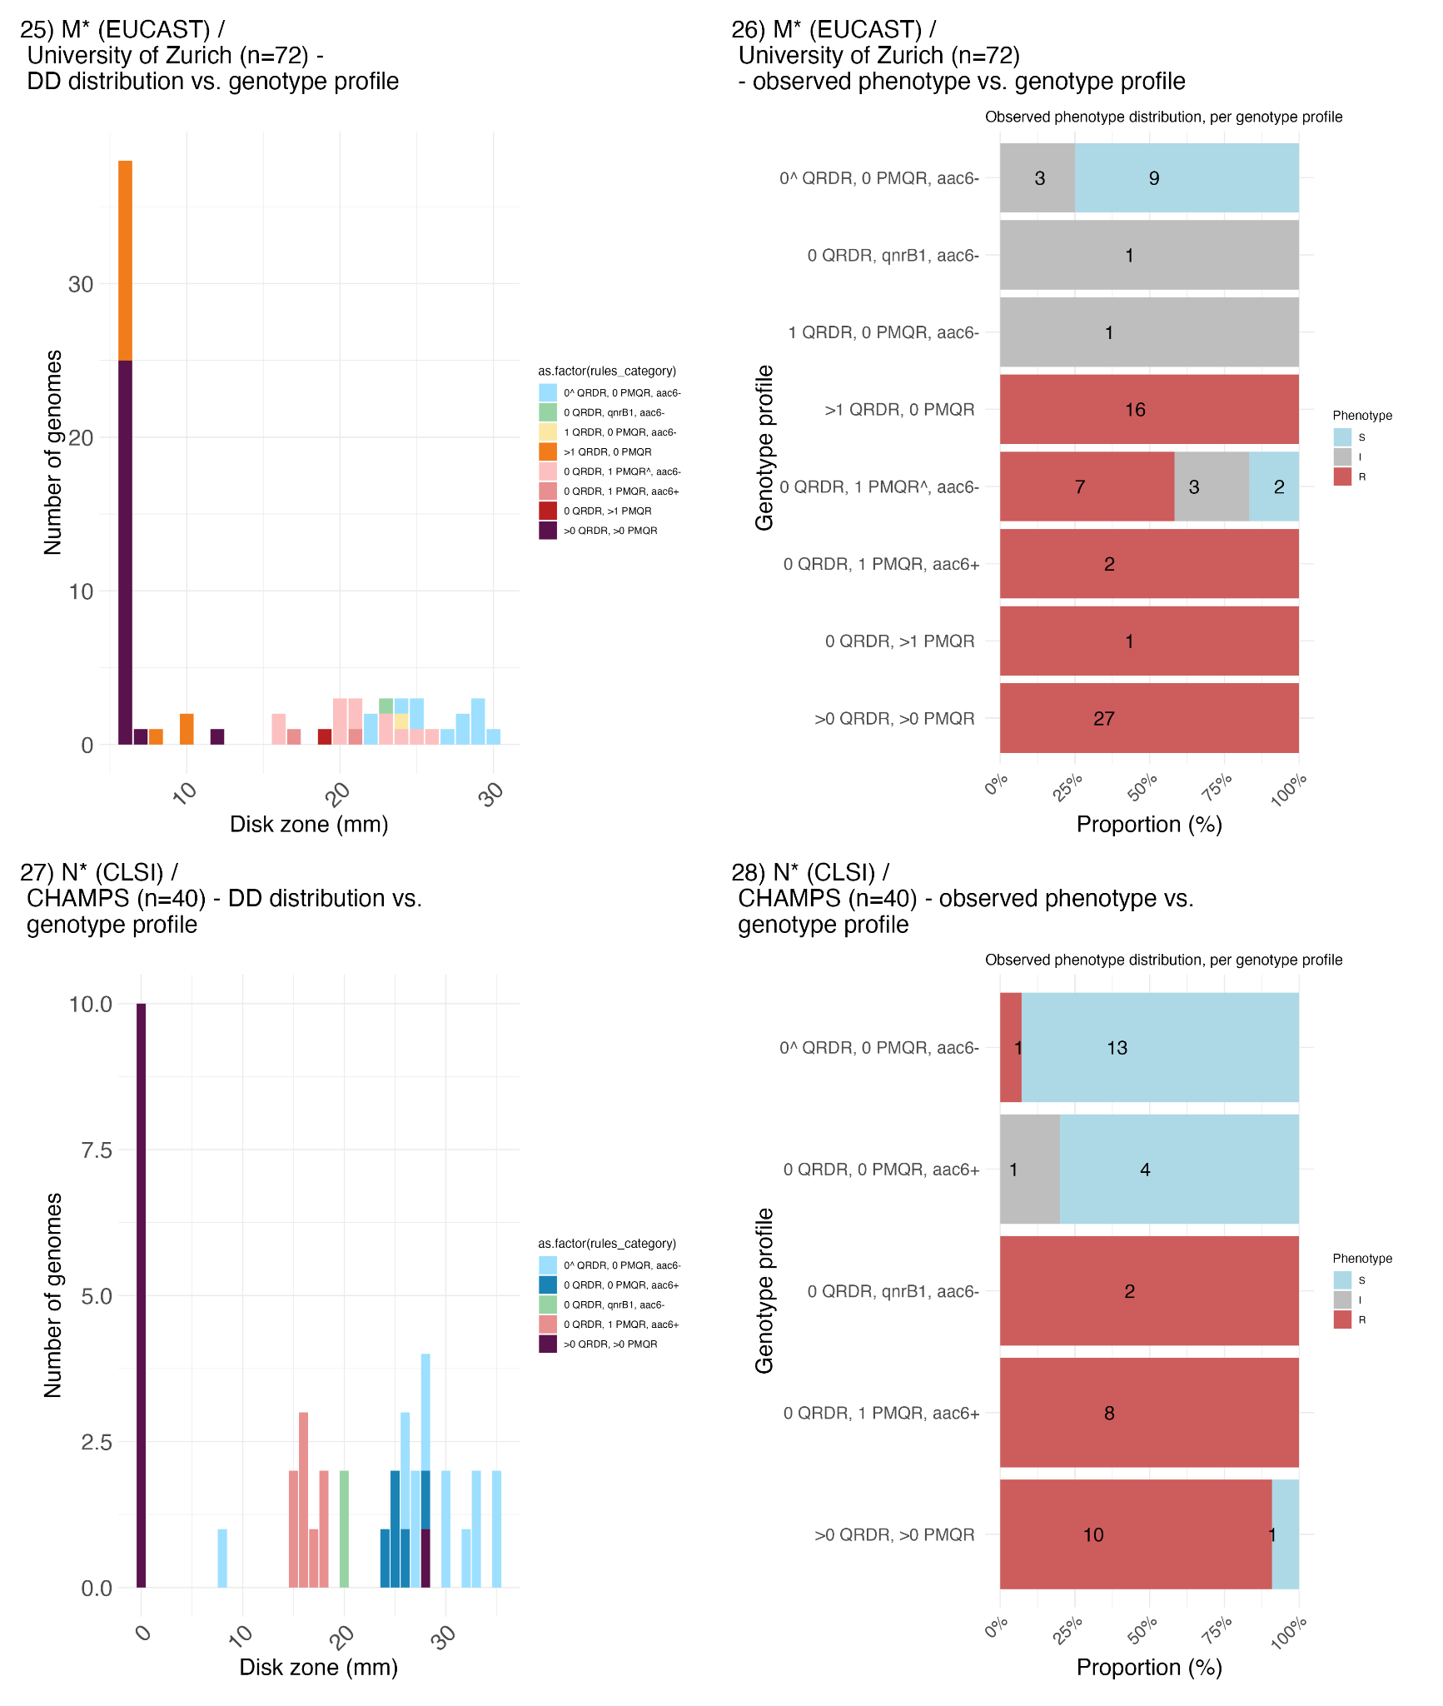

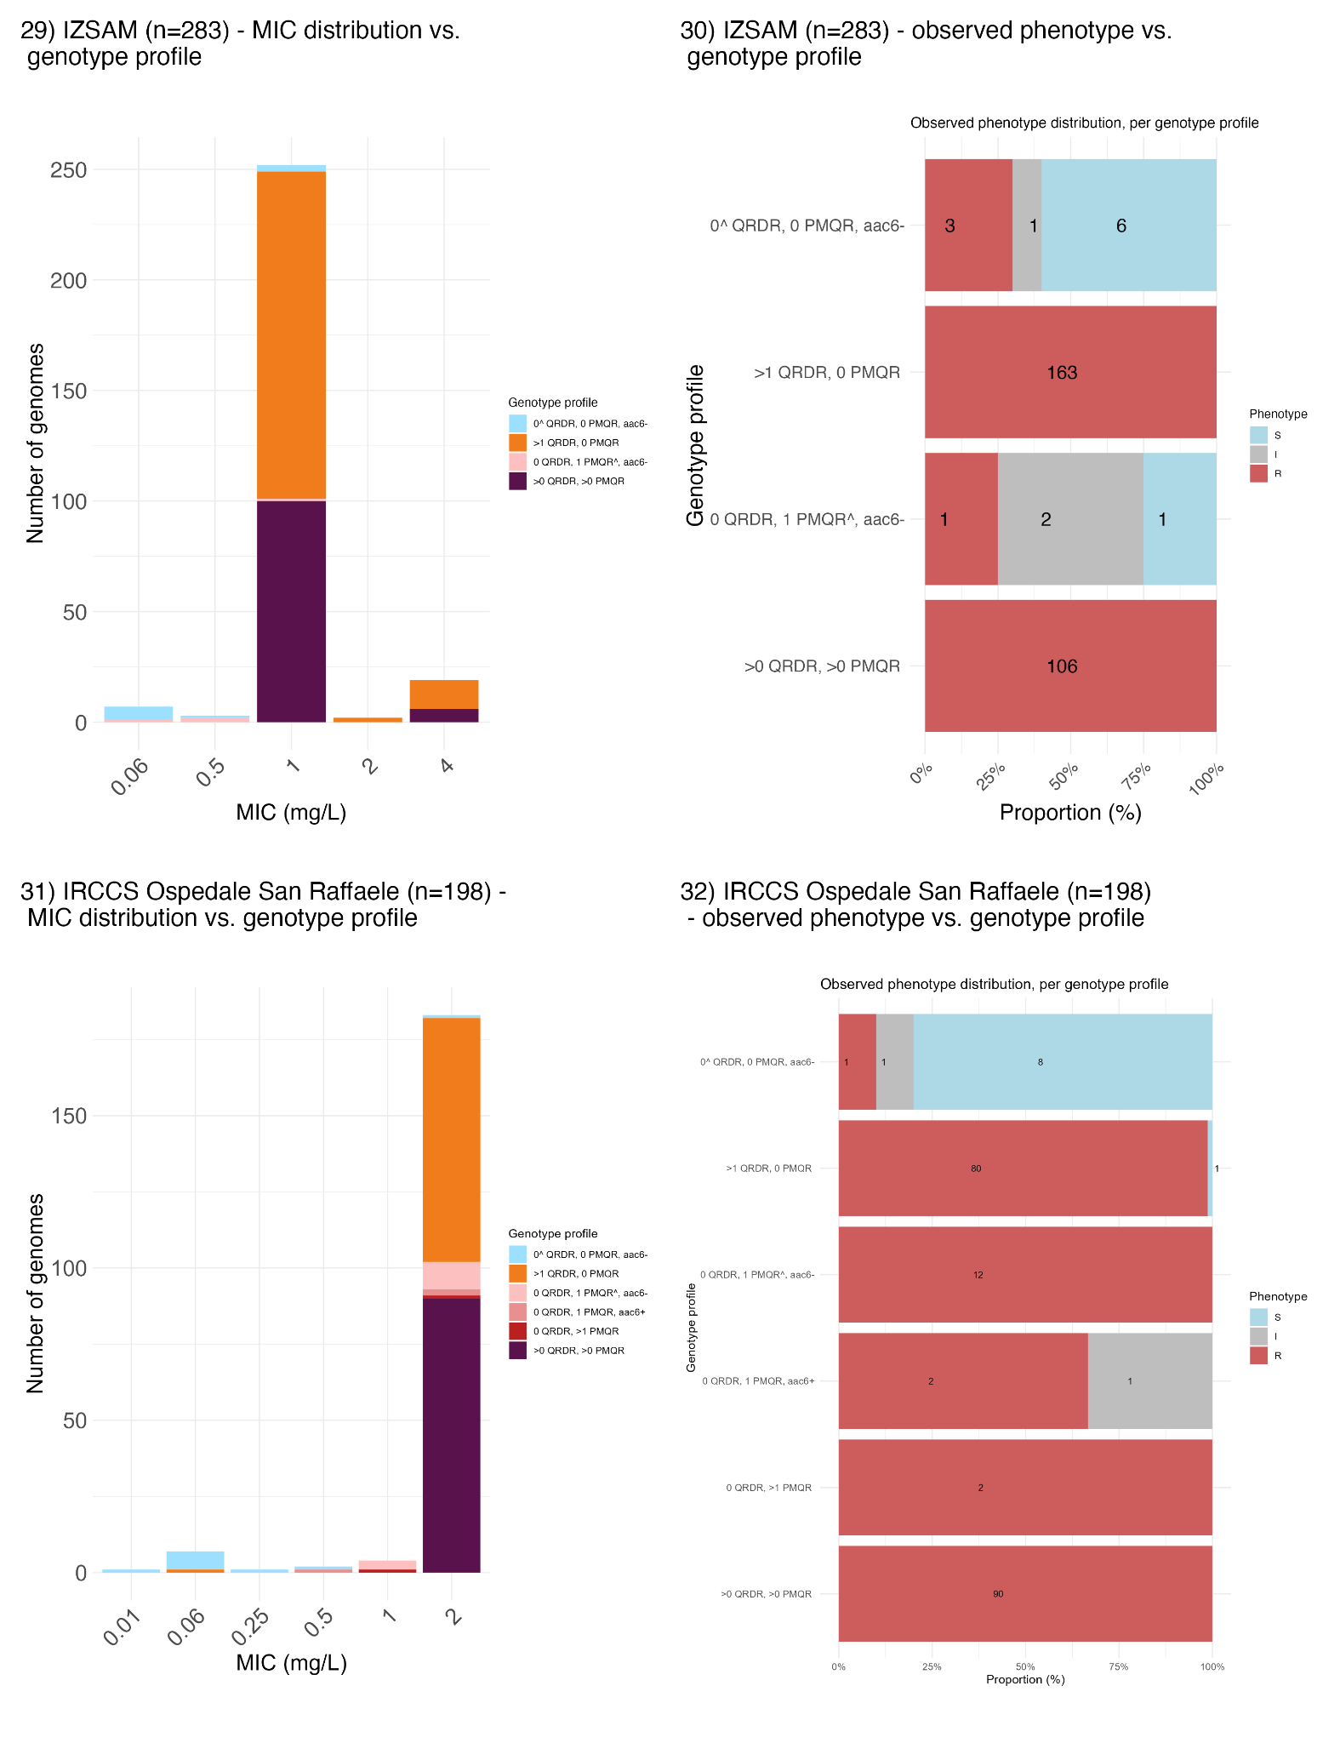

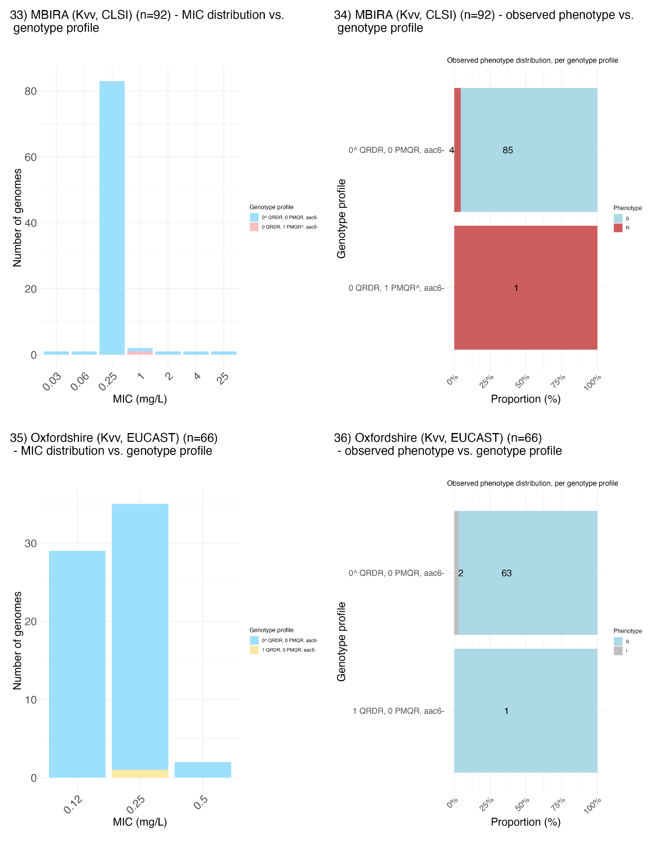
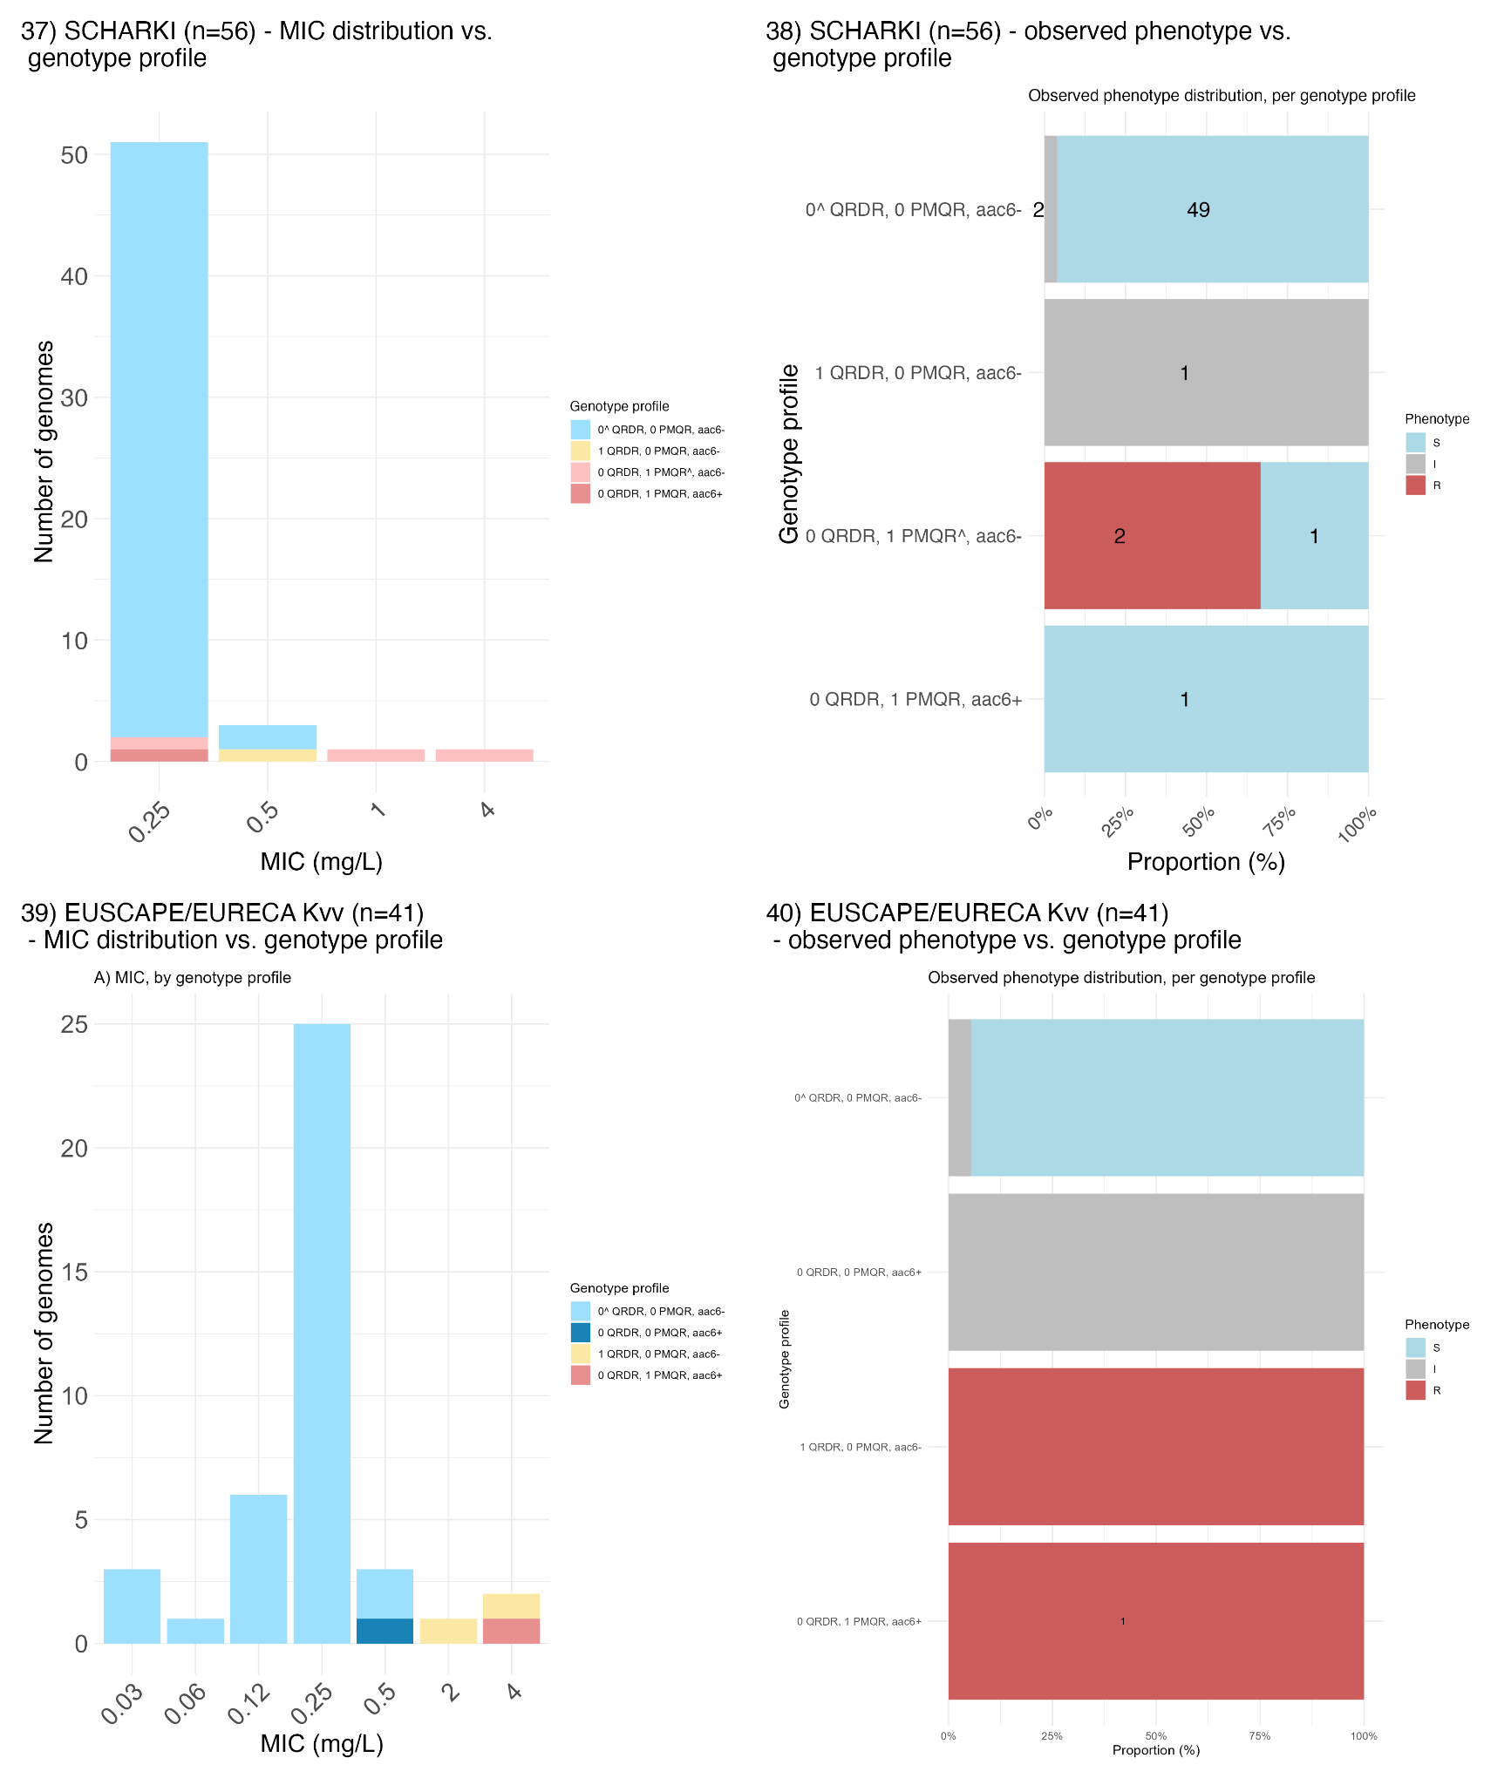

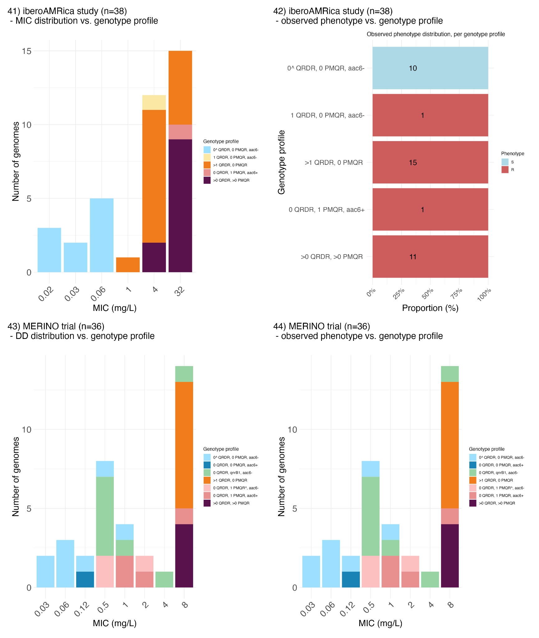

Fig. S11. Genotype profiles of external validation datasets. (Odd numbered panels, e.g., 1, 3, 5, etc.) MIC or disk diffusion zone (DD) distributions coloured by genotype profile assigned by the rule-based classifier per dataset. (Even numbered panels, e.g., 2, 4, 6, etc.) Frequency of true, observed S/I/R phenotypes observed for genomes categorized into each genotype profile used in the rule-based classifier. Ciprofloxacin susceptibility phenotypes were measured using MIC or disk diffusion (indicated by *). For each dataset, the breakpoint guidelines used are indicated in the first bracket, followed by MIC method (Vitek (V), Phoenix (P), Sensititre (S), Microscan Siemens (M), Microscan WalkAway Beckman Coulter (MW), and E-test (E)). Dataset A includes data from laboratories across Europe and they used various MIC methods.

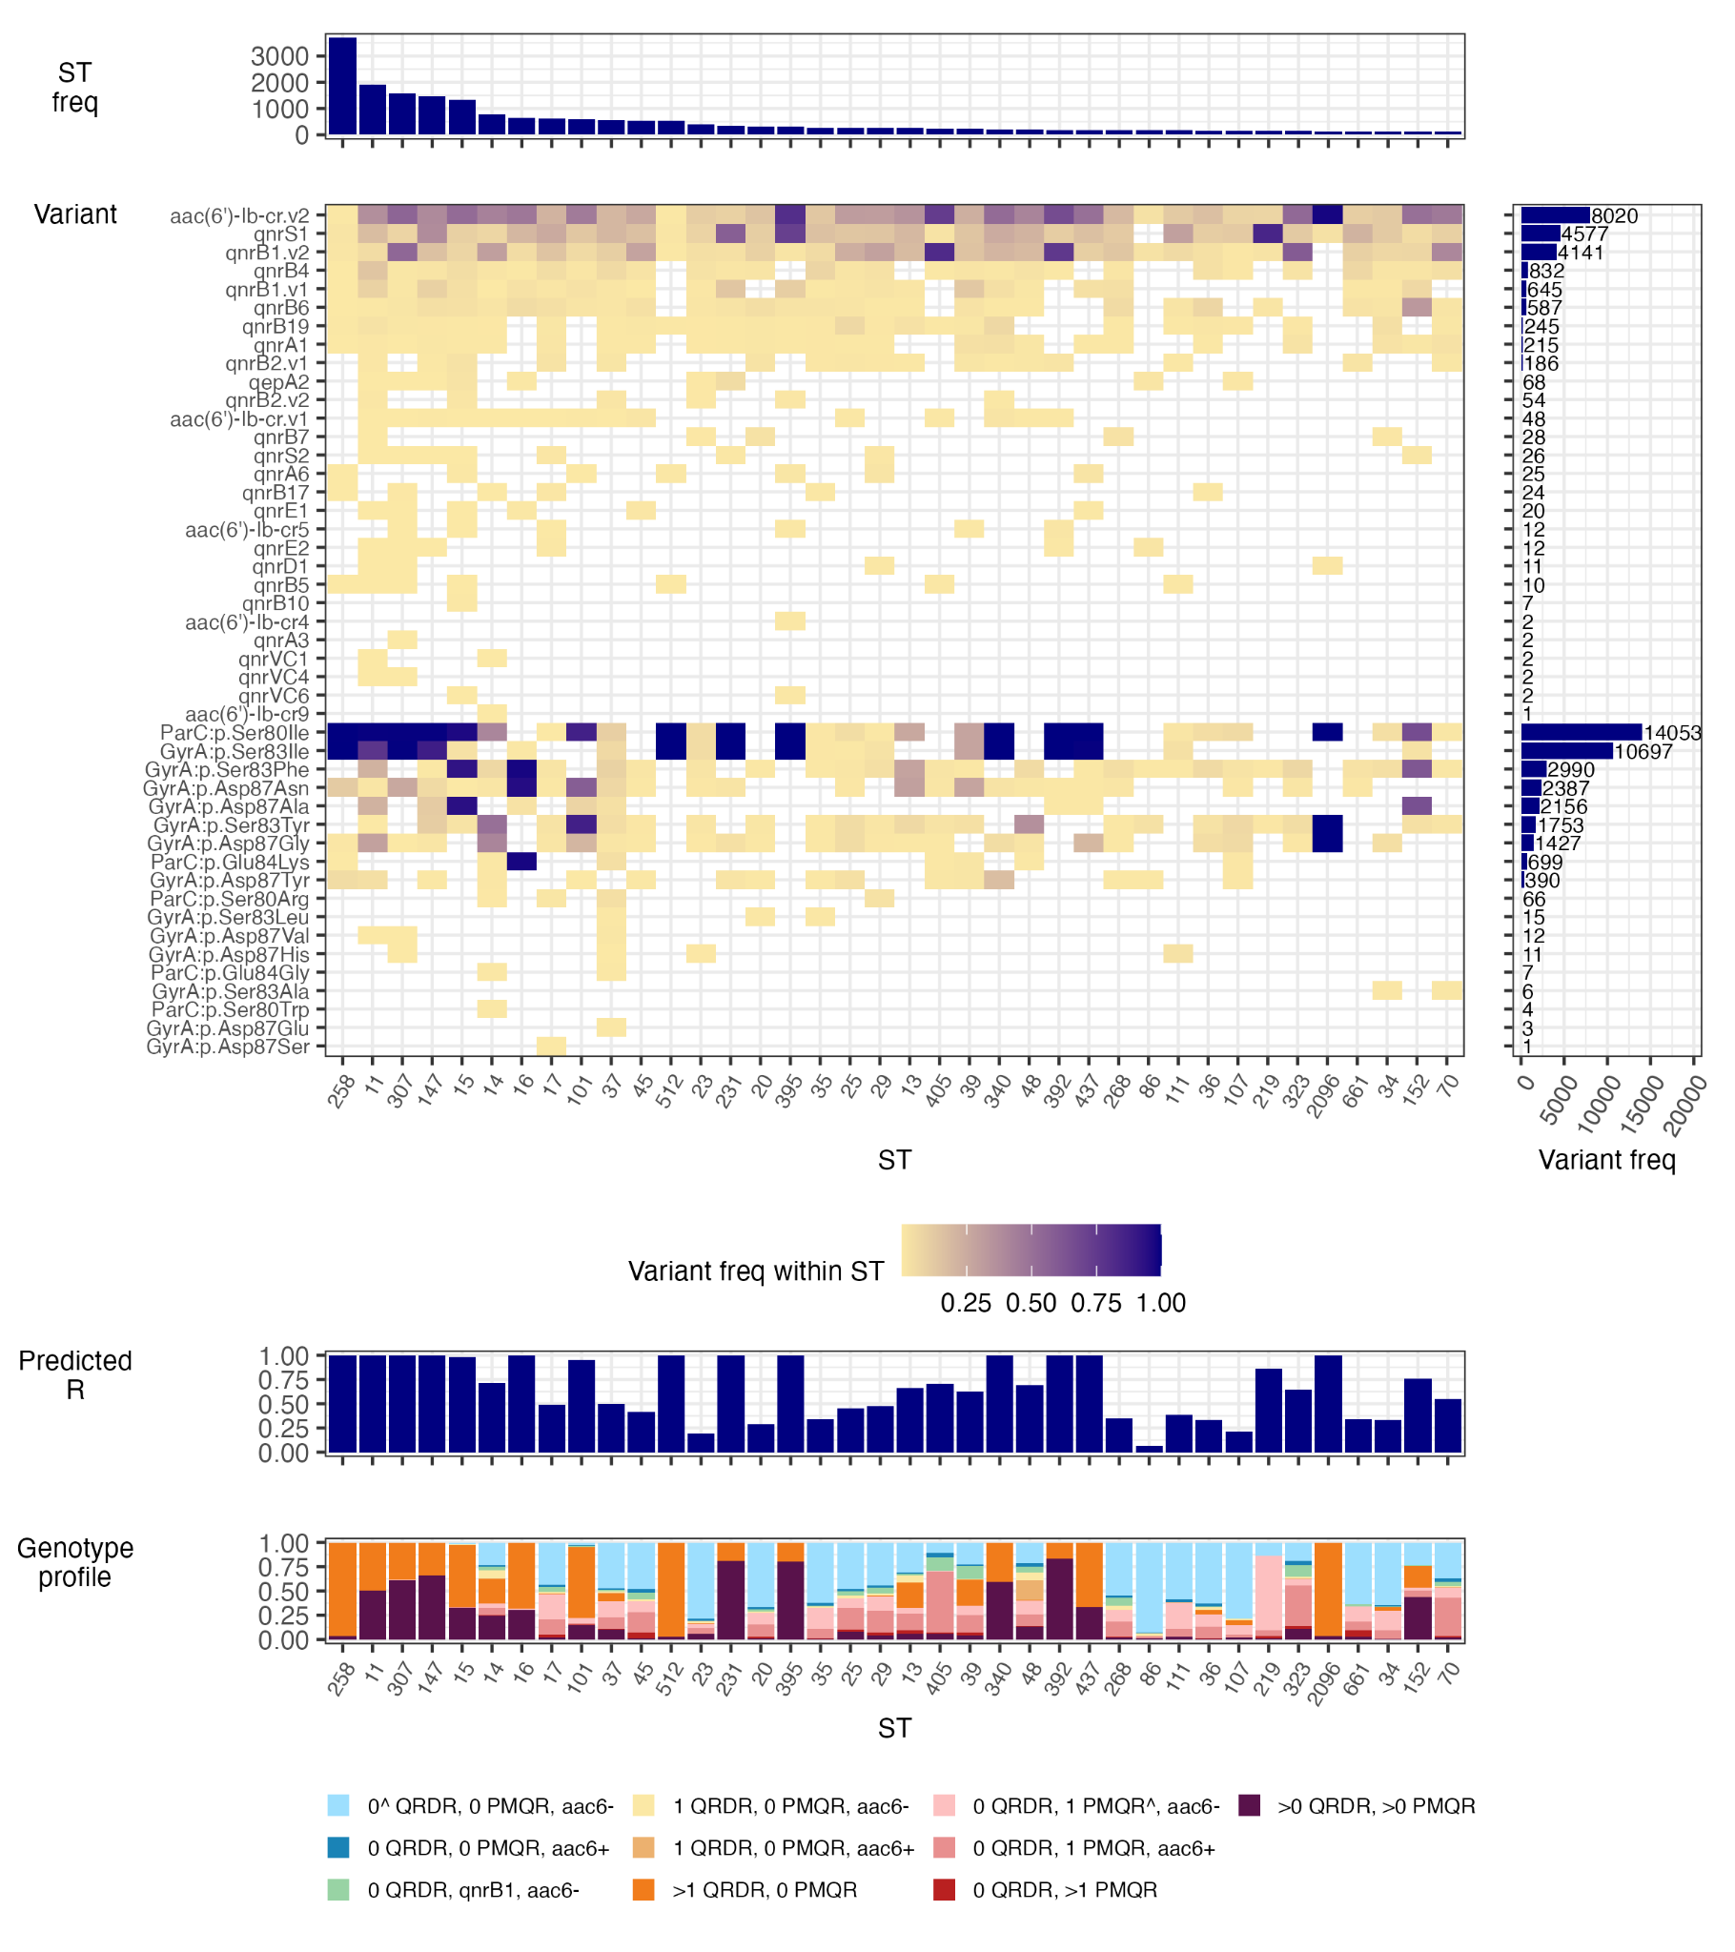

Fig. S12. Ciprofloxacin resistance determinants and predicted resistance in public genome data for K. pneumoniae. Data were downloaded from Pathogenwatch, which assembled all read sets available in ENA as of March 29, 2023 and used Kleborate v3.2.4 to identify resistance variants and 7-locus sequence types (STs), and predict ciprofloxacin resistance using our rule-based classifier. Details are shown for STs with n>100 genomes (n=38 STs, n=18,212 genomes). Variant frequency (freq) in the right-hand panel indicates the total number of genomes in which each determinant was identified (out of n=18,212 K. pneumoniae genomes). ‘Predicted R’ indicates the proportion of genomes predicted as resistant based on genotype profile, using the rule-based classifier.
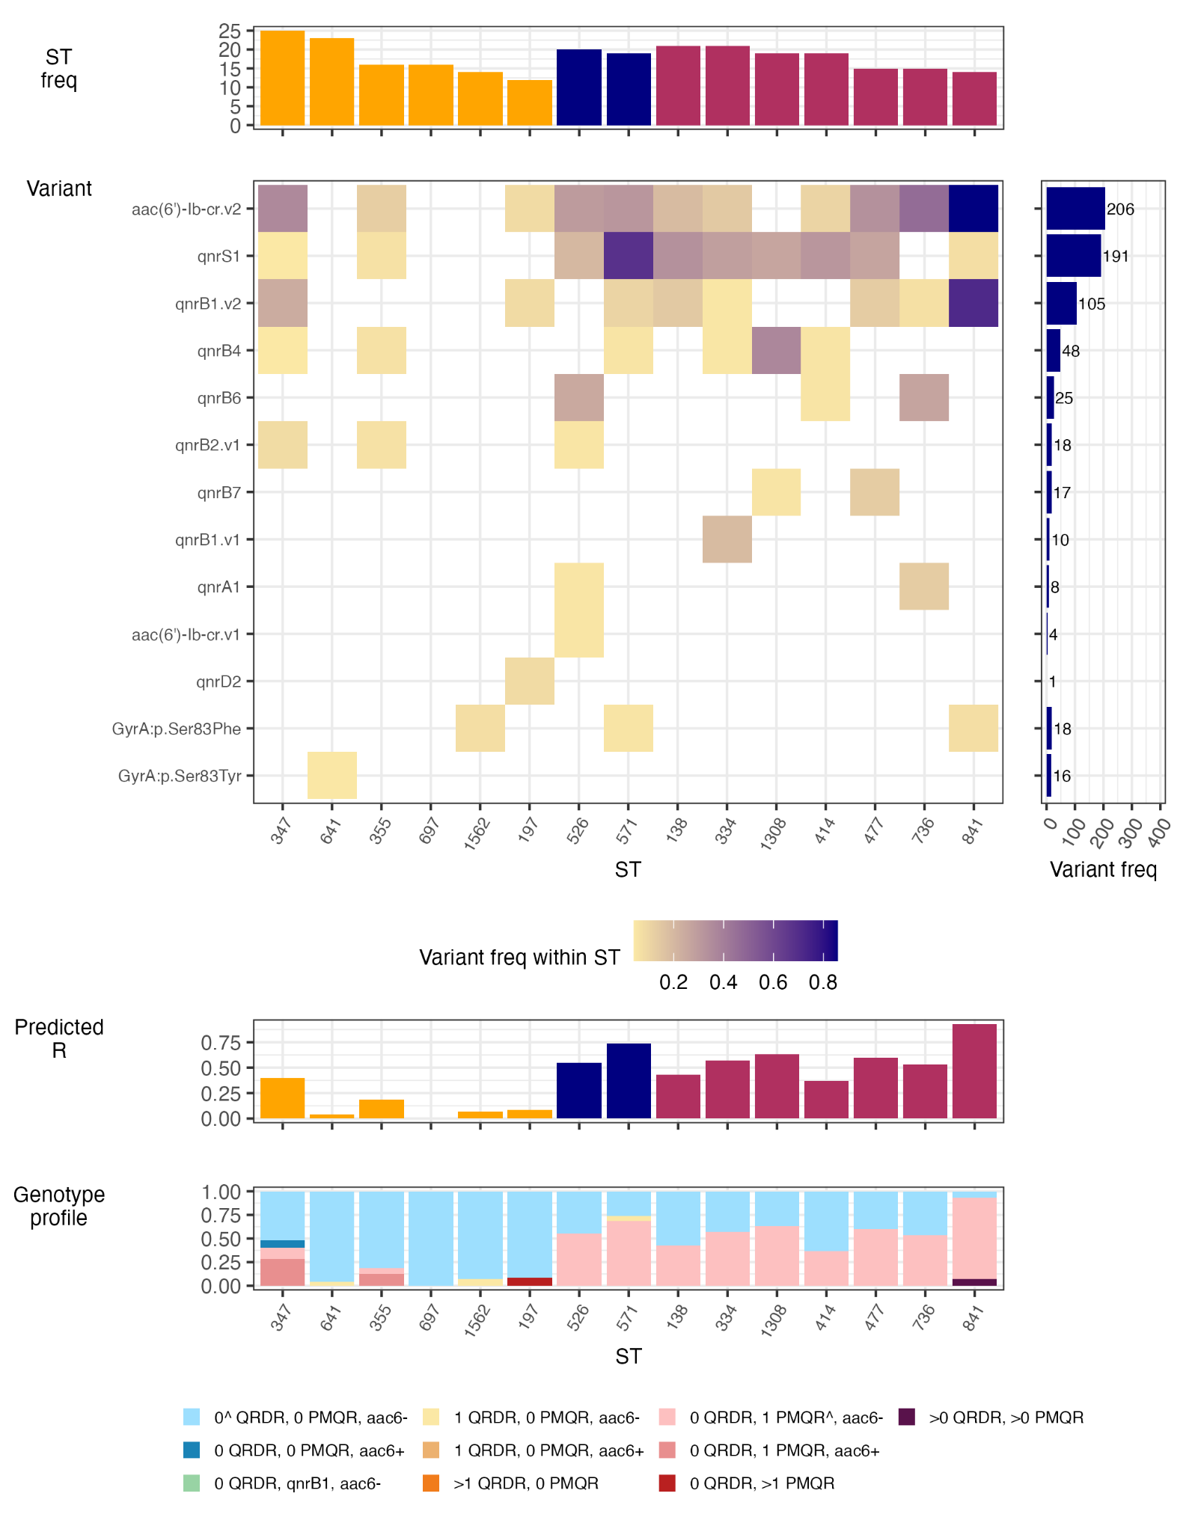

Fig. S13. Ciprofloxacin resistance determinants and predicted resistance in public genome data for other members of the K. pneumoniae species complex. Data were downloaded from Pathogenwatch, which assembled all read sets available in ENA as of March 29, 2023 and used Kleborate v3.2.4 to identify resistance variants and 7-locus sequence types (STs), and predict ciprofloxacin resistance using our rule-based classifier. Details are shown for STs with N>10 genomes (n=15 STs, n=244 genomes). Variant frequency (freq) in the right-hand panel indicates the total number of determinants in which each genome was identified (out of n=244 non-K. pneumoniae genomes). ‘Predicted R’ indicates the proportion of genomes predicted as resistant based on genotype profile, using the rule-based classifier. In the top ST freq plot, yellow=Kv; navy=Kqq, and maroon=Kqs.

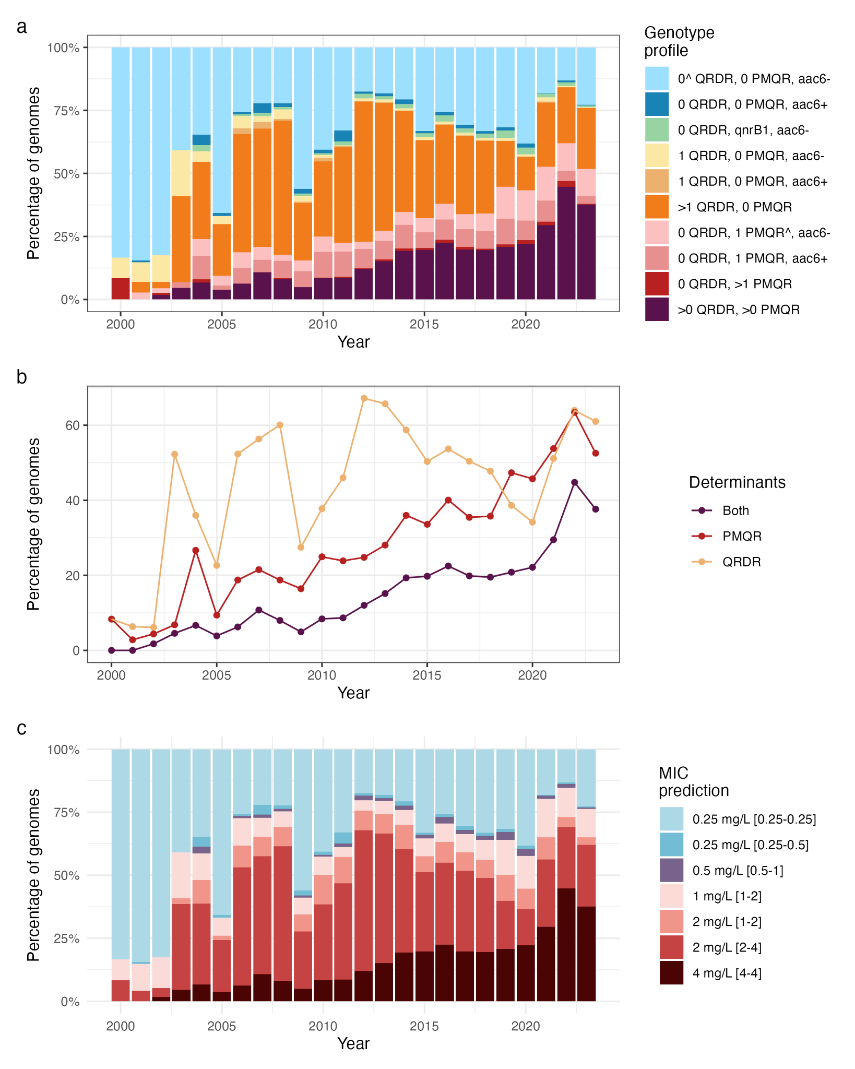

Fig. S14. Ciprofloxacin resistance genotype profile, determinants, and MIC predictions per year in public genome data. (a) Distribution of genotype profiles per year, inferred from 28,022 K. pneumoniae genomes and Kleborate-derived typing information, downloaded from Pathogenwatch. (b) Proportion of genomes per year carrying any quinolone resistance determining region (QRDR) mutation (yellow), any plasmid-mediated quinolone resistance (PMQR) gene (red), or both (maroon); inferred from the same data set. (c) Proportion of genomes and their MIC predictions per year; inferred from the same data set and the rule-based classifier from this study (square brackets indicate interquartile range). Based on EUCAST, MIC values shaded blue would be interpreted as S, those shaded purple (0.5 mg/L) as I, and pink/red/brown shades as R.

