Emergence of locally transmitting and drug-resistant clones shapes global expansion of Mycobacterium tuberculosis Lineage 3

Fig. S1. Terminal branch length (TBL) analysis across M. tuberculosis Lineages 2, 3, and 4 sublineages. (a) Raincloud plot showing the distribution of TBLs for all sublineages of L2, L3, and L4. Each point represents a single isolate, with overlaid density and boxplot. L3.1 exhibited a median TBL of 25.0. Among L2 sublineages, the median TBLs were 11.4 for L2.3, 14.1 for L2.2, and 49.3 for L2.1. Among L4 sublineages, the median TBLs were 11.7 for L4.6, 14.5 for L4.3, 19.2 for L4.1, 19.4 for L4.2, 21.8 for L4.8, 25.0 for L4.7, 26.5 for L4.9, 30.7 for L4.4, 84.8 for L4.11, and 105.0 for L4.5. (b) Heatmap comparing median TBLs of L3.1 sublineages against other L2 and L4 sublineages. L3.1 exhibits significantly shorter TBLs than geographically restricted sublineages (L2.1, L4.5, and L4.11), and is comparable to several widely disseminated L4 sublineages. (c) Comparison of TBLs across L2, L3, and L4 in the top five countries with the highest L3 burden, highlighting the relative branch lengths within each lineage by country.

Fig. S2. Global prevalence maps of all M. tuberculosis Lineages 2, 3, and 4 sublineages. Each map displays the geographic distribution of sublineages within L2, L3, and L4. Colors indicate relative prevalence of each sublineage in individual countries.

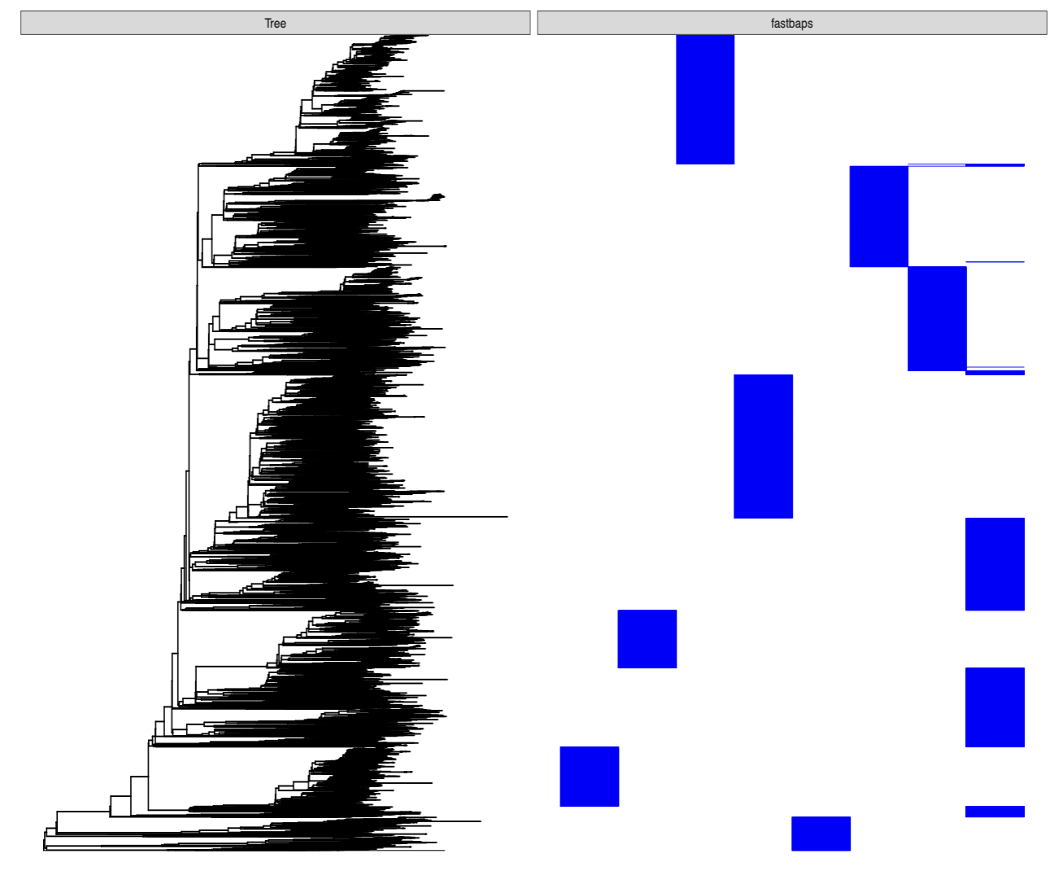Fig. S3. Sublineage delineation of L3.1.1. Sublineage classification of L3.1.1 based on FastBAPS clustering. Single, discrete clusters are labeled L3.1.1.1–6; the remaining non-contiguous composite cluster is designated as the legacy group, representing historical, non-expanding lineages.

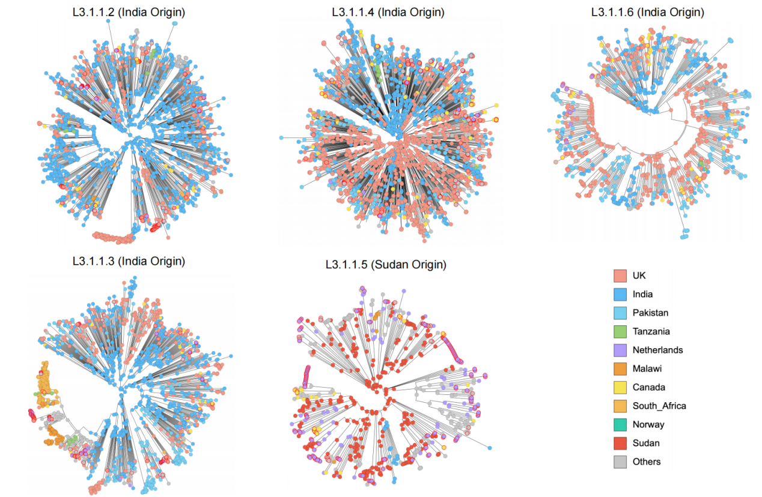

Fig. S4. Inferred country of origin for L3.1.1 sublineages (L3.1.1.2–6).
PastML was used to infer the most likely country of origin for each of the other five L3.1.1 sublineages.

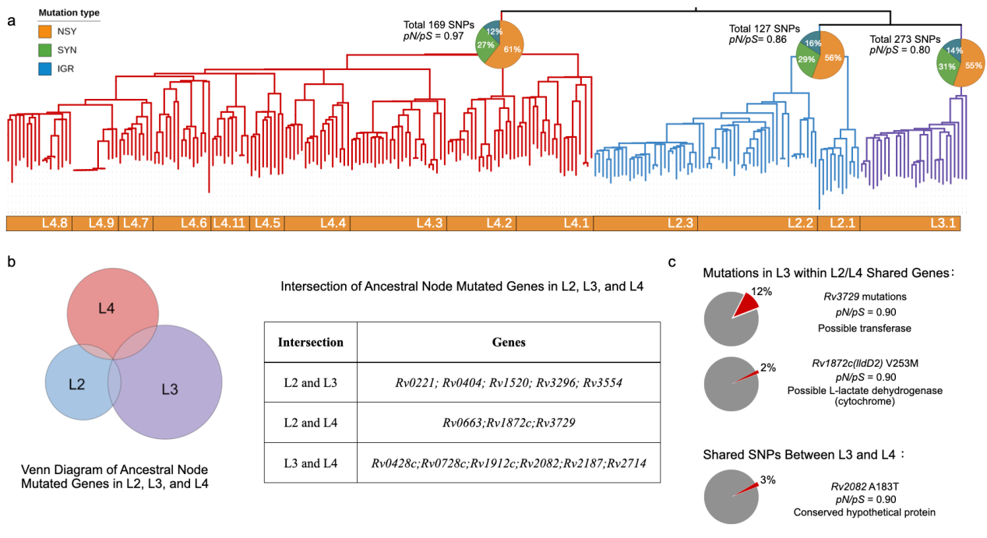
Fig. S5. Analysis of ancestral node mutations across M. tuberculosis Lineages 2, 3, and 4. (a) Phylogenetic tree showing the number of nonsynonymous and synonymous mutations accumulated at ancestral nodes, with corresponding pN/pS ratios annotated for each major lineage. (b) Venn diagram illustrating shared and lineage-specific genes carrying ancestral mutations among L2, L3, and L4. (c) Comparative analysis of convergent ancestral mutations observed in L2 and L4 and their selection status within L3, highlighting potential lineage-intrinsic adaptive constraints.

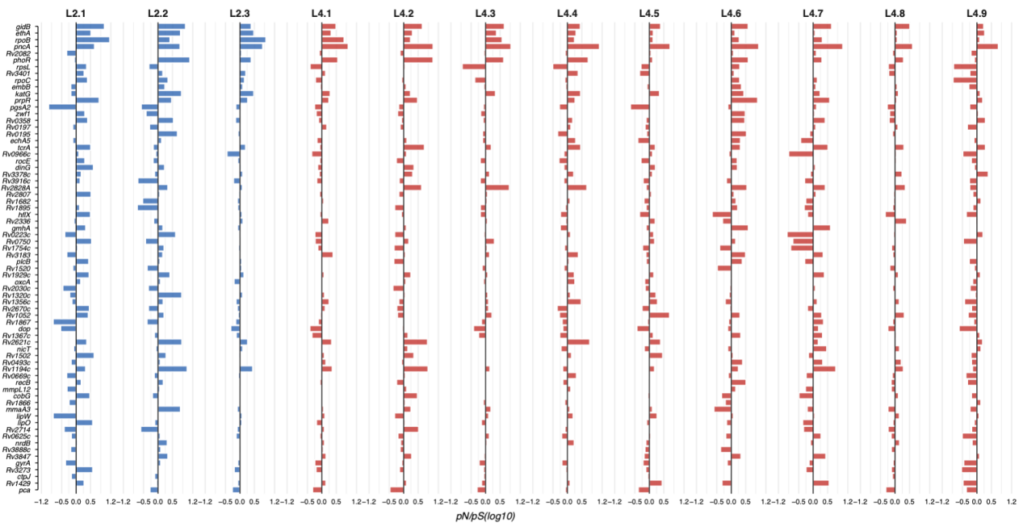
Fig. S6. pN/pS across the L2 and L4 sublineages.

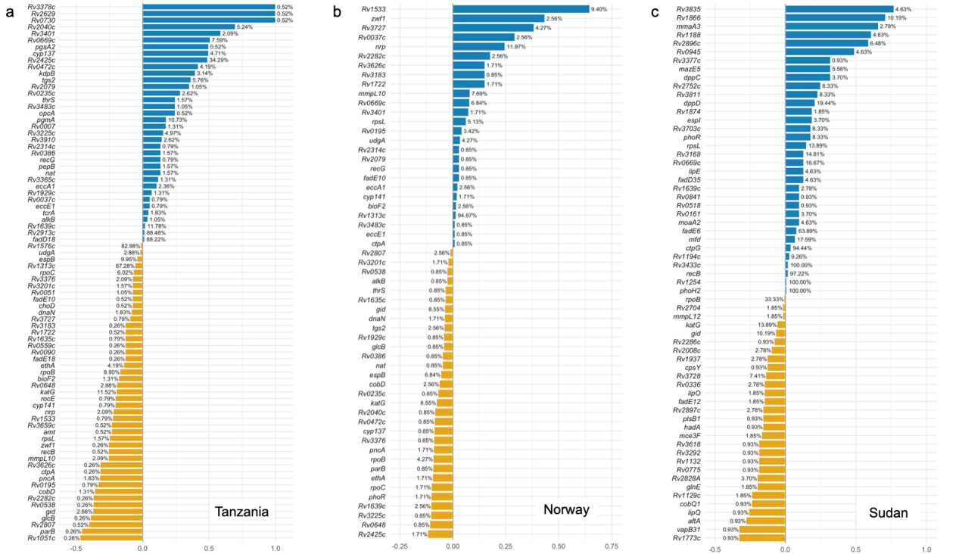
Fig. S7. Country-specific distribution of selected genes within L3.1.1 sublineages. Bar plots indicate the proportion of isolates carrying positively selected mutations in each sublineage relative to the proportion of isolates from the corresponding country. Values of zero indicate perfect concordance between the gene-specific and country-specific proportions; positive values indicate over-representation, and negative values indicate under-representation. Numbers above each bar show the percentage of all isolates from that country carrying the mutation. Only genes where ≥90% of mutated isolates are confined to a single country and account for ≥30% of that country’s isolates are considered to show country-specific selection. Panels show data for (a) Tanzania, (b) Norway , and (c) Sudan.
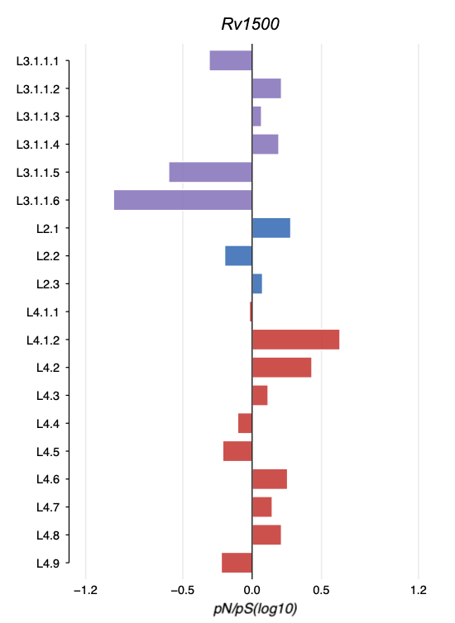
Fig. S8. Comparative pN/pS patterns of Rv1500 across major Mycobacterium tuberculosis lineages.

Fig. S9. THD analysis of L3. Colors indicate two groups: isolates without compensatory mutations and isolates carrying compensatory mutations. Within each group, isolates are further stratified by predicted resistance profile: drug-sensitive, other-DR (all resistance types excluding MDR, pre-XDR, and XDR), MDR, and pre-XDR.
For isolates without compensatory mutations, the median THD values (range) were: drug-sensitive, 0.0116 (1.67×10⁻⁷ to 0.0887); other-DR, 0.00094 (1.55×10⁻⁸ to 0.0697); MDR, 0.0188 (2.53×10⁻⁵ to 0.118); and pre-XDR, 0.00681 (3.86×10⁻⁶ to 0.0853).
For isolates carrying compensatory mutations, the corresponding THD values were: other-DR, 0.0000508 (1.48×10⁻¹⁰ to 0.0574); MDR, 0.00115 (2.29×10⁻⁹ to 0.108); and pre-XDR, 0.00586 (1.12×10⁻⁸ to 0.923). Among these comparisons, only the pre-XDR isolates carrying compensatory mutations showed a statistically significant increase in THD relative to the other groups (P < 0.001).

