Supplementary Figures
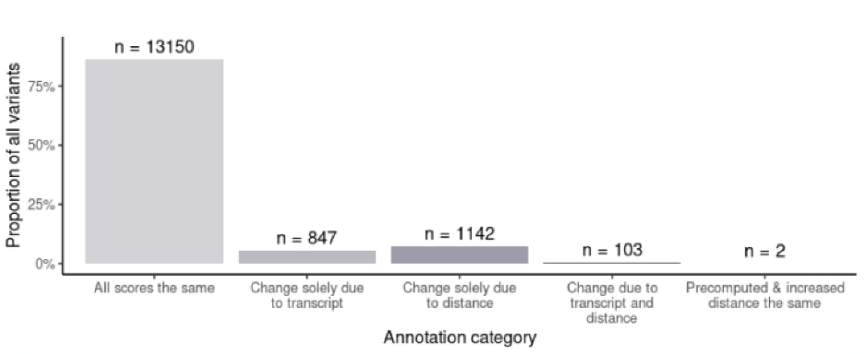

Fig S1:The landscape of change in SpliceAI scores between annotation runs. 86.26 percent of the full set of 15,244 de novo variants had no change in SpliceAI max Δ over each of the 3 conditions. 5.56% had a score change solely attributable to a change in transcript boundaries. 7.49% of variants’ scores were altered in response to a change in the distance parameter alone, and 0.68% of variants were impacted by both transcript annotation, and distance parameter changes. The scores of 2 variants initially changed in response to updated transcript annotations, but gained a new annotation that happened to be the same as their precomputed score scores when the distance parameter was increased.

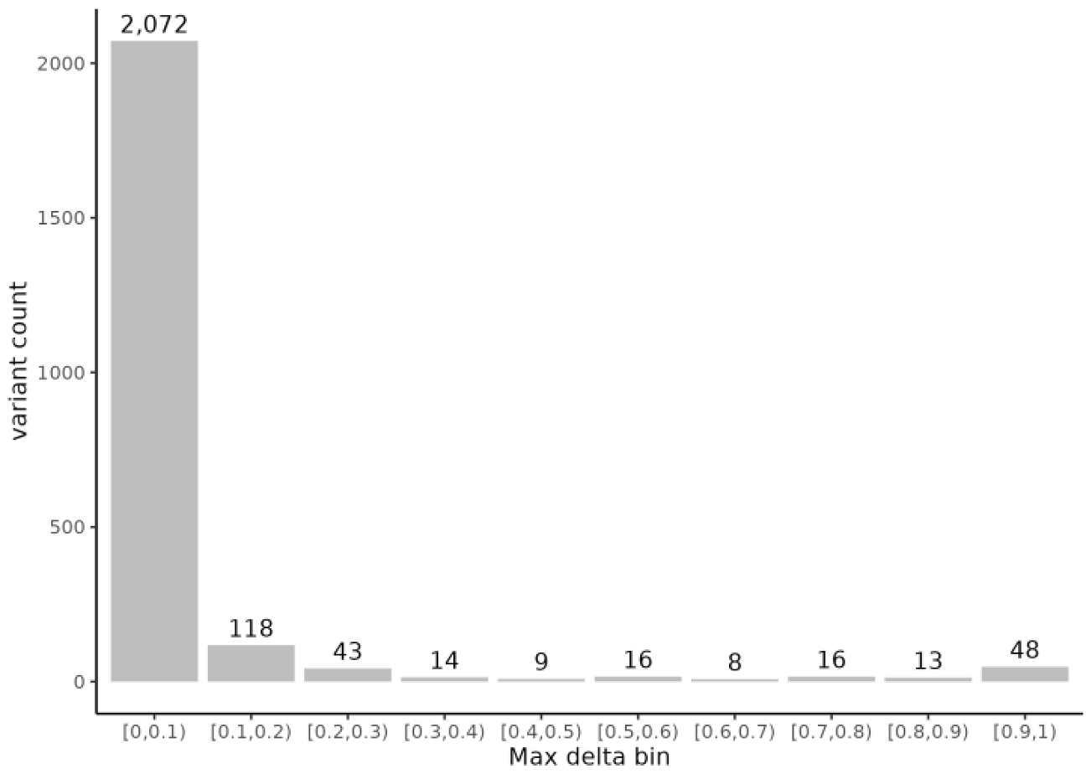
Fig S2: Distribution of genetic variants within max Δ bins. Plot shows the distribution of max Δ bins for 2,385/15,244 de novo variants in NDD genes which had a SpliceAI max Δ > 0 when run with MANE v1.0 transcripts and distance parameter 500.

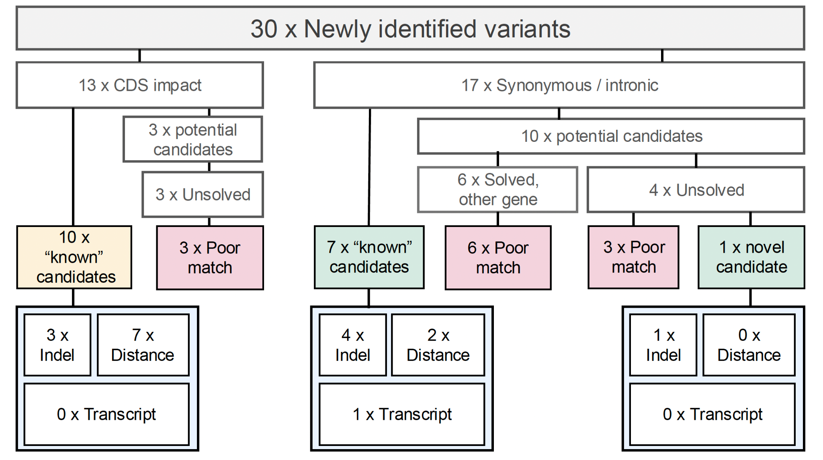
Fig S3: Flowchart of variant interpretation for the 30 newly identified variants from 100kGP, including the mechanism by which they were detected. Variants that were not considered good candidates for the individual’s phenotype, or that were also predicted to have a ‘coding effect’ are shown in pink and yellow respectively, candidate diagnostic variants with a likely splice altering effect are shown in green. The mechanisms by which each of the potentially diagnostic candidate variants were detected are shown in pale blue.

