SUPPLEMENTARY FIGURES

Fig. S1
nf-core-oncoseq workflow. Schema summarizing the different tools and processes called within the nf-core-oncoseq workflow for the full version ran on all samples of the cohort (A), and for the “lite” version to run in realtime (B). Additional details: https://github.com/chusj-pigu/nf-core-oncoseq

Fig. S2
Coverage stability in copy neutral and non-copy neutral samples. Gene level deletion and amplifications shown by differential coverage. Mean coverage of recurrently deleted genes CDKN2A/B and amplified gene MYCN shown across control and positive patients. Blue color represents a coverage with a Z score of < 2.75, red color represents a coverage with a Z score of > 2.75.

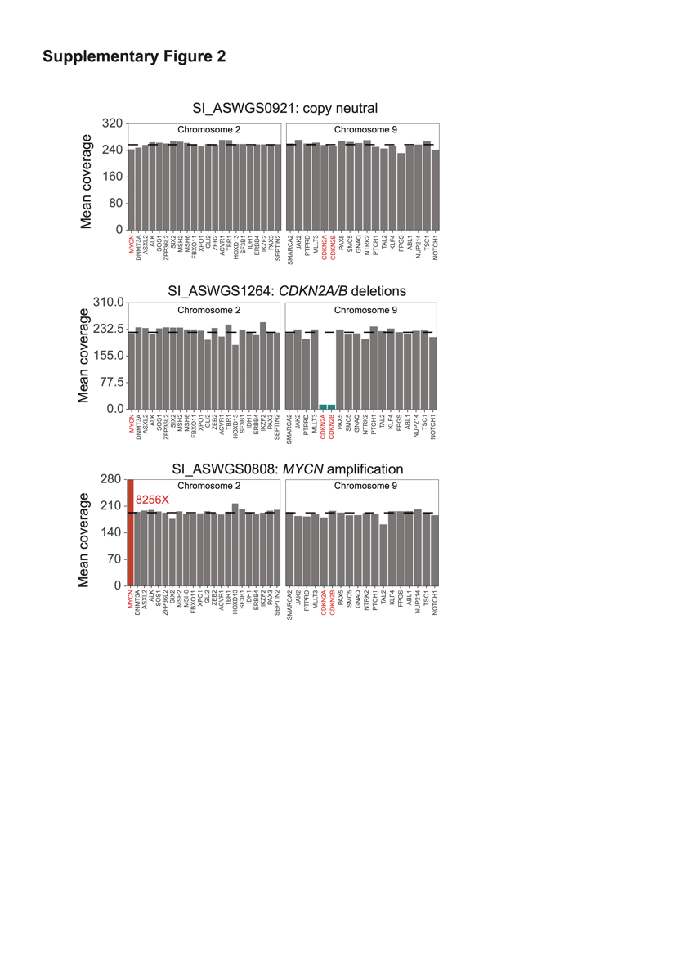

Fig. S3
Mean coverage of on-target genes/loci. Representative normal sample (SI_ASWGS0921 – mean coverage 186X). Genes are ordered by chromosomal position. Coverage of genes that exceed 1.5 times the median is capped to this value, and real value is annotated on the plot to facilitate visualization of variation. Alignment type filters are a combination of samtools flag filters and mapq filters. No filter is representative of all alignments including secondary alignments, primary only excludes secondary alignments but includes alignments of MAPQ= 0, and unique includes only alignments of MAPQ= 60. Dashed lines represent median on target (upper) and off target (lower) coverage. Grey color bars indicate a coverage that is within a range of 2.75 from zscore of said gene compared to mean coverage of targets for the sample.

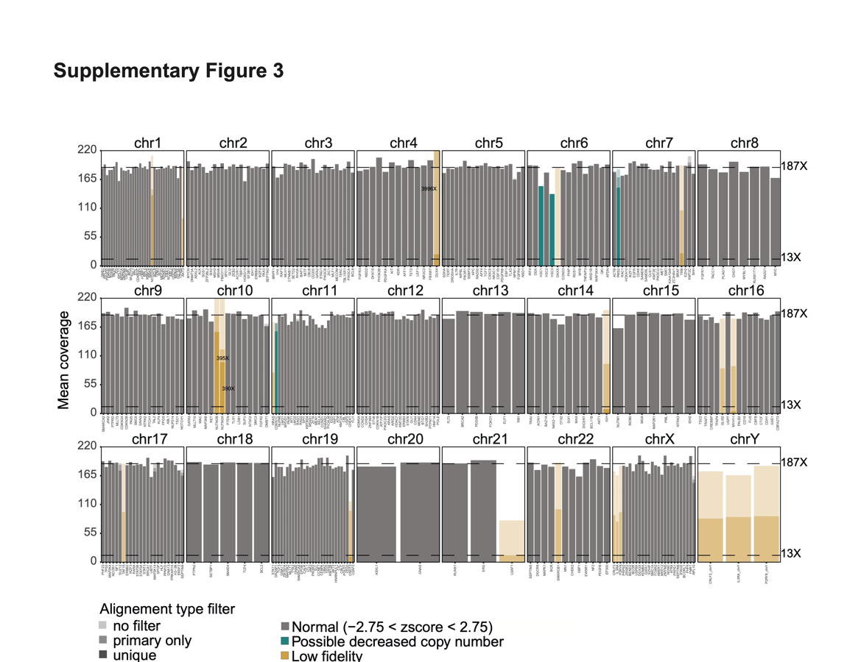

Fig. S4
Coverage Statistics for the cohort. A) Relationship between mean coverage in targeted region and gDNA DIN (n = 36), with point in yellow representing the samples for which a long fragment buffer was used to exclude short fragments (<3kb). B) Relationship between mean coverage inside of target (X) and number of flowcell pores at start of sequencing. Point opacity shows input gDNA DIN. C) Inside of target mean coverage (X) across samples according to flowcell reception date to show variability between flow cell batches. Mann-Whitney test to compare mean coverage between dates of reception 24/07/2024 and 02/01/2025 resulted in a p value of 0.0003. Red dots identify the healthy donor sample that was sequenced twice.

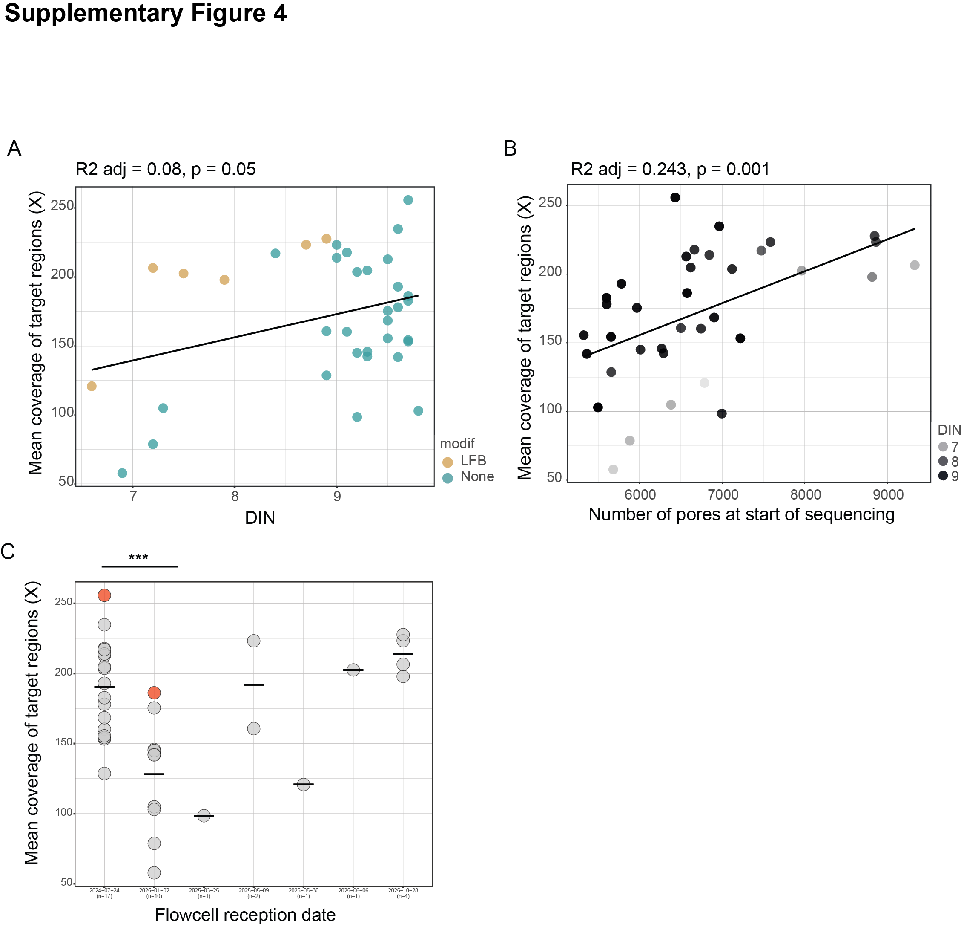

Fig. S5
Examples of visual confirmation of alterations missed by the workflow. A) SET-NUP214 fusion in sample SI_ASWGS1002. B) FLT3-ITD (Internal tandem duplication) in sample SI_ASWGS1196. VAF WES: 11%; VAF AS-WGS: 7%).
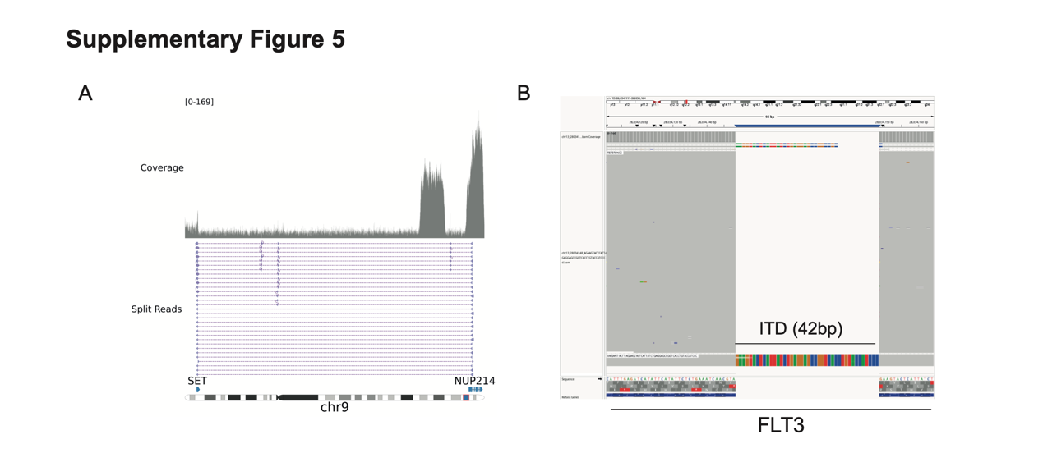

Fig. S6
Variant detection limits. QDNAseq and Sniffles2 variant detection tools were applied to tumor and germline alignments, bioinformatically mixed at known fractions. Automatic CNV detection deteriorates below 70% tumor fraction and automatic SV detection below 40-50% tumor fraction. Manual inspection (denoted by *) enabled the detection of both large and small CNVs at lower tumor fractions, with detection limits of approximately 20% tumor fraction for large CNVs and 5% tumor fraction for focal deletions.

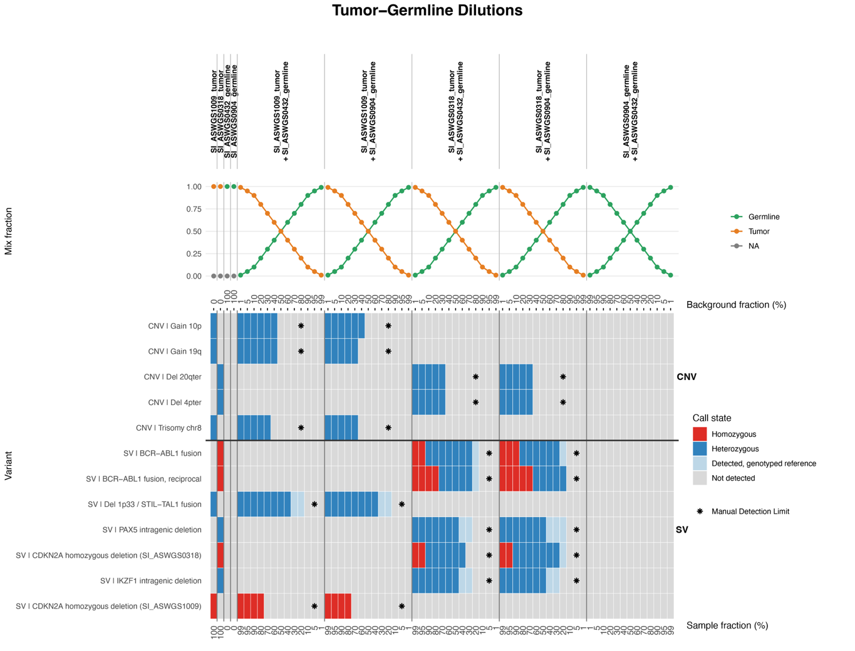

Fig. S7
Methylation classification detection limit. The MARLIN classifier was applied to bioinformatically diluted tumor fractions. For each tumor, the classification loses confidence or is classified as a control at 40-50% tumor fraction. The control germline sample mix was classified as a control type and oscillated consistently respective to the ratio.
