Additional file 1
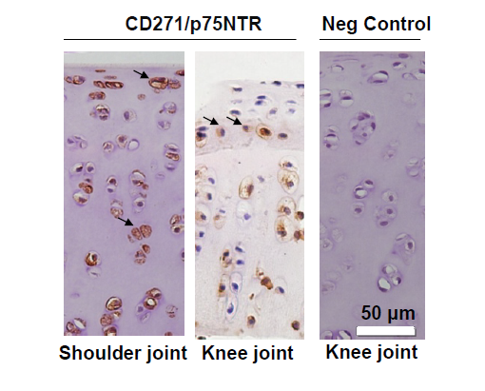

Fig. S1. Immunodetection of CD271/p75NTR in normal rabbit cartilage
Strong CD271 immunostaining was seen in normal shoulder and knee articular cartilage of adult New Zealand White rabbit (age: 3-4 months). Neg Control, negative control without primary antibody. Bar = 50 μm.

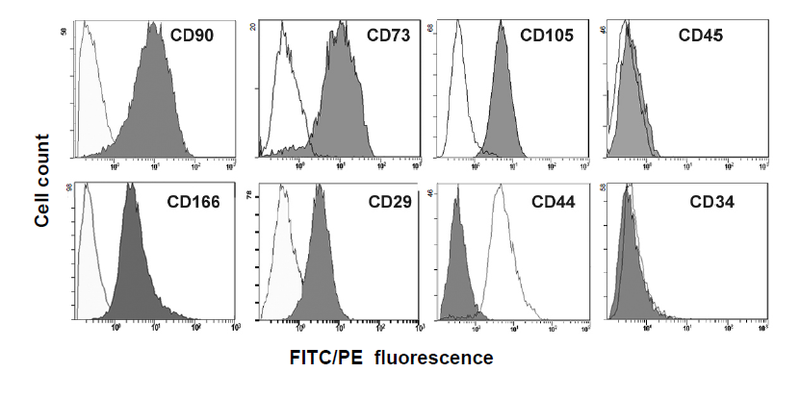
Fig. S2. Characterization of cell surface epitope profile of migratory cells isolated from human OA articular cartilage.
Flow cytometric analysis of stem cell-relevant surface markers revealed the presence of CD90, CD73, CD105, CD166, CD29, and CD44, and absence of CD34, and CD45.

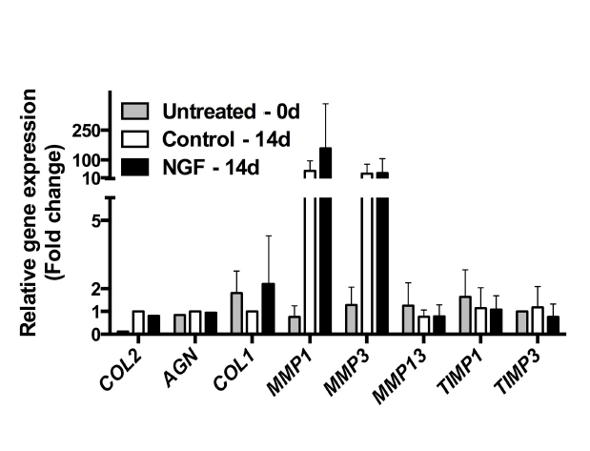
Figure S3. Human OA cartilage explants gene expression profile after NGF (10 ng/ml) treatment for 14 days.
Cartilage explants from OA tissue were cultured in serum free medium (control), or treated with NGF for 14 days, and then the gene expression of the explants were analyzed separately. (N=10, biological replicates; Control versus NGF, no significant difference; values are mean ± S.D).

Table S1. Primer sequences for real-time RT-PCR
Genes | NCBI  Gene ID | Primer sequences (5’-3’) |  | Product size (bp)
_______________ | ______________ | _____________________________________________________________________ |  | __________
COL1A1 | 1277 | Forward | CGATGGATTCCAGTTCGAGTAT | 248
COL1A1 | 1277 | Reverse | CATCGACAGTGACGCTGTAGG | 248
COL2A1 | 1280 | Forward | GGATGGCTGCACGAAACATACCGG | 157
COL2A1 | 1280 | Reverse | CAAGAAGCAGACCGGCCCTATG | 157
SOX9 | 6662 | Forward | AGCGAACGCACATCAAGAC | 84
SOX9 | 6662 | Reverse | CTGTAGGCGATCTGTTGGGG | 84
AGN | 176 | Forward | AGTCACACCTGAGCAGCATC | 147
AGN | 176 | Reverse | AGTTCTCAAATTGCATGGGGTGTC | 147
ADAMTS-5 | 11096 | Forward | ATCACCCAATGCCAAGG | 246
ADAMTS-5 | 11096 | Reverse | AGCAGAGTAGGAGACAAC | 246
MMP13 | 4322 | Forward | ATGCAGTCTTTCTTCGGCTTAG | 269
MMP13 | 4322 | Reverse | ATGCCATCGTGAAGTCTGGT | 269
RPL13a | 23521 | Forward | CATAGGAAGCTGGGAGCAAG | 157
RPL13a | 23521 | Reverse | GCCCTCCAATCAGTCTTCTG | 157
RNA18S5  (18S) | 100008588 | Forward | GTAACCCGTTGAACCCCATT | 151
RNA18S5  (18S) | 100008588 | Reverse | CCATCCAATCGGTAGTAGCG | 151
NGF | 4803 | Forward | CCAGTGGTCGTGCAGTCCAAG | 217
 |  | Reverse | TGTCCTGCAGGGACATTGCTCT
IL-1β | 3553 | Forward | TTACAGTGGCAATGAGGATGAC | 134
 |  | Reverse | TGCTGTAGTGGTGGTCGGAGA
ADAMTS-4 | 9507 | Forward | CTGGCACCTACCTGACTGG | 118
 |  | Reverse | GTAACACGCCTAACAGGGCT
MMP3 | 4314 | Forward | AGTCTTCCAATCCTACTGTTGCT | 226
 |  | Reverse | TCCCCGTCACCTCCAATCC
TIMP1 | 7076 | Forward | CTTCTGCAATTCCGACCTCGT | 79
 |  | Reverse | ACGCTGGTATAAGGTGGTCTG
TIMP3 | 7078 | Forward | CATGTGCAGTACATCCATACGG | 100
 |  | Reverse | CATCATAGACGCGACCTGTCA

