Additional file 2: Synthetic crystals of monosodium urate. A) Scanning electron micrograph of synthetic MSU crystals (50,000 ×). B) MSU crystals under polarized light (400 ×). C) MSU crystals from the synovial fluid of a gout patient (400 ×). The white bar indicates the axis compensator.
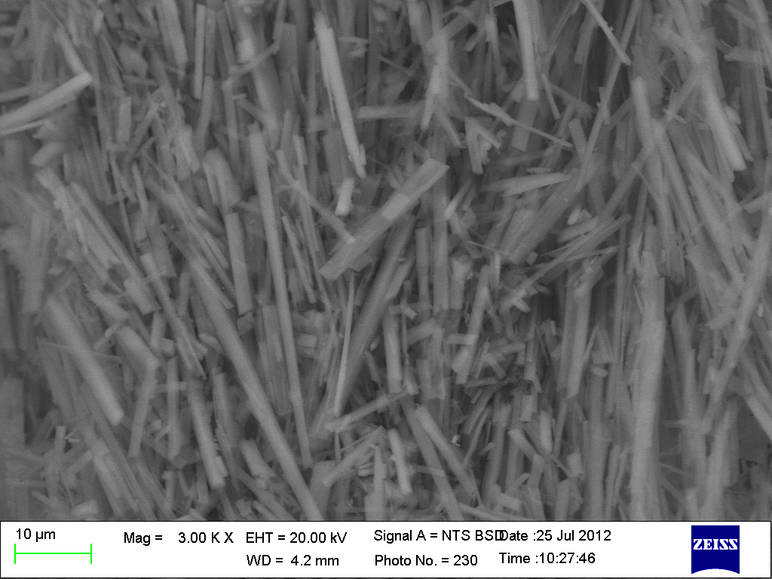
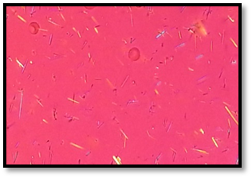
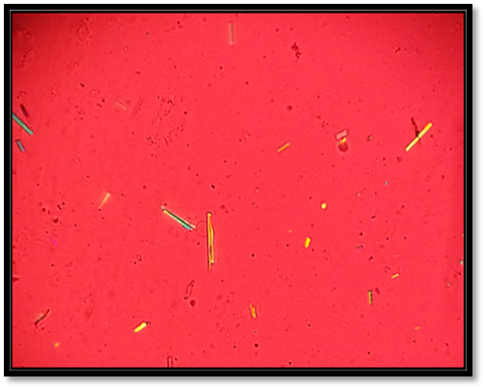

C
B
A

