Additional file 3: Characterization of synoviocytes derived from five primary cultures from different patients. A) Typical morphology of fibroblasts. B) Expression of PDH4+ in synoviocytes by IFA, expression of intracellularly localized PDH4+ by confocal microscopy. C) Protein expression of PDH4+ by WB. Results are representative of one of five separate experiments.
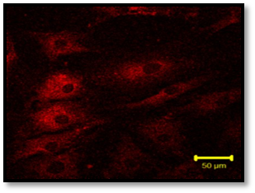
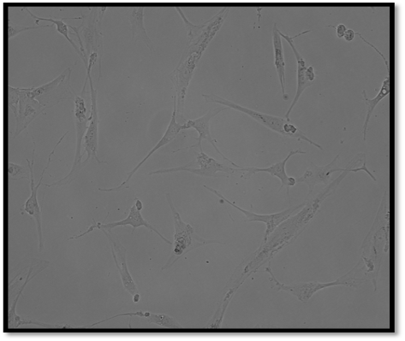
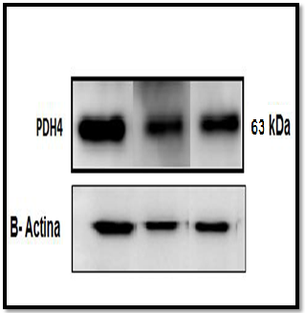

A
B
C

