Additional file 2
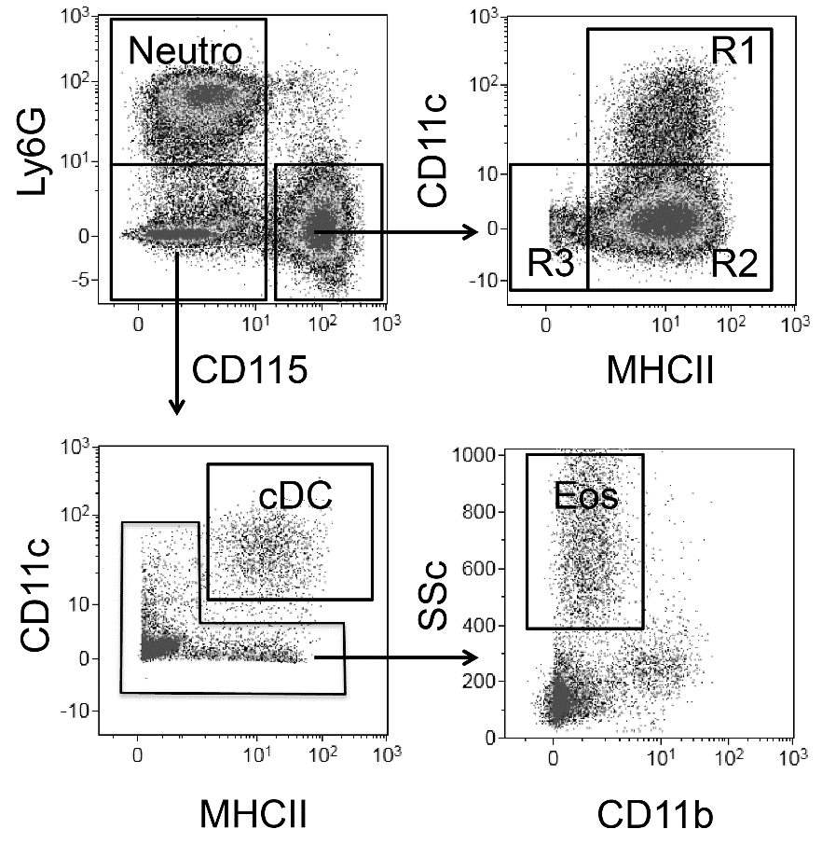
Representative FACS plots showing the gating strategy used to identify populations in AIP. Ly6G⁺ neutrophils (Neutro), CD115⁺CD11c⁺MHCII⁺ Mo-DCs (R1); CD115⁺CD11c⁻MHCII⁺ macrophages (R2); CD115⁺CD11c⁻MHCII⁻ monocytes (R3),CD115⁻ Ly6G⁻CD11c⁺MHCII⁺ cDCs and CD115⁻Ly6G⁻CD11b^{int}SSc^{hi} eosinophils (Eos).

