Additional file 1

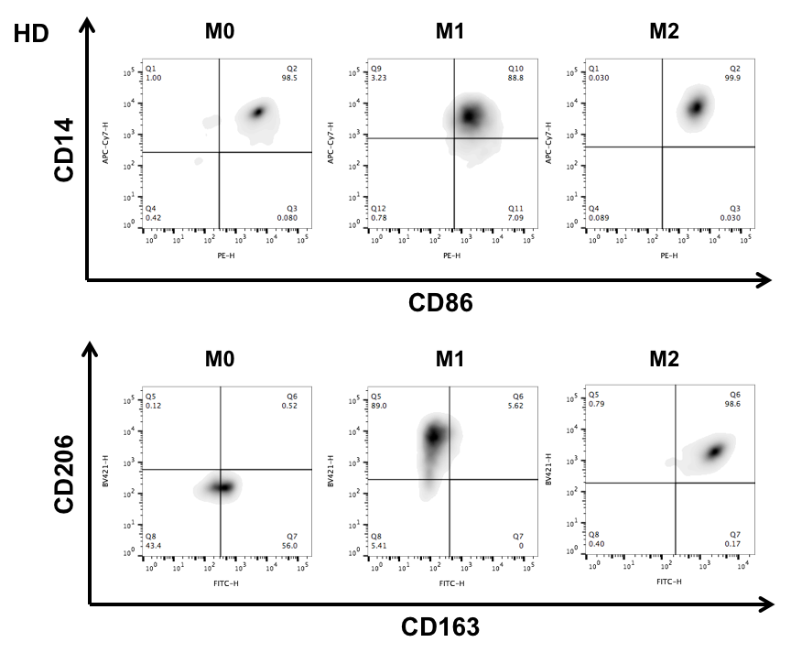
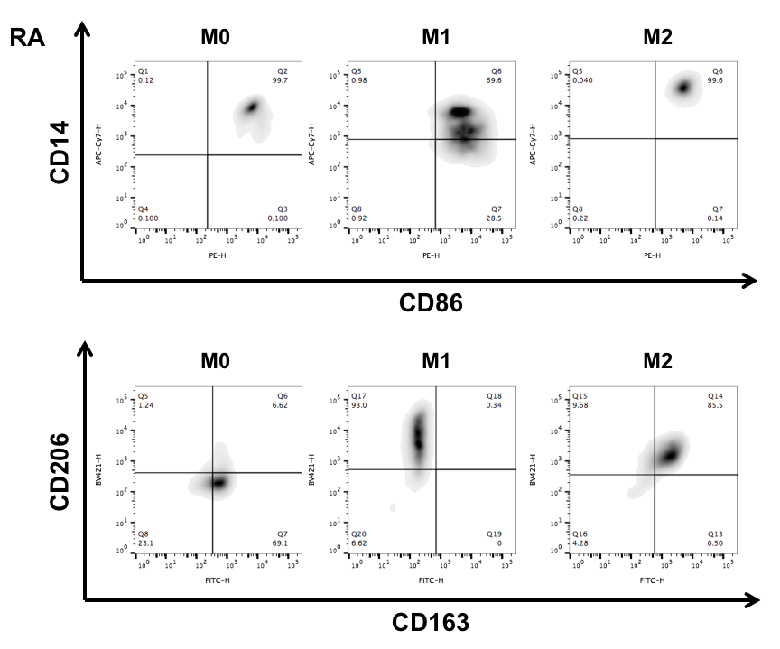
Figure S1A: Characterization of surface markers on M0, M1- and M2-polarized macrophages derived from peripheral blood of healthy donors (HD) compared to rheumatoid arthritis (RA) patients
For phenotypical analysis, M0 (ex vivo monocytes), M1 (GM-CSF) and M2 (M-CSF) differentiated macrophages derived from peripheral blood of HD or RA patients were stained for FACS analysis with fluorescently labeled antibodies CD14-APC-Cy7, CD163-FITC, CD206-BV421 and CD86-PE. Comparison of surface markers expression on freshly isolated M0 or M1- and M2 polarized macrophages from HD (left panels) vs RA (right panels) presented with representative CD14-to-CD86 (upper panels) and CD206-to-CD163 (lower panels) density plots. N=6.

