Supplementary Data – Contents
Table S1: Details of miRNAs included in the study
Table S2: Primers for mRNA targets of miR-103a-3p
Table S3: Clinical features of ACPA+ RA patients
Table S4: Differentially expressed miRNAs in probands and FDRs
Figure S1: IPA target analysis
Table S5: Summary of findings from IPA analysis regarding gene targets of differentially expressed miRNAs
Table S6: Spearman correlation co-efficient between miR-103a-3p and target mRNAs

Table S1: Details of miRNAs included in the study

miRBase ID | Assay Name | Mature miRNA sequence | Assay ID | Relevance | PMID
hsa-miR-155-5p | hsa-miR-155 | UUAAUGCUAAUCGUGAUAGGGGU | 002623 | Up in rheumatoid synovium, PBMCs, synovial fibroblasts; Down in regulatory T -cells in RA | 27079198, 18383392, 20470394, 23897768, 24151514, 24562503
hsa-miR-146a-5p | hsa-miR-146a | UGAGAACUGAAUUCCAUGGGUU | 000468 | Deregulated in arthritic serum, PBMCs, macrophages, CD79a+ B-cells, CD3+ T-cells, Th17 cells, synovium | 27079198, 18383392, 20470394, 23897768, 24562503, 18438844, 20840794
hsa-miR-26b-3p | hsa-miR-26b* | CCUGUUCUCCAUUACUUGGCUC | 002444 | Inhibits synovial fibroblast proliferation and secretion of pro-inflammatory cytokines | 26088648
hsa-miR-26b-5p | hsa-miR-26b | UUCAAGUAAUUCAGGAUAGGU | 000407 | Inhibits synovial fibroblast proliferation and secretion of pro-inflammatory cytokines | 26088648
hsa-miR-103a-3p | hsa-miR-103 | AGCAGCAUUGUACAGGGCUAUGA | 000439 | -n/a-
hsa-miR-323-3p | hsa-miR-323-3p | CACAUUACACGGUCGACCUCU | 002227 | Up in synovial fibroblasts | 23615628, 22562984
hsa-miR-19a-3p | hsa-miR-19a | UGUGCAAAUCUAUGCAAAACUGA | 000395 | Down in synovial fibroblasts of RA; regulate TLR2-mediated NF-κB signaling | 22105995,22684508
hsa-miR-19b-3p | hsa-miR-19b | UGUGCAAAUCUAUGCAAAACUGA | 000396 | Down in synovial fibroblasts of RA | 22105995
hsa-miR-34a-3p | hsa-miR-34a* | CAAUCAGCAAGUAUACUGCCCU | 002316 | Down in synovial fibroblasts in RA | 22161761
hsa-miR-29a-3p | hsa-miR-29a | UAGCACCAUCUGAAAUCGGUUA | 002112 | Regulate DNA methylation by targeting Dnmt3a and Dnmt3b | 22334722,23385088
hsa-miR-29b-3p | hsa-miR-29b | UAGCACCAUUUGAAAUCAGUGUU | 000413 | Regulate DNA methylation by targeting Dnmt3a and Dnmt3b | 22334722,23385088
hsa-miR-29c-3p | hsa-miR-29c | UAGCACCAUUUGAAAUCGGUUA | 000587 | Regulate DNA methylation by targeting Dnmt3a and Dnmt3b | 22334722,23385088
hsa-miR-152-3p | hsa-miR-152 | UCAGUGCAUGACAGAACUUGG | 000475 | Down in rat model of RA; negatively regulates DNMT1 | 22334722, 25194984
hsa-miR-203-3p | hsa-miR-203 | GUGAAAUGUUUAGGACCACUAG | 000507 | Up in synovial fibroblasts | 21279994
hsa-miR-221-3p | hsa-miR-221 | AGCUACAUUGUCUGCUGGGUUUC | 000524 | Up in synovial fibroblasts and serum of RA patients | 22562984  25891943
hsa-miR-222-3p | hsa-miR-222 | AGCUACAUCUGGCUACUGGGU | 002276 | Up in synovial fibroblasts | 22562984
hsa-miR-223-3p | hsa-miR-223 | UGUCAGUUUGUCAAAUACCCCA | 002295 | Up in RA synovium, plasma, T-cells, down in early RA | 27079198, 20470394, 23897768,22903258,19931339
hsa-miR-18a-5p | hsa-miR-18a | UAAGGUGCAUCUAGUGCAGAUAG | 002422 | Up in RA synovial fibroblasts; involved in cartilage homeostasis | 23280137
hsa-miR-24-3p | hsa-miR-24 | UGGCUCAGUUCAGCAGGAACAG | 000402 | Up in plasma from RA patients | 23874885
hsa-miR-125a-5p | hsa-miR-125a-5p | UCCCUGAGACCCUUUAACCUGUGA | 002198 | Up in plasma and monocytes from RA patients | 23874885,27014994
hsa-miR-125a-3p | hsa-miR-125a-3p | ACAGGUGAGGUUCUUGGGAGCC | 002199 | Up in RA synovial monocytes | 22683424
hsa-miR-16-5p | hsa-miR-16 | UAGCAGCACGUAAAUAUUGGCG | 000391 | Down in RA sera | 23897768
hsa-miR-21-5p | hsa-miR-21 | UAGCUUAUCAGACUGAUGUUGA | 000397 | Down in T-cells in RA patients; Up in RA synovial fibroblasts | 25164131,  27429986
hsa-miR-107 | hsa-miR-107 | AGCAGCAUUGUACAGGGCUAUCA | 000443 | Associated with miR-103a-3p as a cluster | 20678503
hsa-let-7e-5p | hsa-let-7e | UGAGGUAGGAGGUUGUAUAGUU | 002406 | Up in synovial monocytes and regulates osteoblast differentiation | 25601191
hsa-miR-132-3p | hsa-miR-132 | UAACAGUCUACAGCCAUGGUCG | 000457 | Down in plasma of RA patients | 20470394
hsa-miR-346 | hsa-miR-346 | UGUCUGCCCGCAUGCCUGCCUCU | 000553 | Controls release and stability of TNF and IL-18 in synovial fibroblasts | 21611196,19342689
hsa-miR-451a | mmu-miR-451 | AAACCGUUACCAUUACUGAGUU | 001141 | Down in RA neutrophils; Up in T-cells | 24574214,24401767
hsa-miR-15a-5p | hsa-miR-15a | UAGCAGCACAUAAUGGUUUGUG | 000389 | Up in synovial tissues; regulates cell proliferation and apoptosis | 22100329
hsa-Let-7a-5p | hsa-Let-7a | UGAGGUAGUAGGUUGUAUAGUU | 000377 | Up in arthritic Th17 cells; down in monocytes | 18438844, 26227320
hsa-miR-26a-5p | hsa-miR-26a | UUCAAGUAAUCCAGGAUAGGCU | 000405 | Up in plasma from RA patients | 23874885
hsa-miR-150-5p | hsa-miR-150 | UCUCCCAACCCUUGUACCAGUG | 000473 | Up in PBMCs and synovium of RA patients | 18438844
hsa-miR-124-5p | hsa-miR-124* | CGUGUUCACAGCGGACCUUGAU | 002197 | Down in RA synovial fibroblasts; regulates chemokine secretion and cell proliferation | 25596157,19404929
RNU48 | RNU48 | GATGACCCCAGGTAACTCTGAGTGTGTCGCTGATGCCATCACCGCAGCGCTCTGACC | 001006 | Used as endogenous control for miRNA quantification | 21407217
U6 SnRNA | U6 | GTGCTCGCTTCGGCAGCACATATACTAAAATTGGAACGATACAGAGAAGATTAGCATGGCCCCTGCGCAAGGATGACACGCAAATTCGTGAAGCGTTCCATATTTT | 001973 | Used as endogenous control for miRNA quantification, regulates spliceosomal assembly | 23829528,
RNU44 | RNU44 | CCTGGATGATGATAGCAAATGCTGACTGAACATGAAGGTCTTAATTAGCTCTAACTGACT | 001094 | Used as endogenous control for miRNA quantification, mapped to intronic regions of genes dysregulated in cancer | 21407217
RNU6B | RNU6B | CGCAAGGATGACACGCAAATTCGTGAAGCGTTCCATATTTTT | 001093 | Used as endogenous control for miRNA quantification, mapped to intronic regions of genes dysregulated in cancer | 21407217

Table S2: Primers for mRNA targets of miR-103a-3p
Gene ID | Primer Sequence | NCBI Accession ID | Amplicon Size (kb) | Gene Name
18S | F 5 -AAAGGAATTGACGGAAGGGCACCA  R 5’-ACCAGACAAATCGCTCCACCAACT | NR_003286.1 | 174 | 18S ribosomal RNA
DICER1 | F 5’ - GTCGTGCCGTATTGGTAGTT  R 5’ - CAGCTCCTCTTGCTCATGTT | NM_030621.4 | 104 | Dicer 1, ribonuclease III
AGO1 | F 5’ - CGGTGTATGCTGAGGTGAAA  R 5’ - AGTCTGAGGTGAGGTCTTGA | NM_012199.4 | 119 | Argonaute 1
AGO2 | F 5’ - CCTCCGGGAGAACAATCAAA  R 5’ - GGCACTTCTCTGGCTTGATA | NM_012154.3 | 102 | Argonaute 2
PTEN | F 5’ - CCCACCACAGCTAGAACTTATC  R 5’ - TCGTCCCTTTCCAGCTTTAC | NM_000314.6 | 109 | Phosphotase and Tensin Homolog
CDK1 | F 5’ – TCACACCGAGTAGTGCATCG  R 5’ - CAAGACTTCGGGTGCTCTGT | NM_001786.4 | 102 | Cyclin dependent kinase 1
CCNE1 | F 5’ -GATCTCTGTGTCCTGGATGTTG  R 5’ - GCACCACTGATACCCTGAAA | NM_001238.3 | 100 | Cyclin E1
TIMP3 | F 5’ - GAGTTTGGGTCTTTCTCCTCTG  R 5’ - CTAGAGACCTTGACTGTGCTTG | NM_000362.4 | 104 | Tissue inhibitor of metalloproteinase 3
CREB1 | F 5’ – GAACCAGCAGAGTGGAGATG  R 5’- GGCATAGATACCTGGGCTAATG | NM_004379.4 | 102 | cAMP responsive element binding protein
TP53 | F 5’ – acacgcttccctggattg  R 5’ - gctcgacgctaggatctgac | NM_000546.5 | 81 | Tumor protein 53
PANK2 | F 5’ - GGTCTCTGCTGTCTTCTTACTG  R 5’ - GCAGTCCAAACCTCTCATAGTC | NM_153638.3 | 133 | Pantothenate Kinase 2
PANK3 | F 5’- TACAGGAGGTGGTGCTTACA  R 5’ - AAGCCCTTTACAAGGCAGTC | NM_024594.3 | 99 | Pantothenate Kinase 3
KLF4 | F 5’ -GACCAGGCACTACCGTAAAC  R 5’ - TTCATGTGTAAGGCGAGGTG | NM_001314052.1 | 99 | Krupppel – like factor 4
DAPK1 | F 5’ - CGTCATCCTGATCTTGGAACTC  R 5’ - GAAGGGAGTGCAGGTAGTAAAC | NM_004938.3 | 137 | Death associated protein kinase 1
ID2 | F 5’- GACTGCTACTCCAAGCTCAAG  R 5’ - CAGGTCCAAGATGTAGTCGATG | NM_002166.4 | 105 | Inhibitor of DNA binding 2
GPD1 | F 5’ – GCTCTGCCAGACTCTCTATCT  R 5’ - CCGGCTAGGAGCATTTAACTC | NM_005276.3 | 106 | Glycerol-3-phosphate dehydrogenase 1
Primers were designed using Primer Quest (IDT Technologies) and Universal Probe Library System (Roche Life Sciences) and verified by Primer Blast (NCBI). 18S Ribosomal RNA; F=Forward; R=Reverse
Table S3: Clinical Features of ACPA+ RA patients
ID | Age | Sex | Disease duration (years) | DAS28 scores | CRP  (mg/L) | Anti-CCP | RF  (IU/mL) | Treatment
RA1 | 56.8 | F | 19.8 | 3.07 | 8.8 | 201 | 289 | Ramipril, Rosuvastatin, Gliclazide, ASA, metformin; Azathioprine, Leflunomide, MTX ((C); HCQ (C)
RA2 | 51.8 | F | 12.9 | 1.42 | 1.14 | 201 | 619 | Prednisone (C); Etanercept (C); MTX; Cyclosporin; Leflunomide; SSZ; Vioxx
RA3 | 29.8 | F | 20.1 | 1.97 | 7.27 | 201 | 1040 | HCQ (C); Etanercept (C); Leflunomide; SSZ; Gold; Naproxen
RA4 | 28.9 | F | 19.5 | 2.24 | 3.47 | 108 | 276 | Enbrel (C); Tylenol, MTX; HCQ; SSZ; Celebrex; Prednisone, Gold
RA5 | 39.2 | F | 11.2 | 3.57 | 2.55 | 201 | 569 | SSZ (C); HCQ; Leflunomide; SSZ; Gold; MTX
RA6 | 55.4 | F | 0.6 | 4.00 | 4.93 | 201 | 886 | MTX; HCQ (C)
RA7 | 54.5 | F | 14.0 | 6.77 | 42.6 | 201 | 287 | Thalidiamine; MTX(C); Prednisone; Arthrotec; HCQ
RA8 | 46.5 | F | 0.0 | 4.35 | 2 | 95 | 1540 | MTX (C); HCQ (C); Tylenol #3; SSZ (C); Prednisone; Voltaren; Diclofenac; Vioxx
RA9 | 35.9 | F | 5.4 | 4.56 | 27.8 | 201 | 82.8 | Celebrex(C); Tylenol, ASA, Atenolol, Leflunomide, Rosuvastatin, HCQ, Naproxen; MTX; Insulin; SSZ
RA10 | 53.1 | F | 14.6 | 4.36 | 4.86 | 201 | 482 | Prednisone(C); Rituximab(C); Etanercept; Gold; AZA; SSZ; Omeprazole (C); Venlafaxine; Diazepam; Amlodipine; Gabapentin; Celebrex; Hydromorphone; Ventolin
RA11 | 46.8 | M | 17.7 | 4.68 | 8.73 | 133 | 1010 | MTX (C): Leflunomide; MTX; Naproxen; Tylenol ES
RA12 | 46.7 | M | 11.1 | 3.69 | 13.1 | 175 | 141 | HUMIRA (C) HCQ (C); Adalimumab; Apo-Omeprazole; Diclofenac; Flovent HFA; Leflunomide; Salbutamol Sulfate; MTX; Minocycline
RA13 | 35.8 | F | 6.0 | 2.90 | 7.44 | 201 | 353 | Active: MTX, HCQ, Tylenol ES
RA14 | 70.1 | F | 35.6 | 3.28 | 4.33 | 101 | 1230 | Adalimumab (C); MTX; Vasotec, Omeprazole, Plavix, L-thyroxine, Clonazepam, Fentanyl patch, Percocet; Etanercept, Leflunomide, HCQ, SSZ, Gold
RA15 | 29.4 | F | 0.1 | 4.39 | 5.86 | 201 | 148 | Azathioprine, Leflunominde, Orencia, Prednisone, Omeprazole, Tylenol #3, Abatacept (C); Gold, MTX, SSZ, Plaquenil, Prednisone, Enbrel
RA16 | 30.5 | M | 2.8 | 5.54 | 6.55 | 76 | 19 | MTX(C); Enbrel (C); prednisone; Tylenol #3; SSZ; HCQ; Leflunomide; Citalopram; Diclofenac; Depomedrol; Naproxen
RA17 | 48.2 | F | 6.6 | 3.14 | 16.4 | 201 | 50.5 | Acetaminophen with codeine, Enalapril Maleate, Etanercept, Ferrous Fumarate, Furosemide, Hydrochlorothiazide, HCQ, Metformin, Omeprazole, Teva-Betahistine,
RA18 | 32.3 | M | 19.6 | 3.12 | 13 | 19 | 19 | HCQ (C); Naproxen, Plaquenil, SSZ
(C) = Current; MTX = methotrexate; HCQ = hydroxychloroquine; SSZ = sulfasalazine
Table S4: Differentially expressed miRNAs in Probands and FDRs compared to HCs

Significantly up-regulated ( ), and down-regulated ( ) or unaltered miRNAs. # only miRNAs differentially expressed in FDRs compared to RA patients.

Figure S1: IPA Target Analysis

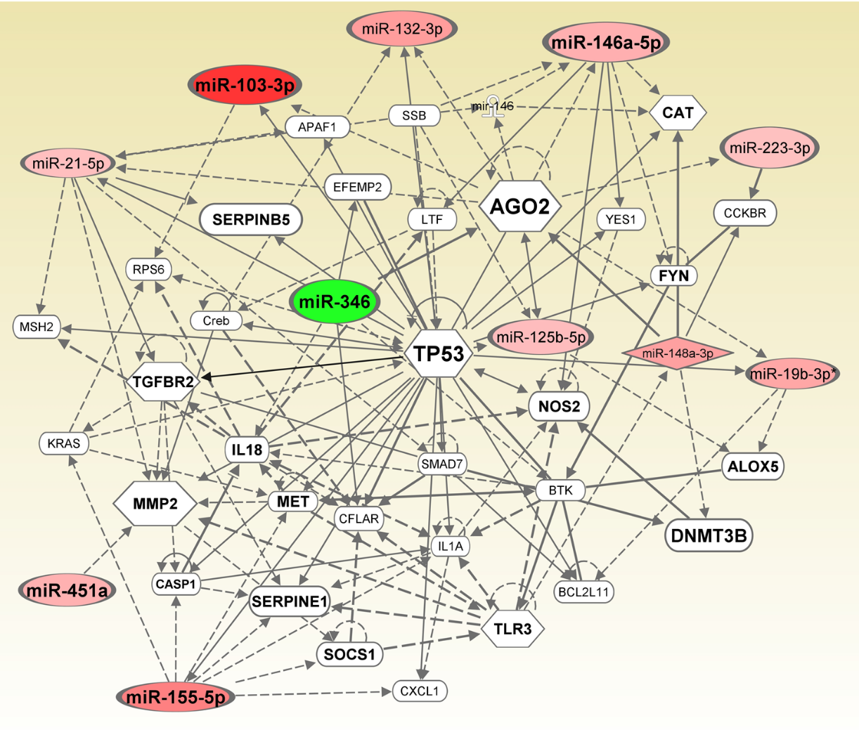

IPA analysis network showing curated molecular interactions between differentially expressed miRNAs and their experimentally-validated target genes.

Table S5: Summary of findings from IPA analysis regarding gene targets of differentially expressed miRNAs

Table summarizing top molecular and cellular functions, physiological system development and function, diseases and disorders and networks regulated by significantly modulated miRNAs and their gene targets (P<0.05; fisher’s exact test).

Table S6: Spearman correlation coefficients between miR-103a-3p and target mRNAs

Table showing Spearman rank correlation coefficient values and corresponding P-values miR-103a-3p and target mRNAs. ΔC_{t} values of miR-103a-3p Vs target mRNAs from HC, RA patients and FDRs were combined for this correlation analyses. Q-values represent adjusted P-values after applying Benjamini-Hochberg correction for multiple comparison.

