Additional file 1
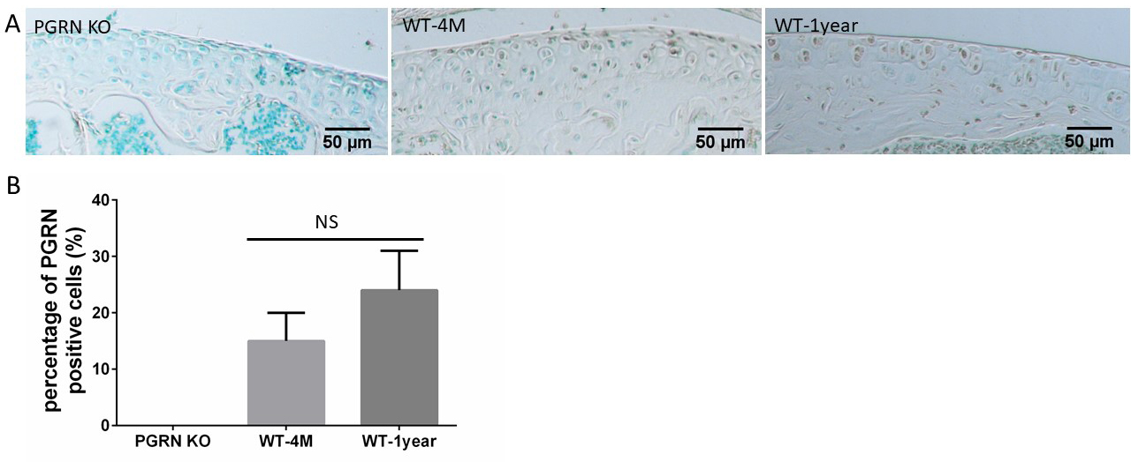
Supplementary Fig. S1. Expression of PGRN in cartilage at different age, assayed by immunohistochemistry. (A) Femur cartilage sections were stained with anti-PGRN (brown) antibody and counterstained with methyl green. Section obtained from PGRN KO mouse is served as negative control. Scale bar=50µm. (B) Level of PGRN in mice cartilage at different age was determined by counting the percentage of immunohistochemistry staining positive cells over total cells (n=4). ns = no significance

