Additional file 2

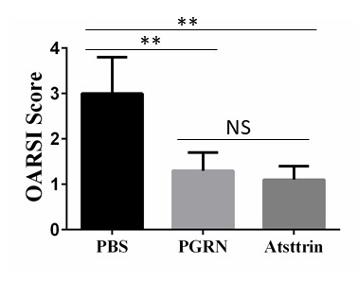
Supplementary Fig. S2. Quantification of OARSI score based on Safranin O staining for PBS, PGRN or Atsttrin treated ACLT mice (n=6 for each group). WT mice were established with ACLT OA model, followed by intra-articular injection of PBS, PGRN or Atsttrin. Values are the normalized mean±SEM. NS=No significant difference, ** p<0.01

