Additional file 10

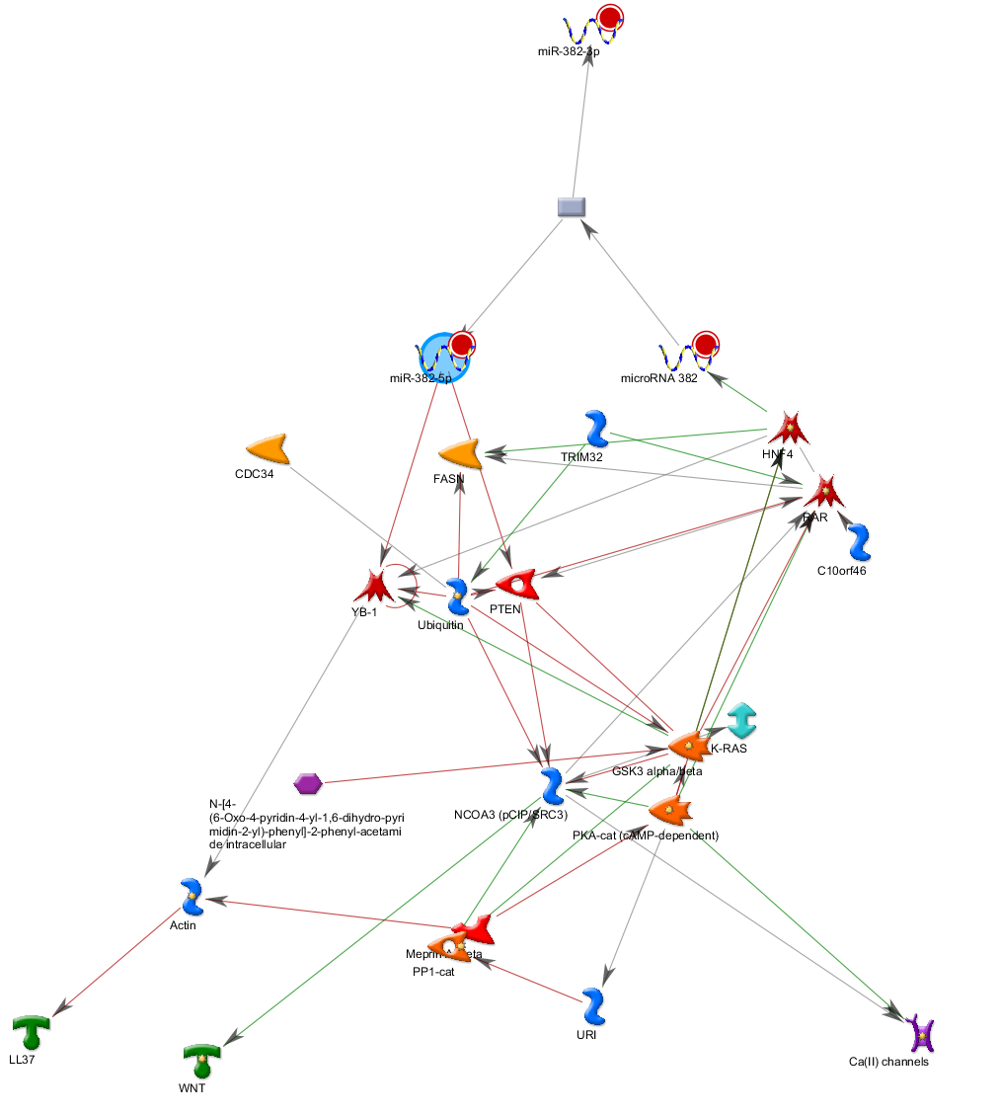
Network of the predicted targets of miR-382 predicted target expanded network.
Red line is indicative of a negative effect (inhibition) and green line a positive effect (activation).

