Additional file 1
Baseline characteristics of individuals for pilot and validation phases. HC Healthy controls, IQR Interquartile range, VERA Very early rheumatoid arthritis.

Pilot phase | HC | CCP+ progression to VERA
Number | 12 | 12
Median Age (IQR) | 43 (38-55.3) | 52 (43-70)
Female | 8 (67%) | 8 (67%)
Median weeks to synovitis (IQR) | - | 34.5 (13.5-56.5)
Validation phase | HC | CCP+ progression to VERA | CCP+ no progression
Number | 12 | 12 | 12
Median Age (IQR) | 35.5 (29.8-43.8) | 54 (39.0-59.2) | 53.5 (50.0-65.5)
Female | 6 (50%) | 10 (83.3) | 6 (50)
Median weeks to synovitis (IQR) | - | 41 (25.8-65.0) | -
Median weeks follow-up (IQR) | - | - | 152 (127.3-241.5)

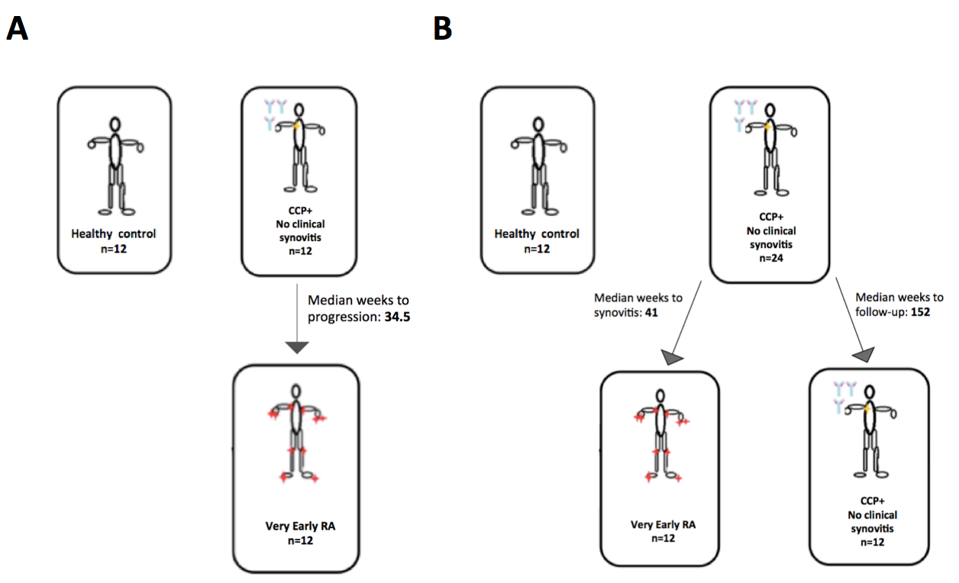

(A) Patients cohorts of serum miRNA profiling for pilot phase Healthy Controls (n=12), CCP positive (CCP) group n=12 progressed to Very Early RA (VERA) group. (B) Patients cohorts for validation phase including HC n=12, CCP+ progressor and 12 CCP+ non progressor groups.

