Additional file 9

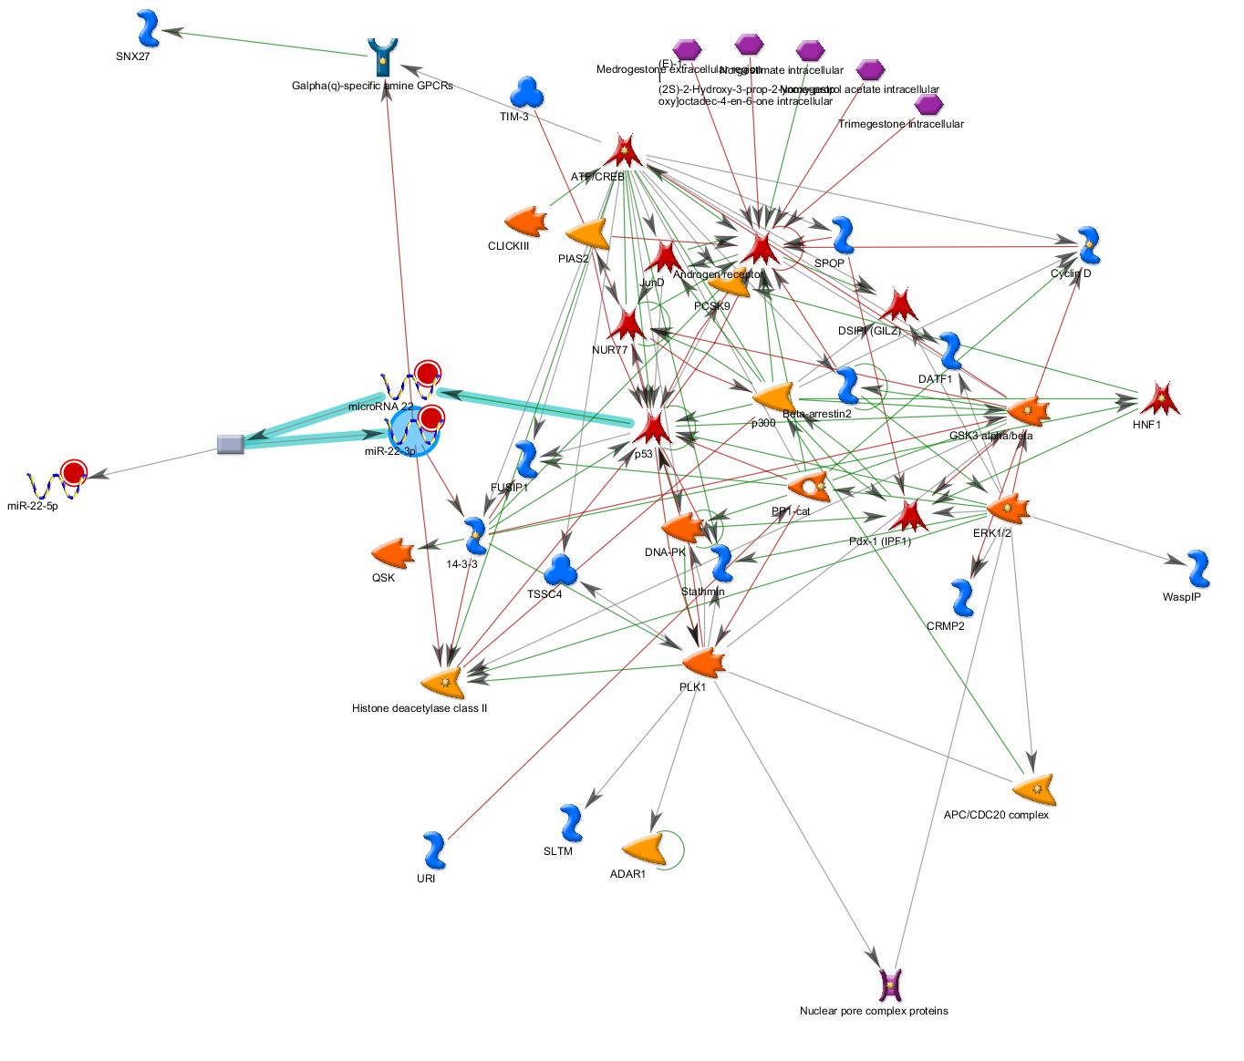

Network of the predicted targets of miR-22 network with main target p53 highlighted.
Red line is indicative of a negative effect (inhibition) and green line a positive effect (activation).

