Supplementary materials for: Dysregulated HO-1-low M2-like macrophages augment lupus nephritis via Bach1 induced by type-I interferons

Daiga Kishimoto¹, Yohei Kirino¹, Maasa Tamura¹, Mitsuhiro Takeno³, Yosuke Kunishita¹, Kaoru Takase-Minegishi¹, Hiroto Nakano¹, Ikuma Kato², Kiyotaka Nagahama⁴, Ryusuke Yoshimi¹, Kazuhiko Igarashi⁵, Ichiro Aoki², and Hideaki Nakajima¹

¹ Yokohama City University Graduate School of Medicine, Department of Stem Cell and Immune Regulation, Yokohama, Japan
² Yokohama City University Graduate School of Medicine, Department of Molecular Pathology, Yokohama, Japan
³ Nippon Medical School Graduate School of Medicine, Department of Allergy and Rheumatology, Tokyo, Japan
⁴ Kyorin University School of Medicine, Department of Pathology, Tokyo, Japan
⁵ Tohoku University Graduate School of Medicine, Department of Chemistry, Sendai, Japan

Supplementary figure 1. Numbers of CD68, CD163, HO-1 positive cells in the glomerulus of lupus nephritis patients (ClassI or II)
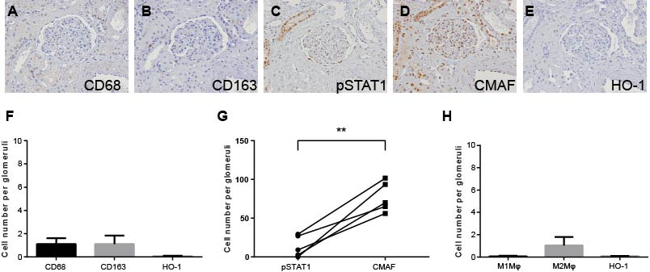

Representative immunohistochemical images of the renal biopsy specimen from a lupus nephritis patient (ISN/RPS class II). Serial sections of a glomerulus stained with antibodies against A; CD68, B; CD163, C; pSTAT1, D; CMAF, and E; HO-1 (x400). F; Numbers of CD68, CD163, HO-1 positive cells in a glomerulus were counted in the renal tissues from SLE patients (n=5). Data were shown as mean + SEM. G; Numbers of pSTAT1 and CMAF positive cells in a glomerulus were counted in the renal tissues from SLE patients (n=5). H; Numbers of estimated M1 Mφ, M2 Mφ and HO-1 positive cells in a glomerulus in the renal tissues from SLE patients (n=5). Data were shown as mean + SEM. **p<0.01 by student t-test.

Supplementary figure 2. Numbers of CD68, CD163, HO-1 positive cells in the extra-glomerulus of lupus nephritis patients
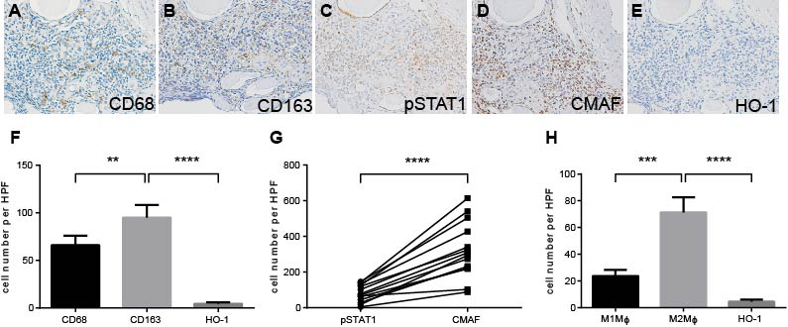
Representative immunohistochemical images of the renal biopsy specimen from a lupus nephritis patient (ISN/RPS class IV-G(A/C)). Serial sections of an extra-glomerulus lesion stained with antibodies against A; CD68, B; CD163, C; HO-1, D; pSTAT1, and E; CMAF (x400). F; Numbers of CD68, CD163, HO-1 positive cells in an extra-glomerulus were counted in the renal tissues from SLE patients (n=19). Data were shown as mean + SEM. G; Numbers of pSTAT1 and CMAF positive cells in an extra-glomerulus were counted in the renal tissues from SLE patients (n=19). H; Numbers of estimated M1 Mφ, M2 Mφ and HO-1 positive cells in an extra-glomerulus in the renal tissues from SLE patients (n=19). Data were shown as mean + SEM. **p<0.01, ***p<0.001, ****p<0.0001 by student t-test.

Supplementary figure 3. HO-1 mRNA expression in M1 and M2 Mϕ stimulated with various regents.
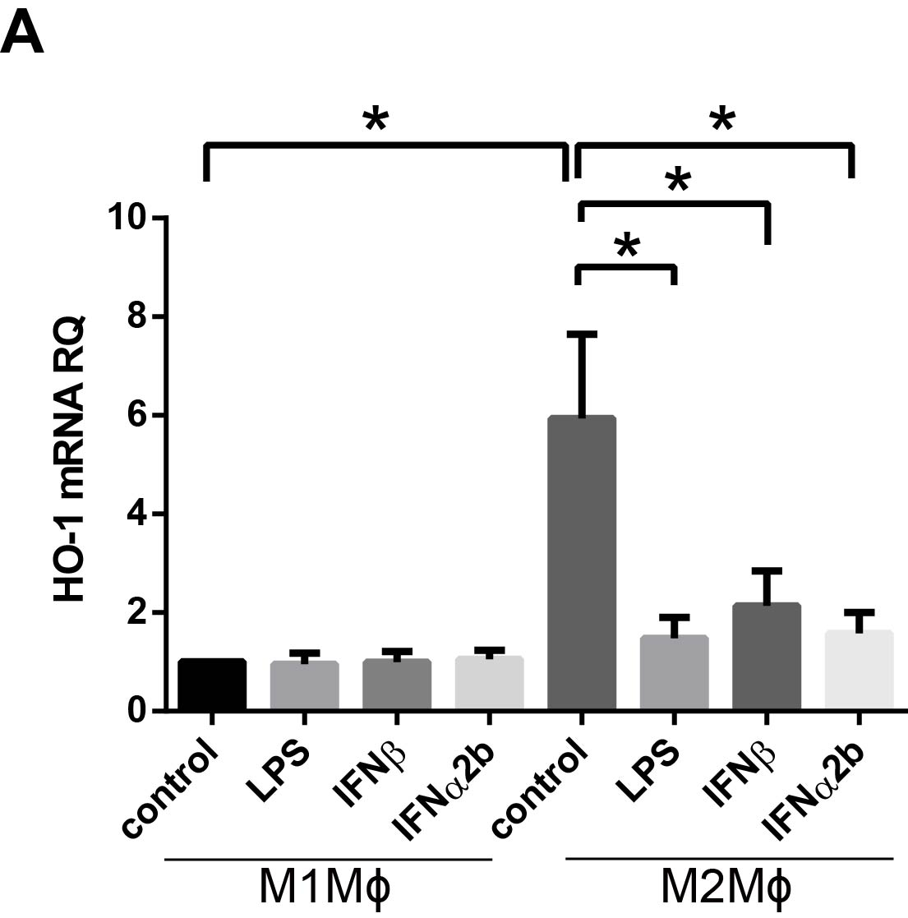
HO-1 mRNA expressions of M1 and M2 Mϕ from HC stimulated with either LPS, IFNβ, or IFNα2b (n=4). *p<0.05, **p<0.01 by student t-test. Data are shown as mean + SEM.

Supplementary figure 4. Genomic background of congenic mice.
Informative 85 short tandem repeat markers were used to compare C57BL/6J (B6), N12, and MRL/lpr strain (MRL). Note that Chr. 16 25.77cM is located near Bach1locus.

Supplementary figure 5. Genotyping of Bach1 knockout mice.
PCR of Bach1 gene with genomic DNA was performed to evaluate Bach1 deficiency in mice.

Supplementary Table 1. Primer sequences used for qRT-PCR.
Target |  | Sequence(5’-3’) | Ref
Ifnα(non-α4) | Fwd | ARSYTGTSTGATGCARCAGGT | [47]
 | Rev | GGWACACAGTGATCCTGTGG
Hprt | Fwd | GATTAGCGATGATGAACCAGGTT
 | Rev | CCTCCCATCTCCTTCATGACA

