Additional File 3: Subgroup Analyses
- Overview of Patient Subgroup Analysis (N = 200)
Patient Subgroup Pair | Patient Subgroup | n (%) | Statistically Significant Difference in All Reponses (P < 0.05) Overall?ª
Age | Above median age of 37.5 years  (Adjustment group) | 100 (50.0%) | Yes, P < 0.01
Age | Equal to or below median age of 37.5 years  (Baseline group) | 100 (50.0%) | Yes, P < 0.01
Gender | Female  (Adjustment group) | 101 (50.5%) | Yes, P < 0.01
Gender | Male  (Baseline group) | 99 (49.5%) | Yes, P < 0.01
Severity of skin symptoms | Above median of 7 for Q17 – rating of severity of skin symptoms in the past week  (Adjustment group) | 92 (46.0%) | Yes, P < 0.01
Severity of skin symptoms | Equal to or below median of 7 for Q17 – rating of severity of skin symptoms in the past week  (Baseline group) | 108 (54.0%) | Yes, P < 0.01
Severity of joint symptoms | Above median of 7 for Q21 – rating of severity of joint symptoms in the past week  (Adjustment group) | 73 (36.5%) | Yes, P < 0.01
Severity of joint symptoms | Equal to or below median of 7 for Q21 – rating of severity of joint symptoms in the past week  (Baseline group) | 127 (63.5%) | Yes, P < 0.01
BSA | 6 or greater hand areas of BSA  (Adjustment group) | 88 (44.0%) | Yes, P = 0.032
BSA | 5 or fewer hand areas of BSA  (Baseline group) | 112 (56.0%) | Yes, P = 0.032
Relationship status | Married/living as married/civil partnership  (Adjustment group) | 142 (71.0%) | Yes, P < 0.01
Relationship status | Not Married/living as married/civil partnership  (Baseline group) | 58 (29.0%) | Yes, P < 0.01
Psoriasis on face and/or neck | Psoriasis patches on face and/or neck in the past week  (Adjustment group) | 100 (50.0%) | Yes, P < 0.01
Psoriasis on face and/or neck | No psoriasis patches on face and/or neck in the past week | 100 (50.0%) | Yes, P < 0.01
Time since diagnosis | Psoriasis and/or psoriatic arthritis for at least 2 years  (Adjustment group) | 107 (53.5%) | Yes, P < 0.01
Time since diagnosis | Psoriasis and/or psoriatic arthritis for less than 2 years  (Baseline group) | 93 (46.5%) | Yes, P < 0.01
Painful skin | Experienced painful skin in the past week  (Adjustment group) | 63 (31.5%) | Yes, P < 0.01
Painful skin | Did not experience painful skin in the past week  (Baseline group) | 137 (68.5%) | Yes, P < 0.01
Currently taking injectable or IV treatment | Currently taking injectable or IV treatment  (Adjustment group) | 62 (31.0%) | Yes, P < 0.01
Currently taking injectable or IV treatment | Not currently taking injectable or IV treatment  (Baseline group) | 138 (69.0%) | Yes, P < 0.01
Currently taking oral, injectable, or IV treatment | Currently taking oral, injectable, or IV treatment  (Adjustment group) | 111 (55.5%) | Yes, P < 0.01
Currently taking oral, injectable, or IV treatment | Not currently taking oral, injectable, or IV treatment  (Baseline group) | 89 (44.5%) | Yes, P < 0.01
BSA = body surface area; IV = intravenous.
ª Statistical significance was estimated based on random-parameters logit models with 100 draws in NLOGIT.
- Best-Worst Scaling Relative-Bother Estimates: Patient Age Subgroups (N = 200)
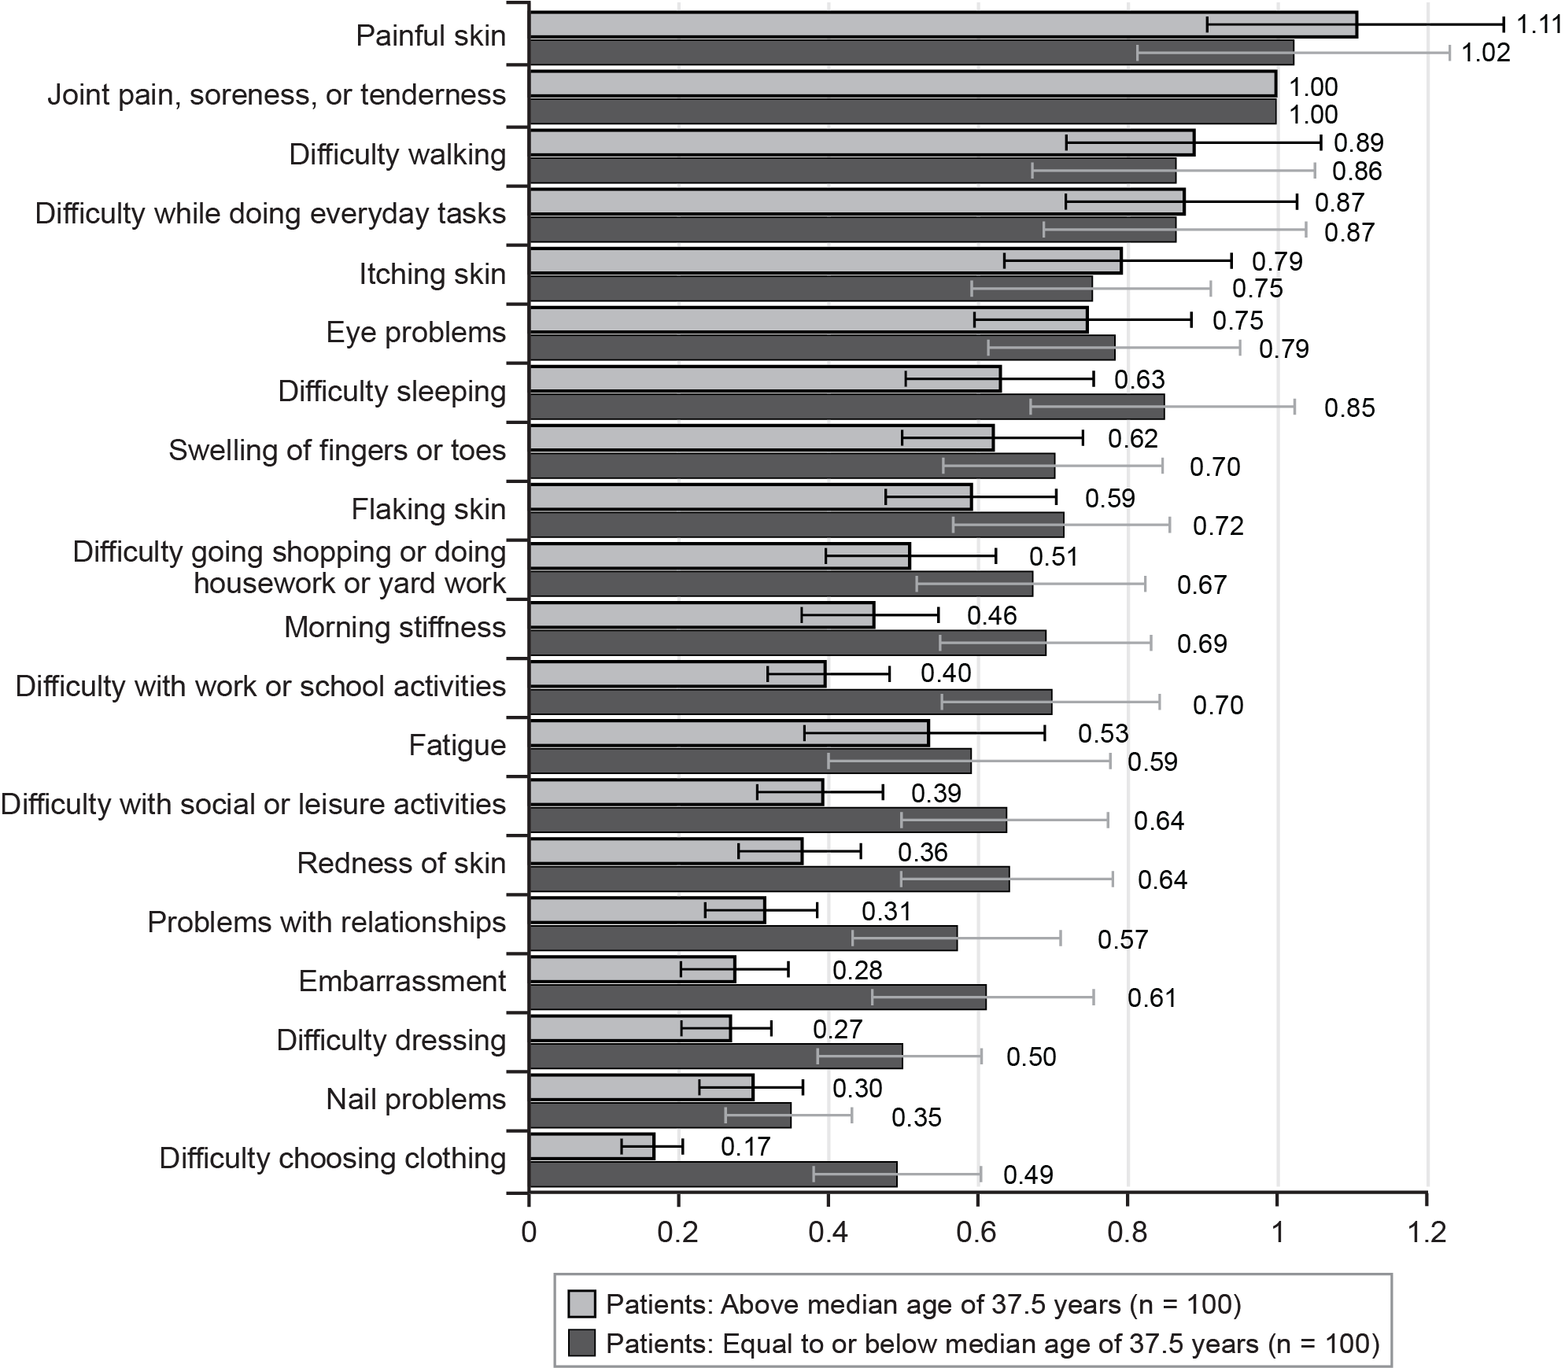
Note: The bars surrounding each mean importance weight denote the 95% confidence interval about the point estimate.
- Best-Worst Scaling Relative-Bother Estimates: Patient Gender Subgroups (N = 200)
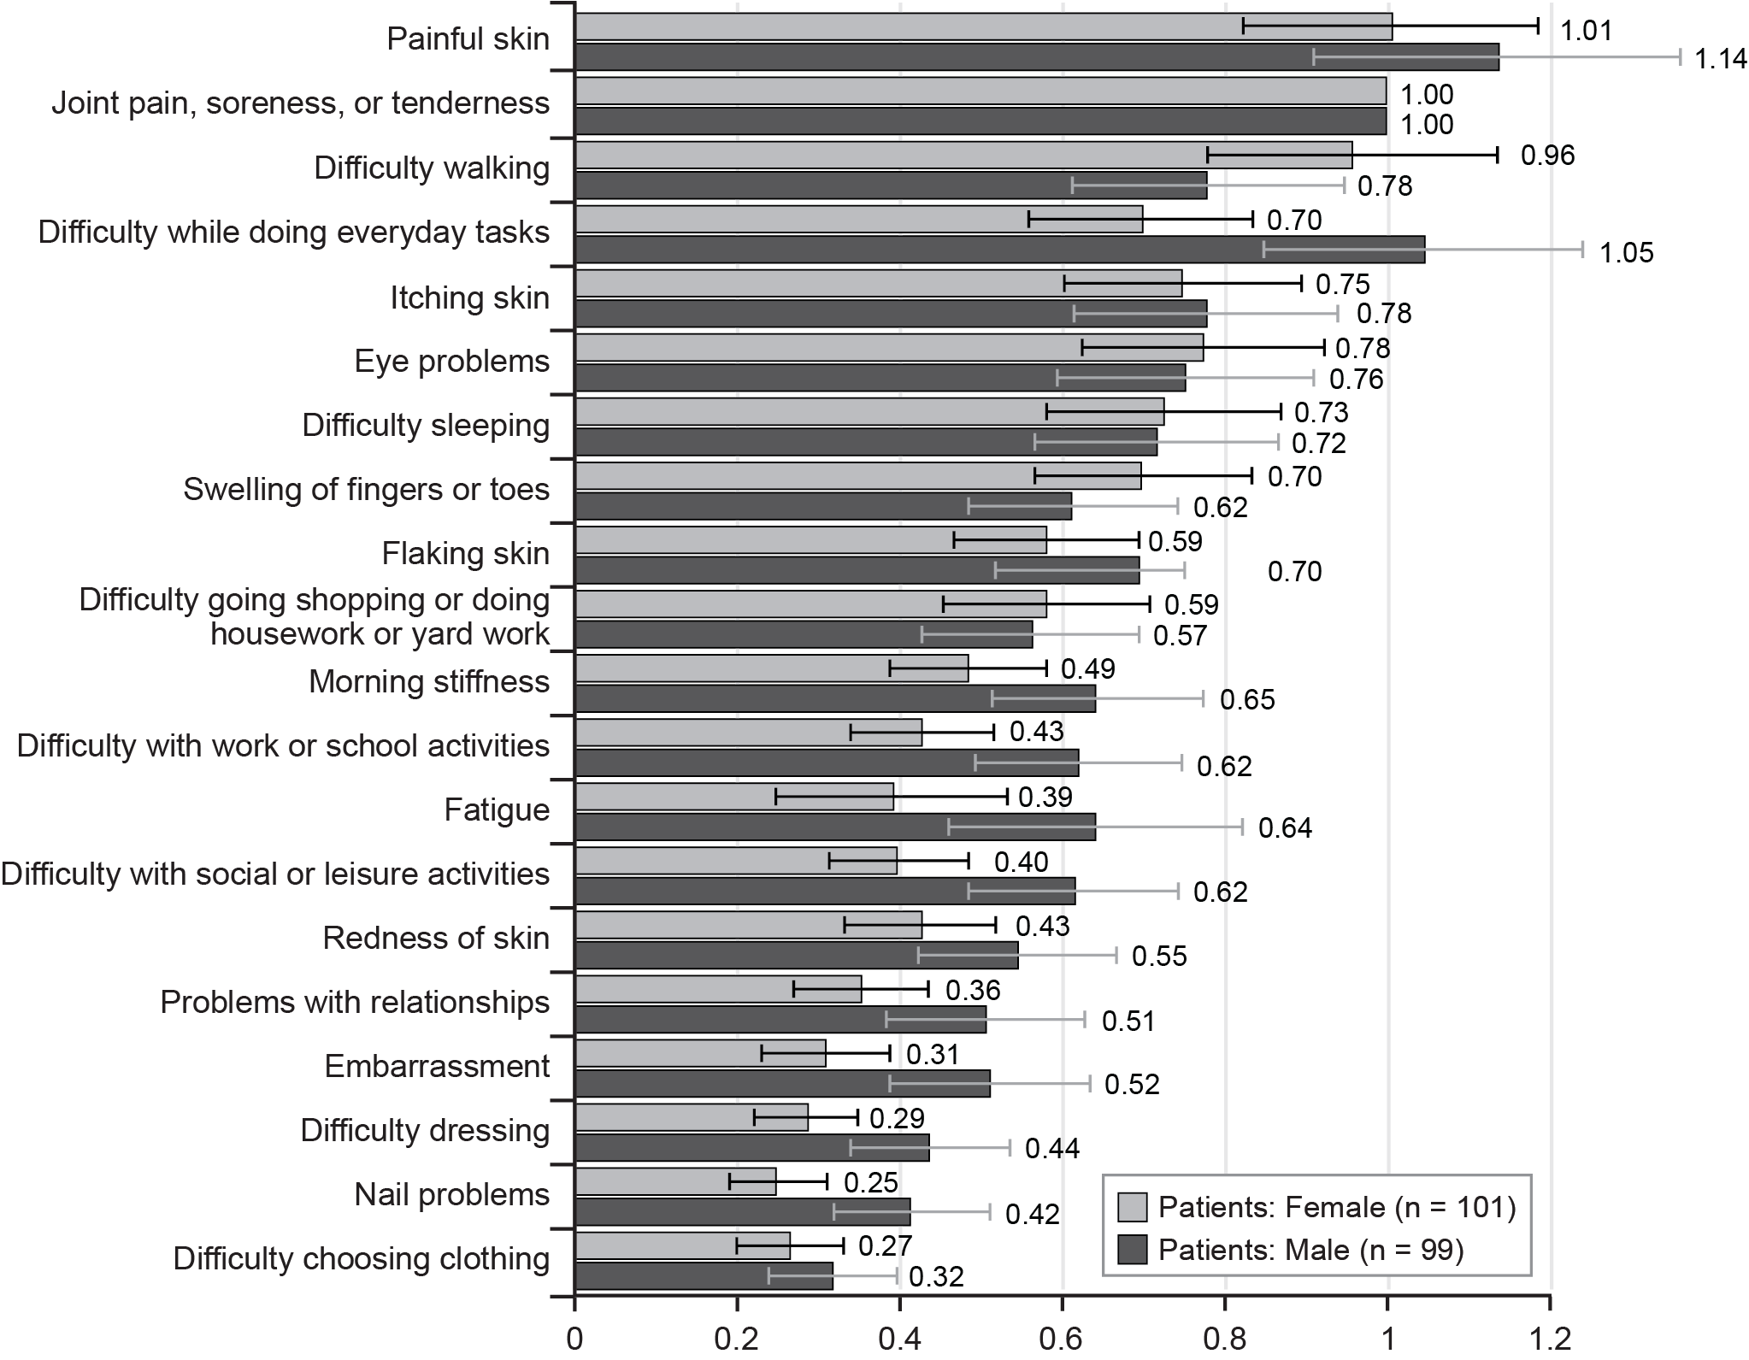
Note: The bars surrounding each mean importance weight denote the 95% confidence interval about the point estimate.
- Best-Worst Scaling Relative-Bother Estimates: Skin Severity Patient Subgroups (N = 200)
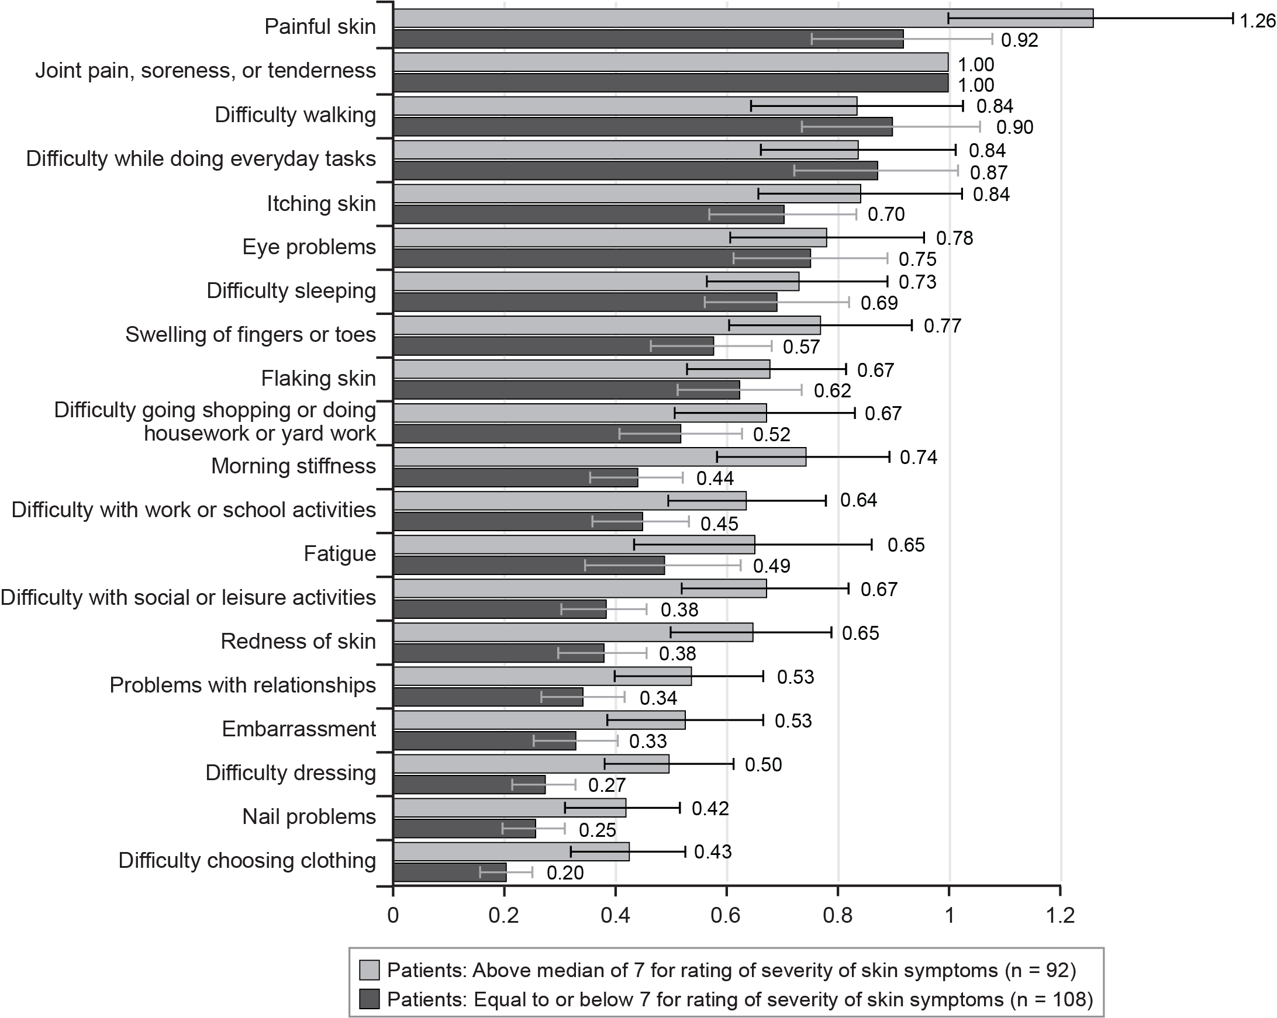
Note: The bars surrounding each mean importance weight denote the 95% confidence interval about the point estimate.
- Best-Worst Scaling Relative-Bother Estimates: Joint Severity Patient Subgroups (N = 200)
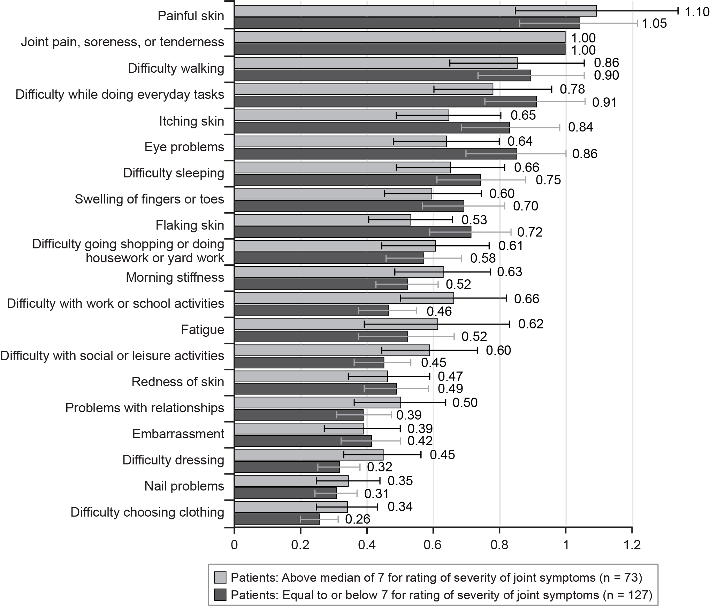
Note: The bars surrounding each mean importance weight denote the 95% confidence interval about the point estimate.
- Best-Worst Scaling Relative-Bother Estimates: Body Surface Area Patient Subgroups (N = 200)
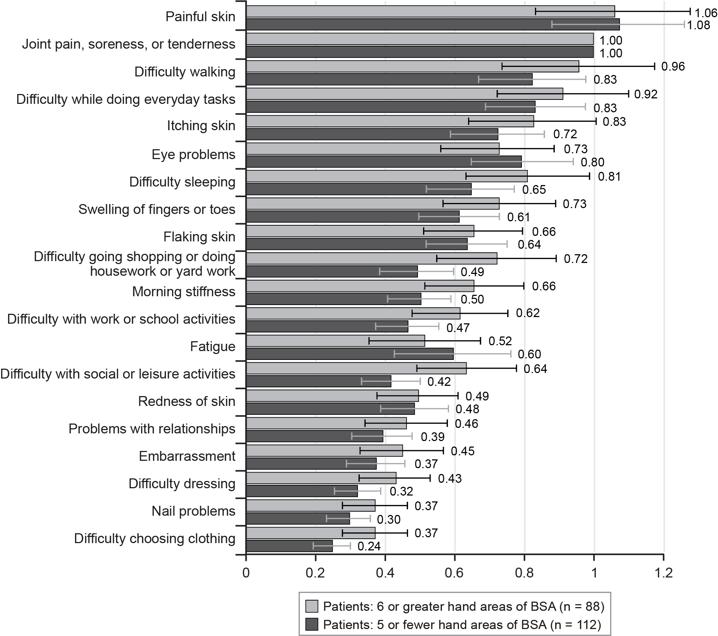
BSA = body surface area.
Note: The bars surrounding each mean importance weight denote the 95% confidence interval about the point estimate.
- Best-Worst Scaling Relative-Bother Estimates: Patient Relationship Status Subgroups (N = 200)
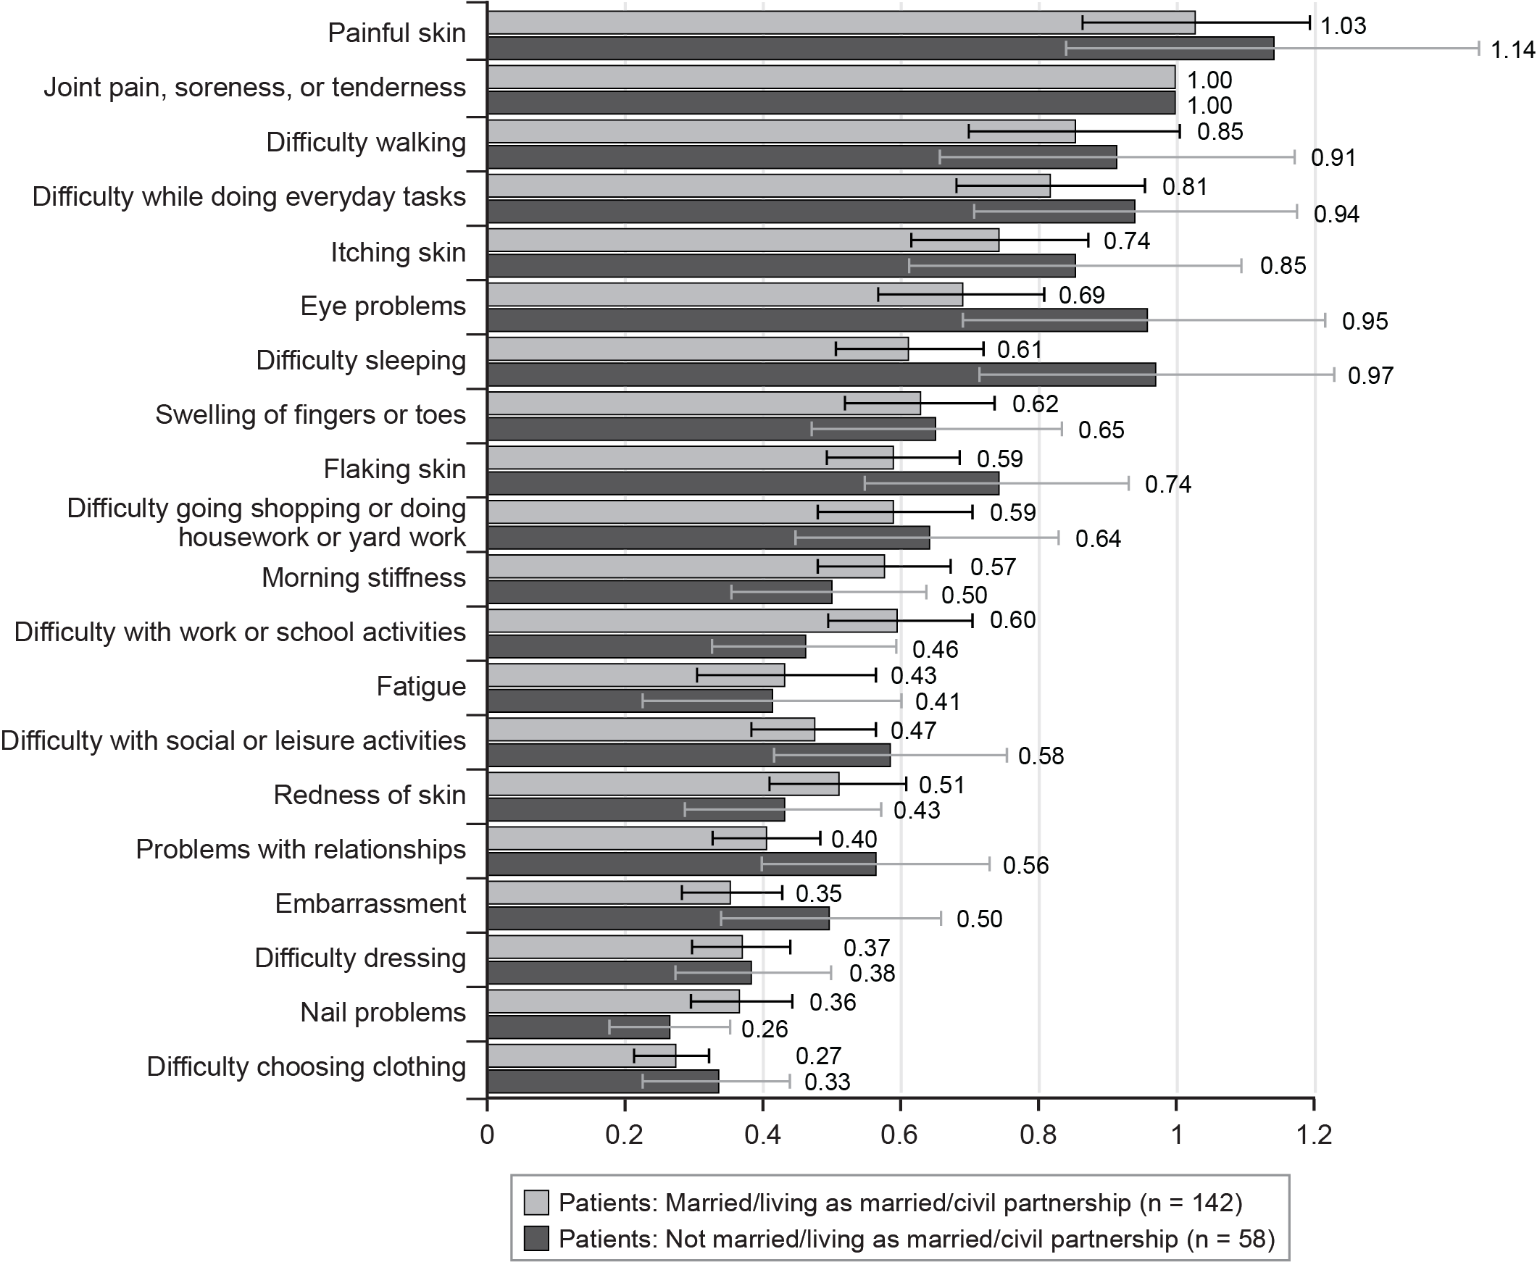
Note: The bars surrounding each mean importance weight denote the 95% confidence interval about the point estimate.
- Best-Worst Scaling Relative-Bother Estimates: Psoriasis on Face and/or Neck Subgroups (N = 200)
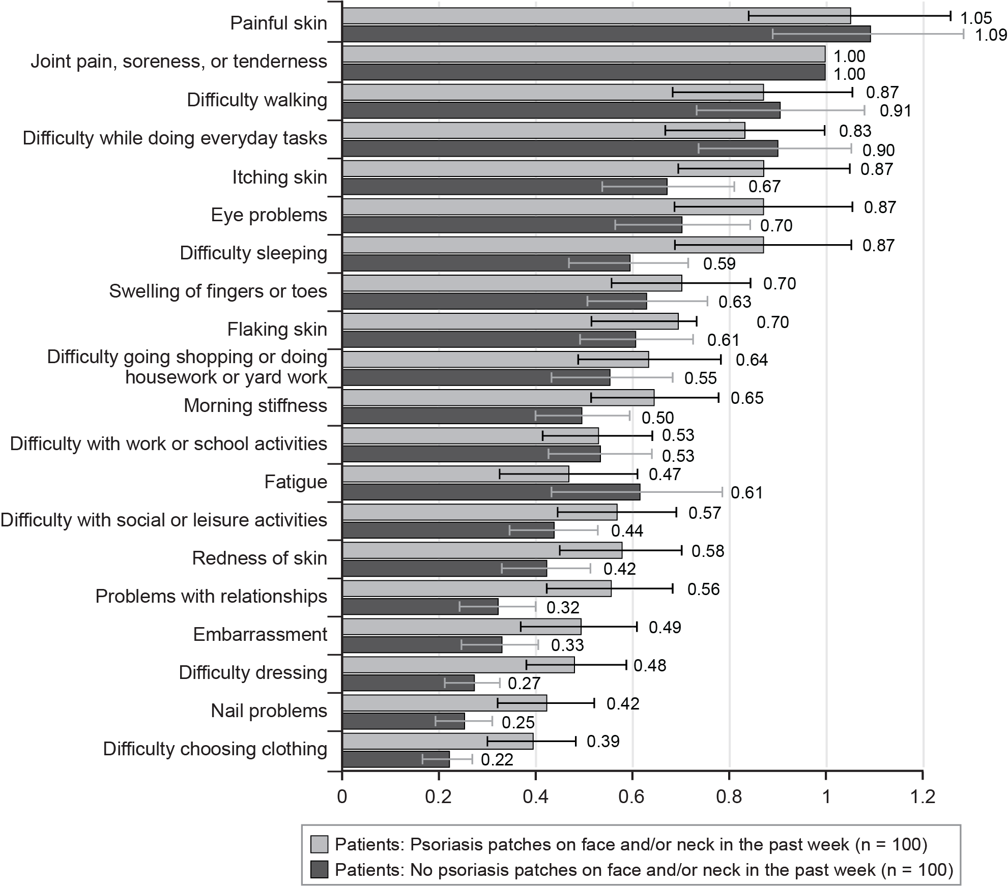
Note: The bars surrounding each mean importance weight denote the 95% confidence interval about the point estimate.
- Best-Worst Scaling Relative-Bother Estimates: Time Since Diagnosis Subgroups (N = 200)
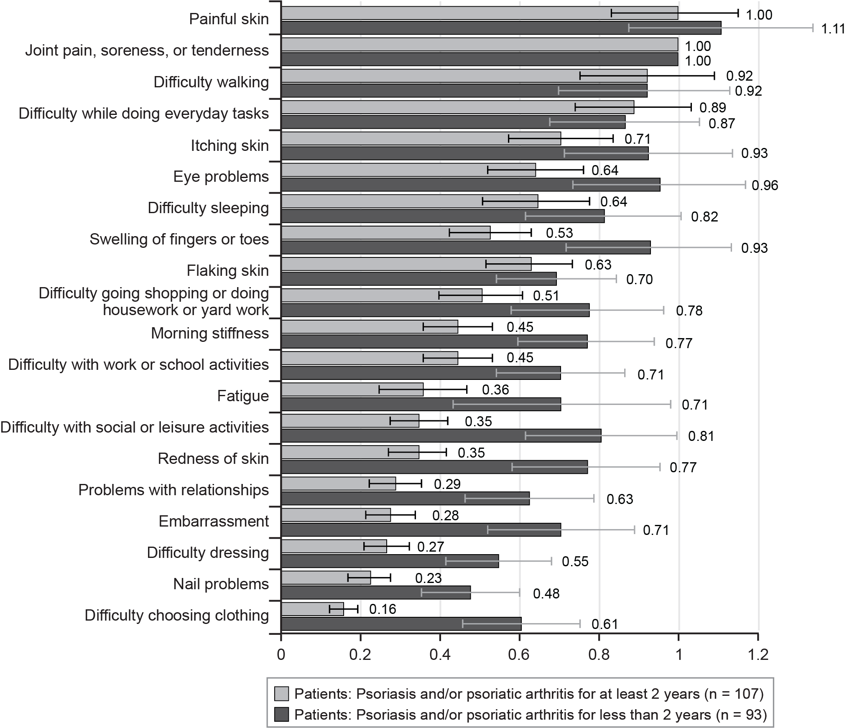
Note: The bars surrounding each mean importance weight denote the 95% confidence interval about the point estimate.
- Best-Worst Scaling Relative-Bother Estimates: Painful Skin Subgroups (N = 200)
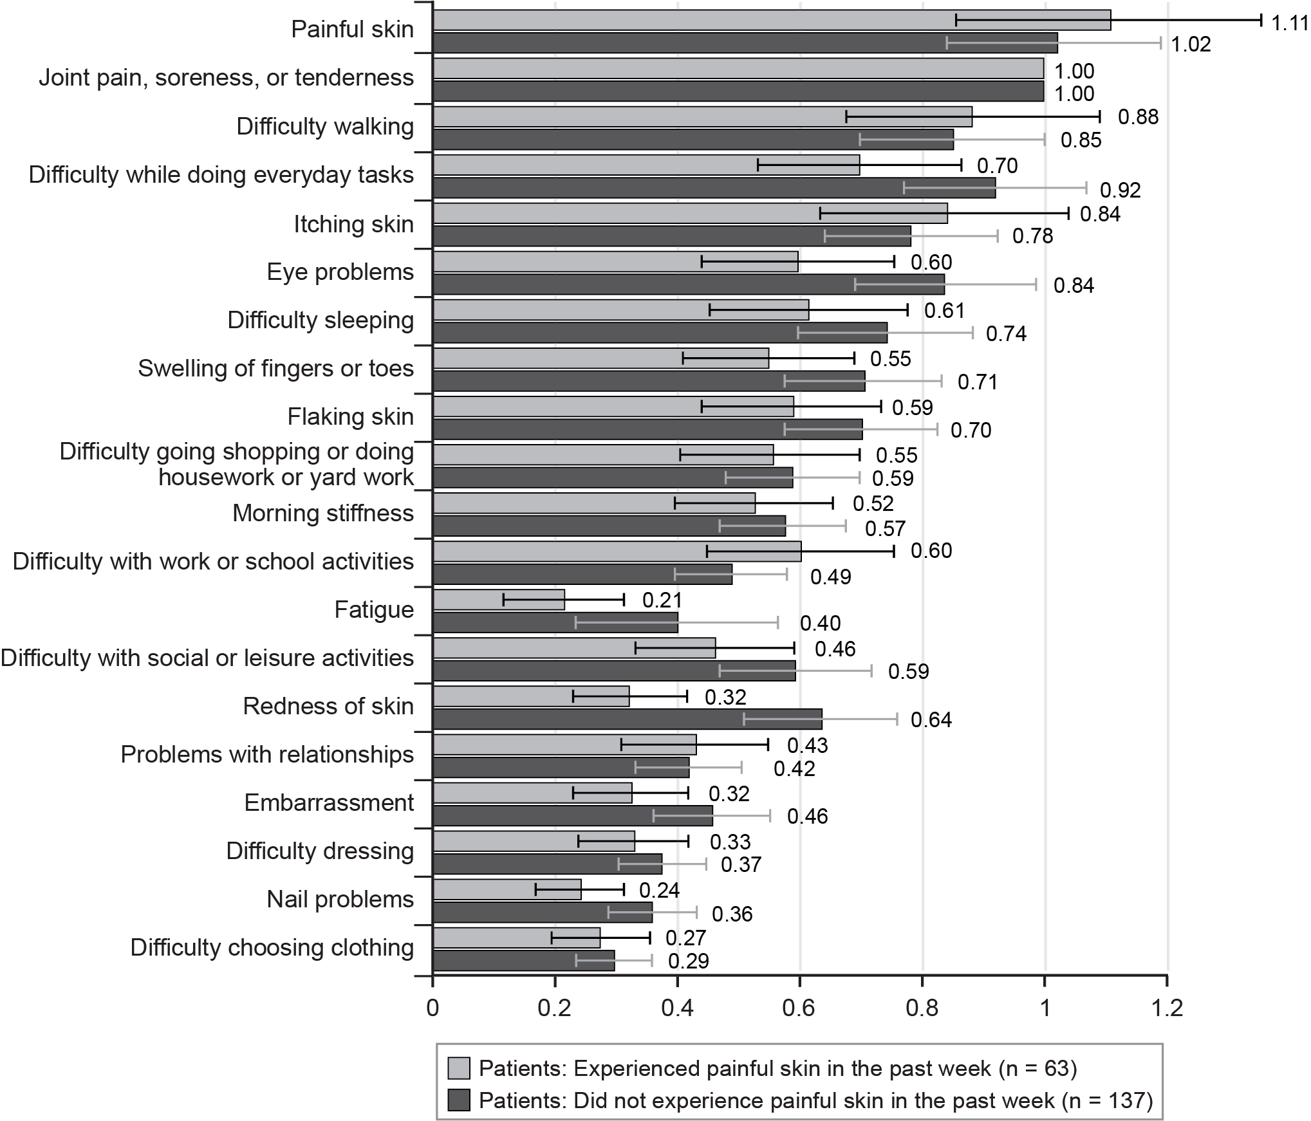
Note: The bars surrounding each mean importance weight denote the 95% confidence interval about the point estimate.
- Best-Worst Scaling Relative-Bother Estimates: Current Treatment (Injectable or IV vs. Others) Subgroups (N = 200)
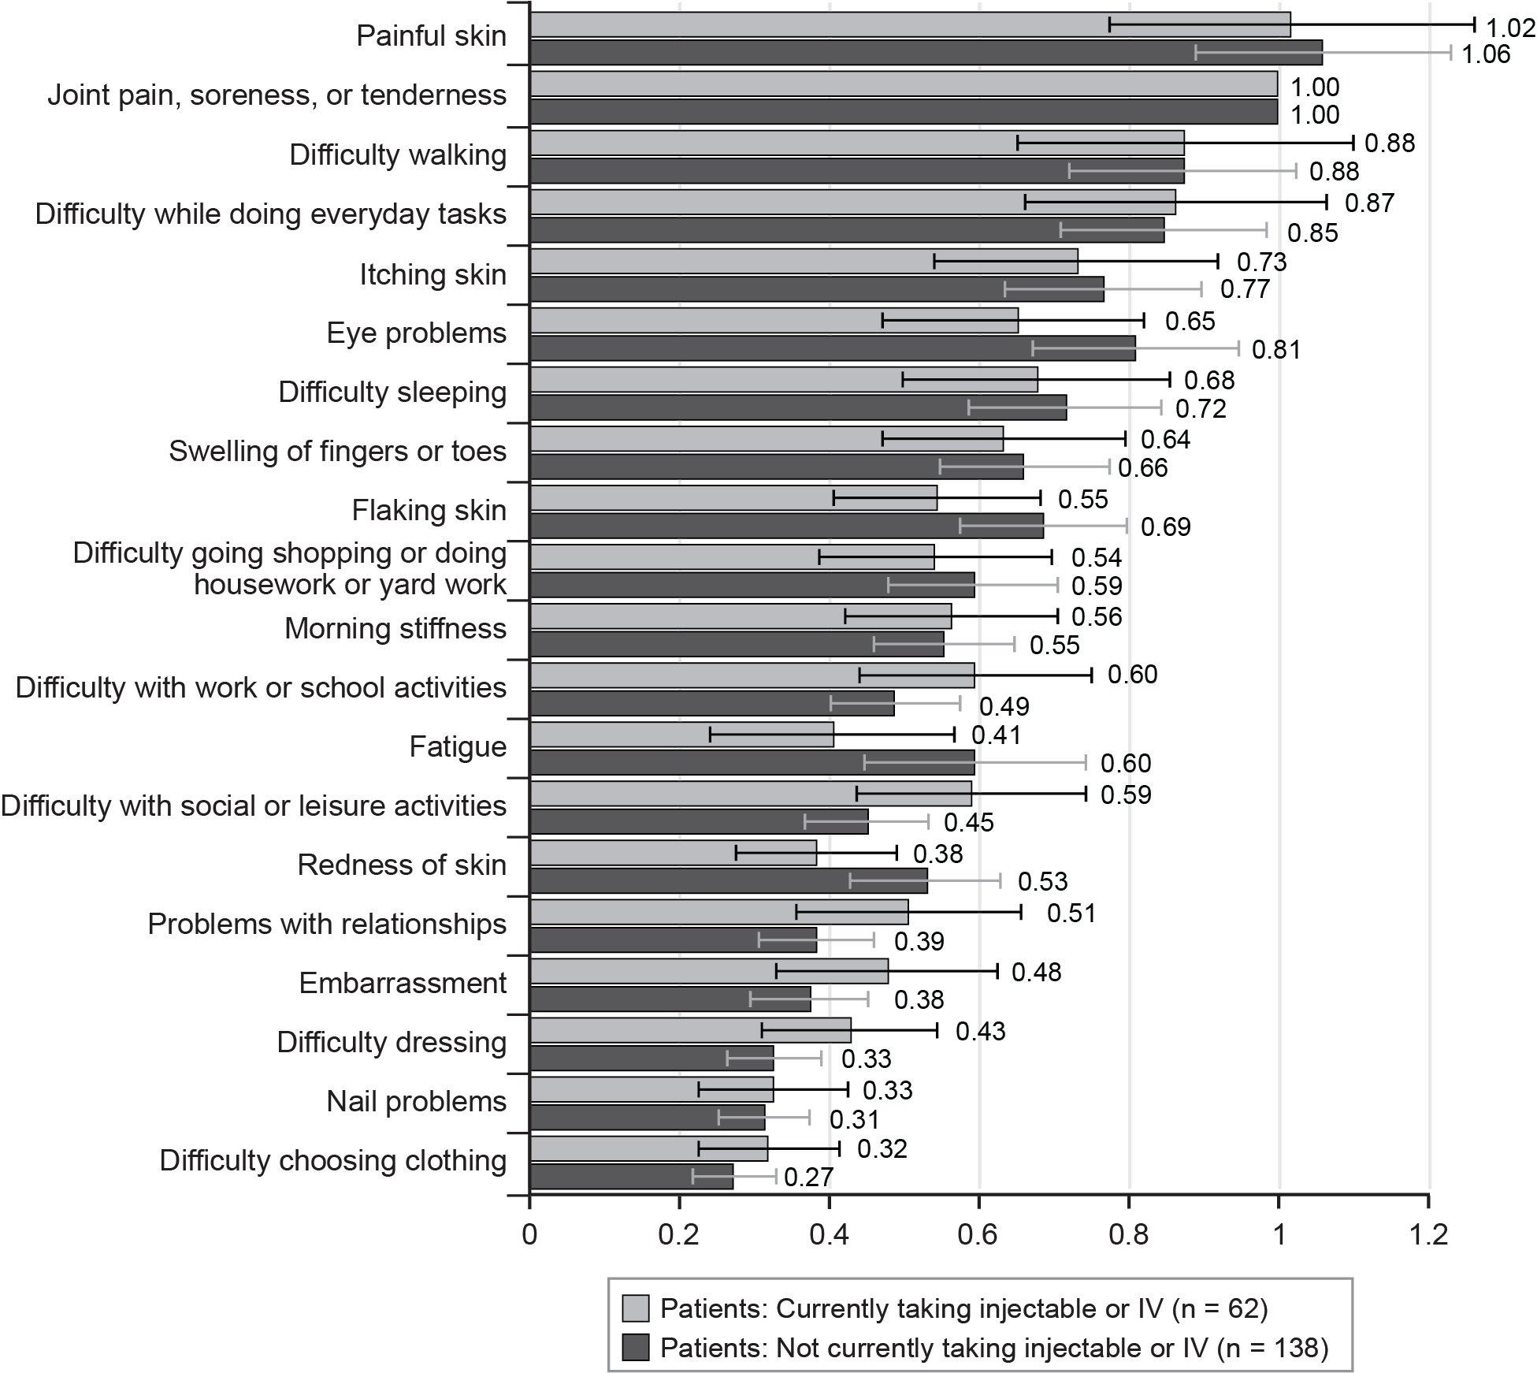
IV = intravenous.
Note: The bars surrounding each mean importance weight denote the 95% confidence interval about the point estimate.
- Best-Worst Scaling Relative-Bother Estimates: Current Treatment (Injectable, IV, or Oral vs. Others) Subgroups (N = 200)
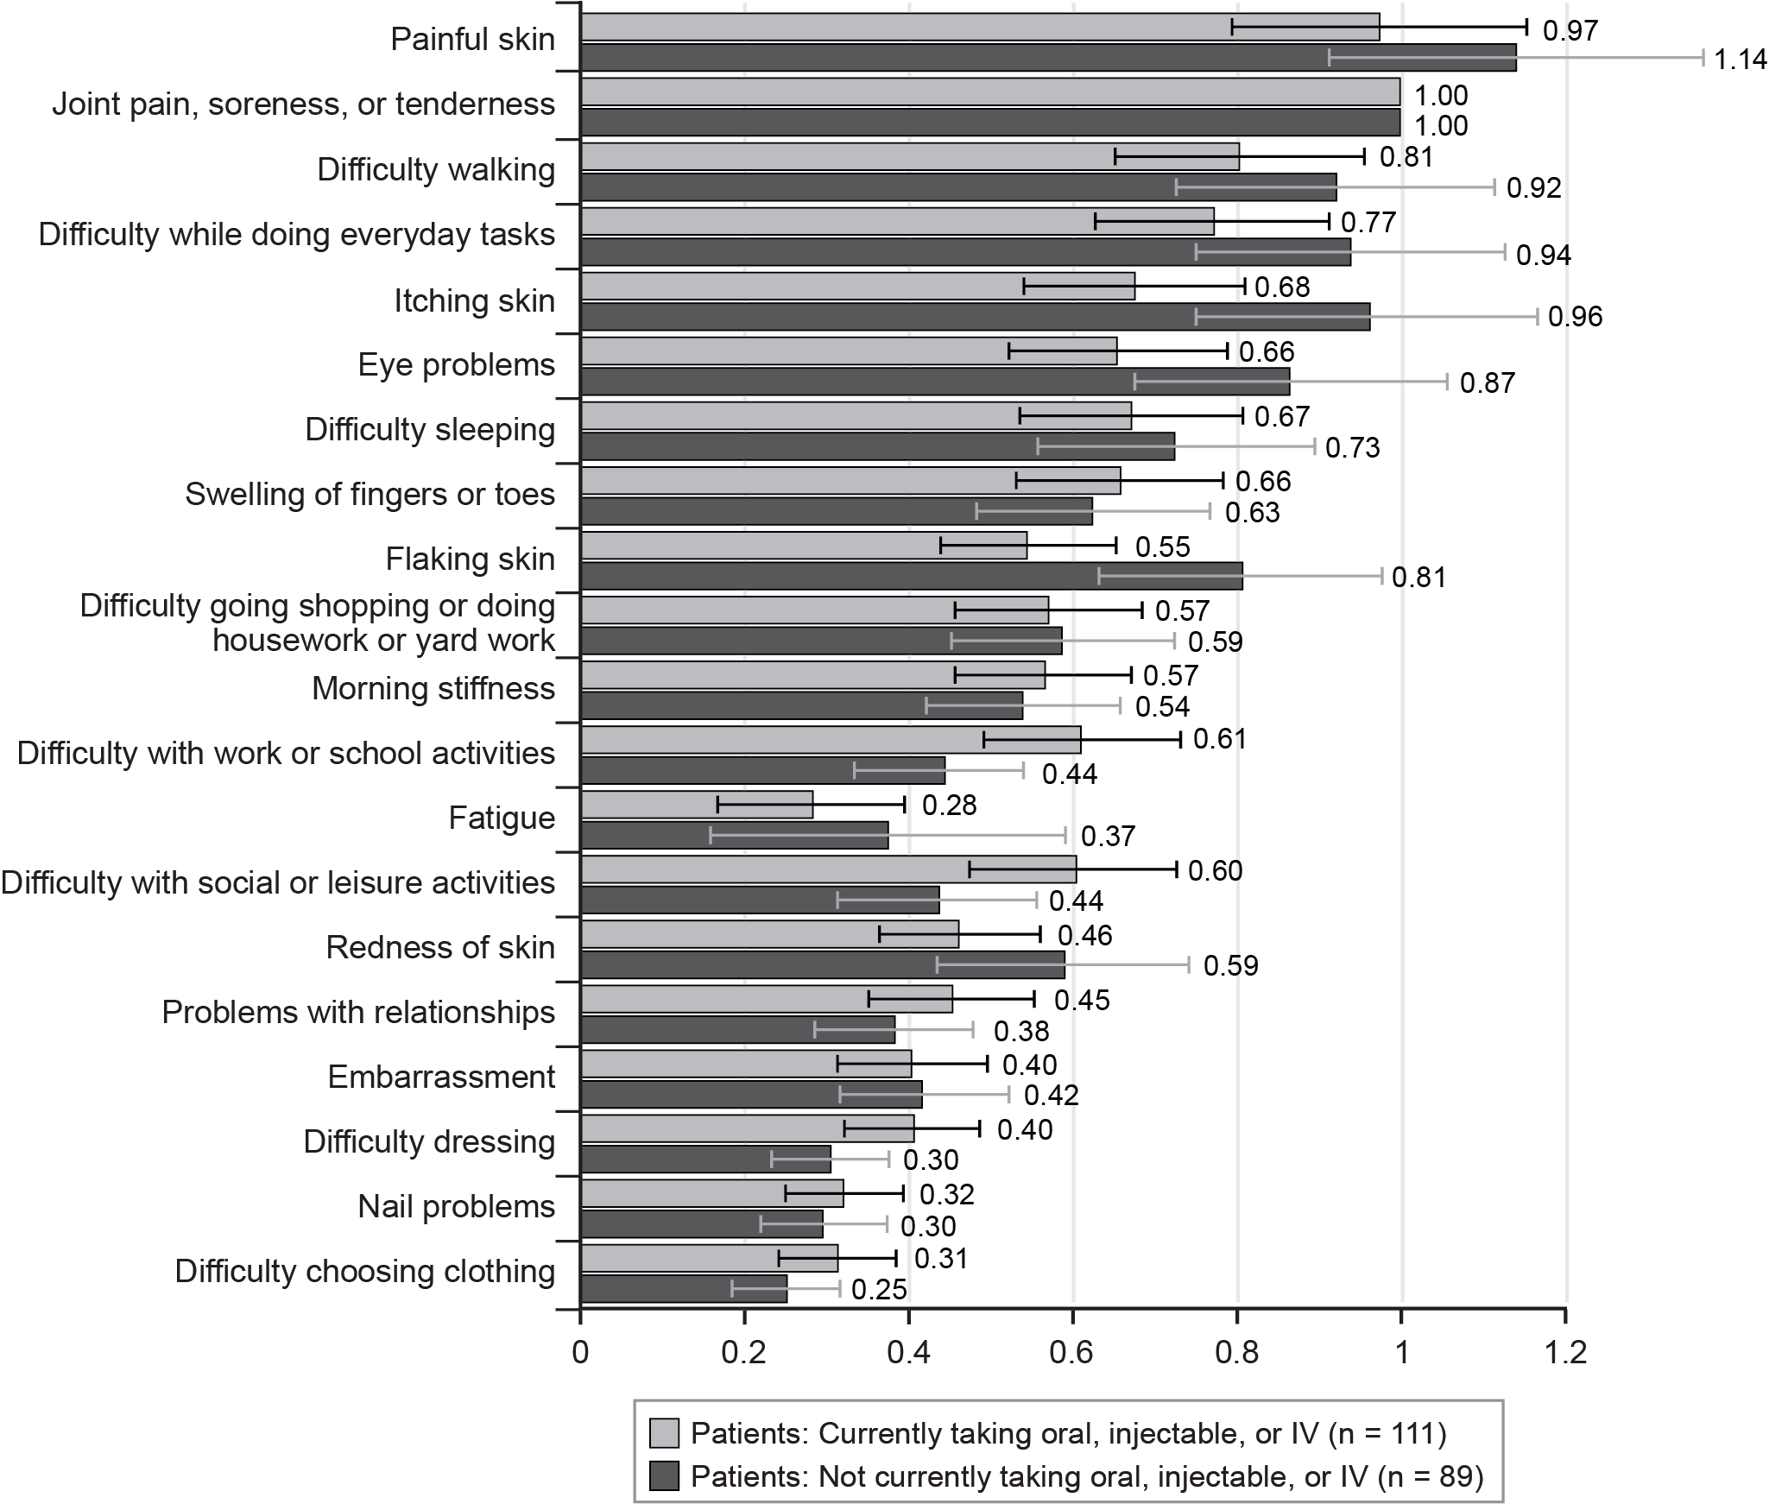
IV = intravenous.
Note: The bars surrounding each mean importance weight denote the 95% confidence interval about the point estimate.

