ADDITIONAL FILES

Association between concomitant csDMARDs and clinical response to TNF inhibitors in overweight patients with axial spondyloarthritis

B. Hernández-Breijo, C. Plasencia-Rodríguez, V. Navarro-Compán, A. Martínez-Feito, A. Jochems, E. L. Kneepkens, G. J. Wolbink, T. Rispens, C. Diego, D. Pascual-Salcedo, A. Balsa

Association between csDMARDs and clinical response (∆ASDAS≥1.1) or remission (ASDAS<1.3) at one year, stratified for body mass index.

 | BMI≤25  (n=53; 44%) |  | BMI>25  (n=66; 56%)
 | OR | 95% CI | OR | 95% CI
Clinical response
Any csDMARD | 1.50 | 0.32-6.98 | 2.98 | 0.37-23.80
MTX [±SSZ] | 1.65 | 0.30-9.08 | 4.52 | 0.36-56.78
SSZ | 1.19 | 1.11-12.63 | 2.42 | 0.27-22.02
Remission
Any csDMARD | 0.61 | 0.18-2.05 | 4.72 | 0.90-24.69
MTX [±SSZ] | 0.70 | 0.18-2.70 | 5.73 | 0.74-44.50
SSZ | 0.44 | 0.65-3.00 | 4.19 | 0.68-25.80

The adjusted multivariable logistic regression analysis included 119 patients. Two different models are presented for the following outcomes: clinical response and remission. Odds ratio (OR) and 95% confidence interval (CI) were calculated. All models were adjusted for age, gender, disease duration, HLA-B27 and baseline ASDAS. BMI, body mass index; HLA-B27, human leucocyte antigen B27; ASDAS, Ankylosing Spondylitis Disease Activity Score; csDMARD, conventional synthetic disease-modifying anti-rheumatic drug; MTX, methotrexate; SSZ, sulfasalazine.

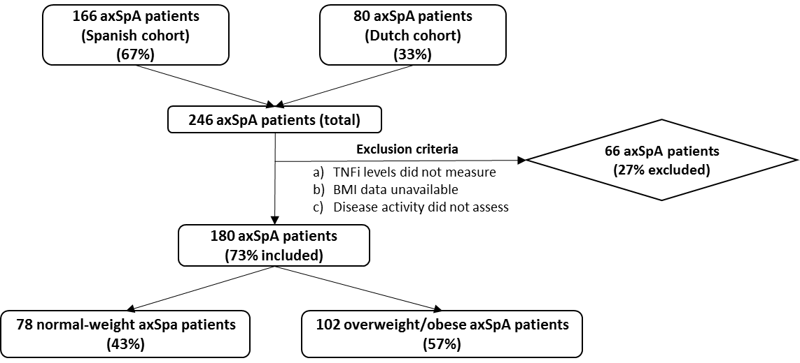
Flowchart of patients included in the present study

