Fig. S2 Effect of maximum ADA titer results on serum drug concentration from Weeks 0 to 54 for (A) FKB327–FKB327, (B) FKB327–RP, (C) RP–FKB327 and (D) RP–RP
(A)
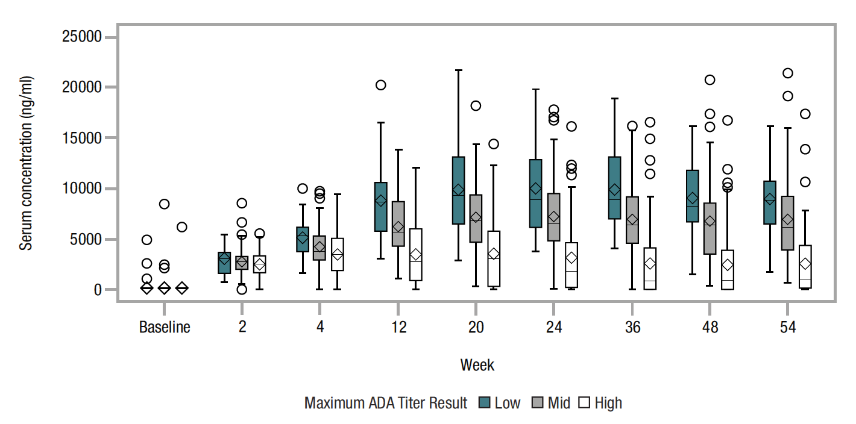
(B)
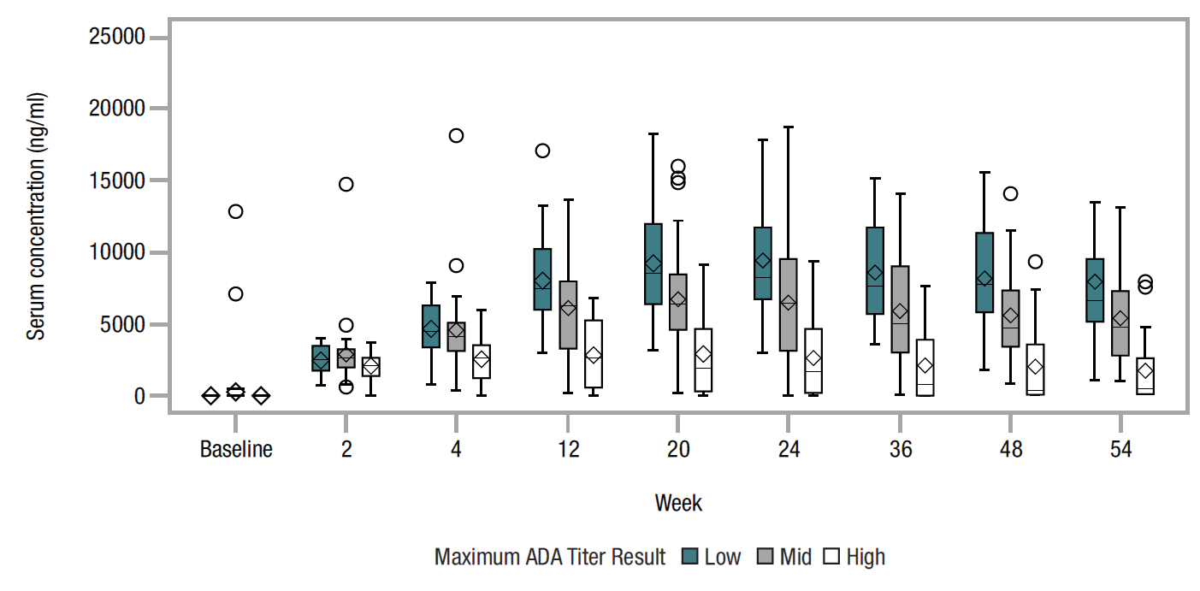
(C) 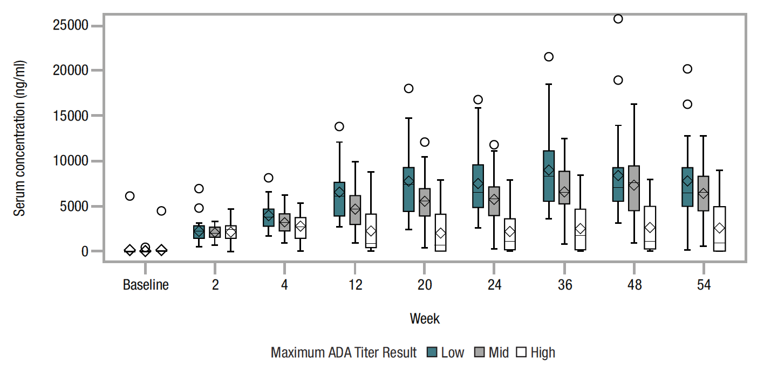

(D)
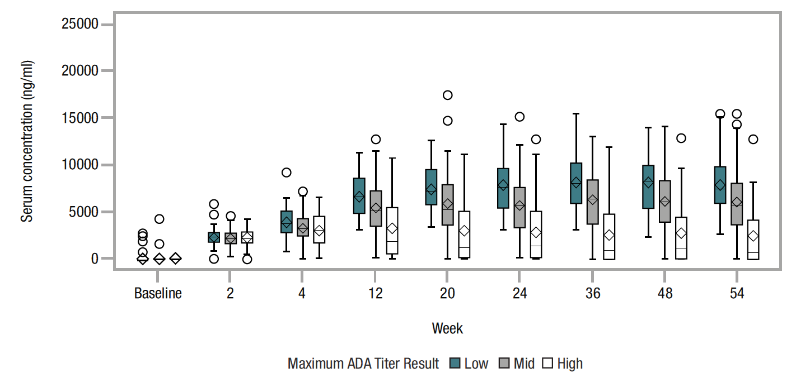
ADA antidrug antibody, RP, reference product. Low ADA titer was defined as ≤ the lower quartile, high ADA titer as ≥ the upper quartile, with mid titer between the lower and upper quartiles (both not included)

