Additional file 1
Table S1. Primer sequence (5′→3′)
primer |  | Sequence
IL-20RA | forward | GGG TAT GCT TCG CAT TTG AT
IL-20RA | reverse | GCA AAC TGA GCT CCT GCT CT
IL-10RB | forward | GCC TGT CTG TGA GCA AAC AA
IL-10RB | reverse | AGG ATG GCC CAA AAA CTC TT
RANKL | forward | ACC AGC ATC AAA ATC CCA AG
RANKL | reverse | CCC CAA AGT ATG TTG CATCC
TRAP | forward | GAC CAC CTT GGC AAT GTC TCT G
TRAP | reverse | TGG CTG AGG AAG TC TCT GAG TTG
Cathepsin K | forward | TGA GGC TTC TCT TGG TGT CCA TAC
Cathepsin K | reverse | AAA GGG TGT CAT TAC TGC GGG
NF-ATc1 | forward | AGC TGC ATG GCT ACT TGG AG
NF-ATc1 | reverse | TTG GTG TTG GAG AGG ATG GC
DC-STAMP | forward | TTC GCT CGT CCT GCT TGG
DC-STAMP | reverse | GCG GGA TGT CTG GTG ATG TAG
OC-STAMP | forward | TGC CCA TCA CGC TCA CG
OC-STAMP | reverse | GGC GGA GCT CCC ATT GGT
ATP6vOd2 | forward | TCT GAT CGA AAC GCC ATT AGC
ATP6vOd2 | reverse | AAC TTC TGC TGT GAC ATC ACC ATG
Beta-actin | forward | GGA CTT CGA GCA AGA GAT GG
Beta-actin | reverse | TGT GTT GGG GTA CAG GTC TTT G

Figure S1. Expression of IL-20RA and IL-10RB in FLSs from osteoarthritis OA patients. OA-FLSs were cultured with IL-26 at various concentrations, and the IL-20RA and IL-10RB mRNA levels were determined by real-time PCR. Results are presented as mean ± SEM (n = 3).

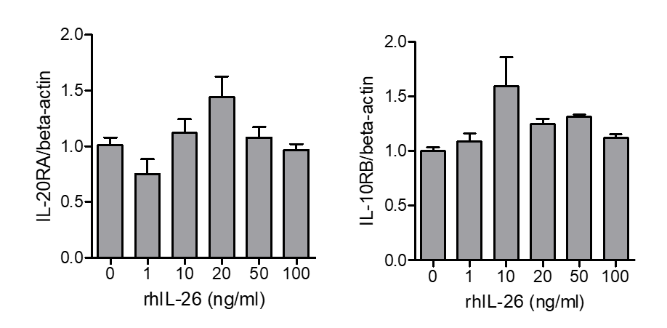

Figure S2. Effect of IL-26 on proinflammatory cytokine levels in FLSs from RA patients. Following culture of RA synovial fibroblasts with rhIL-26 for 72 h, concentrations of TNF-α, IL-6, and IL-1β in the culture media were determined by sandwich ELISA. Results are presented as mean ± SEM (n = 3).

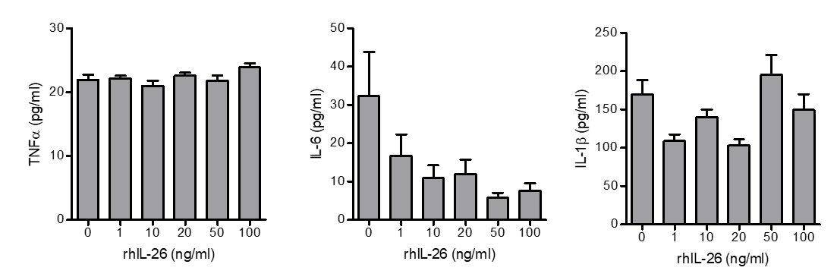

Figure S3. Expression of IL-20RA and IL-10RB in osteoclasts. Osteoclasts were cultured with IL-26 at various concentrations, and IL-20RA and IL-10RB mRNA levels were determined by real-time PCR. Results are presented as mean ± SEM (n = 3). ***P < 0.005.

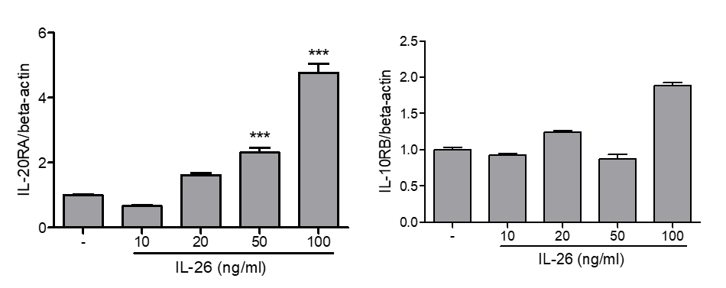

Figure S4. RANKL concentration in culture media. RANKL concentration in the culture media without and with 25 ng/mL macrophage colony stimulating factor (M-CSF) was determined by sandwich ELISA. RANKL concentrations in the culture media were also evaluated following incubation with 0–100 ng/mL rhIL-26 for 72 h. The results are presented as mean ± SEM (n = 3).

