Supplementary Figure 1: Continental PCA plot in all study samples merged with SNP data from 51 known ethnic groups genotyped by Omni-650 Beadchips. Colours and shapes represent study populations (see legends above), including AS samples (black dots), and controls (grey dots) in current study. The black square includes all study samples and red lines show 6 standard deviations from the population mean on principal components.

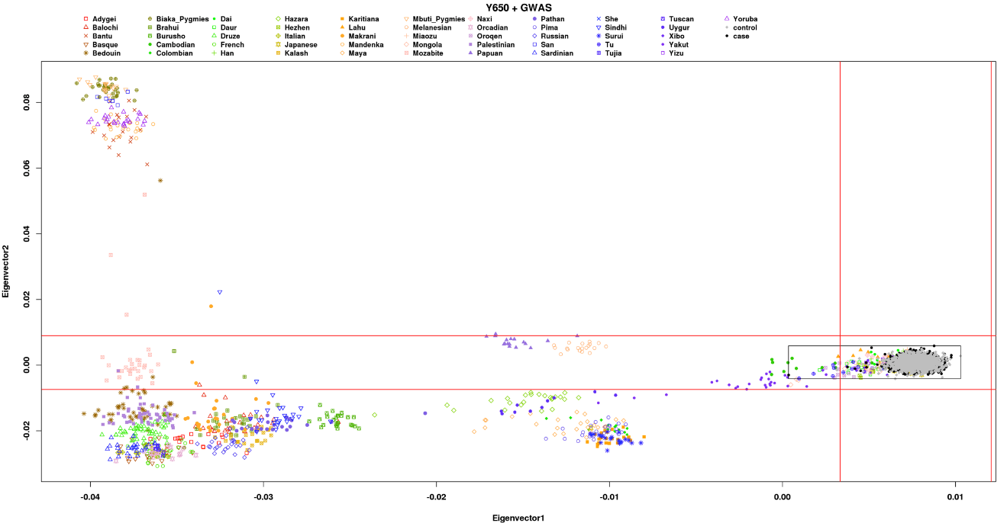

Supplementary Figure 2: Q-Q plots of association for negative control SNPs set
Observed versus expected association for a set of negative control SNPs in regions included on Immunochip for studies of reading and writing disabilities, psychosis and schizophrenia. For the analyses, the negative control SNP lists contained SNPs that were unlinked (r2 < 0.3) and common (MAF > 0.05) in the respective controls sample set. This resulted in a list of 1,767 SNPs for the East Asian ethnicity analysis. The genomic inflation factor in the negative control SNP list in the overall analysis was 1.03 (lambda(1000)=1.02).
