Supplementary materiel (figures)
Figure S1: Receiver operating characteristic (ROC) curve of serum calprotectin as a disease activity marker in early rheumatoid arthritis. Moderate/high activity (n=58) versus low activity (n=53), according to DAS28 ESR. Thresholds of 3.5 µg/ml and 2.5 µg/ml (threshold with the highest sum sensitivity + specificity) and confidence interval for sensitivity are plotted. Area under the curve: 0.74. Boxplots of median calprotectin levels (with interquartile range) of the two groups are also shown (Wilcoxon test was used to compare median levels). Abbreviations: Sn, sensitivity; Sp, specificity
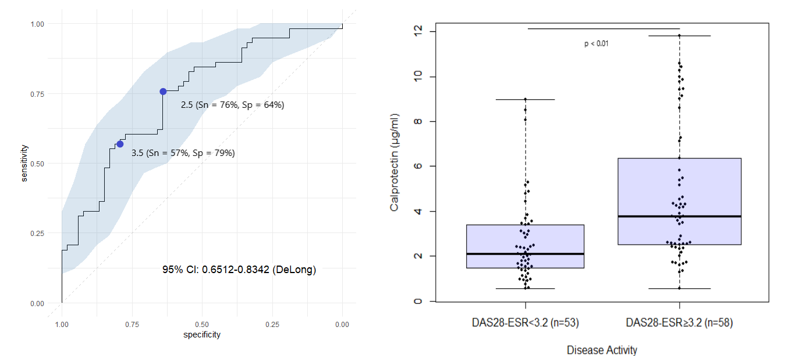
Figure S2: Ultrasound score in Rheumatoid Arthritis (RA): Calprotectin versus C-reactive protein (CRP). Receiver operating characteristic (ROC) curve of the ability of serum calprotectin and CRP to detect a positive Swiss Sonography in Arthritis and Rheumatism (SONAR) score in patients with RA. For calprotectin, thresholds of 1.5 µg/ml (mean serum calprotectin in HC), 3.5 µg/ml and threshold with the highest sum sensitivity + specificity are plotted. For CRP, thresholds of 5.0 mg/l (usual threshold) and threshold with the highest sum sensitivity + specificity are plotted. Abbreviations: AUC, Area Under Curve, 95%CI, 95% Confidence Interval; Sn, Sensitivity; Sp, Specificity.
A: ROC curves on the 209 patients who had an ultrasonography examination: 147 had a positive SONAR score, and 62 were negative.
B: ROC curves on 82 patients with ultrasonography examination and a disease duration less than 5 years: 55 had a positive SONAR score, and 27 were negative.
C: Boxplots of median levels (with interquartile range) of calprotectin and CRP in the 209 RA patients with SONAR negative score versus SONAR positive (Wilcoxon test was used to compare median levels).
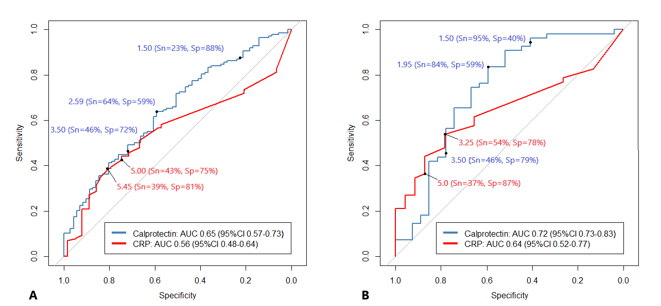
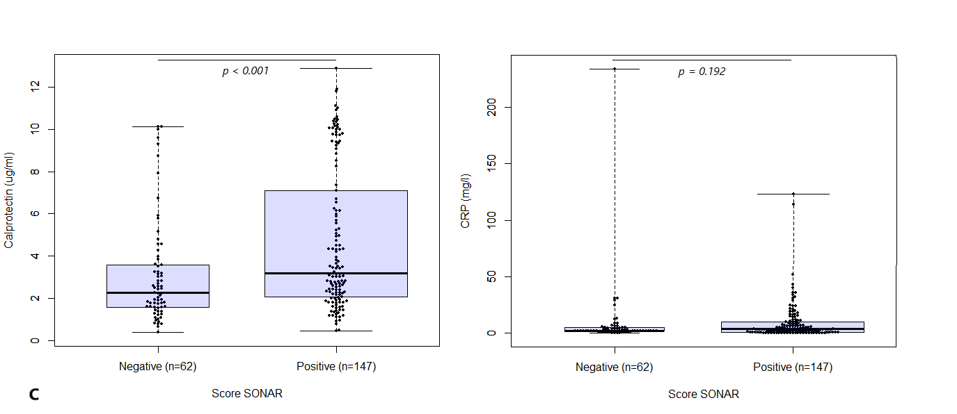

Figure S3: Swollen Joint Count (SJC) in rheumatoid arthritis patients treated with Tocilizumab: calprotectin versus C-reactive protein.
Boxplots of median levels (with interquartile range) of calprotectin (A) and C-Reactive Protein (CRP) (B) in 51 RA patients treated with tocilizumab without swollen joint versus one or more swollen joint. Wilcoxon test was used to compare median levels.
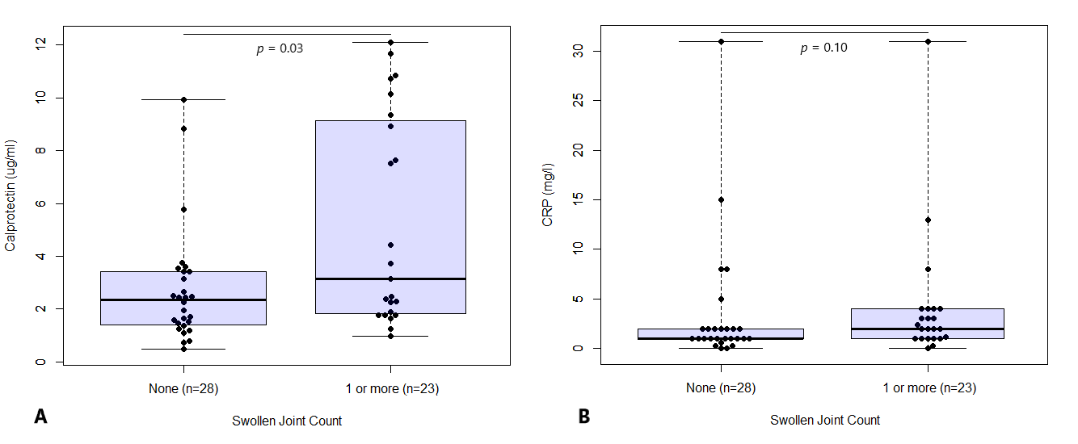

Figure S4: Disease Activity Score in rheumatoid arthritis patients on tocilizumab: Calprotectin versus C-reactive protein (CRP)
A. Boxplots of median levels (with interquartile range) of calprotectin and CRP in RA patients treated with tocilizumab with low disease (DAS28-ESR < 3.2) versus moderate to high disease activity (DAS28-ESR ≥ 3.2). Wilcoxon test was used to compare median levels.
B. Receiver operating characteristic (ROC) curve of the ability of serum calprotectin and CRP to detect a DAS28-ESR above 3.2 in the same population. For calprotectin, thresholds of 3.5 µg/ml and 3.735 µg/ml (threshold with the highest sum sensitivity + specificity) are plotted. Area under the curve: 0.80. 95% CI: 0.66-0.96 (DeLong). For CRP, thresholds of 5.0 mg/l (usual threshold) and 2.7 µg/ml (threshold with the highest sum sensitivity + specificity) are plotted. Area under the curve: 0.71. 95% CI: 0.56-0.91 (DeLong)

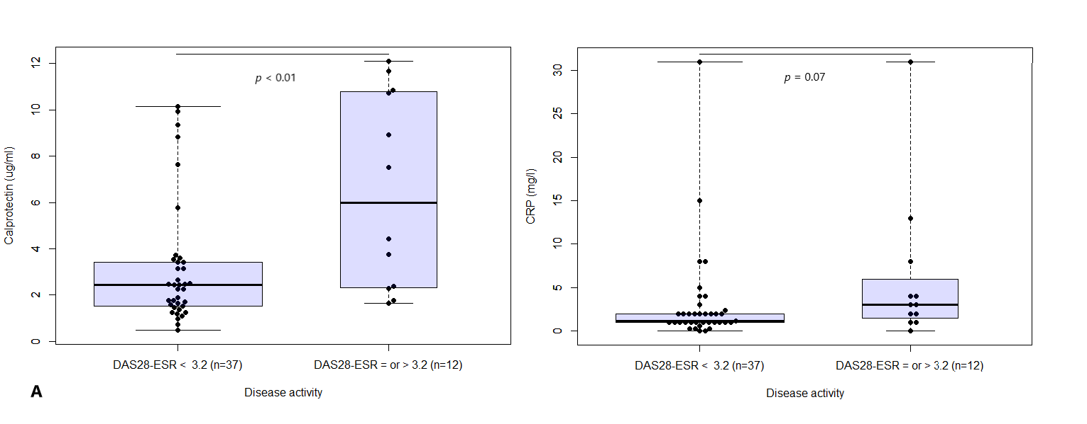
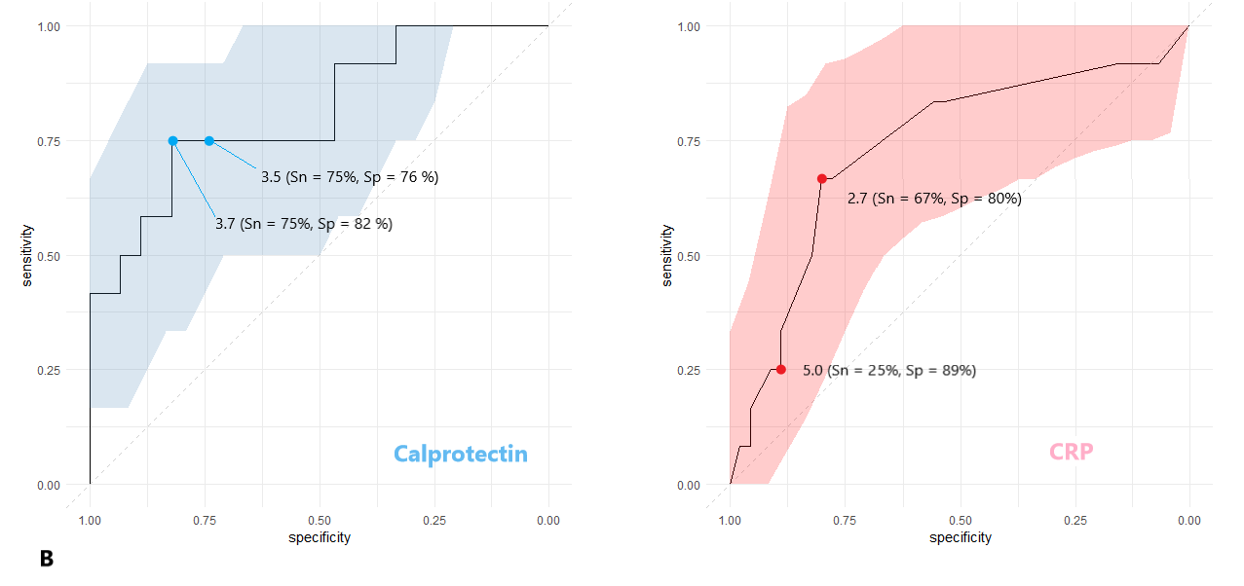

Figure S5: Ratingen score evolution over time for each calprotectin quartile levels in the RA population.

