Genovese MC et al. Interleukin-6 receptor blockade or TNFα inhibition for reducing glycaemia in patients with RA and diabetes: post hoc analyses of three randomized, controlled trials

Supplementary Tables and Figures
Figure S1. Efficacy outcomes at Week 24 in patients with RA with or without diabetes who received sarilumab 150 mg or 200 mg q2w + MTX/csDMARDs in two placebo-controlled trials (A, C, E, G; pooled data) or sarilumab 200 mg q2w monotherapy (B, D, F, H): for ACR20 (A and B), change from baseline in HAQ-DI (C and D), change from baseline in DAS28-CRP (E and F), change from baseline in CDAI (G and H).
Table S1. Patient disposition by diabetes status across three phase III studies of patients with RA
Table S2. Change from baseline at Week 24 in HbA1c by DAS28-CRP category and diabetes status
Table S3. Lack of interaction between change from baseline in HbA1c and (A) baseline oral glucocorticoid use or (B) increase from baseline in haemoglobin at Week 24
Table S4. Interaction between change from baseline in HbA1c and baseline HbA1c <7.0% vs ≥ 7.0%, baseline status of diabetes vs no diabetes, baseline oral glucocorticosteroid use, and with or without increase in haemoglobin at Week 24
Table S5. Change from baseline in body weight at Week 24 by diabetic status

Figure S1. Efficacy outcomes at Week 24 in patients with RA with or without diabetes who received sarilumab 150 mg or 200 mg q2w + MTX/csDMARDs in two placebo-controlled trials (A, C, E, G; pooled data) or sarilumab 200 mg q2w monotherapy (B, D, F, H): for ACR20 (A and B), change from baseline in HAQ-DI (C and D), change from baseline in DAS28-CRP (E and F) and change from baseline in CDAI (G and H).
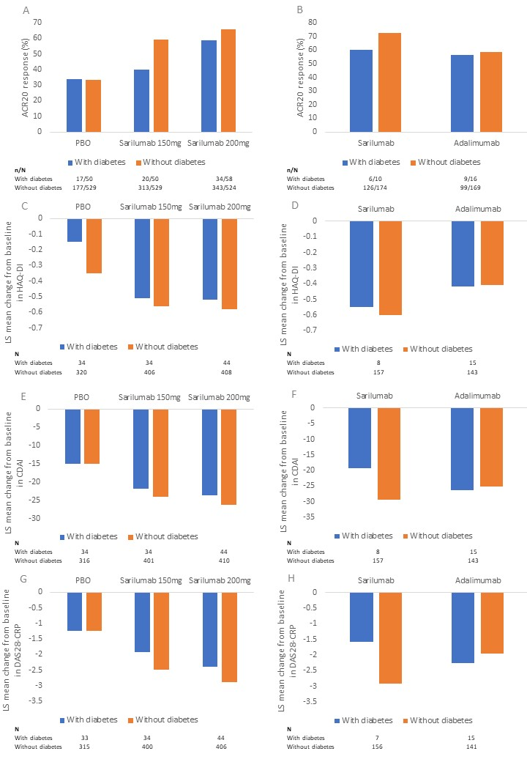

ACR20 = American College of Rheumatology 20% improvement response; CDAI = Clinical Disease Activity Index; csDMARD = conventional synthetic disease-modifying antirheumatic drug; DAS28-CRP = Disease Activity Score 28-C-reactive protein; HAQ-DI = Health Assessment Questionnaire-Disability Index; MTX = methotrexate; q2w = every 2 weeks.

Table S1. Patient disposition by diabetes status across three phase III studies of patients with RA

 | Total
n (%) | With diabetes  (N = 184) | Without diabetes  (N = 1928)
Randomized and not treated | 0 | 4 (0.2)
Randomized and treated | 184 (100) | 1924 (99.8)
Completed the study treatment period up to Week 24 | 145 (78.8) | 1618 (83.9)
Discontinued during double-blind period | 27 (14.7) | 200 (10.4)
Subject’s request for treatment discontinuation | 12 (6.5) | 95 (4.9)
Reason for treatment discontinuation
AE | 16 (8.7) | 123 (6.4)
Lack of efficacy | 3 (1.6) | 24 (1.2)
Poor compliance to protocol | 3 (1.6) | 8 (0.4)
Other reasons | 5 (2.7) | 45 (2.3)
AE = adverse event.

Table S2. Change from baseline at Week 24 in HbA1c by DAS28-CRP category and diabetes status
 | Combination therapy with csDMARDs  in TNF-INT/IR patients |  |  | Monotherapy in MTX-INT/IR patients
Change in HbA1c at Week 24 | Placebo + csDMARDs | Sarilumab 150 mg q2w + csDMARDs | Sarilumab 200 mg q2w + csDMARDs | Adalimumab 40 mg q2w monotherapy | Sarilumab 200 mg q2w monotherapy
DAS28-CRP < 2.6
Patients with a medical history of diabetes or baseline use of antidiabetic medication
Number | 1 | 3 | 2 | 2 | 0
Mean (SD) | −0.20 (-) | 0.17 (0.50) | −0.55 (0.35) | −0.50 (0.14)
Median (Q1, Q3) | −0.20 (−0.20, −0.20) | 0.10 (−0.30, 0.70) | −0.55 (−0.80, −0.30) | −0.50 (−0.60, −0.40)
Patients without diabetes
Number | 12 | 42 | 49 | 23 | 60
Mean (SD) | 0.38 (0.72) | −0.17 (0.32) | −0.21 (0.29) | −0.05 (0.30) | −0.08 (0.55)
Median (Q1, Q3) | 0.15 (0.05, 0.30) | −0.15 (−0.30, −0.10) | −0.20 (−0.40, 0.00) | 0.00 (−0.20, 0.20) | −0.10 (−0.30, 0.00)
DAS28-CRP ≥ 2.6
Patients with a medical history of diabetes or baseline use of antidiabetic medication
Number | 14 | 11 | 13 | 12 | 6
Mean (SD) | 0.25 (1.27) | −0.25 (0.56) | −0.55 (0.99) | 0.17 (0.70) | −0.28 (0.57)
Median (Q1, Q3) | 0.15 (−0.40, 0.50) | −0.30 (−0.60, 0.40) | −0.30 (−0.70, −0.20) | 0.25 (−0.40, 0.30) | −0.20 (−0.80, 0.30)
Patients without diabetes
Number | 70 | 70 | 70 | 111 | 92
Mean (SD) | 0.04 (0.35) | −0.13 (0.32) | −0.32 (0.30) | −0.03 (0.33) | −0.20 (0.32)
Median (Q1, Q3) | 0.00 (−0.20, 0.30) | −0.10 (−0.30, 0.10) | −0.30 (−0.50, −0.10) | 0.00 (−0.20, 0.20) | −0.20 (−0.40, 0.00)

DAS28-CRP < 3.2
Patients with a medical history of diabetes or baseline use of antidiabetic medication
Number | 2 | 5 | 5 | 2 | 0
Mean (SD) | −0.95 (1.06) | −0.16 (0.58) | −0.62 (0.44) | −0.50 (0.14)
Median (Q1, Q3) | −0.95 (−1.70, −0.20) | −0.30 (−0.50, 0.10) | −0.50 (−0.80, −0.30) | −0.50 (−0.60, −0.40)
Patients without diabetes
Number | 23 | 54 | 67 | 42 | 92
Mean (SD) | 0.23 (0.61) | −0.14 (0.32) | −0.22 (0.27) | −0.06 (0.31) | −0.14 (0.50)
Median (Q1, Q3) | 0.10 (−0.10, 0.30) | −0.10 (−0.30, 0.00) | −0.20 (−0.40, −0.10) | 0.05 (−0.30, 0.20) | −0.20 (−0.40, 0.00)
DAS28-CRP ≥ 3.2
Patients with a medical history of diabetes or baseline use of antidiabetic medication
Number | 13 | 9 | 10 | 12 | 6
Mean (SD) | 0.40 (1.19) | −0.16 (0.58) | −0.51 (1.10) | 0.17 (0.70) | −0.28 (0.57)
Median (Q1, Q3) | 0.20 (−0.10, 0.50) | −0.30 (−0.50, 0.40) | −0.30 (−0.70, −0.20) | 0.25 (−0.40, 0.30) | −0.20 (−0.80, 0.30)
Patients without diabetes
Number | 59 | 58 | 52 | 92 | 60
Mean (SD) | 0.04 (0.33) | −0.15 (0.32) | −0.35 (0.32) | −0.03 (0.33) | −0.16 (0.30)
Median (Q1, Q3) | 0.00 (−0.20, 0.30) | −0.10 (−0.30, 0.00) | −0.30 (−0.50, −0.10) | 0.03 (−0.20, 0.20) | −0.20 (−0.35, 0.00)
All assessments are set to missing from the time a patient prematurely discontinues study medication. Patients with nonmissing HbA1c and DAS28-CRP values are considered. Number = Number of patients with assessment at both baseline and Week 24.
csDMARDs = conventional synthetic disease-modifying antirheumatic drug; DAS28-CRP = Disease Activity Score (28 joints) using C-reactive protein; IN = intolerant; IR = inadequate response; MTX = methotrexate; SD = standard deviation; TNF = tumor necrosis factor; Q1 = first quartile; q2w = every 2 weeks; Q3 = third quartile.

Table S3. Lack of interaction between change from baseline in HbA1c and either (A) baseline oral glucocorticoid use or (B) increase from baseline in haemoglobin at Week 24
(A)
Study
Combination therapy in TNF-INT/IR patients |  |  |  |  |  | p value for interactionª
 | Subgroup |  | Placebo  + csDMARD | Sarilumab  150 mg  q2w + csDMARD | Sarilumab  200 mg  q2w + csDMARD | 0.8767
 | With baseline oral  glucocorticoid use | Number | 65 | 91 | 86
 |  | Baseline mean (SD) | 5.82 (0.77) | 5.79 (0.72) | 5.73 (0.73)
 |  | LS mean change (SE)ª | 0.09 (0.05) | −0.18 (0.05) | −0.29 (0.05)
 |  | LS mean diff,  95% CIª |  | −0.27  (−0.41,−0.13) | −0.38  (−0.52,−0.24)
 |  | p value vs. placeboª |  | 0.0001 | < 0.0001
 | Without baseline oral glucocorticoid use | Number | 39 | 41 | 51
 |  | Baseline mean (SD) | 5.92 (0.95) | 5.80 (0.71) | 5.75 (0.80)
 |  | LS mean change (SE)ª | 0.08 (0.07) | −0.13 (0.07) | −0.28 (0.06)
 |  | LS mean diff,  95% CIª |  | −0.21  (−0.40,−0.03) | −0.37  (−0.54,−0.19)
 |  | p value vs. placeboª |  | 0.0245 | < 0.0001
Monotherapy in MTX-INT/IR patients |  |  |  |  |  | p value for interactionª
 | Subgroup |  | Adalimumab 40 mg q2w monotherapy |  | Sarilumab  200 mg q2w monotherapy | 0.7438
 | With baseline oral  glucocorticoid use | Number | 86 |  | 80
 |  | Baseline mean (SD) | 5.63 (0.62) |  | 5.56 (0.56)
 |  | LS mean change (SE)ª | −0.01 (0.04) |  | −0.16 (0.05)
 |  | LS mean diff,  95% CIª |  |  | −0.15  (−0.27,−0.03)
 |  | p value vs. placeboª |  |  | 0.0181
 | Without baseline oral glucocorticoid use | Number | 66 |  | 80
 |  | Baseline mean (SD) | 5.63 (0.59) |  | 5.54 (0.53)
 |  | LS mean change (SE)ª | −0.01 (0.05) |  | −0.13 (0.05)
 |  | LS mean diff,  95% CIª |  |  | −0.12  (−0.25,0.01)
 |  | p value vs. placeboª |  |  | 0.0816
Note: Number = Number of patients with assessment at both baseline and post baseline visit.
ªMMRM assuming an unstructured covariance structure. Model = treatment, region, visit, subgroup, treatment-by-visit interaction, treatment-by-subgroup interaction and treatment-by-visit-by-subgroup interaction.
Missing data were not imputed.
CI = confidence interval; csDMARD = conventional synthetic disease-modifying antirheumatic drug; HbA1c = glycosylated haemoglobin; INT = intolerant; IR = inadequate response; LS = least squares; MMRM = mixed-effect model repeat measurement; MTX = methotrexate; q2w = every 2 weeks; TNF = tumour necrosis factor-α inhibitor.

(B)
Study
Combination therapy in TNF-INT/IR patients |  |  |  |  |  | p value for interactionª
 | Subgroup |  | Placebo  + csDMARD | Sarilumab  150 mg  q2w + csDMARD | Sarilumab  200 mg  q2w + csDMARD | 0.9362
 | Without an increase in haemoglobin | Number | 57 | 24 | 29
 |  | Baseline mean (SD) | 5.93 (0.96) | 5.64 (0.58) | 5.52 (0.86)
 |  | LS mean change (SE)ª | 0.10 (0.06) | −0.17 (0.09) | −0.31 (0.09)
 |  | LS mean diff,  95% CIª |  | −0.27 (−0.49,  −0.05) | −0.41 (−0.61,  −0.20)
 |  | p value vs. placeboª |  | 0.0177 | 0.0001
 | With an increase in haemoglobin | Number | 38 | 100 | 102
 |  | Baseline mean (SD) | 6.09 (1.14) | 5.63 (0.65) | 5.34 (0.50)
 |  | LS mean change (SE)ª | 0.13 (0.08) | −0.15 (0.05) | −0.32 (0.05)
 |  | LS mean diff,  95% CIª |  | −0.28 (−0.45,  −0.11) | −0.45 (−0.63,  −0.28)
 |  | p value vs. placeboª |  | 0.0015 | < 0.0001
Monotherapy in MTX-INT/IR patients |  |  |  |  |  | p value for interactionª
 | Subgroup |  | Adalimumab 40 mg q2w monotherapy |  | Sarilumab  200 mg q2w monotherapy | 0.6580
 | Without an increase in haemoglobin | Number | 77 |  | 42
 |  | Baseline mean (SD) | 5.60 (0.54) |  | 5.37 (0.57)
 |  | LS mean change (SE)ª | −0.02 (0.05) |  | −0.10 (0.06)
 |  | LS mean diff,  95% CIª |  |  | −0.09 (−0.24, 0.07)
 |  | p value vs. placeboª |  |  | 0.2677
 | With an increase in haemoglobin | Number | 70 |  | 113
 |  | Baseline mean (SD) | 5.58 (0.68) |  | 5.41 (0.56)
 |  | LS mean change (SE)ª | −0.04 (0.05) |  | −0.17 (−0.04),
 |  | LS mean diff,  95% CIª |  |  | −0.13 (−0.25, -0.01)
 |  | p value vs. placeboª |  |  | 0.0351
Note: Number = Number of patients with assessment at both baseline and post baseline visit.
ªMMRM assuming an unstructured covariance structure. Model = treatment, region, visit, subgroup, treatment-by-visit interaction, treatment-by-subgroup interaction, and treatment-by-visit-by-subgroup interaction.
Missing data were not imputed.
CI = confidence interval; csDMARD = conventional synthetic disease-modifying antirheumatic drug; INT = intolerant; IR = inadequate response; LS = least squares; MMRM = mixed-effect model repeat measurement; MTX = methotrexate; q2w = every 2 weeks; SD = standard deviation; SE = standard error; TNF = tumour necrosis factor-inhibitor.

Table S4. Interaction between change from baseline in HbA1c and baseline HbA1c <7.0% vs ≥ 7.0%, baseline status of diabetes vs no diabetes, baseline oral glucocorticosteroid use, and with or without increase in haemoglobin at Week 24
 | p value for interactionª
Change from baseline in HbA1c at Week 24 by subgroups | Model 1^{b} | Model 2^{c} | Model 3^{d}
Baseline HbA1c <7.0% vs ≥ 7.0%
Monotherapy in MTX-INT/IR patients | 0.0045 | 0.0077 | 0.0022
Combination therapy with csDMARDs in TNF-INT/IR patients | 0.1101 | 0.0779 | 0.0920
Baseline status of diabetes vs no diabetes
Monotherapy in MTX-INT/IR patients | 0.0374 | 0.0493 | 0.0277
Combination therapy with csDMARDs in TNF-INT/IR patients | 0.0805 | 0.0746 | 0.0637
With or without baseline oral glucocorticosteroid use
Monotherapy in MTX-INT/IR patients | 0.7318 | 0.5382 | 0.8185
Combination therapy with csDMARDs in TNF-INT/IR patients | 0.9794 | 0.9576 | 0.9880
With or without increase in haemoglobin
Monotherapy in MTX-INT/IR patients | 0.6095 | 0.6209 | 0.6854
Combination therapy with csDMARDs in TNF-INT/IR patients | 0.9015 | 0.8257 | 0.8661

ªp comparing LS mean change from baseline in HbA1c between subgroups using MMRM assuming an unstructured covariance structure. ^{b}Model = subgroup, treatment, region, CRP change at week 24, CDAI change at week 24, visit, treatment-by-visit interaction, treatment-by-subgroup, interaction, and treatment-by-visit-by-subgroup interaction. ^{c}Model = subgroup, treatment, region, DAS28-CRP change at week 12, visit, treatment-by-visit interaction, treatment-by-subgroup, interaction, and treatment-by-visit-by-subgroup interaction. ^{d}Model = subgroup, treatment, region, TJC28 change at week 24, SJC28 change at week 24, PtGA change at week 24, SGA change at week 24, CRP change at week 24, visit, treatment-by-visit interaction, treatment-by-subgroup, interaction, and treatment-by-visit-by-subgroup interaction.
Missing data were not imputed.
CDAI = Clinical Disease Activity Index; CRP = C-reactive protein; csDMARD = conventional synthetic disease-modifying antirheumatic drug; HbA1c = glycosylated haemoglobin; INT = intolerant; IR = inadequate response; MTX = methotrexate; MMRM = mixed-effect model repeat measurement; PtGA = patient global assessment; SGA = subjective global assessment; SJC28 = swollen 28-joint count; TJC28 = tender 28-joint count; TNF = tumour necrosis factor-α inhibitor.

Table S5. Change from baseline in body weight at Week 24 by diabetic status.
 | Combination therapy with MTX  in MTX-IR patients |  |  | Combination therapy with csDMARDs  in TNF-INT/IR patients |  |  | Monotherapy in MTX-INT/IR patients
Body weight at Week 24, n (%) | Placebo | Sarilumab 150 mg q2w | Sarilumab 200 mg q2w | Placebo | Sarilumab 150 mg q2w | Sarilumab 200 mg q2w | Adalimumab 40 mg q2w | Sarilumab 200 mg q2w
With diabetes
Number | 18 | 20 | 29 | 15 | 14 | 15 | 14 | 7
> +5% | 1 (5.6) | 2 (10.0) | 5 (17.2) | 2 (13.3) | 2 (14.3) | 2 (13.3) | 2 (14.3) | 1 (14.3)
-5% − ≤+5% | 15 (83.3) | 18 (90.0) | 23 (79.3) | 11 (73.3) | 11 (78.6) | 12 (80.0) | 10 (71.4) | 6 (85.7)
≤-5% | 2 (11.1) | 0 | 1 (3.4) | 2 (13.3) | 1 (7.1) | 1 (6.7) | 2 (14.3) | 0
Without diabetes

Number | 234 | 295 | 288 | 84 | 112 | 120 | 146 | 159
> +5% | 25 (10.7) | 49 (16.6) | 53 (18.4) | 6 (7.1) | 11 (9.8%) | 22 (18.3) | 12 (8.2) | 19(11.9)
-5% − ≤+5% | 192 (82.1) | 232 (78.6) | 222 (77.1) | 74 (88.1) | 96 (85.7) | 91 (75.8) | 126 (86.3) | 134 (84.3)
≤ -5% | 17 (7.3) | 14 (4.7) | 13 (4.5) | 4 (4.8) | 5 (4.5) | 7 (5.8) | 8 (5.5) | 6 (3.8)
csDMARD = conventional synthetic disease-modifying antirheumatic drug; INT = intolerant; IR = inadequate response; MTX = methotrexate; q2w = every 2 weeks; TNF = tumour necrosis factor-α inhibitor.

