Supplementary Material

Table of Contents
Supplementary Table 1. Marker genes of the three synovial membrane fibroblast types. 2
Supplementary Table 2 3
Supplementary Table 3. Preservation of gene expression differences between baseline and response time point (week 20). 4
Supplementary Figure 1. Preservation of differential expression changes associated to anti-TNF response in the synovium from baseline. 6
Supplementary Figure 2. RTPCR replication of CX3CL1 and PIK3CD genes. 7
Supplementary Figure 3. Association of the three fibroblast subsets at baseline with anti-TNF response. 8
Supplementary Figure 4. Cell types associated with anti-TNF response: differences at week 20. 11
Supplementary Figure 5. QRTPCR replication of T_{PH} biomarker genes CTLA4 and TIMELESS. 14
Supplementary Figure 6. Correlation between PD1^{hi}CXCR5-CD4+ T cell abundance estimation using the cell deconvolution approach with the percentage quantified using immunofluorescence. 15

Supplementary Table 1. Marker genes of the three synovial membrane fibroblast types.

CD34+ markers
ADAM22 | CACHD1 | FZD4 | PCDH18
ADAMTSL3 | CAMK2D | G0S2 | PKNOX2
AHR | CD34 | GDA | RHOU
ANGPT1 | CEP126 | IQCC | SETBP1
ASPA | CLIP3 | LPCAT2 | SSPN
BICC1 | CLLU1OS | MAB21L2 | TBX5
C3 | CP | MECOM | TMEM108
C6 | CXCL12 | NOVA1 | TMEM133
C7 | EGR1 | OSR2 | TRDMT1

THY1+ markers
ADCY7 | CCNG1 | FLRT2 | PLXDC1 | THY1
ADGRA2 | COMP | FNDC1 | PRKD1 | TTC39C
ANKRD29 | CRABP2 | IGF1 | PTGIS | VSTM4
ARL4C | CRISPLD2 | LTBP2 | SFRP4 | WISP1
ARSB | CUTC | MBNL2 | SMOC2
ASPN | DPP4 | MCUB | SRGAP1
AXIN2 | EDIL3 | MYOF | STXBP5
C12orf75 | ELN | NLGN2 | THBS1
CADM1 | FHL2 | OAF | THBS2

CD34-THY1- markers
ADAM10 | ERRFI1 | MET | PPIL6 | TIMP3
ADGRA3 | EZR | MFSD6 | RBPMS2 | TMCO3
ADGRG2 | FNIP2 | MSN | RELL1 | TMEM196
AGFG1 | FOXO1 | MT1G | RGS16 | TSPAN15
BTC | GALNT12 | MTHFD1L | RIOK3 | TWISTNB
C10orf105 | GFPT2 | MTUS2 | SEC11C | UBAP1
CLIP1 | GPR18 | NDP | SHTN1 | UGP2
CNTNAP3 | GPR183 | NTN4 | SIX3 | USP24
CSN1S1 | GPX3 | OSTF1 | SORBS2 | UST
CUX1 | GRAMD1B | PACSIN2 | SOX5 | VPS13A
CXCL8 | HBEGF | PCSK6 | STK38L | WARS
DAPK1 | HMGA2 | PDE8A | SUSD4 | ZNF385B
DNASE1L3 | HTRA4 | PDLIM5 | SV2B
ENPP1 | KIF1B | PGM3 | SYT17
EREG | LRRFIP2 | PNP | TIAM2

Genes differentially overexpressed from each fibroblast subset compared to the other two were selected as markers for cell type deconvolution analysis.

Supplementary Table 2. Significantly overexpressed genes in PD-1^{hi} T cells according to Rao et al.
PD-1 | GZMK | F5
SCO2 | DHFR | DUSP2
CDCA7 | TIMELESS | MAF
TOX | DUSP4 | PSMA4
TOX2 | FABP5 | SYT11
ENC1 | FBXO41 | UBE2A
HVCN1 | MAP3K9 | TBC1D4
CHN1 | PMAIP1 | UQCRC1
CCDC86 | PRR5L | ANXA2
CCL5 | MIS18BP1 | SLAMF6
AKR1C3 | EPSTI1 | TUBB4B
CST7 | BZRAP1 | UBE2L6
CEP128 | DPP3 | ITM2A
MYL6B | TIGIT | RGS1
EZH2 | FCRL3
CXCR3 | CTLA4
ICA1 | DDX54
FANCI | RAB37
FAM210A | SHMT2
DIRC2 | PFN1

Supplementary Table 3. Preservation of gene expression differences between baseline and response time point (week 20).
Symbol | Accession | Definition | FCh wk0 | P wk0 | FCh wk20 | P wk20
Significant genes at baseline
PIK3CD | NM_005026.2 | phosphoinositide-3-kinase, catalytic, delta polypeptide (PIK3CD) | -1.56 | 7.10E-18 | -1.22 | 0.3
CX3CL1 | NM_002996.3 | chemokine (C-X3-C motif) ligand 1 (CX3CL1) | 1.94 | 7.40E-12 | 1.96 | 0.0019
PLS3 | NM_005032.3 | plastin 3 (T isoform) (PLS3) | 1.71 | 2.00E-10 | 1.65 | 0.059
DIXDC1 | NM_033425.1 | DIX domain containing 1 (DIXDC1) | 1.90 | 9.30E-10 | 1.69 | 0.01
HCLS1 | NM_005335.3 | hematopoietic cell-specific Lyn substrate 1 (HCLS1) | -1.63 | 4.40E-09 | -1.68 | 0.076
TMOD1 | NM_003275.1 | tropomodulin 1 (TMOD1) | 2.10 | 1.60E-08 | 1.76 | 0.029
PCOLCE2 | NM_013363.2 | procollagen C-endopeptidase enhancer 2 (PCOLCE2) | 2.45 | 3.30E-07 | 2.39 | 0.061
PPP1R3C | NM_005398.3 | protein phosphatase 1, regulatory (inhibitor) subunit 3C (PPP1R3C) | 2.13 | 3.60E-07 | 2.09 | 0.011
CRTAP | NM_006371.3 | cartilage associated protein (CRTAP) | 1.58 | 4.80E-07 | 1.33 | 0.11
PRELP | NM_002725.3 | proline/arginine-rich end leucine-rich repeat protein (PRELP), transcript variant 1 | 2.02 | 6.40E-07 | 1.79 | 0.11
DKFZP686-A01247 | NM_014988.1 | hypothetical protein (DKFZP686A01247) | 2.30 | 7.10E-07 | 1.78 | 0.033
ADA | NM_000022.2 | adenosine deaminase (ADA) | -1.73 | 7.10E-07 | -1.45 | 0.08
NT5DC2 | NM_022908.1 | 5'-nucleotidase domain containing 2 (NT5DC2) | -1.86 | 7.70E-07 | -1.23 | 0.44
UNQ689 | NM_212557.1 | RSTI689 (UNQ689) | 5.09 | 9.50E-07 | 5.53 | 0.0018
SERPINH1 | NM_001235.2 | serpin peptidase inhibitor, clade H (heat shock protein 47), member 1, (collagen binding protein 1) (SERPINH1) | -1.66 | 1.70E-06 | -1.30 | 0.5
OR2A9P | NR_002157.1 | olfactory receptor, family 2, subfamily A, member 9 pseudogene (OR2A9P) on chromosome 7. | 2.01 | 1.90E-06 | 1.71 | 0.0047
Significant genes at week 20
RPS6KA2 | NM_001006932.1 | ribosomal protein S6 kinase, 90kDa, polypeptide 2 | -1.58 | 0.074 | -1.53 | 3.10E-07
LIPA | NM_000235.2 | lipase A, lysosomal acid, cholesterol esterase (Wolman disease) | -1.14 | 0.34 | -1.50 | 1.50E-07
ALPL | NM_000478.2 | alkaline phosphatase, liver/bone/kidney | -1.38 | 0.58 | -2.77 | 7.90E-07
PDE4B | NM_002600.2 | phosphodiesterase 4B, cAMP-specific | 1.03 | 0.88 | 1.57 | 1.10E-07

List of genes that are significant after Bonferroni correction and with an (absolute) >1.5 fold-change (FC) between responders and non-responders to anti-TNF therapy at week 0 and week of response. In bold, the genes at week 20 that preserve the differential expression between the two groups at the nominal level (P < 0.05). Conversely, none of the differentially expressed genes at week 20 had a nominally significant difference at baseline.

Supplementary Figure 1. Preservation of differential expression changes associated to anti-TNF response in the synovium from baseline. The t-values of the genes that are differential at week 0 between responders and non-responders (n=16) are plotted against the t-values of the same genes at week 0. While not all differences are significant at week 20, it the direction of the change is clearly preserved in all overexpressed (red, n=11) and underexpressed (blue, n=5) genes.

Supplementary Figure 2. RTPCR replication of CX3CL1 and PIK3CD genes.

The gene expression of the two genes more differentially expressed at baseline between responders and non-responders was validated using Taqman QRTPCR assays. The correlation between both platform was highly significant (r=0.86 P=2.42e-10 and r=0.90 P=2-11e-11 for PIK3CD and CX3CL1, respectively).

Supplementary Figure 3. Association of the three fibroblast subsets at baseline with anti-TNF response.

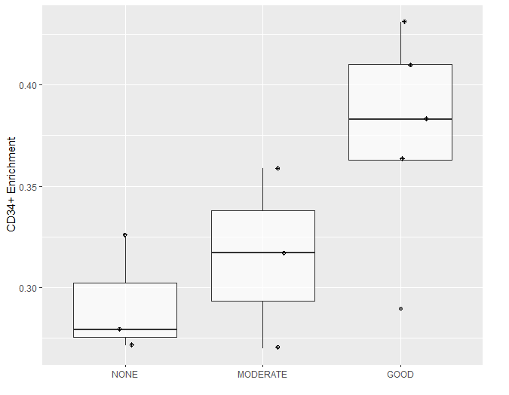

- CD34+ fibroblast enrichment in the synovial membrane in our patient cohort at baseline according to the response to anti-TNF therapy. Improvement in response increases linearly with the proportion of CD34+ fibroblast in the synovial membrane (P=0.027).

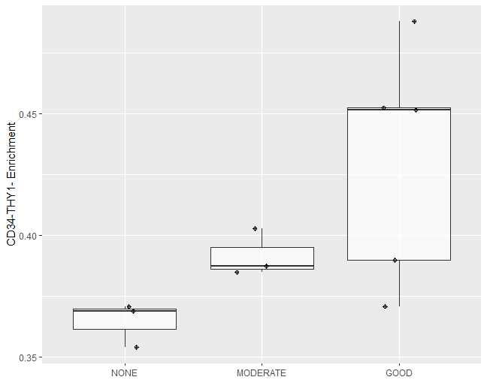
- CD34-THY1- fibroblast enrichment in the synovial membrane in our patient cohort at baseline according to the response to anti-TNF therapy. Improvement in response increases linearly with the proportion of CD34-THY1- fibroblasts in the synovial membrane (P=0.021).

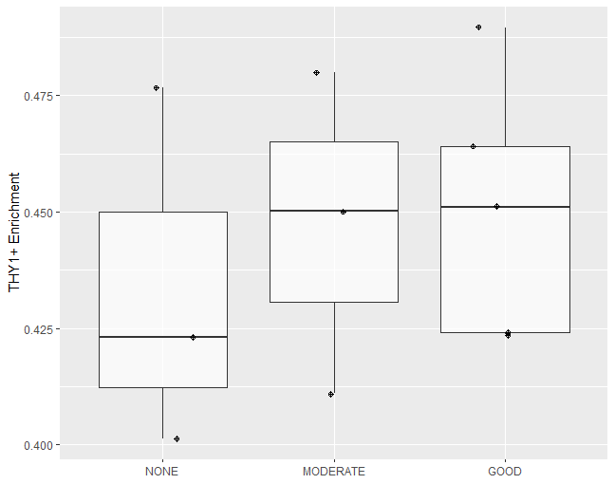
- Boxplot of THY1+ fibroblast enrichment in the synovial membrane in our patient cohort at baseline according to the response to anti-TNF therapy. The estimated proportion of THY1+ fibroblasts is not significantly associated with the response to anti-TNF therapy (P=0.49).

Supplementary Figure 4. Cell types associated with anti-TNF response: differences at week 20.

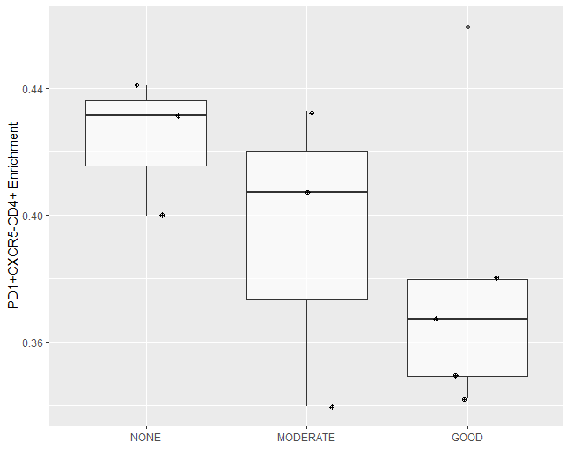
- Boxplot of PD1^{hi}CXCR5-CD4+ T cell enrichment in the synovial membrane in our patient cohort at week20 according to the response to anti-TNF therapy. The trend between lower T_{PH} cells and a better response to anti-TNF therapy identified at baseline is maintained up to week 20 of therapy. Despite this, the association is no longer significant (P=0.29).

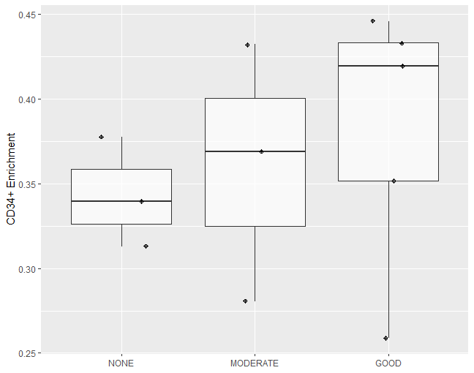

- Boxplot of CD34+ fibroblast enrichment in the synovial membrane in our patient cohort at week 20 according to the response to anti-TNF therapy. The trend between higher CD34+ fibroblasts and a better response to anti-TNF therapy identified at baseline is maintained up to week 20 of therapy but is no longer significant (P=0.43).

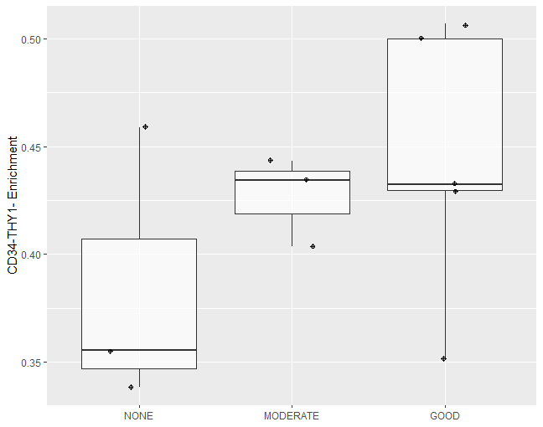

- Boxplot of CD34-THY1- fibroblast enrichment in the synovial membrane in our patient cohort at week 20 according to the response to anti-TNF therapy. The trend between higher CD34-THY1- fibroblasts and a better response to anti-TNF therapy identified at baseline is maintained up to week 20 of therapy but is no longer significant (P=0.16).

Supplementary Figure 5. QRTPCR replication of T_{PH} biomarker genes CTLA4 and TIMELESS.

Plot of gene expression measures for CTLA4 and TIMELESS as quantified using Illumina Beadchip microarrays and using Taqman quantitative RTPCR. The high concordance between both platforms confirms the validity of the microarray gene expression quantification for accurate cell type deconvolution estimation.

Supplementary Figure 6. Correlation between PD1^{hi}CXCR5-CD4+ T cell abundance estimation using the cell deconvolution approach with the percentage quantified using immunofluorescence.

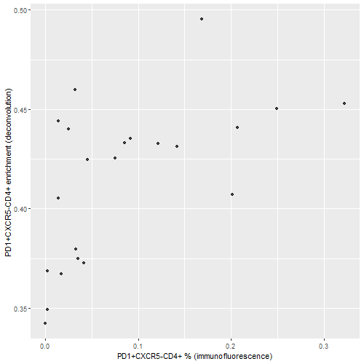

The estimated proportion of T_{PH} cells in the synovial membrane using the cell-type deconvolution approach shows a high correlation with the percentage of cells directly quantified using immunofluorescence on the synovial membrane samples (r2=0.58, P=0.0051). T_{PH} values for all n=11 for the two time points (baseline and wk20) are plotted. This result confirms the suitability of cell type deconvolution approach to estimate even low frequency cell types like T_{PH}.

