Additional File 1. CES-D subscale scores over time, by group

Table. Mean CES-D subscale scores over time, by treatment group
 | Subscale 1  Somatic-retarded activity (0-21) |  | Subscale 2  Depressed  affect (0-15) |  | Subscale 3  Positive  affect (0-12) |  | Subscale 4  Interpersonal affect (0-6)
Time | IFX | PBO | IFX | PBO | IFX | PBO | IFX | PBO
Week 0 | 7.1 (3.8) | 8.0 (3.9) | 2.4 (2.1) | 2.3 (2.0) | 4.4 (3.0) | 5.6 (2.8) | 0.6 (0.8) | 0.6 (0.5)
Week 6 | 4.6 (3.8)* | 9.4 (3.2)* | 1.7 (2.1) | 2.2 (2.1) | 2.7 (2.6) | 3.3 (2.2) | 0.8 (1.6) | 0.0 (0.0)
Week 12 | 4.5 (4.6)* | 8.8 (3.0)* | 1.9 (2.8) | 2.5 (2.0) | 3.4 (3.0) | 4.0 (2.7) | 0.4 (0.7) | 0.3 (0.5)
Week 24 | 4.9 (4.9)* | 9.9 (4.2)* | 1.5 (2.5) | 2.3 (1.5) | 1.9 (2.6) | 3.7 (2.9) | 0.4 (1.0) | 0.1 (0.4)
Week 54 | 4.5 (4.7) | 4.2 (5.8) | 1.3 (1.6) | 1.0 (2.2) | 2.3 (2.5) | 2.4 (3.9) | 0.3 (0.4) | 1.2 (1.3)
All data are expressed as mean (SD).
*Significant difference between treatment groups (not adjusted for multiple testing)

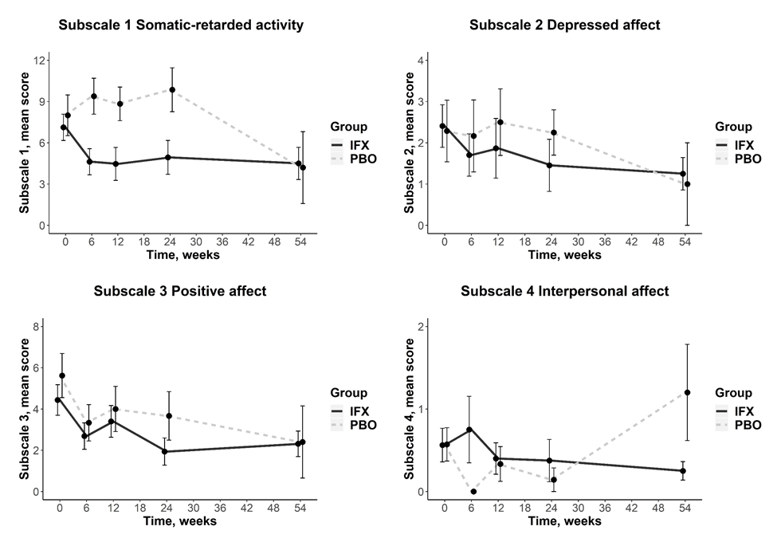
Figure. Mean scores of each CES-D subscale over time, by treatment group

