Supplementary Table 1 Search terms used for determining the incidence, prevalence and mortality of giant cell arteritis
GCA (OR) | AND | Epidemiological terms (OR)
arteriitis,giant cell |  | Incidence
arteritis,cranial |  | incidence rate
arteritis,giant cell |  | rate,incidence
giant cell arteriitis |  | prevalence
GCA |  | prevalence study
arteriitis temporalis |  | mortality
arteritis temporalis |  | excess mortality
arteritis,temporal |  | mortality model
cranial arteritis |  | death rate
headache,histamine |  | death rate model
headache,horton |  | fatal outcome rate
histamine cephalalgia |  | fatality rate
histamine headache |  | lethal outcome rate
Horton disease |  | rate,mortality
horton headache |  | mortality risk index
horton syndrome |  | risk,mortality
migrainous neuralgia |  | mortality, premature
neuralgia,migrainous |  | survival
 |  | disease specific survival

Supplementary Figure 1 Funnel Plots of Incidence, Prevalence and Mortality of Giant Cell Arteritis
a Incidence, b Prevalence c Mortality
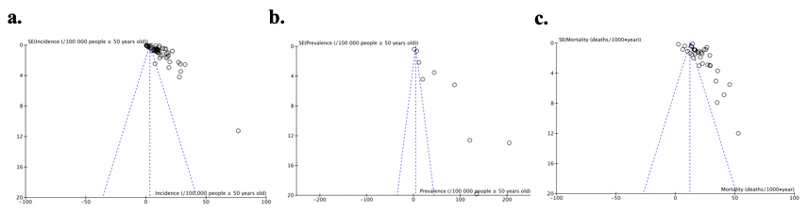

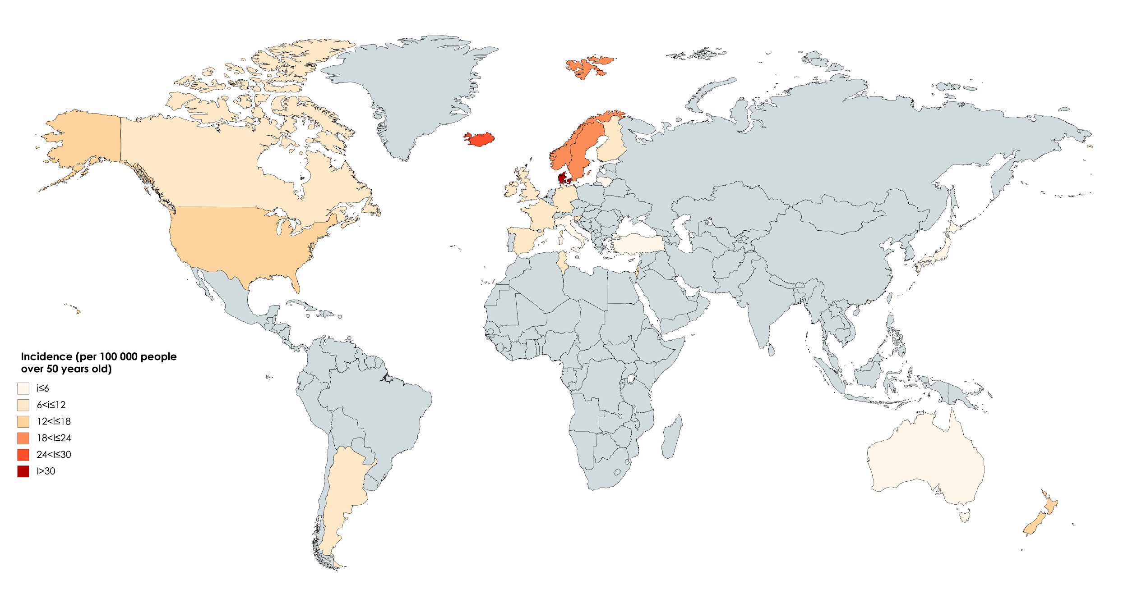

Supplementary Figure 2 Global Incidence of Giant Cell Arteritis on the World Map
*grey = no data

