Additional file 7. Visual examination of FDG PET/CT scans of a case report.
A dcSSc patient with anti-RNA polymerase III antibodies (mRSS=30/51) who had an abnormal interstitial lung pattern of FDG uptake without ILD on HRCT at inclusion. This patient developed later an SSc-ILD.
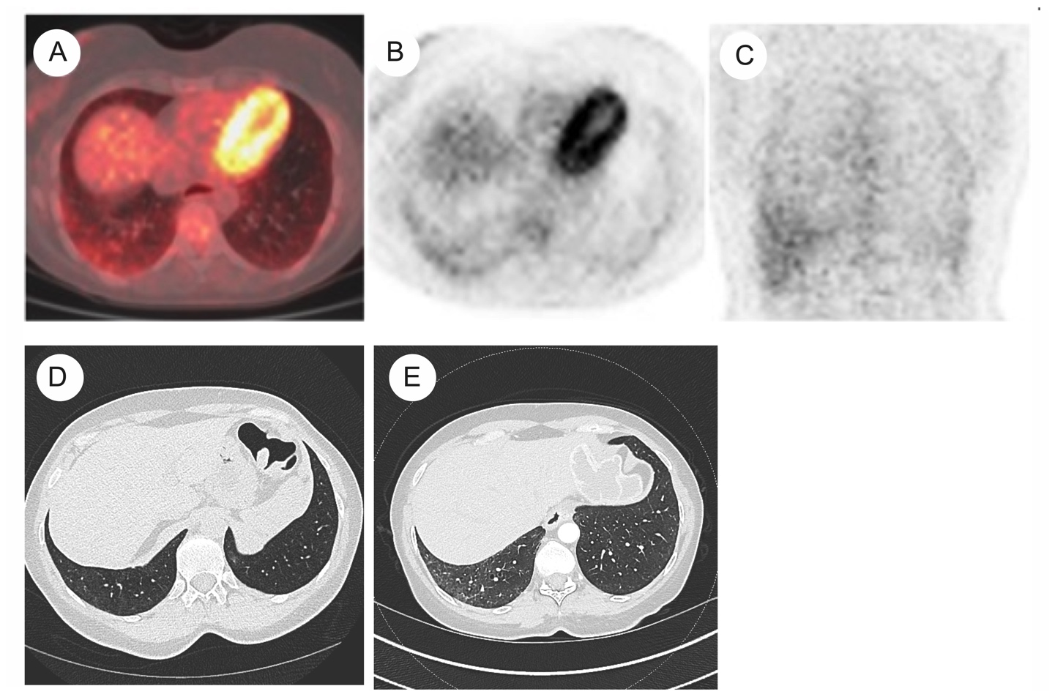
A to D: Transverse slides of the FDG PET/CT scans (A to C) and HRCT (D) scans showing an abnormal interstitial lung pattern without SSc-ILD at inclusion. E: HRCT scans 18 months later showing an SSc-ILD.

