Supplementary Figure 1. Flow-chart of the phone call interview.

The list of symptoms recorded after both doses includes local reactogenicity, arthromyalgia, malaise, fever, lymphadenitis, other.

Supplementary Figure 2. Multivariable logistic regression analysis showing age- and sex-adjusted risk of systemic adverse events after I and II dose of vaccination in patients and controls.

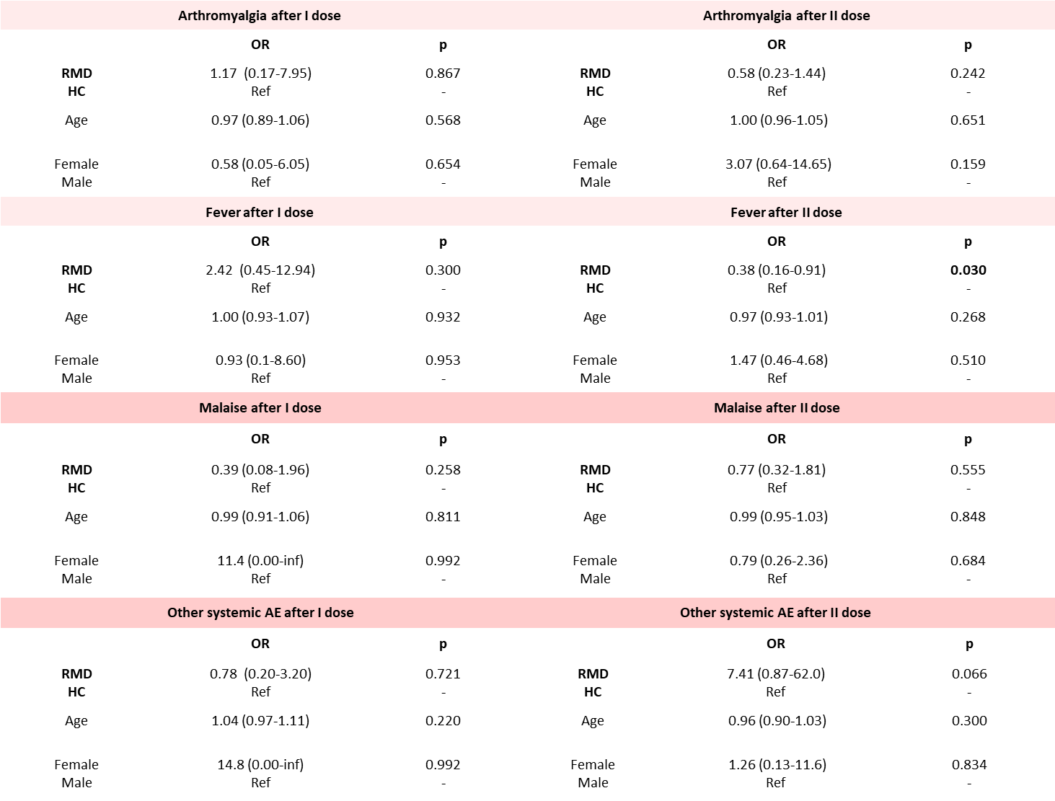

RMD = rheumatic musculoskeletal disease, HC = healthy controls.
Supplementary Figure 3. Occurrence of adverse events following immunization according to age and sex in patients and controls.

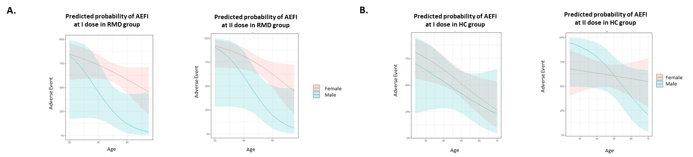

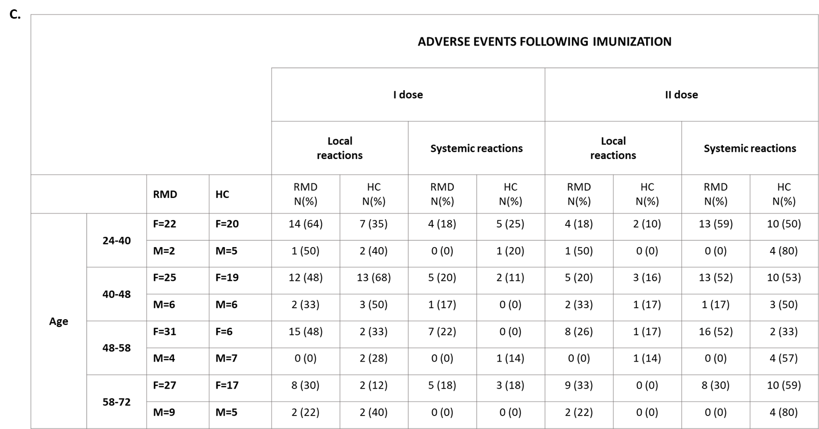

Panel A and panel B represent the interaction model including age and sex in RMD patients (A) and healthy controls (B). Panel C summarizes the proportion of male and female patients and controls complaining of local and systemic reaction, according to age strata.
AEFI = adverse events following immunization, RMD = rhematic musculoskeletal diseases, HC = healthy controls
Figure 4. Risk of adverse events following immunization in RMD patients according to ongoing treatment, previous SARS-CoV2 infection and treatment withdrawal prior to vaccination.

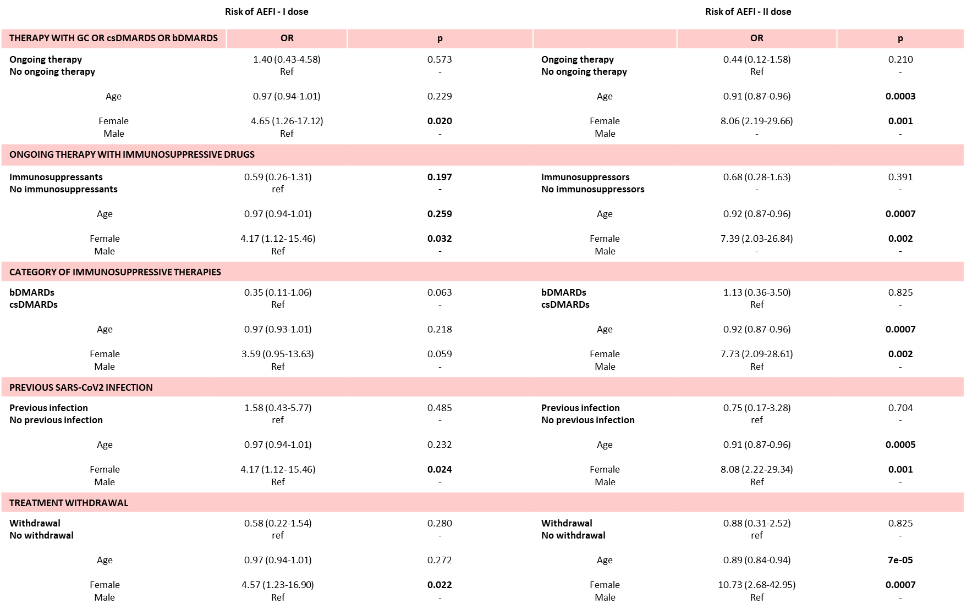

RMD = rheumatic musculoskeletal diseases, GC = glucocorticoids, csDMARDs = conventional synthetic anti-rheumatic drugs, bDMARDs = biological anti-rheumatic drugs

