Chondrocyte-derived exosomes promote cartilage calcification in temporomandibular joint osteoarthritis

Qian Liu^{1a}, Ruoxin Wang^{2a}, Shujie Hou^{3a}, Feng He¹, Yuanjun Ma¹, Tao Ye¹, Shibin Yu¹, Hongwei Chen⁴, Helin Wang^{5*}, Mian Zhang^{1*}
¹State Key Laboratory of Military Stomatology & National Clinical Research Center for Oral Diseases & Shaanxi International Joint Research Center for Oral Diseases, Department of Oral Anatomy and Physiology and TMD, School of Stomatology, the Fourth Military Medical University, Xi’an, China
²Class 1, Grade 2018, School of Stomatology, Zhengzhou University, Zhengzhou, China
³School of Basic Medicine, the Fourth Military Medical University, Xi’an, China
⁴Health Center of 73630 Unit of the Chinese People's Liberation Army, Fuzhou, China
⁵State Key Laboratory of Military Stomatology & National Clinical Research Center for Oral Diseases，Department of Medical Rehabilitation, School of Stomatology, the Fourth Military Medical University, Xi’an, China
ªAuthors contributing equally to this work.

*Corresponding Authors:
Mian Zhang, State Key Laboratory of Military Stomatology & National Clinical Research Center for Oral Diseases & Shaanxi International Joint Research Center for Oral Diseases, Department of Oral Anatomy and Physiology and TMD, School of Stomatology, Fourth Military Medical University, Changle West Road, Xi’an, 710032, China. Email: zhangmian1986@aliyun.com
Helin Wang, State Key Laboratory of Military Stomatology & National Clinical Research Center for Oral Diseases，Department of Medical Rehabilitation, School of Stomatology, the Fourth Military Medical University, Changle West Road, Xi’an, 710032, China. Email: 921441502@qq.com

Supplemental Table 1. Gene primer sequences of rats used for qRT-PCR
Genes | Forward primer | Reverse primer
Tnf-a | ATGGGCTCCCTCTCATCAGTTCC | CCTCCGCTTGGTGGTTTGCTAC
IL-1b | AATCTCACAGCAGCATCTCGACAAG | TCCACGGGCAAGACATAGGTAGC
IL-6 | ACTTCCAGCCAGTTGCCTTCTTG | TGGTCTGTTGTGGGTGGTATCCTC
IL-18 | CGACCGAACAGCCAACGAATCC | GTCACAGCCAGTCCTCTTACTTCAC

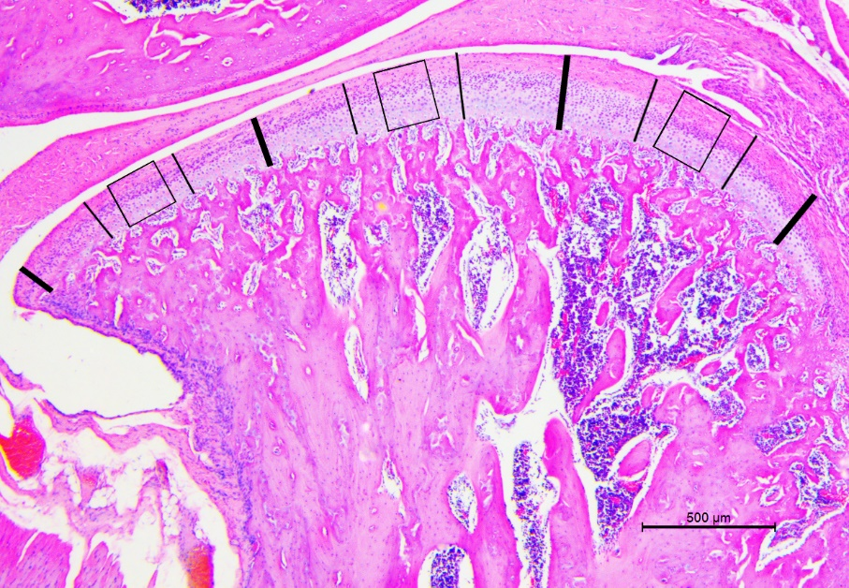
Supplemental Fig1. The representative central sagittal hematoxylin-eosin staining images of rat TMJ represents the outline of measurement for quantitative assessment of histological parameters. The image of condylar cartilage was divided into three sections with equal width (anterior, middle and posterior). The region of interest (ROI) at the center of each section was boxed (width: 200mm, height: cartilage thickness) and analyzed for the thickness of the cartilage or calcified cartilage. The values from three ROIs were averaged and reported for each sample.

Supplemental Fig2. Effect of local injection of GW4869 and exosomes on the inflammation in TMJ cartilage of rats. mRNA expression of Tnf-a, IL-1b, IL-6 and IL-18 in groups of control, control with exosome injection, UAC and UAC with exosome inhibitor injection at 12 w. Control, control group; Control + Exosome, control group with exosome injection; UAC, unilateral anterior crossbite group; UAC + GW4869, unilateral anterior crossbite group with GW4869 injection. All data are presented as means ± SD. The data of compared groups were from the populations of Gaussian distribution and consistent with homogeneity of variance. Comparisons between the control and control + exosome groups or UAC and UAC + GW4869 groups were performed by Student’s t-test. *P<0.05, **P<0.01 and ***P<0.001.

