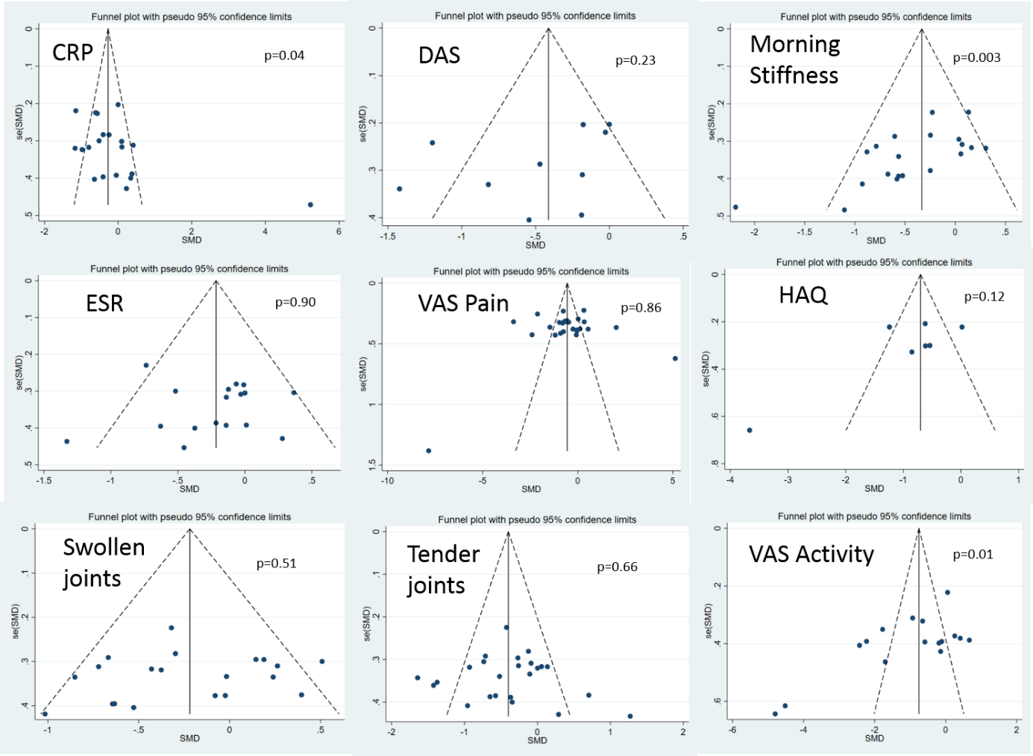
Additional file 16. Funnel plots of publication bias

