Supplementary Table 1. Hazard ratios of the covariates adjusted in the analysis on risk of herpes zoster in rheumatoid arthritis patients during first bDMARD or tsDMARD use
Covariate | Reference | Variable type | HR (95% CI) | P value
Age, years | Continuous | Continuous | 1.02 (1.01-1.02) | <0.001
Sex, female | Male | Categorical | 1.18 (1.02-1.37) | 0.032
Number of csDMARDs | Continuous | Continuous | 1.02 (0.96-1.09) | 0.532
Charlson comorbidity index | Continuous | Continuous | 1.05 (1.03-1.07) | <0.001
Year of the index date |  |  |  | 0.006
2012 | 2011 | Categorical | 0.98 (0.81-1.20) | 0.867
2013 | 2011 | Categorical | 1.05 (0.86-1.30) | 0.625
2014 | 2011 | Categorical | 1.68 (1.35-2.08) | <0.001
2015 | 2011 | Categorical | 2.10 (1.66-2.65) | <0.001
2016 | 2011 | Categorical | 1.48 (1.13-1.94) | 0.005
2017 | 2011 | Categorical | 1.58 (1.17-2.13) | 0.003
2018 | 2011 | Categorical | 1.37 (0.92-2.04) | 0.127
Glucocorticoid use, per 1 mg/day increaseª | Continuous | Continuous | 1.02 (1.00-1.04) | 0.033
History of herpes zoster | No | Categorical | 1.54 (1.33-1.78) | <0.001
HR calculated by multivariate Cox proportional hazards regression.
ªDaily dosage of prednisolone equivalents within 6 months after the index date.
Acronyms: bDMARD, biological disease-modifying anti-rheumatic drugs; tsDMARD, targeted synthetic disease-modifying anti-rheumatic drugs; HR, hazard ratio; CI, confidence interval; csDMARD, conventional synthetic disease-modifying antirheumatic drugs.

Supplementary Table 2. Risk of herpes zoster on rheumatoid arthritis patients started bDMARD or tsDMARD from 2017 during first bDMARD or tsDMARD use.
 | Events | Person-years | Incidence | Time-to-eventª | aHR (95% CI) | P value | aHR (95% CI) | P value
Etanercept (n=433) | 24 (5.5) | 364 | 65.9 | 0.7 (0.3-1.2) | Reference |  | 1.84 (0.87-3.91) | 0.114
Infliximab (n=193) | 11 (5.6) | 160 | 68.8 | 0.4 (0.3-0.6) | 1.08 (0.48-2.42) | 0.853 | 1.98 (0.82-4.83) | 0.131
Adalimumab (n=634) | 33 (5.1) | 546 | 60.4 | 0.5 (0.3-0.9) | 1.10 (0.60-2.01) | 0.770 | 2.01 (0.98-4.13) | 0.057
Golimumab (n=446) | 17 (3.8) | 413 | 41.2 | 0.6 (0.4-0.9) | 0.63 (0.30-1.33) | 0.225 | 1.15 (0.50-2.67) | 0.743
Tocilizumab (n=558) | 28 (4.9) | 527 | 53.1 | 0.6 (0.3-0.9) | 0.69 (0.37-1.30) | 0.255 | 1.27 (0.61-2.65) | 0.521
Tofacitinib (n=679) | 45 (6.5) | 463 | 97.2 | 0.5 (0.3-0.8) | 1.77 (0.99-3.16) | 0.053 | 3.26 (1.63-6.51) | <0.001
Abatacept (n=378) | 14 (3.6) | 331 | 42.3 | 0.4 (0.2-0.7) | 0.54 (0.26-1.16) | 0.114 | Reference
Adjusted hazard ratios calculated by multivariate Cox proportional hazards regression after adjustments for age, sex, number of csDMARD, the Charlson comorbidity index, enrollment year, steroids use, and history of zoster.
Incidence calculated as the number of events per 1,000 person-years.
ªYears to herpes zoster among participants with event, median (interquartile range).
Acronyms: bDMARD, biological disease-modifying anti-rheumatic drugs; tsDMARD, targeted synthetic disease-modifying anti-rheumatic drugs; aHR, adjusted hazard ratio; CI, confidence interval; csDMARD, conventional synthetic disease-modifying antirheumatic drugs.

Supplementary Table 3. Risk of incident herpes zoster on rheumatoid arthritis patients without history of herpes zoster during first bDMARD or tsDMARD use.
 | Events | Person-years | Incidence | Time-to-eventª | aHR (95% CI) | P value | aHR (95% CI) | P value
Etanercept (n=2,369) | 389 (16.4) | 9,589 | 40.6 | 2.6 (1.1-4.3) | Reference |  | 1.19 (0.91-1.57) | 0.209
Infliximab (n=1,129) | 203 (18.0) | 4,039 | 50.3 | 2.2 (1.0-3.8) | 1.20 (0.99-1.46) | 0.067 | 1.43 (1.07-1.91) | 0.015
Adalimumab (n=2,817) | 430 (15.3) | 10,731 | 40.1 | 2.2 (1.0-3.8) | 1.06 (0.90-1.24) | 0.477 | 1.26 (0.96-1.66) | 0.093
Golimumab (n=1,007) | 104 (10.3) | 1,924 | 54.1 | 1.8 (0.9-2.9) | 0.97 (0.74-1.27) | 0.818 | 1.16 (0.84-1.60) | 0.385
Tocilizumab (n=1,131) | 100 (8.8) | 2,227 | 44.9 | 1.4 (0.6-2.1) | 0.70 (0.53-0.91) | 0.009 | 0.83 (0.60-1.14) | 0.254
Rituximab (n=62) | 16 (25.8) | 310 | 51.6 | 2.6 (1.4-5.1) | 1.08 (0.53-2.18) | 0.833 | 1.29 (0.61-2.70) | 0.507
Tofacitinib (n=558) | 30 (5.4) | 382 | 78.5 | 0.6 (0.3-0.9) | 1.67 (1.02-2.74) | 0.044 | 1.99 (1.18-3.37) | 0.011
Abatacept (n=925) | 100 (10.8) | 1,832 | 54.6 | 1.5 (0.7-2.6) | 0.84 (0.64-1.10) | 0.209 | Reference
Adjusted hazard ratios calculated by multivariate Cox proportional hazards regression after adjustments for age, sex, number of csDMARD, the Charlson comorbidity index, enrollment year, and steroids use.
Incidence calculated as the number of events per 1,000 person-years.
ªYears to herpes zoster among participants with event, median (interquartile range).
Acronyms: bDMARD, biological disease-modifying anti-rheumatic drugs; tsDMARD, targeted synthetic disease-modifying anti-rheumatic drugs; aHR, adjusted hazard ratio; CI, confidence interval; csDMARD, conventional synthetic disease-modifying antirheumatic drugs.

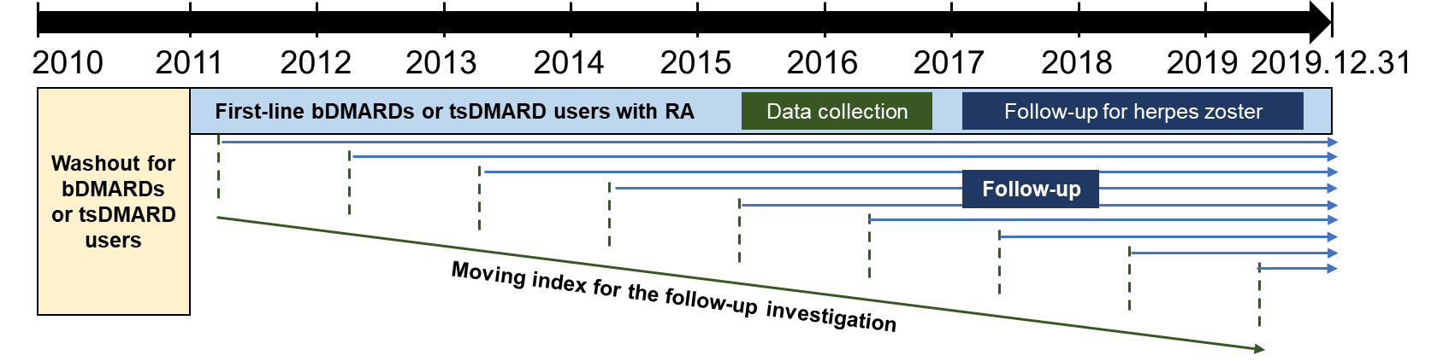

Supplementary Fig. 1. Study design. All patients diagnosed with rheumatoid arthritis and prescribed with bDMARDs or tsDMARDs before 2011 were washed out. Data of RA patients with first-line bDMARD or tsDMARDs were obtained in a moving index setting. A follow-up investigation was carried out from the date of bDMARD or tsDMARD prescription to the date of herpes zoster infection, death, or December 31, 2019, whichever occurred earlier during first-line bDMARD or tsDMARD treatment.

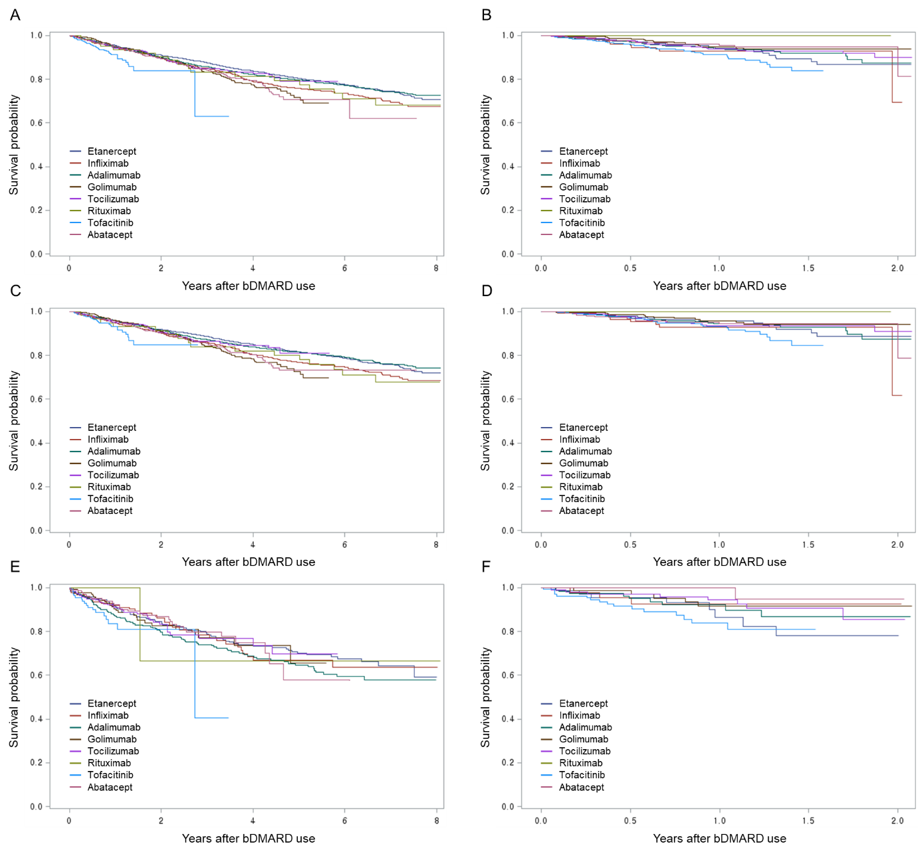

Supplementary Figure 2. Kaplan-Meier estimation on risk of herpes zoster among RA patients according to the first-line bDMARDs or tsDMARD. (A) Estimation of overall herpes zoster in overall patients. (B) Estimation of overall herpes zoster in patients after 2017. (C) Estimation of incident herpes zoster in patients without history of herpes zoster. (D) Estimation of incident herpes zoster in patients without history of herpes zoster after 2017. (E) Estimation of overall herpes zoster in patients with history of herpes zoster. (F) Estimation of recurrent herpes zoster in patients with history of herpes zoster after 2017.

Supplementary Table 4. Characteristics of the patients with and without herpes zoster.
 | Overall participants (n=11,720)
 | Herpes zoster  (n=1,686) | No herpes zoster  (n=10,034) | P value
Age, years | 57 (50-65) | 55 (46-64) | <0.001
Sex, n (%) |  |  | 0.001
Male | 261 (12.1) | 1,891 (87.9)
Female | 1,425 (14.9) | 8,143 (85.1)
No. of csDMARD | 2 (2-3) | 2 (2-3) | 0.862
Steroids, mg/dayª | 4.7 (2.8-6.5) | 4.4 (2.8-6.2) | 0.038
bDMARD or tsDMARD, n (%) |  |  | <0.001
Etanercept | 460 (17.2) | 2,220 (82.8)
Infliximab | 238 (18.1) | 1,077 (81.9)
Adalimumab | 526 (16.3) | 2,703 (83.7)
Golimumab | 130 (10.9) | 1,067 (89.1)
Tocilizumab | 134 (9.7) | 1,244 (90.3)
Rituximab | 17 (25.4) | 50 (74.6)
Abatacept | 133 (11.5) | 1,020 (88.5)
Tofacitinib | 48 (6.8) | 653 (93.2)
Charlson comorbidity index | 3 (2-4) | 3 (2-4) | 0.037
History of herpes zoster, n (%) |  |  | <0.001
Yes | 314 (18.2) | 1,408 (81.8)
No | 1,372 (13.7) | 8,626 (86.3)
Follow-up duration, year
Herpes zoster-free survival | 1.9 (0.8-3.5) | 2.3 (0.7-5.5) | <0.001
First bDMARD or tsDMARD duration | 5.1 (1.9-6.6) | 2.3 (0.7-5.5) | <0.001
Data are median (interquartile range), unless indicated otherwise.
P values calculated by t test and chi-square test for continuous and categorical variables, respectively.
ªDaily dosage within 6 months after the index date.
Acronyms: csDMARD, conventional synthetic disease-modifying antirheumatic drugs; bDMARD, biological disease-modifying anti-rheumatic drugs; tsDMARD, targeted synthetic disease-modifying anti-rheumatic drugs.

Supplementary Table 5. Characteristics of the patients with and without very early herpes zoster.
 | Very early herpes zoster,  ≤6 months (n=267) | Other herpes zoster,  >6 months (n=1,419) | P value
Age, years | 59 (51-67) | 57 (50-64) | 0.012
Sex, n (%) |  |  | 0.902
Male | 42 (16.1) | 219 (83.9)
Female | 225 (15.8) | 1,200 (84.2)
No. of csDMARD | 2 (2-3) | 2 (2-3) | 0.003
Glucocorticoid use, mg/dayª | 4.7 (2.7-6.3) | 4.7 (2.8-6.5) | 0.712
bDMARD or tsDMARD, n (%) |  |  | <0.001
Etanercept | 55 (12.0) | 405 (88.0)
Infliximab | 36 (15.1) | 202 (84.9)
Adalimumab | 77 (14.6) | 449 (85.4)
Golimumab | 13 (10.0) | 117 (90.0)
Tocilizumab | 30 (22.4) | 104 (77.6)
Rituximab | 2 (11.8) | 15 (88.2)
Tofacitinib | 25 (52.1) | 23 (47.9)
Abatacept | 29 (21.8) | 104 (78.2)
Charlson comorbidity index | 3 (2-4) | 3 (2-4) | 0.996
History of herpes zoster, n (%) |  |  | <0.001
Yes | 83 (26.4) | 231 (73.6)
No | 184 (13.4) | 1,188 (86.6)
Follow-up duration, year
Herpes zoster-free survival | 0.3 (0.2-0.4) | 2.3 (1.3-3.8) | <0.001
First bDMARD or tsDMARD duration | 2.4 (0.8-5.5) | 5.3 (2.4-6.7) | <0.001
Data are median (interquartile range), unless indicated otherwise.
P values calculated by t test and chi-square test for continuous and categorical variables, respectively.
ªDaily dosage of prednisolone equivalents within 6 months after the index date.
Acronyms: csDMARD, conventional synthetic disease-modifying antirheumatic drugs; bDMARD, biological disease-modifying anti-rheumatic drugs; tsDMARD, targeted synthetic disease-modifying anti-rheumatic drugs.

