Supplementary Figure 1: Ranking probability based on SUCRA model. Different area under curve represents the predicted rank for each intervention (From first to seventh). (A) VAS score; (B) WOMAC Total; (C) WOMAC Function; (D) WOMAC Pain; (E) WOMAC Stiffness; (F) Adverse events. SUCRA, surface under the cumulative ranking curve.

Supplementary Figure 2: Heterogeneity assessment according to the loop test. (A) VAS score; (B) WOMAC Pain; (C) Adverse events.

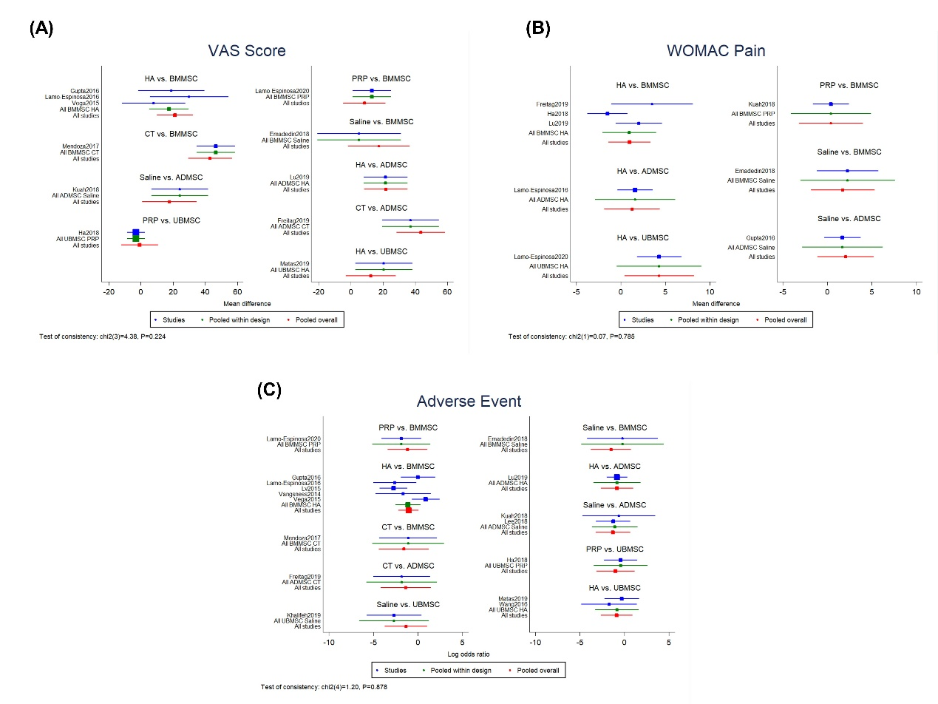
Supplementary Figure 3: Inconsistency assessment according to the inconsistency model. (A) VAS score; (B) WOMAC Pain and (C) Adverse events.

